Pre-processing:
German OBS data,
Møre 2009 Survey

IFM-GEOMAR, Kiel, UiB Bergen
August, 4th 2009

Trond Kvarven

Department of Earth Science, University of Bergen
Allegaten 41, N-5007 Bergen, Norway
Introduction 3
Experiment setup 4
Receiver type 5
Data processing 5
Data loss 7
Data quality 7
Acknowledgement 7
References 7
Appendix 11

Introduction
The acquisition of the three crustal scale OBS profiles (figure 1) was performed during a cruise with M/V “Håkon Mosby” from May 24th to June 9th, 2009. Several institutions participated: UiB, UiO, Hokkaido University and Leibniz Institute of Marine Sciences at the Christian-Albrechts University of Kiel (IFM-GEOMAR). The data were collected as a part of a Collaborative Research Project (CPR) within the multi-national and multi-disiplinary TopoScandiaDeep project. The CPR is called "The Scandinavian mountains: deep processes" and is aiming to understanding the ongoing dynamics of the Møre region, mid-Norway. In addition several land-stations were deployed in the landward continuation of profile 1 and 2. The survey was accompanied by gravity and magnetic measurements. This report describes the pre-processing of the data collected by Geomar during the period from 6th-10th of July in Kiel. The pre-processing of the Japanese OBSs will be treated in a separate report. Consult the cruise report (Mjelde & Minakov, 2009) for more details about the data acquisition.

The main objectives of this CPR project are:
- Mapping of the Jan Mayen Lineament (JML)
- Mapping the possible onshore continuation of the lower crustal high velocity bodies (LCB).
- Investigate if bodies of Caledonian eclogites are present within the lower crust near the coastline
- Investigate the interplay between the Møre-Trøndelag Fault Complex (MTFZ) and the inherited structures.
Figure 1. The study area of the OBS survey Møre Basin 2009. The shot profiles are shown by black solid lines. Purple triangles point to the OBS deployment position. From Mjelde & Minakov (2009).

Figure 1. The study area of the OBS survey Møre Basin 2009. The shot profiles are
shown by black solid lines. Purple triangles point to the OBS deployment position. From Mjelde & Minakov (2009)

Experiment setup
The seismic source comprised four equal seized 1200 inch³ air-guns with a total volume of 4800 inch³. The shooting interval was approximately 200 meters.

For the 281 km profile 1, the OBSs no. 101-105 were provided by the Hokkaido University, while OBSs no. 106-116 were provided by Geomar. For the 293.2 km profile 2, the OBSs no. 201-205 were provided by the Hokkaido University, while OBSs no. 206-216 were provided by Geomar. For the 206.2 km profile 3, the OBSs no. 311, 312 and 313 were provided by the Hokkaido University, while OBSs no. 303, 305, 306, 307, 308 and 310 were provided by Geomar. The OBSs provided by the Hokkaido University were used in the most landward position and were also deployed in a denser interval than the Geomar OBSs (figure 1).

Receiver type
The OBSs from Geomar are of “walze” type. The OBSs are equipped by a Marine Longtime Seismograph recorder (MLS), three-component geophone (HTI) and standard hydrophone (Owen) with a natural frequency of 4.5 Hz. The sampling rate to 2Gb flash memory cards is 200 Hz. Detail description of the equipment can be found on Geomar’s web sites: http://www.ifm-geomar.de/index.php?id=4984&L=1.

Data processing
The OBS data processing was carried out according to the work flow used at Geomar. The processing routines comprised preparation of navigation data, conversion of the records to SEGY format, clock drift removal, relocation of the ocean bottom receivers, band-pass filtering, data display and quality evaluation.

The navigation data was manually edited in case of errors in the records. Then, the time/shot information from airgun synchronization unit and differential GPS data have been merged to obtained the samples with millisecond accuracy. The ukooa-file with specific header included information of OBS-deployment positions and synchronization time has been assembled for each profile to convert data recorded by MLS to standard SEGY format. The conversion to SEGY was performed using “d2s.csh” script. The record has been cut into traces with 60s time length based on the geometry, shooting time and clock drift (skew) information (table 1) contained in the ukooa file. Each trace has been shifted by the ratio offset-to-reduction velocity (8 km/s) to get nearly flat Moho refracted arrivals.

The OBS sinking down to the sea bottom can be affected by ocean currents that could lead to difference between deployment and settle down points. To account for the shift of the instrument's position along the profile the relocation procedure has been adopted. The data was reduced by 1480 m/s velocity to get flat direct water arrivals. In case of station's drift we will get a kink of the direct water arrival relative to zero offset. The estimation of true OBS position is achieved by relocation of the instrument until the flat direct water arrival has been achieved (table 2).

When plotting the water wave first arrival the plot was discontinuous. For that reason the “original” shot event data were suspected to be corrupt. Therefore the Geomar’s “back-up” shot point data were used instead.
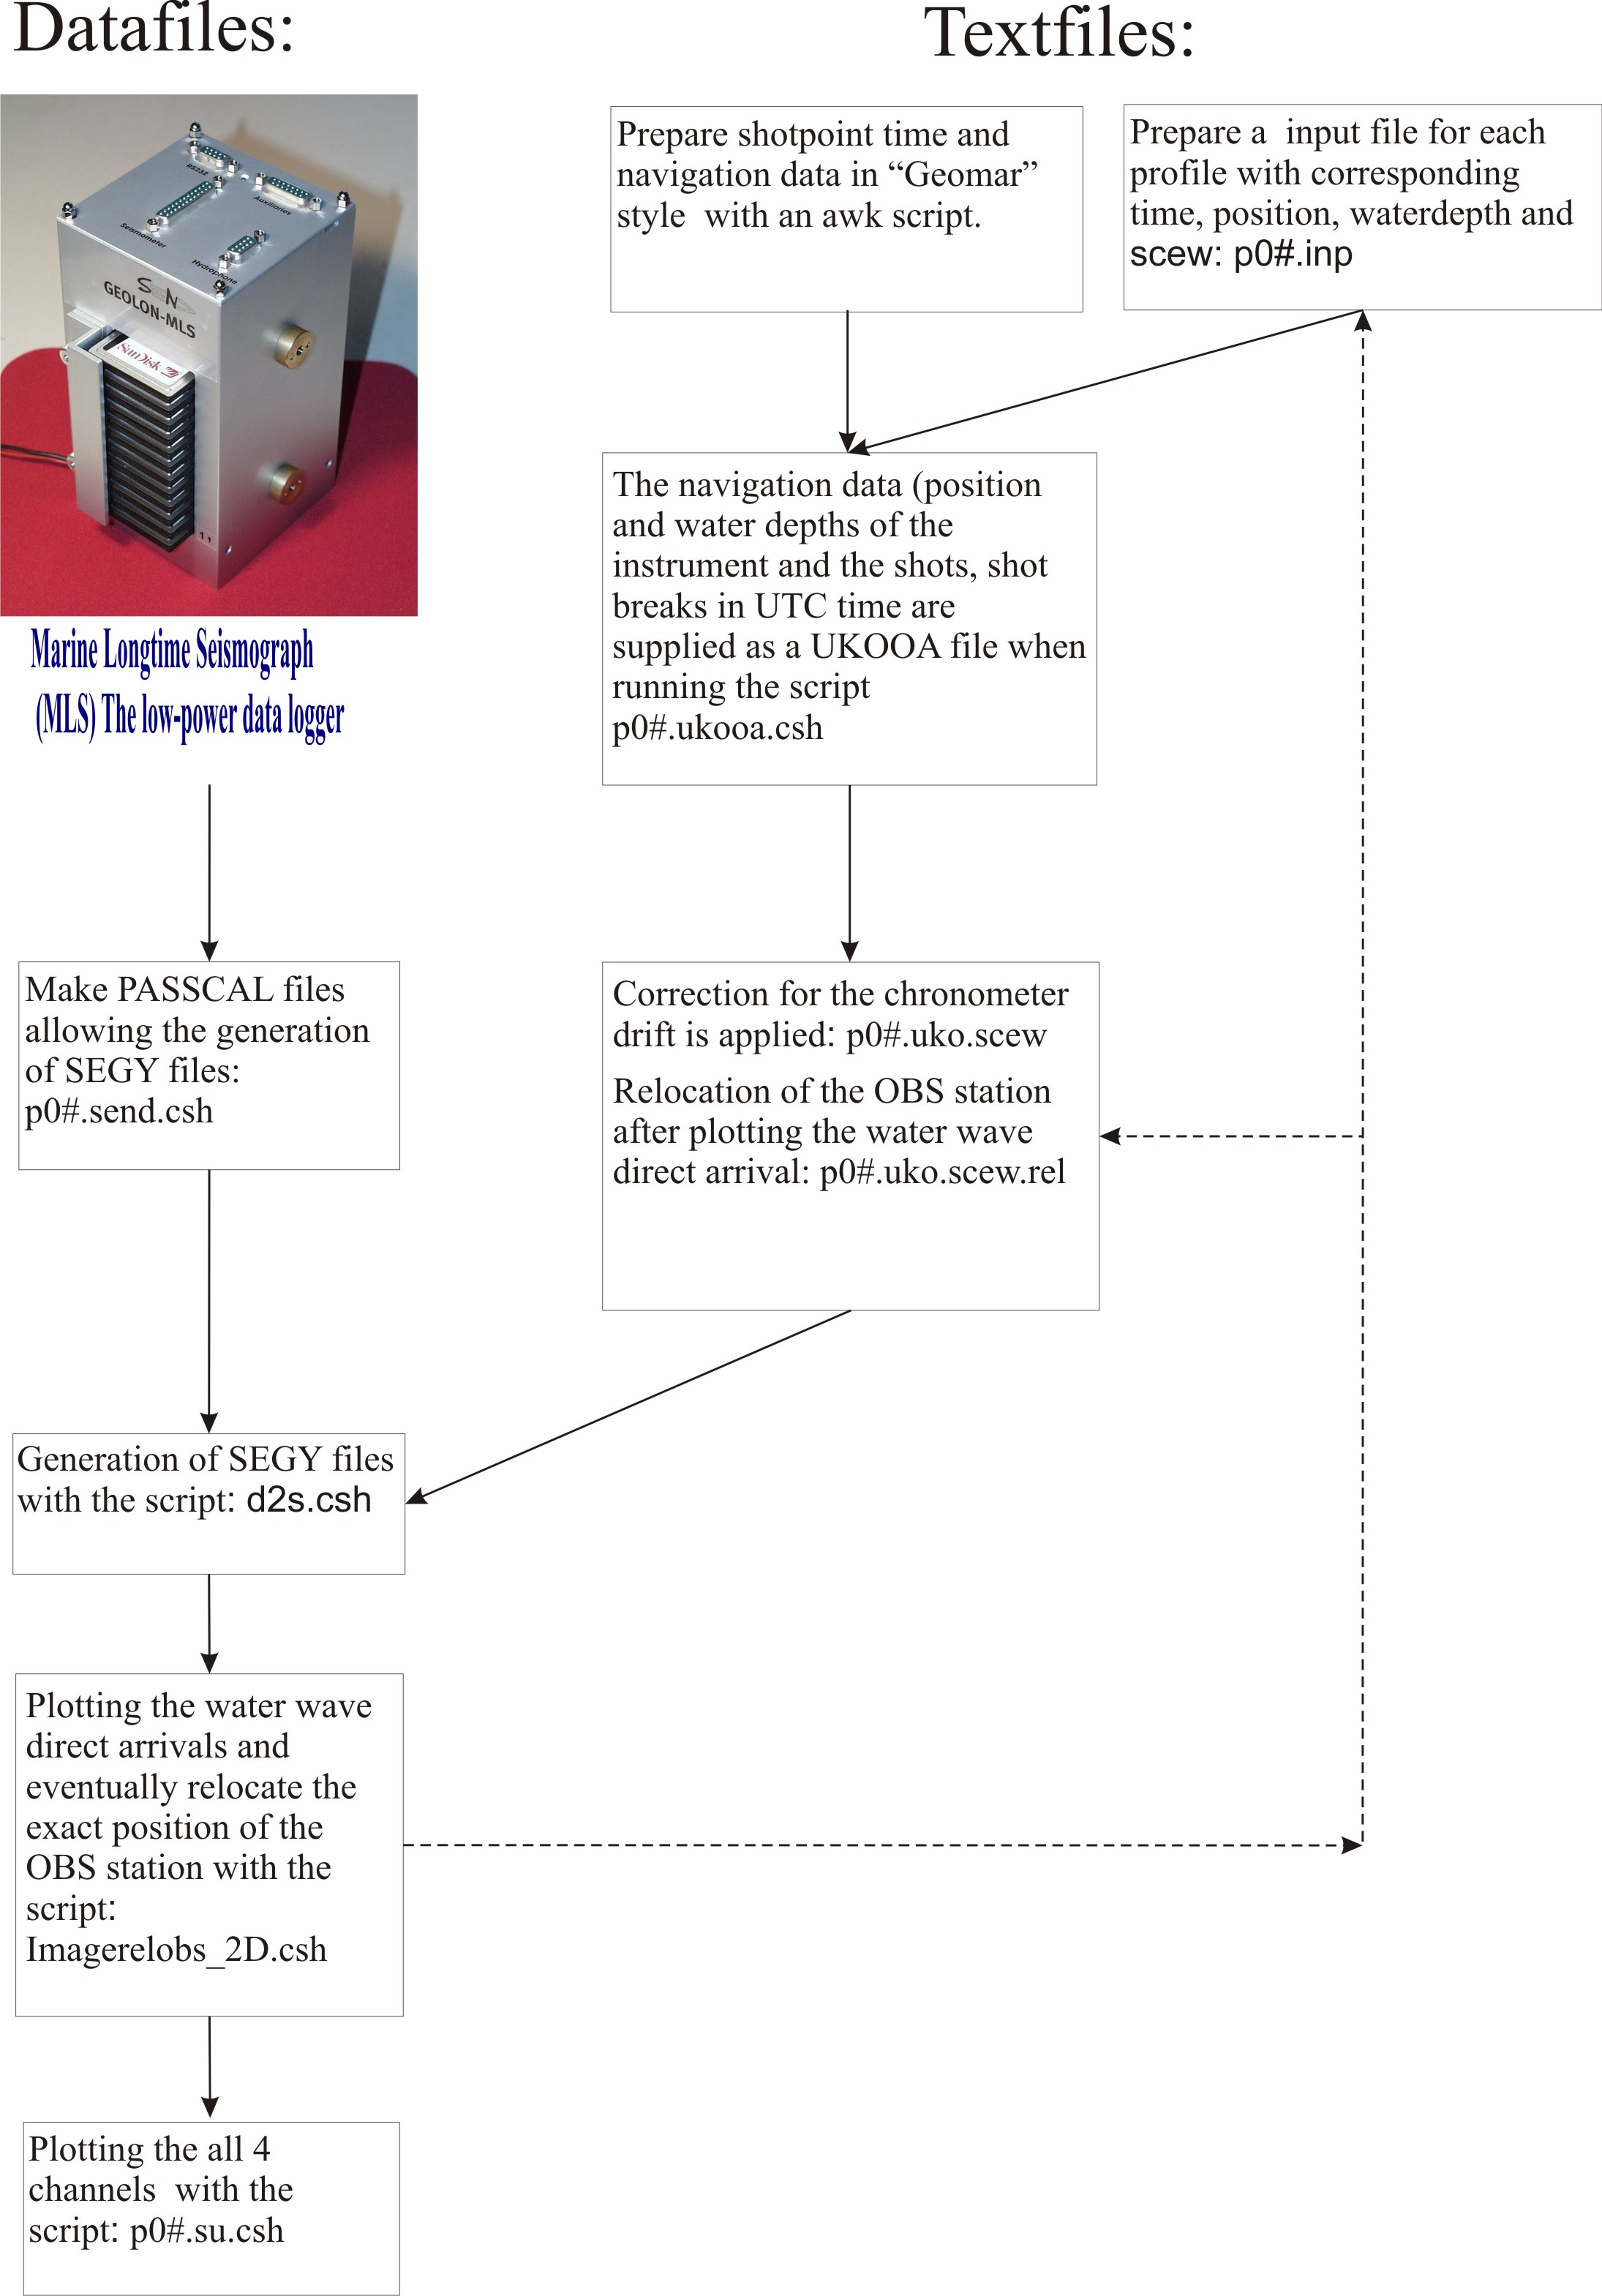
Figure 2. Work flow of the pre-processing of the data collected from the Geomar OBSs.

Data loss
All 43 OBSs deployed were recovered (28 from Geomar), but OBS 209 did not contain useful data. Due to problems with the compressor and poor weather conditions, 19.8 km of profile 1 was acquired with 2 air-guns only, and the rest of the profile (261.2 km) was acquired with 3 air-guns. A total of 36 shots were lost and 76.6 km were acquired with low pressure (120-125 bars), due to compressor problems. Profile 3 was acquired without incident, but two OBSs towards each end of the profile were not deployed, due to the time loss. The above implies the following: 1% of the data along the profiles was lost, 2.5% of the profiles were acquired with 2 air-guns, 33% with 3 air-guns, and 10% was acquired with low pressure. Consult the cruise report (Mjelde & Minakov, 2009) for more details about the data acquisition.

Data quality
The quality of the processed data was analysed by visual inspection of the seismograms shown in Appendix. The signal range and the amount of noise in the data is what decide the quality. Good quality data have signal range greater than 80 km while data with signal range less than 40 km is considered poor/bad. The overall quality of the data can be regarded as moderate to poor (Table 3, Appendix).

Acknowledgement
The data acquisition was funded by the Research Council of Norway (NFR). We would like to thank all the participating institutions and the crew at R/V Håkon Mosby. Prof Ernst Flueh who provided the opportunity to access to the facilities of IFM-GEOMAR. Many thanks to Anke Dannowski and to Wiebke Brunn for all help during the pre-processing.

References

Mjelde, R. & Minakov, A. 2009. Cruise Report: Møre 2009: OBS survey Møre Basin within the Toposcandia project by use of Håkon Mosby. Department of Earth Science, University of
Bergen, Norway.
Tables

Table 1. Clock drift and synchronization times
 |  | Synchronization prior deployment |  |  |  |  | Synchronization after deployment
Profile | Station | Date | Julian day | hour | minutes | Skew (msec) | Date | Julian day | hour | minutes | Scew (msec) | Comments
P01 | 106 | 260509 | 146 | 19 | 48 | 0 | 300509 | 150 | 18 | 21 | -1
P01 | 107 | 260509 | 146 | 19 | 00 | 0 | 300509 | 150 | 17 | 11 | -2
P01 | 108 | 260509 | 146 | 18 | 38 | 0 | 300509 | 150 | 15 | 54 | 4
P01 | 109 | 260509 | 146 | 18 | 19 | 0 | 300509 | 150 | 14 | 21 | 12
P01 | 110 | 260509 | 146 | 17 | 49 | 0 | 300509 | 150 | 12 | 43 | 3
P01 | 111 | 260509 | 146 | 17 | 31 | 0 | 300509 | 150 | 11 | 08 | 0
P01 | 112 | 260509 | 146 | 17 | 03 | 0 | 300509 | 150 | 08 | 35 | -32
P01 | 113 | 260509 | 146 | 16 | 46 | 0 | 300509 | 150 | 06 | 43 | 7
P01 | 114 | 260509 | 146 | 15 | 55 | 0 | 300509 | 150 | 05 | 44 | 4046
P01 | 115 | 260509 | 146 | 15 | 36 | 0 | 300509 | 150 | 03 | 00 | -12
P01 | 116 | 260509 | 146 | 14 | 40 | 0 | 300509 | 150 | 01 | 48 | 5
P02 | 206 | 300509 | 150 | 18 | 28 | 0 | 040609 | 155 | 19 | 59 | --2
P02 | 207 | 300509 | 150 | 17 | 38 | 0 | 040609 | 155 | 18 | 44 | -11
P02 | 208 | 300509 | 150 | 17 | 20 | 0 | 040609 | 155 | 17 | 23 | 0
P02 | 209 |  |  |  |  |  |  |  |  |  |  | No data
P02 | 210 | 300509 | 150 | 14 | 50 | 0 | 040609 | 155 | 14 | 49 | 7
P02 | 211 | 300509 | 150 | 14 | 42 | 0 | 040609 | 155 | 13 | 10 | -16
P02 | 212 | 300509 | 150 | 14 | 30 | 0 | 040609 | 155 | 11 | 39 | 14
P02 | 213 | 300509 | 150 | 12 | 52 | 0 | 040609 | 155 | 10 | 18 | 4
P02 | 214 | 300509 | 150 | 11 | 37 | 0 | 040609 | 155 | 08 | 19 | 11
P02 | 215 | 300509 | 150 | 11 | 20 | 0 | 040609 | 155 | 06 | 39 | -1
P02 | 216 | 300509 | 150 | 10 | 38 | 0 | 040609 | 155 | 04 | 52 | -42
P03 | 303 | 040609 | 155 | 05 | 01 | 0 | 060609 | 157 | 21 | 52 | -24
P03 | 305 | 040609 | 155 | 06 | 53 | 0 | 070609 | 158 | 01 | 25 | -2
P03 | 306 | 040609 | 155 | 08 | 27 | 0 | 070609 | 158 | 03 | 21 | 5
P03 | 307 | 040609 | 155 | 10 | 25 | 0 | 070609 | 158 | 04 | 55 | 2
P03 | 308 | 040609 | 155 | 13 | 18 | 0 | 070609 | 158 | 06 | 18 | -10
P03 | 310 | 040609 | 155 | 14 | 56 | 0 | 070609 | 158 | 08 | 46 | 5

Table 2. Relocation of OBS positions
Profile | Station | Depth (meters) | Latitude of deployment | Longitude of deployment | Latitude after relocation | Longitude after relocation | Comments
P01 | 106 | 270 |  |  |  |  | To shallow
P01 | 107 | 275 |  |  |  |  | To shallow
P01 | 108 | 716 | 63º33’13,39N | 5º33’44,64E | 63º33’11,59N | 5º33’49,44E
P01 | 109 | 1094 | 63º40’18,64N | 5º15’30,66E |  |  | Missing data
P01 | 110 | 1160 | 63º47’23,90N | 4º57’02,51E | 63º47’25,19N | 4º56’59,09E
P01 | 111 | 1322 | 63º54’25,87N | 4º38’25,49E | 63º54’29,30N | 4º38’16,40E
P01 | 112 | 1386 | 64º03’09,15N | 4º15’03,35E | 64º03’10,92N | 4º14’58,54E
P01 | 113 | 1640 | 64º11’51,16N | 3º51’13,69E | 64º11’51,16N | 3º51’13,69E | No relocation
P01 | 114 | 1898 | 64º20’26,50N | 3º27’20,91E | 64º20’26,50N | 3º27’20,91E | No relocation
P01 | 115 | 2316 | 64º28’59,50N | 3º03’06,41E | 64º28’59,50N | 3º03’06,41E | No relocation
P01 | 116 | 2445 | 64º37’28,20N | 3º38’39,00E | 64º37’28,20N | 3º38’39,00E | No relocation
P02 | 206 | 351 |  |  |  |  | To shallow
P02 | 207 | 745 |  |  |  |  | To shallow
P02 | 208 | 940 | 63º02’54,14N | 4º01’05,40E | 63º02’51,49N | 4º01’11,79E
P02 | 209 |  |  |  |  |  | No data
P02 | 210 | 1105 | 63º17’15,35N | 3º25’42,17E | 63º17’20,28N | 3º25’29,94E
P02 | 211 | 1171 | 63º26’16,90N | 3º03’15,83E | 63º26’16,90N | 3º03’15,83E | No relocation
P02 | 212 | 1315 | 63º35’12,58N | 2º40’36,76E | 63º35’13,94N | 2º40’33,27E
P02 | 213 | 1507 | 63º44’06,12N | 2º17’40,15E | 63º44’06,12N | 2º17’40,15E | No relocation
P02 | 214 | 1735 | 63º52’56,04N | 1º54’33,42E | 63º52’56,04N | 1º54’33,42E | No relocation
P02 | 215 | 2200 | 64º01’40,92N | 1º31’13,26E | 64º01’40,92N | 1º31’13,26E | No relocation
P02 | 216 | 2436 | 64º10’24,43N | 1º07’29,10E | 64º10’24,43N | 1º07’29,10E | No relocation
P03 | 303 | 185 |  |  |  |  | To shallow
P03 | 305 | 100 |  |  |  |  | To shallow
P03 | 306 | 133 |  |  |  |  | To shallow
P03 | 307 | 158 |  |  |  |  | To shallow
P03 | 308 | 126 |  |  |  |  | To shallow
P03 | 310 | 192 |  |  |  |  | To shallow

Profile  Table 3. Data quality | Station | Channel 1 (hydrophone | Channel 2 (horizontal component 1) | Channel 3 (horizontal component 2) | Channel 4 (vertical component)
P01 | 106 | 0 | - | - | -
P01 | 107 | 0 | - | - | -
P01 | 108 | 0 | - | -- | 0
P01 | 109 | Noise | Noise | - | -
P01 | 110 | 0 | -- | 0 | 0
P01 | 111 | 0 | -- | -- | --
P01 | 112 | - | - | - | -
P01 | 113 | 0 | -- | - | -
P01 | 114 | -- | -- | -- | --
P01 | 115 | 0 | -- | - | -
P01 | 116 | - | -- | -- | --
P02 | 206 | -- | -- | -- | --
P02 | 207 | - | -- | -- | --
P02 | 208 | 0 | 0 | 0 | 0
P02 | 209 |  |  |  | No data
P02 | 210 | - | -- | - | --
P02 | 211 | 0 | - | - | 0
P02 | 212 | Noise | Noise | - | --
P02 | 213 | -- | Noise | -- | Noise
P02 | 214 | -- | - | - | -
P02 | 215 | 0 | - | - | -
P02 | 216 | 0 | - | - | Noise
P03 | 303 | 0 | - | Noise | -
P03 | 305 | - | - | - | -
P03 | 306 | 0 | - | 0 | -
P03 | 307 | 0 | - | 0 | -
P03 | 308 | + | 0 | 0 | 0
P03 | 310 | + | 0 | 0 | 0

++ | Very good (more than 120km signal range, clear arrivals, few noise)
+ | Good (80 to 120 km signal range, more noise)
0 | Moderate (< 80 km signal range, partly very noisy)
- | Poor (< 40 km signal range, noise dominates)
-- | Bad (< 20 km signal range, noise dominates)
Noise | Noise only

Appendix

