Banana cake – with or without gluten!

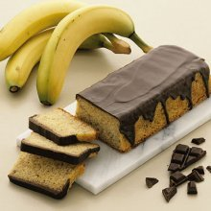
Preparation time: 60+ (minutes)
Slices: approx. 18

Ingredients:

3 eggs
170 g sugar (approx. 2 dl)
2 tsp vanilla sugar
125 g wheat flour (approx. 2 dl)
1 tsp baking powder
100 g melted, cooled butter
3 squashed bananas
100 g finely chopped chocolate (dark and light)

150 g melted chocolate

Baking time: approx. 55 minutes at 175 ºC

How to do…:

Whip eggs, sugar and vanilla sugar together to an airy mass. Mix flour and baking powder, and turn it carefully into the egg-mass with the melted cooled butter. Turn the squashed bananas in. Pour the dough into a cake tin (app. 1 liter) that is greased with butter. Bake the cake in the lower part of the oven. Take the cake out of the form to cool when it is done.

Spread the melted chocolate on the cake.

Is not good for freezing!

Tested by Louise Bjerrum, September 2005

