Notes: On Setting up the SADC10 Driver with Seislog

Mr. Mauro Mariotti ( http://mariottim.interfree.it/index.htm ) manufactures a 4 channel analogue to digital (A/D) card that communicates to the host computer via its serial communications port (RS-232). This “SADC10” (A/D) card has now been interfaced to the University of Bergen’s program “Seislog”. (Please, consult the University of Bergen copyright agreement on this matter). The “SADC10” driver can use all four, 16 bit wide analogue to digital inputs. The “SADC10” card version 1.4 communicates at fixed baud rate of 14400 baud.

These notes should be used in conjunction with the University of Bergen ‘s manual of “Seislog”.

See; http://www.ifjf.uib.no/ or (129.177.55.5) and follow the links on “Seismology” and “software development”.

These instructions are a quick guide to setting up the SADC10 driver.

This Version 1.4 SADC10 driver is first Alpha release.

Seislog SADC10 Driver Features for Version 1.4

- Selectable sample rates of 5, 10, 20, 25, 50, 100 samples per second.
- Possible 16 communications ports with various “baud” rates.
- One, three or four channels of data can be monitored.
- User selectable time correction.
- The PC clock can be synchronised via the SADC10 card. This is particularly useful when the SADC10 card is synchronised with a time reference such as the European (DCF77) standard.
- The SADC10 data can be time tagged with the PC clock’s time. This is particularly useful when the PC clock is synchronised with network time or with a “GPS” or some other method.

Program Settings

If this is the first time “Seislog” is installed then the “Seislog” manual must be consulted and the “Program setting” data under the “configure” menu must be entered.

Installing the SADC10 Driver and Channels in Seislog:

In a new folder install the program “Seislog.exe” and its associated file “cbw32.dll”. Create a shortcut link from the program “Seislog” to your desktop.

Once the program is started select the “configure” option and “administer channels”.

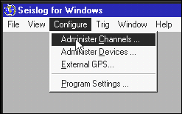

Important
We are about to remove all the Channels that are associated with the SADC10 driver. You need to do this if you change the SADC10 driver “Model” option or wish to increase the ring buffer size. If any “Configured channels” exist, that are associated with the SADC10 driver, press the remove button. Repeat this until all the associated channels are removed.

Installing the SADC driver.

First remove any previous installed versions of the SADC10 driver. Select the “configure” option and “Administer Devices.

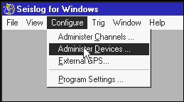

If any “Configured devices” exist that is named “Chan-1”, “Chan-3” or “Chan-4” press the remove button.

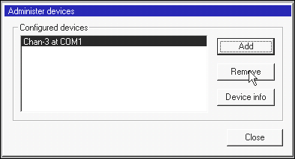

Once the old driver is removed, press the “Add” option in the “Configured devices” dialogue and select the SADC10 driver from the driver list. Press the “configure” button.

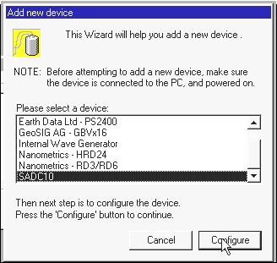

The SADC10 dialogue box will be presented.

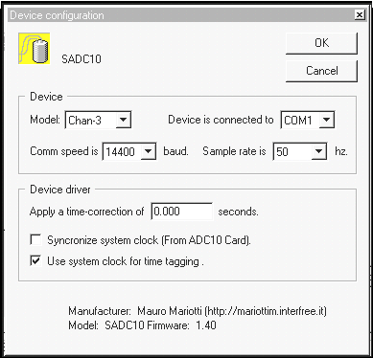

At this point we will discuss each option.

- [ Model ] There are three options; “Chan-4”, “Chan-3” and “Chan-1”. This represents the maximum amount of input channels that can be monitored. “Chan-4” is 4, “Chan-3” is 3 and “Chan-1” is one channel.

- [Device is connected to] This represents which serial communications port that is connected to the SADC10 card.

- [Comm speed is] This is the Baud rate the SADC10 card. For version 1.4 of the SADC10 card, the baud rate is set to 14400.

- [Sample rate is] This is the sample rate of the SADC10 card. If four channels are selected then all four channels operate at this sampling speed. The Sample rate can be. 5,10,20,25,50,100 samples per second. Note: with SADC10 version 1.4 you cannot monitor 4 channels at 100 samples per second. A warning message will appear in the “log” when this option is selected and no data is recorded.

- [Apply a time-correction of] This correction factor in seconds is applied to the sample time of the data. It’s a simple way to correct the time stamp of the data. It’s generally set to 0.000.

- [Synchronize system clock (from SADC10 Card}] The data’s time stamp is taken from the SADC10 card. It also synchronizes the PC clock with the cards time if the “GPS” option in “Seislog” program is not selected. This is particularly useful when the SADC10 card is connected to the DCF77 time reference. It should be noted that the DCF77 time reference is a European standard. See: special note on sending time to the SADC10 card.

- [ Use system clock for time tagging ] The data’s time stamp is taken from the PC clock. If the “GPS” option in “Seislog” program is selected then the PC clock is synchronized via the GPS, hence the data time stamp is synchronized. This also applies if the GPS option is disabled and the PC clock is synchronized by some other means such as the PC being synchronized via the network. If the PC clock is not synchronized to absolute time then the data time stamp will drift with the PC clock. See: special note on sending time to the SADC10 card.

Special note on sending time to the SADC10 card.

When “Seislog” is started with the SADC10 driver, it always sends the PC time to the card. If the PC clock is to be synchronized to absolute time it is prudent to make sure the PC clock is synchronized before starting “Seislog”. Time sent to the “SADC10” card is in U.T.C (Universal) time, not local time.

Once the options have been set press the Ok button followed by the “close” button in the “Configured devices” dialogue box. The SADC10 driver is now installed.

Setting up the Channels to be Monitored

The device driver specifies the maximum number of channels that can be logged and what sample rate the data is taken. The channel information is now required to be set. Open the “configure” and “administer channels” option and press the “add” button. In this example we have selected “Chan-3” option.

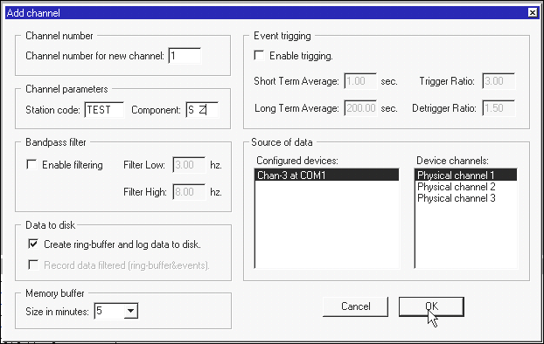

In the “Station code” box, insert in a unique name for this (A/D) channel. In this example its called “TEST”.

In the "component" box, insert is n a valid directional component of your sensor. This code must conform to a pre-described list of valid components. In this example we have typed S followed by two spaces and a Z. Alphanumeric is in upper case. S Z stands for a short period vertical sensor.

[ Valid component List ]

S Z S N S E L Z L N L E AL Z AL N AL E
AH Z AH N AH E A Z A N A E BV Z BV N BV E
BH Z BH N BH E B Z B N B E SV Z SV N SV E
SH Z SH N SH E LV Z LV N LV E S R S T L R
L T AL R AL T AH R AH T A R A T BV R BV T
SV R SV T

In the “Source of Data” box, select the "device channel" then select the "physical channel” that is to be monitor. In this case "physical channel 1". Press the “Ok” button.

The “Ringbuffer configuration” dialogue box appears.

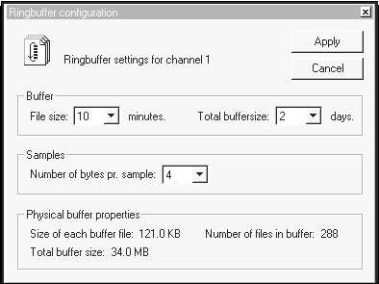

Leave the [Number of bytes pr. Sample] option set to 4. The [Buffer] and [Total buffersize] can be varied according to the “Seislog” manual. The default options are appropriate.

Press the "apply" to the ring buffer question and “OK” to the ring buffers statement.

If more channels are to be added, repeat the above sequence. Make sue that a different “physical channel” is selected each time. The other options in the “Add Channel” dialogue box will require experimentation and knowledge of the “seislog” manual.

Press the “close” button on the “Administer Channels” dialogue box. The channels are now installed for the SADC10 driver.

Physical channel numbers related to the SADC10 card.

Physical channel 1 = A/D input 1 = Pin 5 (A/D) and Pin 6 as A/D ground)

Physical channel 2 = A/D input 2 = Pin 7 (A/D) and Pin 8 as A/D ground) Physical channel 3 = A/D input 3 = Pin 9 (A/D) and Pin 10 as A/D ground)

Physical channel 4 = A/D input 4 = Pin 11 (A/D) and Pin 12 as A/D ground)

Starting and Viewing Live Data

Press the “Start System” button.

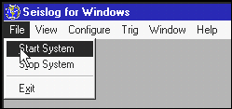

To observe a time slice of the monitored data, select “View” and “Monitor channel”. In the “Monitor channel” dialogue box, select the channels you which to observe. Press “done”. After a short time data will appear.

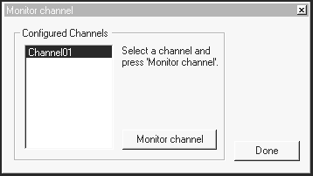

Extra Display information Line2

Displayed in “Seislog’” Log window and recorded in the log file is the change of state information of “line 2” from the SADC10 card. Line 2 is the 3rd pin of the SADC10 card. Grounding this pin will lower its state.

Views and Messages

If a new option is required in the device configuration dialogue box, such as a new sample rate, then you must delete the device driver and re-install a new driver. The channel information can be left intact. If the “model” is changed then the device driver and all the channels must be deleted and re-installed. Failing to do this will result in a message similar to this.

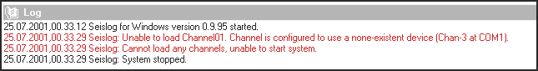

The next time “Seislog” is started it will automatically use its last configuration.

General Notes:

Mr. Mauro Mariotti ( http://mariottim.interfree.it/index.htm ) the manufacture of the SADC10 card also provides a sophisticated logging program called “6smowin”. This program and “Seislog” make’s this acquisition card a powerful tool.

Seislog has many features that should be explored. Please consult the University of Bergen ‘s manual on “Seislog”.

See; http://www.ifjf.uib.no/ or (129.177.55.5) and follow the links on “Seismology” and “software development”. Seislog is only a part of a whole group of programs for earthquake analysis. For example “seislog” files can easily be integration into the program “Seisan”. A very powerful tool.

User Note: The Ringbuffers data files can be read in “Seisian”. See the “dirf” instruction in the “Seisan” manual.

Pin Infromation of the SADC10 Card

Pin1 = + 5 Volts

Pin2 = Line 1 (DCF77 input)

Pin3 = Line 2

Pin4 = Ground

Pin5 = A/D Input Channel 1 (16 Bits)

Pin6 = ground

Pin7 = A/D Input Channel 2

Pin8 = ground

Pin5 = A/D Input Channel 3

Pin10 = ground

Pin11 = A/D Input Channel 4 (Not Used in version 1.4)

Pin12 = ground

End of document.

