SEISLOG

A seismic data acquisition system for Windows9X/NT/2000/XP

Version 1.0.5

Øyvind Natvik
Jens Havskov
Terje Utheim

Institute of Solid Earth Physics
University of Bergen
Allegaten 41, 5007 Bergen
Norway

Ph 47 55583420
Fax 47 55589669
Email seismo@ifjf.uib.no

June 3, 2002

1.0 Introduction 4
2.0 Principle of operation 4
3.0 Installation 5
4.0 Starting and stopping SEISLOG 6
5.0 Setting up and changing SEISLOG parameters 6
Setting up a system for the first time 6
Program settings 7
Setting up a digitizer 9
Channels and ring-buffers 13
Network triggering 17
How to change parameters, how does it affect other setups 19
6.0 Monitoring SEISLOG 19
Plotting signals in real time 21
Arranging the order of the Seislog windows. 23
7.0 Manually trig SEISLOG to record an event 23
8.0 Data recorded and data inspection 23
Continuous data 23
Triggered data 24
Checking triggered events 25
Plotting triggered events 26
9.0 Timing 26
CPU synchronized with external digitizer: 26
CPU synchronized with external GPS: 26
Monitoring time synchronization: 29
10.0 What can go wrong 29
Timing problems 29
Digitizer stops or sends corrupted data 30
Disk full 30
Ring buffer files have shorter length in time than specified 30
System does not trigger 30
Power failure 31
References 31

1.0 Introduction

The standard SEISLOG seismic data acquisition system for the QNX operating system has been around for some years and is well tested (Utheim and Havskov, 1999). It uses a real time operating system with accurate timing built in and, since it is a multi-user system, it is very flexible for network integration and remote use over both serial lines and Internet. More and more digitizers now have built in timing so there is no need for a real time operating system and most users have Windows 95/NT so there is a need for a simpler data acquisition system using the standard operating system. The development of SEISLOG for Windows was initiated in order to have a simple data acquisition with GeoSys low cost GBV recorders, however SEISLOG now operates with several other digitizers as well. In addition, it has been a goal to integrate SEISLOG closer to SEISAN (Havskov and Ottemøller, 1999) in order to facilitate processing. This manual describes the installation and operation of the system. The SEISLOG Windows version will hereafter just be referred to as SEISLOG. SEISLOG QNX, SEISLOG Windows/NT and SEISAN are freely available for non-commercial use at ftp.ifjf.uib.no.

2.0 Principle of operation

The SEISLOG data acquisition system consists of one or several digitizers connected to a PC via the serial lines. Each digitizer (maximum 16) can have up to 64 physical channels. A maximum of 64 logical channels can be handled by the system. The digitizers will normally provide time stamped buffers, however if no timing is given, the CPU can do timing. In this case, less accurate timing will be obtained, even though the CPU time can be synchronized with a GPS (the syncronisation will not be very accurate). The digitizers need not use the same sample rate nor be time synchronized.

The data from the physical channels will enter memory ring buffers (one for each logical channel), where STA/LTA calculations are performed, and single channels detections declared. Each channel can optionally be written to a disk ring buffer, and there can thus be a disk ring buffer for each logical channel.

Using the detection states of the memory ring buffers, network detections are declared using up to 5 different sets of detection criteria, like minimum number of channels to be detecting an event among a given set of channels. On declaration of an event, the waveform data file for selected channels is written out directly from memory. In addition,
trigger-times for each channel is written out in a separate file. Both files are written in SEISAN format and can optionally be written directly into a SEISAN database for ease of later analysis or automatic location and magnitude calculation.

Since SEISAN is intended for the main data inspection and processing system, SEISLOG only has two types of monitor windows where real time signals can be shown, and many real time parameters monitored. Both event files and ring buffer files can be plotted with SEISAN.

The system is intended to be able to recover from power failures and breakdown of digitizers so if e.g. one digitizer falls out, the system will continue to operate and seamlessly start using the digitizer when it comes back. The system can also handle differences up to ±10 seconds between time in timestamed data blocks and the system clock. What this means in practice is that the system can handle delays in transmission of serial data (from digitizers) up to about 8 seconds.

3.0 Installation

SEISLOG requires a standard Pentium PC running Win9x/NT/2000/XP, 16Mb RAM and a digitizer connected to the PC. Windows XP is the recommended operating system.

SEISLOG consists of the executable file (seislog.exe), and other files such as DLL files. These can be downloaded from our WEB site.

- Start Windows
- Make a directory, for example C:\Seislog.
- Copy the seislog.zip file to directory C:\Seislog, and unzip it here.
- Make a shortcut to C:\Seislog\seislog.exe on your desktop.
- If you would like Seislog to start automatically when Windows starts, then make a shortcut in the Startup folder as well.
- Seislog can now be started (no reboot is needed).

When SEISLOG is first started, it will prompt the user for its basic setup configuration. Defaults are supplied. When setup configuration has been entered, SEISLOG saves this information in the Windows registry, and then restarts itself. During this process all needed subdirectories will be created in the \Seislog directory.
Each time SEISLOG start, it will check the information in the registry. If any information is found to be wrong or missing, SEISLOG will prompt the user for the setup configuration again. The registry key used by SEISLOG is: HKEY_LOCAL_MACHINE\SOFTWARE\IFJF\Seislog. Though it is possible to change the registry information using the regedit program, the preferred way is using the Configuration dialog box inside SEISLOG. SEISLOG now uses a driver TVICHW32, to get low-level access to the LPT port. SEISLOG will install this driver automatically from the C:\Seislog\Drivers subdirectory if needed.

The Seislog directory will, when the system is in operation, contain various log and system status files created by SEISLOG. The most important is seislog.log, where all messages from SEISLOG are stored.

SEISLOG system limitations in the current version:
- 16 digitizers (devices).
- 64 channel recording
- 64 ring-buffers
- 64 physical channels pr device

Duration of ring-buffers is limited only by disk space. The maximum duration of event files that can be recorded is limited by allocated memory buffers, which are limited by the memory of the PC. A 16 channel system, with 100hz sampling, 4 byte data and 10 minutes of memory ring-buffers, will require about 4 Mb of memory for the memory ring buffer system.

4.0 Starting and stopping SEISLOG

Clicking on the SEISLOG icon will start SEISLOG. If the system has been set up with relevant parameters, the program will load immediately. If the parameters have not been set up adequately, the user will be prompted for information and several parameters must be defined (see section on program settings). SEISLOG can be started and stopped using the ‘File’ menu where Start, Stop and Exit are the options. Once SEISLOG is running, a monitor screen comes up and the signal can be plotted in real time (see section on monitoring).

5.0 Setting up and changing SEISLOG parameters

Setting up a system for the first time

In order to set up SEISLOG for the first time, several SEISLOG parameters must be set depending on the digitizers connected and the user choices for how the system shall operate. The user must go through all 4 steps of setting up SEISLOG parameters as described in the next sections:

- Program settings
- Digitizer setup
- Channels and ring-buffers
- Network triggering

Program settings

When SEISLOG start, it will try to load some of its configuration from the Windows registry. If the information is missing or incorrect, the dialog box in Figure 1 will notify the user that something is missing. Press OK to continue.

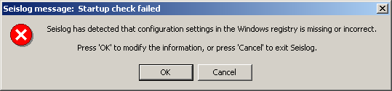
Figure 1: Seislog message: Startup check failed

The program settings window will now appear (Figure 2).
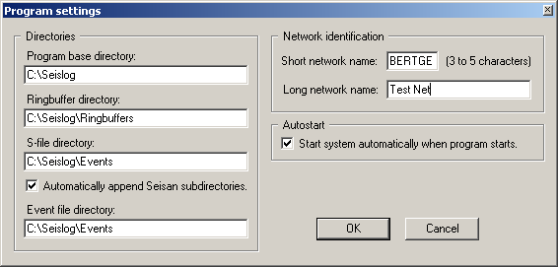
Figure 2: Program settings

Many of the parameters to set will have defaults that can be used in most cases. If this is new system with no special requirements, it is recommended to only set parameters on the right side of the screen, where no defaults are given for a new system. All fields in the sections called Directories and Network identification, must be filled in with valid values before the user is allowed to close the window.

The parameters are:

Program base directory, default c:\seislog
This is the directory under which most SEISLOG parameters and data resides. In registry: ProgDir.

Ring-buffer directory, default c:\seislog\ringbuffers
The directory under which ring-buffer directories are created. There will be one sub-directory for each ring buffer. In registry: RngBufDir.

S-file directory, default c:\seislog\events
Directory for S-files. An S-file (see also SEISAN manual) is created for each triggered event and contains trigger time for each channel as well as the duration of each trigger for each channel. The S-files can be used for SEISAN processing like earthquake location and plotting, section on SEISAN integration. In registry: SFileDir.

Automatically append SEISAN subdirectories, default=no
If many events and corresponding S-files are stored in the S-file directory, it can be an advantage to store the files in a directory structure made from years and months. If choosing this option, the S-files will be stored in the following directory structure by default

c:\seislog\events
|
--------------
| |
1999 2000
| |
------------- --------------
| | | | | |
01 02 ... 12 01 02 ... 12

If this data base structure is to be used directly with SEISAN, the S-file directory must be named in accordance with SEISAN rules (see SEISAN manual) like c:\seisan\REA\BERGE where BERGE is the SEISAN name chosen for the SEISAN data base (user selectable) and REA is the SEISAN directory under which S-files reside. In registry: CreateSFileSubDirs.

Event file directory, default: c:\seislog\events.
The directory where the triggered waveform files are recorded. In registry: EventFileDir.

Short network name
The name MUST be entered and it must be between 3 and 5 characters long. The name is used for naming event files. In registry: NetworkCode.

Long network name
The name MUST be entered, can be 1 to 29 characters long. The name is stored in the event file header. In registry: NetworkName.

Autostart
Ticking off here means that SEISLOG automatically starts up when SEISLOG is launched from Windows. In registry: AutoStart .
To have SEISLOG automatically start when the computer starts up, create a shortcut to SEISLOG and put it in the Windows startup group. This is useful for unattended systems. In registry: AutoStart.

Click Done when all information has been entered, the main SEISLOG window now comes up. SEISLOG data acquisition has not been started yet since configuration is not complete.

Setting up a digitizer
SEISLOG has been made to be used with several digitizers, see Figure 3 for a complete list. The digitizers are connected through the serial lines. Digitizers can be connected to all serial lines available. In order to set up the digitizers, select Configure|Administer devices. The Administer devices window will come up showing which digitizers are already configured, which should be none if this is the first time the system is set up (Figure 3). To add a digitizer, select Add, and a list of available digitizers will be shown (Figure 3). Select a digitizer, and press Configure. To remove a digitizer, select digitizer and click Remove. When adding a digitizer, the configure screen for that device will be shown (Figure 4 shows an example from a GeoSig digitizer). The configure screen will vary a bit from digitizer to digitizer, however the main topics will be the same except for the synthetic digitizer (Internal Wave Generator). Common for all digitizers is, that they must have been set up (using the manufactures setup system) before being connected to SEISLOG.

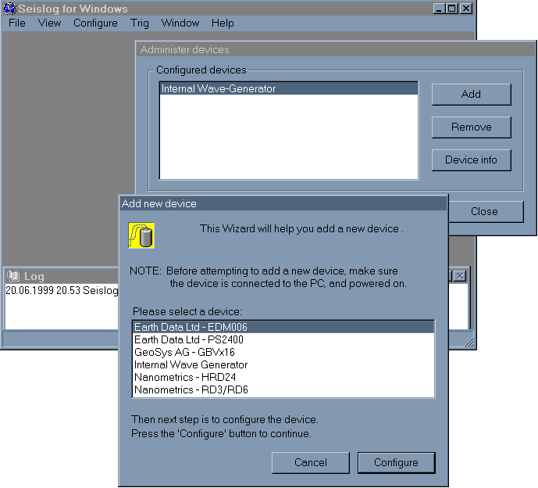
Figure 3. Selecting and configuring a digitizer

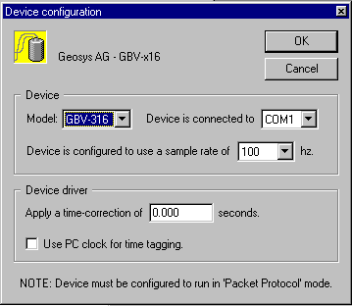Figure 4 Example of digitizer setup

Common parameters to set are:

Model: A manufacturer can have several similar models set up from the same configuration window.

COM port: The digitizer can be connected to COM1 to COM16, choose the appropriate number.

Sample rate: This is the sample rate set up on the digitizer. The sample rates available on the digitizer will be shown here.

Apply time correction: The value entered here will be used to correct the time that are used to timestamp the digitizer blocks.

Use PC clock for time tagging: Incoming data from the digitizer will most often have been time tagged, however if no time tagging is available, the PC clock can optionally be used (Not recommended unless the system clock is syncronized by some means).

When all parameters have been selected, press OK, and the program returns to the Administer devices screen where the newly configured digitizer will be shown in the list of available digitizers. All digitizers connected to the PC must be configured before setting up the channels.

Synthetic digitizer

This internal digitizer has been provided in order to be able to test SEISLOG without any physical digitizer. The digitizer is called Internal Wave Generator and selected like any other digitizer, however the setup is slightly different. The digitizer will by default have 4 different channels (Figure 5). For each channel, 3 parameters can be set up:

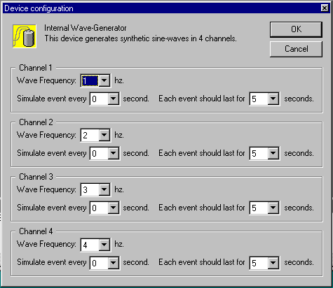
Figure 5 Setup of internal wave generator

Wave frequency: The frequency of the synthetic signal (1-30 Hz). The sample rate is fixed to 120 Hz.

Simulate event: In order to test triggering, an event can be simulated every 10 to 120 seconds. This means that the amplitude in increased by a factor of 3. Selecting 0 seconds means that no event is simulated.

Each event should last..: This is the duration of the event in sec’s.

Once the synthetic generator has been set up, the remaining SEISLOG setup follows the standard procedures.

Channels and ring-buffers

Each digitizer provides physical channels to the system. A 3-channel digitizer will provide 3 physical channels. The user can now use these 3 channels to create any number of logical channels in memory, which each can optionally have a disk ring buffer. A logical channel is a memory ring buffer defined by the user. Event detection is done on the memory ring buffers, and detected events are written out from the memory ring buffers. In the example with a 3-channel digitizer, the user can choose to use only one channel; so only one logical channel is created. Another example is to create 4 logical channels where the fourth channel is the physical channel 1 used twice. The repeated channel could either be filtered or resampled (not yet implemented). Currently the system has been limited to 64 logical channels.

Each channel can optionally have a ring-buffer on disk. The ring-buffer consists of a series of files of equal size. The number of ring-buffers is only limited by disk space. The user sets up the number of ring buffer files, and their size, and each channel may be different. The SEISAN format is used for the ring-buffer files so the files can be directly used with SEISAN which can plot, append, extract and resample the ring-buffer files. If the system has an unexpected stop, the last ring-buffer file will be repaired when the system starts up again.

To set up the logical channels, select under Configure the option Administer channels, and the menu in Figure 6 will come up.

Figure 6. Selecting or adding a channel to configure

For a new system, there are no channels selected, and only the Add option is possible. If channels already have been defined, Modify will change the existing channel, and Remove will delete the channel. When clicking Add or Modify, the following screen comes up (Figure 7).
If using Modify, the existing setup is shown.
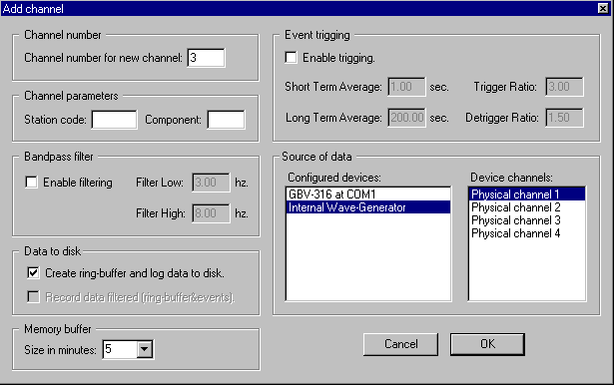
Figure 7 Add or modify channel

The parameters are:

Channels number for new channel, optional: The next available channel is shown by default so no choice needs to be made if adding a channel. Possible choices are: The next free channel (default value) or the number of an existing channel. If a number of an existing channel is given, then the existing channel (and all channels above it) will be moved up one place to make room for the new channel.

Channels parameters, mandatory: Station code is a 1 to 5 letter code and component code is a 4 letter code of which the first letter MUST be one of the following: S (short period), L (long period, B (broad band), A: accelerometer. The last letter MUST be Z, N or E. The other 2 letters can be anything. However, if used with the SEISAN system, there are some restrictions. BOTH STATION CODE AND COMPONENT CODE MUST BE SELECTED AND THEY MUST BE UPPER CASE.

Band-pass filter, optional: The data can be filtered before entering the trigger algorithm. If pressing Enable filtering, the default filters 3 to 8 Hz are selected. Other filters can be selected, however 3 - 8 Hz is a good filter to use with short period data and is also be useful to trigger on tele-seismic data. The filters are 3 pole filters.

Data to disk, optional: Each channel can be recorded in a disk ring-buffer, which is the default (tick in Create ring-buffer and log data to disk). The data can be recorded filtered, however, that is normally not done.

Memory buffer: This indicates how many minutes of data is stored continuesly in memory. The buffer must be larger than the time duration of the largest event to be recorded in event trigger mode. With the default 5 minutes, an event of typically up to 4 minutes long will be completely recorded so for many stations or networks, a larger number must be selected.

Event trigging, optional: If triggering is selected, the default trigger parameters are used unless changed. The default has been set to 'reasonable values' using short period data.

Short term average (STA): The short time window over which the average amplitude of the signal is calculated. The DC component is subtracted before averaging. If a filter is selected, filtering is done before calculating STA.

Long term average (LTA): The long time window over which the average amplitude of the signal is calculated. The DC component is subtracted before averaging. If a filter is selected, filtering is done before calculating LTA.

Trigger ratio: Start of a trigger is declared for the selected channel if the STA/LTA ratio exceeds the trigger ratio. LTA is no longer updated a rate 10 times slower than usual so that a long event do not de-trigger before the event is finish.

De-trigger ratio: The end of the trigger is declared for the selected channel if the STA/LTA ratio is below the de-trigger ratio. LTA starts being updated.

Source of data, mandatory: The current logic channel being configured can now be selected from any of the physica channels of any of the configured devices (digitizers). Select a configured device on the right and on the left, the available channels are seen. Select which channel to use with the current logic channels being configured.
Press OK to continue. If a disk ring buffer has been selected, the Ring-buffer configuration screen comes up (Figure 8).

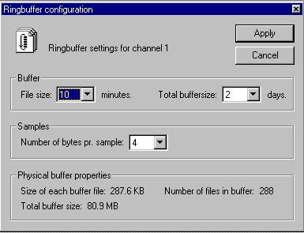Figure 8 Ringbuffer configuration

Defaults are selected, however the options are:

File size: The size of each ring buffer file in minutes, from 1 to 60 minutes is possible. The default 10 minutes is a reasonable number with 50 to 100 Hz data.

Total buffer size: The total size of the ring buffer system in days, settable from 1 to 365.

Samples: Number of bytes pr sample to be written out. Check digitizer for what is delivered. If 2 bytes are written out and the digitizer delivers 4 bytes, the upper 2 bytes are lost and the signal is clipped if larger than 2 bytes.

On the bottom part of the screen, the size of the ring buffer system is given. Make sure it is not larger than there is room for on the disk. If too large, an error message will be given when the disk buffer is created. The buffer is then removed. The user must then liberate space on the disk and create the buffer again.

Press Apply to make the ring-buffer on the disk. When successfully done, the complete configuration of the channel is finished.

Network triggering

Each channel has, as described above, its own trigger set with short term and long term averages, trigger ratio, de-trigger ratio.
The system also has a network trigger. This works in the traditional way in which a certain number of channel triggers is required within a given time window. Once an event is declared, it can be written out with user specified pre and post event lengths. The user can specify which channels are written out so triggering can be done on any of the logical channels and the output file can be made of any of the logical channels. The data does not have to arrive at the different physical channels synchronized in time since the data will be time ordered in memory. A delay of up to 10 sec’s between the PC system time and the channels can be accepted. The event files are written out in SEISAN format and a SEISAN S-file is written out with the trigger times directly in a SEISAN database. An event is declared finished when there are no more triggers on any channels. The system can have up to 5 different trigger sets working at the same time so that the system can be configured to trig on very different conditions.

To set up the network trigger, select Configure Trigger sets under Trig in the main SEISLOG window. The following window comes up (Figure 9).

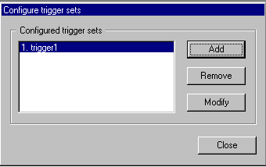Figure 9 Adding trigger sets

Each trigger set already defined has a name. If no trigger-set has been defined, NO EVENTS WILL be written out. If this is the first time a trigger set is to be defined, the only option to use is Add to add a new trigger set. If trigger sets already are defined, their names will be shown and they can be removed (Remove) or modified (Modify). In the case of Add or Modify, the Trigger-set screen will come up and the following parameters can be set:
Figure 10 Configure a trigger set

Name of trigger-set, mandatory: The user MUST give a name to the trigger-set.

Declare event: An event will be declared if this number of channels have a trigger (of any time duration) within a time window of seconds as given in the second input window. The time window is also called array propagation window.

Max duration of event: The maximum duration allowed for event. This parameter is meant to limit the size of a recorded event. The parameter must be set to less than the memory buffer length of the channels written out in this trigger set (checked by the trigger routine when it starts up).

Pre-event time: The number of seconds of pre-event time recorded in event file counted from the channel with the earliest trigger.

Post-event time: The number of seconds added to the event file after the network detector has declared the event finished. If max duration is reached, the post-event recording time is still added.

Maximum time to wait for data: Some devices may delay the sending of data to the PC for an unusual long time. In this case, the data may arrive too late to be processed by the network trigger. If this happens, the trigger will simply ignore the data, and write warnings in the log. To overcome this problem, the user can increase the maximum wait time to a suitable value. If value is increased, then the time it takes for the network trigger to respond to an actual event, will increase accordingly. More memory will also be consumed by Seislog.

How to change parameters, how does it affect other setups

Parameters are essentially changed in the same way as they are set up initially.

Change logical channel: When a logical channel is removed, the ring-buffer is also removed.
Change ring buffer: In order to change a ring buffer (2 to 4 byte or vice versa, length etc), the logical channel will have to be removed first and then created again. If logical channel or ring-buffer configuration is changed, this will affect the trigger-set, which no longer might be valid. The log will warn about problems.

Remove digitizer: If a digitizer used by one or several channels, is removed, SEISLOG will give an error message when started and will not attempt to use those channels. If reconnected, they will automatically be used as configured. It is possible to set up a new device without configuring any channels for it. The device driver will start normally when the system is started, but will not deliver data to any channels.

6.0 Monitoring SEISLOG

SEISLOG has a monitor screen which shows operating status (Figure 11). The monitor window always comes up when SEISLOG is started. A graphical display of any number of logical channels can be shown at the same time. Checking of detected events is done is done by just checking event files in the events directory or using SEISAN EEV function. As soon as an event is detected and written out, it can be displayed and located. Since the trigger times and the duration of the event is given in the SEISAN database, an initial automatic location and magnitude can be made. The initial monitor window is shown in Figure 11 below:
Figure 11. Initial monitor window (Activity monitor)
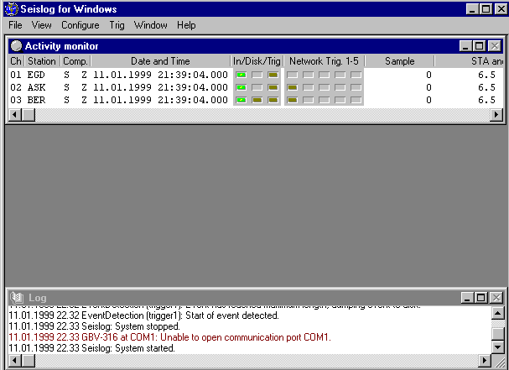

On top is shown part of the Activity monitor, the rest of the window can be seen by scrolling horizontally. The fields shown are:
Ch: Logical channel,
Station: Station code,
Comp: Component code,
Date and Time: Date and time as given in the memory ring-buffer, so this time can be a few seconds behind real time. The different channels can also show different times if they come from different digitizers. However, if the source is the same physical digitizer, the time is usually the same.
In/Disk/Trig: There are 3 indicator lights, which can be green (active, all ok), dark green (set to be active, but doing nothing at the moment), red (error) or gray (not active). The lights are:
In: Data is coming into this channel. If a digitizer stops the light turns red.
Disk: If dark green, a ring buffer is associated with this channel, if green, data is beeing written to the ring-buffer.
Trig.: If a trigger algorithm is running for this channel, the light is dark green and if the channel is in trigger state, the light turn light green.
Snc.: Green: Channel is time synchronized with a GPS, dark green: GPS does currently not have satellite fix, red: a GPS communication error occurs, gray: no GPS set up to synchronize this channel. See also section on timing.
Network Trig, 1-5: SEISLOG can have 5 independent network trigger sets and each set is represented by one column of lights, one pr channel. If a channel is included in the trigger-set, the lights are dark green. If a network trigger is declared, all lights for the trigger-set turn light green. Both the trigger and the network trigger are very useful for testing the operation of the system.
Sample: The current sample value in the memory buffer corresponding to Date and Time. The sample is the first sample in the memory buffer. When using synthetic data, it will always show 0, since the sine waves frequencies are integer numbers.
STA and LTA: Current short and long term averages for channel. Note that LTA is nearly frozen if the channel is in trigger state.
Offset (DC): The DC offset for the channel in counts.
RB file: The ring-buffer file currently being used with the channel.
Filter (Low/High): The band pass filter limits (Hz), if used.

In addition to the Activity monitor, the log window below always comes up. This window shows all SEISLOG messages, like starting and stopping the system, errors, and network trigger activity. The messages are intended to be self-explanatory. The log window and the log file can be cleared bye selecting the appropriate action from the window’s system menu.

Plotting signals in real time

With SEISLOG, it is possible to plot any of the logical channels in semi real time. On the main menu, select View, and then Monitor Channel … The following window (Figure 12) comes up:
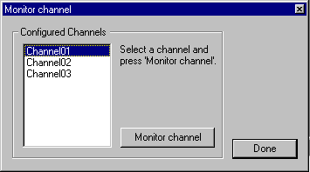

Figure 12 Selection of channel to monitor
Select a channel and press, Monitor channel and then Done. Then the plot comes up (figure 13).

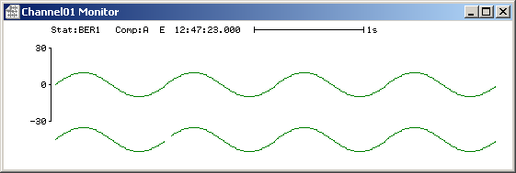
Figure 13 Real time plot of channel 1

The data is plotted using auto scaling. The plot shows station and component and the time refers to the first sample in the plot. The length of one second is shown, and the scaling of the y-axis is in counts. The X and Y-axis scale can be changed by clicking in the top left hand corner, and selecting Properties…, and the following window comes up (Figure 14):

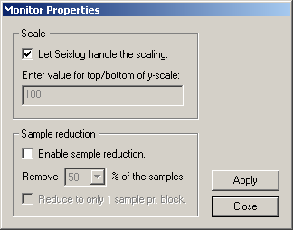
Figure 14 Setting scale for real time plot

If the scale has to be changed, uncheck the Let Seislog handle the scaling check box, and enter a new value for the maximum number on the y-axis, and press Apply or Close. This facility can for example be used to compare unfiltered to filtered data. Note that the auto-scale value is only calculated once, and that’s when the window is opened. Sample reduction is a feature used to reduce the number of samples plotted in the X direction. If enabled, a certain percentage of the samples are removed from the plot, thereby compressing the plot in the X direction.

Arranging the order of the Seislog windows.

The order of the windows can be automatically arranged in the preferred order. To do this, activate all windows in the opposite order, start with the last window and end with the first. Then select ‘tile’ or ‘cascade’ from the windows menu.

7.0 Manually trig SEISLOG to record an event

It can often be useful to manually trig the SEISLOG system. This is done by selecting Trig on the main menu, and then Simulate event. The following window (Figure 15) comes up:

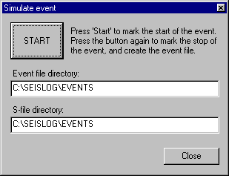Figure 15. Making a manual event.

By pressing the START button, recording starts immediately, and when pressing the button again, it stops. The recording is delayed a few seconds relative to real time. All channels are recorded.

8.0 Data recorded and data inspection

When SEISLOG has been set up and running, data will be recorded in different directories depending on the setup. The ring-buffer files will continuously overwrite, however the event files will gradually fill up the disk and IT IS UP TO THE USER TO MAKE SURE THE DISK DOES NOT
RUN FULL.

Continuous data

For each disk ring buffer defined, there will be a directory where all the ring-buffer files reside. For e.g. channel 2, the ring buffer files are in \seislog\Ringbuffers\Channel02. When a new channel has been set up, the files are empty of data and will all have the same file size and the file names are R00001, R00002, etc, to the number of ring buffer files set up. SEISLOG will start writing in file # 1, then # 2 etc. When a file has been completed with data, the file name will be expanded to give vital information about the file. An example of file names of two buffer files following each other in time is:

R00004-1999-01-11-2133-48-001200-0-BER__-S__Z
R00006-1999-01-11-2213-48-001200-0-BER__-S__Z

The file name is separated in different fields by ‘-‘ and from left to right the fields are:

Ring buffer file number
Year
Month
Day
Hour- minute
Second
Duration of file in seconds: If file is complete, this duration will match the set up for the ring buffer file.
Status of timing
Station
Component

The intention with the informative file name is to have a complete log of the data available in the ring buffer system as well as the status of the ring-buffer system. This information is not available any other place in SEISLOG. By just listing the file names, it is thus straightforward to find out if data in a given time interval is available. The corresponding ring buffer file can then be copied to an analysis system for further processing or it can be plotted directly using SEISAN program MULPLT.

Triggered data

Seismic events triggering SEISLOG will generate two output files, a waveform files with the selected channels and a parameter file with trigger information (S-file) (see below). The files are stored in the directories set up by the user (see setup of Seislog). By default, both files will be in \seislog\events. The file names follow the SEISAN convention and examples are:

Waveform file:

1999-11-12-1145-22S.BERGE-004

The name consists of year, date, and time on the right hand side. On the left hand side is the network name and the number of channels in the file. The waveform files are binary an written in SEISAN format.

S-file: 12-1145-22L.199911

The name consists of day of month and time. The L indicates that the event is a local event by default (see SEISAN). On the left hand side is year and month. The S-files are written in ASCII and the format follows the SEISAN definition. An example for an S-file is shown below:

1999 623 7 5 30.0 LM BBE 1
1999-06-23-0705-30S.BBERG_003 6
ACTION:NEW 99-06-23 07:05 OP:SEIS STATUS: ID:19990623070530 I
STAT SP IPHASW D HRMM SECON CODA AMPLIT PERI AZIMU VELO SNR AR TRES W DIS CAZ7
BER SZ IP 0705 30.10 10
ASK SZ IP 0705 30.10 10
EGD SZ IP 0705 30.10 10

A full description of the format is found in the SEISAN manual, so here only the important points will be given. The first file is a header line giving start time of the recording. The L stands for local event (by default) and the M indicates that this event was triggered manually. TES is the agency. Line 2 gives the name of the corresponding waveform file, which is located in the events directory. Line 3 is a help line for lines following, which gives the trigger time for each channel participating in the detection The duration of the trigger for each channel is given under coda. These times can be used by SEISAN for locating the event if more than 3 stations are present and the magnitude is calculated from the coda. The intention is to do this automatically with SEISAN for every trigger, however this has not been tested yet.

Checking triggered events

Events that have trigged the system can be found by simply listing the files in the events directory. However, the intention is to use SEISAN for event inspection and processing, and there is no Seislog software for plotting the events. If the system is set up to record everything in the events directory, simply write (in a DOS window) cd \seislog\events and then call up SEISAN event editor by typing EEV. Alternatively use the Windows based SEISAN event editor (should appear as an icon on the screen if SEISAN has been installed). A list of events will now appear and normal SEISAN processing can take place. For a system with many events recording over a long time, it will be an advantage to record into a SEISAN data base meaning that the S-files are recorded into the SEISAN year-month directory structure. The command is eev 199905 to inspect data for May 1999. This command can be given from any directory or the SEISAN Windows program can be used.

Plotting triggered events

Plotting can be done in two ways. From the event editor (Windows or prompt), simply enter the command for plotting, and the MULPLT program is started with the current event. Alternatively, MULPLT can be started in the directory where the event waveform files are stored and the waveform files are plotted one by one. In both cases the user can do housekeeping by inspecting events, delete false triggers and do final registration of the event into the SEISAN database.

9.0 Timing
The SEISLOG trigger system is dependent on having a CPU time, which is accurate to within 5-8 seconds since the CPU time is used to align the data in memory from the different digitisers. This means that the system time should be synchronized with some external clock. It can be done in two ways:

CPU synchronized with external digitizer:
Normally, each physical device has independent accurate timing so the data arrives time stamped a little delayed relative to real time. The CPU time can then be synchronized with one of the external digitizer clocks setting an appropriate delay. If it is possible to use the digitizer for time synchronization of the CPU time, this facility is set when the digitizer is configured. Some digitizers have an unpredictable and non-constant time delay (like Nanometrics) and cannot be used. Only one digitizer can be used for system timing.

CPU synchronized with external GPS:
If no external digitizer has accurate time, the CPU can be synchronized to a GPS receiver connected to one of the serial lines. The accuracy of the synchronization is depending on the GPS device. The GPS has its own set-up screen selected under the configure menu in the main SEISLOG window. In principle, any GPS sending a standard $GPRMC string can be used, but the system has only been tested with Garmin GPS. The principle of setting the time is as follows:
1. The system receives the time string.
2. The GPS time is extracted from the string.
3. GPS time is corrected for the time delay caused by the transfer on the serial port.
4. GPS time is corrected with the user specified time correction.
5. The system time is compared with the GPS time. Based on the result, the system time is adjusted 10ms one-way or the other.

Some GPS devices has a delay between the second pulse, and the start of the sending of the $GPRMC sentence. This delay may be of fixed or variable length. The delay should be compensated for. To do this, the user must enter a time correction value when configuring the external GPS. This value should correspond to the GPS delay. If the delay has variable length, then a mean value should be used. Figure 16 shows the GPS set-up screen. If system time is not synchronized, a message appears on bottom of the Seislog window.

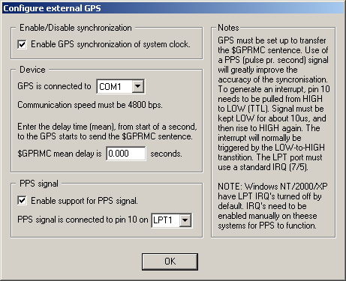
Figure 16, Setting up a system GPS

SEISLOG now support the use of a PPS (Pulse Per Second) signal. This is an electrical pulse that precisely marks the start of a new second. The pulse can be connected to pin 10 (ACK) on an available LPT port, and will generate an interrupt at the start of each second. The interrupt is picked up by SEISLOG, and used to synchronize the PC clock with high precision. The pulse must follow the electrical specifications as required by the TTL specification. The interrupt will be triggered by the LOW-to-HIGH transition of the pulse. If running Windows NT/2000/XP, then the interrupt must be enabled manually for the LPT port. A standard IRQ must be assigned to the port in question, that is IRQ7 for LPT1, and IRQ5 for LPT2.
The following table shows the expected synchronization precision, with or without PPS, using different versions of Windows:

 | Windows 9x | Windows NT/2000 | Windows XP
Without PPS signal | GPS dependant  Typical: <500ms | GPS dependant  Typical: <500ms | GPS dependant  Typical: <500ms
Using PPS signal | Worst case: <70ms  Typical: <=50ms | Worst case: <20ms  Typical: <=9ms | Worst case: <20ms  Typical: <=9ms

Monitoring time synchronization:
For each channel, there is a flag in the main monitor window (see Figure 11) indicating whether a channel is synchronized or not. If a channel is time stamped at the digitiser, and the GPS on the digitiser falls out, this will be indicated. If the same digitiser is used to synchronize the system time, a message will appear at the bottom of the SEISLOG screen that the system clock is NOT synchronized.

If the data-blocks from the digitisers are not time stamped, the time will be taken from the CPU time. In this case it is important that the CPU is synchronized with a GPS. As a general rule, the current system time will be saved immediately after the whole block has been received from the serial port. The saved time will then be corrected for the block’s transfer time on the port, and an additional fixed time, which is 1 second or more (depending on the device). The corrected time will finally be adjusted with the user-specified time correction, and used for time-tagging the block. The user-specified time correction can be entered in the device configuration window.

It is possible to operate SEISLOG without any accurate time reference at all, however, then all timing depends on the CPU time, which might drift between 5 seconds and a few minutes pr day.

All channels time stamped by the CPU will show not synchronized if the system GPS fall out. If no synchronization of the system time is done, the time synch. flag for relevant channels will indicate no information available.

10.0 What can go wrong

Timing problems

GPS clock on digitizer stops: This will be indicated in the monitor window, see description of monitor window. If the external digitizer is used to synchronize the CPU time, then the two clocks might drift apart. If the difference becomes more than 10 seconds, the system might stop triggering, however recording in the ring-buffers will continue as long as data comes in. In order to get it going again with a defect GPS on the digitizer, use the CPU clock to time stamp the data from the digitizer.

Digitizer stops or sends corrupted data

If a digitizer stop sending data to SEISLOG or sends corrupted data, the logical channels connected to the digitizer will stop operating which will be indicated on the monitor screen. This does not affect the other channels, however, the system might not trigger since fewer channels are active. When the data comes back, the channels will automatically become active again without any user interaction. The previous ring-buffer file will close and a new will open so that the data in each ring buffer file is continuous. If a network trigger occur at the time of no data or partly available data from one channel, the available data will be used.
Some digitizers send a checksum: This is used by SEISLOG to detect corrupted data.

Disk full

The system continues to write to the ring buffers, but no event files can be created. An error message will be given in the log.

Ring buffer files have shorter length in time than specified

The system has lost data and the ring-buffer file has been closed. The next ring-buffer file is opened when the data stream is resumed.

System does not trigger

If the system does no trigger on single channels, the trigger ratio might have been set too high.

If there are no network triggers, the first thing to check is if the system time is similar to the system time for each channel (within 5 seconds) and that the difference at least is smaller than the array propagation window. If warning messages of type ‘Block with bad time stamping received…’ appear in the log, then it may help to increase the value named ‘Max time to wait for data’ in the network trigger setup.

Power failure

If the system has been set up to automatically start at boot up, SEISLOG will start again. Otherwise, the system must be manually restarted. All ring buffer files will be properly closed and the system will start with new ring buffer files in order for all ring buffer files to have continuous data. The time gaps will be seen in the ring buffer file names.

References

Havskov, J. and L. Ottemøller, 1999. The SEISAN earthquake analysis software for Windows, Sun and Linux. Manual and software, Instutute of Solid Earth Physics, University of Bergen, Norway.

Utheim, T and J. Havskov, 1999. The SEISLOG data acquisition system, Version 8.0. manual and software, Institute of Solid Earth Physics, University of Bergen, Nowray

