THE JAMAICA SEISMOGRAPH NETWORK
Margaret D. Wiggins-Grandison

JAMAICA (TELEMETERED) SEISMOGRAPH NETWORK, 2003
-78.5˚
-78.5˚
-78˚
-78˚
-77.5˚
-77.5˚
-77˚
-77˚
-76.5˚
-76.5˚
-76˚
-76˚
18˚
18˚
18.5˚
18.5˚
BBJ
BNJ
CMJ
GWJ
HOJ
NEJ
MBJ
MCJ
PCJ
STH
YHJ
CVJ
vertical seismograph (8)
3-component seismograph (4)
digital accelerograph (8)
RHJ relay
Negril
Montego Bay
Ocho Rios
Port Antonio
Mandeville
Kingston
Black River
Old Harbour

The JSN consists of 12 analogue, short-period stations linked by radio telemetry to the Central Recording Station (CRS) at the Mona campus of UWI. Four stations, STH, MBJ, MCJ and PCJ have three-component sensors. The remaining eight are vertical stations. The sensors are Mark L4 1Hertz seismometers. The modulators, demodulators and amplifiers are Geotech instruments. Transmitters and receivers are Monitron UHF band. Yagi high-gain directional antennas are used.

Jamaica measures only 250 km x 80 km therefore it requires a minimum amount of power, often just 1 watt to send directed signals from transmitter to receiver. However, the interior is quite mountainous with elevations of over 2000 meters in the eastern ridges of the Blue Mountains, and averaging 1000 metres elsewhere. UWI is located in a valley south of the Blue Mountains. Typically no direct line-of-sight exists between stations and the CRS, except for GWJ and STH that are located on the hills just north of and overlooking the campus. Most of the remote stations are retransmitted to the CRS via a relay point RHJ at 780m elevation which is located on the hills NW of the campus. GWJ at 1170 m serves as a relay point for YHJ and PCJ. There is marginal line of sight between BNJ and RHJ which retransmits CMJ and BBJ to the CRS. These signals are often noisy and a solution to this problem must be found.

At the CRS the signals are digitized at 50 Hertz using a National Instruments AMUX-64T 16-bit AD board and a PC-based DOS-driven seismic data acquisition (SDA) system. A Trimble SVee8 GPS is used for timing. The signals are demultiplexed and processed on a PC-based windows-driven seismic data processing (SDP) system. Both the SDA and SDP are products of the Geophysical Institute of Israel. For more advanced data processing and analyses, SEISAN running on a SUN Microsystems UNIX platform is used.

The JSN also has eight digital accelerometers that are deployed across the island: 7 Etnas and 1 K-2, and seven portable digital seismographs: 6 Geosig 3-component 16-bit self-contained recorders, and an ORION 24-bit instrument. In addition a GURALP CMG40T-D692 3-component broad band (0.02-30 seconds) seismometer with 24-bit digitizer module has been recently acquired. It is intended that the signals be sent by digital spread spectrum radio to the CRS.

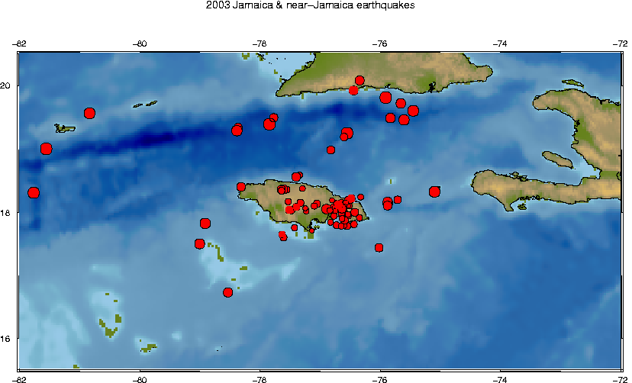

In 2003 the Jamaica and near-Jamaica earthquakes contributed 829 digital seismograms and 2,515 records of phase arrivals to the local seismological database. The station at Stony Hill (STH) continued to outperform the others by recording 98% of the local events (Chart 1). The stations at Greenwich (GWJ), Mona (HOJ), Portland Ridge (PCJ), Munro (MCJ) and Pike (CVJ), also performed well to on-par by recording at least 50% of the events. Stations CVJ and NEJ have high levels of noise because the sensors are not isolated. Stations of north-east and north-central Jamaica, Castle Mountain (CMJ), Bonny Gate (BNJ) and Bamboo (BBJ) were down since July 2002 because the electricity service (used to charge batteries) was disconnected to the owners of the building housing the relay station BNJ.

Just over 20% of the local earthquakes were recorded by 7 or more of the 12 available stations (Chart 2). Though many of the earthquakes are small, if all stations were situated on isolated piers with less noisy transmission lines, such as STH the percentages of well-recorded earthquakes could double or triple.

