Micro Array Volcan Baru

Angel Rodriguez
Volcan, Chiriqui
Panama
angel@tierrasaltas.net

Array Volcan Baru is a private research array with an aperture of about 500 meters.
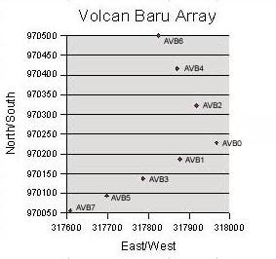
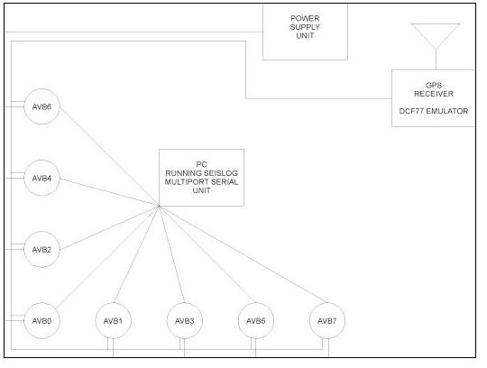

Station AVB0 the central station is a 3 component. Stations AVB 7 and 6 have a Z and N components. All other station have have Z only. All stations use 16 bit SARA digitizers. The stations have high resolution coordinates they receive DC power and a 1 Hz sync pulse and communicate serially with a central computer running Seislog. The central computer has a GPS and is connect via a wireless link to Chirinet.

Software for automatic event detection and notification is being written.

