Chirinet seismic network

Angel Rodriguez
Volcn, Chiriqui
Panama
angel@tierrasaltas.net

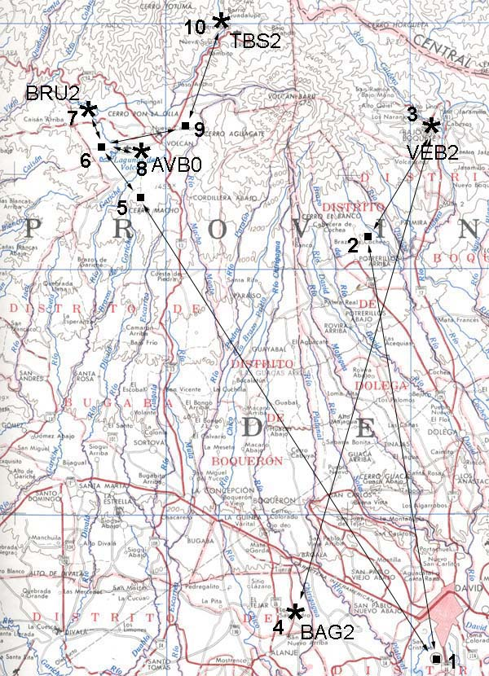
Chirinet is a privately owned and operated research seismic network. It presently consists of 3 to 5 short period, three component stations generally surrounding Volcan Baru. It has one broadband sensor and one micro aperture, eight station array. The stations are all connected by an ethernet wide area wireless network and connected to a central station at BRU2, that gathers data from remote stations and makes that data available to anyone via FTP. The station particulars are:

BRU2 is a GeoDevice broadband sensor with 24 bit Seisad18 digitizer
AVB0 it the central 3c station of the array, 16 bit SARA digitizer
BAG2 is a 3c 4.5 Hz station, 16 bit SARA digitizer
VEB2 is a 3c 4.5 Hz station, 16 bit SARA digitizer
TBS2 is a 3c 4.5 Hz station, 16 bit SARA digitizer

Radio link 1-5 is a YDI 5.8 gHz backbone
All other links are 2.4 gHz
Radios 6 and 10 are Karlnet AP's

The station at site 7, (BRU2) is where the central data collection takes place using MiniSeisNet (MSNet). MSNet polls all stations every half hour. It also has a public FTP server at chirinet.serverftp.org where the events files are available to anyone. The network detects about 8 events per day

