Chirinet Overview

Chirinet is a privately owned and operated research seismic network It presently consist of 3 to 5 short period 3 component stations generally surrounding Volcan Baru. It has one broad band sensor and one micro aperture eight station array. The stations are all connected by a ethernet wide area wireless network and connect to a central station at BRU2 that gathers data from remotes and makes that data available to anyone via FTP.

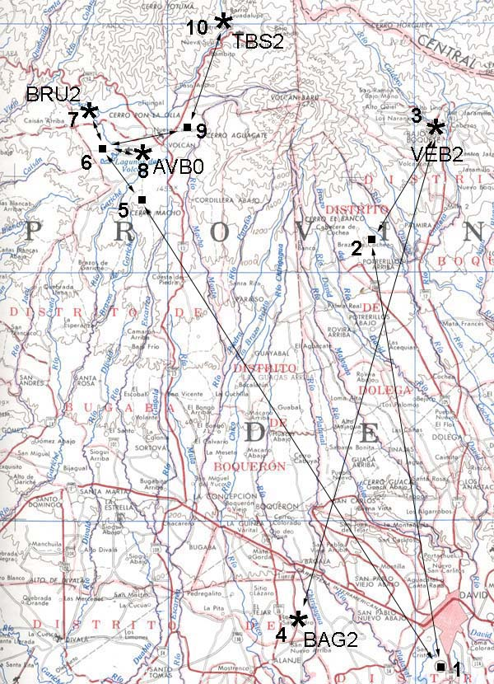

BRU2 is the GeoDevice Broadband with 24 bit Seis18
AVB0 it the central 3c station of the array
BAG2 is a 3c 4.5 Hz station
VEB2 is a 3c 4.5 Hz station
TBS2 is a 3c 4.5 Hz station

Radio link 1-5 is a YDI 5.8 gHz backbone
All other links are 2.4 gHz
Radios 6 and 10 are Karlnet AP's

The station at site 7 which is also BRU2 is where the central collection point where MiniSeisNet (MSNet) runs and polls all stations every half hour. It also has a public FTP server at chirinet.serverftp.org where the events files are available to anyone.

All inquires can be addressed to Angel Rodriguez at angel@tierrasaltas.net

