Configuring the Lucent Orinoco Silver Card
Although the card will come with a CD with drivers and configuration software, that software will almost certainly be out of date. So, the tasks are
- Download updated drivers and client software
- Install the drivers
- Update the card's software
- Configure the card to use the GSB network.
Instructions for the Lucent Orinoco Silver card:
Download updated drivers and client software. Visit Lucent's web site and go to the software download page. Select your operating system and product and download the file(s). Extract the files to a directory on your computer (but NOT the desktop).
- Windows 2000:
  - Run the setup program you downloaded to install the drivers BEFORE you first insert the card
  - From the DRIVERS directory run SETUP.EXE to install the drivers.
  - From the CLIENT directory, run SETUP.EXE to install the client software.
  - When done, insert the PC card.
    - I did it in the wrong order. I put the card in before I installed the software. What do I do?
      - Take a deep breath. You can recover from this.
      - With the card sitting in your computer, right click My Computer.
      - Select Properties.
      - Click the Hardware tab.
      - Click the Device Manager link.
      - Expand the Network Adapters list.
      - Right click on Wavelan or Orinico and select Properties.
      - Click the Drivers tab.
      - Click Update Driver...
      - Follow the wizard to select the driver you installed from the Lucent software installation (WLUC48).
      - Reboot.
- Windows 95/98/NT:
  - Insert the card.
  - Wait for the detecting new hardware dialog.
  - Select the "have disk" option. Enter the folder into which you extracted the downloaded files.
  - Afterwards, double click SETUP in that folder to install the client software.

Configuration for Lucent and Dell cards

The card configuration should start during the installation process. If it doesn't, you can start it from the card setup icon in the control panel. | 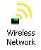
Click Edit Profile | 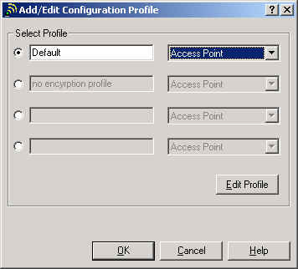
Join an existing network. The network name is "uchicago". | 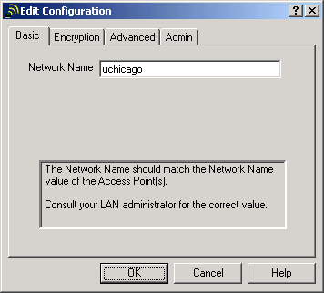
Do not enable encryption. | 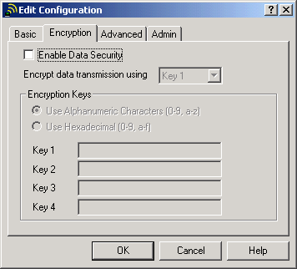
The Card Power Managerment setting can be useful. Turn it off if you usually use your computer connected to the power line.  If you usually run on batteries, turn it on.  Click OK to save your settings and exit. | 