ARRAY REMI SURVEY:

Array piks with model fit……………..E-W line

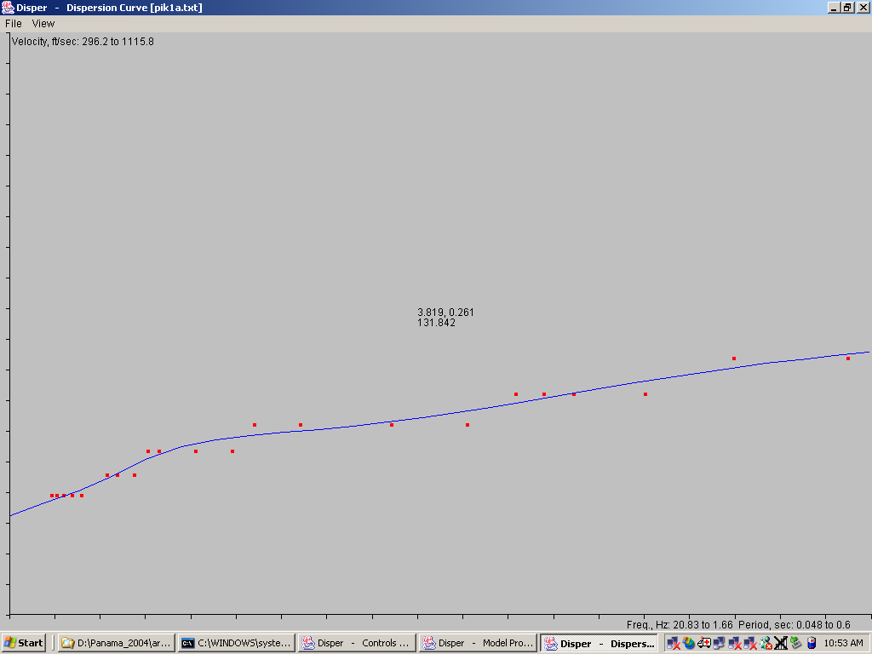

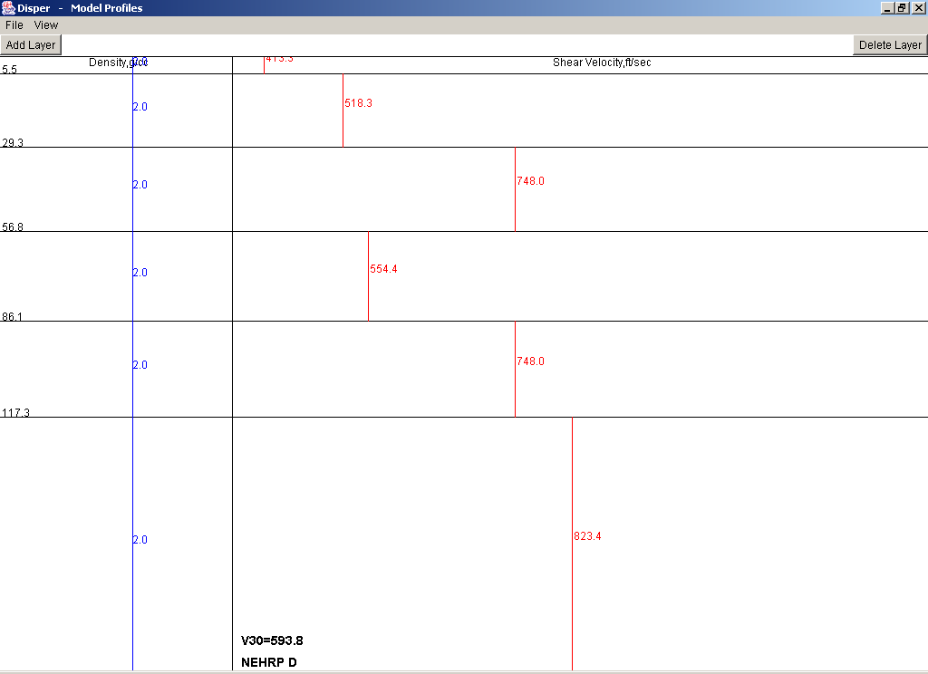

Model fit using ft/s, first layer ~400’/s & is 5.5’ thick. Seismic soil classification is low D, almost an E, which is very soft material and undergoes much shaking during an EQ….
I have an inversion showing but other good fits possible, by changing thickness of layering and velocities. But you will not change the classification much.

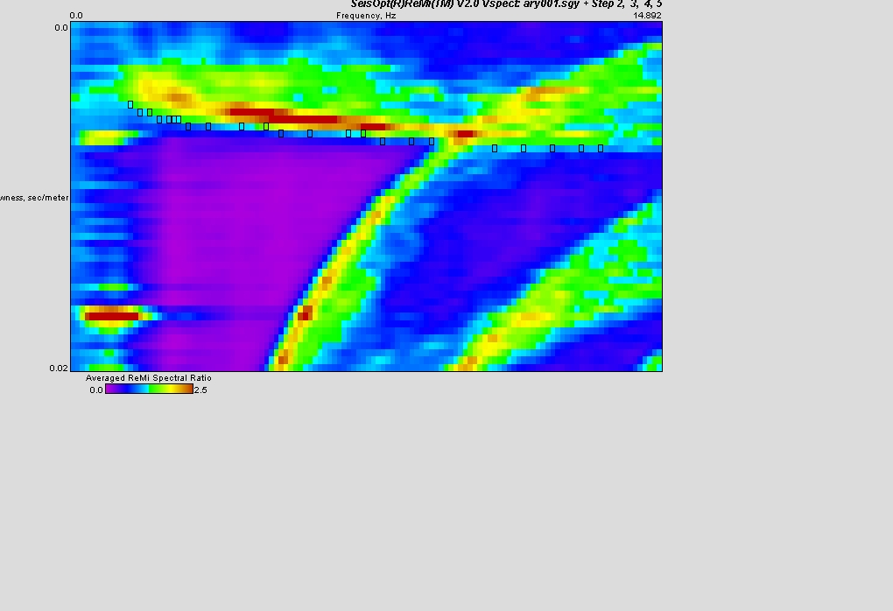
Velocity spexa with piks…..9 data records were used to get this averaged spectrum….

