REMI SURVEY IN VOLCAN:

PN1 was ReMi survey run outside by our building on road by Don Tavo hotel. Perpendicular line has not been processed yet.

PN1 Dispersion curve- Red is picks
– Blue is model fit
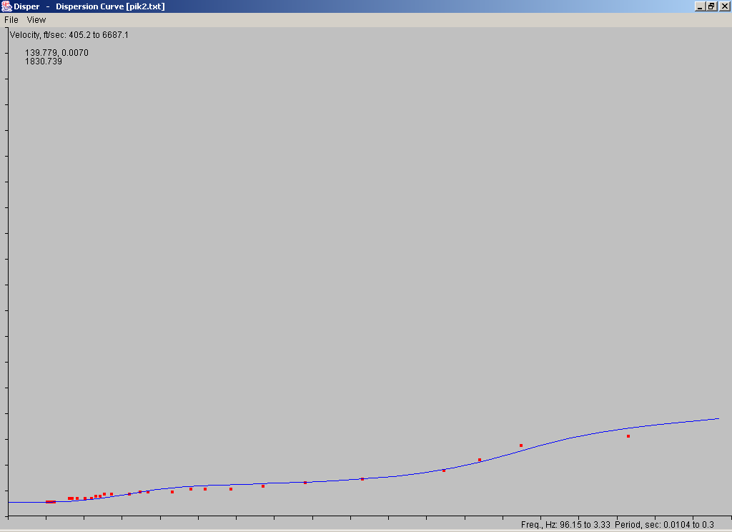

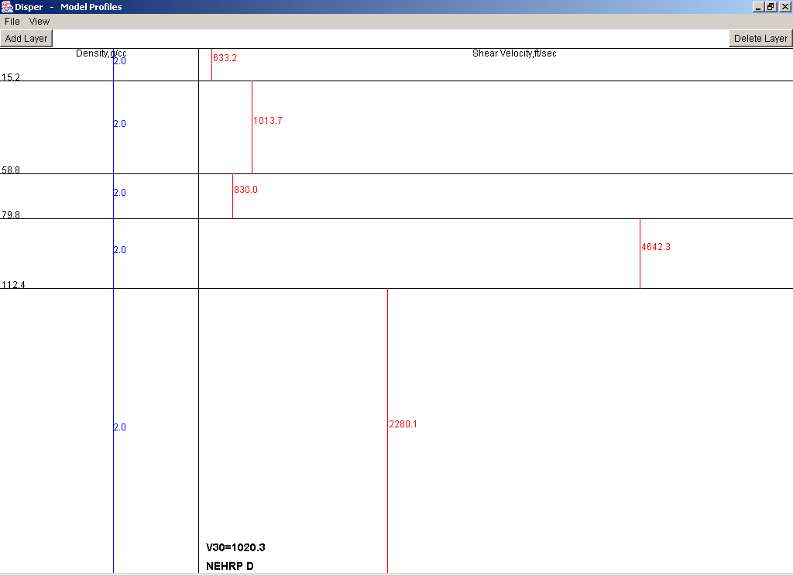

Note low velocities and velocity inversion at ~112’, still D classification but much higher than Array survey.

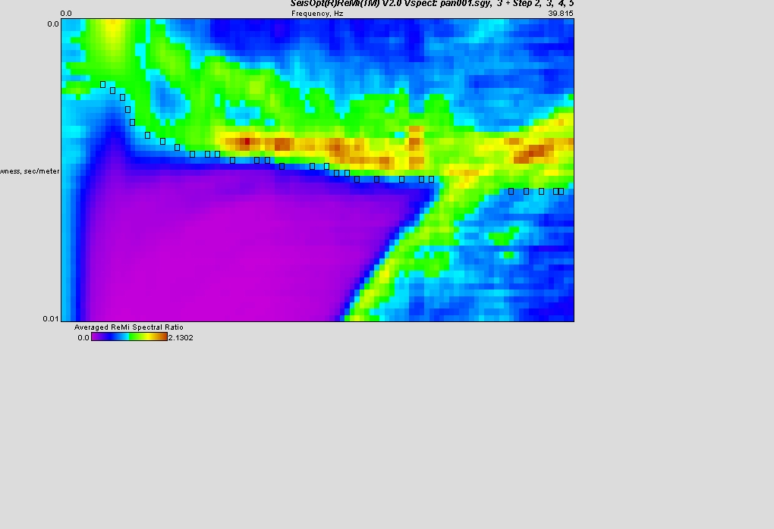
Velocity spexa which is used to get the Rayleigh Dispersion curve.

