Seismic Surveys to Image P & S Velocities for Site Characterization

(jeo 10/30/03)
Shear velocity, averaged over 30 meters depth (V₃₀) is a predictor of earthquake ground motion amplification and potential hazard in alluvium-filled basins. V₃₀ is the basis of site hazard classification under NEHRP-UBC provisions. The values of V₃₀ are an important predictor of earthquake ground motion amplification and potential hazard in similar alluvium-filled basins in California (Field et al., 2000).
Under NEHRP-UBC provisions (BSSC, 1998) sites are categorized using V₃₀. Due to the costs of borehole or penetrometer V₃₀ measurement methods (e.g., ASTM standards D4428 and D5778), site classification is presently based largely on geological maps with sparse downhole measurement support. Wills et al., (2000) have prepared a site-conditions map for California on this basis. The economics of site characterization often force acceptance of what now appears to be overly conservative map-based classification.
The shear-velocity characterization of the Reno basin is based on the refraction microtremor (ReMi) technique (Louie, 2001), which provides an economical new approach to V₃₀ estimation. Ambient seismic noise (vehicle traffic, etc.) excites Rayleigh waves in urban alluvium, eliminating the need for an explosive or hammer source. A noisy urban environment is thus advantageous to this method. One can record the noise sources with an array of vertical refraction geophones 100-300 m long. The array records are transformed into slowness-frequency space; dispersion is picked and modeled to produce a velocity-depth profile and thus V_{30.}

Time Series recording for ReMi Analysis-Las Vegas Site
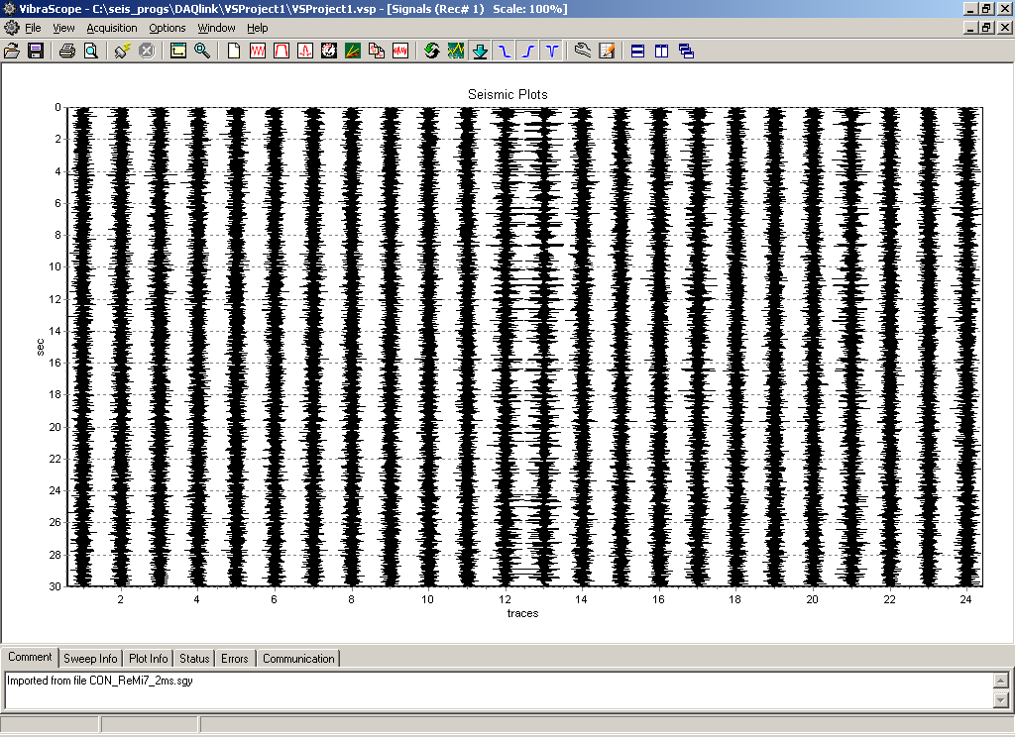
24 traces (geophones) displaying 30s of data, which is background noise. Rayleigh waves have the largest amplitude of all the seismic waves….

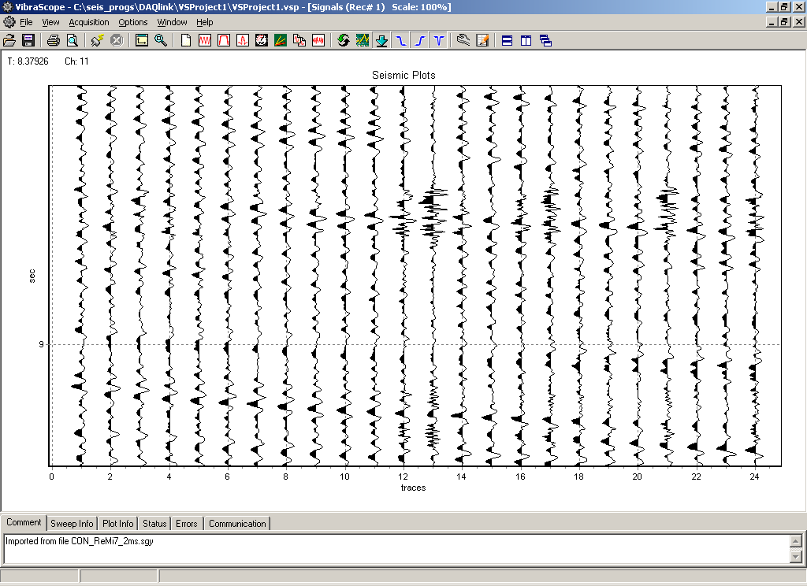
Data expanded to ~1s, shows waves moving across array, left to right.

Results from ReMi recordings, Caliche layer between ~70-140’

Shallow P refraction survey using a hammer source: Showing a buried fill area, dark blue- low P velocity, Vp~1500’/s. Using 24 channels of data, same system that records ReMi data to obtain S wave profile above, but different field parameters. 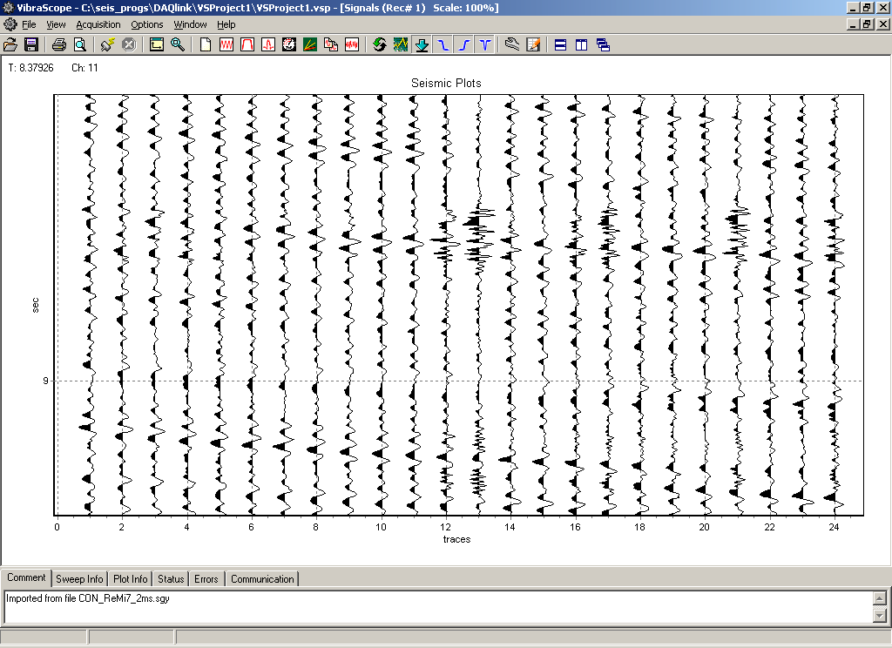

State-of-the Art Equipment & Very Sophisticated Software Does Seismic..….

Hardware system used: http://www.seismicsource.net/DAQLINK.html
Software analysis used: http://www.optimsoftware.com/products/

References
ASTM: American Society for Testing and Materials (2003).
D4428: Standard test methods for crosshole seismic
Testing, Annual Book of ASTM Standards Vol. 04.08 Soil and Rock (I)

ASTM: American Society for Testing and Materials (2003).
D5778: Standard test method for performing electronic
friction cone and piezocone penetration testing of soils,
Annual Book of ASTM Standards Vol. 04.08 Soil and Rock (I)

Building Seismic Safety Council– BSSC (1998) 1997 Edition
NEHRP Recommended Provisions for Seismic Regulation
for New Buildings, FEMA 302/303, developed for the
Federal Emergency Management Agency, Washington, D,C.

Field, E.H. and the SCEC Phase III Working Group (2000)
Accounting for site effects in probabilistic seismic hazard
analyses of southern California: Overview of the SCEC
Phase III Report, Bull. Seis. Soc. Amer., 90, no. 6B, S1-S31.

Louie, J.N. (2001). Faster, better: shear-wave velocity to 100
meters depth from refraction microtremor arrays, Bull.
Seis. Soc. Amer., 91, no. 2, 347-364.

Wills, C.J., Petersen, M., Bryant, W.A., Reichle, M., Saucedo,
G.J., Tan, S., Taylor, G., and Treiman, J. (2000). A site-
conditions map for California based on geology and shear-
wave velocity, Bull. Seis. Soc. Amer., 90, no. 6B, S187-S208.

Reno Basin ReMi Survey:
Scott, J. B., M. Clark, T. Rennie, A. Pancha, H. Park and J. N. Louie, 2003, A shallow shear-velocity transect across the Reno, Nevada area basin: submitted to Bull. Seismol. Soc. Amer., Oct. 7. (6.6 Mb PDF version)

Earthquake Hazard Surveys Across Urban Basins- Nevada Seismological Laboratory
http://quake.seismo.unr.edu/hazsurv/

Refraction Microtremor (ReMi) for Shear Velocity
The Most Efficient Shallow Shear-Velocity Estimates
More information on the refraction microtremor surveying technique.
September 19, 2003

Jim O’Donnell

Geological/Geophysical Consultant
Reg Geologist #1240, 1970
Reg Geophysicist #158, 1974

GEOTECHNICAL APPLICATIONS
ENGINEERING SEISMIC SURVEYS
- Refraction Microtremor & Refraction
- Downhole Velocity & Tomography
    - jim_odonnell@cox.net
702.281.7044 cell jimo17@juno.com

