UNIVERSITETET I BERGEN
Matematisk-naturvitenskapelig embetseksamen

Subject: GFJ 270: Applied seismology
Wednesday, November 29, 2000 0900-1400 hrs.

Permitted remedy: Calculator and English dictionary.

The total number of points for this exam is 100. The number of points for each question is indicated with the question.

Question 1, 10 points

Explain the terms of the expression below.

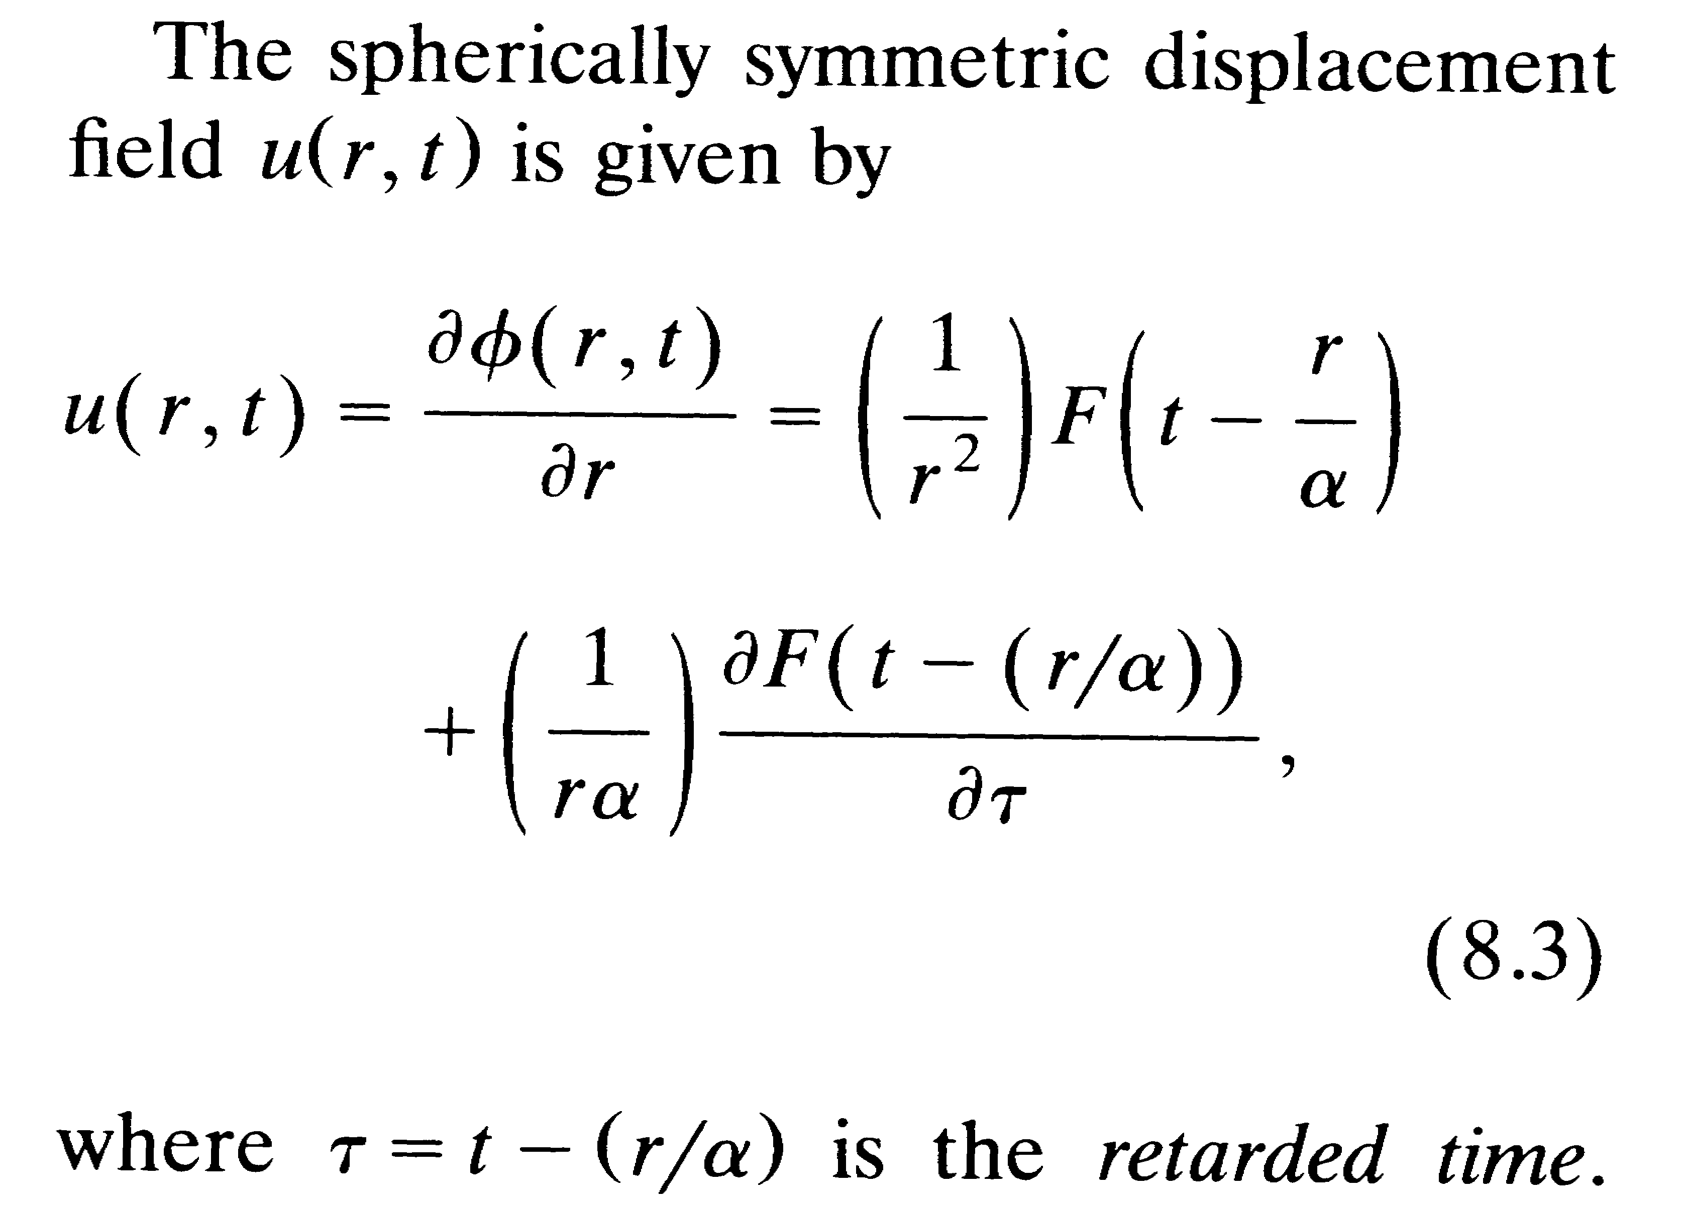

Question 2, 5 points

- What is the displacement of a suspended mass of 20 s natural period which is subject to an acceleration of 0.00001 m/s².

Question 3, 10 points

- Set up, for the Haskell source model, the far field expression for the total rupture time τ of a fault with length L. The rupture velocity is v_{r}, P-wave velocity v_{p} and the angle between fault direction and the direction to the station is θ.

Question 4, 5 points

- What is the principle definition of the Mb magnitude scale. - Which part of the seismogram is used and on which instrument.

Question 5, 12 points

- Define the elements of the moment tensor.
- Write down the elements of the moment tensor for a pure strike-slip fault where the fault plane is in the xy plane and the slip vector is along the positive x-axis.
- What does it mean physically if the trace of the moment tensor is non zero.

Question 6, 13 points

- Explain the principle and individual computations used for body wave modeling including the effects of finite fault size.
- Which source parameters can be determined using body wave modeling ?

Question 7, 10 points

- Define the t* attenuation factor and explain how it is used.

Question 8, 10 points

- Explain why hypocentral depth often is a difficult parameter to obtain.

Question 9, 6 points

The figure below shows 8 different faults of which the two faults on each line can be represented by the same fault plane solution.
- Draw the lower hemisphere fault plane solution for each pair.

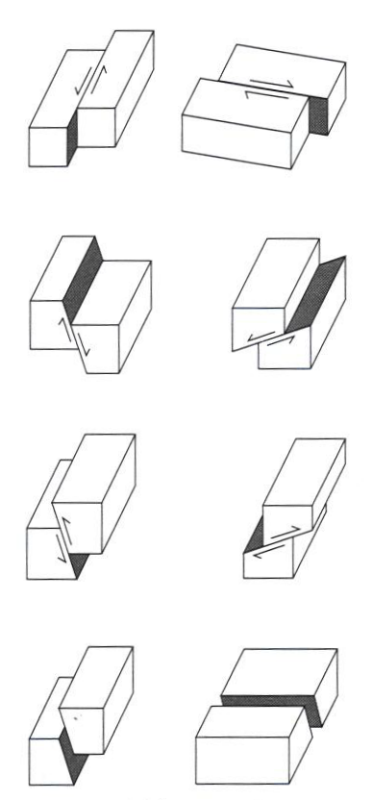

Question 11, 5 points

- From the figure below, it can be concluded that the earth has radial symmetry, why

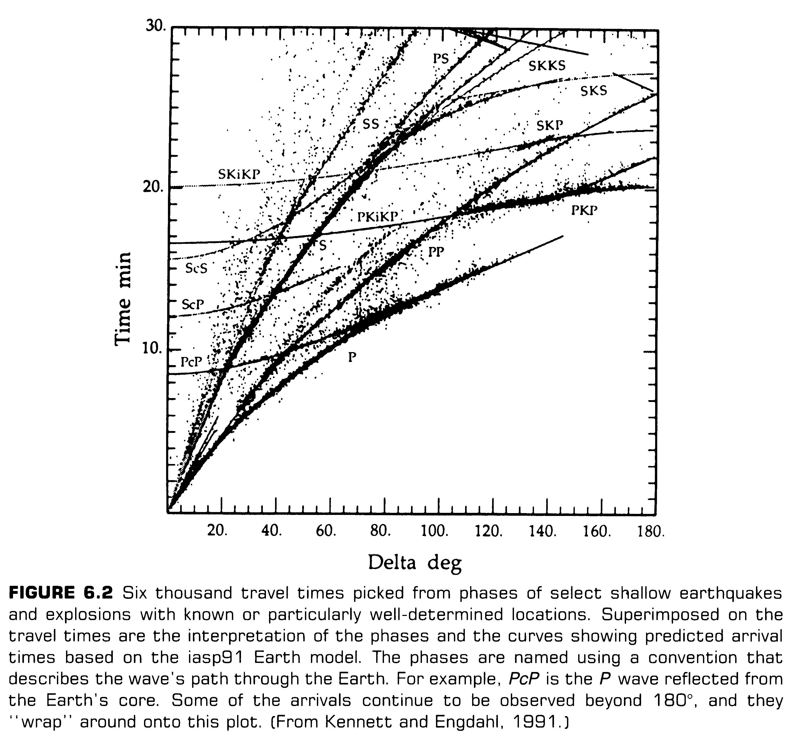

Question 12, 4 points

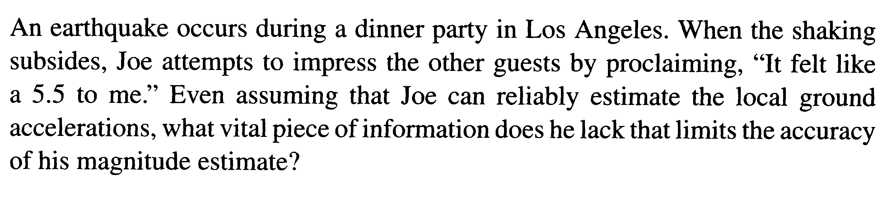

Question 13, 2 points

- What is seismic efficiency

Question 14, 2 points

- What is typical stress drop of interplate and intraplate
earthquakes respectively ?

Question 15, 2 points

- What is the Lg wave and at what distance is it typically recorded ?

Question 16, 3 points

- How does stress drop scale with corner frequency.

Question 18, 2 points

- How many stations and how many phases are needed to calculate the hypocenter and origin time.

