UNIVERSITETET I BERGEN
Matematisk-naturvitenskapelig embetseksamen

Subject: GFJ 270: Applied seismology
Monday, December 9, 2002 0900-1400 hrs.

Permitted remedy: Calculator and English dictionary.

The total number of points for this exam is 100. The number of points for each question is indicated with the question.

Question 1, 12 points

Figure 1 shows the relationship between log(fault length) and log(seismic moment) showing a near linear relationship.

- Using the figure, write the linear relationship between log(fault length) and log ( seismic moment).

- Derive the theoretical relationship between fault length and seismic moment.

- How does the seismic moment deviate from the expected values for large strike slip earthquakes ?

- How do you explain this deviation

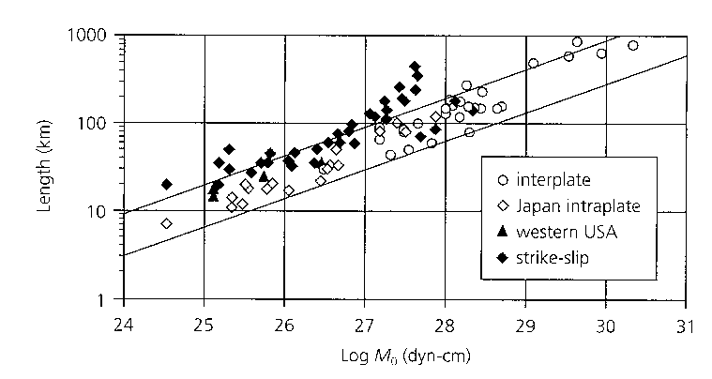
Question 2, 10 points

- In which way can synthetic modeling be used to determine hypocentral depth for a distant earthquake.

Question 3, 10 points

- Give the moment tensor for the 4 fault plane solutions seen below.

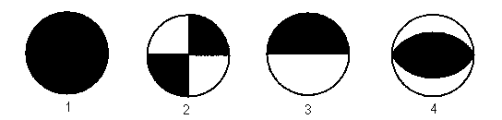

Question 4, 10 points

The figure below shows the theoretical source displacement spectra.

- Explain the phenomena of magnitude saturation for Ms.

- If Ms had been determined at the frequency of 100 s, at what magnitude would the Ms scale had saturated ?

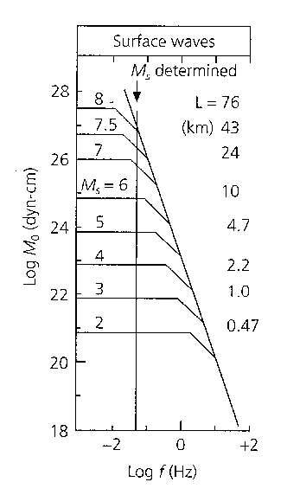

Question 5, 10 points

- What is the principle behind earthquake location using inversion.
- How many stations and how many phases are needed to calculate the hypocenter and origin time.

Question 6, 5 points

-Draw a typical seismic background noise spectrum, remember axis units

- What is a typical earth noise displacement in nm at 1 Hz at a low noise station ?
Question 7, 10 points

A model variance-covariance matrix for a seismic network is:

0.1 0.0 0.0 0.0
0.0 0.3 0.0 0.0
0.0 0.0 0.2 0.0
0.0 0.0 0.0 0.1

- What is the standard deviation in the determination of x,y,z
and origin time ?

- What is the orientation of minor and major axis of the error
ellipse in the x-y plane ?

Question 8, 5 points

If you know the travel time curve tp(distance) for P-waves, how can you determine the travel time curve tpp(distance) for PP waves ?

Question 9, 8 points

A fault oriented EW has a length of 50 km, it ruptures with a rupture velocity of 2.5 km/s from East to West and the slip time can be considered zero. The P-wave velocity near the fault is 6 km/s.

- How long time does the initial displacement pulse last East end West of the fault, respectively ?

Question 10, 2 points

- How much more energy is radiated when the magnitude
increases by one unit.

Question 11, 2 points

- What is the definition of seismic moment.

Question 12, 2 points

- What is seismic efficiency

Question 13, 2 points

- What is Rg waves ?

Question 14, 2 points

- Give the general definition of the magnitude scale based on amplitudes

Question 15, 2 points

- What is the upper mantle transition zone ?

Question 16, 2 points

- What is the natural period of the WWSSN SP and LP
seismographs ?

- What is typical gain of the two instruments respectively ?

Question 17, 2 points

-Give the relation for attenuation of seismic waves.

Question 18, 2 points

What is a typical fault area of a magnitude 8 earthquake ?

Question 19, 2 points

- Draw the S-wave radiation pattern for a double couple seismic source.

