UNIVERSITETET I BERGEN
Matematisk-naturvitenskapelig embetseksamen

Subject: GFJ 270: Applied seismology
Friday, May 3, 2002 0900-1400 hrs.

Permitted remedy: Calculator and English dictionary.

The total number of points for this exam is 100. The number of points for each question is indicated with the question.

Question 1, 10 points

Explain the terms of the expression below.

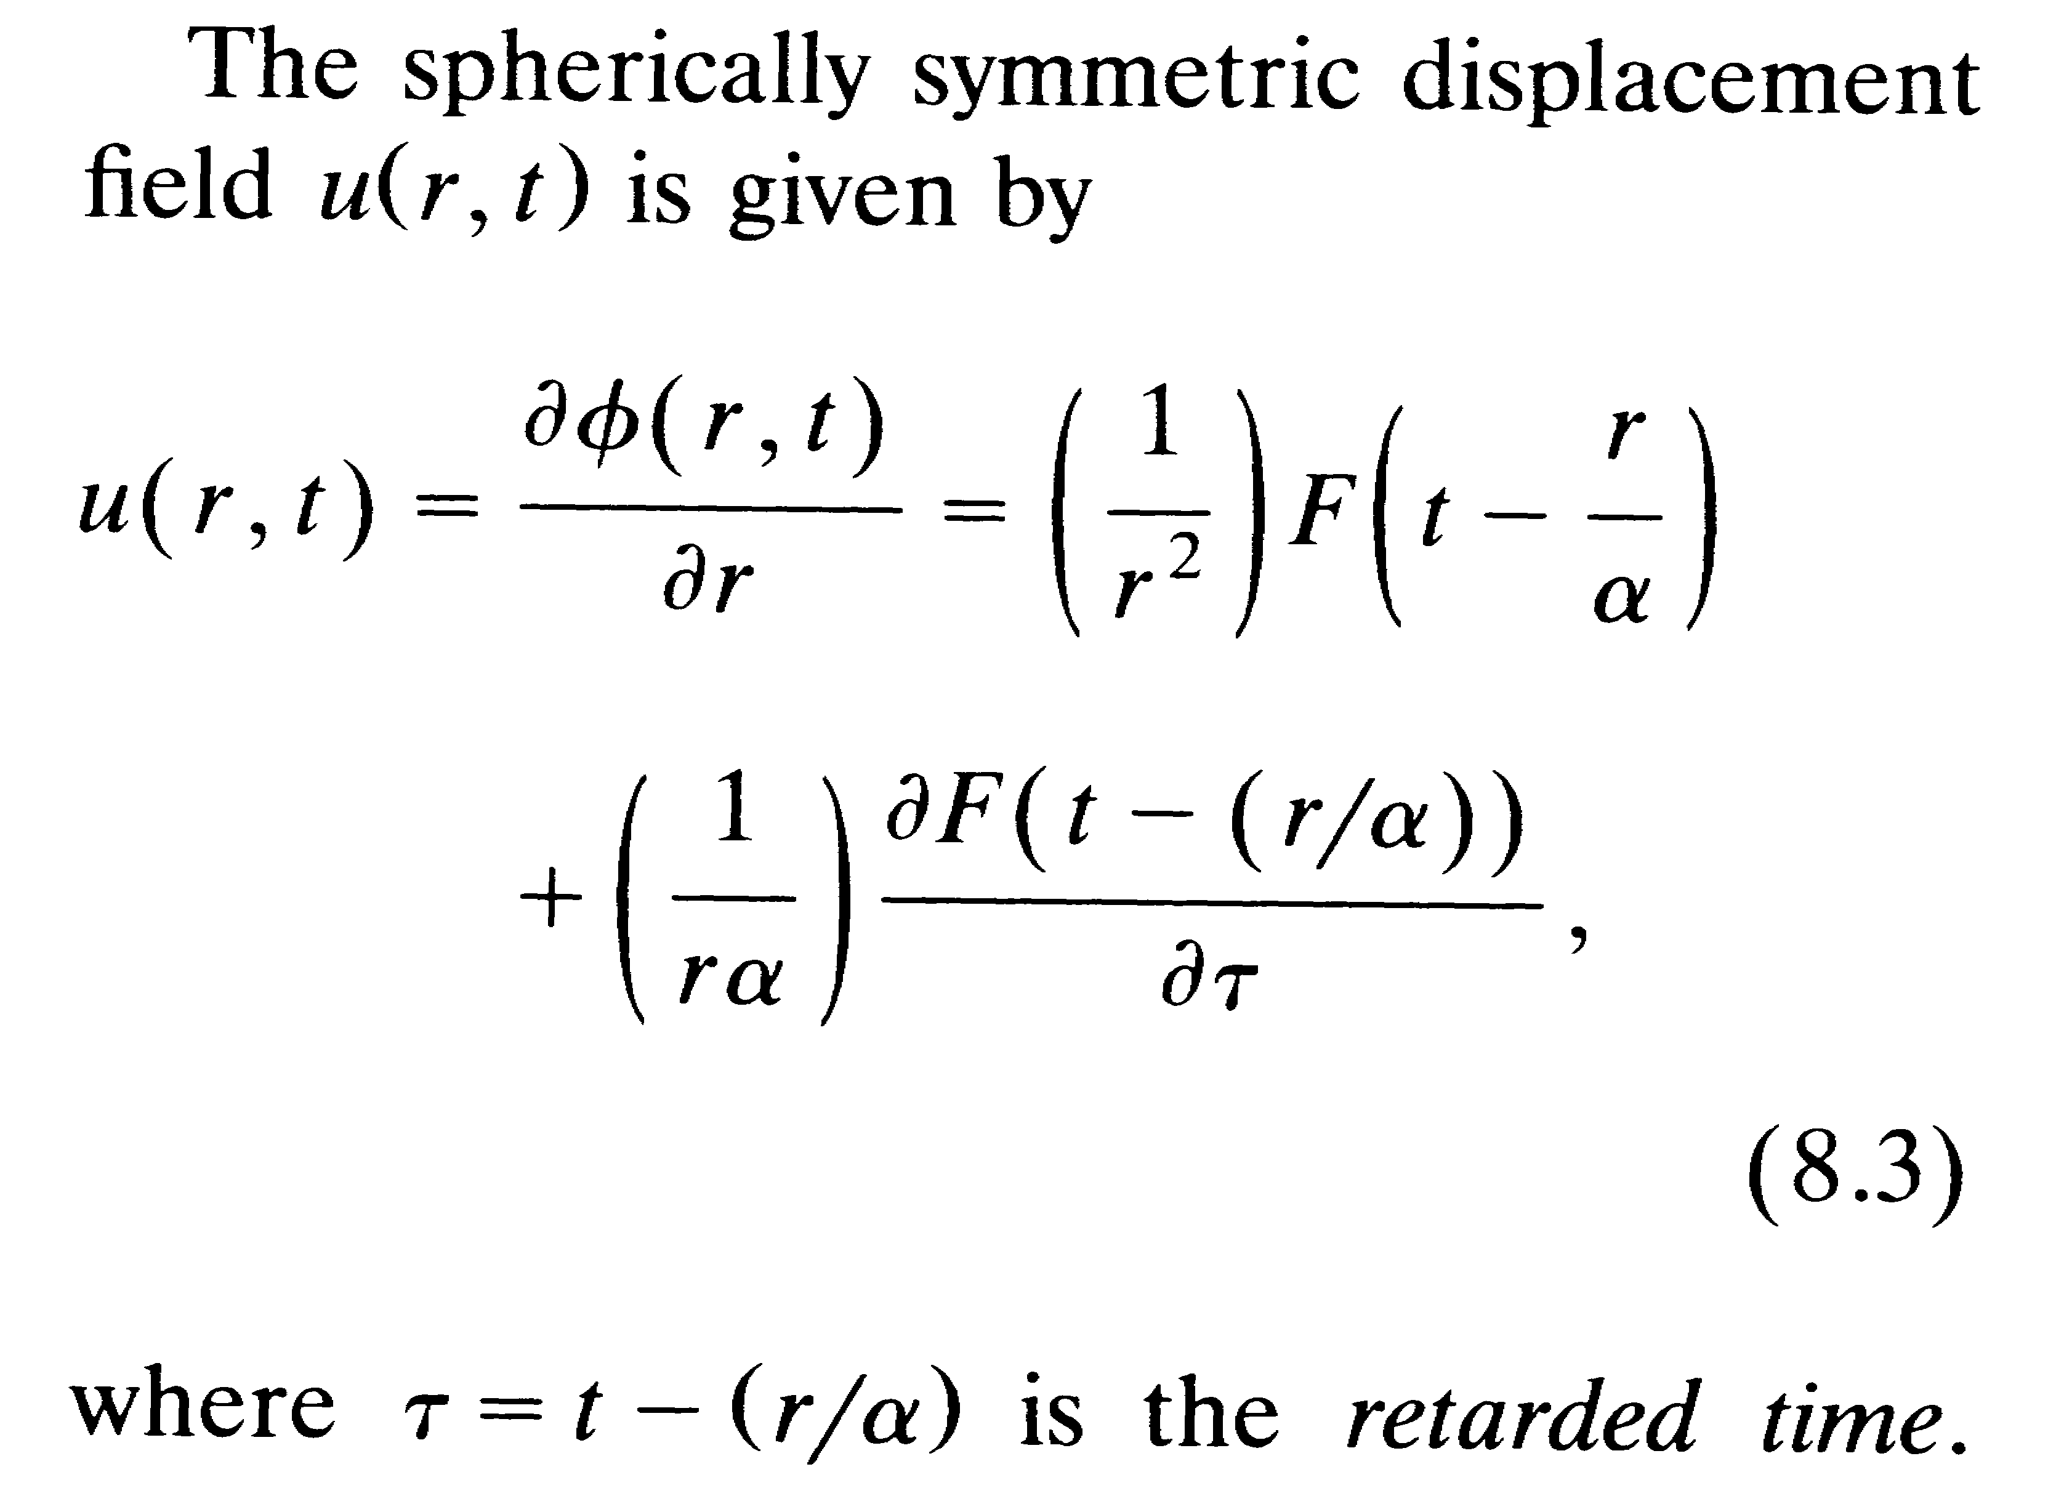

Question 2, 10 points

- In which way can synthetic modeling be used to determine hypocentral depth for a distant earthquakes.

Question 3, 10 points

Explain the significance of the figure below. In particular, what does it tell about earthquake self similarity ?
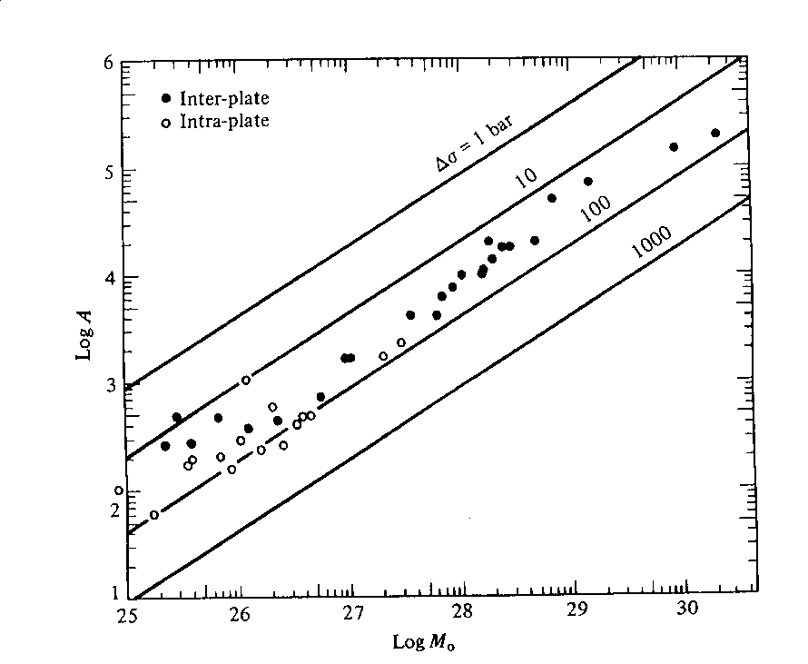

Area versus moment for inter and intra plate earthquakes.

Question 4, 10 points

- Define the elements of the moment tensor.
- Write down the elements of the moment tensor for a pure strike-slip fault where the fault plane is in the xy plane and the slip vector is along the positive x-axis.
- What does it mean physically if the trace of the moment tensor is non zero.

Question 5, 10 points

- Define the t* attenuation factor and explain how it is used.

Question 6, 5 points

- What is a seismic array and what is it used for.

Question 7, 10 points

A model variance-covariance matrix for a seismic network is:

0.1 0.0 0.0 0.0
0.0 0.3 0.0 0.0
0.0 0.0 0.2 0.0
0.0 0.0 0.0 0.1

- What is the standard deviation in the determination of x,y,z
and origin time ?

- What is the orientation of minor and major axis of the error
ellipse in the x-y plane ?

Question 8, 5 points

If you know the travel time curve tp(distance) for P-waves, how can you determine the travel time curve for PP waves tpp(distance) ?

Question 9, 10 points

From which data (P or S) and how, can it be explained that a double couple source model is a better representation of the seismic source compared to a single couple model ?

Question 10, 3 points

- How much more energy is radiated when the magnitude
increases by one unit.

Question 11, 3 points

- Draw the fault plane solution for a pure thrust earthquake where one of the fault planes has a strike of 30 deg. and a dip of 30 deg.

Question 12, 2 points

- What is seismic efficiency

Question 13, 2 points

- What is Rg waves ?

Question 14, 3 points

- What is a receiver function ?

Question 15, 2 points

- What is the upper mantle transition zone ?

Question 16, 2 points

- Which Q is highest, Q for P or Q for S ?

Question 17, 3 points

- How does stress drop scale with corner frequency.

