UNIVERSITETET I BERGEN
Matematisk-naturvitenskapelig embetseksamen

Subject: GFJ 270: Applied seismology
Monday, December 1, 2003 0900-1400 hrs.

Permitted remedy: Calculator and English dictionary.

The total number of points for this exam is 100. The number of points for each question is indicated with the question.

Question 1, 5 points

- From Figure 1, it can be concluded that the earth has radial symmetry, why ?

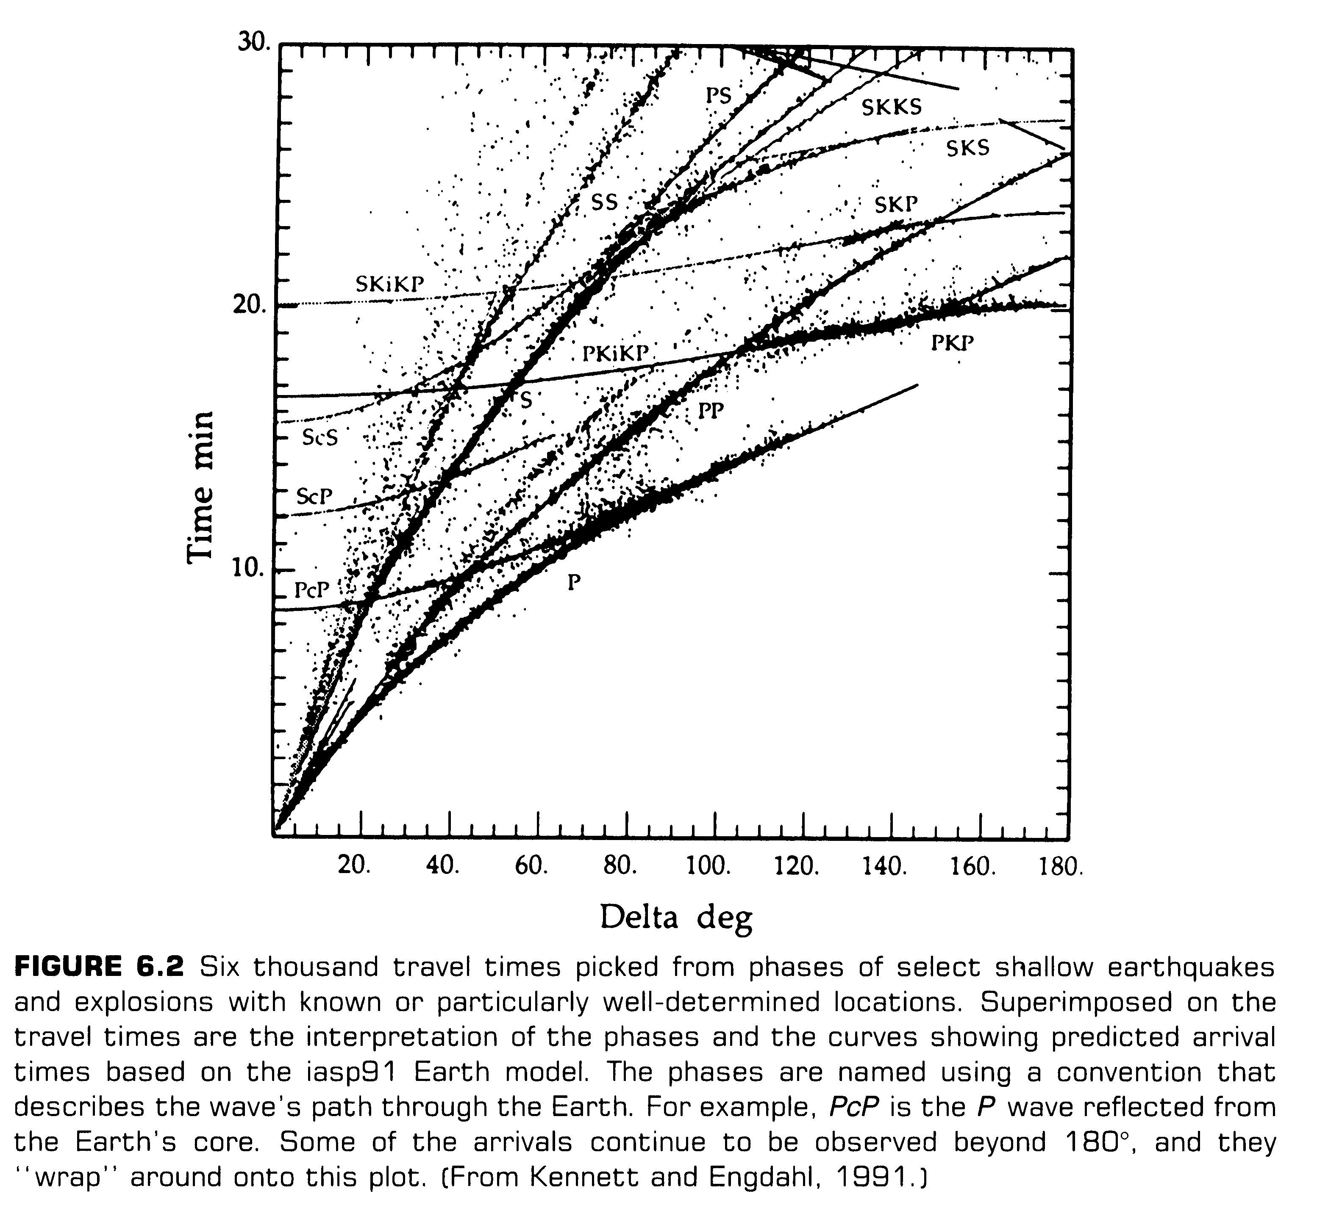

Figure 1, travel times versus distance

Question 2, 10 points

- What is aftershocks ?
- How large is the largest aftershock generally compared to the main shock ?
- How much energy is there in the aftershocks compared to the main shock ?
- How do the number of aftershocks per day decay as a function of time (sketch) ?

Question 3, 10 points

- Give the moment tensor for the 4 fault plane solutions seen below in Figure 2.

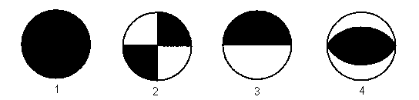

Figure 2 Fault plane solutions, lower hemisphere.

Question 4, 10 points

Figure 3 shows the theoretical source displacement spectra.

- Explain the phenomena of magnitude saturation for Ms.

- If Ms had been determined at the frequency of 100 s, at what magnitude would the Ms scale had saturated ?

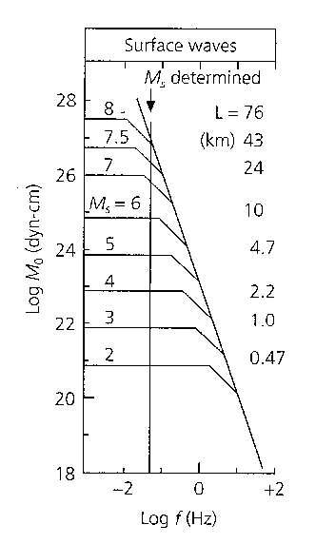

Figure 3 Source displacement spectra

Question 5, 5 points

Figure 4 shows the of an earthquake and an explosion at the same stations and at the same epicentral distance.

- Which seismogram is from the explosion and why ?
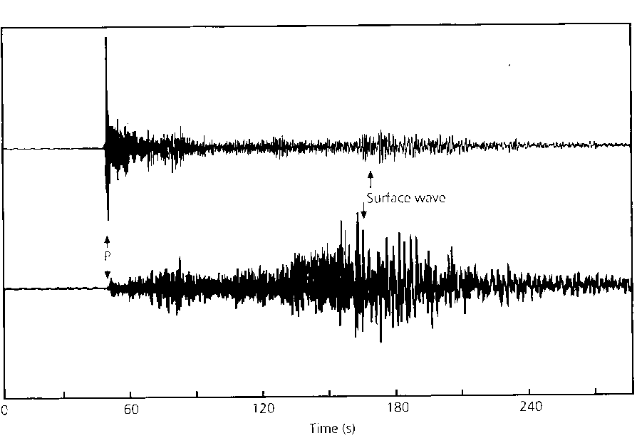

Figure 4, Seismogram of an explosion and an earthquake.

Question 6, 5 points

Derive the relation for stress drop as a function of seismic moment and fault dimension.

Question 7, 5 points

How many stations are needed to determine the hypocenter and origin time if:

- Only P arrivals available.
- P arrival from all stations and S-arrival from one of the stations.
- Only S arrival available.

Explain the answers.

Question 8, 5 points

What is the Mercali intensity scale and what is it used for.

Question 9, 5 points

- Explain the principle behind the theory of elastic rebound.

Question 10, 10 points

A model variance-covariance matrix for a seismic network is:

0.1 0.0 0.0 0.0
0.0 0.3 0.0 0.0
0.0 0.0 0.2 0.0
0.0 0.0 0.0 0.1

- What is the standard deviation in the determination of x,y,z
and origin time ?

- What is the orientation of minor and major axis of the error
ellipse in the x-y plane ?

Question 11, 5 points

If you know the travel time curve tp(distance) for P-waves, how can you determine the travel time curve tpp(distance) for PP waves ?

Question 12, 5 points

A fault oriented EW has a length of 50 km, it ruptures with a rupture velocity of 2.5 km/s from East to West and the slip time can be considered zero. The P-wave velocity near the fault is 6 km/s.

- How long time does the initial displacement pulse last East end West of the fault, respectively ?

Question 13, 2 points

- What is a typical earth noise displacement in nm at 1 Hz at a low noise station ?

Question 14, 2 points

- Give the general definition of the magnitude scale based on amplitudes

Question 15, 2 points

How does amplitude decrease as a function of distance
- For body waves ?
- For surface waves ?

Question 16, 2 points

- How much more energy is radiated when the magnitude
increases by one unit ?

Question 17, 2 points

-Give the relation for attenuation of seismic waves.

Question 18, 2 points

What is a typical fault area of a magnitude 8 earthquake ?

Question 19, 2 points

- Draw the S-wave radiation pattern for a double couple seismic source.

Question 20, 2 points

- How much more energy is radiated when the magnitude
increases by one unit.

Question 21, 2 points

- What is the definition of seismic moment.

Question 22, 2 points

- What is seismic efficiency

