UNIVERSITETET I BERGEN
Matematisk-naturvitenskapelig embetseksamen

Subject: GFJ 270: Applied seismology
Wednesday, May 26, 2004 0900-1300 hrs.

Permitted remedy: Calculator and English dictionary.

The total number of points for this exam is 100. The number of points for each question is indicated with the question.

Question 1, 5 points

- From Figure 1, it can be concluded that the earth has radial symmetry, why ?

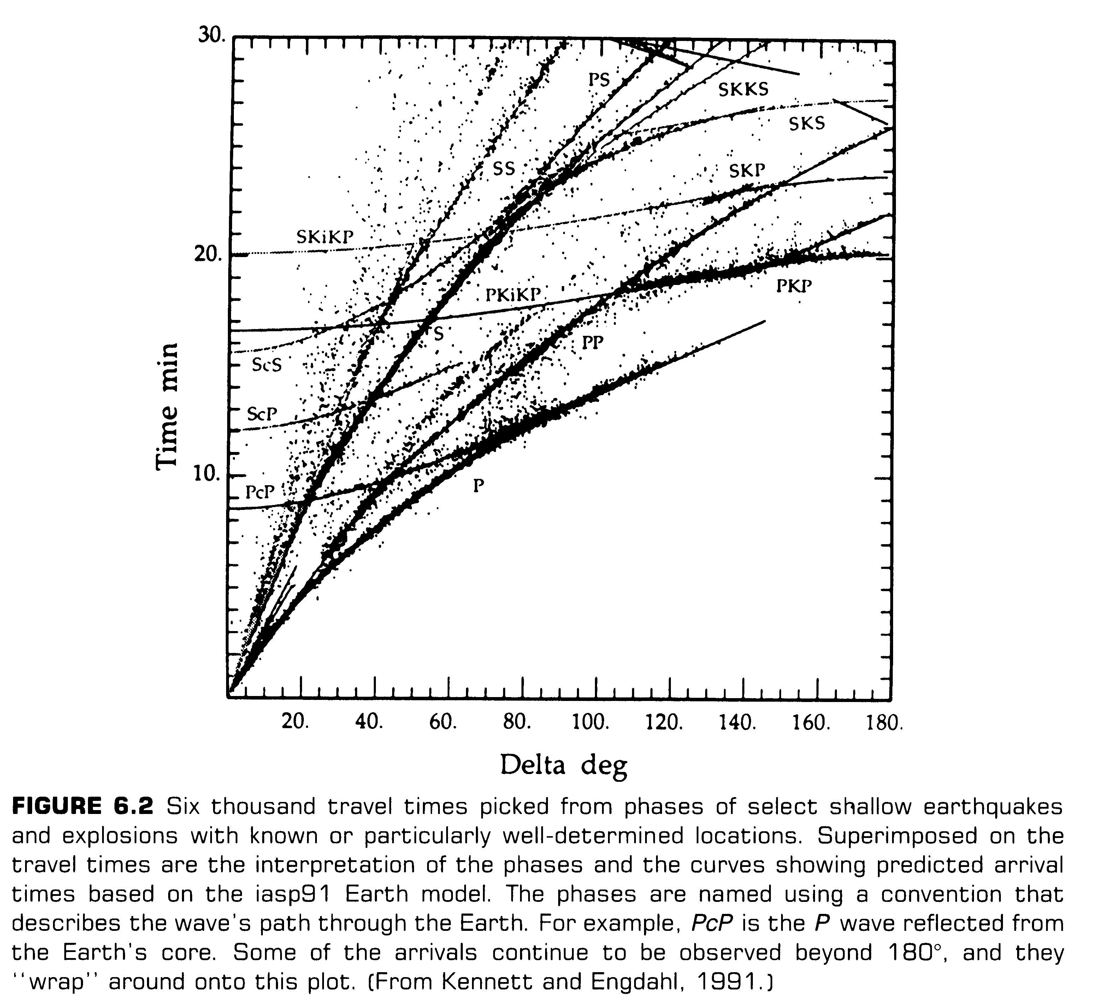
Figure 1

Question 2, 12 points

- In which way can synthetic modeling be used to determine hypocentral depth for a distant earthquakes.

Question 3, 10 points

Explain the significance of the figure below (Figure 2). 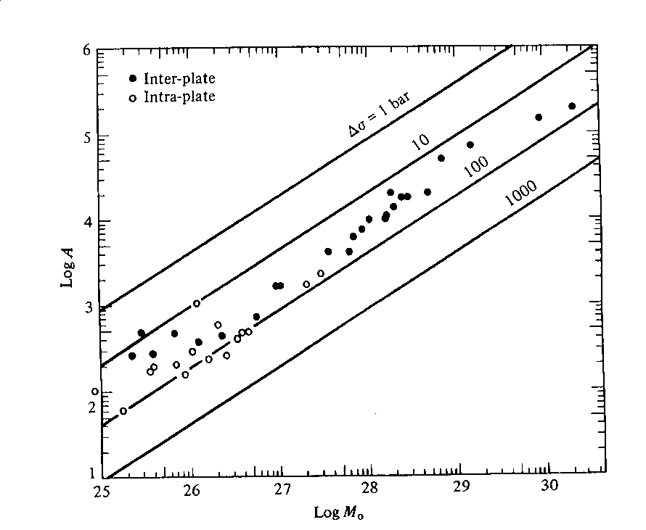

Figure 2. Area versus moment for inter and intra plate earthquakes.

Question 4, 12 points

- Define the elements of the moment tensor.
- Write down the elements of the moment tensor for a pure strike-slip fault where the fault plane is in the xy plane and the slip vector is along the positive x-axis.
- What does it mean physically if the trace of the moment tensor is non zero.

Question 5, 10 points

- Define the t* attenuation factor and explain how it is used.

Question 6, 10 points

Figure 3 shows the theoretical source displacement spectra.

- Explain the phenomena of magnitude saturation for Ms.

- If Ms had been determined at the frequency of 100 s, at what magnitude would the Ms scale had saturated ?

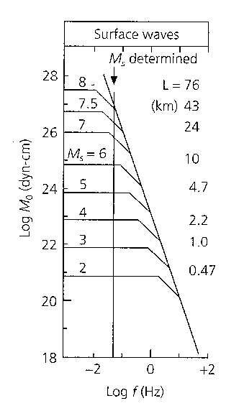

Figure 3 Source displacement spectra

Question 7, 10 points

A model variance-covariance matrix for a seismic network is:

0.1 0.0 0.0 0.0
0.0 0.3 0.0 0.0
0.0 0.0 0.2 0.0
0.0 0.0 0.0 0.1

- What is the standard deviation in the determination of x,y,z
and origin time ?

- What is the orientation of minor and major axis of the error
ellipse in the x-y plane ?

Question 8, 5 points

If you know the travel time curve tp(distance) for P-waves, how can you determine the travel time curve for PP waves tpp(distance) ?

Question 9, 5 points

Figure 4 shows seismograms of an earthquake and an explosion at the same station and at the same epicentral distance.

- Which seismogram is from the explosion and why ?
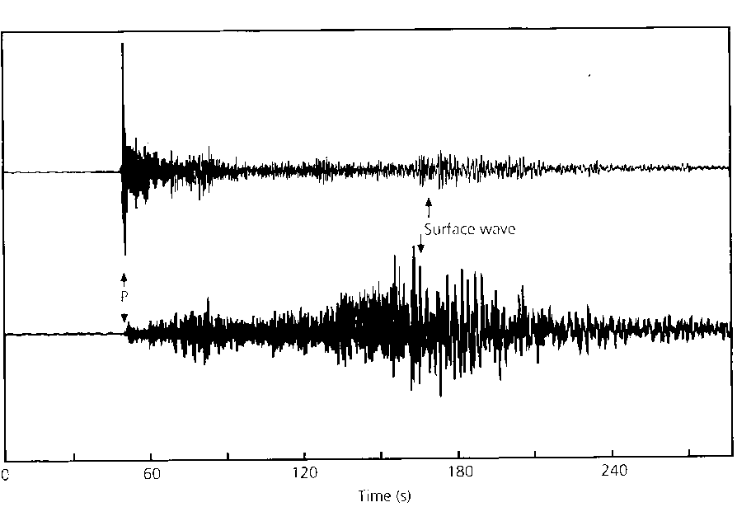

Figure 4, Seismogram of an explosion and an earthquake.

Question 10, 3 points

- How much more energy is radiated when the magnitude
increases by one unit.

Question 11, 4 points

- Draw the fault plane solution for a pure thrust earthquake where one of the fault planes has a strike of 30 deg. and a dip of 30 deg.

Question 12, 2 points

- What is seismic efficiency

Question 13, 2 points

- What is Rg waves ?

Question 14, 3 points

How does amplitude decrease as a function of distance
- For body waves ?
- For surface waves ?

Question 15, 2 points

- What is a typical fault area of a magnitude 8 earthquake ?

Question 16, 2 points

- Which Q is highest, Q for P or Q for S ?

Question 17, 3 points

- How does stress drop scale with corner frequency.

