UNIVERSITETET I BERGEN
Matematisk-naturvitenskapelig embetseksamen

Subject: GFJ 270: Applied seismology
Monday, November 21, 2005 0900-1300 hrs.

Permitted remedy: Calculator and English dictionary.

The total number of points for this exam is 100. The number of points for each question is indicated with the question.

Question 1, 10 points

- Write an expression for the strain energy released during an earthquake assuming an average stress during faulting.
- If the average stress is the final stress plus half the stress drop, how much seismic energy can be radiated ?
- How is the energy related to seismic moment ?

Question 2, 10 points

- In which way can synthetic modelling be used to determine hypocentral depth for distant earthquakes.

Question 3, 5 points

The hypocenter can be determined from arrival times (International Seismic Center) or from the moment tensor solution (Harard CMT solution)
- Why are the two hypocenters and origin times different ?

Question 4, 10 points

- How does the P-wave radiation pattern look as a result of directivity ?
- How does directivity affect the source time function (sketch the source time function in the direction of rupture and at a right angle to the rupture propagation direction)?

Question 5, 10 points

- Define the t* attenuation factor and explain how it is used.

Question 6, 5 points

What is the Mercali intensity scale and what is it used for.

Question 7, 10 points

A model variance-covariance matrix for a seismic network is:

0.4 0.0 0.0 0.0
0.0 0.9 0.0 0.0
0.0 0.0 0.4 0.0
0.0 0.0 0.0 0.1

- What is the standard deviation in the determination of x,y,z
and origin time ?

- What is the orientation of minor and major axis of the error
ellipse in the x-y plane ?

Question 8, 5 points

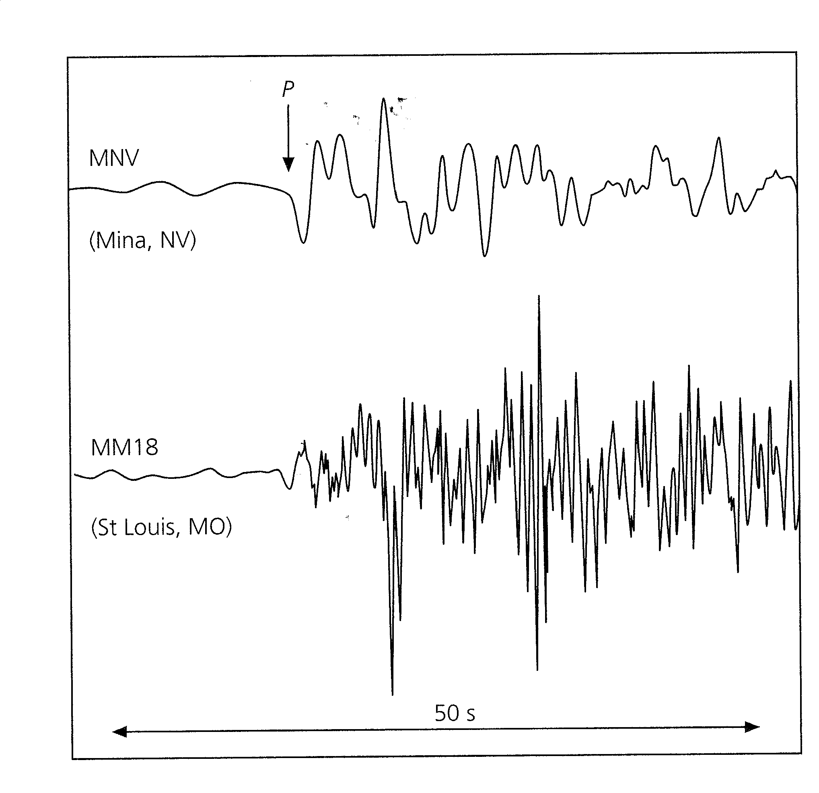

Figure 1 Seismograms from an earthquake in Texas recorded in Nevada (MNV, distance 15 deg.) and Missouri (MM18, distance 14 deg.). Both instruments have the same response function.

- Why are the two seismograms so different ?

Question 9, 10 points

From which data (P or S) and how, can it be explained that a double couple source model is a better representation of the seismic source compared to a single couple model ?

Question 10, 3 points

- How much more energy is radiated when the magnitude
increases by one unit.

Question 11, 3 points

- Write the moment tensor for seismic sources that are compensated linear vector dipoles (CLVD).

Question 12, 2 points

- What is seismic efficiency

Question 13, 2 points

- What is a typical earth noise displacement in nm at 1 Hz at a low noise station ?

Question 14, 3 points

Why is ScS a more distinct arrival than PcP ?

Question 15, 2 points

- What is a typical rupture velocity ?

Question 16, 2 points

- Which Q is highest, Q for P or Q for S ?

Question 17, 3 points

- How does stress drop scale with corner frequency.

Question 18, 3 points

- Where is the D" layer located and how thick is it ?

Question 19, 2 points

- Give typical b-values of aftershocks and seismic swarms, respectively

