UNIVERSITETET I BERGEN

Matematisk-naturvitenskapelig embetseksamen

Subject: GFJ 374 Observational seismology, now geo 271
Monday, December 11, 2000, 0900-1300 hrs.

Permitted remedy: Calculator, transparent paper, millimeter paper and English dictionary.

A total of 100 points is possible for this exam. The number of points for each question is indicated.

Question 1, 10 points

A digital broad band seismogram (flat velocity response) for an earthquake at 100 km's distance has a maximum amplitude of 2000 counts at a frequency of 2Hz. The gain is 10**9 counts/m at 1 Hz.
- What is the earth displacement at 2 Hz.
- Assuming that the Wood Anderson seismograph has a gain of 2800, calculate the local magnitude Ml.

Question 2, 5 points

Seismic signals often have to filtered in order to enhance the signal to noise ratio. Which would be a good filter to use for the following signals:

- P-phase of a magnitude 2.0 event at 100 km distance recorded on a SP seismograph.
- P-phase of a magnitude 5.0 event at 2000 km distance recorded on a SP seismograph.
- P-phase of a magnitude 6.0 event at 5000 km distance recorded on a broad band seismograph.
- Surface wave of a magnitude 6.0 event at 5000 km distance recorded on a broad band seismograph.

Question 3, 5 points

- An earthquake is recorded at an epicentral distance of 90 degrees. The travel time difference between sP and P is 50 secs. Assuming a constant P-velocity of 9 km/sec under the station and Vp/Vs ratio of 1.78, calculate the approximate hypocentral depth.

Question 4, 10 points

- A 3 station array has the coordinates (km) and P-arrival times as shown below.

station 1 (0,0)
station 2 (20,0)
station 3 (0,10)

A seismic wave arrive with an azimuth of 45 degrees and has the apparent velocity of 10 sec/deg.
- Calculate the apparent velocity in km/sec.

- If the wave arrives at station 1 at time t=10 secs, at what time does the wavefront arrive at stations 2 and 3.

Question 5, 5 points

A region has 100 earthquakes between magnitude 4.6 and 5.0 per year.
- With no more information, estimate how many earthquakes of magnitude 7 occur each year.
- State which assumption has been used.

Question 6, 10 points

3 seismic stations (s1,s2 and s3) are located at (-10km,0km), (10km,0km) and (0km,-10km) respectively. The P-waves from an earthquake arrive at the same time to s1 and s2 and earlier to s3. The S-P time at s3 is 3.0 secs, the Vp velocity 6 km/sec and the Vp/Vs ratio 1.73. Determine the epicenter assuming a hypocentral depth of 3 km.

Question 7, 5 points

- On a 3 component seismometer, the amplitude on the EW and NS components are equal and positive. The earthquake is located at an azimuth of 225 deg from the station. What is the polarity on the Z-component.

Question 8, 10 points

5 different seismic stations have the following arrival times from one earthquake for P and S given in hours, minutes and seconds:

P-time S-time
10:50 50 10:51 7
10:50 52 10:51 00
10:51 00 10:51 14
10:51 11 10:51 38
10:51 15 10:51 40

Calculate the origin time and Vp/Vs velocity ratio.
One of the readings has a wrong phase identification. Which one is it and what misidentification could have been made.

Question 9, 7 points

The figure below shows a long period seismogram.
- Given the phases identified, what are the phases labeled 1, 2, 3 and 4 ? ‘
- Explain how they were identified.

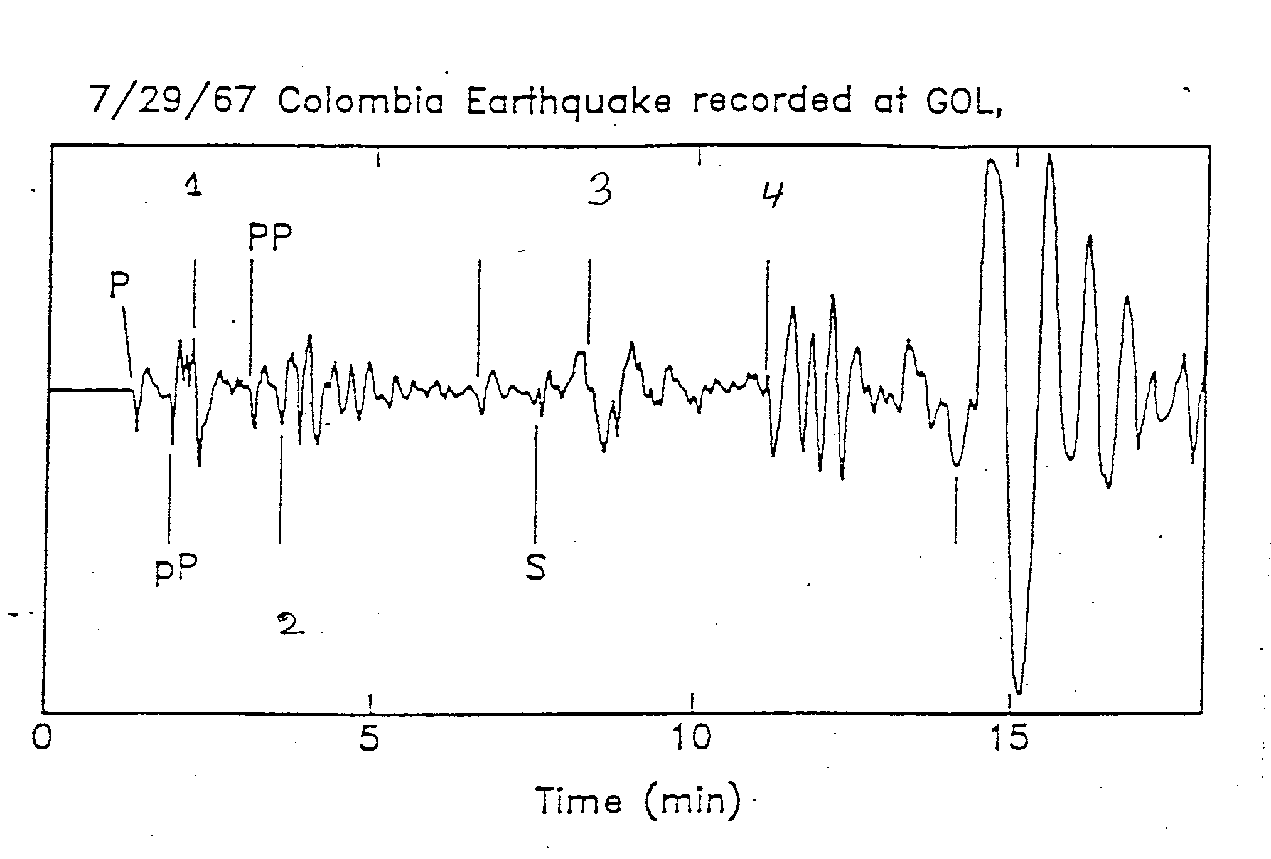

Question 10, 5 points

- An earthquake has Ms = 7.5. The amplitude used was measured at 18 secs. If the same amplitude had been measured at 22 secs, what would the magnitude had been.

Question 11, 10 points

- Schematically draw an earthquake displacement spectrum and indicate what measurements are used to determine seismic moment and stress drop.
- What is the effect on the spectra of using a) A constant Q, b) Q =Q0*f where Q0 is a constant and f is the frequency.

Question 12, 10 points

A single layered crust is assumed ( one layer over Moho). TPg and TPn are the travel times of Pg and Pn respectively.

- Schematically draw the curve TPg - TPn as a function of depth assuming that the distance is large enough so that TPg > TPn.
- How can this curve be used to determine the hypocentral depth of local earthquakes.

Question 13, 5 points

- Show on an earth model the ray paths of the following phases: ScP, PKPPKP, PKiKP, PKIKP.

Question 14, 3 points

A signal is sampled at 20 Hz. Can a band pass filter from 10 to 15 Hz be used for filtration ? Explain the answer.

