UNIVERSITETET I BERGEN

Matematisk-naturvitenskapelig embetseksamen

Subject: GFJ 374 Observational seismology, now geo 271
Wednesday, December 4, 2002, 0900-1300 hrs.

Permitted remedy: Calculator, transparent paper, millimeter paper and English dictionary.

A total of 100 points is possible for this exam. The number of points for each question is indicated.

Question 1, 8 points

- A digital broad band seismogram (flat velocity response) for an earthquake at 100 km's distance has a maximum amplitude of 2000 counts at a frequency of 2Hz. The gain is 10⁹ counts/m at 1 Hz. What is the earth displacement at 2 Hz.
- Assuming that the Wood Anderson seismograph has a gain of 2800, calculate the local magnitude Ml.

Question 2, 5 points

- On a 3 component seismometer, the amplitude on the EW and NS components are equal and positive. The earthquake is located at an azimuth of 225 deg measured from the station. What is the polarity on the Z-component.

Question 3, 12 points

The figure below shows the short period and long period seismograms from a deep focus earthquake recorded by stations in the distance range 50.1 to 92.5 degrees (marked on left on seismograms).

- Which seismograms are short period and which are long
period ?

- Show the rays of the phases seen on the seismogram.

- Why is the PcP phase arrival getting closer to the P-arrival time as the distance increases ?

- Assuming a P-velocity of 9 km/s, calculate the approximate depth of the earthquake using station COL.

- Calculate the approximate depth using station SCP ?
- Are the two depths equal, if not why ?

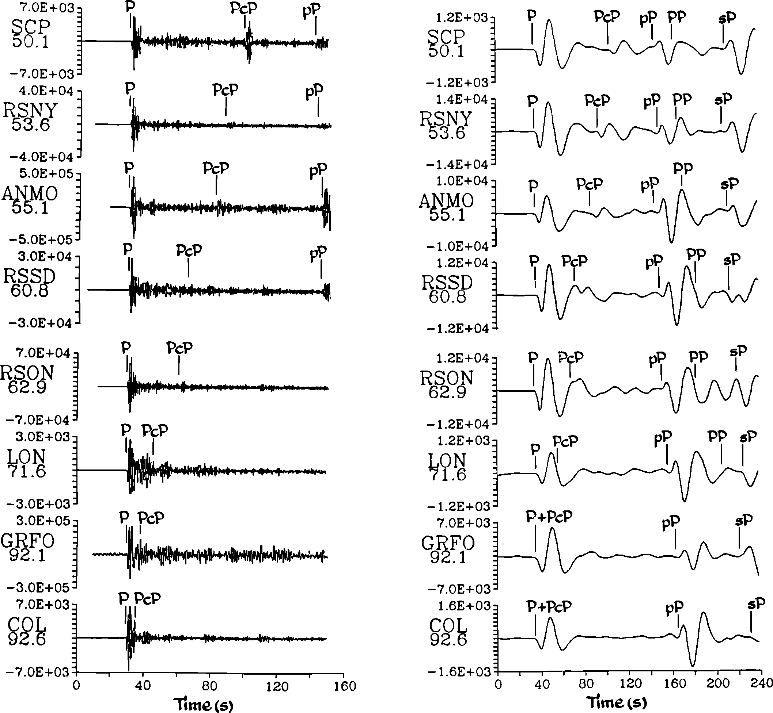

Question 4, 10 points

- A 3 station array has the coordinates (km) and P-arrival times as shown below.

station 1 (0,0)
station 2 (20,0)
station 3 (0,10)

A seismic wave arrives with an azimuth of 45 degrees and has the apparent velocity of 10 sec/deg.

- Calculate the apparent velocity in km/sec.

- If the wave arrives at station 1 at time t=10 sec, at what time does the wavefront arrive at stations 2 and 3 ?

Question 5, 8 points

- If you have the following arrival times at 2 seismic stations for the same earthquake, determine the Vp/Vs velocity ratio.

station 1 Pg= 20.0 sec
Sg= 30.0 sec

station 2 Pg= 25.0 sec
Sg= 39.0 sec

- Determine the origin time

Question 6, 5 points

An earthquake catalog for a 15 year period can be described as

Log N = -1.2 * M + 6.5

- What does the relation describe.
- How often will an earthquake of magnitude 6.0 occur.

Question 7, 10 points

3 seismic stations (s1,s2 and s3) are located at (-10km,0km), (10km,0km) and (0km,-10km) respectively. The P-waves from an earthquake arrive at the same time to s1 and s2 and earlier to s3. The S-P time at s3 is 3.0 secs, the Vp velocity 6 km/sec and the Vp/Vs ratio 1.73. Determine the epicenter assuming a hypocentral depth of 3 km.

Question 8, 10 points

The figure below shows the seismograms of two different shallow earthquakes occurring in the same region (time scale s). The epicentral distances are around 500 km for both events.

- Identify the most prominent phases on both seismograms (give arrival time relative to P).

- Some of the same phases on the two seismograms have very different amplitudes, give a possible explanation.

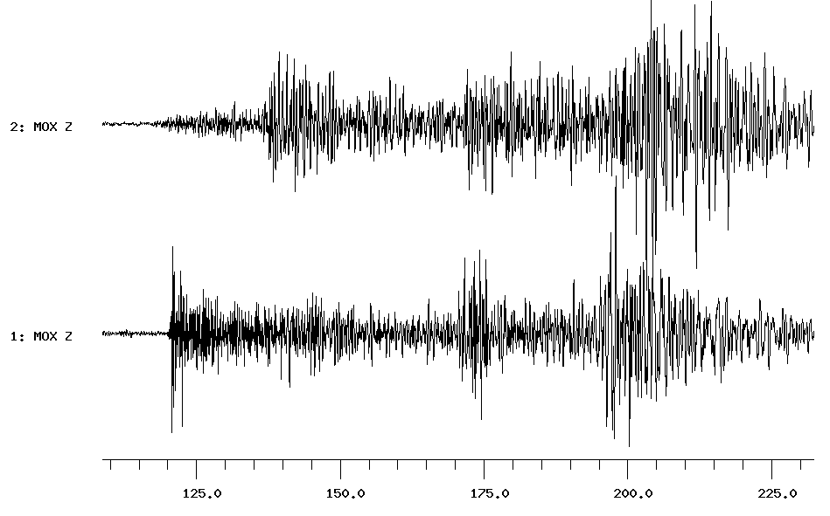

Question 9, 12 points

Figure 1 shows a lower hemisphere plot of polarities.
- Determine the fault plane solution.
- Give strike and dip of the two fault planes.
- Indicate location of P and T-axis.
- What type of fault is it ?

Question 10, 6 points

- Show the shapes of typical earthquake displacement, velocity and acceleration spectra with axis units.

- Which of the 3 spectra is used for determining seismic moment and stress drop ?

- Which parameters are you reading off the spectrum to determine seismic moment and stress drop ?

Question 11, 5 points

- What is the typical average continental crustal velocity of Pg and Pn waves, respectively ?
- How can you use a seismic array to identify if a phase is Pg or Pn ?

Question 12, 3 points

- Under what circumstances will you get two different PPP arrivals at the same station at the same time.

Question 13, 2 points

- Show on an earth model the ray paths of the following phases: pScP, PKIKP and PKP.

Question 14, 2 points

Filtering is often needed to see seismic phases on a broad band seismogram. Which band pass filters are used to see the following phases:

- S, SS and surface waves at teleseismic distances ?
- P for small local earthquakes ?

Question 15, 2 points

- What does component rotation mean ?

Figure 1a

Polarities, filled out symbols are compressions

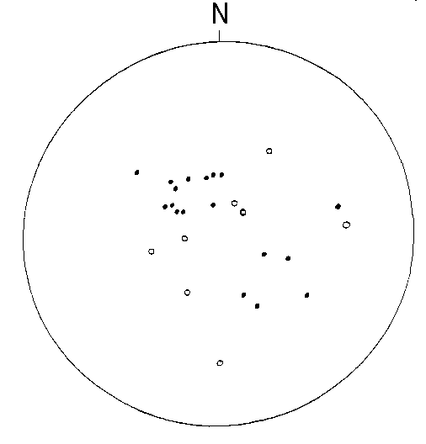

Figure 1b Stereonet

