UNIVERSITETET I BERGEN

Matematisk-naturvitenskapelig embetseksamen

Subject: GEOF 271 Observational seismology
Wednesday, December 3, 2003, 0900-1300 hrs.

Permitted remedy: Calculator, transparent paper, millimeter paper and English dictionary.

A total of 100 points is possible for this exam. The number of points for each question is indicated.

Question 1, 5 points

-A digital broad band seismogram (flat velocity response) has a maximum amplitude of 2000 counts at a frequency of 2 Hz. The gain is 10⁹ counts/m at 1 Hz.
-What is the ground velocity at 2 Hz ?
-What is the ground displacement at 2 Hz ?

Question 2, 5 points

- On a 3 component seismometer, the amplitude on the EW and NS components are equal and positive. The earthquake is located at an azimuth of 225 deg measured from the station. What is the polarity on the Z-component.

Question 3, 8 points

- Given the seismogram in Figure 1 and the travel time table in Figure 2, identify the clear phases. Assume that the time scale on the seismogram is the same as the time scale on the travel time curve.
- Determine the origin time.

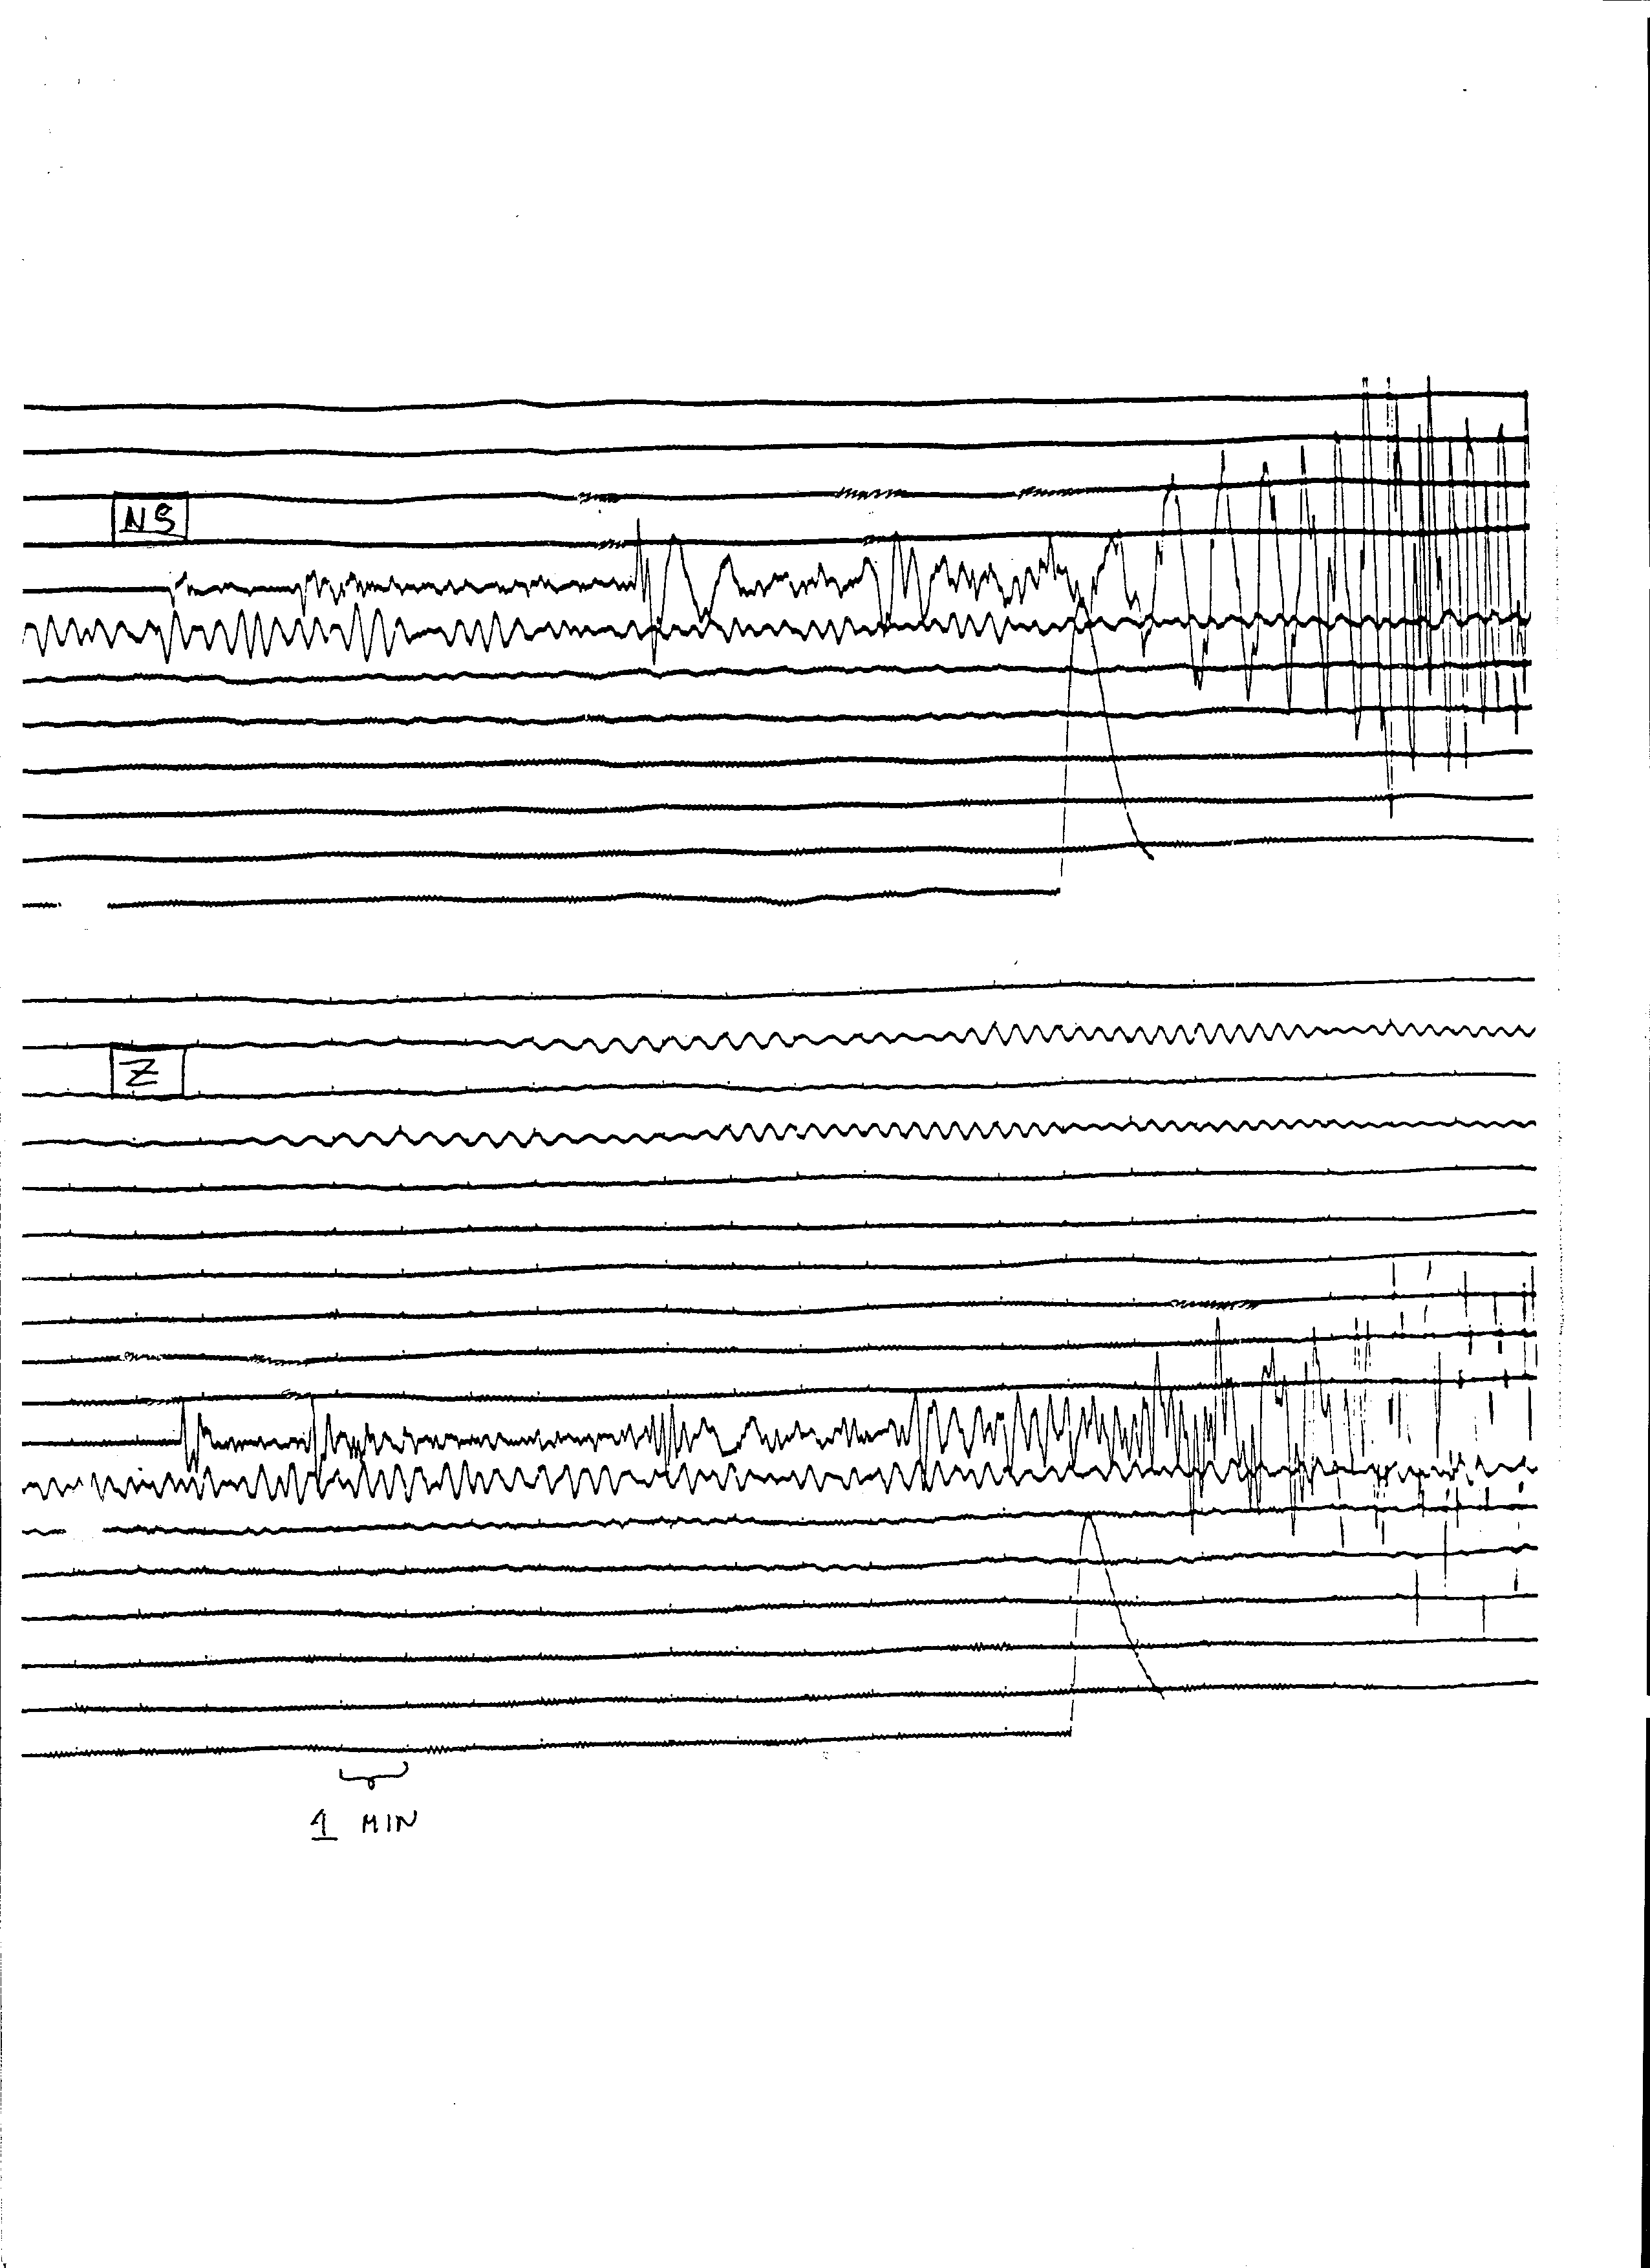

Figure 1 Long period seismograms

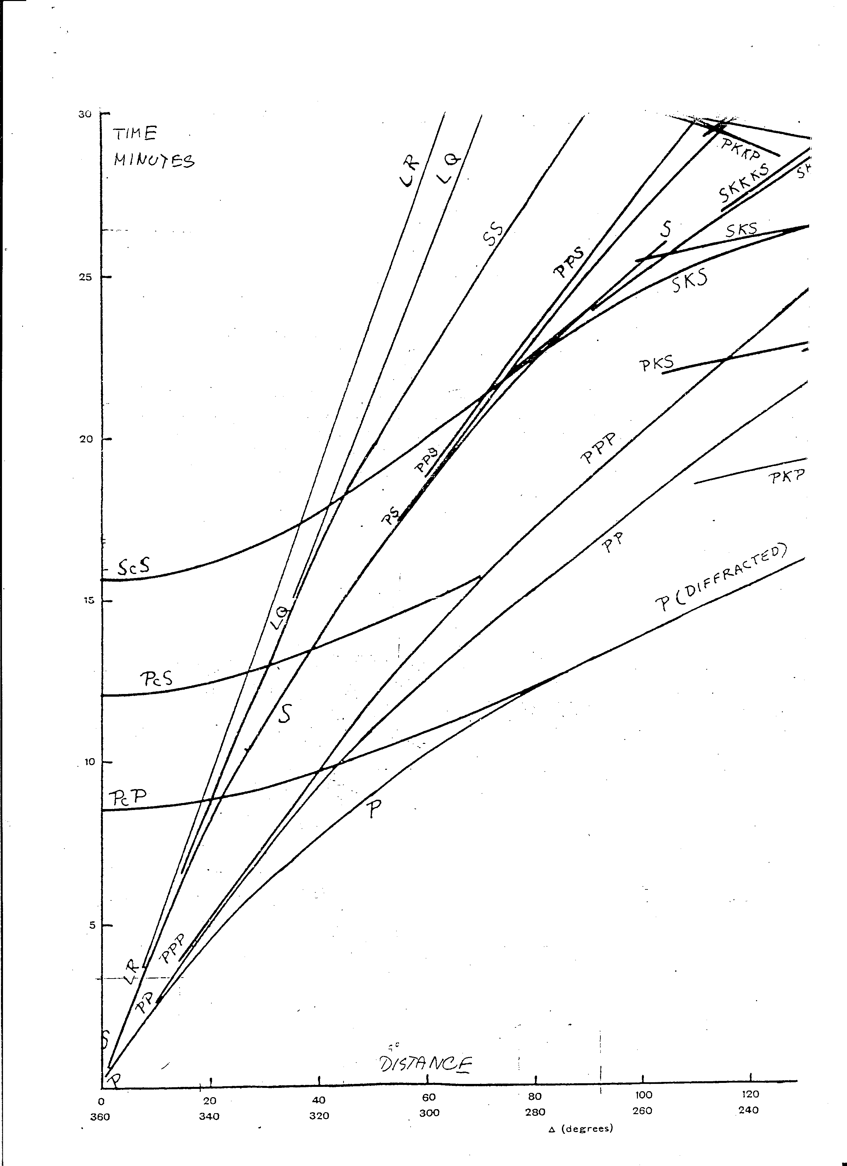

Figure 2 Bullen travel time tables for a shallow earthquake

Question 4, 8 points

Figure 3 shows the short period and long period seismograms from a deep focus earthquake recorded by stations in the distance range 50.1 to 92.5 degrees (marked on left on seismograms).

- Which seismograms are short period and which are long
period and why ?

- Show the ray paths of the phases seen on the seismogram.

- Why is the PcP phase arrival getting closer to the P-arrival time as the distance increases ?

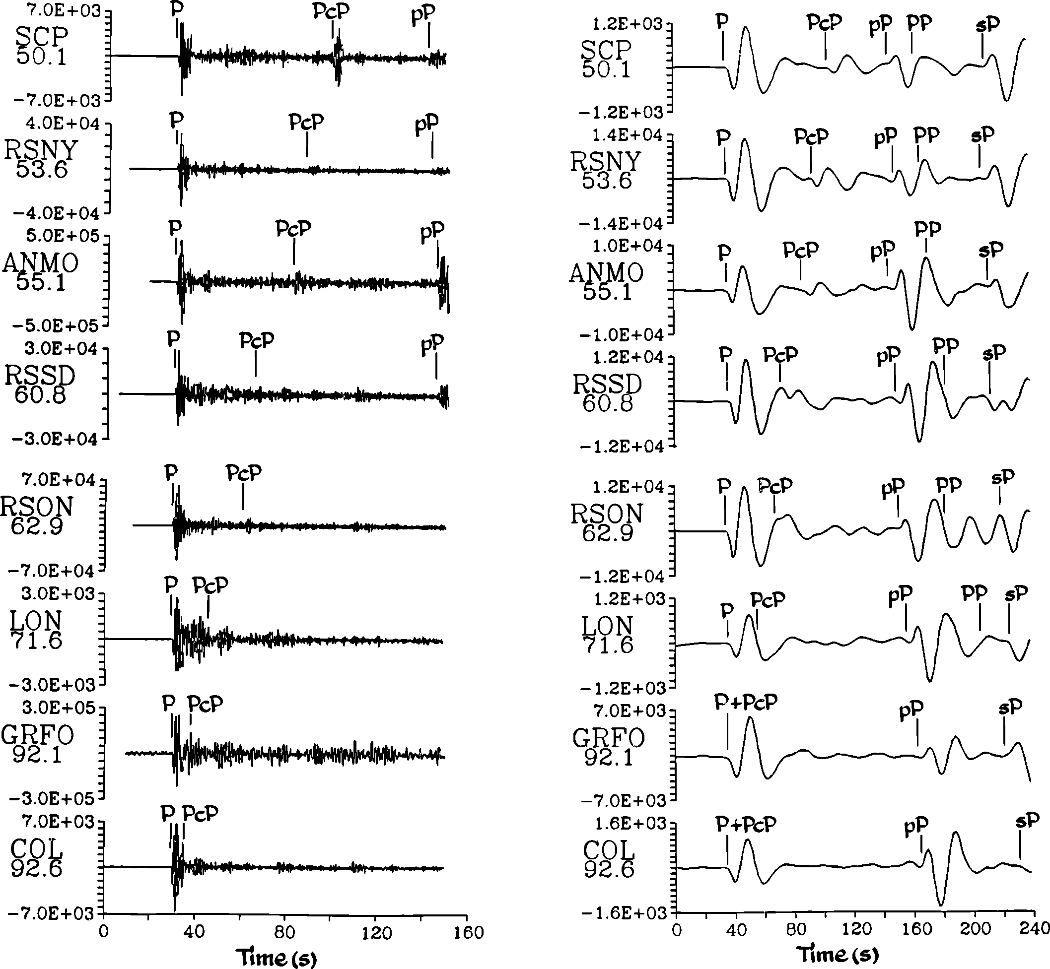

Figure 3

Question 5, 10 points

- A 3 station array has the coordinates (km) and P-arrival times as shown below.

station 1 (0,0)
station 2 (20,0)
station 3 (0,10)

A seismic wave arrives with an azimuth of 45 degrees and has the apparent velocity of 10 sec/deg.

- Calculate the apparent velocity in km/sec.

- If the wave arrives at station 1 at time t=10 sec, at what time does the wavefront arrive at stations 2 and 3 ?

Question 6, 8 points

- If you have the following arrival times at 2 seismic stations for the same earthquake, determine the Vp/Vs velocity ratio.

station 1 Pg= 20.0 sec
Sg= 30.0 sec

station 2 Pg= 25.0 sec
Sg= 39.0 sec

- Determine the origin time

Question 7, 10 points

- For a 2 month period, the earthquakes recorded at a particular network had the following magnitudes:

1.7, 1.5, 3.0, 2.1, 2.3, 2.7, 2.3, 3.1, 1.7, 2.2, 1.9,
2.6, 3.5, 1.9, 2.3, 2.5, 2.3, 2.1, 1.5,3.1, 2.6

- Determine the b-value and the detections threshold.
- How many magnitude 6 events will statistically occur in a 20 year period ?

Question 8, 8 points

3 seismic stations (s1,s2 and s3) are located at (-10km,0km), (10km,0km) and (0km,-10km) respectively. The P-waves from an earthquake arrive at the same time to s1 and s2 and earlier to s3. The S-P time at s3 is 3.0 secs, the Vp velocity 6 km/sec and the Vp/Vs ratio 1.73. Determine the epicenter assuming a hypocentral depth of 3 km.
Question 9, 8 points

- An earthquake is recorded at an epicentral distance of 90 degrees. The travel time difference between sP and pP is 20 secs. Assuming a constant P-velocity of 9 km/sec under the station and Vp/Vs ratio of 1.78, calculate the approximate hypocentral depth.

Question 10, 12 points

Figure 3 shows a lower hemisphere plot of polarities.
- Determine the fault plane solution.
- Give strike and dip of the two fault planes.
- Indicate location of P and T-axis.
- What type of fault is it ?

Question 11, 4 points

Make a drawing showing the crustal structure responsible for the phases P* (or Pb) and Pn.
- What is typical Vp velocities for Pn and P* respectively ?

Question 12, 2 points

- Show on an earth model the ray paths of the following phases: pScP, PKIKP and PKP.

Question 13, 2 points

Filtering is often needed to see seismic phases on a broad band seismogram. Which band pass filters are used to see the following phases:

- S, SS and surface waves at teleseismic distances ?
- P for small local earthquakes ?

Question 14, 3 points

- What is the angle of incidence if the apparent velocity is 10 km/s and the velocity is 6 km/s ?

Question 15, 2 points

- What is the general expression for of the coda wave magnitude relation ?

Question 16, 3 points

- Assuming that the Wood Anderson seismograph has a gain of 2800, the ground displacement is 1 nm, the epicentral distance is 100 km, calculate the local magnitude Ml.

Question 17, 2 points

- How many stations are needed to locate an earthquake (hypocenter and origin time) using P waves only ?

Figure 3a

Polarities, filled out symbols are compressions

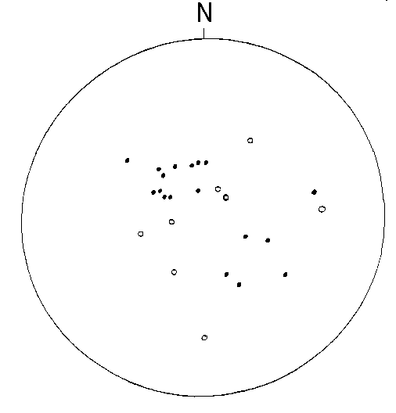

Figure 3b Stereonet

