UNIVERSITETET I BERGEN

Matematisk-naturvitenskapelig embetseksamen

Subject: Special course in observational seismology
Monday, November 29, 2004, 0900-1300 hrs.

Permitted remedy: Calculator, transparent paper, millimeter paper and English dictionary.

A total of 100 points is possible for this exam. The number of points for each question is indicated.

Question 1, 5 points

-A digital broad band seismogram (flat velocity response) has a maximum amplitude of 2000 counts at a frequency of 2 Hz. The gain is 10⁹ counts/m at 1 Hz.
-What is the ground velocity at 2 Hz ?
-What is the ground displacement at 2 Hz ?

Question 2, 5 points

- On a 3 component seismometer, the amplitude on the EW and NS components are equal and positive. The earthquake is located at an azimuth of 225 deg measured from the station. What is the polarity on the Z-component.

Question 3, 8 points

- Given the seismogram in Figure 1 and the travel time table in Figure 2, identify the clear phases. Assume that the time scale on the seismogram is the same as the time scale on the travel time curve.
- Determine the origin time.

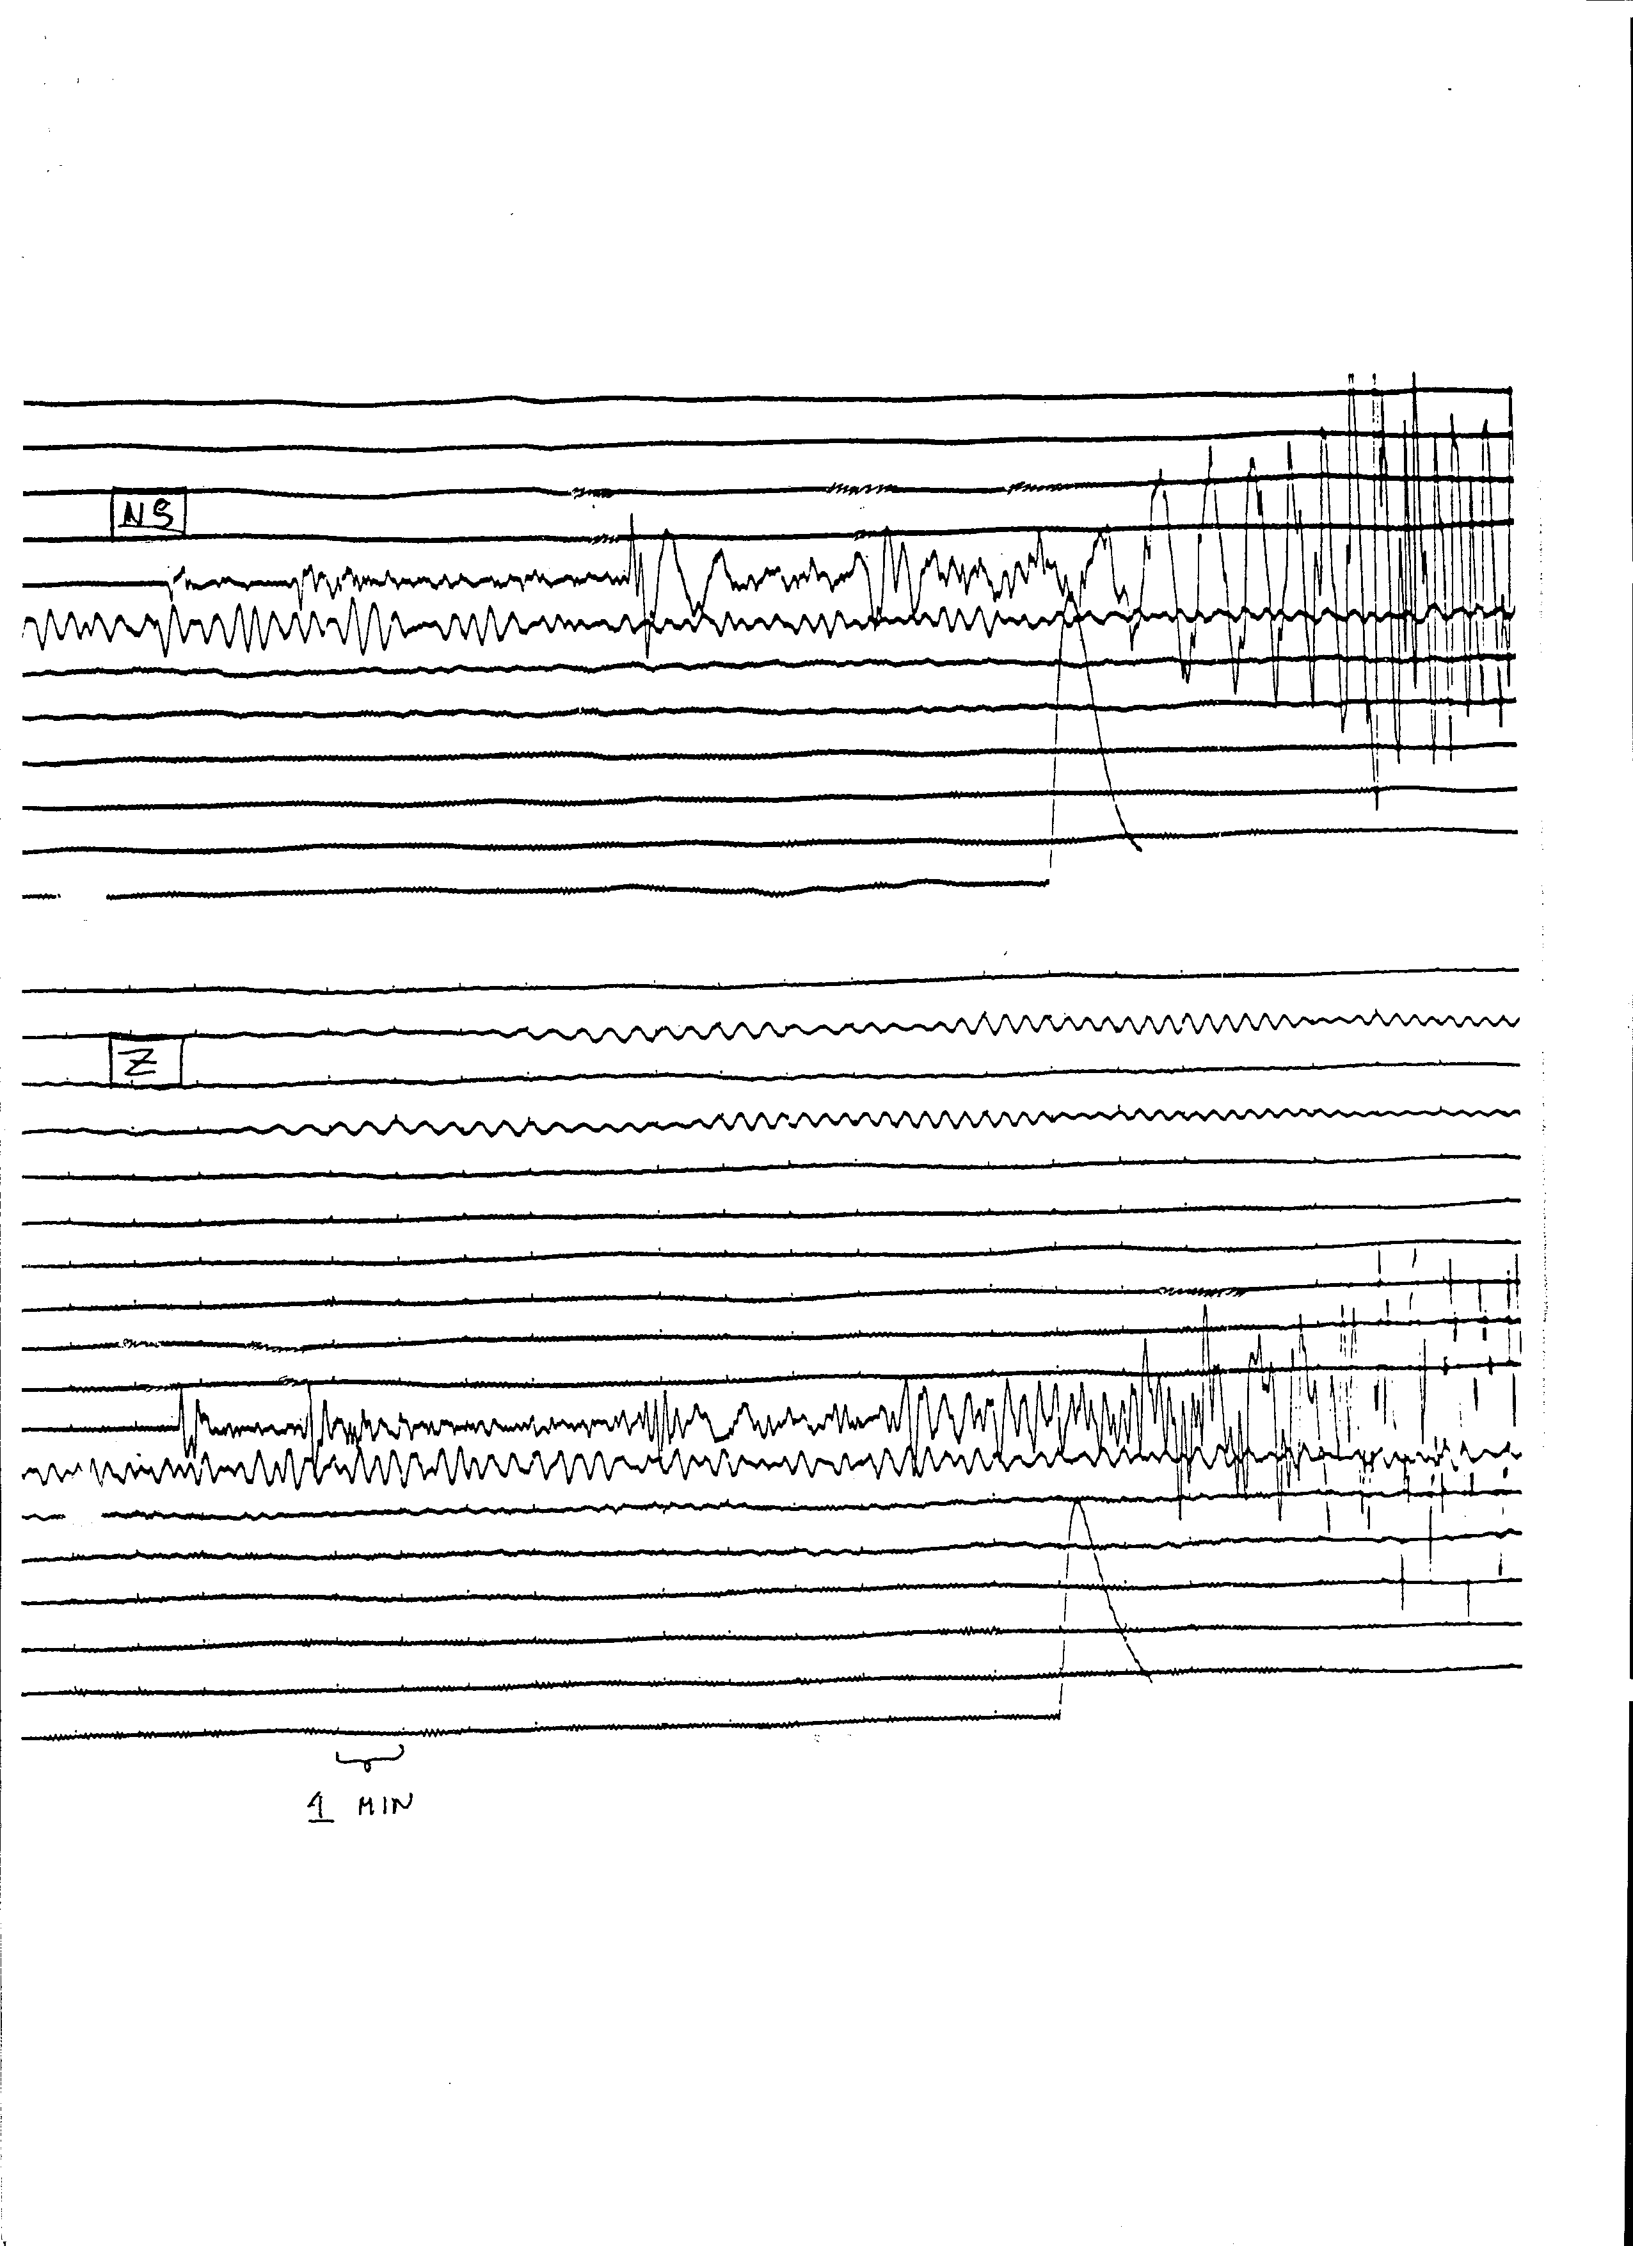

Figure 1 Long period seismograms

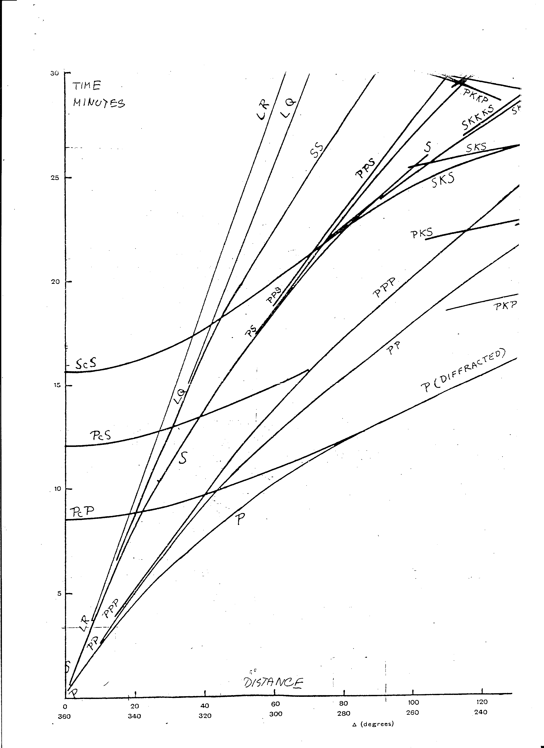

Figure 2 Bullen travel time tables for a shallow earthquake

Question 4, 8 points

When doing fault plane solutions with teleseismic data only, the solution will in some cases be badly constrained.
- Why is that the case ?
- For which types of faults will the solution be badly constrained and for which types well constrained (illustrate)?

Question 5, 10 points

- A 3 station array has the coordinates (km) and P-arrival times as shown below.

station 1 (0,0)
station 2 (20,0)
station 3 (0,10)

A seismic wave arrives with an azimuth of 45 degrees and has the apparent velocity of 10 sec/deg.

- Calculate the apparent velocity in km/sec.

- If the wave arrives at station 1 at time t=10 sec, at what time does the wavefront arrive at stations 2 and 3 ?

Question 6, 8 points

Figure 3 shows local and distant seismograms. Some phases have been identified as indicated with a vertical bar and a number.

- Assign phases to the numbers

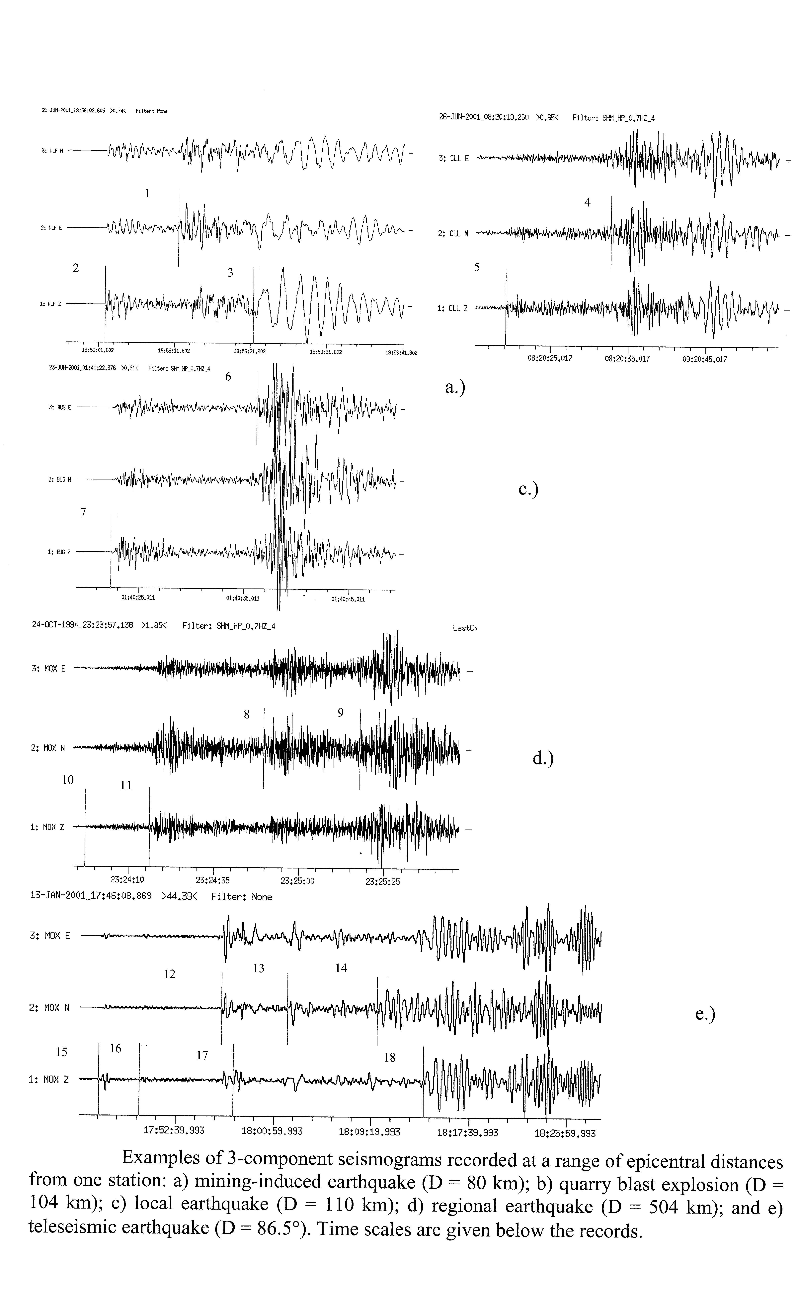
Figure 3 Some seismograms

Question 7, 10 points

- For a 1 month period, the earthquakes recorded at a particular network had the following magnitudes:

1.7, 1.5, 3.0, 2.1, 2.3, 2.7, 2.3, 3.1, 1.7, 2.2, 1.9,
2.6, 3.5, 1.9, 2.3, 2.5, 2.3, 2.1, 1.5, 3.1, 2.6

- Determine the b-value and the detections threshold.
- How many magnitude 6 events will statistically occur in a 100 year period ?

Question 8, 10 points

4 seismic stations (s1, s2, s3 and s4) are located at (0,0),(0,10),(10,0) and (-10,0) respectively. The P-waves from an earthquake arrive in the time order s1,s2,s3,s4. Determine the area within which the epicenter must be located.

Question 9, 8 points

- An earthquake is recorded at an epicentral distance of 90 degrees. The travel time difference between sP and pP is 20 secs. Assuming a constant P-velocity of 9.5 km/sec under the station and Vp/Vs ratio of 1.74, calculate the approximate hypocentral depth.

Question 10, 10 points

- Explain the principle of earthquake location by grid search.

Question 11, 4 points

- What is the typical average continental crustal velocity of Pg and Pn waves, respectively ?
- How can you use a seismic array to identify if a phase is Pg or Pn ?

Question 12, 2 points

- Show on an earth model the ray paths of the following phases: pScP, PKIKP, SS and PKP.

Question 13, 2 points

Filtering is often needed to see seismic phases on a broad band seismogram. Which band pass filters are used to see the following phases:

- S, SS and surface waves at teleseismic distances ?
- P for small local earthquakes ?

Question 14, 3 points

- What is the angle of incidence if the apparent velocity is 10 km/s and the velocity is 6 km/s ?

Question 15, 2 points

- What is the general expression for of the coda wave magnitude scale ?

Question 16, 3 points

- Assuming that the Wood Anderson seismograph has a gain of 2800, the ground displacement is 1 nm, the epicentral distance is 100 km, calculate the local magnitude Ml.

Question 17, 2 points

- Which are the critical observations to obtain to get accurate location of local earthquakes ?

