UNIVERSITETET I BERGEN

Matematisk-naturvitenskapelig embetseksamen

Subject: GEOF 271 Observational seismology
Friday, December 15, 2006, 0900-1300 hrs.

Permitted remedy: Calculator and English dictionary.

A total of 100 points is possible for this exam. The number of points for each question is indicated.

Question 1, 5 points

-A digital broad band seismogram (flat velocity response) has a maximum amplitude of 2000 counts at a frequency of 10 Hz. The gain is 10⁹ counts/m at 1 Hz.
-What is the ground velocity at 10 Hz ?
-What is the ground displacement at 10 Hz ?

Question 2, 5 points

- Under which condition will the Moho reflected phase PmP have a larger amplitude than Pg.

Question 3, 8 points

- Given the seismogram in Figure 1 and the travel time table in Figure 2, identify the clear phases. Assume that the time scale on the seismogram is the same as the time scale on the travel time curve.
- Determine the origin time.

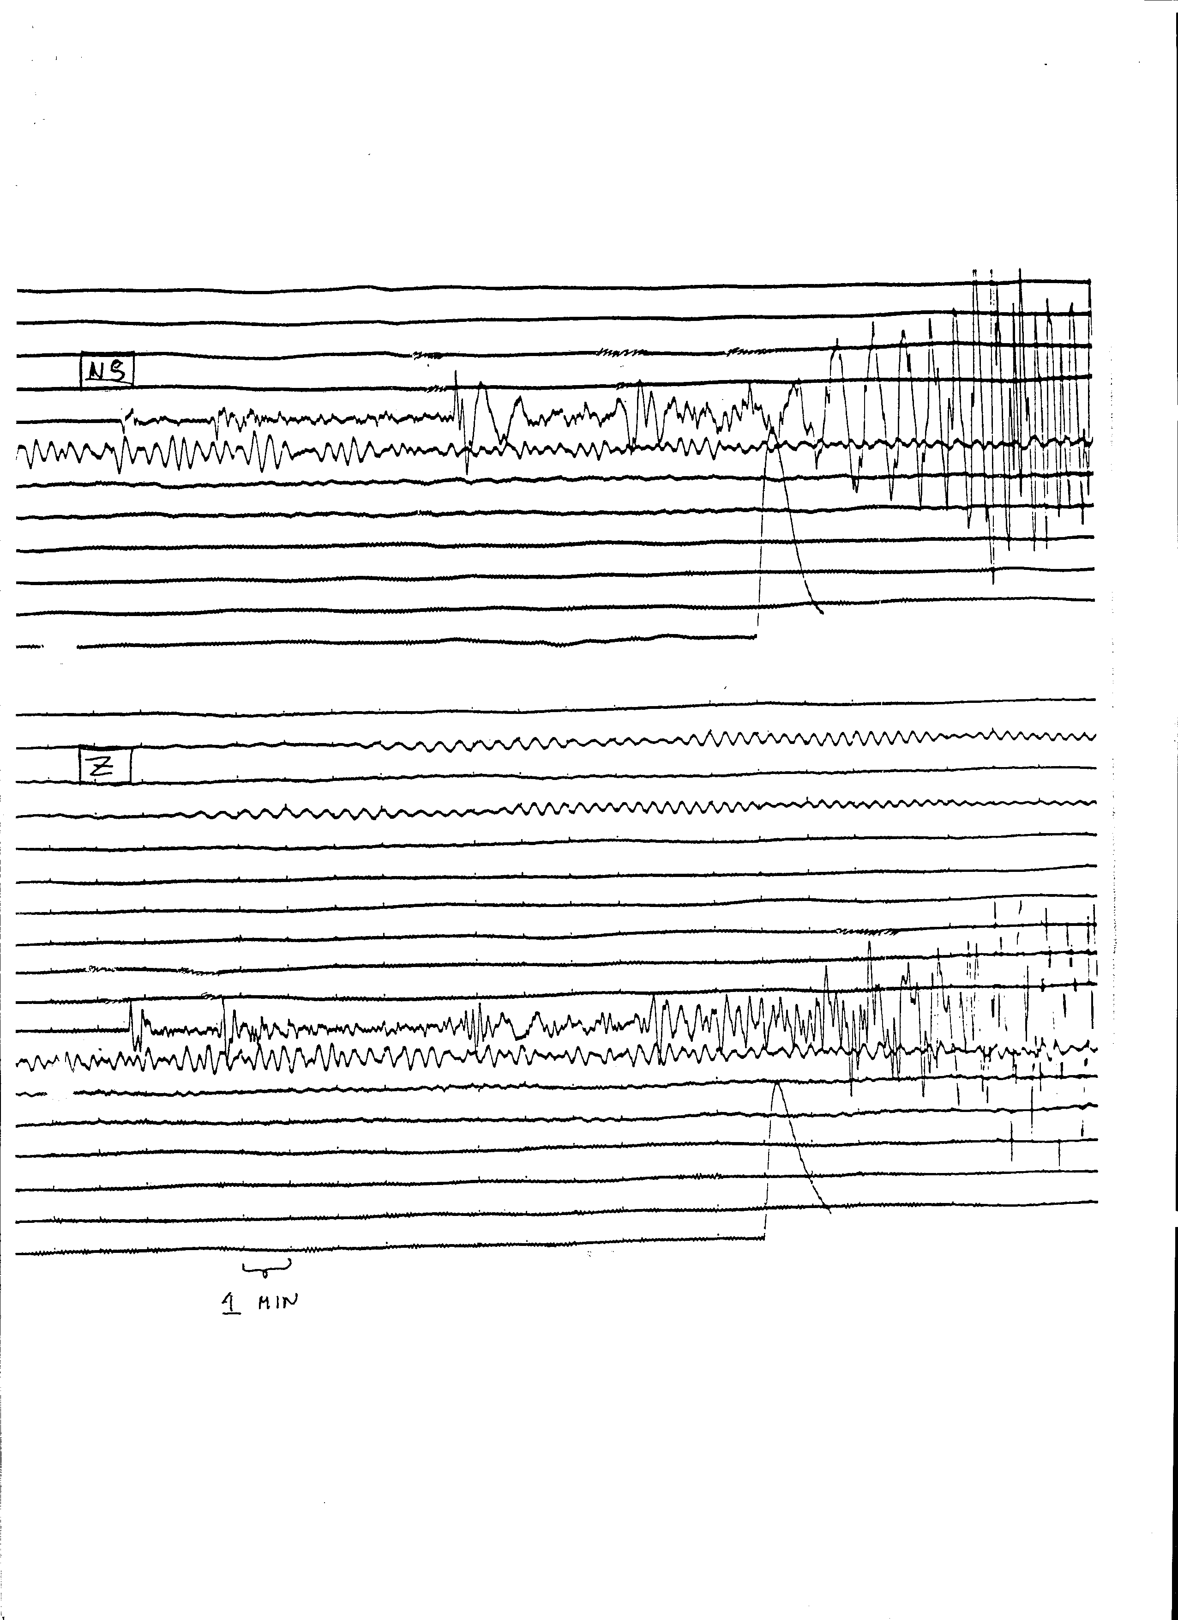

Figure 1 Long period seismograms

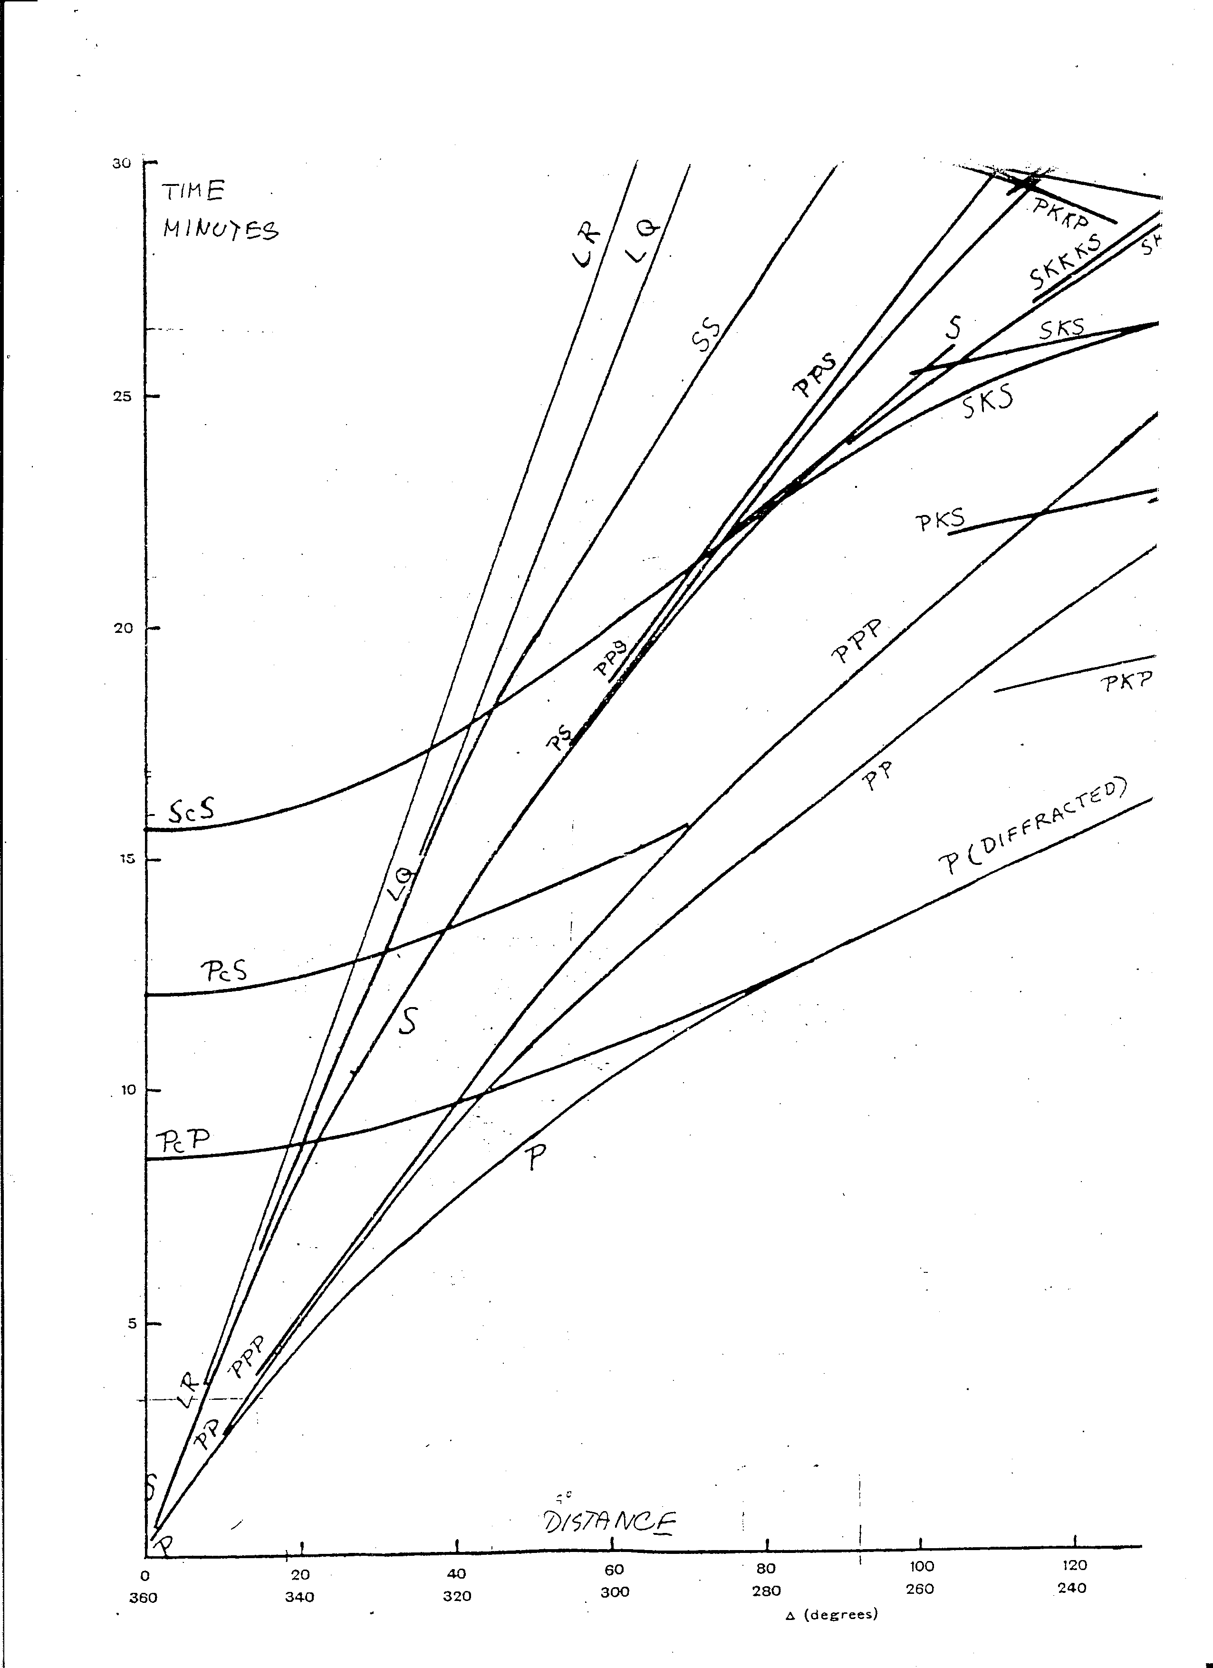

Figure 2 Bullen travel time tables for a shallow earthquake

Question 4, 6 points

When doing spectral analysis of earthquakes, both the spectrum of the signal and the noise is calculated and displayed.

- Why is it important to calculate the noise spectrum ?
- For a magnitude 2 earthquake, what is the approximate frequency bandwidth that can be used for analysis ?

Question 5, 8 points

- A borehole has 2 seismic sensors s1 and s2 at 1 and 2 km's depth, respectively. A signal for an earthquake arrives at s2 at t2=10.0 s and at s1 at t1=10.5 s.

- Can the azimuth of arrival be determined ?
- What is the angle of incidence ?
- What is the apparent velocity along the surface ?

Question 6, 8 points

- If you have the following arrival times at 2 seismic stations for the same earthquake, determine the Vp/Vs velocity ratio.

station 1 Pg= 20.0 sec
Sg= 30.0 sec

station 2 Pg= 25.0 sec
Sg= 39.0 sec

- Determine the origin time

Question 7, 6 points

Figure 4 shows a magnitude frequency plot

- Determine the b-value.
- How many magnitude 9 events will statistically occur in a 100 year period ?

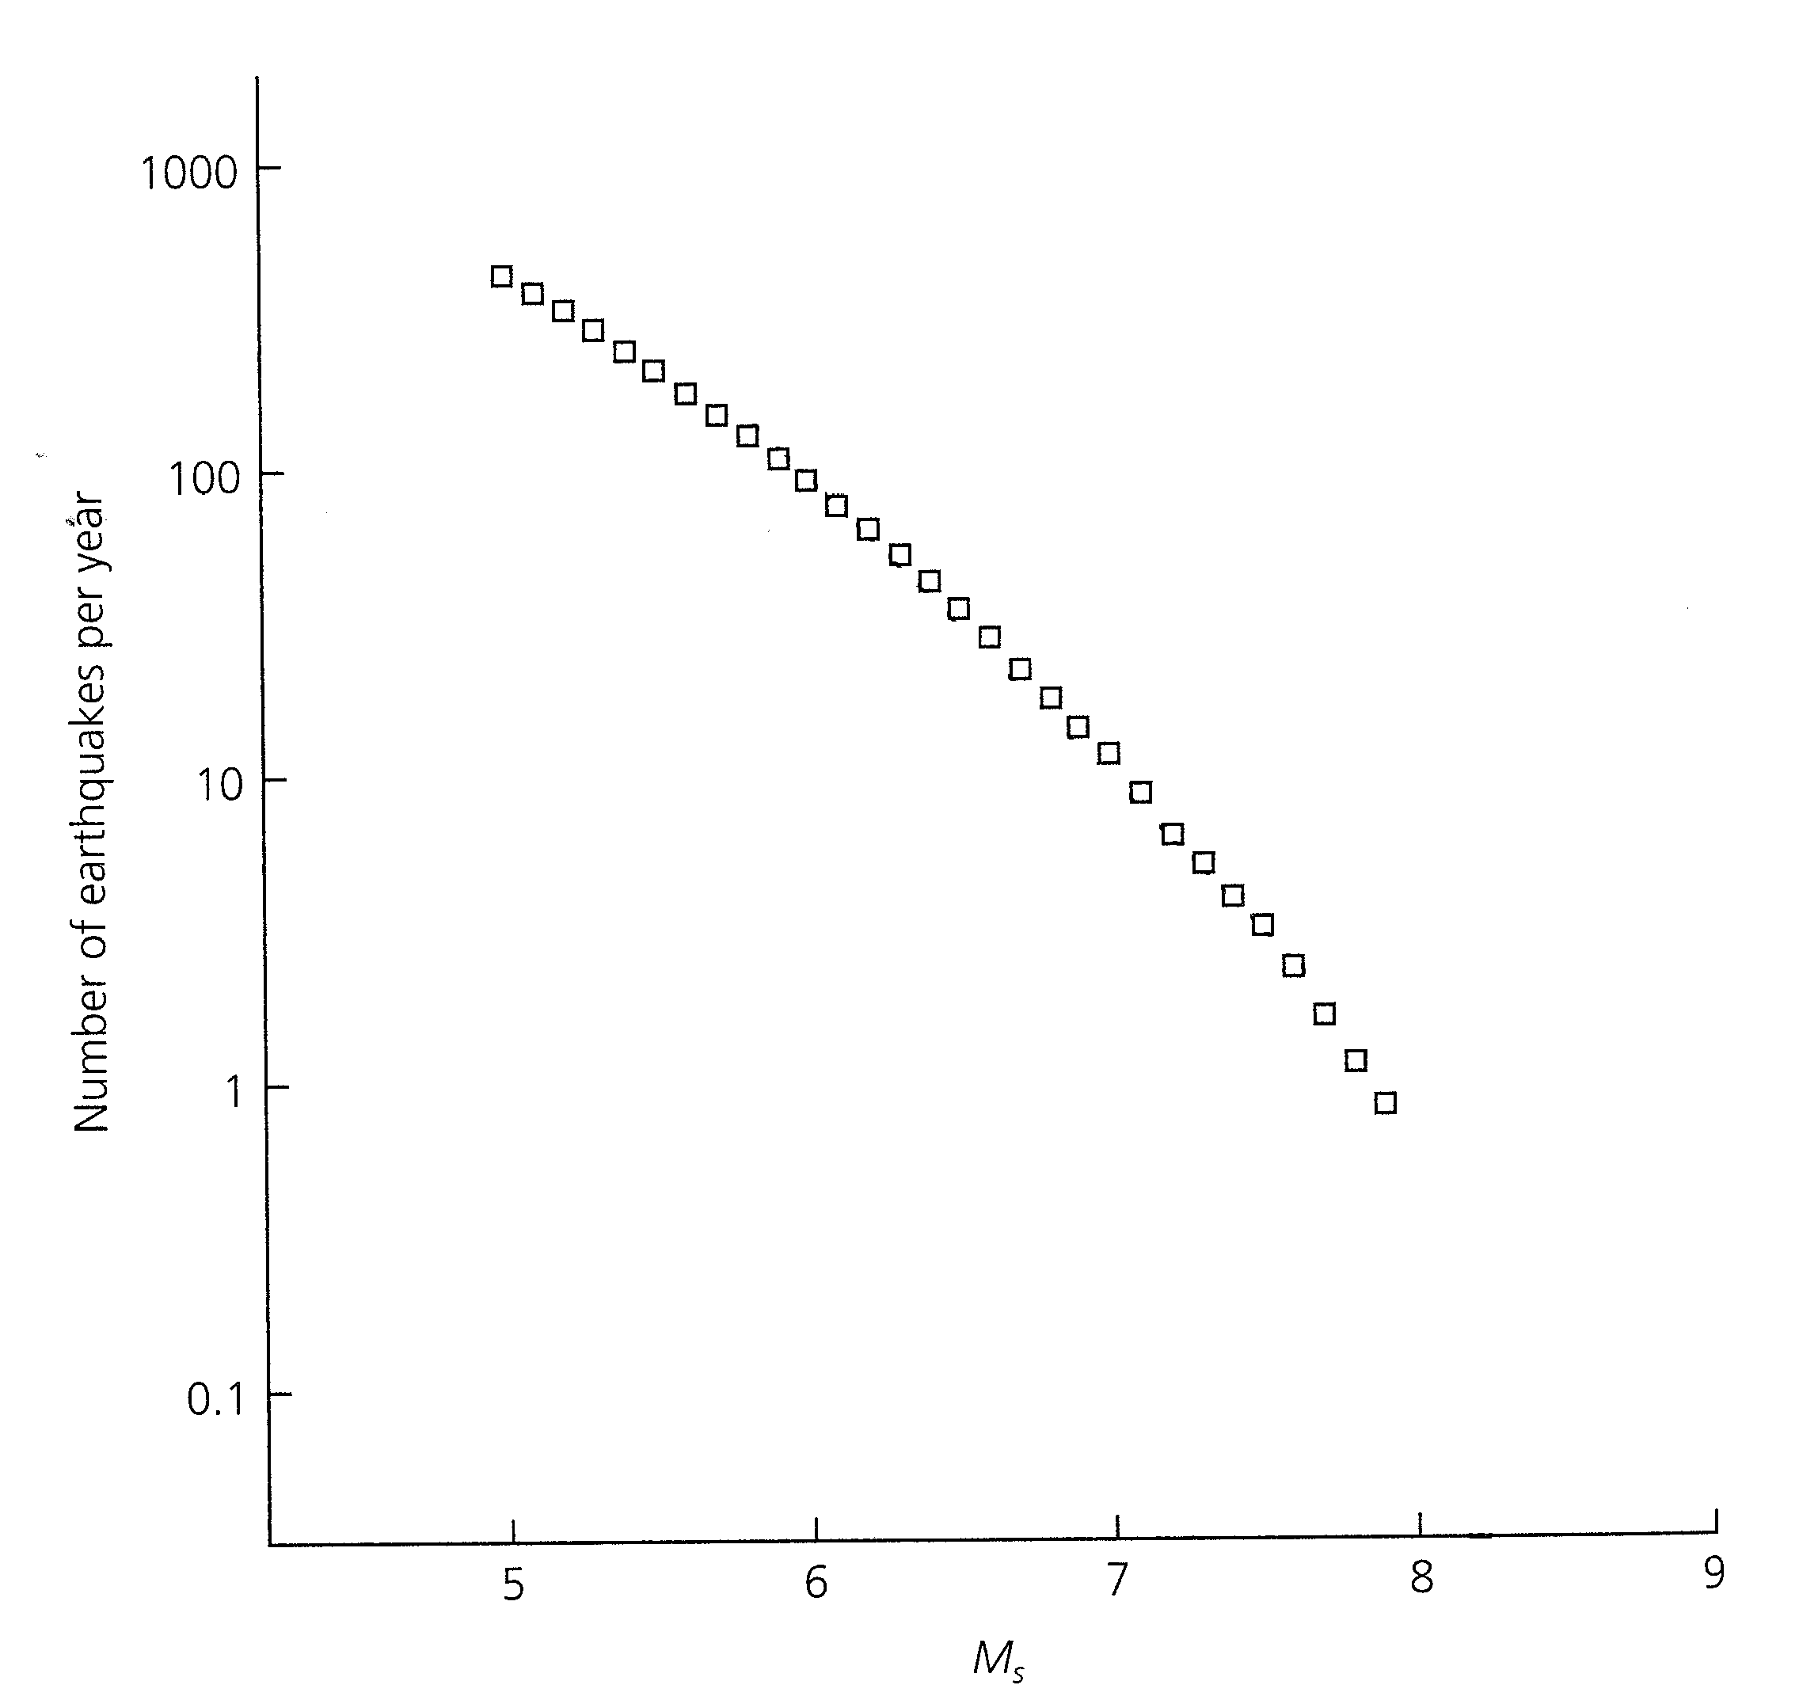

Figure 4 Frequency magnitude plot for all global earthquakes during 1968-1997 listed in the USGS catalog.

Question 8, 8 points

3 seismic stations (s1,s2 and s3) are located at (-10km,0km), (10km,0km) and (0km,-10km) respectively. The P-waves from an earthquake arrive at the same time to s1 and s2 and earlier to s3. The S-P time at s3 is 3.0 secs, the Vp velocity 6 km/sec and the Vp/Vs ratio 1.73. Determine the epicenter assuming a hypocentral depth of 3 km.

Question 9, 8 points

- An earthquake is recorded at an epicentral distance of 90 degrees and has a depth of 80 km. Assuming a constant P-velocity of 9 km/sec under the station and Vp/Vs ratio of 1.78, calculate the approximate travel time difference between sP and pP.

Question 10, 10 points

Figure 5 shows a lower hemisphere plot of polarities.
- Determine the fault
plane solution.
- Give strike and dip of the two fault planes.
- Indicate location of P and T-axis.
- What type of fault is it ?

Question 11, 8 points

An explosion has the travel times observed as given in Table 1

Distance (km) | Travel time(sec)
10 | 1.7
50 | 8.1
80 | 13.5
90 | 15.1
140 | 23.3
160 | 25.8
180 | 28.7
200 | 30.9

Table 1 Travel times

- Plot the travel time curve
- What is the velocity in the top layer ?
- How many other layers can be seen from the travel time curve ?
- If more then one layer, what is the velocity in the other layers(s) ?

Question 12, 6 points

A three component seismic station is located at (0,0). The P-amplitude on the Z, NS and EW
components are -10 nm, 10 nm and 10 nm respectively. The hypocentral distance is 10 km.

- What is the azimuth of arrival ?
- What is the angle on incidence ?
- Calculate the epicenter.

Question 13, 2 points

Filtering is often needed to see seismic phases on a broad band seismogram. Which band pass filters are used to see the following phases:

- S, SS and surface waves at teleseismic distances ?
- P for small local earthquakes ?

Question 14, 3 points

- When locating a local earthquake with 5 stations, what is considered as acceptable travel time residuals ?

Question 15, 2 points

- If the coda length is 100 s, what is the approximate coda magnitude ?

Question 16, 3 points

- Assuming that the Wood Anderson seismograph has a gain of 2800, the ground displacement is 10 nm, the epicentral distance is 100 km, calculate the local magnitude Ml.

Question 17, 2 points

- How many stations are needed to locate an earthquake with fixed depth (epicenter and origin time) using P waves only ?

Question 18, 2 points

- Show on an earth model the ray paths of the following phases: pScP, PKIKP, PmS and PKP.

Figure 5a

Polarities, filled out symbols are compressions

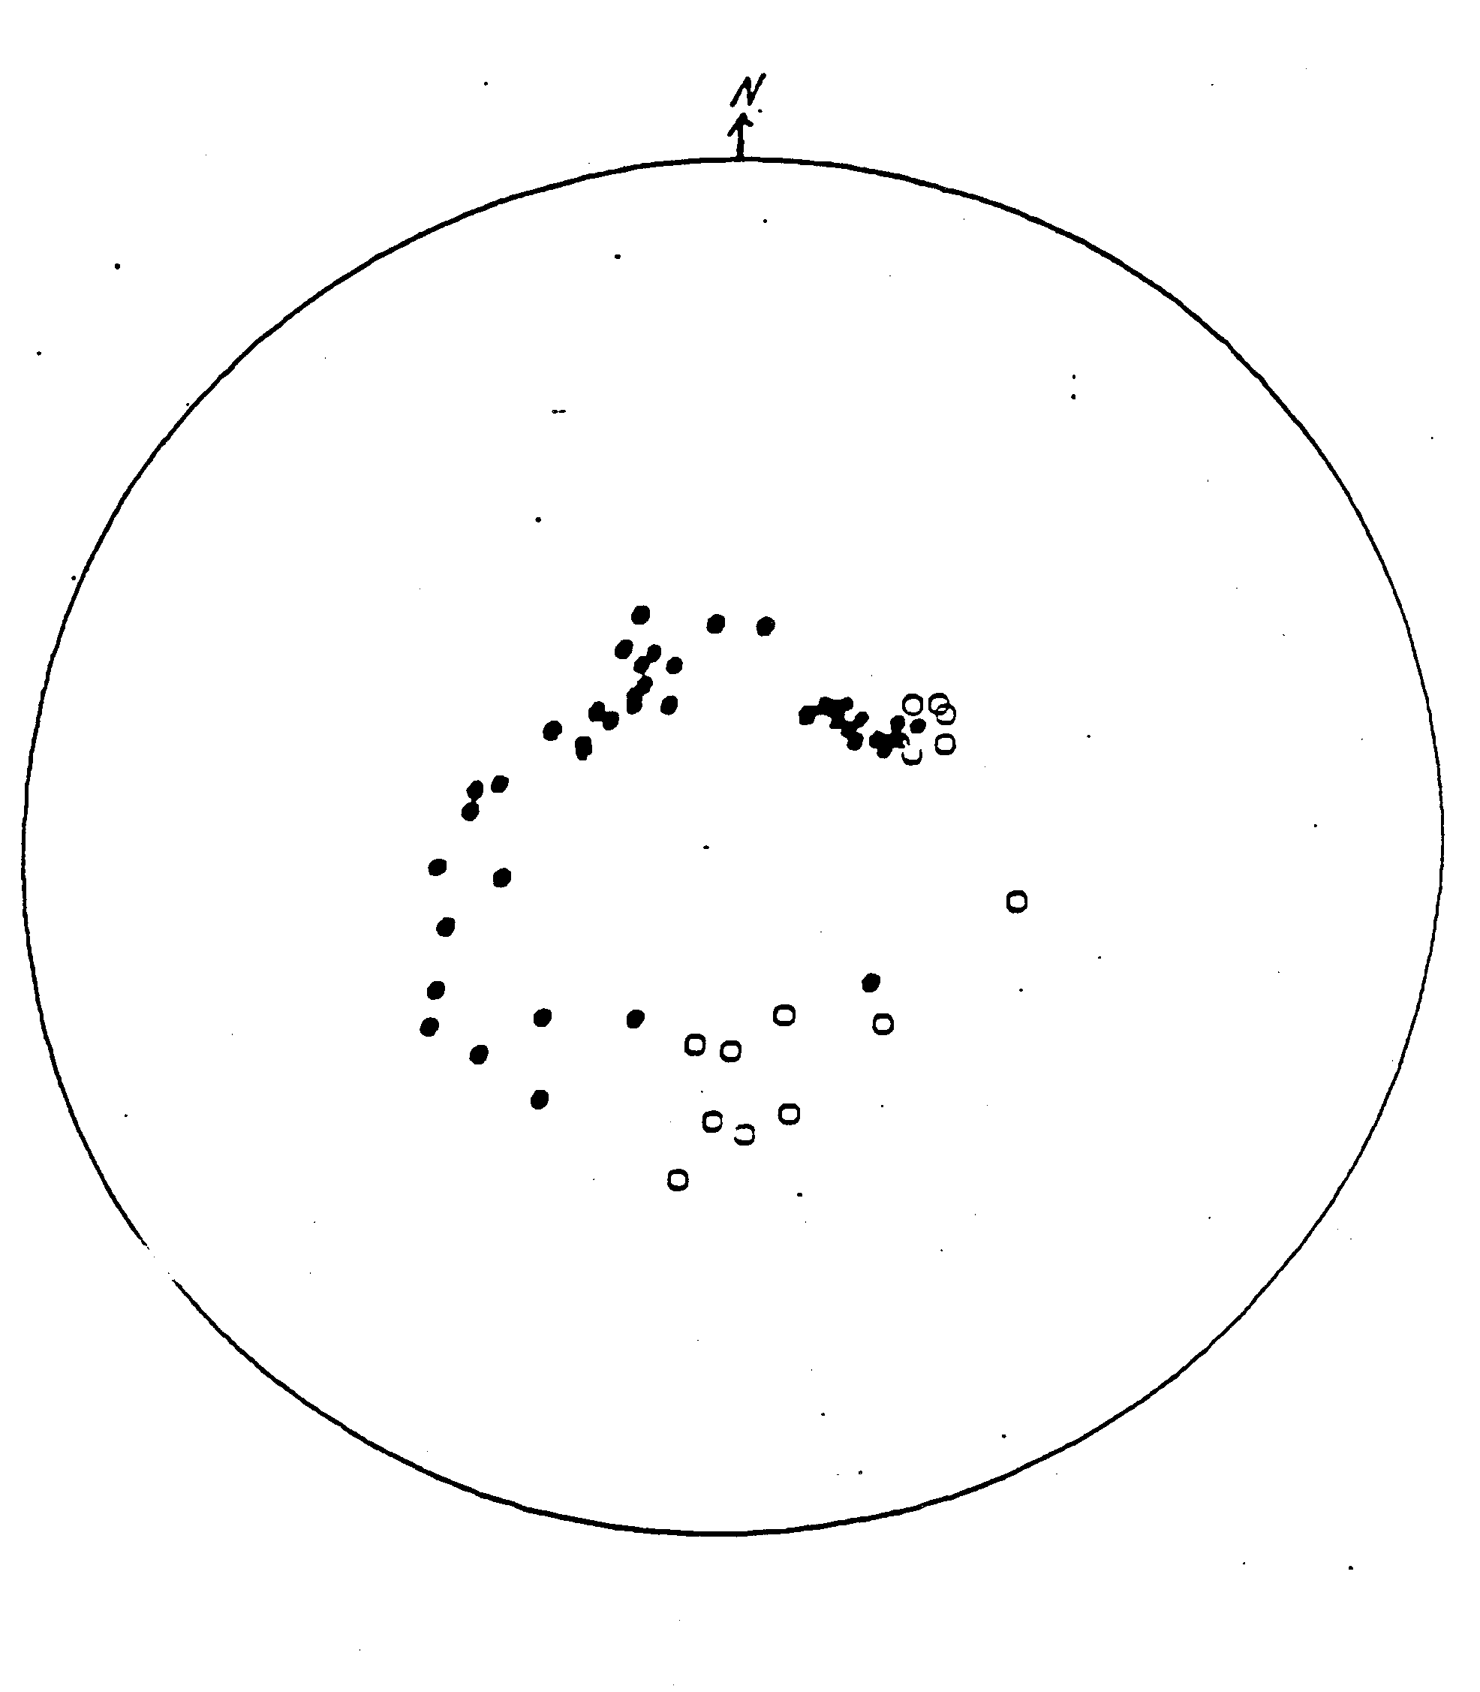

Figure 5b Stereonet

