UNIVERSITETET I BERGEN

Matematisk-naturvitenskapelig embetseksamen

Subject: GEOF 271 Observational seismology
Wednesday, December 7, 2005, 0900-1300 hrs.

Permitted remedy: Calculator, transparent paper, millimeter paper and English dictionary.

A total of 100 points is possible for this exam. The number of points for each question is indicated.

Question 1, 5 points

-A digital broad band seismogram (flat velocity response) has a maximum amplitude of 20000 counts at a frequency of 4 Hz. The gain is 10⁹ counts/m at 1 Hz.
-What is the ground velocity at 4 Hz ?
-What is the ground displacement at 4 Hz ?

Question 2, 8 points

Figure 1 show seismograms at different distances

- What kind of phase is the first arriving P-phase ?
- Is the P-velocity changing or constant for a distance of up to 65 km from the epicenter ?
- What is the average P and S-velocity for the area ?

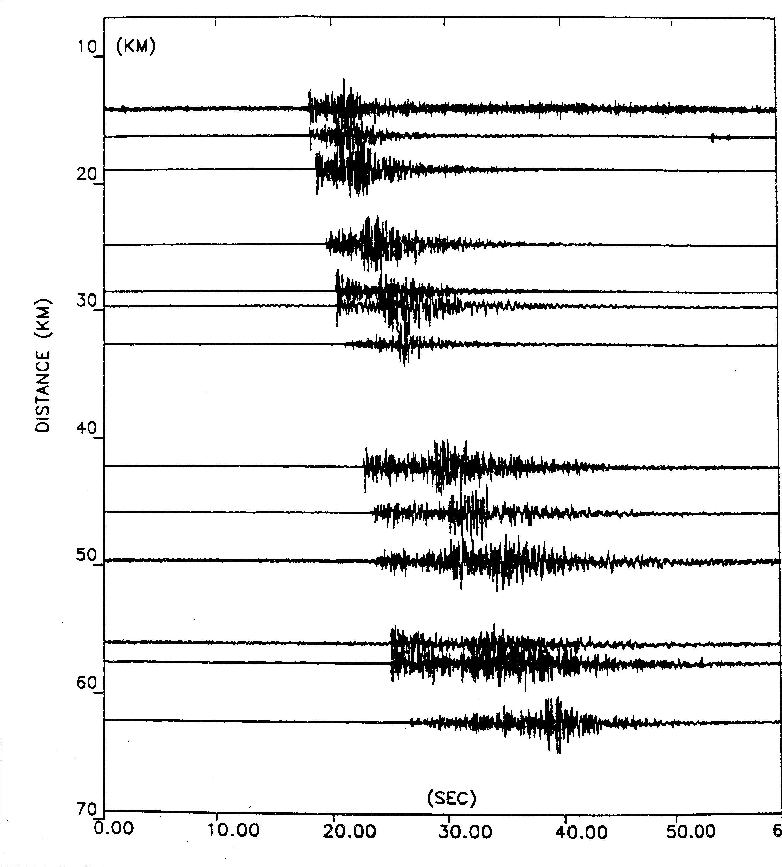
Figure 1 Vertical component ground motion recordings arranged from top to bottom with increasing distance from an earthquake.

Question 3, 8 points

Figure 2 shows a long period seismogram.

- Given the phases identified, what are the phases labeled 1, 2, 3 and 4 ?
- Explain how they were identified.

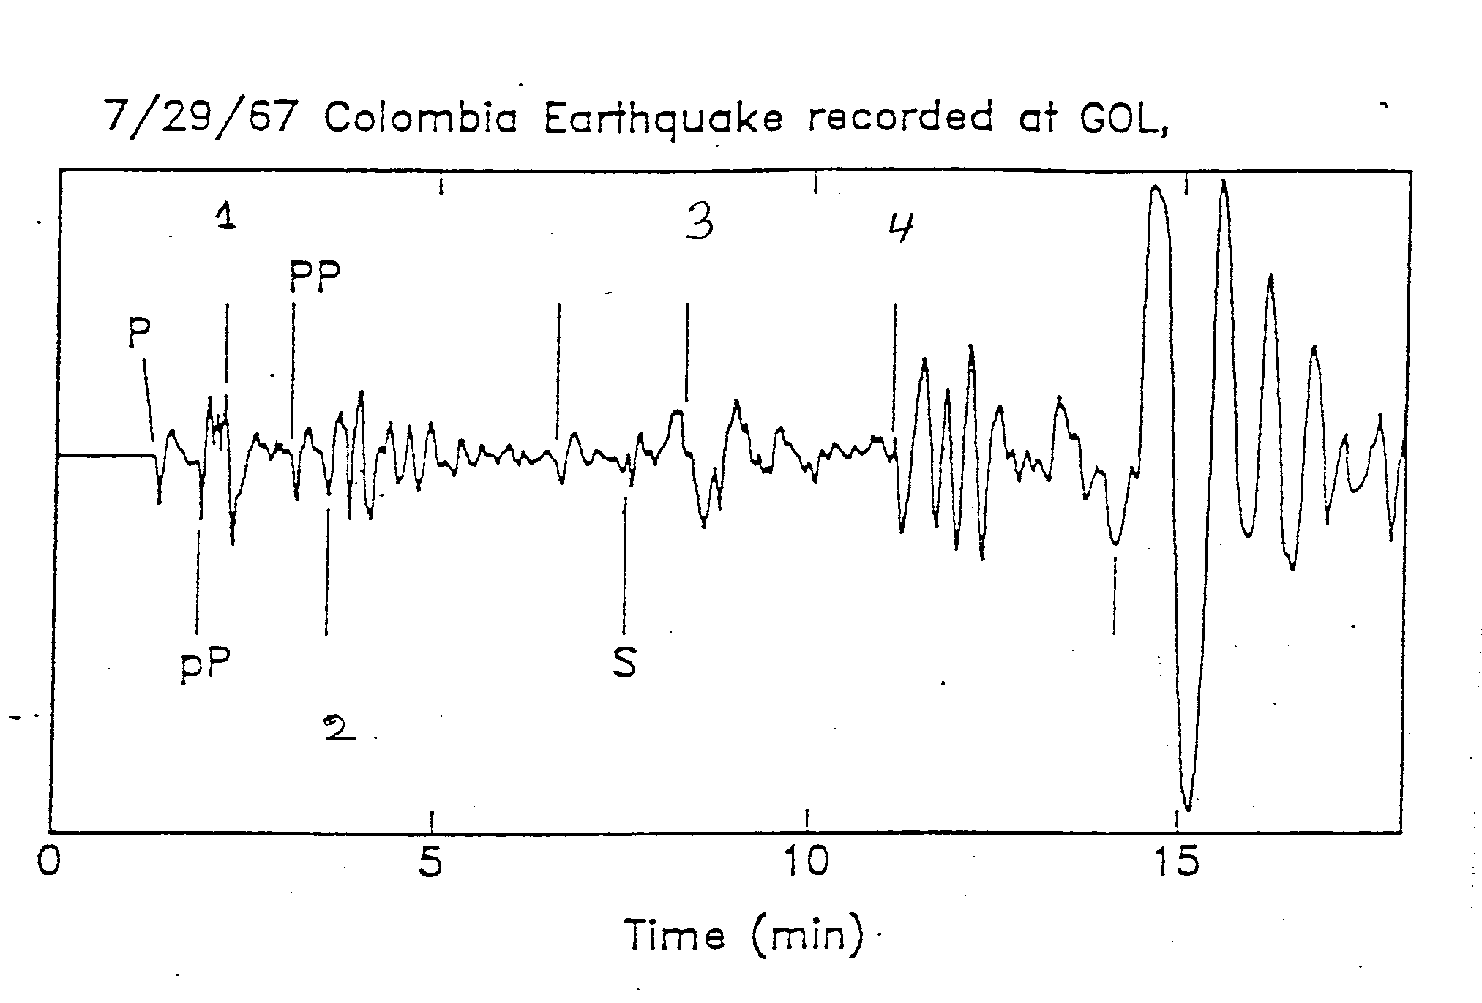
Figure 2 A long period seismogram

Question 4, 8 points

5 different seismic stations have the following arrival times from one earthquake for P and S given in hours, minutes and seconds:

P-time S-time
10:50 50 10:51 7
10:50 52 10:51 00
10:51 00 10:51 14
10:51 11 10:51 38
10:51 15 10:51 40

Calculate the origin time and Vp/Vs velocity ratio.
One of the readings has a wrong phase identification. Which one is it and what misidentification could have been made.

Question 5, 10 points

- A 3 station array has the coordinates (km) and P-arrival times as shown below.

station 1 (0,0)
station 2 (20,0)
station 3 (0,10)

A seismic wave arrives with an azimuth of 45 degrees and has the apparent velocity of 10 sec/deg.

- Calculate the apparent velocity in km/sec.

- If the wave arrives at station 1 at time t=10 sec, at what time does the wavefront arrive at stations 2 and 3 ?

Question 6, 10 points

- Schematically draw an earthquake displacement spectrum and indicate what measurements are used to determine seismic moment and stress drop.
- What is the effect on the spectra of using a) A constant Q, b) Q =Q0*f where Q0 is a constant and f is the frequency.

Question 7, 6 points

Figure 3 shows a magnitude frequency plot

- Determine the b-value.
- How many magnitude 9 events will statistically occur in a 100 year period ?

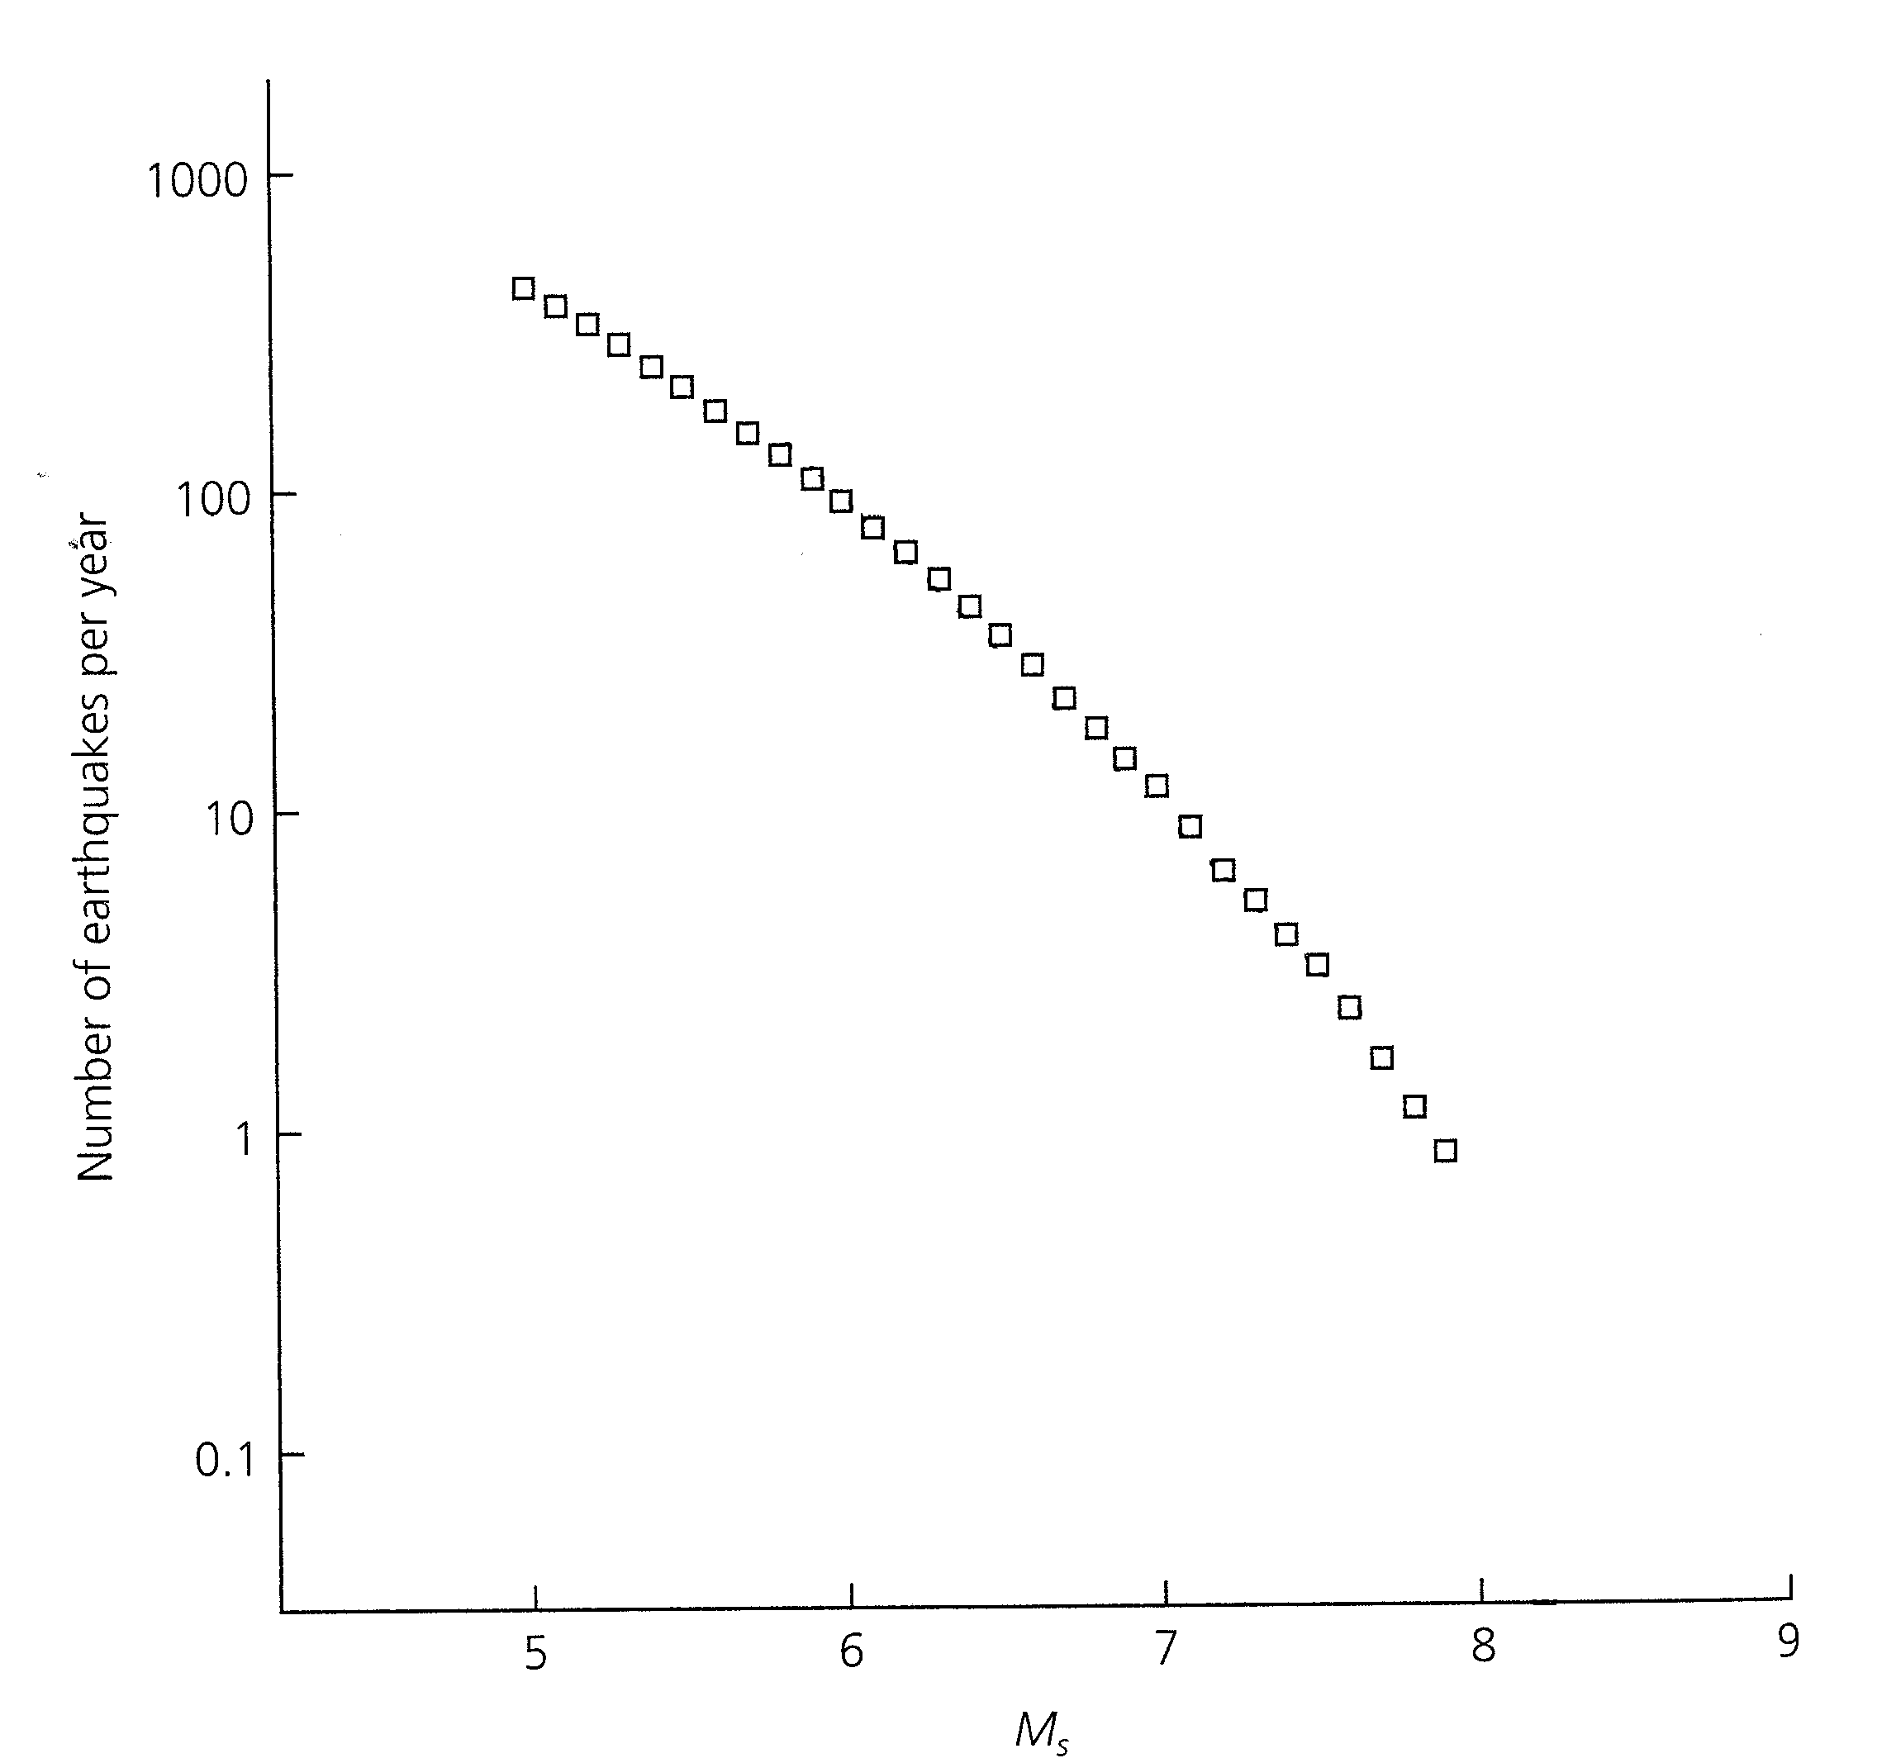

Figure 3 Frequency magnitude plot for all global earthquakes during 1968-1997 listed in the USGS catalog.

Question 8, 8 points

3 seismic stations (s1,s2 and s3) are located at (-10km,0km), (10km,0km) and (0km,-10km) respectively. The P-waves from an earthquake arrive at the same time to s1 and s2 and earlier to s3. The S-P time at s3 is 3.0 secs, the Vp velocity 6 km/sec and the Vp/Vs ratio 1.73. Determine the epicenter assuming a hypocentral depth of 3 km.

Question 9, 8 points

- An earthquake is recorded at an epicentral distance of 90 degrees. The travel time difference between sP and pP is 20 secs. Assuming a constant P-velocity of 9 km/sec under the station and Vp/Vs ratio of 1.78, calculate the approximate hypocentral depth.

Question 10, 10 points

Describe the principle of earthquake location using grid search.

Question 11, 5 points

Figure 4shows a seismogram

- Which seismic phases can be identified in the seismogram.
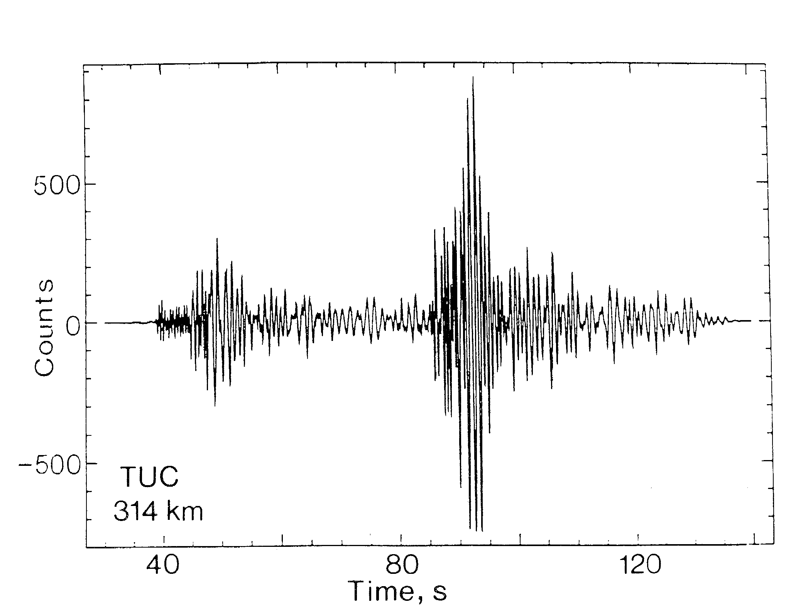
Figure 4 Vertical component of ground motion for an earthquake of local magnitude 2.7 recorded at TUC at a distance of 314 km.

Question 12, 2 points

- Show on an earth model the ray paths of the following phases: PPP, SCPPcP and PKIKP.

Question 13, 2 points

Filtering is often needed to see seismic phases on a broad band seismogram. Which band pass filters are used to see the following phases:

- S, SS and surface waves at teleseismic distances ?
- P for small local earthquakes ?

Question 14, 3 points

- What is the angle of incidence if the apparent velocity is 10 km/s and the velocity is 6 km/s ?

Question 15, 2 points

- How can you use a seismic array to identify if a phase is Pg or Pn ?

Question 16, 3 points

- Assuming that the Wood Anderson seismograph has a gain of 2800, the ground displacement is 1 nm, the epicentral distance is 100 km, calculate the local magnitude Ml.

Question 17, 2 points

- How many stations are needed to locate an earthquake (hypocenter and origin time) using P waves only ?

