UNIVERSITETET I BERGEN

Matematisk-naturvitenskapelig embetseksamen

Subject: GFJ 372 Seismic Instrumentation
Friday, May 30, 2003, 0900-1400 hrs.

Permitted remedy: Calculator, English dictionary

A total of 100 points is possible for this exam. The number of points for each question is indicated.

Question 1, 10 points

In the circuit below, all resisters have a resistance of 1 kohm.
- Calculate the current through each resistor
- Calculate the total current delivered by the power source

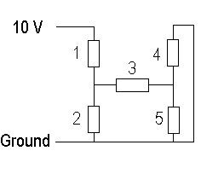

Question 2, 10 points

A weight of 20 g is lifted off a seismometer. This gives a pulse of 20 mV amplitude out of the signal coil. A DC pulse of 20 mA into the calibration coil gives an amplitude of 30 mV.
- Calculate the seismometer calibration coil motor constant. If the seismometer mass is 5 kg and a sine wave of 10 mA (p-p) at 5 Hz is input to the calibration coil, what is the equivalent earth displacement (p-p) at 5 Hz.

Question 3, 10 points

You have an unknown A/D converter. Set up an experiment to determine maximum voltage range and sensitivity in counts/volt. How do you calculate the dynamic range from the above two parameters.

Question 4, 12 points

A seismic recording system is recording with a 12 bit AD converter. The sensor is a 1 Hz velocity sensor.

- What is the dynamic range of the recording system ?

The gain of the system is so that at 10 Hz, 1 count corresponds to 0.001 nm of displacement (100 counts/nm). The seismic background noise can be described by the curve shown below (curve marked with an arrow)

- What is the gain of the system at 1 Hz in counts/nm (assuming the velocity response curve is flat from 1 to 10 Hz) ?
- What is the smallest seismic signal (in counts) that can be recorded above the seismic background noise level at 10 Hz ?
- What is the dynamic range of earthquake signals that can be recorded at 10 Hz considering that the smallest signal must be above the seismic background noise ?
-What is the smallest seismic signal (in counts) that can be recorded above the seismic background level at 1 Hz ?
- What is the dynamic range of earthquake signals that can be recorded at 1 Hz considering that the smallest signal must be above the seismic background noise ?

Assuming a 5 Hz sensor with the same generator constant, repeat the above 5 questions.

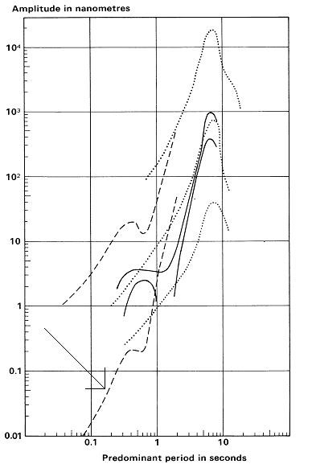
Noise curves in rural environment

Question 5, 3 points

A digital seismic station has 10 channels of data. The sample rate is 200 samples/sec and a 12 bit A/D converter is used. The data is compressed by a factor of 2. The recording is continuous.

- How much data (Mbytes) are recorded in 24 hours ?

Question 6, 10 points

Give a general description of a triggered data acquisition system like SEISLOG or GBV316. In particular, describe the following:
- Explain how the standard STA/LTA trigger works.
- Explain what effect a signal DC component can affect the operation of the trigger and how it is corrected for.

Question 7, 8 points

- What is an anti alias filter ?
- If the analog to digital converter has a dynamic range of 60 dB, what must the damping of the filter be at the Nyquist frequency ?
- If we assume a 6 pole filter and a sampling rate is 100 Hz, what is the corner frequency of the 6 pole filter ?

Question 8, 5 points

- What is open circuit damping ?
- How do you measure it (describe qualitatively) ?

Question 9, 4 points

Given a standard seismic station with a velocity transducer and digital recording, what is the parameters needed to generate the seismic response function ?

Question 10, 2 points

Give an example of a 2 octave filter

Question 11, 2 points

A seismic signal is band pass filtered between 1 and 10 Hz and between 4 and 6 Hz. Which filtered signal has the largest amplitude ?

Question 12, 3 points

A seismometer has a critical damping resistance of 10 kohm and the coil resistance is 13 kohm.
- What is the highest damping that can be obtained for this sensor and what is the damping resistor for the highest possible damping ?

Question 13, 3 points

Sketch the acceleration response for a velocity transducer.

Question 14, 2 points

A Ranger seismometer is connected to a seismic recording system. How can you determine the total electrical noise (in terms of counts) generated by the seismometer and recording system ?

Question 15, 2 points

Write the poles and zeros expression for the acceleration response of a velocity transducer.

Question 16, 3 points

- What is cross talk and in which unit is it measured ?
- What is a typical value for an analog to digital converter ?

Question 17, 3 points

How do we measure polarity of a seismometer ?
What is the polarity of the output voltage from the seismometer supposed to be when the ground moves down.

Question 18, 2 points

- A sine wave has 1 V p-p, what is the RMS voltage ?
- A square wave has 1 V p-p, what is the RMS voltage ?

Question 19, 3 points

An accelerometer with a sensitivity of 5V/g is inclined 20 degrees from vertical.
- What is the output from a horizontal channel ?

Question 20, 2 points

What is the major source of low frequency seismic noise in broad band installations ?

