UNIVERSITETET I BERGEN

Matematisk-naturvitenskapelig embetseksamen

Subject: GEOF 275 Seismic Instrumentation
Friday, June 3, 2005, 0900-1300 hrs.

Permitted remedy: Approved calculator, English dictionary

A total of 100 points is possible for this exam. The number of points for each question is indicated.

Question 1, 10 points

In the circuit below, resisters 1, 2 and 3 have a resistance of 1 kohm and resistors 4 and 5 a resistance of 100 ohm.
- Calculate the current through each resistor.
- Calculate the total current delivered by the power source.

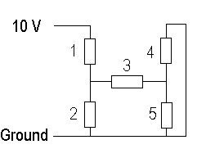

Question 2, 8 points

Explain the general principle behind the flash analog to digital converter.

Question 3, 6 points

- Explain what cross talk is in an A/D converter.
- How do you measure cross talk ?

Question 4, 12 points

A seismic recording system is recording with a 12 bit AD converter. The sensor is a 1 Hz velocity sensor.

- What is the dynamic range of the recording system ?

The gain of the system is so that at 10 Hz, 1 count corresponds to 0.01 nm of displacement (100 counts/nm). The seismic background noise can be described by the curve shown below (curve marked with an arrow).

- What is the gain of the system at 1 Hz in counts/nm (assuming the velocity response curve is flat from 1 to 10 Hz) ?
- What is the smallest seismic signal (in counts) that can be recorded above the seismic background noise level at 10 Hz ?
- What is the dynamic range of earthquake signals that can be recorded at 10 Hz considering that the smallest signal must be above the seismic background noise ?
-What is the smallest seismic signal (in counts) that can be recorded above the seismic background level at 1 Hz ?
- What is the dynamic range of earthquake signals that can be recorded at 1 Hz considering that the smallest signal must be above the seismic background noise ?

Assuming a 5 Hz sensor with the same generator constant, repeat the above 5 questions.

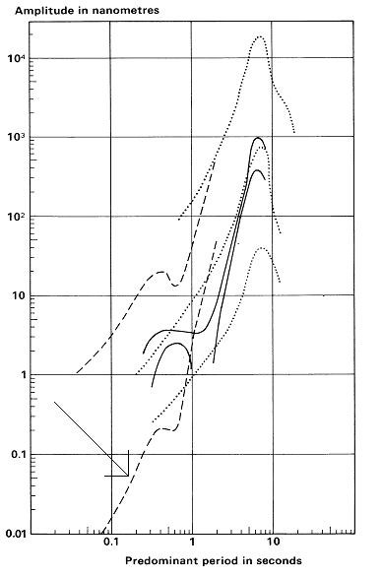
Noise curves in a rural environment

Question 5, 5 points

Explain why an accelerometer, with a high dynamic range, cannot be used directly as broad band sensor.

Question 6, 10 points

Give a general description of a triggered data acquisition system like SEISLOG or GBV316. In particular, describe the following:
- Explain how the standard STA/LTA trigger works.
- Explain what effect a signal DC component can affect the operation of the trigger and how it is corrected for.

Question 7, 8 points

The figure below shows the background noise at two broad band stations.
- Explain what noise sources the signals represent.
- Do any of the stations have an acceptable noise level ?
- Explain why there is a difference in noise in horizontal and vertical channels.
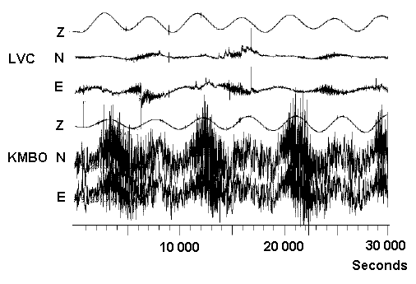
Seismic background noise at two different seismic stations. Z, N and E means vertical, North-South and East-West components, respectively.

Question 8, 6 points

- What is open circuit damping ?
- How do you measure it (describe qualitatively) ?

Question 9, 4 points

- What is phase shift between input and output signals ?
- What is the definition of a positive phase shift ?

Question 10, 2 points

- What is a typical internal resistance of a digital voltmeter ?

Question 11, 2 points

A seismic signal is band pass filtered between 1 and 10 Hz and between 4 and 6 Hz. Which filtered signal has the largest amplitude ?

Question 12, 3 points

A seismometer has a critical damping resistance of 10 kohm and the coil resistance is 10 kohm.
- What is the damping when the sensor is short circuited ?
- What damping resistor is needed for a damping of 0.5 ?

Question 13, 3 points

Sketch the acceleration response for a mechanical seismometer.

Question 14, 3 points

A Ranger seismometer is connected to a seismic recording system. How can you determine the total electrical noise (in terms of counts) generated by the seismometer and recording system ?

Question 15, 2 points

Write the poles and zeros expression for the displacement response of a velocity transducer.

Question 16, 2 points

- What is the longest period that can be used in practice with a standard long period seismometer ?

Question 17, 3 points

- How do we measure polarity of a seismometer ?
- What is the polarity of the output voltage from the seismometer supposed to be when the ground moves down ?

Question 18, 2 points

- A sine wave has 1 V p-p, what is the RMS voltage ?
- A square wave has 1 V p-p, what is the RMS voltage ?

Question 19, 3 points

An accelerometer with a sensitivity of 10V/g is inclined 30 degrees from vertical.
- What is the output from the vertical channel ?

Question 20, 3 points

A digital seismic station has 10 channels of data. The sample rate is 200 samples/sec and a 18 bit A/D converter is used. The data is compressed by a factor of 3. The recording is continuous.
- How much data (Mbytes) are recorded in 24 hours ?

Question 21, 3 points

- What is the Nyquist frequency for an A/D converter with a sample rate of 100 Hz ?
- If the analog to digital converter has a dynamic range of 60 dB, what must the damping of the filter be at the Nyquist frequency ?

