Seismic instrumentation

Short course

Jens Havskov

Department of Earth Science
University of Bergen
Norway

jens@geo.uib.no

November 2004

CONTENT

Introduction

Experiment 1 : Basic electronics

Experiment 2 : Measurement of signals: Oscilloscope, and function generator

Experiment 3 : Recording digital signals

Experiment 4 : Seismic sensors, basic tests

Experiment 5 : Response

Experiment 6 : Seismic sensors, calibration

Experiment 7 : Digital recorders using triggered recording

Experiment 8 : Field recording, optional

-----------------------------------------------------------------------------------------------------------------

Background material:

Instrumentation in earthquake seismology by Havskov and Alguacil, version June 2003
Seislog manual
Seisan manual
Introduction

The purpose of the course is to get a practical understanding of installing, calibrating, and operating seismic stations. The course consists of a series of lectures and short practical exercises, each resulting in a small report. About half the main time in the course is spent on the practical experiments.

The course starts with an introduction to basic electronics, since it is assumed that the participants do not have much prior experience in electronics. The first experiments thus deals with common components such as batteries, resisters and capacitors. At the same time basic measuring instruments are used: Multimeter, oscilloscope, power supply, and function generator.

The first experiments related to seismology (and other fields also) deals with power supplies: Batteries, AC to DC converters and solar cells. This is often an neglected part of seismic instruments.

Common to other fields also are measurement of AC signals and use of filters. In this section digital recorders are used.

With the above background, seismic sensors of all types are introduced: Geophones, short period seismometers, broad band sensors and accelerometers. The experiments deal with selected aspects of test and calibrations.

The participants are now ready to deal with complete station since all elements have been dealt with. Time and weather permitting, there will be a visit to a field station and practical field tests.

The final part of the course deals with more advanced aspects of digital recording and data processing. Signals are digitally recorded from different sensors, calibration function are made and, in the computer, the signals are filtered and corrected for instrument response. The complete background noise spectra are calculated digitally and compared to world wide measurements.

In addition to these experiments, there will also be lectures on timing systems, transmissions of signals and installation of seismic stations.

All references to chapters or sections in the following refer to the book mentioned above.

The following text has space for answering question and making simple graphs. All questions to be answered are given in italics.

Experiment 1

Basic electronics

Background: Chapter 1 and Appendix

The purpose is to get to know and use the most common electronic instruments and power sources.

The theoretical background is Ohms law:

Voltage = current * resistance

Multimeter

The general purpose multimeter can measure V (AC and DC), ohms, current (AC and DC). A few more advanced models will also measure frequency, db, and peak values. Most of these functions will be tested.

Experiment 1.1

Voltage DC

- Measure the voltage of a 1.5 v battery to all available digits (Note: This depends on range used, use range which gives highest accuracy).

Voltage of 1.5 V battery:

- Measure the range of voltages the power supply can deliver by varying the output voltage. Use measurements from both the built in analog voltmeter, if available, and an externally connected digital multimeter.

Range of voltages of power supply:

- Compare the measurements with analog and digital voltmeters, how accurate is the analog multimeter in comparison with the digital multimeter (if available) ?

Accuracy of 2 measurements:

- Does the power supply give an output voltage in accordance with specifications (if available) ?

Answer:

- If the power supply has current limitation, explain what its purpose is.

Purpose of current limitation:

Make measurements of the same voltage source at the same time with 5 multimeters by putting the multimeters in parallel ( if possible the same model). Calculate average and standard deviation and compare to manual (if available).

Voltages of 5 multimeters:

Average and sd:

Accuracy in %:

Experiment 1.2

Voltage AC

-Measure the AC voltage of wall socket, compare to specifications (should be 220 V).

Voltage of AC in wall socket:

Experiment 1.3

Resistance

-Measure the resistance of 3 different resistors.

Resistor | Measured value | Given value | Given accuracy | Measured accuracy
1
2
3

Are values within given accuracy ?

Experiment 1.4

Current and internal resistance

All power sources have an internal resistance. This means that when current is flowing through the power source (e.g. a battery), there will be a voltage drop internally in the power source. The voltage available to the user is therefore smaller than the unloaded voltage (or nominal voltage).

- Measure the voltage for a 1.5 V battery (unloaded before connecting it), use maximum resolution of the voltmeter.

Unloaded voltage:

- Connect the 1.5 V batty in series with a 10 ohm resistor and measure voltage again.

Loaded voltage:

- Calculate the current through resistor and internal resistance of the battery.

Current through resistor (show calculation):

Internal resistance in battery (show calculation):

Power sources

This exercise will deal with the most common power sources used: Batteries, AC power supplies and solar panels.

Battery capacity is measured in ampere-hours, meaning number of hours it will deliver 1 amp. If a higher current is used, the corresponding discharge time become correspondingly smaller. This process in not linear and a higher discharge results in a lower battery capacity. The capacity is also temperature dependent.

The capacity of a battery can be measured by the maximum charge it can give. A standard 1.5 V battery will deliver about 3-5 A when short-circuited if in good charge. Less than about 1 A and it has a low charge.

Experiment 1.5

State of charge of a 1.5 V battery

- Test the 1.5 batty by shorting it with the multimeter measuring ampere DC (MAKE SURE YOU USE THE RIGHT RANGE, IF NOT YOU BLOW THE FUSE). Calculate the internal resistance and compare to the value obtained in experiment 1.3.

Calculation for internal resistance:

Experiment 1.6

State of charge of a lead acid car battery

The capacity of a car battery (#1) (lead-acid) can also be measured by shorting it, however a special high capacity ammeter is required. A simpler way of measuring the state of charge is by measuring the voltage of the battery which is linearly proportional to the charge under the condition that the battery has not been charged or discharged within the preceding 5 hours. At 20 deg., a fully charged battery will have a voltage of 12.90 V and at zero charge it is at 11.80 V.

- Determine the state of charge in % for the car battery.

Voltage of lead acid battery:

Percentage state of charge:

Assuming the battery has a capacity of 60 amp-hours, for how many hours will it be able to operate a light bulb with a current drain of 0.2 amps?

Answer with calculation:

Experiment 1.7

Power supplies

The power supply converts 220V AC to e.g. 12V DC. It will have an internal regulator so that the voltage does not drop when the load changes unless loaded to a higher current that it can sustain. All power supplies will have some AC left (ripple, see Appendix) which can disturb the instruments. Normally this should be very small and cause no problem.

-Connect a 10 ohm power resistor to a 12 V power supply. Measure the AC voltage (ripple) coming out of the DC power supply and compare to specifications in power supply manual.

AC voltage:

Experiment 1.8

Solar panels

Solar panels generate a voltage which is proportional to the light input. They must therefore have a regulating circuit when charging batteries to avoid overcharging in strong light and draining the battery through the solar panel in low light.

- Measure output (V) of solar cell turned towards light and turned away from light (in lab). Find maximum current it can deliver in the lab and calculate internal resistance. Results in table below. Note, panel can be of 3 V or 12 V type.

What is the maximum power it can deliver in the lab (show calculation):

Can it be used to charge a 12 V (3 V) battery, explain answer:

Repeat measurements outside, towards and away from sun, describe if full sun or no sun !!! Calculate charging current at 14 V (3.5 V) when placed outside (remember to take internal resistance into account).

 | Voltage (V) | Current (mA) | R(ohms)
Towards light, inside
Away from light, inside
Towards light, outside
Away from light, outside

How is the internal resistance dependent on the light intensity:

Experiment 2

Measurement of signals: Oscilloscope, function generator

Background text: Appendix

This section will deal with signals, how to generate and measure them.

The function generator generates oscillating electrical signals of various frequencies and amplitude. Generally sinusoidal signals are used, but most generators can also produce square waves and triangular waves. The signals are used for testing electronic circuits and in this course, specifically to generate test signals simulating the earthquake generated signals. The generators usually have a frequency band from a little below 1 Hz to some MHz. When used in connection with seismology, it is important to use generators which can generate low enough frequencies, since many standard instruments will not go below 1 Hz. For use in seismology, the instrument must be able to go to at least 0.1 Hz and preferable lower.

The oscilloscope (OC) is used for graphically visualize an oscillating electric signal (Volt AC) and can be used to measure both the amplitude and frequency of the signals. However, it can also measure DC signals. Like the multimeter, the oscilloscope can also be set to different sensitivities.

For details of operation of these instruments, look in instrument manuals.

Experiment 2.1

Measure signal with an oscilloscope

- Set the sensitivity of the OC to 1V/cm, the sweep time to 0.1 sec, 1 sec, 10 s or whatever is the largest, note the sweep time used. Time settings are in seconds/unit while sweep times is total time across screen.

What is observed:

- What is the range of voltages and sweep times that can be used and what is the approximate frequency range which can be measured with the resolution of at least one division per period and not less than one whole period pr screen.

Range of voltages:

Range of sweep times:

Frequency range:

Experiment 2.2

DC and the oscilloscope

- With a sweep time of 1 sec, connect the 1.5 V battery, what is observed, measure the battery voltage, try the AC and DC switch of the instrument and explain what is does. Invert the battery poles and observe what happens.

What is seen:

Experiment 2.3

Measuring AC with the oscilloscope

- Connect the OC test probes to the function generator set at 10 Hz and 10000 Hz, any voltage.
Adjust gain and sweep time and measure the voltage and frequency, how do the values compare to what is given on the generator ( voltage not always given). Make sure you indicate the accuracy of the measurements.

10 Hz Measured frequency: Measured voltage:

10000 Hz Measured frequency: Measured voltage:

Experiment 2.4

RMS voltage

- The multimeter measures AC RMS values (RMS is root mean square). Connect the function generator (FG) to the multimeter, adjust the frequency to 100 hz and the amplitude to 1V RMS. Connect the same signal to the OC (DC coupled) and measure the frequency and amplitude.

Explain the difference in measurements:

Experiment 2.5

Noise pickup

- Any cable not grounded will pick up 50 Hz radiated from the power cables nearby. This is a source of noise in electrical circuits. Connect a 1m long unshielded cable to the + input of the multimeter and measure the amplitude of the 50 Hz signal picked up.

Amplitude of ground pick up (V rms):

Experiment 3

Recording digital signals

Background text: Chapter 4 and 5, SEISLOG manual.

Seismic signals converted to voltages and other signals are generally recorded continuously for analysis. So far in the experiments, we have only dealt with signals measured instantaneously. Modern digital oscilloscopes can store some limited time sequence and even on the traditional oscilloscope, it is possible to see some time sequence (afterglow). However for further measurements, it will often be desirable to be able to see seconds or minutes of data plotted, either on paper or on a screen. So in this exercise we will jump to the final recording of signals although we have not yet dealt with sensors, since it is simply practical to be able to use some of the recording tools we have available.

All modern systems record digitally. In these experiments we will use the SEISLOG digital seismic stations. SEISLOG is capable of many things to be dealt with later, however in this experiment we will just use the ability to record and playback a signal.
If Seislog is not already installed, do so using given CD and Seislog manual. Adjust Seislog for the AD converter available.

Experiment 3.1

SEISLOG A/D converter sensitivity

The SEISLOG system used in this exercise has an external A/D converter connected to the PC via a serial line. Different digitizers might be used by different groups. Familiarize yourself with the SEISLOG operation, including set up of digitizer and recording (see manual). At this time, do not record in ring buffers or set up trigger, this will be done in a later exercise. Test the main functions under view, configure and trig and make sure you understand most parameters on the main display. It is also assumed that you are familiar with main functions of SEISAN to be used for inspecting the data.

- Connect a variable voltage power supply at 0.5 V to channel 1 of the digitizer.
- Measure the number of counts using monitor screen.
- Test at least 2 different digitizers.
- Calculate the A/D converter sensitivity in counts/V, which one is the most sensitive ? Also calculate how many volts one count represent (LSB: Least significant bit).
- Increase the voltage slowly from about 0.5 V until the numbers (counts) become constant. The corresponding voltage is the maximum the converter can use. Note down maximum counts and corresponding voltage.
Calculate the number of bits for the converter. Put results in Table below.

Digitizer model | Counts | Voltage | Counts/V | LSB | Max voltage | Max counts | Number of bits

Most sensitive digitzer:

Experiment 3.2

Recording a signal with SEISLOG

Connect a signal generator to channel 1, frequency 10 Hz, unknown amplitude (to be determined by the recording). The signal should be visible using the View facility and amplitude.
- Start and stop recording with Trig/Simulate event facility.
- Plot the signal with SEISAN.
- Find the maximum amplitude in counts and convert to V using results from 3.1.
- Measure the input signal with an oscilloscope, compare.

Voltage (p-p) on oscilloscope:

- Measure the recorded amplitude at frequencies given in Table below, either by using the monitor values (use max amplitude) or by recording the signal in a file and checking it using SEISAN. In this way the frequency response curve can be determined.

Frequency (Hz) | Amplitude (counts)
10
20
25
30
35
40
45
50
55
70
80
90
100
150

- Plot the amplitude as a function of frequency and determine the cutoff frequency of the antialias filter

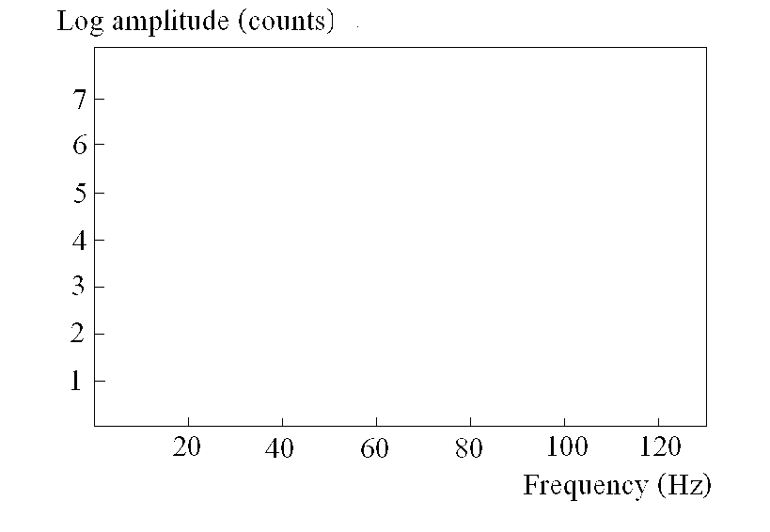

Determine the sample rate by zooming:

Experiment 3.3

A/D converter internal noise and cross-talk

Most converters have an internal noise, which will limit the dynamic range. The purpose is to measure the true dynamic range. There is always some overplay from one channel to another which is also called cross-talk. The purpose is to measure both quantities.

- Short the input channels and make a recording. The signal now seen represents the internal noise. Measure the average amplitude (by plotting) and calculate the converter dynamic range. Compare to manufacturer specifications.

Digitizer model:

Shorted noise level:

Dynamic range (times and dB, show calculation):

Manufacture specifications (if available):

- Connect signal generator to channel 1, a resistor of ca 5 kohm to channel 2 and short channel 3. Put in a 10 Hz signal at close to clipping level and measure the signal amplitude in channel 2 and 3. Calculate the percentage overplay to the other channels, convert to dB and compare to specifications.

Digitizer model:

Shorted noise level channel 2:

Shorted noise level channel 3:

Overplay channel 2 and 3 (% and dB, show calculation):

Manufacture specifications (if available):

Experiment 4

Seismic sensors, basic tests

Background text: Chapter 2 and 10

The purpose of this exercise is to become familiar with the most common type of seismic sensors and be able to make simple checks.

Experiment 4.1

Seismometer clamping

The most common short period seismometers are Ranger SS1, Teledyne S13 and Mark Products L4. In this exercise, any one can be used as well as one high frequency geophone. Many seismometers have a clamping device used when transporting the instrument.

- Explain the use of the clamping device and determine which of the units you test have a clamping device. If there is no clamping device, how can the seismometers safely be transported ?

Answer:

- Connect a voltmeter to the sensor output, move the sensor and measure approximately the output voltage to get an idea of sensitivity. Is there a difference in using AC or DC mode ?

Answer:

Experiment 4.2

Horizontal and vertical seismometers

Seismometers are normally horizontal or vertical. Can any of the seismometers operate in both ways and what must be done to change between vertical and horizontal operation ? Try it with the model, which can be changed in the field and set up the seismometer.

Answer:

Experiment 4.3

Basic parameters

-Measure basic parameters of the test seismometers available: Free period, resistance of signal coil, resistance of calibration coil (if present). NOTE which seismometer is used. The signal coil will normally have a much larger resistance than the calibration coil.

Seismometer type | Natural period (sec) | Resistance generator coil (ohm) | Resistance calibration coil (ohm)

When measuring the resistance of the signal coil, it is recommended to clamp the seismometer mass, why ?

Answer:

What is observed if the mass is not clamped, explain:

Answer:

Describe how you measure free period. Note that some seismometers, like the L4C, might have a damping resistor built in !!!.

Answer:

Using the a sensitive seismometer, connect a multimeter in DC mode (most sensitive range).

- How much do you have to move the sensor to get an output ?
- How much output do you get by tilting the instrument slightly (less than needed for the mass hitting the stop) ?

Answer:

Experiment 4.4

Polarity

In order to make fault plane solutions, it is important that the polarity is ok. The convention is that an ground movement UP, to the EAST and NORTH shall give positive signals and finally result in a positive signal on the display (screen, plot or seismogram). The first step is to identify the positive terminal on the seismometer. This can be done with a multimeter, or better an oscilloscope while doing a tilt test. SEISLOG can also be used. This is done by rapidly tilting the seismometer, which means that the seismometer moves UP when using a vertical seismometer or horizontally in direction of rotation for a horizontal seismometer. Notice the first pulse on the measuring device and determine the positive terminal on at least 2 different seismometers of which one is a horizontal.

Seismometer Terminal ID (letter or color)

Seismometer Terminal ID (letter or color)

Experiment 4.5

Broad band sensor

The broadband band sensor can be understood as a usual velocity sensor with an extended frequency range in the low frequency end. The long period sensor is usually going down to about a period of 20 seconds, while broad band sensors can go down to a period of several hundred seconds by using sophisticated electronics. In this experiment, a Guralp broad band sensor will be used.

- Check which sensor is used (e.g. CMG40T or CMG3T) and get free period and generator constant from the book or the manual. How are the values compared to a Ranger seismometer ?

Answer:

Which is the most sensitive ?

Answer:

- Connect the broad band sensor to the control box and check the mass position (explain what mass position is). If the mass position is out of specifcations (see manual), re-center the mass. How is it done ?

Answer:

- Connect the sensor to the SEISLOG system and monitor the channels with the View facility. What is the dominant period of the signal ?

Dominant period:

- Connect a voltmeter to the output of the sensor. Can you follow the signal variations with the voltmeter ? What is the dominant period ?

Answer:

Experiment 5 Frequency response

Background text: SEISAN RESP, Appendix and Chapter 6.

Any electrical circuit which has an input and an output (like multimeter, oscilloscope, amplifier or a combination of electronic elements such as resistors and capacitors) might modify an incoming AC signal in both amplitude and phase. The relation between the output and input signals is called the frequency response of the circuit. We assume that we are dealing with linear systems meaning that if e.g. we double the input signal, the output will also double. In this exercise we will look at the frequency response of both the voltmeter and the oscilloscope and also construct a simple filter.
A seismometer can be considered in a similar way except that the input is ground motion and the output is voltage, we will look at that in a later experiment.
The RESP program calculate response functions for seismic systems with both sensors, filters etc. In this experiment, we will only use the filter part of RESP.

Experiment 5.1

Frequency response of multimeter and oscilloscope

- Connect the FG to the multimeter, adjust the frequency to 100 hz and the voltage to 1 VRMS. Now measure the amplitudes at the following frequencies: 10, 80, 50, 40, 25, 10, 5, 2, 1, 0.5, 0.2, 0.1.

Frequency (Hz) Voltage

- Plot the voltages as a function of frequency (below).

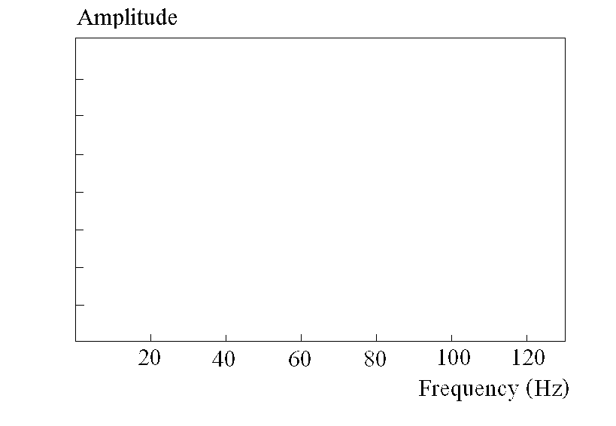

What does the curve show, what does it tell about the use of a multimeter for measuring low frequency AC signals, for which frequencies are the measurements reliable.

Answer:

- In DC mode, it is possible, using a multimeter to follow the voltage of a slowly varying signal, however when the frequency increases, the averaging of the multimeter will make this measurement inaccurate. Determine this frequency.

Answer:

Explain the use of the dB scale:

Optional: Repeat the experiment with the OC in AC mode and DC mode, what is observed ?.

Answer:

Experiment 4.3

Filter

- Construct a low pass filter (Appendix) with a cutoff frequency of about 10 Hz , show a drawing of the filter with input and output. Make sure you do not used a polarized capacitor, why ?

Answer:

What is your calculated 3dB point:

- Connect a signal generator to the input and one trace of an OC to the input and one trace of the OC to the output and vary the frequency. Alternatively use Seislog. Now measure the amplitude and phase shift of the output signal relative to the input signal. Plot the measured values of amplitude and phase shift as a function of frequency and also plot the theoretical curve on the same graph.

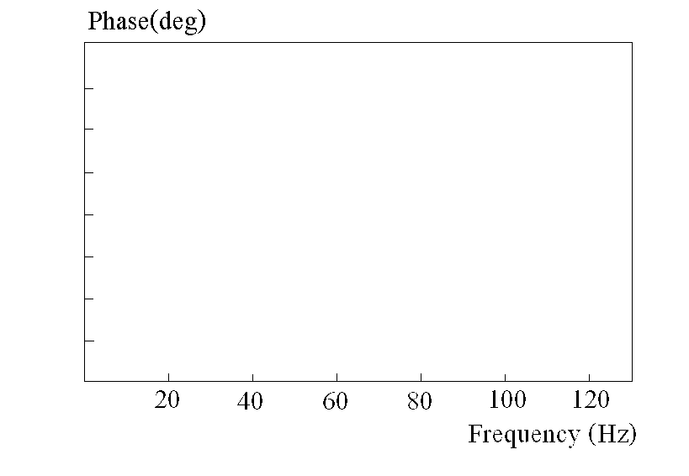

How do they compare:

The theoretical curve can be calculated with RESP or calculated manually.

Note on phase shift: A sine wave can be described as

sin(2*pi*f)

where f is the frequency. If the phase shift is s, the expression is

sin(2*pi*f+s)

Comparing the two signals on an oscilloscope then means that if s is positive, the output signal is shifted backwards relative to the input signal.

Experiment 5

Seismic sensors, calibration

Background text: Chapter 2 and 10

This exercise is a continuation of exercise 4 where more advance features are tested. In particular, the procedures of calibration are tested and the accelerometer is also used.

Experiment 5.1

Determine seismometer damping

The damping is an important parameter which must be set right in order to record the signals without too much over swing. The damping is normally set to (0.7 * critical damping).

- Connect the seismometer to an OC or SEISLOG. Make the seismometer swing by either giving it a small kick or sending in a calibration pulse (if calibration coil). Determine two subsequent amplitudes and calculate open circuit damping (section 10.22). Explain what open circuit damping is, can it be ignored for the seismometers tested ? Repeat experiment with a geophone.

1 Hz sensor type:

Amplitude swing 1:

Amplitude swing 2:

Open circuit damping, value (show calculation):

Geophone type (optional BB sensor):

Amplitude swing 1:

Amplitude swing 2:

Open circuit damping, value (show calculation):

- Repeat the experiment (1 Hz seismometer only) with a 'suitable resistor' (1-30 kohm depending on sensor) in parallel with the seismometer signal coil so the over-swing is about 20-30 % (meaning that following amplitude is 20-30% of previous amplitude). Determine the ratio of two subsequent swings and calculate (section 10.22) critical damping resistance (ignore open circuit damping). If it is difficult to read the signal on the OC, use a digital recording.

Amplitude swing 1:

Amplitude swing 2:

Damping (show calculation

- Calculate the external resistance needed for critical damping and for 0.7 of critical damping.

Answer, show calculation:

When a damping resistance is connected to a seismometer, the output from the seismometer is reduced. This can be specified by giving the seismometer loaded generator constant which is the generator constant as seen from outside when the damping resistor has been connected. Below is an example of the calculation.

- A seismometer has a generator constant of 300 V/(m/s), an internal resistance of 5000 ohms and a damping resister of 3000 ohms, what is the loaded generator constant ?

Answer, show calculation:

Experiment 5.2

Seismometer generator constant

The generator constant can be measured directly by placing the seismometer on a shaking table and measuring the output for a given shaking table velocity. We have no shaking table but it is possible to compare two seismometers by simply comparing the voltage outputs generated with background noise, the earth is then the shaking table.

- Connect two different seismometers with the same natural period (why ?) to the two channels of a digitizer. Remember damping resistors. Place the seismometers close to each other. The two signals should be very similar in shape. Measure the signal levels of each. Record the signals if they are difficult to see. By taking into account the damping resistors, what is the ratio of the two generator constants ?

Answer, show measurement and calculation:

Experiment 5.3

Frequency response of seismometer

Use a SP seismometer where all constants are known and connect a damping resistor (corresponding to a damping of 0.7) to the signal coil. Connect the calibration coil to the frequency generator. Set the frequency to 1.0 Hz, connect the oscilloscope to the signal coil and slowly increase the amplitude until a clear signal is seen. Without changing the output level of the signal generator, measure the output of the seismometer at frequencies given in table below.

Frequency (Hz) | Output voltage | Equivalent ground displacement (m) | Seismometer gain in V/m | Theoretical gain in V/m
0.1
0.2
0.5
1.0
2.0
5.0
10.0
15.0
25.0
50.0
100.0

At 50 Hz, measure the voltage sent to the calibration coil with a multimeter. Then calculate the current (remember measurement is RMS with multimeter).Using equation 10.17, the equivalent ground displacement can be measured and seismometer gain in V/m calculated. Get mass and calibration coil constant from Table 2.2

Voltage into calibration coil:

Resistance of calibration coil:

Current through calibration coil:

Why can this measurement not be done at e.g. 1 Hz:

- Using the theoretical values, calculate fraction of critical damping, and the loaded generator constant and calculate the theoretical response with the RESP program (see SEISAN manual).

Compare the theoretical values with the measured values, how do they compare :

Experiment 5.4

Accelerometer testing

The accelerometer measures the ground acceleration from DC to about 50 Hz without significant change in gain. The instrument therefore can measure static changes in the gravity field as well as dynamic changes. When the accelerometer is placed horizontally, theoretically output from all 3 sensors should be zero. This is not possible in practice due to leveling problems and DC shifts in the internal electronics.
- Using an accelerometers, connect power and using a multimeter, determine the smallest simultaneous voltage out of all 3 sensors, compare to manual (if available).

Voltage out channel 1:

Voltage out channel 2:

Voltage out channel 3:

Is sensor ok:

The simplest way to check the static properties of an accelerometer is by making a tilt test thereby changing the static acceleration in the 3 component directions. Tilt the accelerometer towards North at an angle of 30 deg (or any angle easily set up, but smaller than the angle which will saturate the horizontal sensor), measure output of all 3 channels, tilt 30 deg to the South, East and West and measure output of all 3 sensors (see section 10.3.4).
- What is the sensitivity in V/g. What is the maximum acceleration the accelerometer can measure assuming the max accelerometer output is 2.5 V (explain your calculations) ?

Voltage out channel 1: Sensitivity:

Voltage out channel 2: Sensitivity:

Voltage out channel 3: Sensitivity:

Maximum acceleration:

How is the polarity:

Do the tests indicate that the accelerometer is OK :

Experiment 6

Digital recorders using triggered recording

Background text: Chapter 5 and SEISLOG manual.

A digital recorder can simply be a device recording a signal continuously in digital form, as it has been used in experiment 3. The problem with continuous recording in seismology is that very large amounts of data will have to be recorded. Usually there is a detection program on the recorder continuously checking the signal levels and only recording time intervals where signals where the detector recognizes a signal different from the background noise. This way of operation is the most common, specially on field recorders, where due to the requirement of low power consumption, the storage capacity might be limited.
The current development of increases in capacity of memory and hard disks, reduction of physical size and power consumption has partly resulted in more systems using continuous recording, particular for system only recording 3 channels. However, most systems will at the same time use event detectors, simply to be able to get information about at which times seismic events are likely to occur.

Experiment 6.1

SEISLOG parameters

The trigger on the SEISLOG recording system is using several parameters.
- Explain the principle behind the trigger including the use of STA, LTA and trigger ratio. Explain the use of preevent memory, post event recording and array propagation window.

Answer:

- On a system recording 3 channels, 4 byte integers and has a sample rate of 50 Hz, how many Mbytes does one day of recording represent.

Answer, show calculation:

- Assuming 1.5 Gbytes is allocated for continuous recording, how many days of continues recording is there room for.

Answer, show calculation:

Experiment 6.2

SEISLOG testing

Use the SEISLOG system. Connect a 1 Hz seismometer (on pier if possible) to channel one of the system. Start the system.

- Check the signal with command View, does it look right ? Explain !

Answer:

- Set the trigger to work on only channel 1 (Config/Administer channels and Trig) , use no filters. Vary the parameters STA, LTA, RATIO and FILTER to find out which combination will trigger the system most easily when jumping at 2 m's distance. Note down. Remember to start and stop the system when trigger parameters are changed.

Answer:

- Configure a second channel using the same seismic input and use a filter of 5 to 6 Hz. Observe the signals with View Give the seismometer a kick and observe the delay caused by the filter. This might be easier to see by looking at a recording. How much is the delay (in degrees) ?

Phase delay:

- By trial and error, find which frequency band has the highest noise. Set the filter to reduce the noise. Plot the filtered and unfiltered signal. How does the filter improve signal to noise ratio ?

Answer:

Experiment 7

Using SEISLOG for sensor testing and seismic noise measurements

Background text: Chapter 3 on noise and SEISLOG manual.

With digital recording, it is possible to manipulate the signals from one sensor so it resembles another sensor. This means that the distinction between LP and SP sensors to some degree disappear, since when knowing the response function of one, we can convert to another limited by the signal to noise ratio. The broad band sensor can simulate both the LP and SP sensor and therefore replace both. A broad band sensor is based on the forced feedback principle and can in some cases be considered an advanced accelerometer, except it has been electronically modified to give velocity as output.
The reason for still using SP sensors is mainly cost and simplicity since in many cases (micro earthquakes) there is no need to record low frequencies (less than 0.2 hz). In this experiment we will test how similar signals we can get out of a very cheap geophone and a traditional 1 Hz seismometer. Optionally, an accelerometer can also be used.

When installing seismic stations, the quality of the recordings depend to large extent on the local background noise. It is therefore important to have a standard to compare with when measuring background noise. The most widely used standard is the Peterson curves (Chapter 3) which however is given in acceleration power spectral density, something which has to be calculated. The earlier measurements done in this course has been in nm displacement and can be converted, to be compared to the Peterson curve. In order to get the whole curve, spectral analysis must be done, which it the aim of experiment 7.3.

Experiment 7.1

Sensor comparison

On the SEISLOG, connect a Ranger seismometer to channel 1 and the 4.5 Hz geophone to channel 2. Make sure polarity is ok by jumping.
- Plot one channel at a time, make some noise to see if the sensors react.
- Make a file of about 10 s duration with, jump a bit to make a pulse.
- Check with EEV if the 'event' has been recorded.
- Plot signals. How do the signals compare in frequency and shape.

Answer:

- Plot with a band-pass filter of 10 to 15 Hz, how do the signals compare in shape now. Which 2 signals are most similar.

Answer:

-With the above filtered signals, read max amplitudes of the 2 seismometer channels. Can you explain the difference in amplitude by the difference in generator constants, show calculation.

Answer:

Experiment 7.2

Response correction

- Make response files for the 2 channels recorded, remember to put files in the CAL directory.
Now plot the 2 channels again using multitrace mode. Remove the response (use option g and filters 1-5 Hz and filters 5-10 Hz) and compare the 2 channels now showing displacement.

- Explain what you have done and what you expect ?

Answer:

- How different are they, any difference using the two frequency bands ?

Answer:

- What is most comparable, the noise or the 'event' ?

Answer:

- Make the noise spectra (N option) using traces for each sensor, use only noise section. In which frequency bands do the spectra agree ? What does it tell you about the frequency bands in which the instruments can resolve earth noise ?

Answer:

Exercise 8, optional

Select a field instrument with sensor (e.g. a Seislog on a laptop with 4.5 Hz sensor and digitizer). Take it to the field and measure the background noise in time windows of at least 60 second at different sites.

Setup response files and calculate noise Peterson noise curves

Are the curves reasonable for the sites used

If possible, measure noise at a permanent seismic station.

Compare noise measurement with the noise spectra from the permanent station.
Pensum

- All explanatory text in these experiment notes.

- General electronics. Ohms law, use of multimeter, internal resistance, power supply.

- Seismic sensors: Mechanical and electrical constants, how to measure constants, overview of main types.
Knowledge of approximate values of generator constants and free period for different types of sensors.

- Signal conditioning: Amplifier general properties, filters.

- Digital instruments: What is an A/D converter, what does number of bits mean, typical units on the market, anti alias filters, GSN station, SEISLOG station.

- Triggered systems: Detector and data storage.

- Seismic noise: Generally expected shape of noise curves, noise measured as displacement or power spectral density of acceleration.

Pensum from book:

Chapter 1, 2.4-2.14, 3, 4.1-4.9, 5.1-5.9, 6-6.1, 6.4-6.8, 7 10-10.3.2, 10.3.4-10.6. p 282-288, p 291-293
From book, no boxes are pensum, no detailed derivations and no technical details.

