Seismology in the Dominican Republic

The Dominican Republic (DR) has two seismic networks: The official network operated by the university (Instituto Sismológico Universitario, Universidad Autónoma de Santo Domingo (ISU)) and a small new network operated by the Lyola Institute (LO) in San Cristobal.

Instituto Sismológico Universitario

The institute operates 5 broad band and 5 short period stations (of which three are analog and digitized centrally) and in addition receives data from 14 stations in Puerto Rico and other countries. There are 14 strong motion stations of which 2 are part of the real time network. Equipment has been ordered for 8 new RefTec broad band stations. ISU has no portable equipment. Most of the station data are sent to IRIS in real time. The data is sent to EarthWorm and EarlyBird (Windows) and initially processed by PRDANIS, a combination of Hypoinverse and SeisGram. The events are found by scanning the continuous data and the event files are then extracted manually into a GSE file. Triggered data is thus not used. Location and magnitude (coda) is made with hypoinverse. The events are then passed on to SEISAN on a Linux server (hypoinverse files converted to Nordic format, program by Mario Villagran) where final location and Ml is calculated. Mw from spectra and fault plane solutions are not made.
No distant events are processed. Digital data and phase data exists back to 2005, while all older data seems to have been lost, however paper seismograms exist. Thus readings from the network, which started in 1984, are lost and it seems that the data has not been sent to ISC. There are 5 analysts working in 6 hr shifts so there are always one at the institute. In addition 3 people work in instrumentation and 3 in seismology. About 1200 events are located per year and the acceleration stations trigger on about 10 events. The acceleration data is not used for processing. Most of the events are processed by the chief analyst. ISU has a web page, sismologicouasd.org where the largest events are published.

Recommendations

- It seems inefficient to process in two systems and manually look for events. A better approach would be to use the EW trigger and process the detected events directly in SEISAN. The SeisGram can still be used to check for undetected events. Alternatively the EW continuous data can be exported to SEISAN in a BUD archive.
- Calculate Mw and fault plane solutions
- Process all distant events.
- Include the acceleration data in the data base and use it to improve locations and magnitudes.
- Convert GSE format files to MiniSeed, plotting time is then reduced from 20 to 1 s.
- Send all data to ISC, this will ensure that data is not lost in the future and also show ISU’s contribution to seismology.
- Try to recover old data from the seismograms. This can be done by downloading readings from ISC for e.g. the 100 largest events per year and then add readings from the ISU network. This could significantly improve the hypocenter locations for events in DR.

Loyola Institute
The institute has 3 accelerometer stations (NetQuake) in the SW of the country. The stations send the data to LO over internet using the GeoDAS software. Continuous data (1 hr MiniSeed files) and triggers are sent. In addition, data from some DR stations are received over internet from IRIS, enter a RT_quake system which generates triggered events that are stored in SEISAN. It would be an advantage if the data could be received directly from ISU. The intention is to include the NetQuake stations in this network once the NetQuake units have been upgraded to send SeedLink.
The purpose of the LO network is to create a data base of DR earthquakes to be used in different studies, mainly with students, and to get experience in processing earthquakes. There is particularly interest in the SW part of the country.

Loyola has no personnel yet but plans to engage one person to do the processing.

The stations are installed on soil at or near populated areas. In order to evaluate the noise levels, measurements were made at 2 of the stations using a geophone and a SARA digitizer.
Station 1 is located about 100 m from the beach at the outskirt of a small quiet hotel. The waves could clearly be seen as well as traffic on the road 100 m away but only larger waves and trucks were visible. Station 2 is located in the center of a small town and presents a rather stable noise level with only a few spikes from larger cars. Figure 1 shows the noise spectrum at station 1 and Figure 2 at station 2.

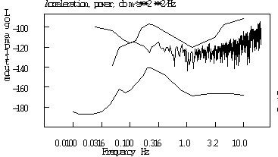

Figure 1: Station 1, quiet period

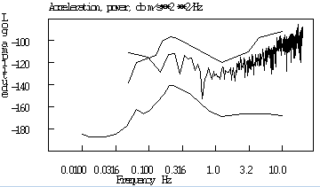

Figure 2 Station 2, quiet period

The 2 spectra are calculated in quiet periods meaning that there are no large spikes due to traffic or waves. Including spikes, the noise spectra go up about 10 dB. The spectra should therefore reflect the recording ability between noise bursts (about 90 % of the time). Considering the locations, the noise spectra are surprisingly low and although not very good locations, a sensitive station at the sites should be able to record smaller events in quiet periods. The spectra were then compared to the spectra from the accelerometers, see Figure 3.

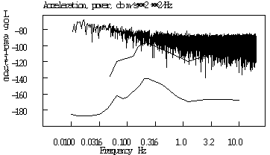

Figure 3 Typical NetQuake noise spectrum

It is seen that the NetQuake instrument shows a much higher noise level at all frequencies below 15 Hz as compared to the real noise as measured with the geophone. The noise is typically around 200 000 nm/s⁻² as measure with SEISAN. This level is very constant and the same on all stations indicating that it is instrument noise. The instrument specification indicates that the minimum acceleration it can measure is 0.00001 g (independent of frequency). This corresponds to 10⁻⁵g x 10ms⁻²/g x 10⁹nm/m = 100 000 nm/s⁻² or about what has been measured. It can thus be concluded that the NetQuake cannot resolve the noise since the internal noise is about 10-20 times higher than the seismic noise.
A noise test was also made at a road cut where there was hard rock, see Figure 4. This noise can be compared to the noise of one of the best stations in the DR network, see Figure 5.

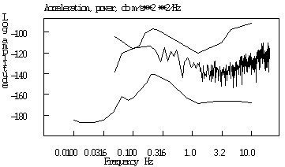

Figure 4 Noise spectrum at road cut.

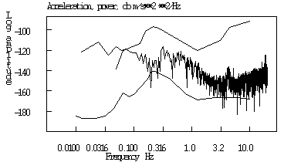

Figure 5 Noise level at short period DR station HATO

Both the road cut and the DR station show significantly lower noise levels than the LO stations so there is room for improvement in case more sensitive stations are acquired.
Despite the low gain, LO has recorded several nice events on all 3 stations and the acceleration stations will provide important information for larger events in SW DR. It is estimated, from the recordings, that magnitude 3 events at a distance less than 100 km will be clearly recorded. However, at least one new high gain station should be installed to enable detection of small events in the area.

The data base
The idea is to build a data base to be used with students and others interested in DR seismology. The data base will be located in the Linux computer. The following steps a can be followed:
- Include available processed information like the ISC the catalog.
- Process triggered events:
  - Being in WOR, check all events triggered with eev
  - Delete false triggered (del s in mulplt)
  - Register ok events (regis in mulplt)
  - Locate and calculate magnitudes
  - Add LO network waveform file if available: put waveform file in WAV and file name in s-file. When LO data comes in with SeedLink, this step is not needed.
  - Process LO data

Cooperation
LO should cooperate with others to operate since there currently are no persons dedicated to seismology and no seismological competence. It also seems desirable that all institutions in DR cooperate considering the small number of qualified seismologists and lack of instruments, whether permanent stations or portable equipment. DR can offer very good computer competence and new stations while ISU has seismological competence and stations in area of LO’s interest. Suggestions are:
- LO gets real time data directly from ISU instead of from IRIS, possibly only for stations in area of LO’s interest
- LO sends real time data to ISU
- LO gets help from ISU initially to do processing
- LO and ISU meets regularly to exchange information on recent DR seismicity
- Get portable equipment. There is no portable equipment in DR. Portable equipment is important for aftershock monitoring and special seismicity monitoring near suspected active faults. All institutions should cooperate to apply for government money to acquire a pool of instruments. Currently it seems that the Geological Survey is trying to get a pool of accelerographs

Jens Havskov, November 2012

