PROGRESS REPORT ON PALEOMAGNETIC RESEARCH CONDUCTED WITHIN THE EPIWA PROJECT

Background
A number of active faults in the Izmir region divide the area into separate tectonic blocks, and have been the site of destructive earthquakes in historic times. Understanding the differential motions between these blocks is a crucial part of determining seismic hazard in the area. On the short time scale, GPS data may be employed, as has been done recently by Aktu and Kiliolu (2006), while studies of geomorphological features and paleoseismology (also undertaken within the EPiWA project) can reveal fault movements over time scales of thousands of years. To aid the understanding of the longer time tectonic development (exceeding one million years), paleomagnetic data from different fault blocks may be utilized to determine differential rotations.

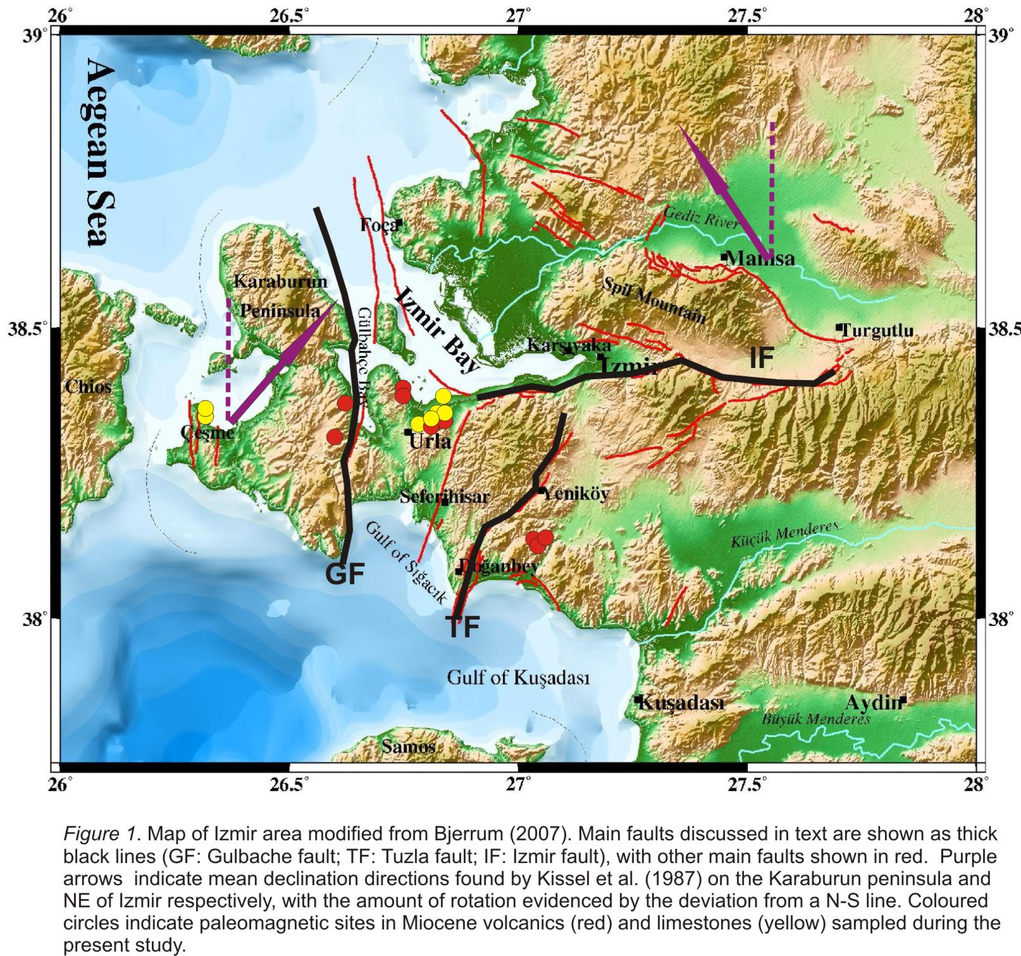

Some relevant paleomagnetic data from the Izmir area have already been published in international journals. From results obtained by Kissel et al.(1987) it is clear that major differential block rotations occur between the Karaburun peninsula and the area immediately NE of Izmir (Figure 1). However, there are several major tectonically active faults between these two regions, and it is much less clear which of these contribute most to the differential block movements. In particular, the Glbahe fault, Tuzla fault and Izmir fault, all potential sites of destructive earthquakes, are found between the previously paleomagnetically studied areas. The paleomagnetic study conducted within the EPiWA project targets rocks of Miocene and younger age in this specific area, with the principal aim of establishing differential rotations occurring between each of the three above faults.

Work to date
To this end, paleomagnetic field work, involving staff and an MSc student from the University of Bergen, as well as local geoscientists from Dokuz Eylül University, Izmir was conducted in September 2007. A total of 120 independently oriented core samples for paleomagnetic analysis were collected from 16 different localities, comprising 7 sites in limestones and the remaining 9 in volcanic rocks of varying composition (Figure 1). Analysis of the collected material is currently well under way, utilizing a high-sensitivity 2G SQUID magnetometer at the paleomagnetic laboratory of the University of Bergen. Results to date reveal a wide range of magnetic intensities in the different rock types studied, with NRM intensities ranging from around 0.1 mA/m in limestones, through 3mA/m in rhyolites, to above 5000mA/m in basalts. Regardless of magnetic intensity and rock type, all sampled localities show reasonably good grouping of NRM directions, with particularly consistent directions being obtained from the three rhyolite localities east of the Tuzla fault (Figure 1). While several localities cluster close to the present day field direction, reversed polarity magnetizations appear to be present at others, suggesting the presence of a remanent magnetization of some stability.

In summary, initial results are promising. However, firm conclusions about the age and stability of magnetization, as well as interpretation in terms of block rotations, must wait until the completion of detailed magnetomineralogical analysis, and the thermal- and AF-demagnetization experiments currently under way.

Publication plans and possible future work
As well as forming the basis for a MSc thesis, we envisage that the results from the analysis of the paleomagnetic samples collected to date will be published in an international journal, and provide important input for future modelling of seismic hazard in the Izmir area. Should more funding for paleomagnetic studies be made available, future field work would extend the sampling area eastwards, (i.e. to the area immediately south and east of Izmir city), with particular emphasis on obtaining samples on both sides of the Izmir fault (Figure 1). Based on our preliminary analysis given above, we would also try to sample more of the rhyolitic volcanics in general.

References
Aktu B. and Kiliolu A., 2006. Recent crustal deformation of Izmir, Western Anatolia and surrounding regions as deduced from repeated GPS measurements and strain field. Journal of Geodynamics, 41, 471-484.

Bjerrum, L.W., 2007. Ground motion simulations for Izmir, Turkey, based on earthquake rupture scenarios. Msc thesis, University of Bergen. 156pp.

Kissel, C., Laj C., Sengr, A.M.C., & Poisson A., 1987. Paleomagnetic evidence for rotation in opposite senses of adjacent blocks in Northeastern Aegea and Western Anatolia. Geophysical Research letters, Vol. 14, No. 9, 907-910.

