

Progress Report No 13

for the project

Norwegian National Seismic Network

For the period July 1st to December 31th, 1998

Sponsored by

Oljeindustriens Landsforening

March 1999

Institute of Solid Earth Physics
University of Bergen
Allegaten 41, N-5007 Bergen

and

NORSAR
Boks 51, N-2007 Kjeller

1. Introduction

This 13th progress report, under the project Norwegian National Seismic Network (NNSN), covers the second half of 1998. The purpose of this report is to describe the current technical operation of the stations, the data recorded, the costs and the budget for the project for the reporting period. A separate report is given on the seismicity of Norway and surrounding areas in which the data recorded is presented (Appendix 1). A report for the NORSAR arrays is given in Appendix 2.

2. Operation

The operational stability for each station is seen in Table 1. The average downtime for all
13 stations is 3.5 %. while it was 9.4% for the last reporting period (4.9 % excluding BJO). This is an improvement relative to the previous period and similar to previous years, however further improvement should be possible.

Table 1. Downtime in % for the time period July to December, 1998 for each station of the NNSN.

Station | Downtime in %
Karmøy (KMY) | 13.0
Odda (ODD1) | 2.5
Blåsjø (BLS) | 0
Høyanger (HYA) | 0
Sulen (SUE) | 1.2
Molde (MOL) | 3.0
Florø (FOO) | 0
Namsos (NSS) | 0.3
Mo i Rana (MOR8) | 12.1
Lofoten (LOF) | 4.3
Tromsø (TRO) | 0
Kautokeino (KTK) | 8.7
Bjørnøya (BJO1) | 0

3. Field stations and technical service

The technical changes for each station, are listed below. If these changes are not related to a visit of the UiB technical staff, it is noted. When a station stops working, tests are made to find the problem like failing power etc. Sometimes the reason cannot be found and the cause of the problem will be marked as unknown. The BJO stations has been in continuous operation for the second half of 1998. However, no events were detected in the last 3 months of 1998, despite the signal looking ‘normal’. Inspecting the tapes arriving later, it seems that the sensor was not working properly. In February, 1999, operation became normal again without any intervention.

Bjørnøya (BJO1)
No visit or technical changes. There does not seem to be detections since October, 1998 due to either a bad seismometer or electrical noise pickup by the seismometer cable which produces spikes. Currently (March 99) the system is working ok without any changes being made.

Florø (FOO)
No visit or technical changes

Høyanger (HYA)
02.11.98: GPS restarted by the local operator.

Karmøy (KMY)
05.07.98: Installation of new PC, system was down since the 1st of July, due to a defect serial line.
13.08.98: Seislog restarted by the local operator.
31.08.98: The station was down for four days, reason unknown
15.09.98: Seislog restarted by the local operator, stopped 4 days for
unknown reason.
09.10.98: For the last nine days the station was out of order due to
big spikes from the digitizer. The local operator connected the digitizer
and the PC to common ground and restarted the system. This
spike problem seems to have caused the stops without known reason in the
previous months.

Lofoten (LOF)
2.07.98: The station has been down for two days, reason unknown
23.08.98: The station has been down for 5 days, reason unknown
20.10.98: The station has been down for 12 hours, reason unknown

Mo i Rana (MOR8)
23.11.98: The station had been down since November 1 due to a defect PC.
Installation of:
• SEISLOG version 7.11
• Modem
• Garmin GPS clock

Molde (MOL)
06.07.98: There were problems with the PC since 1st of July. A new PC was installed by the local operator.
04.10.98: The station has been down for 18 hours, reason unknown
06.11.98: Seislog stopped, the digitizer was restarted by the local operator.
13.11.98: A high voltage trafo was reinstalled by the local power company.

Namsos (NSS)
No visit or technical changes

Tromsø (TRO)
No visit or technical changes

Sulen (SUE)
17.09.98: The station was restarted by the local operator.
30.12.98: The station has been down for 1 day, reason unknown

Odda (ODD1)
07.08.98. Installation of: Cisco box
21.10.98: GPS clock out of work since October 10, restarted by the local
operator.
18.11.98: The station has been down for one day, reason unknown
23.11.98: When restarting the GPS by the remote control unit, the power to
PC was turned off by a mistake. Station was out 4 days.

Blåsjø (BLS)
No visit or technical changes.

Kautokeino (KTK)

22.07.98: Replacement of old VME system and installation of PC and
modem.
14.08.98: The modem gave problems with the new system, system reconfiguration and restarted. Data was lost for the previous 13 days.

Other technical matters

For the stations Kautokeino, Mo i Rana and Blåsjø, it is still not possible to get ISDN connections and the stations have to remain operated with modems.
In order to improve the technical stability, uninterruptle power supplies (UPS) will be installed on the most unstable and/or remote stations. So far, UPS has been installed
at BJO, KMY and SUE. For the same reason, remote control power on/of devices will be installed. These allow, via a telephone, to turn power on and off separate on all devices. The on/off switch has been installed on ODD and SUE.

4. Data

An overview of the seismic activity in Norway and surrounding areas for the last half of 1998 is given in Appendix 1. The data recorded by the seismic stations were collected and monthly bulletins were prepared and distributed. Since there was no event in Norway of magnitude larger than 5.0 during the last half of 1998, no special report has been written.

7. Operation of the Bjørnøya station (BJO) since installation

The BJO station was installed in 1992 as a special project sponsored by OKN (Operatør Komite Nord). The station hardly came in operation before it was taken over by the new national network project in 1993. The station has had recurring operation problems and has recorded less than other stations. The following will give an overview of operation, data recorded and costs.

Equipment and operation

The station currently has a 3 component Guralp broad band seismometer installed 500 m from the recording site inside the meteorological department building. The signal is transmitted via a cable from the seismometer to the recording site and the digitizing unit is installed in the pit with the seismometer to avoid electrical interference. The SEISLOG data acquisition system is connected via a slow modem to the University of Bergen. The triggered events are transmitted to Bergen via modem, while the continuos data is sent with tape. There is a possibility to establish internet at BJO in cooperation with the University of Tromsø.
The station started operating with short period sensors and in 1996, the sensor was replaced by a broad band sensor which improved the detection of distant earthquakes. The down time
is seen below:

Year | Downtime in %
1993 | 22
1994 | 10
1995 | 65
1996 | 6
1997 | 22
1998 | 32
Average | 26

This means that the station has only operated ¾ of the time compared to the other stations which all are above 95 %.

Data

In the period 1992-98, BJO has recorded a total of 463 events of which 153 are in the region of BJO (Figure 1) and the rest are further away. In the BJO region, the NNSN network detected 872 events in the same time period (Figure 1). Considering the 25 % down time, this means that the BJO station detects 44 % of what is detected on the NSN network. Closer to BJO this percentage is higher. These calculations are a bit uncertain since the local network on Jan Mayen detects small events which cannot be seen on BJO. This also happens with the Svalbard array, however, only a few of the events from the Svalbard array were sent to the NNSN before 1998, so this bias will be mostly felt after 1997. Part of the reason for the lower detection on BJO is the high seismic background noise level. There are also problems with electrical spikes in and around the installations which in some time periods (counted as operational) lowers the detection level.
Figure 2 shows the monthly number of events detected at BJO since 1992. There are obviously operational gaps and few events were detected before 1994. From 1996, the number of events detected increased substantially due to the installation of the broad band seismometer which increased sensitivity to distant events.

Figure 1
Seismicity around BJO for the time period 1992 to 1998. The top figure shows all events recorded by the national network while the bottom figure shows which of the events have been recorded by BJO.

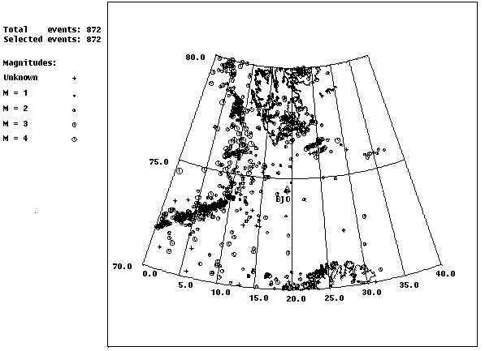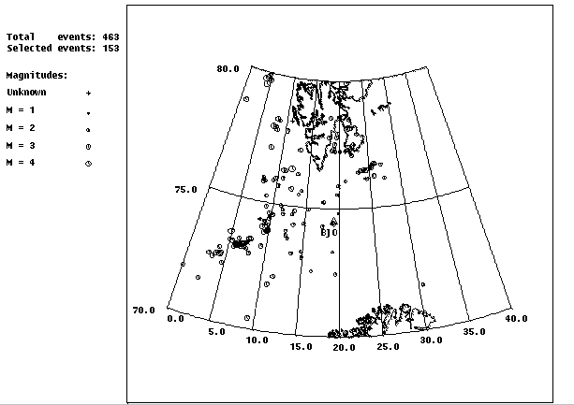

Figure 2
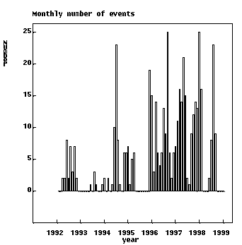Monthly number of event recorded on the BJO station. The data include all events, both in the region and globally

Costs

It is difficult to estimate the exact costs since there is no special entry to the accounting system related to BJO. An estimate can be obtained by looking at the equipment bought by the project and the number of travels to the stations. There has been a total of 5 visits to the station. Although there is a fixed satellite link to BJO since 1996 (shared by University of Tromsø) communication costs have been low since the satellite link is paid by University of Tromsø, so only calls to N. Norway have been charged to the project, estimated at 12 000 NOK for the whole period. There are no local salaries paid since the operation is done by the meteorological department.

Equipment: 180 000 NOK
5 visits * 15000 75 000 NOK
Communication 12 000 NOK
Total for 6 years 367 000 NOK

The current yearly running costs are estimated to:

Yearly visit 15 000 NOK
Communication 3 000 NOK
Spare parts 10 000 NOK
Shipments 3 000 NOK
Total 31 000 NOK

If this amount is subtracted from the total running budget for field station operation and communication, the average cost for the remaining stations is 34 000 NOK and the cost of BJO operation is therefore estimated to be similar to the other stations.

Conclusion

The BJO station is very noisy and far away from most of the seismicity in the region. A 44 % detection level can therefore not be considered unreasonably. Considering the strategic position with other stations far away, it has a significant constraining effect on the earthquake locations in the region. The technical operation can clearly be improved with respect to electrical interference which should increase the number of detections. The cost of the operation of the station is similar to the stations in mainland Norway, however, in order to get significantly lower downtime, operation costs would increase. The most serious problem preventing operational stability has been the problem of accessing the sensor and digitzer in the winter. In order to improve this situation, it is planned to install the sensor in a large fibreglass prefabricated water tank.

7. Use of NNSN data during 1998

Publications and reports

Atakan,K. 1998. Comments on the possible effects of seismicity on slope instabilities in the Norwegian continental margin, with special emphasis on the Storegga submarine slide. Technical Report 98-04, prepared for the ENAM project, Geological Institute, University of Bergen, Norway, 21p.

Federenko, Yu.V., Husebye, E.S., Heincke, B., and Ruud, B.O., 1998. Recognizing explosion sites without seismogram readings: neural network analysis of envelope-transformed multistation SP recordings 3-6 Hz, Geophys. J. Int., 133, F1-F6

Hicks, E. (1998): Accurate location of seismic events in northern Norway using
local network, and implications for regional calibration of IMS stations. In:
Semiannual Tech. Summ., 1 October 1997 - 31 March 1998, NORSAR Sci. Rep.
2-97/98, Kjeller, Norway, May.

Hicks, E. & H. Bungum (1998): Jordskjelvaktiviteten rundt Bleikvassli gruber.
Report. for Gjensidige Forsikring, Oslo, 11 pp.

Hicks, E., H. Bungum & C. Lindholm (1998): Seismicity in the Ranafjord area. In:

Neotectonics in Norway. Annual Tech. Rep., NGU Rep. 98.016. 14 pp

Husebye, E.S., Ruud, B.O. and Dainty, A.M., 1997. Robust and Reliable Epicenter Determinations; Envelope Processing of Local Network Data, Bull. Seism. Soc. Am., 88, 284-290.

Husebye, E.S., Ruud B.O. and Federenko, Yu.V., 1998 Automated Explosion Site Recognition Using 3-Component Covariance Time Traces in 12 Frequency Bands for Analysis. In proceedings of the 20th Annual Seismic Research Symposium on Monitoring a Comprehensive Test Ban Treaty (CTBT), Santa Fe, NM, USA.

NORSAR (1998): Halsnøysambandet. Vurdering av jordskjelvrisiko. Report prepared
for Statens vegvesen, Hordaland Vegkontor, November.

NORSAR (1998): NORZINK A.S., Odda. Earthquake Hazard Analysis for Residue Depository Site Phase 1: Report for Grøner a.s.

NORSAR (1999): NORZINK A.S., Odda. Earthquake Hazard Analysis for Residue Depository Site. Phase 2: Detailed analysis. Report for Grøner a.s.

NORSAR & IKU (1998): Earthquake hazard update and slope stability evaluation Ñ
Active faulting and earthquake loading. Report SP-29-NS-01R-00000-98 prepared
for Norsk Hydro Produksjon a.s., December.

NORSAR & NGI (1998): Development of a seismic zonation for Norway. (Report
prepared for the Norwegian Council for Building Standardization (on behalf of a
consortium of industrial partners), NORSAR, 185 pp, January.

Talks

Atakan,K. Anundsen,K. and Helle,S.K. 1998. Active tectonics in intraplate areas: A case study from Southwestern Norway. Abstract in the ‘ESC XXVI General Assembly’, 23-28 Aug.1998, Tel Aviv, Israel.

Bungum, H. (1998): Seismotectonics on- and offshore in Mid Norway, with emphasis
on the correlation between mapped earthquakes and mapped faults. 29th Nordic
Seminar on Detection Seismology, Karasjok, Norway, August.

Bungum, H. (1998): A new seismic zonation for Norway. 29th Nordic Seminar on
Detection Seismology, Karasjok, Norway, August.

Hicks, E., H. Bungum, C. Lindholm & O. Olesen (1998): New seismicity and focal
mechanism stress data from Ranafjord, northern Norway. European Geophysical
Society Annual Meeting, Nice, April.

Federenko, Yu.V., Husebye, E.S., Ruud, B.O. and V. Pinsky: Explosion Site Recognition; Neural Net Discriminator Using Single 3-Component Stations. XXVI General Assembly of the European Seismological Commision (ESC), Tel Aviv, Israel, August 23-28, 1998.

Hicks, E., H. Bungum & F. Ringdal (1998): Results from a new local seismic
network in Ranafjord, northern Norway, and comparison of epicenter locations to
NORSAR GBF locations. 29th Nordic Seminar on Detection Seismology, Karasjok,
Norway, August.

Hicks, E., H. Bungum & C. Lindholm (1998): Crustal stresses in onshore and
offshore Norway. Preliminary results from the inversion of earthquake focal
mechanism solutions. 29th Nordic Seminar on Detection Seismology, Karasjok,
Norway, August.

Hicks, E., H. Bungum, C. Lindholm & J. Dehls (1998): The NEONOR project:
Neotectonics in Norway. 29th Nordic Seminar on Detection Seismology, Karasjok,
Norway, August.

Husebye, E.S. Ruud B.O. and Federenko, Yu.V. 1998.: Automated Explosion Site Recognition Using 3-Component Covariance Time Traces in 12 Frequency Bands for Analysis. 20th Annual Seismic Research Symposium on Monitoring a Comprehensive Test Ban Treaty (CTBT), Santa Fe, TX, USA, September 21-23.

Lindholm, C., H. Bungum, A. Dahle, J. Schweitzer, F. Nadim & J. Holme (1998): A
new seismic zonation for Norway. 29th Nordic Seminar on Detection Seismology,
Karasjok, Norway, August.

Lindholm, C., H. Bungum, A. Dahle, J. Schweitzer, F. Nadim & J. Holme (1998): A
new seismic zonation for Norway. XXVI General Assembly, ESC, Tel Aviv, Israel,
August.

Midzi,V., Singh,D.D., Atakan,K. and Havskov,J. 1998. Quasi-continental oceanic structure beneath theNorwegian Sea from inversion of surface wave group velocity data. Abstract in the ‘ESC XXVI General Assembly’, 23-28 Aug.1998, Tel Aviv, Israel.

Ottemøller, L. and J. Havskov. Automatic data collection in the Norwegian national seismic network. XXVI General Aseembly of the European Seismological Commission, Israel, August.

