

Operation of the

Norwegian National Seismic Network

2002

Supported by

University of Bergen, Faculty of Mathematics and Natural Sciences

and

Norwegian Oil Industry Association

Prepared by

Department of Earth Science
University of Bergen
Allegaten 41, N-5007 Bergen

March 2003

CONTENTS

Introduction 2

Operation of field stations 2

Field stations and technical service 3

Communications 7

Economy 7

Appendix 1
Seismicity of Norway and surrounding areas

Appendix 2
The NORSAR regional arrays

Introduction

This annual report describes the operation of the Norwegian National Seismic Network (NNSN) for the year 2002. It covers operational aspects as well as a financial report for all seismic stations operated by Department of Earth Science at the University of Bergen (UiB), which comprise the NNSN. (January 1st 2002 the Institute of Solid Earth Physics was merged with the Institute of Geology and the new Institute “Department of Earth Science” was founded).
The network is supported by the oil industry (Norwegian Oil Industry Association or ‘Oljeindustriens Landsforening” (OLF)) and the Faculty of Mathematics and Natural Sciences, UiB.
The seismic arrays operated by NORSAR are covered in Appendix 2 in this report. NORSAR is subcontracted to deliver data of interest to NNSN.

Operation of field stations

The operational stability for each station is shown in Table 1. The stations have been divided into high priority and low priority stations (Table 1a and 1b respectively). The average downtime for all stations, high and low priority, during 2002 is 2,5% compared to 8.8 % for 2001. This is close to our ideal goal of 2%.

Table 1a. Downtime in % for the time period January to December 2002 for the
high priority stations of the NNSN.

Station | Downtime in %
Karmøy (KMY) | 1
Odda (ODD1) | 13
Blåsjø (BLS) | 4
Kongsberg (KONO) | 1
Rundemannen (RUND) | 0
Høyanger (HYA) | 0
Sulen (SUE) | 0
Molde (MOL) | 0
Florø (FOO) | 0
Namsos (NSS) | 3
Mo i Rana (MOR8) | 5
Lofoten (LOF) | 0
Tromsø (TRO) | 2
Kautokeino (KTK) | 8
Jan Mayen BB (JMI) | 0
Kings Bay (KBS) | 17
Average | 3.4
Table 1b. Downtime in % for the time period January to December 2002 for the
low priority stations of the NNSN.

Oslo (OSL) | 0
Stavanger (STAV) | 1
Espegrend (EGD) | 0
Trondheim | 1
Askøy (ASK) | 0
Bergen (BER) | 0
Dombås (DOMB) | 3
Bjørnøya (BJO) | 8
Jan Mayen SP (JMI) | 0
Jan Mayen (JNE) | 0
Jan Mayen (JNW) | 0
Average | 1.2

The station with the largest downtime was KBS (Kings Bay). This station is operated in cooperation with US Geological Service and UiB. Most spare parts come from USGS and repair has to be done locally since there are no funds for maintenance visits to KBS. This explains the long down time.
The station with the second highest downtime is ODD (Odda). This is near enough to Bergen that a lower down time should have been expected. At the time when the ODD station was out of order, the main problem was thought to be communication and it was anticipated that once reestablished, it would have been possible to download the stored data, however the data acquisition was actually disrupted.

Field stations technical service

The technical changes for each seismic station are listed below. When a station is out of order, tests are made to locate the problem. Sometimes the reason cannot be found and the cause of the problem will be marked as unknown.

Bjørnøya (BJO1)
07.12.02. From this date no data is received from the digitiser due to broken
signal cable. Due to the frozen ground, the signal cable (180m) has to be
replaced in the summer season. A temporary station was installed by the
local operator 28.03.03. The station was down for 24 days in 2002.

Blåsjø (BLS)
    - A new UPS and lightning protection was installed by the local
operator. The station was down for 13 days due to software problems
    - The station was down for 3 days due to a broken fuse.
    - Visit.
Installed Telecommander. Damping resistor 5.6 Kohm installed

Florø (FOO)
No visit or technical changes.

Høyanger (HYA)
No visit or technical changes.

Karmøy (KMY)
07.01.02. The PC was restarted by the local operator. The station was down for
3.5 days.
24.04.02 The station was down for 2.5 days due to power failure by the local
power company.

Lofoten (LOF)
07.07.02. Visit.
The aluminium box housing the sensors was dried out, had 3 cm of water in the bottom. Repair to leaky joints.
The accelerometer was recentered.
Inspected the plastic pipe, housing the vertical seismometer, for water leakage, humidity only.
The aluminium box should be replaced by a new one, due to corrosion

Mo i Rana (MOR8)
22-23.01.02 Visit
Power supply connected to digitiser and sensor.
The 220V was disconnected and a new power supply 12-30V was
installed.
16.04.02. The station was down for 1 day due to power failure by the local
power company.
19-21.06.02 Visit.
Since 25.05 the recording became unstable. One reason might be drop in DC
voltage to the digitiser (ED24) due to a long cable (300m). 1 sec.
spikes were observed on all channels.
After several tests to remove the spikes, a new digitizer (ED24) was
installed. The signals were improved, but spikes were observed on
channel 2 (NS).
05-06.08.02 Visit
Since September 20 2000, a Broadband sensor has been installed. The BB
sensor was on loan, and was returned to the Danish Lithosphere Centre.
The station was reinstalled:
Three SS-1 seismometers ware connected. Earth Data Digitiser was
installed inside the building.

Molde (MOL)
No visit or technical changes.

Namsos (NSS)
04-05.02.02 Visit
The electrical spikes have continued since last 20.12.01. Started to install
new PC and digitiser, no improvement was observed. When disconnecting
GPS, the spikes disappeared. By installing a new GPS, the
signal and timing was ok.
Installed a new Guralp Broadband CMG-40T sensor, since the EW
channel was hanging in the old sensor.
18.12.02 During the last week, electrical spikes in the signal have been
observed. The local operator installed a new GPS, the signal and timing
was then ok.
11-18.12.02. The recording was unstable.

Odda (ODD1)
03.04.02 Installed a new version (8.42) of Seislog.
14.05.02 Visit. A new digitizer (ED24) was installed indoors. The old one was
installed in the aluminium box outdoors.
Unfortunately the damping resistors were not reinstalled.
13.06.02. Damping resistors installed by the local operator. During the previous
week, the output from Z channel in the digitiser was -300 000 counts.
Some tests confirmed there was a malfunction.
20.06.02. A new digitiser installed by the local operator. The old one was
returned to Bergen.
25.07.02. Broken ISDN box due to lightning. A new one was installed by Telenor.
    - A new Cisco box was installed by the local operator, still unable to
login to the PC. Recording looked ok.
06.09.02. Visit.
At arrival it was observed that the power to digitiser was turned off on the
Telecommander. The power might has been turned off during some tests
September 1.
A new PC and monitor was installed. New lightning protection was
installed.
Tested connection from local PC to Cisco, working. When testing from
Bergen, login to PC in Odda failed.
Decided to bring Cisco box to Bergen for tests. The system was apparently working locally.
17.10.02. Cisco box installed by the local operator. This time it was observed
that the PC had problem with the software configuration. PC was refigured
the login was succesful.
After September 1, no events were recorded due to wrong settings in the
parameter file.
18.10.02. Visit
Noise was observed on all channels of the digitiser. This apparently started August 7.
A new digitiser was installed, then ok.

Tromsø (TRO)
18.02.02. The PC was restarted by the local operator. The station was down for
4 days.
22.06.02. The PC was restarted by the local operator. The station was down for
1 day.

Sulen (SUE)
No visit or technical changes.

Kautokeino (KTK)
    - A new Cisco box was installed by the local operator.
03.10.02. A new Telecommander and lightning protection was installed by the
local operator. The mass position was centered on the vertical sensor.

Stavanger (STAV)
07-13.03.02 Software problems. Unstable operation.
14.03.02. Installed a new version (8.42) of Seislog.

WNN network: Bergen (BER), Espegrend (EGD), Ask (ASK)
11.03.02. A new PC with windows version of Seislog and a new
Nanometrics digitiser was installed at local recording site at Bergen.

Rundemanen (RUND)
23.07.02 Visit. The sensor was recentered due to the mass position was out of
range.
20.11.02 Visit. The sensor was recentered due to the mass position was out of
range.

Trondheim (TRON)
08-23.01.02 The PC was unstable, reason unknown
08.02.02 The PC was restarted by the local operator. The station was down for
1.5 days.
12.02.02 A new PC was installed by the local operator.
18.02.02 The PC was restarted by the local operator. The station was down for
1 day.
02.03.02 The PC was restarted by the local operator. The station was down for
1 day.

Oslo (OSL)
25.02.02 The station code was changed from OSLO to OSL.
08.03.02 The PC was restarted by the local operator. The station was down for
1 day.

Dombås (DOMB)
13.05.02. Visit: Installation of a new station.
PC QNX-system with Seislog vers. 8.42.
Garmin GPS Clock HVS-35
Digitiser model no. TDT3C24.
1 SS Ranger seismometer.
Telecommander.
The equipment was installed in the same building as the Magnetic
Station.
11.06.02. The PC was restarted by the local operator. The station was down for
8,5 days.

Jan Mayen (JMI, JNW, JNE)
No visit or technical changes.

Kongsberg (KONO)
No visit or technical changes.

Kings Bay (KBS)
08.11.02. A new DP (Data Processing Unit) was installed by the local operator.
The station was down for 63 days. This station is mainly maintained by
USGS.

Technical plans

A plan has been made for a higher degree of standardization of interconnection of equipment such that it should be easier for the local operators to change equipment. At the same time all equipment, description of field stations and technical changes are being recorded in a web based database (SEISDAT) for easier access for all involved persons.
A site for a new station in the Mo i Rana area has been found approximately 30 km west of MOR and it is expected that a new low priority station will be installed during the spring. The station will help to better resolve the seismicity in one of the most active areas in Norway.

Communication

There has been no major problems with communication in 2002. The modem connection to Bjørnøya is still too unstable and slow to be of any practical use, and data is therefore still transferred by tape. There is now a new satellite provider in Norway (Tiscali) offering very economical fixed links (1600 NOK/Month.) It is expected that such a link will be establish to Bjørnøya in the first half of 2003.
In a meeting at the Norwegian Meteorological Institute’s (NMI) regional centre in Tromsø in March, NMI informed the participants that Tiscali can not establish this link to Bjørnøya. NMI will ask Telenor for cost of establishing internett to Bjørnøya and the operational cost.

APPENDIX 1

Seismicity of Norway and surrounding areas.

Seismicity of Norway

and surrounding areas

for 2002

Prepared by

Department of Earth Science
University of Bergen
Allegt. 41
N-5007 Bergen

e-mail: seismo@geob.no
Phone: (+47) 55 58 36 00
Fax: (+47) 55 58 36 60

March 2003

CONTENTS

- Introduction 3

- Velocity models and magnitude relations 5

- Events recorded by the Norwegian stations 7

- The seismicity of Norway and adjacent areas 7

- Well recorded earthquakes 17

- Felt earthquakes 21

- Use of NNSN data during 2002 23

- References 27
1. Introduction

This annual report on the seismicity of Norway and adjacent areas encompasses the time period January 1st - December 31st, 2002. The earthquake locations have been compiled from all available seismic stations operating on Norwegian territory including the Arctic islands of Spitsbergen, Bjørnøya and Jan Mayen. In addition, stations from neighbouring countries have been included for large or well recorded events.

In Norway, the University of Bergen (UiB) operates the Norwegian National Seismic Network (NNSN) consisting of 25 seismic stations and NORSAR operates 4 seismic arrays (Figure 1) sponsored by different organisations. Data from temporarily installed local networks are also included whenever data is made available. Phase data from arrays in Russia (Apatity), Finland (Finess), Sweden (Hagfors) and from stations operated by the British Geological Survey (BGS) are also included when available. All phase data are collected by UiB, and a monthly bulletin is prepared and distributed. A brief overview of the events published in the monthly bulletins is given in this annual report. Macroseismic data for most of the felt earthquakes in Norway are collected, and macroseismic maps are presented. In cases where only very few people have felt the earthquake, macroseismic information is not collected (questionaries are not sent).
All local and regional events with magnitude larger than 1.5 and all teleseismic events that are detected by the UiB network are included. The merging of data between NORSAR and UiB is based on the following principles:
i) All local and regional events recorded by NORSAR that are also detected by the UiB network are included.
ii) All local and regional events with local magnitude larger than 2.0 detected by NORSAR and not recorded by the UiB network are included.
iii) All teleseismic events recorded by NORSAR and also detected by the UiB network are included.
iv) All teleseismic events with NORSAR magnitude M_{b}≥5.0 are included.

The data from British Geological Survey (BGS) are included in the database in Bergen following the same criteria as for NORSAR data. The only exception is that no teleseismic events are included.

Data availability to the public

All the data stored in the NNSN data base (currently 100 Gb), is also available to the public via internet, e-mail or manual request. It is possible to search interactively for specific data, display the data remotely (waveforms and hypocenters) and then download the data. The various forms of access are:

ftp server: ftp.geo.uib.no
The user logs in to address above, manually move to the directory containing the data of interest (directory organized in year-month) and copy the data.

AutoDrm to an E-mail address
The user sends an e-mail with a request coded with the AutoDrm syntax (autodrm@geo.uib.no) and receives the data by e-mail.

Web access: User connects to http://www.geo.uib.no/seismo/seisweb/seisweb.html, and start the SEISWEB access system (Moreno et al, 2001).
Through this system the user can select data by area and magnitude and display the results.

Figure 1. Norwegian seismic stations. NORSAR operates the four arrays and UiB operates the 25 stations in the national seismic network. The NORSAR array has the same position as the NORES array.
2. Velocity models and magnitude relations

The velocity model used for locating all local and regional events, except for the local Jan Mayen events, is shown in the table below (Havskov and Bungum, 1987). Event locations are performed using the HYPOCENTER program (Lienert and Havskov, 1995) and all processing is performed using the SEISAN data analysis software (Havskov and Ottemöller, 1999).

P-wave velocity (km/sec) | Depth to layer interface (km)
6.2 | 0.0
6.6 | 12.0
7.1 | 23.0
8.05 | 31.0
8.25 | 50.0
8.5 | 80.0

Magnitudes are calculated from coda duration, amplitudes or seismic spectra. The coda wave magnitude scale (M_{C}) is estimated through the relation:

M_{C} = -3.0 + 2.6 * log10(T) +0.001 * D.

where T is the coda length in seconds and D is the epicentral distance in km. When instrument corrected ground amplitudes A (nm) are available, local magnitude M_{L} is calculated using the equation given by Alsaker et al. (1991):

M_{L}= 1.0 * log(A) + 0.91 * log(D) + 0.00087 * D - 1.67

where D is the hypocentral distance in km.
The moment magnitude M_{w} is calculated from the seismic moment M₀ using the relation (Kanamori, 1977)

M_{w} = 0.67 * log(M₀) – 6.06

The unit of M₀ is Nm. The seismic moment is calculated from standard spectral analysis assuming the Brune model (Brune, 1970) and using the following parameters:
Density: 3.0 g/cm²
Q = 440 * f^{0.7}
P-velocity = 6.2 km/s
S velocity = 3.6 km/s

For more computational details, see Havskov and Ottemöller, 2001.

For the Jan Mayen area, local velocity model and coda magnitude scales are used (Sørnes and Navrestad, 1975)

P-wave velocity (km/sec) | Depth to layer interface (km)
3.14 | 0
6.33 | 3
8.27 | 18

The coda magnitude for Jan Mayen is given by Westre (1975):

M_{C} = 3.27log(T)-3.24+0.001*D

where T is the coda duration and D is the epicentral distance in km.

The regional and teleseismic events recorded by the network are located using the global velocity model IASPEI91 (Kennett and Engdahl, 1991).

Body wave magnitude is calculated using the equation by Veith and Clawson (1972):

Mb = log(A/T) + Q(D,h)

here h is the hypocentre depth (km), A is the amplitude (microns), T is period in seconds and Q(D,h) is the correction for distance and depth.

Surface wave magnitude Ms is calculated using the equation (Karnik et al., 1962):

Ms = log(A/T) + 1.66log(D) + 3.3

where A is the amplitude (microns), T is period in seconds and D is the hypocentral distance in degrees.

Starting from January 2001, European Macroseismic Scale, EMS98, (Grünthal, 1998) is used. From now on all macroseismic intensity mentioned in the text will refer to the EMS98 instead of the previously used Modified Mercalli Intensity scale. The two scales are very similar at the lower end of the scale for intensities less than VII.

3. Events recorded by the Norwegian stations

A total of 3570 local and regional events, based on the criteria mentioned in section 1, were detected by the Norwegian seismic stations during 2002. Of these local and regional events analysed, 42% were located.
The number of local/regional and teleseismic events, recorded per month in 2002 is shown in Figure 2. The average number of local and regional events recorded per month is 298.
Figure 2. Monthly distribution of local and teleseismic events, recorded during 2002.

A total of 883 teleseismic events were recorded during 2002, of which 82% were located. In addition to the locations determined at UiB, also preliminary locations published by the USGS (United States Geological Survey) based on the worldwide network are included in the UiB database whenever the earthquake is recorded on Norwegian stations. The monthly average of teleseismic earthquakes recorded by NNSN is 73. All events (883 teleseismic, regional and local) recorded from January to December 2002 with M ≥ 3 are plotted on Figure 3. It is also important for UiB, as an observatory in the global net of seismological observatories, to read and report as many secondary phases as possible from the teleseismic recordings.
The station recording statistics for each month from January to December, 2002 are given in Table 1. This table shows the number of local events that were recorded only at one station, local events recorded on more than one station and recorded teleseismic events. It must be observed that Table 1 shows both earthquakes and explosions, and that the large number of detections at KTK and MOR is mainly due to explosions at the Kiruna/Malmberget mines in Sweden.

4. The seismicity of Norway and adjacent areas

A total of 1402 of the recorded events are located inside the area 54°N-82°N and 15°W-32°E. Using the explosion filter (Ottemöller, 1995) 50% of these events were identified as probable explosions. Figure 4 shows all local and regional events analysed and located during 2002.
Figure 5 and Table 2 shows the 78 local and regional events, with magnitudes greater or equal to 3.0. 24 of these are located in the vicinity of the Jan Mayen Island. It is emphasized that it is often difficult to get a good magnitude estimate for the earthquakes located on the oceanic ridge in the Norwegian sea, since distances are too large to compute a proper M_{L}, too short for M_{b} and coda magnitudes for these locations are often unreliable. Most of the recorded earthquakes in this area have magnitudes above 3.0 if the earthquakes are recorded on Norwegian mainland stations.
The largest local or regional earthquake, occurring between January and December 2002 and recorded on Norwegian stations, was located in the Norwegian Sea along the Knipovich Rigde. The earthquake was recorded on July 10th at 13:13(UTC) with an estimated magnitude of 4.0.
In the vicinity of the Norwegian mainland the largest earthquake occurred February 14th at 19:00 (UTC). This earthquake was located in the North Sea and was recorded both by stations operated by BER and BGS. The earthquake local magnitude was 4.0. Due to damping of seismic waves propagating the North Sea, the most reliable magnitude was in this case estimated by BGS. Some of the recorded seismograms are shown in Figure 6.

Figure 3. Epicentre distribution of earthquakes with M ≥ 3.0, located by the Norwegian seismic stations from January to December 2002. Teleseismic events
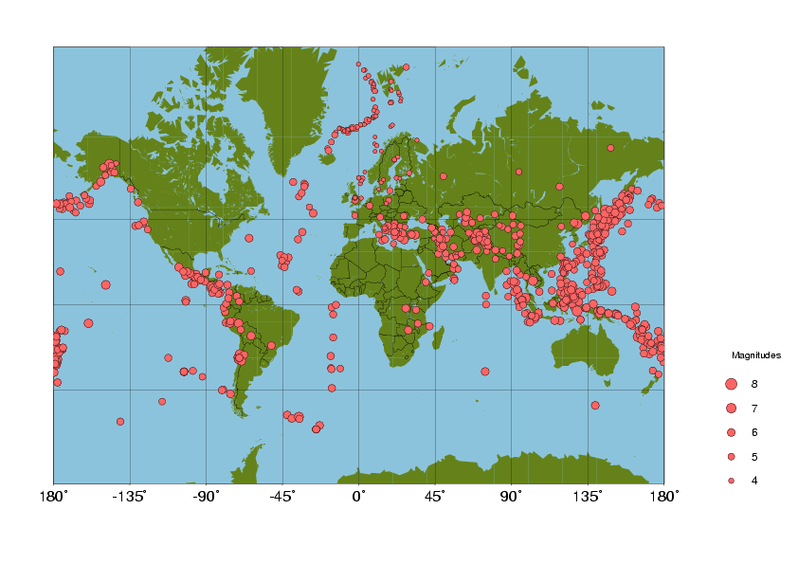
recorded only by NORSAR have M≥5.0.

Table 1a. Monthly statistics of events recorded at each station for January-June 2002. Abbreviations are: Event types: LM=Number of local events recorded
at more than one station, LS=local events recorded at only one station and D=teleseismic events per month.

 | JANUARY |  |  | FEBRUARY |  |  | MARCH |  |  | APRIL |  |  | MAY |  |  | JUNE
STATION | LM | LS | D | LM | LS | D | LM | LS | D | LM | LS | D | LM | LS | D | LM | LS | D
ASK | 17 | 0 | 4 | 18 | 0 | 3 | 16 | 0 | 1 | 19 | 0 | 3 | 47 | 0 | 3 | 29 | 0 | 2
BER | 10 | 0 | 4 | 7 | 0 | 3 | 3 | 0 | 1 | 6 | 0 | 2 | 12 | 0 | 5 | 10 | 0 | 4
BJO1 | 4 | 2 | 5 | 1 | 1 | 1 | 6 | 2 | 5 | 3 | 0 | 6 | 5 | 1 | 5 | 0 | 0 | 0
BLS5 | 15 | 0 | 7 | 10 | 0 | 5 | 13 | 0 | 11 | 18 | 0 | 12 | 27 | 0 | 1 | 19 | 0 | 9
EGD | 18 | 0 | 4 | 16 | 0 | 2 | 13 | 0 | 1 | 16 | 0 | 2 | 41 | 0 | 0 | 23 | 0 | 2
FOO | 9 | 0 | 4 | 6 | 0 | 2 | 11 | 1 | 6 | 18 | 0 | 6 | 24 | 2 | 2 | 16 | 0 | 5
HYA | 15 | 0 | 2 | 14 | 0 | 1 | 11 | 0 | 4 | 18 | 0 | 5 | 28 | 0 | 0 | 21 | 0 | 3
JMI | 17 | 0 | 7 | 11 | 0 | 5 | 4 | 0 | 12 | 5 | 0 | 12 | 10 | 0 | 19 | 14 | 0 | 3
JNE | 18 | 0 | 0 | 12 | 0 | 0 | 6 | 0 | 1 | 12 | 1 | 0 | 14 | 0 | 0 | 17 | 0 | 0
JNW | 18 | 0 | 2 | 12 | 0 | 1 | 6 | 0 | 2 | 11 | 0 | 0 | 14 | 0 | 1 | 17 | 0 | 3
KBS | 16 | 0 | 24 | 8 | 0 | 19 | 32 | 9 | 36 | 10 | 3 | 44 | 23 | 17 | 59 | 14 | 5 | 57
KMY | 15 | 0 | 2 | 14 | 0 | 1 | 18 | 0 | 5 | 28 | 4 | 7 | 45 | 1 | 0 | 28 | 0 | 1
KONO | 9 | 2 | 25 | 9 | 0 | 20 | 10 | 0 | 38 | 11 | 0 | 50 | 11 | 1 | 51 | 8 | 0 | 48
KTK1 | 199 | 104 | 20 | 206 | 118 | 15 | 284 | 143 | 25 | 207 | 101 | 20 | 144 | 24 | 7 | 167 | 57 | 19
LOF | 55 | 2 | 15 | 53 | 0 | 5 | 74 | 3 | 18 | 91 | 5 | 16 | 125 | 9 | 14 | 100 | 2 | 17
MOL | 21 | 10 | 20 | 19 | 9 | 11 | 18 | 7 | 25 | 25 | 7 | 27 | 24 | 4 | 6 | 25 | 3 | 13
MOR8 | 80 | 12 | 18 | 112 | 24 | 21 | 151 | 18 | 36 | 108 | 9 | 32 | 111 | 10 | 29 | 43 | 2 | 8
NORSAR | 0 | 0 | 54 | 0 | 0 | 32 | 0 | 0 | 58 | 0 | 0 | 62 | 0 | 0 | 52 | 0 | 0 | 64
NSS | 0 | 0 | 7 | 30 | 2 | 11 | 26 | 0 | 25 | 21 | 2 | 23 | 40 | 1 | 22 | 42 | 2 | 18
ODD1 | 18 | 0 | 2 | 16 | 0 | 2 | 21 | 0 | 3 | 18 | 0 | 5 | 15 | 0 | 0 | 7 | 0 | 1
OSL | 0 | 0 | 7 | 1 | 0 | 8 | 0 | 0 | 9 | 1 | 0 | 11 | 3 | 0 | 10 | 0 | 0 | 4
RUND | 5 | 0 | 9 | 2 | 0 | 9 | 1 | 0 | 15 | 5 | 0 | 20 | 6 | 0 | 20 | 5 | 0 | 6
STAV | 1 | 0 | 3 | 4 | 0 | 2 | 0 | 0 | 5 | 1 | 0 | 5 | 11 | 0 | 3 | 2 | 0 | 3
SUE | 12 | 0 | 1 | 7 | 0 | 1 | 9 | 0 | 4 | 20 | 0 | 3 | 31 | 0 | 0 | 21 | 0 | 3
TRO | 27 | 0 | 22 | 31 | 0 | 12 | 34 | 0 | 22 | 42 | 0 | 23 | 64 | 0 | 20 | 65 | 0 | 28
TRON | 2 | 0 | 3 | 3 | 0 | 1 | 0 | 0 | 6 | 2 | 1 | 4 | 3 | 0 | 3 | 6 | 0 | 4
NORES | 52 | 0 | 0 | 45 | 0 | 0 | 55 | 0 | 0 | 50 | 0 | 0 | 57 | 0 | 0 | 17 | 0 | 0
SPITS | 23 | 0 | 0 | 16 | 1 | 0 | 27 | 0 | 0 | 22 | 0 | 0 | 11 | 0 | 0 | 17 | 0 | 0
ARCES | 58 | 0 | 0 | 44 | 0 | 0 | 60 | 0 | 0 | 58 | 0 | 0 | 48 | 0 | 0 | 43 | 0 | 0

Table 1b. Monthly statistics of events recorded at each station for July-December 2002. Abbreviations are: Event types: LM=Number of local events
recorded at more than one station, LS=local events recorded at only one station and D=teleseismic events per month.

 | JULY |  |  | AUGUST |  |  | SEPTEMBER |  |  | OCTOBER |  |  | NOVEMBER |  |  | DECEMBER
STATION | LM | LS | D | LM | LS | D | LM | LS | D | LM | LS | D | LM | LS | D | LM | LS | D
ASK | 28 | 0 | 0 | 50 | 1 | 5 | 34 | 0 | 4 | 43 | 0 | 6 | 31 | 0 | 16 | 23 | 0 | 8
BER | 5 | 0 | 0 | 37 | 0 | 4 | 18 | 0 | 2 | 23 | 0 | 1 | 12 | 0 | 15 | 12 | 0 | 7
BJO1 | 5 | 0 | 8 | 2 | 0 | 11 | 3 | 0 | 6 | 1 | 0 | 3 | 1 | 0 | 6 | 0 | 0 | 0
BLS5 | 4 | 0 | 3 | 30 | 0 | 17 | 24 | 0 | 9 | 42 | 0 | 14 | 22 | 0 | 17 | 13 | 0 | 11
EGD | 22 | 0 | 0 | 44 | 0 | 4 | 31 | 0 | 2 | 32 | 0 | 1 | 31 | 0 | 16 | 22 | 0 | 8
FOO | 16 | 0 | 1 | 36 | 1 | 13 | 20 | 0 | 6 | 19 | 0 | 10 | 20 | 0 | 17 | 13 | 0 | 10
HYA | 15 | 0 | 2 | 27 | 0 | 8 | 21 | 0 | 6 | 21 | 0 | 10 | 18 | 0 | 13 | 17 | 0 | 7
JMI | 13 | 0 | 21 | 19 | 0 | 15 | 12 | 0 | 18 | 14 | 0 | 20 | 8 | 0 | 16 | 10 | 0 | 8
JNE | 22 | 0 | 0 | 23 | 0 | 0 | 14 | 0 | 0 | 19 | 0 | 0 | 11 | 0 | 0 | 10 | 0 | 0
JNW | 22 | 0 | 0 | 23 | 0 | 0 | 15 | 0 | 0 | 20 | 1 | 2 | 10 | 0 | 3 | 10 | 0 | 0
KBS | 28 | 7 | 41 | 22 | 6 | 44 | 0 | 0 | 0 | 0 | 0 | 0 | 14 | 1 | 10 | 17 | 0 | 0
KMY | 31 | 0 | 1 | 47 | 0 | 7 | 34 | 1 | 5 | 49 | 0 | 9 | 30 | 0 | 10 | 15 | 0 | 6
KONO | 4 | 0 | 34 | 10 | 2 | 51 | 11 | 0 | 38 | 12 | 0 | 41 | 10 | 0 | 34 | 6 | 0 | 24
KTK1 | 124 | 25 | 11 | 124 | 30 | 13 | 26 | 8 | 2 | 158 | 50 | 31 | 190 | 67 | 35 | 155 | 50 | 18
LOF | 96 | 4 | 13 | 93 | 3 | 19 | 30 | 2 | 19 | 90 | 2 | 23 | 76 | 2 | 26 | 62 | 0 | 16
MOL | 22 | 2 | 9 | 43 | 1 | 21 | 21 | 4 | 19 | 23 | 2 | 26 | 22 | 5 | 26 | 18 | 2 | 16
MOR8 | 9 | 0 | 2 | 98 | 14 | 19 | 41 | 8 | 18 | 115 | 8 | 31 | 124 | 14 | 36 | 95 | 3 | 20
NORSAR | 0 | 0 | 39 | 0 | 0 | 65 | 0 | 0 | 48 | 0 | 0 | 60 | 0 | 0 | 84 | 0 | 0 | 39
NSS | 34 | 0 | 22 | 50 | 3 | 27 | 15 | 0 | 33 | 33 | 2 | 36 | 22 | 0 | 21 | 13 | 0 | 14
ODD1 | 1 | 0 | 0 | 1 | 0 | 2 | 0 | 0 | 0 | 14 | 0 | 4 | 31 | 0 | 9 | 23 | 0 | 6
OSL | 0 | 0 | 4 | 1 | 0 | 5 | 0 | 0 | 5 | 0 | 0 | 5 | 0 | 0 | 8 | 0 | 0 | 4
RUND | 5 | 0 | 11 | 11 | 0 | 14 | 10 | 0 | 19 | 9 | 0 | 24 | 3 | 0 | 16 | 9 | 0 | 10
STAV | 2 | 0 | 1 | 4 | 0 | 7 | 3 | 0 | 4 | 2 | 0 | 4 | 2 | 0 | 9 | 0 | 0 | 1
SUE | 12 | 0 | 2 | 28 | 0 | 9 | 20 | 0 | 5 | 20 | 0 | 9 | 20 | 0 | 11 | 12 | 0 | 7
TRO | 72 | 0 | 17 | 59 | 0 | 29 | 22 | 2 | 23 | 45 | 0 | 33 | 41 | 0 | 38 | 38 | 0 | 18
TRON | 3 | 0 | 1 | 8 | 0 | 7 | 2 | 2 | 3 | 1 | 0 | 6 | 0 | 0 | 14 | 0 | 0 | 3
NORES | 0 | 0 | 0 | 0 | 0 | 0 | 0 | 0 | 0 | 0 | 0 | 0 | 0 | 0 | 0 | 0 | 0 | 0
SPITS | 24 | 0 | 0 | 21 | 1 | 0 | 25 | 4 | 0 | 17 | 1 | 1 | 29 | 0 | 0 | 33 | 0 | 0
ARCES | 57 | 0 | 0 | 52 | 0 | 0 | 47 | 0 | 0 | 70 | 0 | 1 | 66 | 0 | 0 | 62 | 0 | 0

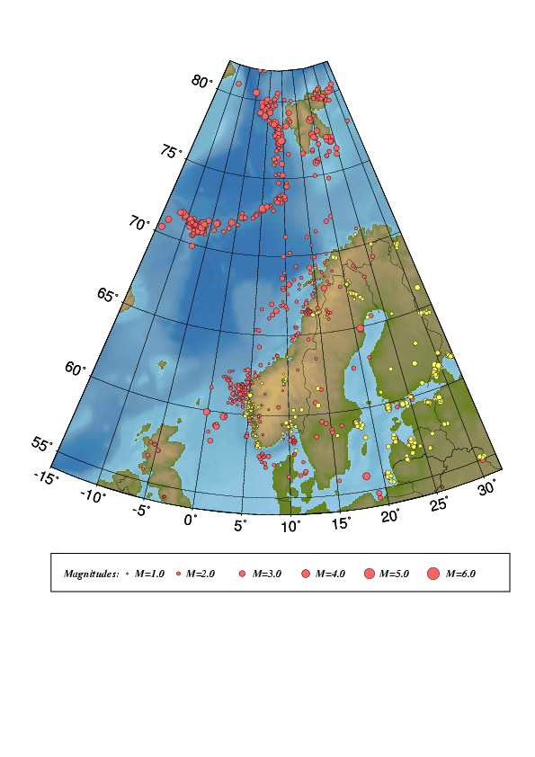

Figure 4. Epicentre distribution of events analysed and located from January through December, 2002.
Earthquakes are plotted in red and probable and known explosions in yellow.
For station locations, see Figure 1.

Figure 5. Epicentre distribution of located events with one of the calculated magnitudes above or equal

to 3.0. All earthquakes are listed in Table 2. For station locations, see Figure 1.

Table 2. Local and regional events with any magnitude ≥ 3.0 for the time period January
trough December, 2002, in the area between 54°N-82°N and 15°W-32°E. For depth determination, see section 5.

Year MODA HRMM Sec d Latitud Longitud Depth F AGA NST RMS Mc Ml Mw
------------------------------------------------------------------------------------
2002 1 5 0954 38.6 L 71.454 -9.533 15.0 F BER 3 0.1 2.8 3.0
2002 1 5 1914 52.9 L 71.246 -6.746 8.0 F BER 3 0.4 2.1 3.0
2002 111 1714 12.4 L 76.471 24.852 17.0 F BER 10 2.5 3.1 2.7
2002 117 0205 24.8 L 71.297 -8.507 10.0 F BER 3 0.5 2.5 3.2
2002 120 1250 37.9 L 64.812 20.940 15.0 F BER 12 1.5 3.7 2.8
2002 123 1120 10.4 L 80.493 -0.264 17.0 F BER 13 1.3 3.3 3.3
2002 124 1955 49.7 L 75.901 18.983 15.0 F BER 8 1.3 3.2 3.1
2002 127 0426 31.0 L 75.841 18.663 15.0 F BER 6 1.7 3.3 3.1
2002 2 8 2357 4.0 L 76.368 8.344 10.0 F BER 7 1.4 3.1 2.5
2002 2 9 2148 10.3 L 75.215 9.523 10.0 F BER 10 1.4 3.8 2.8
2002 211 2122 11.7 L 73.644 8.321 10.0 F BER 16 1.6 3.1
2002 214 1900 43.3 L 59.760 2.003 21.0 F BER 49 1.6 3.1 3.3 3.1
2002 217 1246 39.7 L 70.991 -6.355 10.0 F BER 11 0.6 3.6 3.7
2002 3 5 0805 55.0 L 71.219 -7.356 10.0 F BER 3 0.2 2.3 3.2
2002 3 5 2306 29.4 L 69.998 9.606 10.0 F BER 13 1.3 3.0 2.0 2.2
2002 3 7 1152 30.7 L 79.855 3.568 10.0 F BER 10 0.8 3.4 2.8
2002 310 1228 3.8 L 78.661 18.826 15.0 F BER 11 2.1 3.6 3.4
2002 313 2232 30.3 L 72.003 18.607 22.0 F BER 13 1.5 3.0 2.3
2002 4 7 0026 35.0 L 71.964 -1.003 10.0 F BER 9 1.1 3.5 2.3
2002 4 8 0355 44.0 L 73.685 9.144 10.0 F BER 12 1.8 3.4 2.6
2002 4 8 1445 13.9 L 73.805 9.004 15.0 F BER 13 1.3 3.3 2.7
2002 411 2018 59.6 L 64.884 21.041 15.0 F BER 16 1.7 3.8 3.4
2002 5 5 1719 34.3 L 72.897 5.474 10.0 F BER 5 0.4 3.1 2.4
2002 512 1058 51.6 L 79.846 3.163 10.0 F BER 7 1.3 3.2 3.2
2002 515 1528 32.3 L 71.583 -10.484 10.0 F BER 3 0.1 2.5 3.1
2002 517 0315 37.3 L 72.592 4.010 10.0 F BER 13 1.3 3.2 2.5
2002 527 0658 50.8 L 78.690 7.456 19.0 F BER 13 1.6 3.7 3.7
2002 528 0543 37.3 L 78.300 8.432 10.0 F BER 4 0.9 3.4 3.7
2002 6 2 0925 45.8 L 70.978 -6.826 10.0 F BER 3 0.2 2.6 3.1
2002 7 4 1212 3.9 L 76.093 24.551 13.0 F BER 3 0.7 3.0 2.5
2002 7 4 2258 59.1 L 78.513 7.114 10.0 F BER 11 1.4 3.3 3.0
2002 7 4 2315 53.0 L 77.020 23.837 22.0 F BER 8 1.0 3.1 3.3
2002 7 8 1752 34.9 L 71.135 -7.039 15.0 F BER 3 0.1 2.5 3.2
2002 710 1413 14.0 L 73.069 5.202 10.0 F BER 13 1.5 4.0 3.6 4.0
2002 714 1531 47.2 L 56.445 11.636 15.0 F BER 3 1.3 3.0 2.1
2002 716 1447 9.3 L 70.787 -12.902 10.0 F BER 5 1.0 3.6 3.2
2002 720 0126 10.2 L 72.257 19.696 15.0 F BER 8 1.1 3.2 2.2
2002 8 1 0651 5.4 L 77.958 8.499 10.0 F BER 3 1.0 3.7 3.0
2002 811 0756 33.2 L 73.185 5.992 10.0 F BER 15 1.9 3.5 2.8
2002 812 0542 38.0 L 71.265 -8.296 10.0 F BER 3 0.2 2.2 3.4
2002 813 1617 6.2 L 79.141 3.407 10.0 F BER 6 0.9 3.1 2.9
2002 814 1342 0.2 L 77.630 8.665 10.0 F BER 3 1.6 3.2 3.0
2002 817 1129 15.0 L 74.490 10.557 10.0 F BER 11 1.5 3.5 2.6
2002 825 0443 29.7 L 58.184 0.817 10.0 F BER 52 1.7 3.0 2.6
2002 828 1217 42.3 L 71.218 -8.440 18.0 F BER 3 0.0 2.5 3.1
2002 9 6 1230 46.2 L 61.629 3.502 13.0 F BER 20 1.2 2.7 2.7 2.8
2002 9 9 2314 0.6 L 74.728 8.682 10.0 F BER 11 1.6 2.5 2.3
2002 912 2308 6.6 L 65.514 22.935 15.0 F BER 8 1.8 3.3 2.1
2002 914 0247 16.3 L 77.435 9.965 20.0 F BER 2 0.0 3.0
2002 914 0440 45.1 L 59.114 1.277 10.0 F BER 30 0.5 2.9
2002 917 1949 58.3 L 72.300 1.141 10.0 F BER 7 1.0 3.2 2.4
2002 918 0233 41.7 L 72.321 0.973 10.0 F BER 9 1.5 3.4 2.7
2002 928 0236 41.8 L 71.957 -1.188 10.0 F BER 14 1.5 3.7 3.1
2002 10 3 1644 3.0 L 59.462 14.467 15.0 F BER 6 1.8 3.1 2.4
2002 1010 0840 3.6 L 70.922 -6.606 10.0 F BER 12 1.3 3.4 3.1
2002 1012 0042 26.1 L 59.925 -0.037 10.0 F BER 24 0.8 2.9 2.6 2.4
2002 1012 0346 48.6 L 71.705 -3.869 10.0 F BER 24 1.8 4.0 3.1
2002 1017 0521 35.2 L 68.600 9.313 5.0 F BER 13 1.5 3.0 2.5
2002 1018 1450 26.4 L 71.683 -4.001 4.0 F BER 16 0.8 3.3 3.2 3.7
2002 1020 1440 58.3 L 71.475 -7.015 11.0 F BER 6 0.7 3.7 3.3
2002 1021 0048 20.6 L 71.103 -6.798 10.0 F BER 3 0.1 2.5 3.0
2002 1023 0908 21.5 L 77.702 18.843 15.0 F BER 2 0.8 3.0
2002 1023 1216 47.7 L 80.165 27.964 13.0 F BER 10 1.1 4.4 3.9
2002 1029 0320 45.3 L 73.881 10.281 10.0 F BER 8 1.3 3.3 2.4
2002 1030 0630 14.7 L 71.728 -11.153 10.0 F BER 3 0.2 2.9 3.0
2002 11 3 0643 42.3 L 71.025 -9.098 14.5 F BER 3 0.2 3.0
2002 1113 2047 1.2 L 79.370 6.282 10.0 F BER 5 1.4 2.7 2.9
2002 1114 1609 20.9 L 71.463 -9.345 10.0 F BER 3 0.6 3.1 3.0
2002 1115 0348 18.4 L 66.930 13.159 5.0 F BER 11 1.7 3.0 2.1
2002 1130 2316 16.1 L 71.253 -8.671 10.0 F BER 3 0.2 2.4 3.0
2002 12 3 1305 33.3 L 59.828 24.114 15.0 F BER 4 1.9 3.0
2002 1210 0105 43.5 L 68.197 10.469 14.0 F BER 17 1.1 3.2 2.6
2002 1215 0907 24.4 L 71.510 -6.916 8.0 F BER 3 0.2 2.4 3.0
2002 1218 2102 52.0 L 71.185 -6.816 13.0 F BER 3 0.1 3.0 3.4
2002 1218 2114 22.1 L 55.877 18.286 15.0 F BER 17 2.1 4.5 3.5
2002 1223 0616 40.9 L 77.498 19.213 13.0 F BER 5 1.4 3.0
2002 1226 0841 50.1 L 71.385 -6.546 10.0 F BER 3 0.3 1.8 3.0
2002 1227 1021 5.7 L 71.560 -11.992 10.0 F BER 3 0.3 2.7 3.0

Abbreviations are: date: year, mo = month, da = day, origin time UTC: hr = hour, mi = minutes, sec = seconds, m= model identification (blank=standard model, J=Jan Mayen model, L=only nearest stations used), d = distance identification (L=local, R=regional, D=teleseismic)
e=event identification (*=well recorded, P=probable explosion, E=known explosion)
location: lat = latitude, long=longitude, depth = focal depth (km) F: fixed depth
agency: (BER=Bergen, NAO=NORSAR, PDE=Preliminary Determination of Epicentres)
nst = number of stations, rms = root mean square of the travel-time residuals
magnitudes: magnitude type (C=coda, L=local, B=body wave, W=moment)

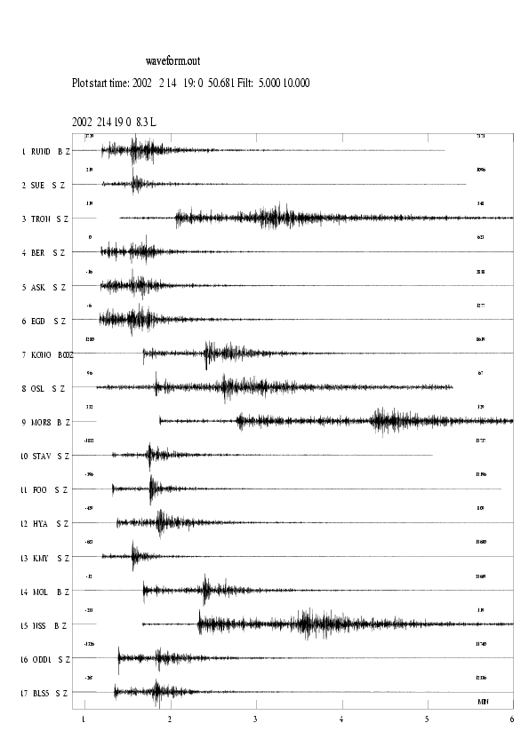
Figure 6. Seismograms for the earthquake on February 14th 2002 at 19:00 (UTC). The seismograms are
Filtered between 5-10Hz. The station abbreviations are: RUND=Rundemannen, SUE=Sulen,
TRON=Trondheim, BER=Bergen, ASK=Askøy, EGD=Espegrend, KONO=Kongsberg,
OSL=Oslo, MOR8=Mo i Rana, STAV=Stavanger, FOO=Florø, HYA=Høyanger, KMY=Karmøy,
MOL=Molde, NSS=Namsos, ODD=Odda and BLS=Blåsjø.

Jan Mayen

The Jan Mayen island is located in an active tectonic area with two major structures, the mid Atlantic ridge and the Jan Mayen fracture zone interacting in the vicinity of the island. Due to both the tectonic and magmatic activity in the area, the number of recorded earthquakes is higher than in other areas covered by Norwagian seismic stations. During 2002 a total of 123 earthquakes were located as seen on Figure 7 and of these 25 were calculated to have a magnitude equal to or above 3.0.

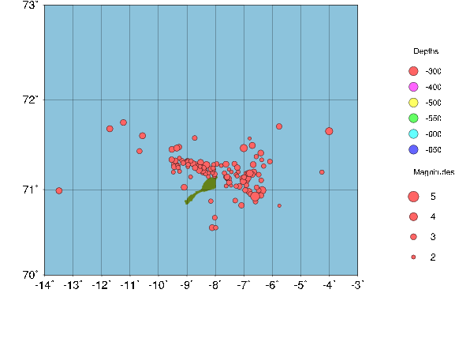
Figure 7. Earthquakes recorded in the vicinity of the Jan Mayed island during 2002.

5. Well recorded earthquakes

Since January, 1995, well recorded earthquakes have been selected during the daily analysis and specially marked in the NNSN data base. The event selection is based on signal to noise ratio and the number of recording stations, which entails that both small events near the network and large events further away have been selected. In a few cases also location has been a qualification to mark an event as an event of special interest. These events are studied in greater detail than the other events. Additional phase readings and waveform data are collected if available, mainly from NORSAR and BGS. Particularly the location and the depth estimates are checked. For each event the rms-vs-depth plot is checked and if possible the event is located using only the nearest stations (D< 200 km) to check if this gives a better location with a well constrained depth. If this is the case, the depth is fixed and the event is relocated using all stations. If no reasonable depth can be determined, the depth is fixed at 15 km for continental earthquakes and at 10 km for oceanic. The same principle for depth determination is also used for the local and regional events with magnitude equal to or above 3.0. For this report 14 special events have been analysed (see Table 3). The locations of these events are shown in Figure 8.

Focal Mechanisms

None of the 14 well-recorded events had enough polarities to determine the focal mechanism.
Table 3. List of 14 well recorded events in 2002.

Year MoDa HrMi Sec d Latitud Longitud Depth FF AGA NS RMS Mc Ml Mb Mw STRIK DIP RAKE Mo St f0 r
---------------------------------------------------------------------------------------------------------------------
2002 110 0828 48.3 L 61.783 4.004 10.0 F BER 17 1.4 2.5 2.9 2.6 12.9 9.4 7.46.1817
2002 3 4 1513 46.7 L 61.993 5.194 15.0 F BER 12 1.3 2.2 1.8 2.1 12.3 6.911.09.1222
2002 4 5 0810 2.3 L 61.580 2.472 12.0 F BER 9 1.0 2.3 1.6 1.9 11.90.847 6.87.1857
2002 424 1140 6.3 L 61.582 4.207 5.0 F BER 21 1.6 2.6 2.9 2.7 13.1 7.5 6.10.2215
2002 5 3 0752 54.4 L 60.038 4.616 15.0 F BER 13 1.2 1.8 2.0 2.2 12.40.191 3.34.3793
2002 5 9 1846 10.3 L 61.705 4.140 15.0 F BER 20 1.5 2.6 2.5 2.6 13.00.927 3.37.3842
2002 524 0149 40.4 L 61.730 3.249 11.0 F BER 23 1.0 2.7 2.4 2.4 12.6 3.4 6.90.1997
2002 817 2006 6.3 L 61.121 4.034 14.0 F BER 11 0.7 2.1 1.6 1.9 11.9 1.1 8.37.1592
2002 9 6 1230 46.2 L 61.629 3.502 13.0 F BER 20 1.2 2.7 2.7 2.8 13.2 21.3 7.36.1917
2002 916 1848 31.9 L 67.054 -17.919 10.0 F BER 22 1.7 4.5 3.7 5.5
2002 924 1012 43.8 L 60.095 4.878 15.0 F BER 16 1.5 1.8 1.9 2.0 12.10.296 4.59.2788
2002 1012 0042 26.1 L 59.925 -0.037 10.0 F BER 24 0.8 2.9 2.6 2.4 12.7 5.6 7.94.1602
2002 11 2 0526 58.4 L 61.235 3.011 10.0 F BER 13 0.6 1.8 1.9 2.0 12.1 1.1 6.76.2194
2002 12 7 0120 23.8 L 61.587 3.667 10.0 F BER 13 1.3 2.2 2.1 2.1 12.2 1.2 6.76.1893

Abbreviations are:
date: year mo = month da = day, origin time given in UTC: hr = hour mi = minutes sec = seconds, d = distance identification (L=local, R=regional, D=teleseismic);
location: latitud = latitude, longitud=longitude depth = focal depth (km); FF= fixed depth and location; AGA=reporting agency; NS = number of stations; RMS = root mean square of the travel-time residuals, magnitudes: magnitude type (C=coda, L=local, B=body wave, W=moment); focal mechanism (strike, dip and rake);
MO = log of seismic moment in Nm, ST = stress drop in bar, f0 = corner frequency in Hz, R = source radius in km.

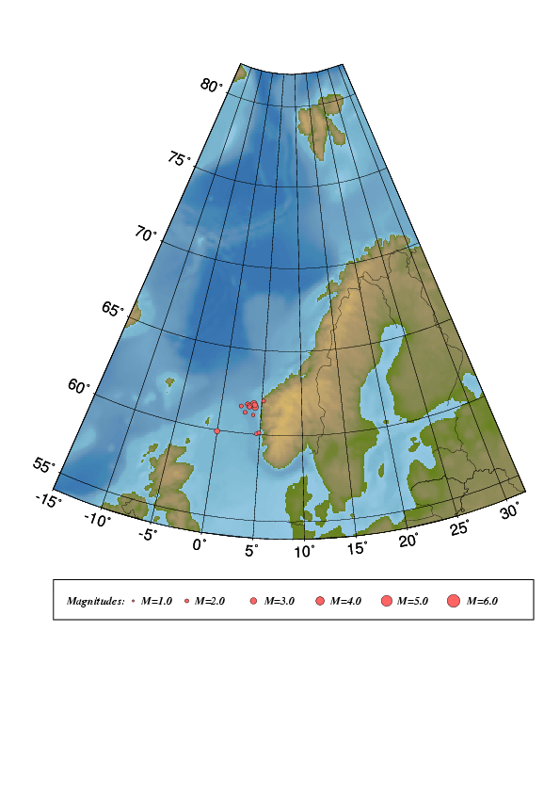

Figure 8. Epicentre distribution of well recorded events in 2002. For station
locations, see Figure 1.

6. Felt earthquakes

Five earthquakes were reported felt during 2002 (see Table 4 and Figure 10). None of the earthquakes reported felt in Norway were felt by a sufficient number of people for questionnaires to be distributed as basis for isoseismal maps.

Table 4 Earthquakes felt and recorded in the BER database between January and December, 2002.
Abbreviations: Mc; Coda magnitude, Ml; Local magnitude and Mw; Moment magnitude.

Date | Time (UTC) | Max. Intensity (on MMI scale) | Magnitude (BER) | Instrumental Epicentre Location
07.06.02 | 22:18 | III | M_{C} =2.7, M_{L} =2.2 | 66.45N / 13.60E
09.06.02 | 06:44 | III | M_{C} =2.9, M_{L} =2.3 | 59.46N / 6.16E
27.06.02 | 11:22 | III | M_{C} =1.5, M_{L} =1.5 | 59.60N / 6.48E
16.11.02 | 12:27 | III | M_{C} =2.4, M_{L} =2.3 | 61.21N / 5.07E
21.11.02 | 07:03 | III | M_{C} =2.8, M_{L} =2.7 | 67.80N / 16.35E

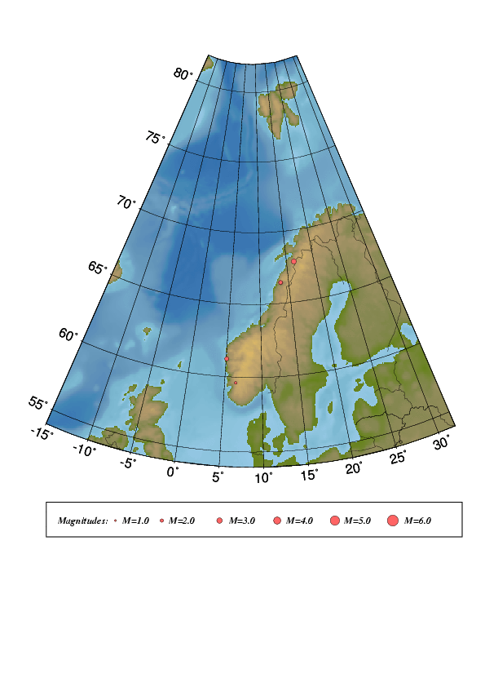
Figure 10. Locations of the five earthquakes felt during 2002.

7. Use of NNSN data during 2002

Data collected on Norwegian seismic stations are made available through the Internet and is provided on request to interested parties. The use and publication of this data is beyond our control.

Publications and reports

Atakan, K., 2001. Jordskjelv dreper ikke, men bygninger gjør. Populærvitenskapelig manuskript P2-Akademiet, Engers Boktrykkeri as., Otta, pp. 68-77.

Atakan,K. and Ojeda,A. 2002. Stress transfer as a potential triggering mechanism for the Storegga submarine slide. Storegga-Stress Project Final Report (Confidential), Report No. UiB/IFJ-NH-2002-StS01, Prepared for Norsk Hydro a.s., Sandvika, Norway, August 2002.

Atakan,K., Ojeda,A., Pascal,C., and Gabrielsen,R.H. 2002. Potential Influence of the Møre-Trøndelag Fault Complex on the Storegga submarine slide. IN: A.Hurst (Ed.) ‘Onshore-offshore relationships on the North Atlantic Margin’, Proceedings of the Norwegian Geological Society, NGF 2-2002. 15-18.
Bormann P. (2002): IASPEI New Manual of Seismological Observatory Practice. GeoForschungsZentrum, 3 Chapter, ISBN 3-9808780-0-7
Bungum, H. (2002): Norwegian neotectonics in a global perspective. In: Proceedings, Onshoreoffshore relationships on the North Atlantic Margin, Norsk Petroleumsforening, Trondheim,

Dost, B, J. Zednik , J. Havskov, R. Willemann and P. Bormann (2002) Data Archival,
Exchange and Seismic Data Formats. Chapter 10 in ’ New Manual of Seismological
Observatory Practice’, ’ New Manual of Seismological Observatory Practice, Vol 1,
editor Peter Borrmann, published by GeoForschungsZentrum Potsdam, Germany, 20 pp

Havskov,J., Tvedt,E., and Atakan,K. 2002. Seismisk aktivitet i nord-Norge siden 1980. Ottar (Populær vitenskapelig tidsskrift fra Tromsø Museum) 3.2002, Nr.241, 40-46.

Havskov, J and P. Bormann and J. Sweitzer (2002). Earthquake location. In ’ New Manual of Seismological Observatry Practice’, ’ New Manual of Seismological Observatory Practice, Vol 2, editor Peter Borrmann, published by GeoForschungsZentrum Potsdam, Germany, 28 pp.

Havskov, J. and L. Ottemøller (2002). SEISAN earthquake analysis and SEISNET network automation software, International handbook of Earthquake and Engineering Seismology, 81B, 15 – 16.

Havskov, J. And G. Alguacil (2002). Trends in seismic instrumentation, extended abstract for ’Primer centenario del observatorio de Cartuja’, 9pHicks, E.C. (2002): Local and regional seismicity and crustal stresses in Norway and surrounding areas. Dissertation for the degree Doctor Scientiarum, Faculty of Mathematics and Natural Sciences, University of Oslo, 126 pp.

Hicks, E.C., T. Kværna, S. Mykkeltveit, J. Schweitzer & F. Ringdal (2002): Travel times and attenuation relations for regional phases in the Barents Sea region, In: Tech. Summ., 1 Jul - 31 Dec 2001, NORSAR Sci. Rep. 1-2002, Kjeller, Norway.
Holden, L., S. Sannan and H. Bungum (2002): A stochastic marked point process model for earthquakes. Natural Hazards and Earth System Sciences, 2, 1-7.

Klinge, K. J. Schweitzer & P. Bormann (2002): DS11.4: Record examples of underground nuclear explosions. In: Bormann, P. (Ed.) (2002). IASPEI New Manual of Seismological Observatory Practice (NMSOP), GeoForschungsZentrum Potsdam, Vol 2.
Kremenetskaya, E.O., S. Baranov, V.E. Asming & F. Ringdal (2002): Monitoring the seismicity of the Spitsbergen archipelago, In: Semiannual Tech. Sum., 1 July - 31 December 2001, NORSAR Sci. Rep. 2-2001Kjeller, Norway.
Kværna, T. (2002): Estimating global and regional IMS detection capability, In: Semiannual Tech. Summ., 1 July - 31 December 2001, NORSAR Sci. Rep. 1-2002, Kjeller, Norway. Page 2

Kværna, T., E. Hicks, J. Schweitzer & F. Ringdal (2002): Regional Seismic Threshold Monitoring, In: Semiannual Tech. Summ., 1 January - 30 Jun 2002, NORSAR Sci. Rep. 2-2002, Kjeller, Norway.
Kværna, T., E. Hicks, J. Schweitzer & F. Ringdal (2002): Regional Seismic Threshold Monitoring. 24th Seismic Research Review: Nuclear Explosion Monitoring: Innovation and Integration. Ponte Vedra Beach, Florida, September 17-19, Proceedings, CD-version file 07-03; Volume 2, 859-868.
Lindholm, C.D. (2002): Site-specific hazard for the Ormen Lange field and postglacial earthquakes in the larger Møre region. Rep. prepared for Norsk Hydro.
Lindholm, C.D. (2002): Site-specific hazard for the Ormen Lange field and postglacial earthquakes in the larger Møre Region. Update report. Rep. prepared for Norsk Hydro, December.
Lindholm, C., H. Bungum, J. I. Faleide & M. Roth (2002): Site specific hazard for the Ormen Lange field and postglacial earthquakes in the larger Moere region. Update report for Norsk Hydro, December 2002
Lindholm, C., S. Gibbons, T. Kvaerna & F. Ringdal (2002): Analysis of seismic decoupling. Quarterly NORSAR Sci. Rep.1-2002, Kjeller, Norway. Report for SAIC, July.
Lindholm, C., S. Gibbons, T. Kvaerna & F. Ringdal (2002): Analysis of seismic decoupling. Quarterly report for SAIC, October. Page 3
Molina, S., C.D. Lindholm and H. Bungum (2001): Probabilistic seismic hazard analysis: Zoning free versus zoning methodology. Boll. di Geofis. Teor. ed Appl., 42, pp. 19-40
NORSAR (2002): Analysis and Processing of Events from the Kovdor Mine, Kola, NW Russia, Report prepared for US Dept. of Energy, Lawrence Livermore Natnl. Laboratory, NORSAR Contribution No. 793.
Ottemöller,L. and Midzi,V. 2003. The crustal structure of Norway from inversion of teleseismic receiver functions. Journal of Seismology 7 (1):35-48, January 2003.

Trnkoczy, A, J. Havskov, L. Ottemöller and Peter Bormann (2002). Seismic networks.

Chapter 8 in ’ New Manual of Seismological Observatory Practice, Vol 1, editor Peter
Borrmann, published by GeoForschungsZentrum Potsdam, Germany, 59 pp

Tvedt, E., J. Havskov, K. Atakan, B. Storheim and A. L Kjærgaard (2002). Seismicity of Norway 1900-2000, report, Institute of Solid Earth Physics, University of Bergen, 63 pp.

Schweitzer, J. (2002): Simultaneous inversion of steep-angle observations of PcP and ScP in Europe what can we learn about the core-mantle boundary? Geophys. J. Int. 151, 209-220.
Schweitzer, J. (2002): Some results derived from the seismic signals of the accident of the Russian submarine Kursk. In: Semiannual Tech. Sum., 1 July 2001 - 31 December 2001, NORSAR Sci. Rep. 1-2002, Kjeller, Norway.
Schweitzer, J., J. Fyen, S. Mykkeltveit & T. Kværna (2002). Chapter 9: Seismic Arrays. In: Bormann, P. (Ed.) (2002). IASPEI New Manual of Seismological Observatory Practice (NMSOP), GeoForschungsZentrum Potsdam, Vol. 1, 52 pp.
Schweitzer, J.& B.L.N. Kennett (2002): Comparison of location proceduresùthe Kara Sea event of 16 August 1997. In: Semiannual Tech. Sum., 1 July 200 - 31 December 2002, NORSAR Sci. Rep. 1-2002, Kjeller, Norway.
Schweitzer, J. & T. Kværna (2002): Design study for the refurbishment of the SPITS Array (AS72). In: Semiannual Tech. Sum., 1 January - 30 June 2002, NORSAR Sci. Rep. 2-2002, Kjeller, Norway.

Oral and poster presentations

Atakan, K. 2002. Stress triggering as a potential mechanism for the Storegga Slide. Seminar on ‘Ormen Lange, Slope Stability and Submarine Slides’, Losby, Lørenskog, Norway, 12-13 March 2002.

Atakan, K. 2002 (invited). Jordskjelvrisiko i Norge og konsekvenser for byggninger. Seminar arranged by ’Norsk Naturskadepool’, Trondheim, Norway, 19 September 2002.

Atakan, K. and Ojeda, A. 2002 (invited). Stress-transfer as a potential triggering mechanism for the Storegga submarine slide. Ormen Lange Seminar, arranged by Norsk Hydro a.s., Norway. Soria Moria, Oslo, Norway, 4-5 Sept.2002 (presented by Anders Solheim).

Atakan, K., Ojeda.A., Pascal,C. and Gabrielsen,R.H. 2002. Potential influence of the Møre-Trøndelag Fault Complex on the Storegga submarine slide. Onshore Offshore Relationships in the North Atlantic Margin. Trondheim, Norway, 7-9 October 2002.

Braunmiller, J., Ottemöller,L., Jensen,S.L., Ojeda,A. and Atakan,K. 2002. The May 7, 2001 Ekofisk Earthquake, North Sea. Deutsche Geophysikalische Gesellschaft e.V. (DGG) German Geophysical Society Meeting, Hannover, Germany, March 3-8, 2002.
Bungum, H.: Ormen Lange earthquake hazard update. Seabed and Merocean Work Meeting: Ormen Lange Results Update and Slide Issues, Soria Moria, Oslo, 4-5 September 2002.
Bungum, H.: A new stochastic model for earthquakes and its application to synthetic catalog generation. 33rd Nordic Seminar on Detection Seismology, Lahti, Finland, 25-27 September 2002.
Bungum, H.: Holocene seismicity at the Norwegian continental margin; observations and models. 33rd Nordic Seminar on Detection Seismology, Lahti, Finland, 25-27 September 2002. Page 5
Bungum, H.: Norwegian neotectonics in a global perspective. NPF Conference on Onshore-Offshore Relationships on the North Atlantic Margin, Trondheim, 7-9 October 2002.

Gibbons, S.J., C. Lindholm & T. Kvaerna: Analysis of seismic decoupling. 33rd Nordic Seminar on detection seismology, Lahti, Finland, 25-27 September 2002.

Havskov, J. And G. Alguacil (2002). Trends in seismic instrumentation, ’Primer centenario del observatorio de Cartuja’

Hicks, E.C., T. Kværna, S. Mykkeltveit, J. Schweitzer & F. Ringdal: Travel times and attenuation relations for regional phases in the Barents Sea region, 33rd Nordic Seminar on Detection Seismology, Lahti, Finland, 25-27 September 2002.

Kværna, T., J. Schweitzer & J. Fyen: Automatic Processing of Regional and Teleseismic Events at NORSAR. European Seismological Commission (ESC), XXVIII General Assembly, Genoa, Italy, 1-6 September 2002.

Ottemöller,L., Braunmiller,J., Havskov,J. and Atakan,K. 2002. The Ekofisk seismic event of May 7, 2001. European Seismological Commission (ESC) XXVIII General Assembly, Genoa, Italy, 1-6 September 2002.

Schweitzer, J. & B.L.N. Kennett: Comparison of location procedure - the Kara Sea event of 16 August 1997. 4th Workshop on IMS Location Calibration and Screening, Oslo, 22-26 April 2002.
Schweitzer, J: Analysis of seismic data from arrays, IMS Technical Training Programme, Hailar, China, 29 June - 2 July 2002 (invited lesson).
Schweitzer, J.: Some results derived from the seismic signals of the Kursk accident, ESC, Genova.
Schweitzer, J.: Einige seismologische Untersuchungen zum Kursk-Unglück, (AG Seismologie, talk). 16 August 1997, ESC, Genova, September 2002.

8. References

Alsaker A., L.B. Kvamme, R.A. Hansen, A. Dahle and H. Bungum 1991. The ML scale in Norway, Bull. Seism. Soc. Am., Vol. 81, No. 2, pp.379-398.

Brune J.N. 1970. Tectonic stress and spectra of seismic shear waves. Journal of Geophysical Research, 75, 4997-5009.

Grünthal, G., (1998). "European Macroseismic Scale 1998", Cahiers du Centre Européen de
Géodynamique et de Séismologie Volume 15, Luxembourg.

Havskov J., and H. Bungum 1987. Source parameters for earthquakes in the northern North
Sea, Norsk Geologisk Tidskrift,Vol.67, pp 51-58.

Havskov, J. and L. Ottemöller, 1999. SEISAN earthquake analysis software, Seism. Res.
Letters, Vol. 70, pp. 532-534.

Kanamori, H. 1977: The energy release in great earthquakes. Journal of Geophysicsl Research
82; 20, pp2981-2987.

Karnik, V., Kondorskaya, N.V., Yu. V. Riznichenko, Ye. F. Savarensky, S.L. Solovev., N.V. Shebalin, J. Vanek, and A. Zatopek 1962. Standardisation of the earhquake magnitude
scales. Studia Geophys. et Geod., Vol. 6, pp. 41-48.

Kennett, B.L.N. and E.R. Engdahl 1991. Traveltimes for global earthquake location and phase
identification, Geophys. J. Int., Vol. 105, pp. 429-465.

Lienert, B.R. and Havskov, J., 1995. HYPOCENTER 3.2 A computer program for locating earthquakes locally, regionally and globally. Seismological Research Letters,
Vol. 66, 26-36.

Moreno, B, L. Ottemöller, J. Havskov and K.A. Olesen, 2002: Seisweb: A Client-Server-
Architecture-Based Interactive Processing Tool for Earthquake Analysis. Seism. Res.
Letters. Vol.73, No.1

Ottemöller, L., (1995). Explosion filtering for Scandinavia. Technical Report No. 2, Institute

of Solid Earth Physics, University of Bergen, Norway.

Sørnes A. and T. Navrestad 1975. Seismic survey of Jan Mayen. Norsk Polarinstitutt, Årbok

37-52.

Veith K.F., and G.E. Clawson 1972. Magnitude from short-period P-wave data. Bull. Seism.
Soc. Am., Vol. 62, pp.435-452.

Westre S. 1975. Richter's lokale magnitude og total signal varighet for lokale jordskjelv på

Jan Mayen. Cand. real thesis., Seismological Observatory, University of Bergen,

Norway.

APPENDIX 2

The NORSAR regional arrays.

The NORSAR Regional Arrays
NORSAR operates the three regional seismic arrays NORES (southern Norway), ARCES (near Karasjok, Finnmark) and SPITS (on Svalbard). In addition, data from NORSAR (the original large aperture array in southern Norway), FINES (in Finland), HAGFORS (southern Sweden), KBS (Kings Bay on Svalbard), KONO (Kongsberg, southern Norway), JMI (Jan Mayen) and APATITY (near Murmansk, Russia) are collected and analyzed.
- Systems Recording Performance
The arrays have continuous data recording. In 2002 the average recording time for the SPITS array was 98.78%, for the ARCES array 99.59%, for the NORES array 88.92%, and for the NORSAR array 100%. NORES was completely destroyed by a lightening induced fire on June 11 at 12:04.
The recording performance in terms of monthly uptime statistics is shown in Table 1.
 | NORES | ARCES | SPITS | NORSAR
January | 100 % | 99.94 % | 92.07 % | 100 %
February | 99.95 % | 95.21 % | 93.63 % | 100 %
March | 98.58 % | 100 % | 99.98 % | 100 %
April | 99.98 % | 99.93 % | 99.94 % | 100 %
May | 99.99 % | 100 % | 100 % | 100 %
June | 35 % | 100 % | 99.98 % | 100 %
July | 0 % | 100 % | 100 % | 100 %
August | 0 % | 100 % | 100 % | 100 %
September | 0 % | 100 % | 99.92 % | 100 %
October | 0 % | 100 % | 100 % | 100 %
November | 0 % | 100 % | 99.87 % | 100 %
December | 0 % | 100 % | 99.99 % | 100 %

Table 1. Systems recording performance (uptime in % of theoretical) for four arrays operated by NORSAR in 2002.

- Detections
The NORSAR analysis results are based on automatic phase detection and automatic phase associations which produce the automatic bulletin. Based on the automatic bulletin a manual analysis of the data is done, resulting in the reviewed bulletin (which is available under the NORSAR web pages). This procedure is often referred to as the Regional Monitoring System (RMS), and has been in operation since 1989. To reduce the work load on the analyst, the Generalized Beam Forming (GBF) is used as a pre-processor to RMS, so that only phases associated with selected events in northern Europe are considered in the automatic RMS phase association. However, all detections are available for analyst screening and review.
Table 2 gives a summary of the phase detections and events declared by the RMS.

 | Jan. | Feb. | March | April | May | June
Phase detections | 115917 | 106190 | 160733 | 161223 | 215085 | 171119
Associated phases | 4318 | 3513 | 6828 | 5245 | 6576 | 4226
Un-associated phases | 111599 | 102677 | 153905 | 155978 | 208509 | 166893
Events automatically declared by RMS | 783 | 646 | 1388 | 976 | 1287 | 855
No. of events defined by the analyst | 76 | 76 | 82 | 68 | 66 | 66
 | July | Aug. | Sep. | October | Nov. | Dec.
Phase detections | 171290 | 174227 | 209691 | 197836 | 193039 | 185678
Associated phases | 4244 | 5044 | 6823 | 6289 | 4236 | 5280
Un-associated phases | 167046 | 169183 | 202868 | 191547 | 188803 | 180398
Events automatically declared by RMS | 922 | 1160 | 1647 | 1445 | 931 | 1109
No. of events defined by the analyst | 72 | 62 | 77 | 83 | 79 | 81

Table 2. IMS phase detections and event summary.

  - NORSAR’s Internet pages
NORSAR implemented new Internet pages in March 2003 (www.norsar.no). The pages with bulletin information can now be found under the “National Data Center”
(www.norsar.no/NDC).

Average for the months January through June, where the array was in operaton.

