

Operation of the

Norwegian National Seismic Network

2004

Supported by

University of Bergen, Faculty of Mathematics and Natural Sciences

and

Norwegian Oil Industry Association

Prepared by

Department of Earth Science
University of Bergen
Allegaten 41, N-5007 Bergen

April 2005

CONTENTS

1. Introduction 1

2. Operation of field stations 1

3. Field stations and technical service 2

4. Technical changes and plans 8

5. Communications 8

6. Economy 8

Appendix 1
Seismicity of Norway and surrounding areas

Appendix 2
The NORSAR regional arrays

1. Introduction

This annual report describes the operation of the Norwegian National Seismic Network (NNSN) for the year 2004. It covers operational aspects as well as a financial report for all seismic stations operated by Department of Earth Science at the University of Bergen (UiB), which comprise the NNSN.
The network is supported by the oil industry through the Norwegian Oil Industry Association (‘Oljeindustriens Landsforening” (OLF)) and the Faculty of Mathematics and Natural Sciences, University of Bergen (UiB).
The seismic arrays operated by NORSAR are covered in Appendix 2 in this report. NORSAR is subcontracted to deliver data of interest to NNSN.

2. Operation

The operational stability for each station is shown in Table 1. The stations have been divided into high priority and low priority stations. The average downtime for all stations during this reporting period is 2.8 %, compared to 2.7 % for 2003. This is a bit high and mainly caused by the exceptionally high downtime for KBS.

Table 1a. Downtime in % for the period 1/1-31/12 2004 for the high priority stations of the NNSN.

Station | Downtime in %
Karmøy (KMY) | 1.0
Odda (OOD1) | 0.5
Blåsjø (BLS) | 0
Kongsberg (KONO) | 1.5
Rundemanen (RUND) | 0.5
Høyanger (HYA) | 0.5
Sulen (SUE) | 1.0
Molde (MOL) | 0
Florø (FOO) | 8.0
Namsos (NSS) | 0
Mo i Rana (MOR8) | 0
Lofoten (LOF) | 0
Tromsø (TRO) | 9.5
Kautokeino (KTK) | 1
Jan Mayen BB (JMI) | 0
Kings Bay (KBS) | 35.0
Average | 3.6

Table 1b. Downtime in % for the period 1/1-31/12 2004 for the low priority stations of the NNSN.

Station | Downtime in %
Oslo (OSL) | 9.0
Stavanger (STAV) | 3.0
Espegrend (EGD) | 0.5
Askøy (ASK) | 4.0
Bergen (BER) | 0.5
Dombås (DOMB) | 0
Bjørnøya (BJO) | 0.5
Jan Mayen SP (JMI) | 0
Jan Mayen (JNE) | 0
Jan Mayen (JNW) | 0
Stokkvågen (STOK) | 2.5
Snartemo (SNART) | 4.0
Trondheim (TRON) | 0
Average | 1.8

Table 1c. The average downtime in % for all stations.

Total average | 2.8

3. Field stations and technical service

The technical changes for each seismic station are listed below. It is noted if these changes are not related to a visit from the technical staff at the University of Bergen. When a station stops working, tests are made to locate the problem. Sometimes the reason cannot be found and the cause of the problem will be marked as unknown.

Bjørnøya (BJO1)

28.06.04. Station coordinates changed in SeisDat. Old
coordinates: 74.502N, 18.999E, H= 18m. Now same
coordinates at USGS, BER and bulletin.
04.07.04. The PC was restarted. Station down for 0.5 day
26.07.04. The PC was restarted. Station down for 0.5 day
23.09-01.10 Visit. Inspected the aluminium box where the BB sensor and digitiser are located – ok.
29.09. The QNX PC connected to Internet

Blåsjø (BLS)

05.01.04 The PC was restarted. The station was down for 1 day.
04.08.04. Station coordinates changed in SeisDat. Old
coordinates: 59.423N, 06.456E, H= 540m. Now same
coordinates at USGS, BER and bulletin.
01.10.04. Visit. Changed polarity on channel NS. Disconnected external damping resistor from channel NS. When disconnecting a broken lightning protector on channel NS the noise was decreased.

Florø (FOO)
05.01.04. The PC was restarted. Station down for 4.5 days
16.02.04. The PC was restarted. Station down for 2 days
19-23.02.04. The PC unstable. Station down for 2.5 days
03.03.04. The PC was restarted. Station down for 0.5 day
19.03.04. The PC was restarted. Station down for 1 day
31.03.04. The PC was restarted. Station down for 1 day
03.05.04. The PC was restarted. Station down for 2.5 days
07.06.04. The PC was restarted. Station down for 1.5 days
14.07.04. The PC was restarted. Station down for 6 days
04.08.04. Station coordinates changed in SeisDat. Old
coordinates: 61.598N, 05.044E, H= 10m. Now same
coordinates at USGS, BER and bulletin.
25.08.04. The PC was restarted. Station down for 4 days.
30.08.04. The PC was restarted. Station down for 2.5 days.
06.09.04. The PC was restarted. Station down for 1.5 days.
15.11.04. The PC was restarted. Station down for 2.5 days.

Høyanger (HYA)
31.07.04. The PC was restarted. Station down for 1 day.
04.08.04. Station coordinates changed in SeisDat. Old
coordinates: 61.166N, 06.187E, H= 30m. Now same
coordinates at USGS, BER and bulletin.
31.12.04. The PC was restarted. Station down for 1.5 days.

Karmøy (KMY)
17.02.04. The PC was restarted. Station down for 1 day
07.03.04. The PC was restarted. Station down for 1 day
04.08.04. Station coordinates changed in SeisDat. Old
coordinates: 59.212N, 05.247E, H= 58m. Now same
coordinates at USGS, BER and bulletin.
11.11.04. The PC was restarted. Station down for 1 day.
07.12.04. Phone line broken, no communication with the PC. PC is running, no data lost.

Lofoten (LOF)
No visit or technical changes
04.08.04. Station coordinates changed in SeisDat. Old
coordinates: 68.131N, 13.542E, H= 80m. Now same
coordinates at USGS, BER and bulletin.

Mo i Rana (MOR8)
11.05.04. Visit. The polarity of the 3 sensors was changed.
Inspected the aluminium box where the sensors are located – ok.
04.08.04. Station coordinates changed in SeisDat. Old
coordinates: 66.1713N, 14.4411E, H= 445m. Now same
coordinates at USGS, BER and bulletin.

Molde (MOL)
13.05.04. Visit. During the last months the accelerometer has been malfunctioning. When testing, it turned out that the accelerometer was not working. The accelerometer was brought back to Bergen for repair.
Inspected the aluminium box where the sensors are located – ok.
04.08.04. Station coordinates changed in SeisDat. Old
coordinates: 62.57N, 07.548, H= 98m. Now same
coordinates at USGS, BER and bulletin.

Namsos (NSS)
No visit or technical changes.
04.08.04. Station coordinates changed in SeisDat. Old
coordinates: 64.53N, 11.967E, H= 102m. Now same
coordinates at USGS, BER and bulletin.

Odda (ODD1)
19.03.04. The PC was restarted. Station down for 1 day
04.08.04. Station coordinates changed in SeisDat. Old
coordinates: 59.912N, 06.628E, H= 684m. Now same coordinates at USGS, BER and bulletin.
27.08.04. The PC was restarted. Station down for 1 day

Tromsø (TRO)
18.03.04. The PC was restarted. Station down for 2 days
15.04.04. GPS time not in sync. Local operator reset power
on GPS and centered the mass of the Guralp BB sensor.
16.04.04. The PC was restarted. Station down for 1/2 day
30.04.04. The PC was restarted. Station down for 2.5 days
12.05.04. The PC was restarted. Station down for 4 days
24.05.04. The PC was restarted. Station down for 5 days
23.06.04. New digitiser ED 2400 installed by the local operator.
The installation of a new digitiser did not improve the recording stability.
29.06.04. Installed older version of Seislog 8.45 (from vers. 8.49). Auto
processing disabled. The recording is now stable.
Before the Seislog vers. 8.45 was installed, the recording was unstable for four weeks due to a bug in the software.
04.08.04. Station coordinates changed in SeisDat. Old
coordinates: 69.6325N, 18.9281E, H= 15m. Now same
coordinates at USGS, BER and bulletin.
28.10.04. The PC was restarted. Station down for 2 days.
Due to unstable timing the last 2 weeks, the digitiser and GPS was restarted. The Guralp BB sensor was recentered.

Sulen (SUE)
05.01.04. The PC was restarted. Station down for 4 days
13.07.04. Visit. The accelerometer had been malfunction for the last weeks. The cables was rearranged due to a broken power cable. The accelerometer restarted. Not able to adjust the EW comp.
06.08.04. Visit. Reason for bad signal on EW was broken cable. The whole installation is quite rotten (18 years old), a new connection must be made and all cables replaced. Accelerometer was taken back to Bergen.
08.11.04. Visit. A new cable was installed from the recording house to the aluminium box where the accelerometer is installed. Accelerometer reinstalled.
23.11.04. The accelerometer is still not working properly. The local operator disconnected the sensor and shipped it to Bergen. The accelerometer was sent to factory for repair and calibration.

Kautokeino (KTK)
11.07.04. The PC was restarted. Station down for 4 days.
04.08.04. Station coordinates changed in SeisDat. Old
coordinates: 69.017N, 23.2371E, H= 340m. Now same
coordinates at USGS, BER and bulletin.

Stavanger (STAV)
05.02.04. The PC was restarted. Station down for 11 days. Reason unknown.

WNN network: stations: Bergen (BER), Espegrend (EGD), Ask (ASK)

10.05.04. Station WNN stopped on May 10 due to power failure. Since password had expired, it did not restart automatically. Started May 10 at 10:33.
09.07.04. ASK station coordinates changed in SeisDat. Old
coordinates: 60.483N, 05.195E, H= 50m. Now same
coordinates at USGS, BER and bulletin.
09.07.04. BER station elevation changed from 50m to 21m. coordinates changed in SeisDat. Old coordinates: 69.017N, 23.2371E, H= 340m. Now same coordinates at USGS, BER and bulletin.
04.08.04. EGD station coordinates changed in SeisDat. Old
coordinates: 60.2712N, 05.2257E, H= 20m. Now same
coordinates at USGS, BER and bulletin.
22.09.04. ASK down for 9 days due to lightning. A new DC/DC converter installed.
06.10.04. ASK. New PTS-3 box installed, the old one destroyed by lightning. Station down for 5 days.
21.10.04. ASK. New power supply installed. Station down for 1 day.
22.10.04. ASK and EGD. September 29 WNN PC was moved from basement to 2. floor in Realfagbygget. A mistake was done when reconnecting the PC, ASK was recorded as EGD and vice versa in the database. This is only for PC recordings, data to the analog recorders was correct. The data from this time period will be corrected in the data base.

Rundemanen (RUND)
22.01.04. The PC was restarted. Station down for 1 day

Trondheim (TRON)
No visit or technical changes.

Oslo (OSL)
24.08.04. A new PC installed by the local operator. The old PC had defect mainboard. Station down for 32 days since no local operator
was available in the summer vacation.

Dombås (DOMB)
14.05.04. Visit. Changed the polarity. The aluminium box with the sensor was dry.
04.08.04. Station coordinates changed in SeisDat. Old
coordinates: 62.042N, 09.0642E, H= 660m. Now same
coordinates at USGS, BER and bulletin.

Jan Mayen (JMI)
30.03 - 06.04.04. Visit
The station has worked properly since last visit.
The broadband station in Trolldalen (JMI) was closed March 31, 2004, since the new broadband station (JMIC) at the centre of the Island has been in operation since October 2003. This is an IMS station operated by NORSAR. Data arrives in near real time to Bergen.
A new AD converter, (SEISAD18), was installed. This converter has a higher solution than the old one.
A new Windows PC for data logging and a new printer was installed.
Gain on all channels was reduced with 18 db due to the new AD converter, which has a higher sensitivity.
At Ulla (JNE) and Liberg (JNW) the gain was reduced to 60db and the sensitivity increased from 5V to 10V.
04.08.04. JNE station coordinates changed in SeisDat. Old
coordinates: 70.99N, 08.297W, H= 57m. Now same
coordinates at USGS, BER and bulletin.
04.08.04. JNW station coordinates changed in SeisDat. Old
coordinates: 71.029N, 08.428W, H= 95m. Now same
coordinates at USGS, BER and bulletin.

Kongsberg (KONO)
08.07.04. GPS timing quality has degraded due to a damaged cable.
04.08.04. Station coordinates changed in SeisDat. Old
coordinates: 59.6490N, 09.5982E, H= 216m. Now same
coordinates at USGS, BER and bulletin.

Kings Bay (KBS)
04.08.04. Station coordinates changed in SeisDat. Old
coordinates: 78.9256N, 11.9173E, H= 74m. Now same
coordinates at USGS, BER and bulletin.
29.09.04. The DAU (data acquisition unit) is not starting up. A ground fault has been discovered in the vault possibly destroying some equipment. Station down for 93 days since it had to be repaired by USGS personell.

Stokkvågen (STOK)
12.05.04. Visit. Inspected the aluminium box where the sensors are located – ok.
22.06.04. GPS fix ok, and 1 PPS ok. Due to a bug in the software the pulse pr. second (PPS) has not been used to sync the internal clock in the PC. Timing is now correct.
14.09.04. Digitiser restarted. Station down for 7 days.
After restart PC log says bad blocks from SeisAD18 (digitiser). Values are 0. Trigging all the time. Local operator restarted digitiser, did not help.
17.09.04 A new SeisAD18 was installed by the local operator. Station down for 3 days.

Snartemo (SNART)
01.03.04. From 16.02 problem with communication to station, no PC connection. Phoneline ok. 20.02 new Cisco box installed, no effect. It turned out that the local operator occupied both ISDN lines while surfing Internet. No data lost.
22.06.04. GPS fix ok, and 1 PPS ok. Due to a bug in the software the pulse pr. second (PPS) has not been used to sync the internal clock in the PC. Timing is now correct.
30.09.04. No data on Com2 and bad block received on Com1. No triggers 17/8-1/9. Station down for 14 days. After restart of GPS and Digitiser then serial data ok. Triggerset file in Seislog corrupt, made new triggerset . Now trigging on all channels, not only ch2 as before.
19.10.04. SZ channel sample is frozen to -4836 counts. Horisontal channels are ok.
26.10.04. The local operator restarted digitiser. Station down for 1 day.

Hopen (HOPEN)
27-29.09 2004. Visit. A new station installed.
The following equipment installed:
3 SS-1 Ranger seismometer
1 digitiser SARA SRO/S3 24 Bits Seismic Unit m/GPS
1 laptop Fujitsu Siemens Lifebook C1020
2 power supplies

The data is sent to the institute using a memory stick every 1-2 months.
After two weeks the PC broke down. A new laptop was sent from Bergen 12.11.04.
19.11.04. The new laptop was installed by the local operator.

4. Technical changes and plans

A new station was installed at Hopen in September 2004. It only operated for a short time and the PC broke down. A new PC was installed in November and the station has operated well since then. The data is sent to the institute using a memory stick every 1-2 months. Despite a very high noise level, particularly at low frequencies, the station records many events in the area.

The network now has 6 broadband stations where continuous data is collected: KONO, BER, NSS, TRO, BJO and KBS. In addition, continuous data is received from the CTBTO station JMIC on Jan Mayen via NORSAR. The plan is to install one or two more stations with sensors already available and where the broadband installation already is in place. MOL will be the first since we can get ADSL there.

5. Communication

Bjørnøya now has a satellite link so continuous data is transferred. The link was installed in September 2004.
The use of ADSL has been tested and the plan is to install this kind of communication at stations where it is possible. The first stations to convert are SNART, FOO and MOL. Use of ADSL will make it possible to get constant communication at slightly lower cost and higher transfer rate. It will also be possible to transfer continuous real time data and thereby set up a real time monitoring system in Bergen.

APPENDIX 1

Seismicity of Norway and surrounding areas.

Seismicity of Norway

and surrounding areas

for 2004

Prepared by

Department of Earth Science
University of Bergen
Allegt. 41
N-5007 Bergen

e-mail: seismo@geo.uib.no
Phone: (+47) 55 58 36 00
Fax: (+47) 55 58 36 60

April 2005

CONTENTS

- Introduction 4

- Velocity models and magnitude relations 6

- Events recorded by the Norwegian stations 7

- The seismicity of Norway and adjacent areas 8

- Well recorded earthquakes 18

- Felt earthquakes 20

- Use of NNSN data during 2004 27

- References 33
1. Introduction

This annual report on the seismicity of Norway and adjacent areas encompasses the time period January 1st - December 31st 2004. The earthquake locations have been compiled from all available seismic stations operating on Norwegian territory including the Arctic islands of Spitsbergen, Bjørnøya and Jan Mayen. In addition, stations from neighbouring countries have been included for large or well-recorded events.

In Norway, the University of Bergen (UiB) operates the Norwegian National Seismic Network (NNSN) consisting of 29 seismic stations and NORSAR operates 4 seismic arrays and one seismic station (Figure 1) sponsored by different organisations. Data from temporarily installed local networks are also included whenever data is made available. Phase data from arrays in Russia (Apatity), Finland (Finess), Sweden (Hagfors) and from stations operated by the British Geological Survey (BGS) are also included when available. All phase data are collected by UiB, and a monthly bulletin is prepared and distributed. A brief overview of the events published in the monthly bulletins is given in this annual report. Macroseismic data for most of the felt earthquakes in Norway are collected, and macroseismic maps are presented. In cases where only very few people felt an earthquake, macroseismic information is not collected (questionnaires are not sent).

All local and regional events with magnitude larger than 1.5 and all teleseismic events that are detected by the UiB network are included. The merging of data between NORSAR and UiB is based on the following principles:
i) All local and regional events recorded by NORSAR that are also detected by the UiB network are included.
ii) All local and regional events with local magnitude larger than 2.0 detected by NORSAR and not recorded by the UiB network are included.
iii) All teleseismic events recorded by NORSAR and also detected by the UiB network are included.
iv) All teleseismic events with NORSAR magnitude M_{b}≥5.0 are included.

The data from British Geological Survey (BGS) are included in the database in Bergen following the same criteria as for NORSAR data. The only exception is that no teleseismic events are included.

Data availability to the public

All the data stored in the NNSN database is also available to the public via Internet, e-mail or manual request. It is possible to search interactively for specific data, display the data remotely (waveforms and hypocenters) and then download the data. The various forms of access are:

1. ftp server:
The user logs in to the address ftp.geo.uib.no/pub/seismo/DATA, manually moves to the directory containing the data of interest (directory organized in year-month) and copies the data.

2. AutoDrm:
The user sends an e-mail with a request coded with the AutoDrm syntax (Kradolfer, 1996) to autodrm@geo.uib.no and receives the data by e-mail.

3. Web access:
The user connects to http://www.geo.uib.no/seismo/seisweb/seisweb.html, and starts the SEISWEB access system (Moreno et al, 2002). Through this system, the user can select data by area and magnitude and display the results.

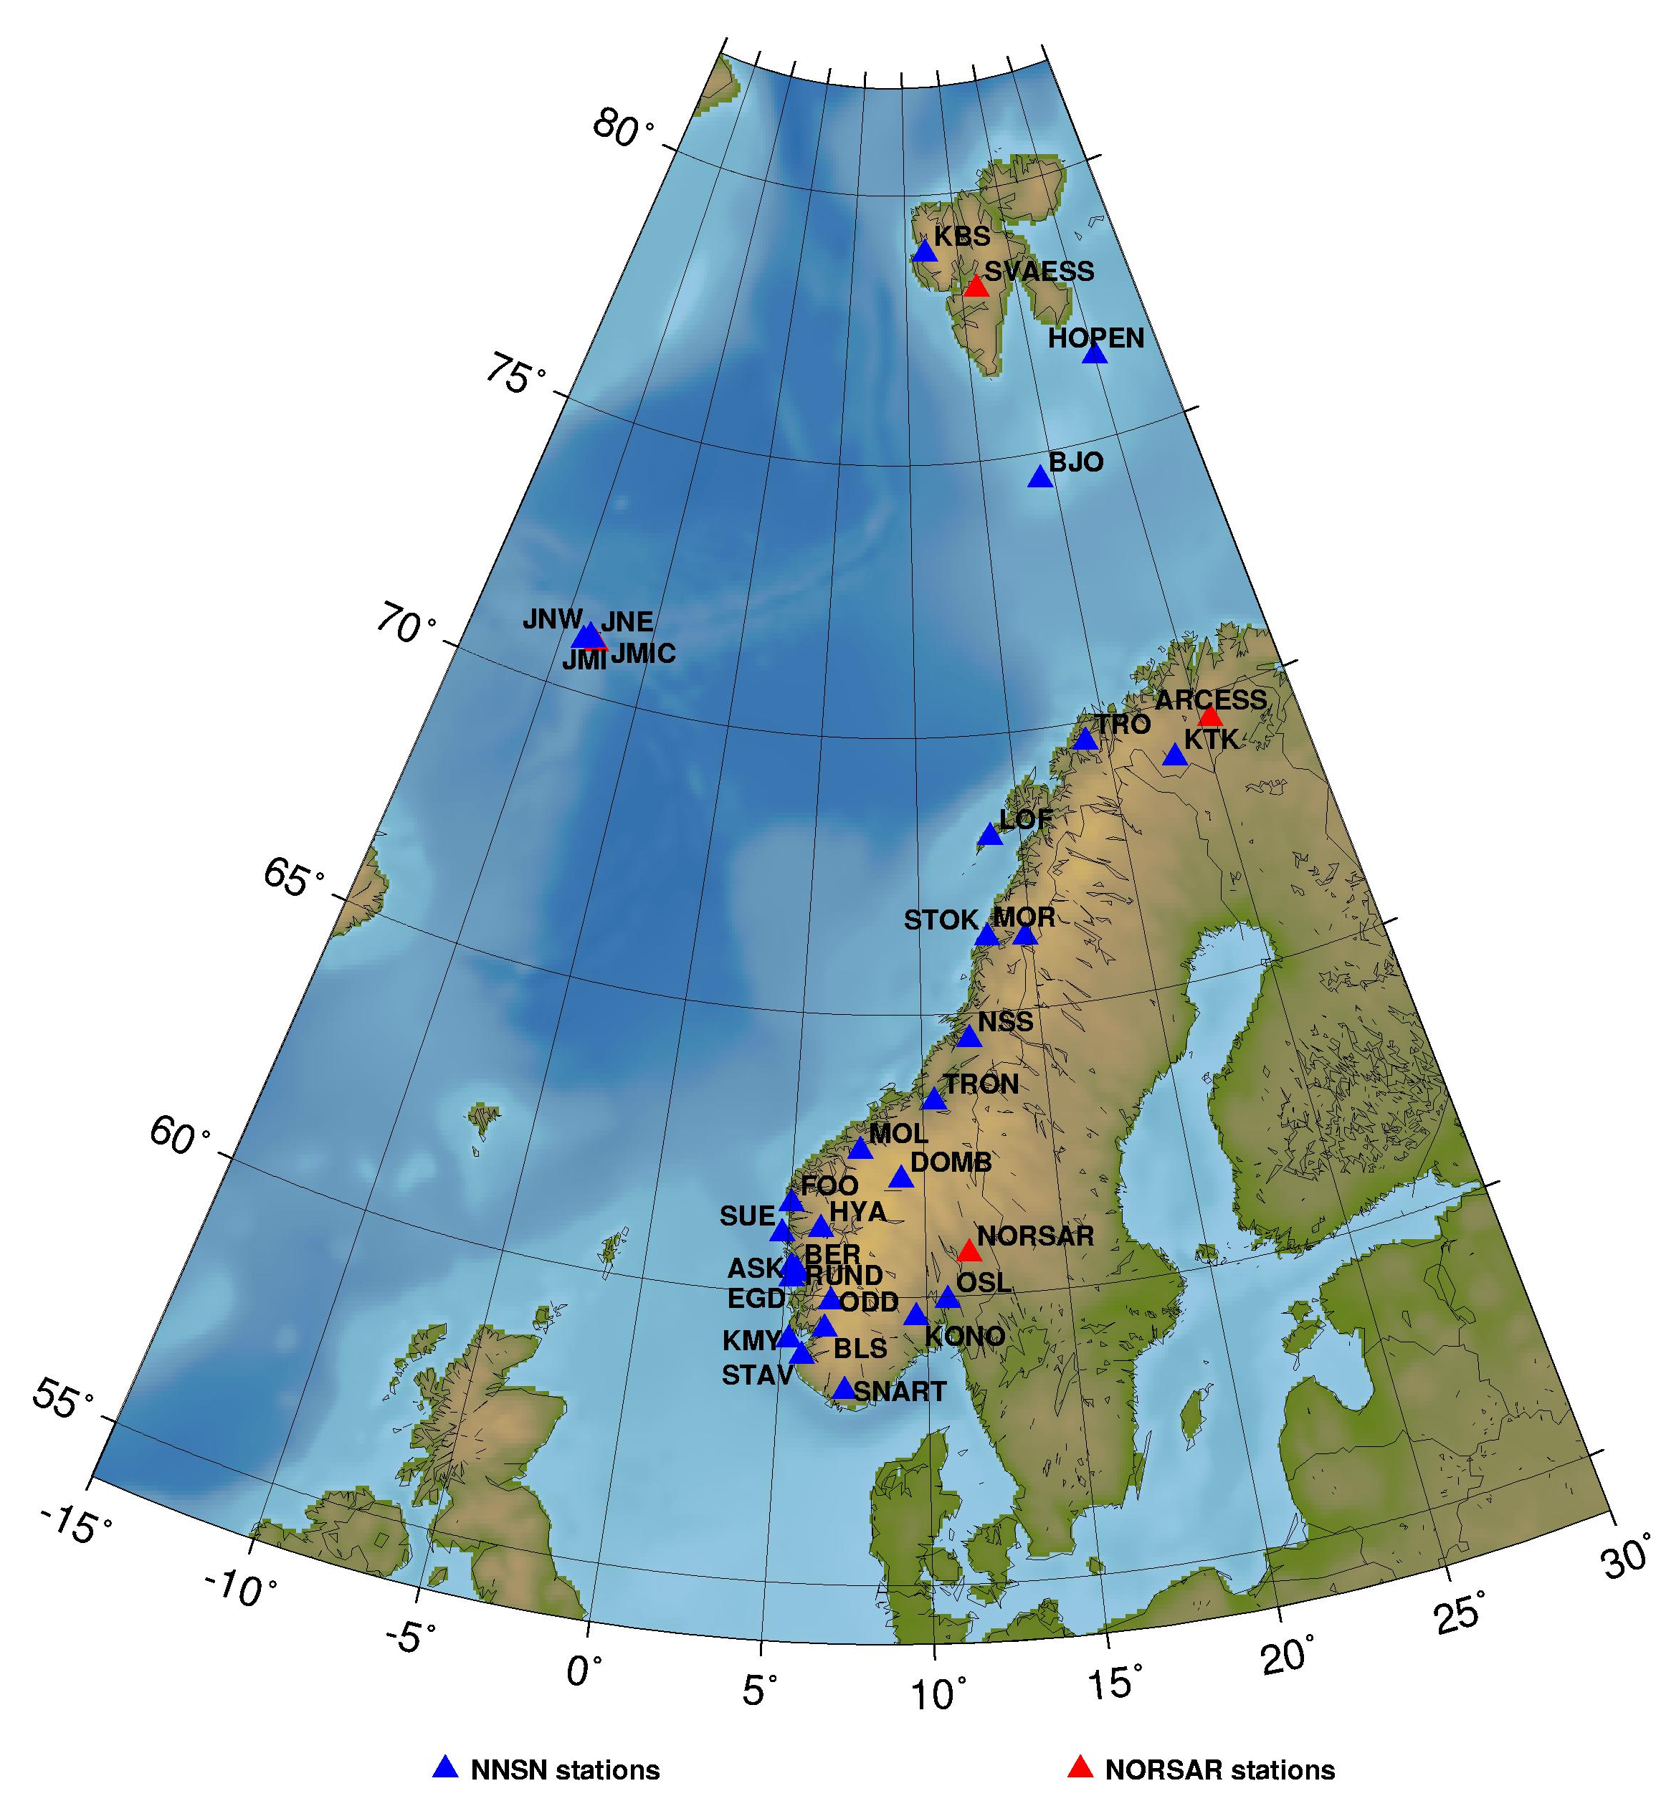

Figure 1: Norwegian seismic stations. UiB operates the 29 stations in the National Seismic Network (NNSN) and NORSAR operates the four arrays and the station JMIC.

2. Velocity models and magnitude relations

The velocity model used for locating all local and regional events, except for the local Jan Mayen events, is shown in Table 1 (Havskov and Bungum, 1987). Event locations are performed using the HYPOCENTER program (Lienert and Havskov, 1995) and all processing is performed using the SEISAN data analysis software (Havskov and Ottemöller, 1999).

P-wave velocity (km/sec) | Depth to layer interface (km)
6.2 | 0.0
6.6 | 12.0
7.1 | 23.0
8.05 | 31.0
8.25 | 50.0
8.5 | 80.0
Table 1: Velocity model used for locating all local and regional events, except for the local Jan Mayen events. From Havskov and Bungum (1987).

Magnitudes are calculated from coda duration, amplitudes or seismic spectra. The coda wave magnitude scale (M_{C}) is estimated through the relation:

M_{C} = -3.0 + 2.6 ⋅ log10(T) +0.001 ⋅ D

where T is the coda length in seconds and D is the epicentral distance in km. When instrument corrected ground amplitudes A (nm) are available, local magnitude M_{L} is calculated using the equation given by Alsaker et al. (1991):

M_{L}= 1.0 ⋅ log(A) + 0.91 ⋅ log(D) + 0.00087 ⋅ D - 1.67

where D is the hypocentral distance in km.
The moment magnitude M_{w} is calculated from the seismic moment M₀ using the relation (Kanamori, 1977)

M_{w} = 0.67 ⋅ log(M₀) – 6.06

The unit of M₀ is Nm. The seismic moment is calculated from standard spectral analysis assuming the Brune model (Brune, 1970) and using the following parameters:

Density: 3.0 g/cm²
Q = 440 ⋅ f^{0.7}
P-velocity = 6.2 km/s
S velocity = 3.6 km/s

For more computational details, see Havskov and Ottemöller, 2003.

For the Jan Mayen area, a local velocity model (see Table 2) and coda magnitude scale is used (Sørnes and Navrestad, 1975).

P-wave velocity (km/sec) | Depth to layer interface (km)
3.14 | 0
6.33 | 3
8.27 | 18
Table 2: Velocity model used for locating local Jan Mayen events. From Sørnes and Navrestad (1975).

The coda magnitude for Jan Mayen is given by Westre (1975):

M_{C} = 3.27 ⋅ log(T) - 3.24 + 0.001 ⋅ D

where T is the coda duration and D is the epicentral distance in km.

The regional and teleseismic events recorded by the network are located using the global velocity model IASPEI91 (Kennett and Engdahl, 1991).

Body wave magnitude is calculated using the equation by Veith and Clawson (1972):

Mb = log(A/T) + Q(D,h).

Here h is the hypocentre depth (km), A is the amplitude (microns), T is period in seconds and Q(D,h) is a correction for distance and depth.

Surface wave magnitude Ms is calculated using the equation (Karnik et al., 1962):

Ms = log(A/T) + 1.66 ⋅ log(D) + 3.3

where A is the amplitude (microns), T is period in seconds and D is the hypocentral distance in degrees.

Starting from January 2001, the European Macroseismic Scale, EMS98, (Grünthal, 1998) is used. All macroseismic intensities mentioned in the text will refer to the EMS98 instead of the previously used Modified Mercalli Intensity scale. The two scales are very similar at the lower end of the scale for intensities less than VII.

3. Events recorded by the Norwegian stations

A total of 4756 local and regional events, based on the criteria mentioned in section 1, were detected by the Norwegian seismic stations during 2004. Of these local and regional events analysed, 58% were located.
The number of local/regional and teleseismic events, recorded per month in 2004 is shown in Figure 2. The average number of local and regional events recorded per month is 396.

A total of 998 teleseismic events were recorded during 2004, of which 94% were located. In addition to the locations determined at UiB, also preliminary locations published by the USGS (United States Geological Survey) based on the worldwide network are included in the UiB database whenever the earthquake is recorded on Norwegian stations. The monthly average of teleseismic earthquakes recorded by NNSN is 83.
Figure 2: Monthly distribution of local/regional and distant events, recorded during 2004.

It is important for UiB, as an observatory in the global net of seismological observatories, to read and report as many secondary phases as possible from the teleseismic recordings. All events (teleseismic, regional and local) recorded from January to December 2004 with M ≥ 3 are plotted on Figure 3.

The station recording statistics for each month from January to December 2004 are given in Table 3. This table shows, for each station, the number of local events that were recorded only at one station, local events recorded on more than one station and recorded teleseismic events. It must be observed that Table 3 shows both earthquakes and explosions, and that the large number of detections at KTK and MOR is mainly due to explosions at the Kiruna/Malmberget mines in Sweden

4. The seismicity of Norway and adjacent areas

A total of 2617 of the recorded events are located inside the NNSN prime area, 54°N-82°N and 15°W-32°E. During analysis and using the explosion filter (Ottemöller, 1995), 42% of these events were identified as probable explosions. Figure 4 shows all local/regional events in the prime area, analyzed and located during 2004.
Figure 5 and Table 4 show the 177 local and regional events, located in the prime area, with magnitudes greater than or equal to 3.0. 87 of these are located in the vicinity of the Jan Mayen island.
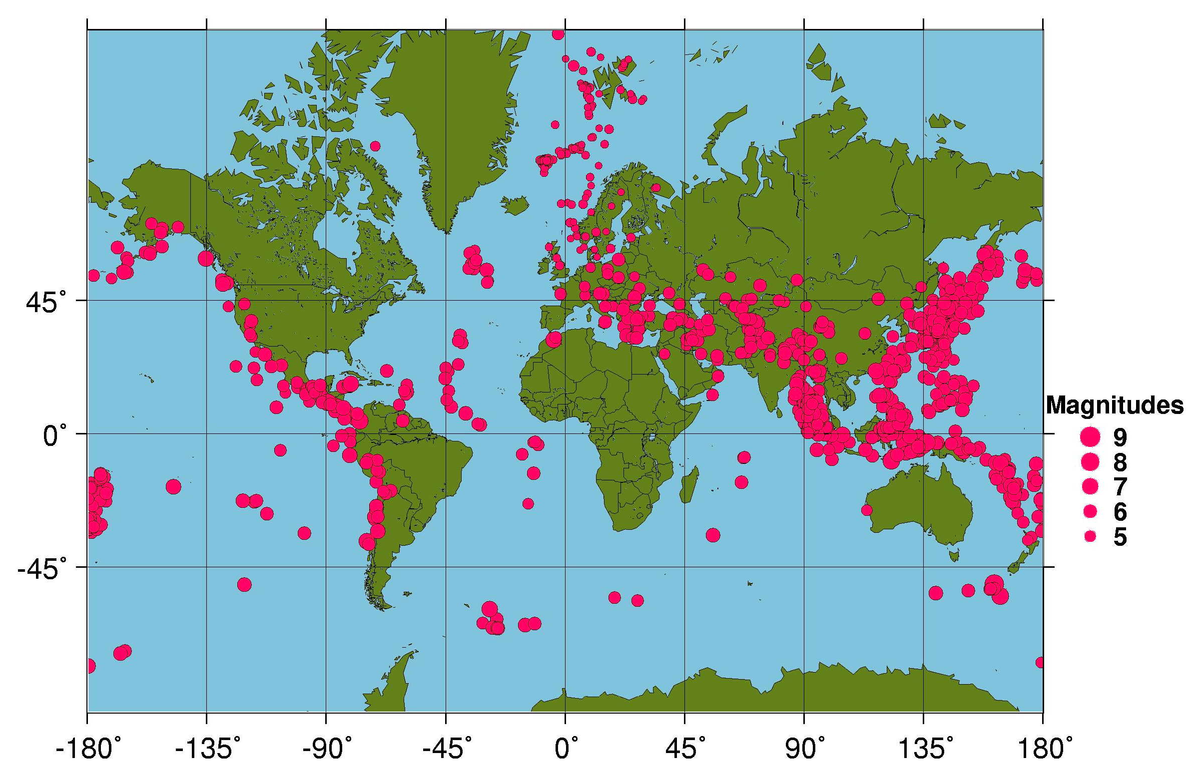

Figure 3: Epicentre distribution of earthquakes with M ≥ 3.0, located by the Norwegian Seismic Network from January to December 2004. Teleseismic events recorded only by NORSAR have M ≥ 5.0.
Table 3a: Monthly statistics of events recorded at each station for January-June 2004. Abbreviations are: LM = Number of local events recorded at more than one station, LS = Number of local events recorded at only one station and D = Number of teleseismic events.
 | JANUARY |  |  | FEBRUARY |  |  | MARCH |  |  | APRIL |  |  | MAY |  |  | JUNE
STATION | LM | LS | D | LM | LS | D | LM | LS | D | LM | LS | D | LM | LS | D | LM | LS | D
ASK | 32 | 0 | 2 | 30 | 0 | 6 | 38 | 0 | 3 | 30 | 0 | 6 | 31 | 0 | 4 | 32 | 0 | 5
BER | 22 | 0 | 2 | 9 | 0 | 5 | 23 | 0 | 3 | 11 | 0 | 6 | 12 | 0 | 5 | 9 | 0 | 5
BJO1 | 7 | 1 | 10 | 4 | 0 | 9 | 0 | 0 | 9 | 4 | 0 | 26 | 5 | 0 | 5 | 5 | 0 | 11
BLS5 | 0 | 0 | 0 | 0 | 0 | 0 | 0 | 0 | 0 | 0 | 0 | 0 | 0 | 0 | 0 | 0 | 0 | 0
DOMB | 13 | 0 | 10 | 3 | 0 | 8 | 9 | 0 | 20 | 5 | 0 | 8 | 4 | 0 | 13 | 6 | 0 | 7
EGD | 32 | 0 | 2 | 28 | 0 | 6 | 37 | 0 | 3 | 29 | 0 | 6 | 31 | 0 | 4 | 30 | 0 | 5
FOO | 19 | 0 | 2 | 7 | 0 | 5 | 21 | 0 | 8 | 19 | 0 | 3 | 11 | 0 | 4 | 18 | 0 | 9
HOPEN | 0 | 0 | 0 | 0 | 0 | 0 | 0 | 0 | 0 | 0 | 0 | 0 | 0 | 0 | 0 | 0 | 0 | 0
HYA | 24 | 0 | 0 | 14 | 0 | 0 | 21 | 0 | 1 | 21 | 0 | 3 | 15 | 0 | 1 | 20 | 0 | 4
JMI | 7 | 0 | 0 | 8 | 0 | 0 | 12 | 0 | 0 | 298 | 0 | 1 | 158 | 0 | 0 | 36 | 0 | 0
JMIC | 0 | 0 | 13 | 1 | 0 | 10 | 3 | 0 | 19 | 104 | 0 | 28 | 7 | 0 | 28 | 1 | 0 | 32
JNE | 7 | 0 | 0 | 10 | 0 | 0 | 14 | 0 | 0 | 301 | 0 | 1 | 157 | 0 | 0 | 39 | 0 | 0
JNW | 7 | 1 | 0 | 11 | 2 | 0 | 14 | 4 | 2 | 302 | 0 | 2 | 161 | 4 | 0 | 39 | 0 | 1
KBS | 15 | 3 | 34 | 12 | 0 | 19 | 16 | 6 | 39 | 27 | 1 | 37 | 28 | 1 | 51 | 22 | 5 | 45
KMY | 34 | 0 | 0 | 36 | 0 | 3 | 43 | 0 | 1 | 37 | 0 | 1 | 35 | 1 | 1 | 36 | 0 | 4
KONO | 21 | 0 | 39 | 14 | 0 | 29 | 23 | 0 | 39 | 16 | 0 | 40 | 20 | 0 | 84 | 14 | 0 | 42
KTK1 | 132 | 67 | 20 | 104 | 73 | 23 | 171 | 100 | 21 | 156 | 104 | 19 | 137 | 29 | 21 | 133 | 46 | 19
LOF | 89 | 0 | 8 | 50 | 0 | 7 | 108 | 2 | 10 | 114 | 0 | 11 | 136 | 1 | 19 | 119 | 5 | 13
MOL | 25 | 14 | 21 | 13 | 7 | 14 | 35 | 18 | 28 | 15 | 8 | 9 | 22 | 3 | 16 | 13 | 1 | 14
MOR8 | 127 | 8 | 25 | 92 | 3 | 21 | 163 | 2 | 36 | 135 | 5 | 20 | 131 | 2 | 24 | 124 | 2 | 22
NORSAR | 0 | 0 | 77 | 0 | 0 | 84 | 0 | 0 | 87 | 11 | 0 | 77 | 22 | 0 | 85 | 14 | 0 | 79
NSS | 52 | 1 | 36 | 25 | 1 | 27 | 54 | 4 | 36 | 41 | 1 | 29 | 71 | 0 | 32 | 56 | 1 | 25
ODD1 | 42 | 0 | 2 | 40 | 0 | 5 | 52 | 0 | 4 | 24 | 0 | 1 | 25 | 0 | 1 | 23 | 0 | 6
OSL | 1 | 0 | 2 | 1 | 0 | 1 | 0 | 0 | 5 | 2 | 0 | 3 | 1 | 0 | 3 | 1 | 0 | 2
RUND | 23 | 0 | 3 | 12 | 0 | 1 | 10 | 0 | 7 | 11 | 0 | 4 | 14 | 0 | 6 | 20 | 0 | 4
SNART | 16 | 0 | 1 | 13 | 0 | 2 | 10 | 0 | 2 | 15 | 0 | 1 | 17 | 0 | 1 | 15 | 0 | 1
STAV | 0 | 0 | 1 | 3 | 0 | 1 | 1 | 0 | 3 | 2 | 0 | 2 | 2 | 0 | 2 | 5 | 0 | 3
STOK | 20 | 0 | 1 | 7 | 0 | 1 | 31 | 0 | 3 | 20 | 0 | 1 | 24 | 0 | 3 | 11 | 0 | 2
SUE | 22 | 0 | 0 | 14 | 0 | 0 | 19 | 0 | 0 | 16 | 0 | 3 | 15 | 0 | 1 | 18 | 0 | 4
TRO | 105 | 5 | 41 | 81 | 0 | 34 | 133 | 0 | 37 | 109 | 2 | 45 | 45 | 0 | 26 | 18 | 0 | 13
TRON | 2 | 0 | 0 | 1 | 0 | 0 | 0 | 0 | 0 | 3 | 0 | 0 | 2 | 0 | 3 | 4 | 0 | 4
SPITS | 28 | 1 | 0 | 27 | 0 | 0 | 32 | 0 | 0 | 23 | 0 | 0 | 58 | 0 | 0 | 34 | 0 | 0
ARCES | 70 | 0 | 0 | 53 | 0 | 0 | 77 | 0 | 0 | 82 | 0 | 0 | 149 | 0 | 0 | 91 | 0 | 0

Table 3b: Monthly statistics of events recorded at each station for July-December 2004. Abbreviations are: LM = Number of local events recorded at more than one station, LS = Number of local events recorded at only one station and D = Number of teleseismic events.
 | JULY |  |  | AUGUST |  |  | SEPTEMBER |  |  | OCTOBER |  |  | NOVEMBER |  |  | DECEMBER
STATION | LM | LS | D | LM | LS | D | LM | LS | D | LM | LS | D | LM | LS | D | LM | LS | D
ASK | 26 | 0 | 5 | 29 | 0 | 9 | 25 | 0 | 7 | 17 | 0 | 7 | 20 | 0 | 8 | 24 | 0 | 2
BER | 18 | 0 | 5 | 15 | 0 | 9 | 14 | 0 | 9 | 12 | 0 | 7 | 3 | 0 | 7 | 11 | 0 | 2
BJO1 | 6 | 1 | 23 | 2 | 0 | 18 | 0 | 0 | 16 | 3 | 1 | 11 | 3 | 0 | 21 | 1 | 0 | 14
BLS5 | 0 | 0 | 0 | 0 | 0 | 0 | 0 | 0 | 0 | 0 | 0 | 0 | 0 | 0 | 0 | 0 | 0 | 0
DOMB | 4 | 0 | 9 | 3 | 0 | 7 | 6 | 0 | 12 | 8 | 0 | 21 | 5 | 0 | 17 | 11 | 0 | 38
EGD | 26 | 0 | 5 | 27 | 0 | 8 | 34 | 0 | 8 | 24 | 0 | 8 | 18 | 0 | 9 | 22 | 0 | 2
FOO | 11 | 0 | 5 | 14 | 0 | 7 | 21 | 0 | 7 | 15 | 0 | 10 | 11 | 0 | 10 | 17 | 0 | 6
HOPEN | 0 | 0 | 0 | 0 | 0 | 0 | 0 | 0 | 0 | 0 | 0 | 0 | 8 | 31 | 0 | 12 | 43 | 0
HYA | 14 | 0 | 2 | 14 | 0 | 7 | 24 | 0 | 11 | 21 | 0 | 8 | 15 | 0 | 9 | 20 | 0 | 2
JMI | 32 | 0 | 0 | 37 | 0 | 0 | 9 | 0 | 0 | 29 | 0 | 0 | 37 | 0 | 0 | 5 | 0 | 0
JMIC | 3 | 0 | 43 | 5 | 0 | 33 | 0 | 0 | 20 | 1 | 0 | 12 | 1 | 0 | 19 | 0 | 0 | 12
JNE | 32 | 0 | 0 | 37 | 0 | 0 | 9 | 0 | 0 | 25 | 0 | 0 | 37 | 0 | 0 | 5 | 0 | 0
JNW | 32 | 0 | 3 | 37 | 0 | 2 | 9 | 0 | 2 | 30 | 0 | 1 | 37 | 0 | 2 | 5 | 0 | 1
KBS | 20 | 10 | 50 | 12 | 6 | 38 | 24 | 0 | 12 | 0 | 0 | 0 | 0 | 0 | 0 | 0 | 0 | 0
KMY | 30 | 0 | 1 | 39 | 1 | 7 | 40 | 1 | 7 | 40 | 0 | 6 | 37 | 0 | 8 | 10 | 0 | 0
KONO | 9 | 0 | 49 | 10 | 0 | 23 | 16 | 0 | 23 | 3 | 0 | 19 | 13 | 0 | 31 | 10 | 0 | 24
KTK1 | 176 | 13 | 18 | 153 | 18 | 22 | 125 | 27 | 20 | 163 | 7 | 30 | 97 | 24 | 41 | 112 | 9 | 73
LOF | 175 | 3 | 14 | 122 | 2 | 18 | 90 | 2 | 14 | 128 | 0 | 19 | 56 | 3 | 20 | 49 | 0 | 49
MOL | 19 | 5 | 16 | 16 | 5 | 18 | 20 | 4 | 16 | 29 | 3 | 25 | 17 | 3 | 25 | 23 | 0 | 63
MOR8 | 161 | 0 | 22 | 143 | 1 | 22 | 115 | 3 | 20 | 160 | 0 | 34 | 93 | 3 | 43 | 101 | 0 | 77
NORSAR | 10 | 0 | 87 | 12 | 0 | 66 | 18 | 0 | 66 | 12 | 0 | 95 | 22 | 0 | 114 | 12 | 0 | 280
NSS | 65 | 1 | 36 | 55 | 1 | 23 | 42 | 2 | 24 | 69 | 0 | 23 | 35 | 0 | 37 | 33 | 0 | 60
ODD1 | 19 | 0 | 2 | 31 | 0 | 9 | 35 | 0 | 10 | 39 | 0 | 9 | 34 | 0 | 10 | 22 | 0 | 5
OSL | 1 | 0 | 5 | 0 | 0 | 0 | 3 | 0 | 8 | 1 | 0 | 8 | 0 | 0 | 10 | 0 | 0 | 26
RUND | 12 | 0 | 4 | 15 | 0 | 8 | 23 | 0 | 9 | 18 | 0 | 14 | 10 | 0 | 13 | 15 | 0 | 12
SNART | 15 | 0 | 3 | 5 | 0 | 0 | 7 | 0 | 4 | 8 | 0 | 2 | 32 | 0 | 3 | 10 | 0 | 2
STAV | 2 | 0 | 2 | 2 | 0 | 4 | 4 | 0 | 5 | 2 | 0 | 7 | 4 | 0 | 4 | 3 | 0 | 4
STOK | 12 | 0 | 2 | 12 | 0 | 1 | 8 | 0 | 3 | 15 | 0 | 7 | 9 | 0 | 1 | 9 | 0 | 1
SUE | 11 | 0 | 2 | 14 | 0 | 5 | 23 | 0 | 5 | 16 | 0 | 6 | 8 | 0 | 5 | 15 | 0 | 1
TRO | 165 | 0 | 56 | 121 | 0 | 41 | 102 | 0 | 27 | 114 | 0 | 29 | 68 | 0 | 45 | 75 | 0 | 87
TRON | 2 | 0 | 2 | 0 | 0 | 2 | 4 | 0 | 7 | 1 | 0 | 8 | 4 | 0 | 3 | 3 | 0 | 3
SPITS | 29 | 0 | 0 | 13 | 0 | 0 | 31 | 2 | 0 | 23 | 10 | 0 | 21 | 1 | 0 | 20 | 1 | 0
ARCES | 81 | 0 | 0 | 69 | 0 | 0 | 112 | 0 | 0 | 79 | 0 | 0 | 71 | 0 | 0 | 66 | 3 | 0

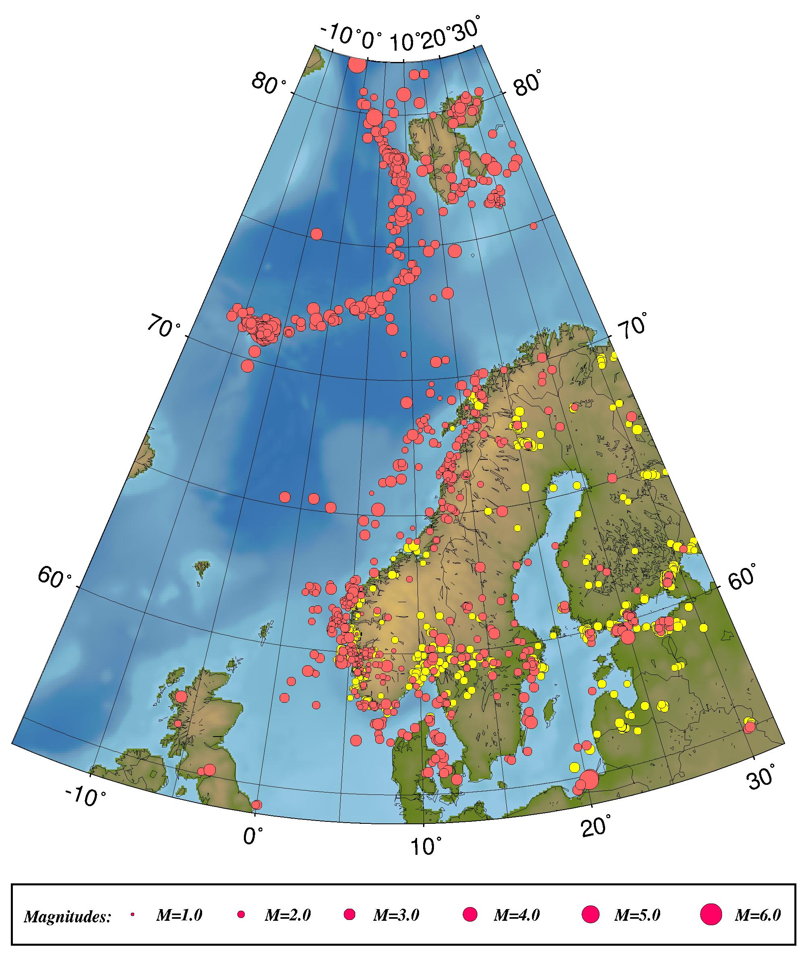
Figure 4: Epicentre distribution of events analyzed and located from January through December 2004. Earthquakes are plotted in red and probable and known explosions in yellow. For station locations, see Figure 1.

It is emphasized that it is often difficult to get a good magnitude estimate for the earthquakes located on the oceanic ridge in the Norwegian sea, since distances are too large to compute a proper M_{L}, too short for M_{b} and coda magnitudes for these locations are often unreliable.
Most of the recorded earthquakes in this area have magnitudes above 3.0 if the earthquakes are recorded on Norwegian mainland stations.

The largest local or regional earthquake in 2004, recorded on Norwegian stations, occurred on April 14th 2004 at 23:07 (UTC) east of the northern tip of Jan Mayen. The earthquake had a magnitude of Mb = 6.0 and was felt at Jan Mayen and mainland Norway.

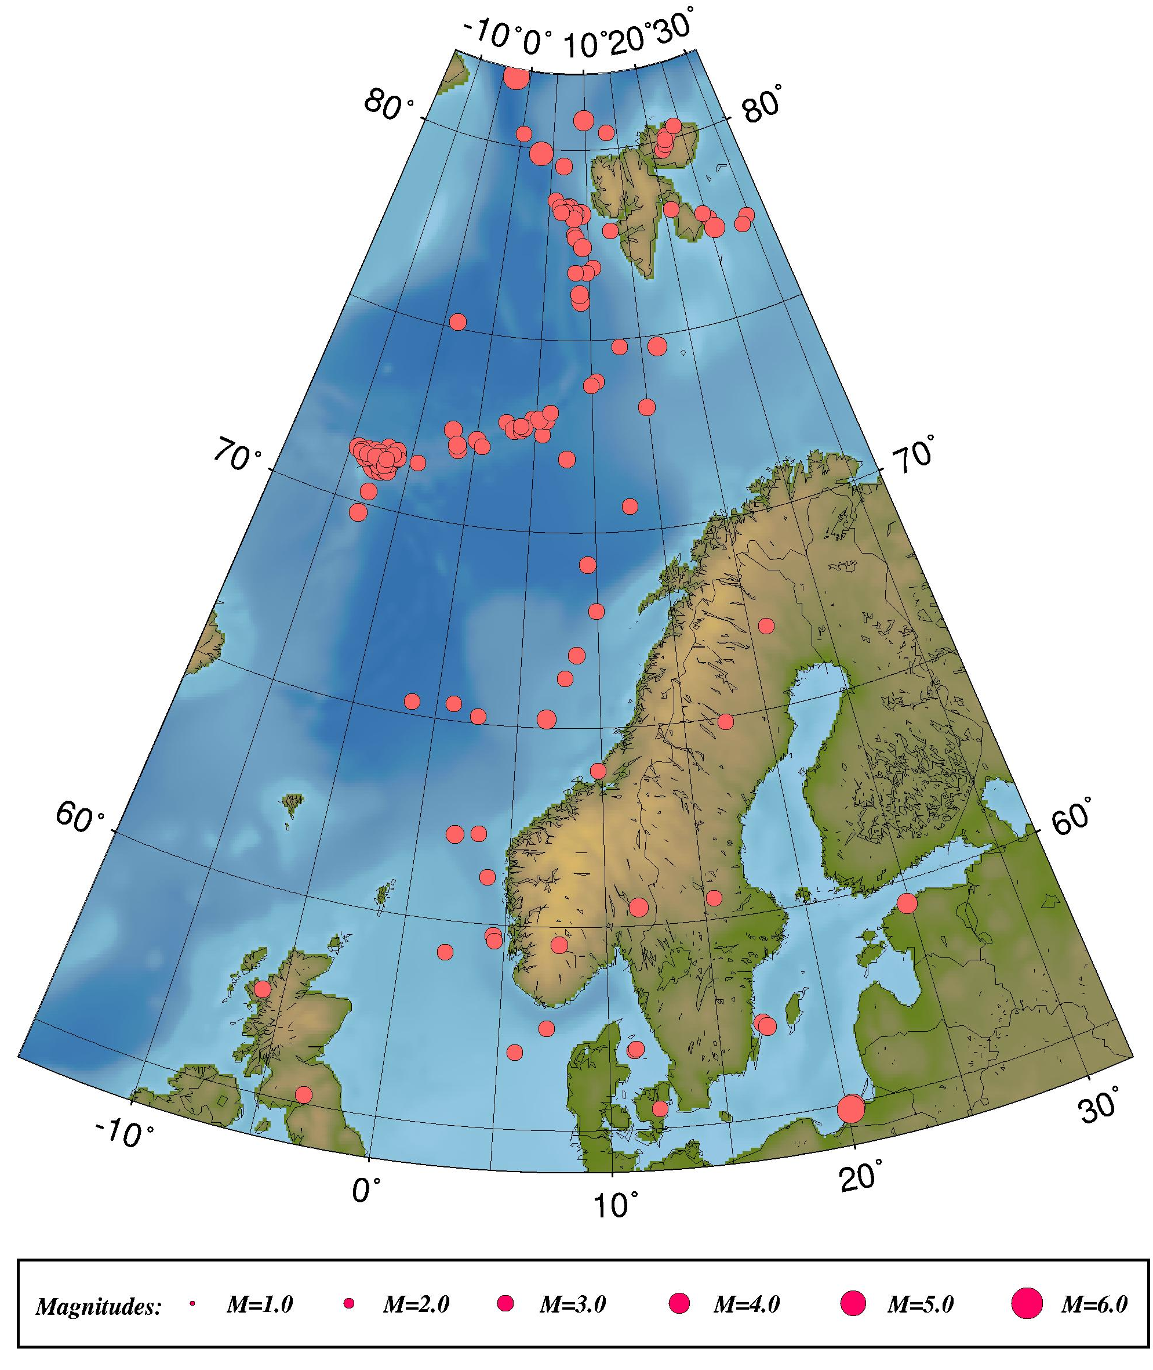
Figure 5: Epicentre distribution of located events with one of the calculated magnitudes above or equal to 3.0. All earthquakes are listed in Table 2. For station location, see Figure 1.

The largest earthquake in the vicinity of the Norwegian mainland occurred on April 7th at 8:53 (UTC). The earthquake was located in southeast Norway at 60.5°N, 11.6°E and had a moment magnitude of M_{w} = 3.6. Some of the recorded seismograms from the earthquake are shown in Figure 6.

Table 4: Local and regional events in prime area with any magnitude above or equal to 3.0 for the time period January through December 2004. For depth determination, see section 5.
Only magnitudes reported by the University of Bergen are included. In cases where all BER magnitudes are below 3 but the event still is included in the list, NORSAR has reported a magnitude of 3.0 or larger.
Abbreviations are: HR = hour (UTC), MM = minutes, Sec = seconds, L = distance identification (L=local, R=regional, D=teleseismic), Latitud = latitude, Longitud = longitude, Depth = focal depth (km), F = fixed depth, AGA = agency (BER=Bergen), NST = number of stations, RMS = root mean square of the travel-time residuals, Mc = coda magnitude, Ml = local magnitude and Mw = moment magnitude.

Year Date HRMM Sec L Latitud Longitud Depth F AGA NST RMS Mc Ml Mw
2004 117 0002 26.0 L 71.902 -1.402 10.0 F BER 14 1.2 3.5 2.6
2004 120 0040 57.7 L 69.728 -7.930 10.0 F BER 3 0.6 3.2 3.5
2004 123 0641 0.0 L 56.892 5.763 15.0 F BER 8 0.9 3.1 2.0
2004 130 2220 37.8 L 78.320 9.187 10.0 F BER 10 1.4 3.3 3.9
2004 2 1 1342 36.9 L 73.923 10.443 13.0 F BER 13 2.0 3.2 2.4
2004 2 4 2119 4.7 L 77.713 25.199 12.0 F BER 5 1.1 3.0 2.1
2004 220 2345 59.7 L 72.780 2.427 10.0 F BER 3 1.1 3.1 2.4
2004 221 0654 26.9 L 71.316 -7.784 10.0 F BER 13 1.0 3.7 3.6
2004 223 0838 25.7 L 55.478 12.109 15.0 F BER 16 1.9 3.0 2.5
2004 227 1811 59.9 L 61.174 3.904 12.0 F BER 24 1.5 3.0 3.0 3.0
2004 3 3 0508 59.5 L 77.427 25.528 15.0 BER 9 1.3 3.9 3.0
2004 3 5 0714 29.3 L 78.183 20.851 15.0 BER 3 0.5 3.2 2.6
2004 3 5 1019 7.9 L 65.438 1.008 10.0 F BER 7 1.6 3.1 2.0
2004 316 0509 44.4 L 66.866 8.558 15.0 F BER 20 1.2 3.4 2.6 2.9
2004 318 0849 50.3 L 74.713 16.589 10.0 F BER 13 1.5 3.8 3.0
2004 319 0331 51.7 L 72.606 3.198 10.0 F BER 10 1.0 3.7 2.4
2004 320 0118 23.5 L 71.139 -6.658 11.8 BER 3 0.1 2.6 3.1
2004 321 0440 45.8 L 80.084 22.439 15.0 BER 3 0.7 3.5 2.9
2004 324 1240 18.9 L 71.316 -6.701 15.9 BER 9 0.9 3.6 3.4
2004 328 0039 8.2 L 72.220 0.081 10.0 F BER 4 0.9 3.6 2.3
2004 328 0819 1.7 L 71.110 -6.832 10.0 F BER 17 1.0 4.5 3.3
2004 4 7 0853 20.8 L 60.458 11.692 17.6 F BER 20 1.6 3.6 3.4 3.6
2004 410 0842 57.4 L 78.678 5.813 10.0 F BER 3 0.6 2.8 2.7
2004 411 2022 17.9 L 65.232 6.744 5.0 F BER 31 1.5 3.8 3.2 3.5
2004 412 0942 32.3 L 79.749 21.432 17.7 BER 3 0.6 3.0 3.2
2004 414 2307 39.2 L 71.093 -7.472 10.5 FF BER 31 3.3 6.3 5.2 5.1
2004 414 2343 41.1 L 71.328 -7.019 13.7 BER 4 0.3 2.7 3.2
2004 415 0020 11.2 L 71.313 -8.085 10.0 F BER 12 0.7 3.1 3.1
2004 415 0022 34.2 L 71.256 -8.074 10.0 F BER 16 0.8 3.4 3.5
2004 415 0037 9.8 L 71.227 -7.923 10.0 F BER 9 0.8 2.8 3.5
2004 415 0111 20.4 L 71.378 -8.668 15.0 BER 19 1.0 3.2 3.4
2004 415 0123 35.6 L 71.284 -7.812 10.0 F BER 4 0.3 2.9 3.6
2004 415 0336 11.2 L 71.177 -7.563 10.0 F BER 4 0.3 3.1
2004 415 0911 47.8 L 71.199 -7.791 15.8 BER 3 0.1 3.1
2004 415 0911 0.4 L 71.266 -8.108 10.0 F BER 4 0.3 3.2
2004 415 0947 9.0 L 71.202 -7.559 15.3 BER 4 0.3 3.3
2004 415 1104 17.4 L 71.417 -8.011 10.0 F BER 4 0.4 2.7 3.0
2004 415 1409 8.8 L 71.578 -7.030 14.6 BER 4 0.2 3.0 2.9
2004 415 1421 0.3 L 71.166 -7.511 15.4 BER 4 0.2 2.5 3.0
2004 415 1928 33.6 L 71.390 -6.465 15.0 BER 4 0.2 3.1
2004 415 2332 55.9 L 71.155 -7.518 15.4 BER 4 0.2 2.2 3.1
2004 416 0459 38.9 L 71.275 -7.803 10.0 F BER 4 0.4 2.9 3.1
2004 416 0850 22.1 L 71.065 -7.393 8.7 BER 6 0.3 2.9 3.7
2004 416 1512 36.4 L 70.924 -7.162 15.4 BER 4 0.2 2.3 3.5
2004 417 0040 2.1 L 71.155 -7.473 17.7 BER 4 0.2 2.0 3.2
2004 417 0805 50.7 L 71.225 -6.878 14.2 BER 4 0.2 2.8 3.1
2004 417 0840 28.1 L 71.146 -6.963 3.3 BER 13 0.6 3.5 3.7
2004 417 1141 16.6 L 71.138 -6.975 12.8 BER 5 0.3 2.7 3.2
2004 418 0222 52.5 L 71.103 -7.391 15.1 BER 4 0.2 2.5 3.0
2004 418 1148 28.7 L 80.432 13.399 15.0 BER 3 0.8 3.0 2.8
2004 420 0611 24.9 L 71.254 -7.960 10.0 F BER 18 1.1 3.6
2004 421 1253 9.4 L 71.028 -6.887 10.0 F BER 3 0.2 2.8 3.2
2004 424 0313 54.1 L 71.159 -7.124 14.4 BER 3 0.0 2.6 3.0
Year Date HRMM Sec L Latitud Longitud Depth F AGA NST RMS Mc Ml Mw
2004 424 1755 53.7 L 71.132 -7.362 16.4 BER 3 0.1 2.5 3.4
2004 425 0820 29.3 L 71.003 -6.763 10.0 F BER 3 0.1 2.4 3.0
2004 426 2014 0.5 L 71.124 -7.414 14.7 BER 3 0.1 2.5 3.1
2004 427 1354 34.3 L 71.230 -6.860 18.0 BER 3 0.2 2.8 3.2
2004 428 0714 59.2 L 70.994 -6.935 10.0 F BER 3 0.3 3.1 3.2
2004 428 2238 51.2 L 65.334 -1.522 10.0 F BER 6 1.4 3.2 1.9
2004 5 4 1141 24.9 L 69.190 9.374 7.1 BER 14 1.3 3.3 2.7
2004 5 4 1444 53.3 L 76.908 10.465 14.0 BER 8 1.5 2.6 2.5
2004 5 4 1826 31.9 L 76.767 9.752 10.0 F BER 10 1.8 2.6 2.9
2004 5 5 0439 34.1 L 71.034 -7.005 10.0 F BER 3 0.2 2.4 3.1
2004 5 5 1644 21.6 L 71.128 -6.928 18.0 BER 3 0.2 2.2 3.0
2004 5 5 2143 1.0 L 71.250 -7.196 15.0 BER 4 0.3 3.1
2004 5 6 0111 32.6 L 71.234 -7.993 10.0 F BER 17 1.1 2.7 3.3
2004 5 6 1727 22.8 L 71.204 -6.960 14.9 BER 3 0.1 2.6 3.3
2004 5 6 1905 11.2 L 71.239 -7.268 13.0 BER 5 0.4 2.7 3.2
2004 5 6 2301 54.1 L 71.250 -7.145 15.1 BER 3 0.1 2.4 3.0
2004 5 7 0212 8.6 L 71.189 -6.931 14.8 BER 3 0.1 2.4 3.2
2004 5 7 0243 9.7 L 71.204 -7.293 15.0 BER 11 0.5 2.6 3.2
2004 5 7 0301 48.4 L 80.311 24.042 15.0 BER 3 1.3 3.1
2004 5 7 0753 29.5 L 71.175 -7.149 5.1 BER 13 0.5 3.0 3.5
2004 5 7 1058 10.9 L 71.145 -7.045 10.0 F BER 5 0.5 3.2 3.3
2004 5 7 1252 57.0 L 71.225 -6.849 17.9 BER 3 0.2 2.5 3.1
2004 5 8 0813 24.7 L 71.224 -8.945 18.9 BER 4 0.2 3.2 3.2
2004 510 0835 35.5 L 70.934 -6.805 13.8 BER 3 0.2 2.8 3.2
2004 510 1155 45.0 L 71.379 -7.598 15.6 BER 7 0.6 3.2 3.4
2004 510 1346 19.2 L 71.225 -7.334 14.7 BER 12 0.6 3.5 3.7
2004 512 1838 48.1 L 72.589 3.722 10.0 F BER 12 1.6 2.8
2004 513 0321 52.9 L 71.284 -6.449 7.4 BER 8 0.9 3.3 2.9
2004 513 0658 52.8 L 62.160 1.991 15.0 F BER 38 2.0 3.6 3.2 3.2
2004 517 0438 24.7 L 70.648 12.753 3.4 BER 13 2.0 3.1 2.4
2004 521 2001 27.1 L 71.236 -7.291 10.0 F BER 11 0.7 3.1 3.5
2004 522 1150 55.7 L 71.168 -7.002 15.2 BER 3 0.1 2.4 3.0
2004 524 1051 16.3 L 71.308 -7.367 14.2 BER 3 0.1 2.9 3.2
2004 525 0205 59.3 L 71.211 -7.141 13.3 BER 5 0.3 2.8 3.3
2004 525 1703 43.9 L 71.215 -7.255 1.6 BER 10 0.7 3.1 3.5
2004 526 0225 2.4 L 71.175 -7.217 14.2 BER 7 0.5 2.8 3.2
2004 527 2228 52.9 L 71.301 -7.332 15.0 BER 5 0.5 3.0 3.2
2004 529 2014 25.1 L 72.529 5.615 10.0 F BER 8 1.1 3.2 2.4
2004 6 1 1112 1.8 L 59.732 4.442 15.0 F BER 12 1.5 2.0 1.9
2004 6 4 1859 58.9 L 71.059 -7.387 9.5 BER 3 0.1 3.2 3.6
2004 610 0557 23.5 L 71.173 -8.574 10.0 F BER 6 0.9 3.0 3.9
2004 611 1034 21.8 L 71.184 -8.263 10.0 F BER 7 0.6 2.9 3.3
2004 611 2039 50.8 L 71.177 -7.432 10.0 F BER 3 0.1 2.7 3.4
2004 612 0036 45.8 L 72.911 5.886 10.0 F BER 3 1.3 3.5 2.2
2004 612 0525 53.2 L 79.577 6.810 15.0 BER 5 1.0 3.4 2.7
2004 615 0357 49.6 L 72.931 4.693 10.0 F BER 11 1.2 3.0 2.9
2004 620 0233 48.3 L 72.074 0.557 10.0 F BER 4 0.2 3.2 2.5
2004 627 1302 14.0 L 71.341 -9.389 15.2 BER 3 0.2 3.7
2004 627 1306 45.5 L 71.328 -9.064 10.0 F BER 3 0.3 3.1 2.8
2004 629 0125 32.9 L 59.558 7.707 8.0 F BER 23 1.3 2.9 3.1 2.9
2004 629 0222 49.3 L 72.920 5.258 21.0 BER 19 1.5 2.9 3.1
2004 630 1410 13.1 L 65.182 2.590 10.0 F BER 24 1.3 3.2 3.0
2004 7 8 0006 16.6 L 72.681 4.033 10.0 F BER 8 1.0 3.3 2.4
2004 710 0235 5.8 L 72.711 3.694 10.0 F BER 3 1.8 3.1 1.8
2004 710 0358 20.6 L 71.366 -4.438 10.0 F BER 10 1.4 3.2 1.7
2004 711 1814 48.1 L 71.259 -9.090 17.4 BER 3 0.1 3.0 3.1
2004 713 0240 17.1 L 78.447 7.398 10.0 F BER 3 1.0 2.6 3.7
2004 715 1702 50.3 L 67.087 21.102 15.0 BER 7 1.2 3.1 1.5
2004 715 1936 51.0 L 71.253 -8.557 11.7 BER 3 0.1 2.6 3.1
2004 721 1125 45.4 L 78.479 7.630 10.0 F BER 14 1.3 3.4 3.6
2004 721 1506 7.0 L 78.498 7.330 10.0 F BER 6 1.3 3.0 3.3
2004 722 0539 32.3 L 78.334 8.538 12.9 BER 6 1.5 2.8 3.0
2004 722 1118 54.9 L 78.351 8.402 10.0 F BER 3 0.8 1.7 3.0
2004 725 1444 47.8 L 77.881 24.625 15.0 BER 4 1.0 2.7
2004 8 1 0503 9.5 L 70.954 -6.630 10.0 F BER 14 0.9 3.4 3.3
2004 8 3 0625 27.7 L 70.333 -7.600 10.0 F BER 6 1.0 3.4 3.1
2004 8 8 0003 28.7 L 71.243 -7.877 10.0 F BER 9 0.6 2.9 3.4
Year Date HRMM Sec L Latitud Longitud Depth F AGA NST RMS Mc Ml Mw
2004 8 9 0930 58.9 L 79.887 3.299 15.0 F BER 14 1.6 3.6 3.7 3.7
2004 8 9 1318 11.1 L 73.115 6.222 15.0 BER 13 1.2 3.1 2.7
2004 818 0656 17.1 L 75.177 -3.641 10.0 F BER 8 1.4 3.3 3.4
2004 826 0927 26.0 L 59.604 4.503 6.0 F BER 14 1.1 1.8 2.0
2004 829 0448 17.5 L 71.917 7.759 10.0 F BER 9 1.2 3.3 1.9
2004 9 9 0829 34.0 L 77.784 8.360 10.0 F BER 3 1.2 3.2
2004 913 0446 48.5 L 78.489 6.384 10.0 F BER 2 1.1 3.0
2004 913 2322 23.6 L 78.382 7.188 10.0 F BER 2 0.9 3.2
2004 914 0241 35.8 L 73.834 9.930 4.7 BER 7 1.0 3.0 1.9
2004 916 0817 43.2 L 57.501 -5.961 4.7 S BER 15 1.9 2.9
2004 921 1105 7.8 L 54.903 20.252 10.0 F BER 26 2.7 5.0 4.5
2004 921 1332 33.8 L 54.848 20.161 10.0 F BER 26 1.6 5.4 4.8
2004 922 0511 3.1 L 77.690 8.477 10.0 F BER 3 1.5 3.4
2004 928 1153 40.0 L 57.499 7.172 13.2 BER 19 1.4 3.0 2.9 2.9
2004 929 1945 24.5 L 57.306 17.020 4.1 BER 6 0.8 3.5 2.2
2004 929 2315 22.1 L 57.210 17.198 5.0 F BER 11 1.0 3.6 2.5
2004 10 4 0713 5.8 L 78.197 8.281 10.0 F BER 2 1.2 3.4
2004 10 6 2242 48.0 L 64.880 17.509 10.0 F BER 15 1.9 3.1 2.3
2004 10 7 0126 22.4 L 71.165 -6.671 10.0 F BER 16 1.2 3.6 3.4
2004 10 8 0707 56.8 L 80.790 9.848 10.7 BER 2 0.1 3.9
2004 10 9 0305 48.6 L 77.455 29.667 15.0 BER 2 0.3 3.0
2004 10 9 1425 8.1 L 72.389 -2.111 10.0 F BER 5 0.7 3.5 2.4
2004 10 9 1830 55.7 L 78.354 6.659 15.0 BER 1 0.0 3.2
2004 1010 2232 29.4 L 77.283 28.864 10.0 F BER 2 2.0 3.0
2004 1010 2323 50.0 L 77.450 9.295 10.0 F BER 2 0.3 3.6
2004 1011 0952 51.6 L 76.053 8.934 7.3 BER 6 1.2 2.4
2004 1011 1006 10.4 L 76.023 9.041 10.0 F BER 7 1.5 2.7
2004 1022 0340 7.9 L 79.883 22.106 15.0 BER 4 0.7 3.2
2004 1024 1921 13.7 L 80.338 0.287 24.5 BER 2 0.8 3.0
2004 1031 1314 18.3 L 62.231 3.266 22.9 BER 15 1.2 2.4 2.4
2004 1031 1433 39.3 L 71.068 -6.970 14.3 BER 3 0.1 2.3 3.1
2004 11 1 1850 39.1 L 72.022 -1.502 10.0 F BER 6 1.3 3.5 2.6
2004 1110 0803 8.2 L 63.922 9.772 0.0 F BER 11 1.8 2.0
2004 1116 0136 21.0 L 71.347 -6.342 14.8 BER 3 0.1 2.7 3.4
2004 1116 1135 53.9 L 71.471 -6.099 18.0 BER 3 0.4 2.7 3.0
2004 1116 1213 39.7 L 71.451 -6.420 13.2 BER 3 0.2 3.2 3.7
2004 1116 1245 59.8 L 71.464 -6.201 17.9 BER 3 0.1 2.7 3.0
2004 1116 1311 38.6 L 71.546 -6.247 17.9 BER 3 0.4 3.0 3.4
2004 1116 1330 52.3 L 71.322 -6.095 14.8 BER 3 0.1 2.5 3.0
2004 1116 2137 54.6 L 71.348 -6.038 15.0 BER 3 0.1 3.1 3.2
2004 1119 0459 54.5 L 71.408 -6.496 8.7 BER 3 0.2 3.0 3.0
2004 1119 1015 19.5 L 60.526 15.512 10.0 F BER 3 1.8 3.1
2004 1122 0819 24.1 L 77.863 12.795 10.0 F BER 2 1.2 3.0 2.4
2004 1124 1125 39.6 L 56.928 11.153 15.0 F BER 9 1.0 2.6 2.6
2004 1124 1219 58.6 L 56.967 11.230 15.0 BER 9 1.0 2.6 1.7
2004 1124 1439 21.5 L 59.428 24.855 12.1 BER 7 1.0 3.9 2.4
2004 1127 0638 33.5 L 76.217 8.927 10.0 F BER 12 1.5 3.5 3.3
2004 1128 0811 54.5 L 55.211 -3.156 3.4 BER 46 0.6 3.4 2.8
2004 1130 0532 19.9 L 74.798 12.900 14.0 BER 5 1.2 3.0 2.5
2004 12 2 0622 41.4 L 71.252 -6.960 17.9 BER 3 0.7 2.4 3.2
2004 12 2 2017 10.7 L 59.223 2.169 15.0 BER 37 1.1 3.0 2.7
2004 1215 0647 4.0 R 81.813 -2.585 10.0 F BER 7 1.7 3.8 3.9
2004 1216 0557 35.6 L 73.174 14.922 10.0 F BER 6 1.3 3.3 2.0
2004 1217 1230 44.0 L 80.012 22.180 15.0 BER 3 0.9 3.1 2.4
2004 1218 1437 26.7 L 76.772 8.497 6.9 BER 3 1.0 3.0 2.9
2004 1223 0547 24.2 L 66.263 7.831 15.0 F BER 14 1.2 3.1 2.7
2004 1225 1608 1.4 L 67.988 9.905 11.5 BER 6 0.9 3.1 2.2

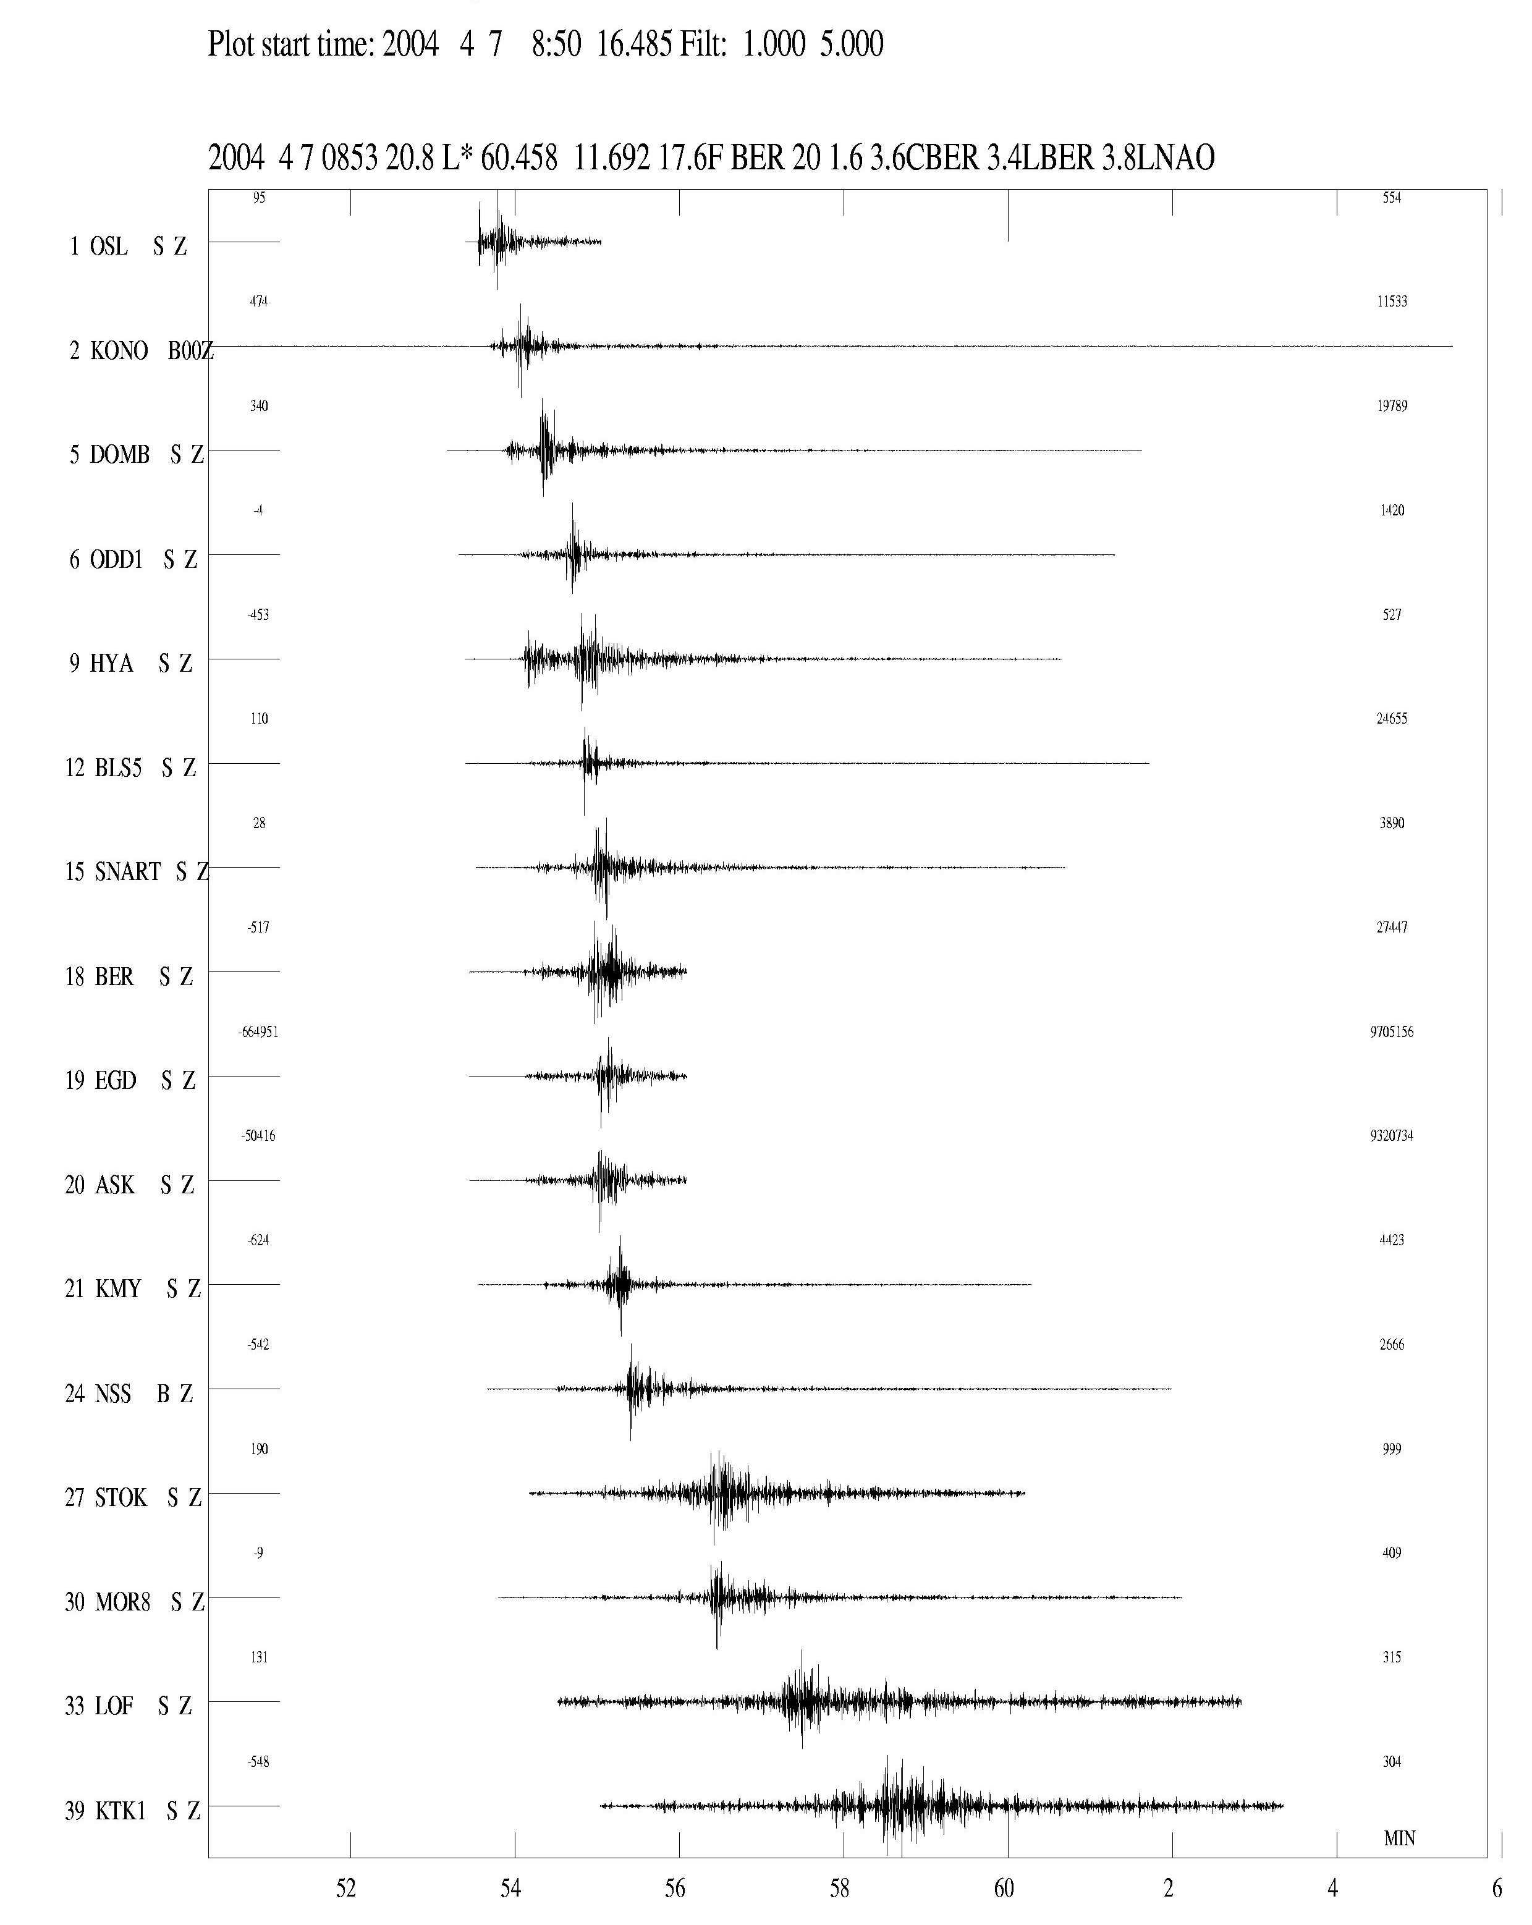
Figure 6: Seismograms for the earthquake on April 7th 2004 at 8:53 (UTC). The seismograms are filtered between 1-5 Hz. The horizontal time scale is minutes, first marking at 8:54 (UTC). The station abbreviations are: HYA: Høyanger, KMY: Karmøy, ODD: Odda, BLS: Blåsjø, BER: Bergen, EGD: Espegrend, ASK: Askøy, OSL: Oslo, SNART: Snartemo, DOMB: Dombås, LOF: Lofoten, NSS: Namsos, KTK: Kautokeino, MOR: Mo i Rana, STOK: Stokkvågen.

Jan Mayen

The Jan Mayen island is located in an active tectonic area with two major structures, the Mid Atlantic ridge and the Jan Mayen fracture zone, interacting in the vicinity of the island. Due to both tectonic and magmatic activity in the area, the number of recorded earthquakes is higher than in other areas covered by Norwegian seismic stations. During 2004 a total of 661 earthquakes were located as seen on Figure 7 and of these, 83 were calculated to have a magnitude equal to or above 3.0.
On April 14th 2004 a M=6 earthquake occurred east of the north tip of Jan Mayen. The event was well recorded at stations all over Norway (Figure 8) and several hundreds of aftershocks have been recorded. The large amount of high-quality data available from the aftershock sequence has made a detailed study of the tectonics in the region possible (Sørensen et al., in prep.).
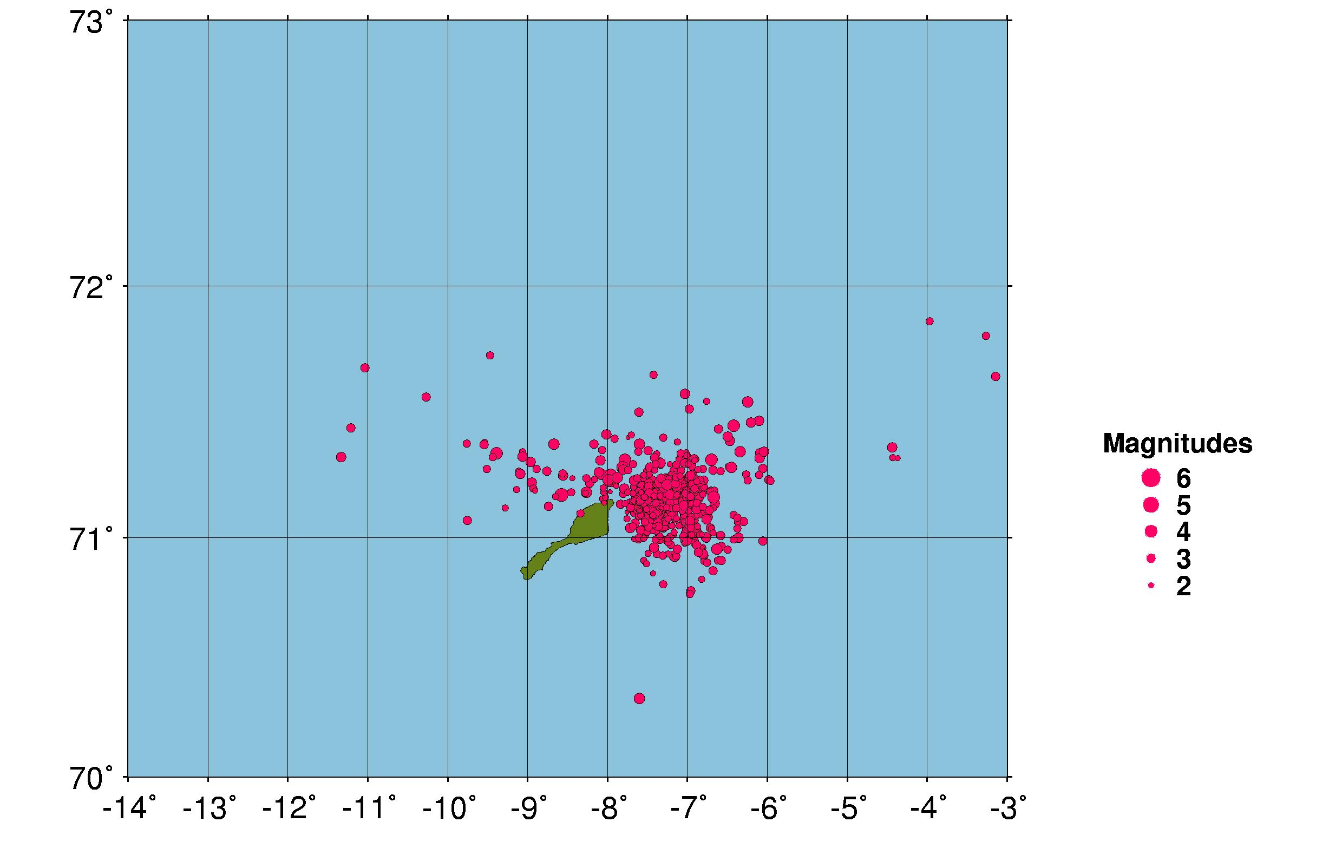
Figure 7: Earthquakes located in the vicinity of the Jan Mayen island during 2004.

5. Well recorded earthquakes

Since January 1995, well recorded earthquakes have been selected during the daily analysis and specially marked in the NNSN data base. The event selection is based on signal to noise ratio and the number of recording stations, which entails that both small events near the network and large events further away have been selected. In a few cases also location has been a qualification to mark an event as an event of special interest. These events are studied in greater detail than the other events recorded by the network. Additional phase readings and waveform data are collected if available, mainly from NORSAR and BGS. Particularly the location and the depth estimates are checked. For each event, the rms-vs-depth plot is checked and if possible the event is located using only the nearest stations (D < 200 km) to check if this gives a better location with a well constrained depth. If this is the case, the depth is fixed and the event is relocated using all stations. If no reasonable depth can be determined, the depth is fixed at 15 km for continental earthquakes and at 10 km for oceanic. The same principle for depth determination is also used for the local and
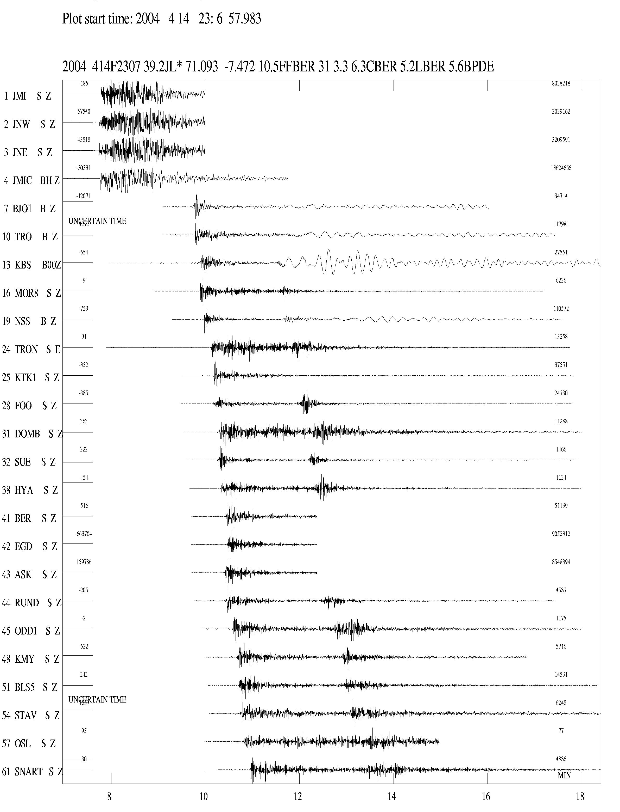
Figure 8: Seismograms for the M=6 earthquake on April 14th 2004 at 23:07 (UTC) in the Jan Mayen area. The horizontal time scale is minutes, first marking at 23:08 (UTC). The station abbreviations are: JMI, JNE, JNW, JMIC: Jan Mayen, KONO: Kongsberg, TRON: Trondheim, KBS: Kingsbay, MOR: Mo i Rana, LOF: Lofoten, TRO: Tromsø, BJO: Bjørnøya, NSS: Namsos, FOO: Florø, KTK: Kautokeino, DOMB: Dombås, SUE: Suelen, HYA: Høyanger, BER: Bergen, EGD: Espegrend, ASK: Askøy, RUND: Rundemanen, ODD: Odda, OSL: Oslo, KMY: Karmøy, BLS: Blåsjø, STAV: Stavanger, SNART: Snartemo.
regional events with magnitude equal to or above 3.0. For this report, 15 special events have been analyzed (see Table 5). The locations of these events are shown in Figure 9.

Focal mechanisms

It has been possible to determine a focal mechanism for 3 of the 15 well recorded events. These mechanisms are shown in Figure 10.

6. Felt earthquakes

17 earthquakes were reported felt during 2004 (see Table 6 and Figure 11). Four of the earthquakes reported felt in Norway were felt by a sufficient number of people for questionnaires to be distributed as basis for isoseismal maps. These events are marked in Table 6. For two of the events, very few felt reports were returned with the questionnaires. For the resulting two events, macroseismic data are presented in Figures 12 and 13.

Table 5: List of 17 well recorded events in 2004.
Abbreviations are: HH = hour (UTC), MM = minutes, Sec = seconds, L = distance identification (L=local), Latitud = latitude, Longitud=longitude, Depth = focal depth (km); F= fixed depth , AGA = reporting agency (BER=Bergen), NST = number of stations, RMS = root mean square of the travel-time residuals, Mc = coda magnitude, Ml = local magnitude, Mb = body wave magnitude, Ms = surface wave magnitude, Mw = moment magnitude, STRIK = strike, Mom = log of seismic moment in Nm, Strs = stress drop in bar, f0 = corner frequency in Hz and r = source radius in km.

Year Date HRMM Sec L Latitud Longitud Depth F AGA NST RMS Mc Ml Mb Ms Mw STRIK DIP RAKE Mom Strs f0 r
2004 1 1 1526 51.5 L 60.439 4.332 16.0 F BER 12 1.1 2.2 2.1 2.4 12.6 6.9 7.96.1736
2004 112 0711 25.2 L 60.220 5.133 14.5 F BER 14 1.4 2.2 1.9 1.9 116 80 -2 12.0 7.413.18.1106
2004 227 1811 59.9 L 61.174 3.904 12.0 F BER 24 1.5 3.0 3.0 3.0 13.5 35.3 6.24.2575
2004 3 6 1004 20.0 L 60.159 10.689 13.0 F BER 11 1.5 2.3 1.6 1.8 11.8 1.1 8.51.1563
2004 316 0509 44.4 L 66.866 8.558 15.0 F BER 20 1.2 3.4 2.6 2.9 13.4 5.4 4.55.2843
2004 4 7 0853 20.8 L 60.458 11.692 17.6 F BER 20 1.6 3.6 3.4 3.6 14.5 15.2 2.77.4802
2004 414 2307 39.2 L 71.093 -7.472 10.5 FF BER 31 3.3 6.3 5.2 5.6 4.9 5.1 22 82 -173 16.7372.7 1.40.0993
2004 5 2 1924 53.8 L 59.888 6.267 5.0 F BER 15 1.3 1.8 1.3 1.8 11.70.707 7.62.1757
2004 511 0050 47.7 L 60.014 5.302 7.0 F BER 16 1.0 1.7 1.8 2.0 12.1 1.3 7.75.1678
2004 513 0658 52.8 L 62.160 1.991 15.0 F BER 38 2.0 3.6 3.2 3.2 13.9 13.2 3.90.3479
2004 629 0125 32.9 L 59.558 7.707 8.0 F BER 23 1.3 2.9 3.1 2.9 13.4 8.0 4.94.2620
2004 9 3 0931 29.2 L 58.219 7.680 17.5 F BER 21 1.5 2.9 2.8 2.9 13.4 10.8 5.97.2111
2004 921 1332 33.8 L 54.848 20.161 10.0 F BER 26 1.6 5.4 4.9 3.4 4.8 16.2234.7 1.79.7223
2004 928 1153 40.0 L 57.499 7.172 13.2 BER 19 1.4 3.0 2.9 2.9 13.5 3.1 3.58.3657
2004 11 1 2226 58.7 L 60.542 4.909 12.0 F BER 21 1.3 2.3 2.5 2.5 125 90 30 12.8 8.2 7.79.1627

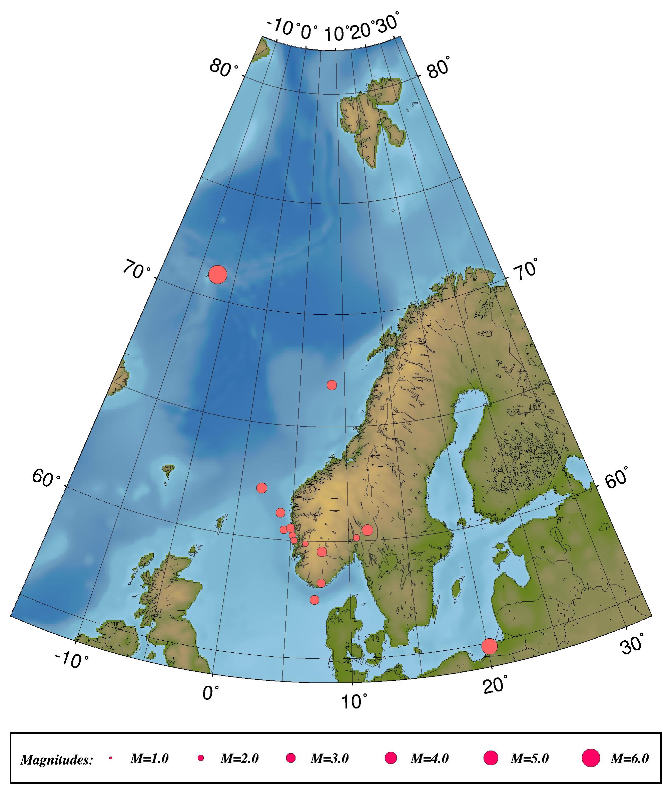
Figure 9: Epicentre distribution of well-recorded events in 2004. For station locations, see Figure 1.

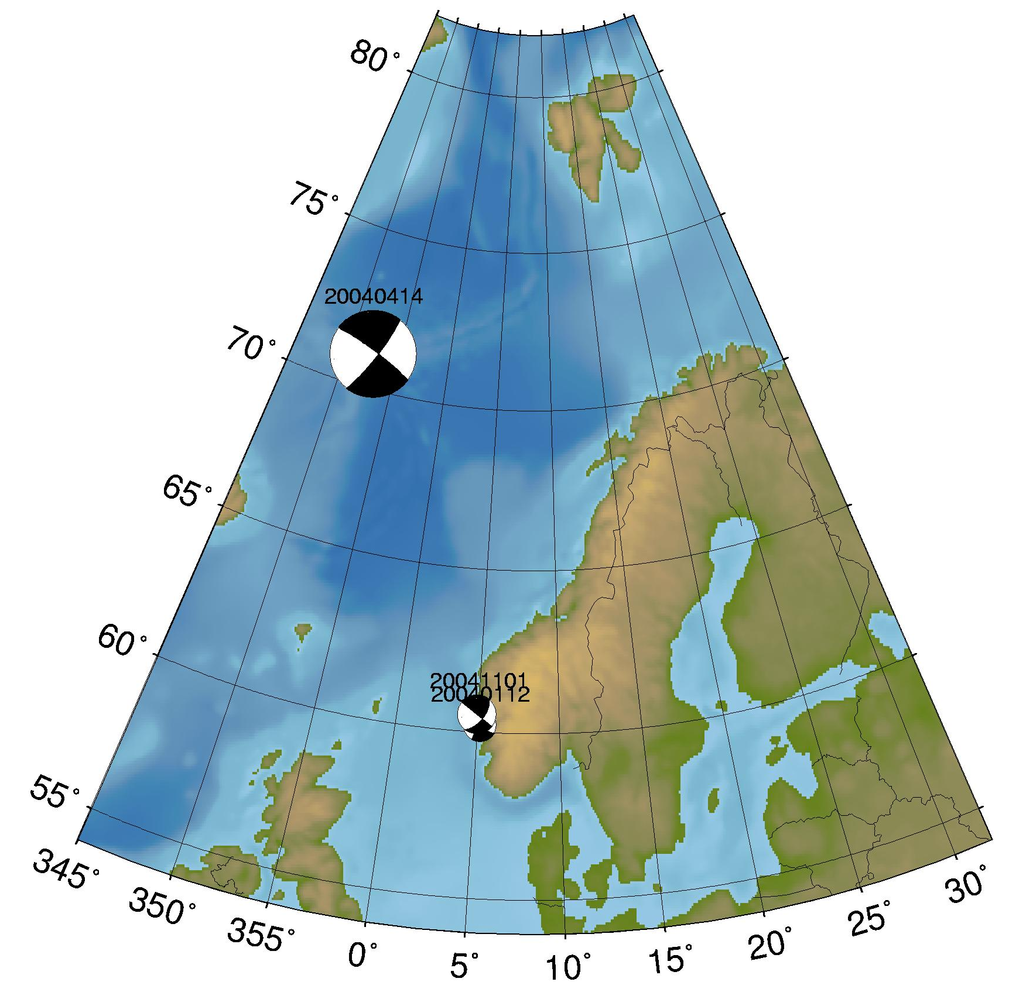
Figure 10: Earthquakes with focal mechanisms in 2004.

Table 6: Earthquakes reported felt in the BER database in 2004. Abbreviations are: M_{c} = coda magnitude, M_{l} = local magnitude and M_{w} = moment magnitude, Q: questionnaires sent.

Nr | Date | Time (UTC) | Max. intensity  (on MMI scale) | Magnitude (BER) | Instrumental epicentre location | Q
1 | 12.01.04 | 7:11 | III | M_{c}=2.2, M_{l}=1.9, M_{w}=1.9 | 60.22N / 5.13E
2 | 15.02.04 | 8:08 | III | M_{c}=2.0, M_{l}=1.6 | 62.08N / 5.63 E
3 | 27.02.04 | 18.11 | III | M_{c}=3.0, M_{l}=3.0, M_{w}=3.0 | 61.17N / 3.90E
4 | 07.04.04 | 8:53 | VI | M_{c}=3.6, M_{l}=3.4, M_{w}=3.6 | 60.46N / 11.69E | Q
5 | 14.04.04 | 23:07 | V | M_{c}=6.3, M_{l}=5.2, M_{w}=5.1 | 71.09N / 7.47W
6 | 02.05.04 | 19:24 | III | M_{c}=1.8, M_{l}=1.3, M_{w}=1.8 | 59.89N / 6.27E
7 | 11.05.04 | 0:50 | III | M_{c}=1.7, M_{l}=1.8, M_{w}=2.0 | 60.01N / 5.30E
8 | 29.06.04 | 1:25 | III | M_{c}=2.9, M_{l}=3.1, M_{w}=2.9 | 59.56N / 7.71E | Q
9 | 12.08.04 | 16:36 | III | M_{c}=2.4, M_{l}=1.7 | 69.15N / 17.19E
10 | 15.08.04 | 20.39 | III | M_{c}=2.2, M_{l}=1.2 | 69.19N / 17.17E
11 | 15.08.04 | 20:48 | III | M_{c}=2.0, M_{l}=1.3 | 69.20N / 17.11E
12 | 20.08.04 | 07:58 | III | M_{c}=2.6, M_{l}=1.7 | 69.28N / 17.07E
13 | 03.09.04 | 9:31 | III | M_{c}=2.9, M_{l}=2.8, M_{w}=2.9 | 58.22N / 7.68E | Q
14 | 21.09.04 | 13:32 | III | M_{l}=5.4, M_{w}=4.8 | 54.85N / 20.16E
15 | 28.09.04 | 11:53 | III | M_{c}=3.0, M_{l}=2.9, M_{w}=2.9 | 57.50N / 7.17E
16 | 01.11.04 | 22:26 | V | M_{c}=2.3, M_{l}=2.5, M_{w}=2.5 | 60.54N / 4.91E | Q
17 | 29.12.04 | 6:34 | III | M_{c}=1.7, M_{l}=1.8 | 59.86N / 10.98E

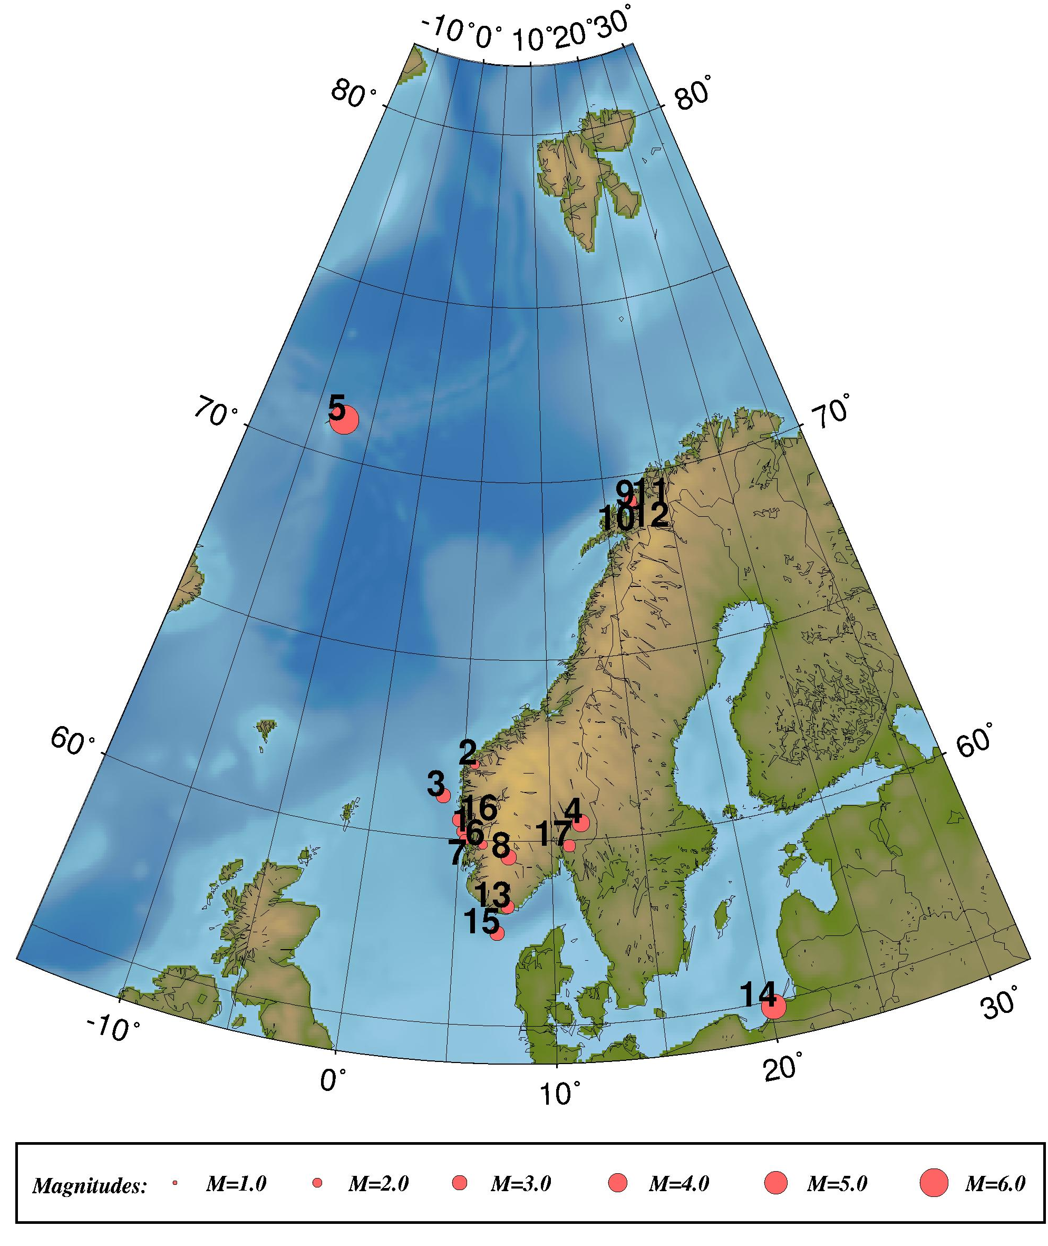
Figure 11: Location of the 17 earthquakes reported felt during 2004. Numbers refer to numbers in Table 6.

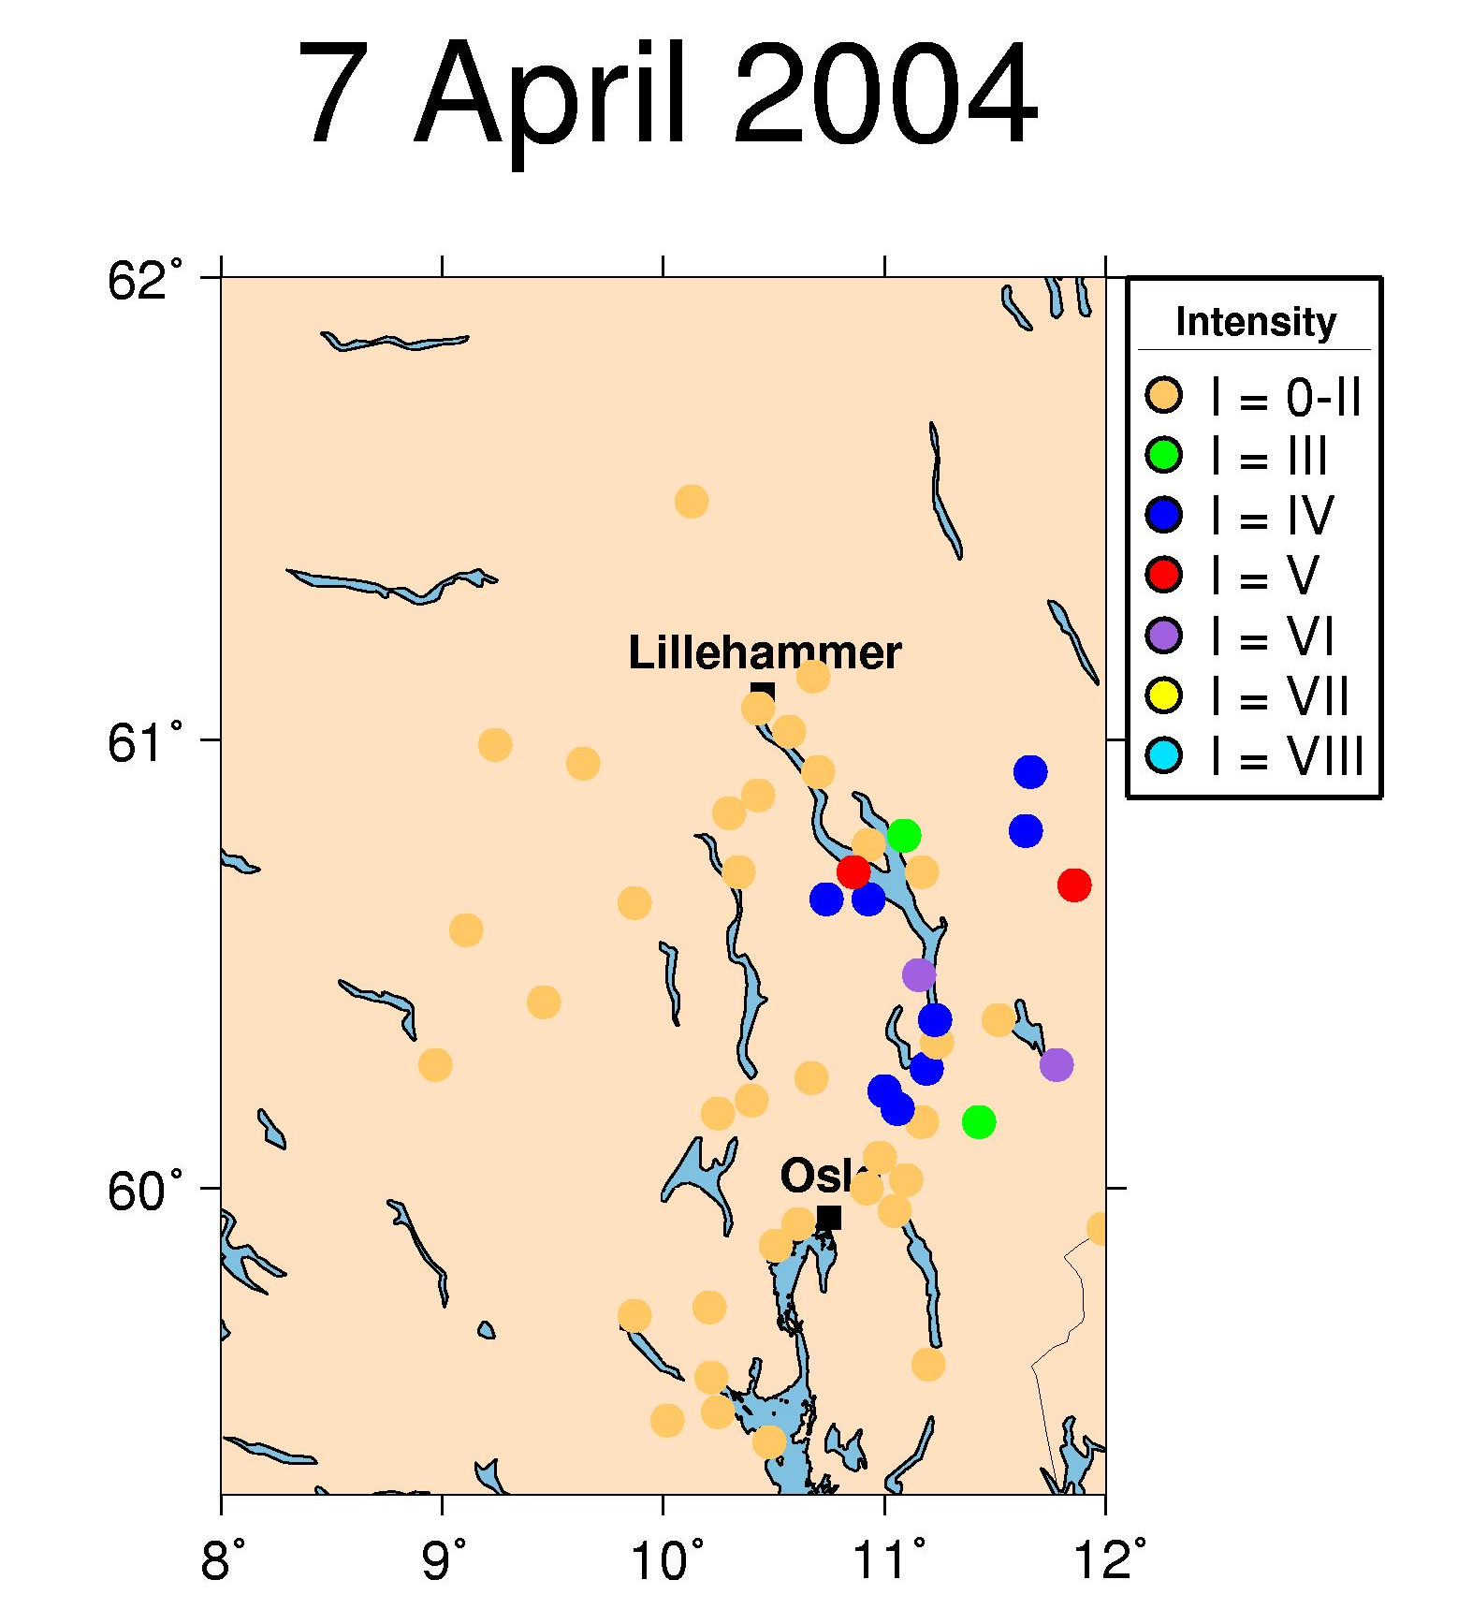

Figure 12: Macroseismic information for the event on April 7th, 2004 as returned in questionnaires.

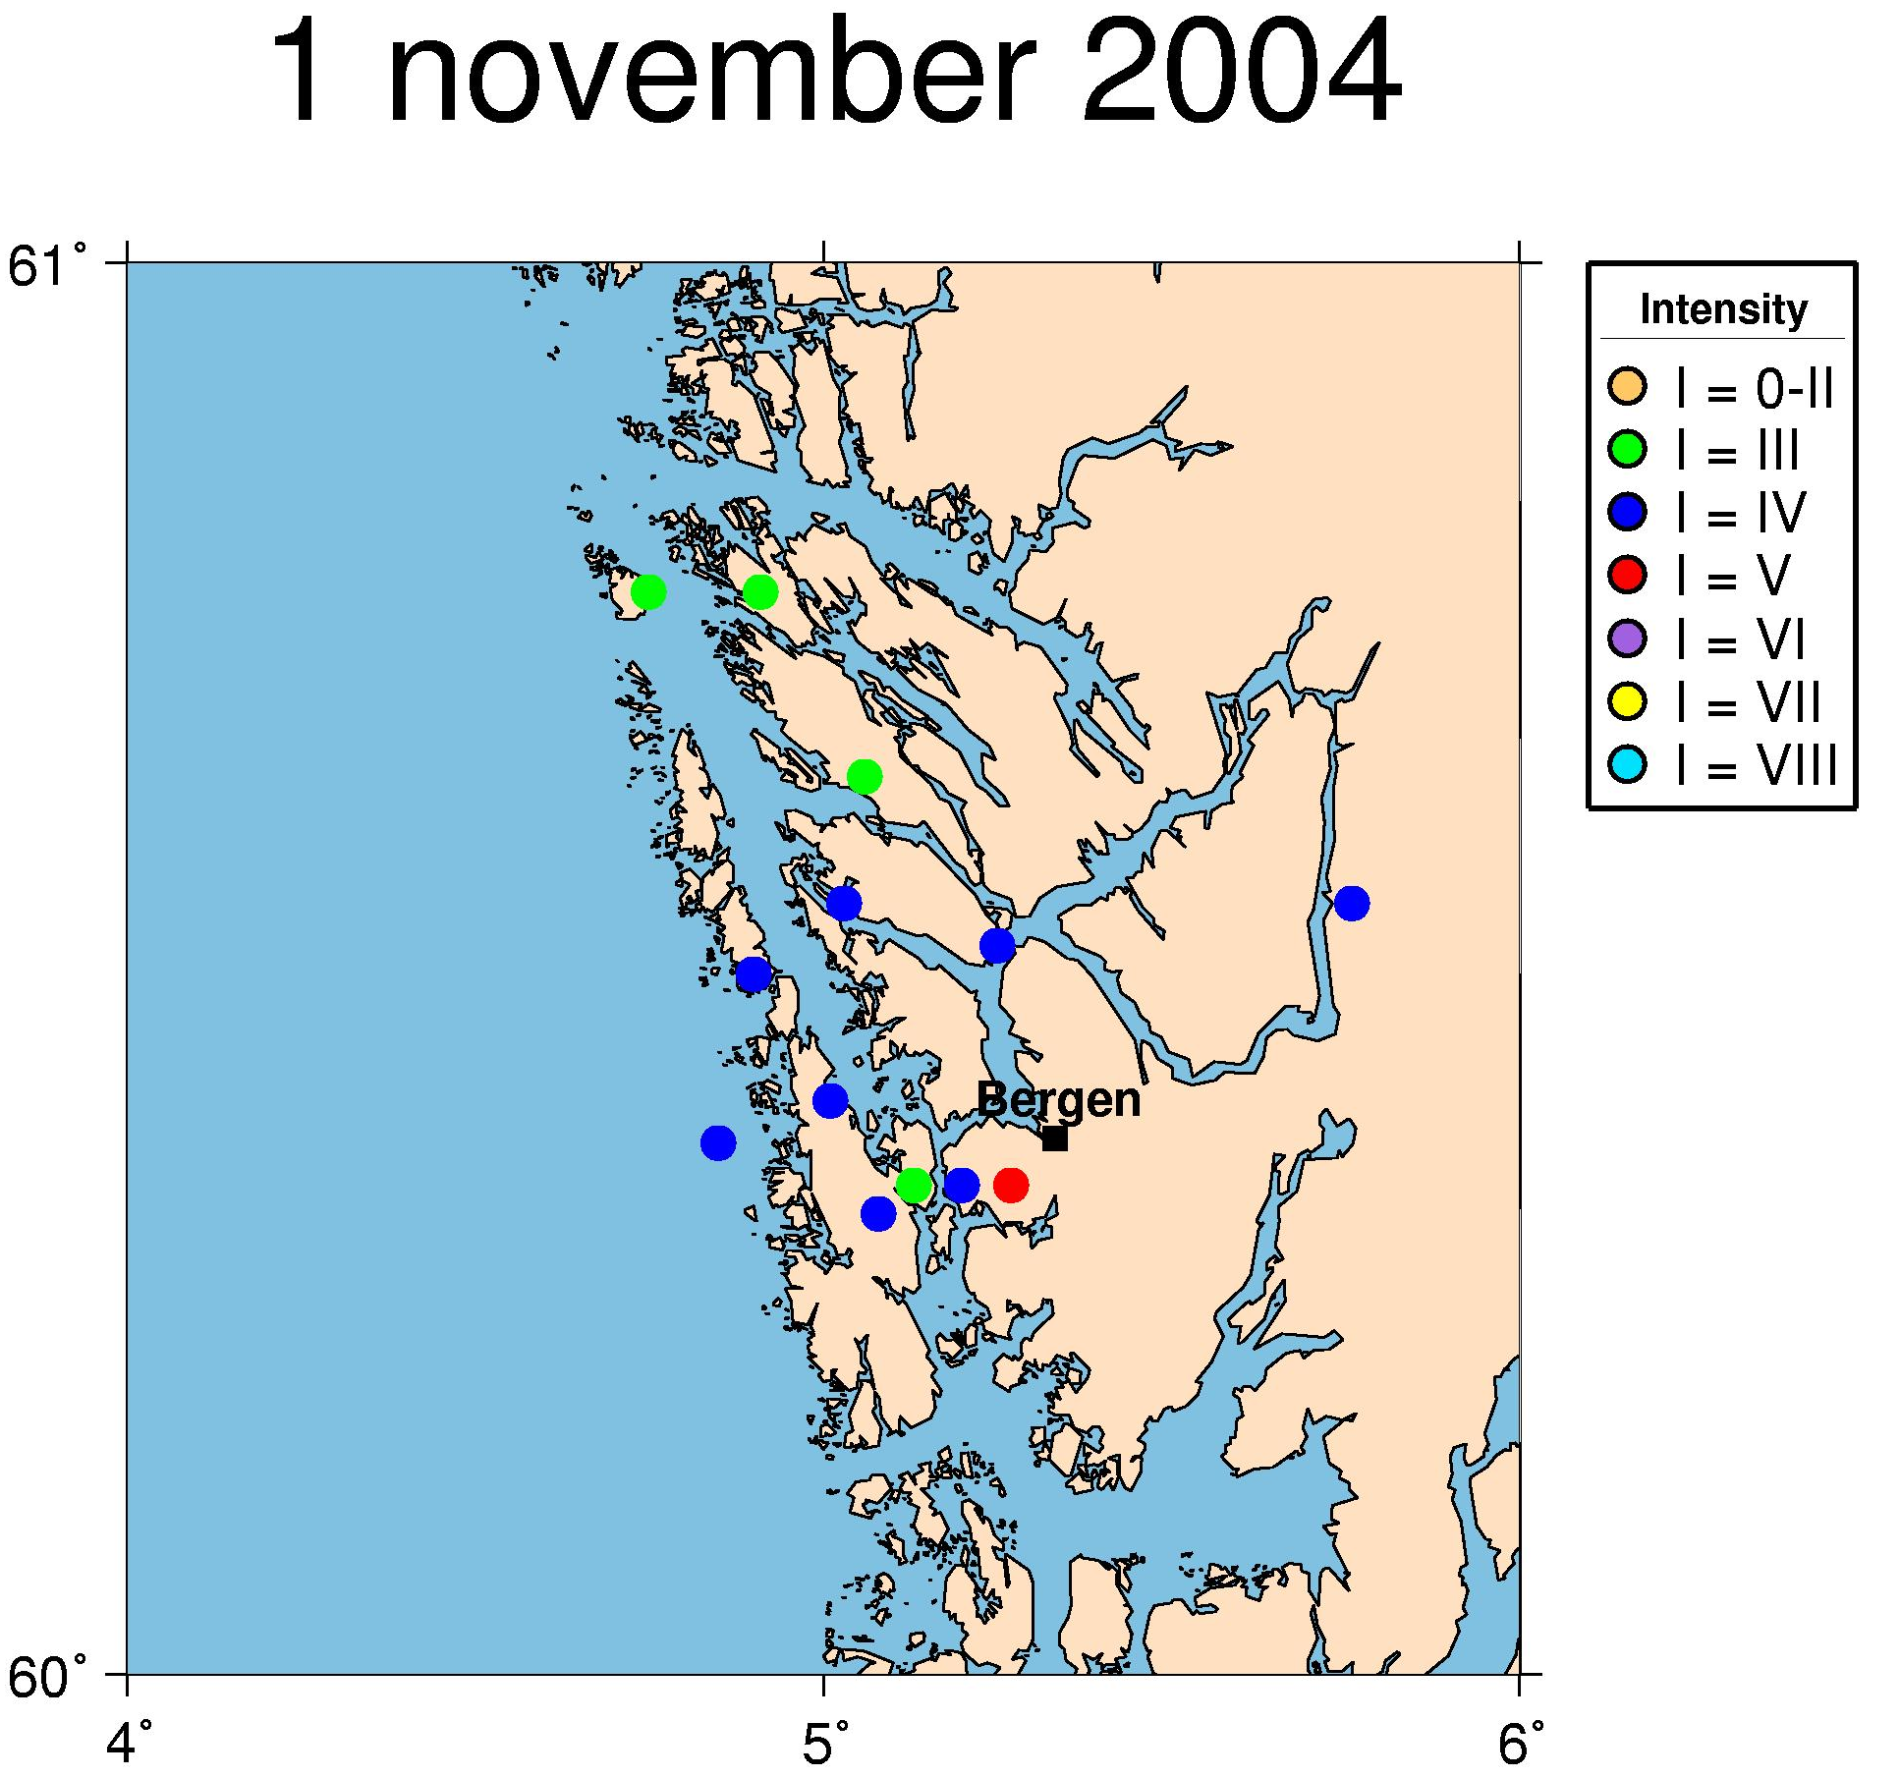

Figure 13: Macroseismic information for the event on November 1st, 2004 as returned in questionnaires.

7. Use of NNSN data during 2004

Data collected by Norwegian seismic stations are made available through the Internet and are provided on request to interested parties. The use and publication of this data is beyond our control.

Publications and reports

Asming V., E. Kremenetskaya and F Ringdal (2004): Locating seismic events near the Spitsbergen archipelago. NORSAR Sci. Report 1-2004
Bischoff, M., T. Maier, J. Schweitzer & H.-P. Harjes (2004): Comparison of the Love-Rayleigh discrepancy in Central Europe (GRSN) and Scandinavia (NORSAR). Geophysical Research Abstracts 6, 05131 (abstract).
Bischoff, M., J. Schweitzer, T. Meier & H.-P. Harjes (2004): Anisotropy in the lower crust and the upper mantle inferred from the inversion of Love and Rayleigh phase velocities: GRSN and NORSAR. In: B. Stöckhert & G. Dresen (eds.): Symposium: Tectonics on Human Time Scale, Bochumer Geowissenschaftliche Arbeiten, Heft 3, 93-94, 2004 (extended abstract).
Bischoff, M., J. Schweitzer & T. Meier (2004): Comparison of the Love-Rayleigh discrepancy in central Europe and southern Scandinavia (NORSAR). In: Semiannual Technical Summary, 1 January – 30 June 2004, NORSAR Scientific Report 2–2004, 70-78, Kjeller, Norway, August.
Bungum, H., O. Ritzmann, J.I. Faleide, N. Maercklin, J. Schweitzer, W.D. Mooney, S.T. Detweiler & W.S. Leith (2004): Development of a three-dimensional velocity model for crust and upper mantle of the Barents Sea, Novaya Zemlya, Kara Sea and Kola-Karelia Regions. Proceedings, 26th Seismic Research Review, Orlando, Florida, 21-23 September, LA-UR-04- 5801.
Bungum, H., C. Lindholm and J. I. Faleide (2005): Postglacial seismicity offshore mid-Norway with emphasis on spatio-temporal-magnitudal variations. Marine and Petroleum Geology, in press.
Engdahl, E. R. & J. Schweitzer (2004): Observed and predicted travel times of Pn and P phases recorded at NORSAR from regional events. In: Semiannual Technical Summary, 1 January – 30 June 2004, NORSAR Scientific Report 2–2004, 51-56, Kjeller, Norway, August.
Engdahl, E. R. & J. Schweitzer (2004): Observed and predicted travel times of Pn and P phases recorded at NORSAR from regional events. Eos Trans. AGU, 85 (47), Fall Meeting Supplement, Abstract S13B-1050.
Gibbons, S. J., Kværna, T. and F. Ringdal (in press): Monitoring of seismic events from a specific source region using a single regional array: a case study. Journal of Seismology, in press.
Gibbons S. J. and F. Ringdal (2004). A waveform correlation procedure for detecting decoupled chemical explosions. NORSAR Sci. Report 2-2004
Harris, D.B., F. Ringdal, E. Kremenetskaya, S. Mykkeltveit, D. Rock, J. Schweitzer, T. Hauk & J. Lewis (2004): Ground-truth collection for mining explosions in Northern Fennoscandia and Russia. 26th Seismic Research Review – Trends in Nuclear Explosion Monitoring. Orlando, Florida, September 21 – 23, 2004, LA-UR-04-5801, Proceedings, CD Version file 02 – 06; Volume 1, 73–82.
Havskov, J. and G. Alguacil. (2004): Instrumentation in Earthquake Seismology, book, Springer 358 pp.
Hicks, E.C, T. Kværna, S. Mykkeltveit, J. Schweitzer & F. Ringdal (2004): Travel-times and attenuation relations for regional phases in the Barents Sea region. Pure appl. geophys. 161, 1-19, 2004
Kozyrev, S., E. Kremenetskaya, V. Asming, F. Ringdal & T. Kværna. (2004): Ground Truth information from Khibiny mining explosions. In: Semiannual Technical Summary, 1 July – 31 December 2003, NORSAR Sci. Report 1-2004.
Kværna, T. (2004): ARCES recordings of events from the Khibiny and Olenegorsk mines. In: Semiannual Technical Summary, 1 July – 31 December 2003, NORSAR Sci. Report 1-2004.
Kværna, T. (2004): Seismiske hendelser i Barentsburg i forbindelse med gruveulykken den 26. juli 2004. NORSAR Contribution No. 905.
Kvaerna, T., S. Gibbons, F. Ringdal & D. Harris (2004): Integrated Seismic Event Detection and Location by Advanced Array Processing. 26th Seismic Research Review – Trends in Nuclear Explosion Monitoring. Orlando, Florida, September 21 – 23, 2004, LA-UR-04- 5801, Proceedings, CD Version file 8-07; Volume II, 297–306, 2004
Lindholm C., M. Roth, H. Bungum & J.I. Faleide (in press): Probabilistic and deternministic seismic hazard results and influence of the sedimentary Møre Basin, NE Atlantic. Marine and Petroleum Geology.
Ringdal, F. (ed.) (2004): Semiannual Technical Summary, 1 July - 31 December 2003, NORSAR Sci. Rep. 1-2004, Kjeller, Norway, February.
Ringdal, F. (ed.) (2004): Semiannual Technical Summary, 1 January - 30 June 2004, NORSAR Sci. Rep. No. 2-2004, Kjeller, Norway, August.
Ringdal, F. & T. Kværna, (2004): Some aspects of regional array processing at NORSAR, In: Semiannual Technical Summary, 1 July – 3 December 2003, NORSAR Sci. Report 1-2004.
Ringdal, F., T. Kværna, E. Kremenetskaya, V. Asming, S. Kozyrev, S. Mykkeltveit , S. Gibbons and J. Schweitzer (2004): Research in Regional Seismic Monitoring. In: Semiannual Technical Summary, 1 January – 30 June 2004, NORSAR Sci. Report 2-2004.
Ringdal, F. , T. Kværna, E. Kremenetskaya, V. Asming, S. Kozyrev, S. Mykkeltveit, S. Gibbons & J. Schweitzer (2004): Research in Regional Seismic Monitoring. 26th Seismic Research Review – Trends in Nuclear Explosion Monitoring. Orlando, Florida, September 21 – 23, 2004, LA-UR-04-5801, Proceedings, CD Version file 3–10; Volume I, 297–306, 2004
Ritzmann, O., J.I. Faleide, H. Bungum, N. Maercklin, J. Schweitzer, W. D. Monney, S. T. Detweiler & W. S. Leith (2004): Construction of a 3D seismic velocity model fort he Barents Sea region using sedimnet vs. crystalline crust thickness relationships. Eos Trans. AGU, 85 (47), Fall Meeting Supplement, Abstract S23B-0315
Schisselé, E. & J. Schweitzer (2004): Study of regional variations of the coda characteristics in the Barents Sea using small-aperture arrays. In: Semiannual Technical Summary, 1 July – 31 December 2003, NORSAR Scientific Report 1–2004.
Schweitzer, J. (2004): NORSAR Institutional Report, 4th Annual Meredian Report, 14 pp, December.
Schweitzer, J. (2004): NORSAR’s Data Center. Proceedings, FDSN Meeting, September 2004, Potsdam, Germany.
Schweitzer, J. (2004): NORSAR Status Report,Proceedings, 5th Meredian Workshop, Potsdam, Germany, September
Seismology group, UiB (2004): Seismic events 19th of Jenuary 2004 related to M/S Rocknes accident. Technical report No. 17, Department of Earth Science, University of Bergen, Norway.
SIMPSON, B. A. (2004). Bulletin of British earthquakes 2003. British Geological Survey, Internal Report, CR/04/074N.

Stange, S. & J. Schweitzer (2004): Source depths at regional distances: an example from the Western Barents Sea / Svalbard Region. In: Semiannual Technical Summary, 1 July – 31 December 2003, NORSAR Scientific Report 1–2004, 45-50, Kjeller, Norway, February.
Stevens, J, N. Rimer, H. Xu, J. Murphy, B. Barker, S. Gibbons, C. Lindholm, F. Ringdal, T. Kvaerna & I Kitov (2004):Analysis and Simulation og Cavity-Decupled Chemical Explosions. 26th Seismic Research Review – Trends in Nuclear Explosion Monitoring. Orlando, Florida, September 21 – 23, 2004, LA-UR-04-5801, Proceedings, CD Version file 4-13 ; Volume I, 495-502, 2004
Öberg, D., T. Kværna & F. Ringdal (2004): Discriminants for seismic monitoring. In: Semiannual Technical Summary, 1 January – 30 June 2004, NORSAR Sci. Report 2-2004.

Oral and poster presentations

Atakan, K. (2004): Kan oljeutvinning forårsake jordskjelv? Fysikk og Kjemiforum, 28th Oct.2004, Dept.of Physics and Technology, Univ. of Bergen, Norway.
Bischoff, M., J. Schweitzer, T. Maier & H.-P. Harjes (2004): Messung der Love-Rayleigh-Diskrepanz: GRSN und NORSAR. 64th Jahrestagung der Deutschen Geophysikalischen Gesellschaft, Berlin 8 – 12 March (poster).
Bischoff, M., J. Schweitzer, T. Maier & H.-P. Harjes (2004): Anisotropy in the lower crust and the upper mantle inferred from the inversion of Love and Rayleigh phase velocities: GRSN and NORSAR.Symposium: Tectonics on Human Time Scale, Spockhövel (poster).
Bischoff, M., T. Maier, J. Schweitzer & H.-P. Harjes (2004): Comparison of the Love-Rayleigh discrepancy in central Europe (GRSN) and Scandinavia (NORSAR). EGU General Assembly, Nice (poster)
Bungum, H. (2004): Seismotectonics: The geophysics of earthquake processes. The 17th Kongsberg Seminar, Kongsberg, Norway, 5-7 May.
Bungum, H. (2004): Oslo-jordskjelvet i 1904. Oslo-geofysikernes Forening, Oslo, 6 October.
Bungum, H., F. Pettenati, L. Sirovich & J. Schweitzer (2004): Source inversion of regional intensity patterns: the Ms = 5.5, 1904 Oslofjord earthquake, and some smaller well recorded Norwegian events. ESC 29th Gen. Ass., Potsdam, Germany, September.
Bungum, H., T. Kvaerna, S. Mykkeltveit, M. Roth, V. Oye, K. Aastebol, D, Harris & S. Larsen (2004): Energy Partitioning for Seismic Events in Fennoscandia and NW Russia. 26th Seismic Research Review – Trends in Nuclear Explosion Monitoring. Orlando, Florida, 21-23 September (Poster)
Bungum, H., O. Ritzmann, J.I. Faleide, N. Maercklin, J. Schweitzer, W. Mooney, S. Detweiler & W. Leith (2004): Development of a three-dimensional velocity model for the crust and upper mantle in the Barents Sea, Novaya Zemlya, Kara Sea and Kola-Karelia Regions. 26th Seismic Research Review – Trends in Nuclear Explosion Monitoring. Orlando, Florida, 21 - 23 September (poster).
Engdahl, E. R. & J. Schweitzer (2004): Observed and predicted travel times of Pn and P phases recorded at NORSAR from regional events. AGU, Fall Meeting, December (poster).
Galiana-Merino J.J., C. Lindholm, S. Gibbons, P. Jauregui, S. Molina, J. Rosa-Herranz & J.J. Giner (2004): Time-frequency analysis of earthquakes and explosions located at the northwest of the province of Alicante. 4’a Asamblea Hispano Portoguesa de Geodesia y Geofisica. Figueira da Foz, 2004, 1.
Harris, D.B., F. Ringdal, E. Kremenetskaya, S. Mykkeltveit, D. Rock, J. Schweitzer, T. Hauk & J. Lewis (2004): Ground-truth collection for mining explosions in Northern Fennoscandia and Russia. 26th Seismic Research Review – Trends in Nuclear Explosion Monitoring. Orlando, Florida, 21 - 23 September (poster).
J. Havskov (2004). The Norwegian nation Seismic Network, Conference titled “High Quality Seismic Stations and Networks for Small Budgets” in Volcan, Panama, march 2004.

Kind, R. (2004): The seismic lithosphere-asthenosphere boundary, Seminar at Cornell University, Ithaka, New York, May 2004
Kind, R. (2004): Seismic discontinuities in the upper mantle, AGU-Meeting, December 2004, San Francisco.

Krüger, F., J. Schweitzer & Masi Working Group (2004): Crust and upper mantle structure of northernmost Fennoscandia. AG Seismologie, Bochum, Germany, 27 – 29 September.
Kumar, P. and R. Kind (2004): The lithosphere of the NW Atlantic and the Iceland plume track, Iceland working group, AGU-Meeting, December 2004, San Francisco.

Kvaerna, T., S.J. Gibbons, F. Ringdal & D. Harris (2004): Integrated Seismic Event Detection and Location by Advanced Array Processing. 26th Seismic Research Review – Trends in Nuclear Explosion Monitoring. Orlando, Florida, 21 - 23 September (poster).
Musson, R., J. Battlo, J. Dewey & J. Schweitzer (2004): The IASPEI working group on seismological archives: A status report. ESC 29th Gen. Ass., Potsdam, Germany, September (poster).
Ottemöller,L., Nielsen, H.H., Braunmiller,J., Havskov,J., and Atakan,K. (2004): The Ekofisk seismic event of May 7, 2001. European Seismological Commission (ESC) XXIX General Assembly, 12-17 Sept. 2004, Potsdam, Germany. (Poster presentation).
Pettenati, F., H. Bungum, J. Schweitzer, L. Sirovich (2003): Automatic source inversion of macroseismic intensity data: case studies for Norwegian earthquakes, 22º Covegno Nazionale, GNGTS, Roma, 18 – 22 November 2003.

Ringdal, F. , T. Kværna, E. Kremenetskaya, V. Asming, S. Kozyrev, S. Mykkeltveit, S.J. Gibbons & J. Schweitzer (2004): Research in Regional Seismic Monitoring. 26th Seismic Research Review – Trends in Nuclear Explosion Monitoring. Orlando, Florida, 21 - 23 September (poster)
Ritzmann, O., J.I. Faleide, H. Bungum, N. Maercklin, J. Schweitzer, W. D. Monney, S. T. Detweiler & W.S. Leith (2004): Construction of a 3D seismic velocity model fort he Barents Sea region using sedimnet vs. crystalline crust thickness relationships. AGU, Fall Meeting, December (poster).
Schisselé, E. & J. Schweitzer (2004): Study of regional variations of the coda characteristics in the Barents Sea using small-aperture array analysis. 64th Jahrestagung der Deutschen Geophysikalischen Gesellschaft, Berlin, 8 – 12 March (poster).
Schweitzer, J. (2004): The 7 April 2004 Flisa earthquake – A GT-1 event in Southern Norway. ESC 29th Gen. Ass., Potsdam, Germany, September.
Schweitzer, J. (2004): The 7th April 2004 Flisa earthquake – a GT 1 event in Southern Norway. 35th Nordic Seminar on Detection Seismology, Åkersberga, Sweden, 29 September – 1 October.
Schweitzer, J., F. Pettenati and H. Bungum (2004): The earthquake of 23 October 1904 in the Oslo Fjord area, AG Seismologie, Bochum, 27. ñ 29. September 2004.
Schweitzer, J., F. Pettenati and H. Bungum (2004): The earthquake of 23 October 1904 in the Oslo Fjord area, 35th Nordic Seminar on Detection Seismology, Åkersberga, Sweden, September 29 – October 1, 2004.

Stevens, J, N. Rimer, H. Xu, J. Murphy, B. Barker, S.J. Gibbons, C. Lindholm, F. Ringdal, T. Kvaerna & I. Kitov (2004): Analysis and Simulation og Cavity-Decupled Chemical Explosions. 26th Seismic Research Review – Trends in Nuclear Explosion Monitoring. Orlando, Florida, 21 - 23 September (poster)
Sørensen, M. B., Ottemöller, L., Havskov, J., Atakan, K., Hellevang, B. and Pedersen, R. B. (2004): The April 14th, 2004 Jan Mayen earthquake, poster presentation at the 29th general assembly of the European Seismological Commission, Potsdam, Germany, 12-17 September, 2004.

Sørensen, M. B., Ottemöller, L., Havskov, J., Atakan, K., Hellevang, B. and Pedersen, R. B. (2004): The April 14th, 2004 Jan Mayen earthquake, oral presentation on the 35th Nordic seminar on detection seismology, Åkersberga, Sweden, 29 September – 1 October, 2004.

Öberg, D. and T. Kværna (2004): Discriminants for seismic monitoring, 35th Nordic Seminar on Detection Seismology, Åkersberga, Sweden, September 29 – October 1, 2004.

8. References

Alsaker A., Kvamme, L.B., Hansen, R.A., Dahle, A. and Bungum, H. (1991): The ML scale in Norway. Bull. Seism. Soc. Am., Vol. 81, No. 2, pp.379-398.

Brune J.N. (1970): Tectonic stress and spectra of seismic shear waves. Journal of Geophysical Research, 75, 4997-5009.

Grünthal, G. (1998): "European Macroseismic Scale 1998". Cahiers du Centre Européen de Géodynamique et de Séismologie Volume 15, Luxembourg.

Havskov J., and Bungum, H. (1987): Source parameters for earthquakes in the northern North Sea. Norsk Geologisk Tidskrift,Vol.67, pp 51-58.

Havskov, J. and Ottemöller, L. (1999): SEISAN earthquake analysis software. Seism. Res. Letters, Vol. 70, pp. 532-534.

Havskov, J. and Ottemöller, L. (2001): SEISAN: The earthquake analysis software. Manual for SEISAN v. 8.0, Department of Earth Science, University of Bergen, Norway.

Kanamori, H. (1977): The energy release in great earthquakes. Journal of Geophysicsl Research 82; 20, pp. 2981-2987.

Karnik, V., Kondorskaya, N.V., Riznichenko, Y. V., Savarensky, Y. F., Solovev, S.L., Shebalin, N.V., Vanek, J. and Zatopek, A. (1962): Standardisation of the earthquake magnitude scales. Studia Geophys. et Geod., Vol. 6, pp. 41-48.

Kennett, B.L.N. and Engdahl, E.R. (1991): Traveltimes for global earthquake location and phase identification. Geophys. J. Int., Vol. 105, pp. 429-465.

Kradolfer, U. (1996): AuroDRM – The First Five Years. Seismological Research Letters, vol. 67, no. 4, 30-33.

Lienert, B.R. and Havskov, J. (1995): HYPOCENTER 3.2 A computer program for locating earthquakes locally, regionally and globally. Seismological Research Letters,
Vol. 66, 26-36.

Moreno, B, Ottemöller, L., Havskov, J. and Olesen, K.A. (2002): Seisweb: A Client-Server-Architecture-Based Interactive Processing Tool for Earthquake Analysis. Seism. Res. Letters. Vol.73, No.1.

Ottemöller, L. (1995): Explosion filtering for Scandinavia. Technical Report No. 2, Institute of Solid Earth Physics, University of Bergen, Norway.

Sørensen, M. B., Ottemöller, L., Havskov, J., Atakan, K., Hellevang, B. And Pedersen, R. B. (in prep.): Tectonic processes in the Jan Mayen Fracture Zone based on earthquake occurrence and bathymetry, manuscript in preparation.

Sørnes A. and Navrestad, T. (1975): Seismic survey of Jan Mayen. Norsk Polarinstitutt, Årbok 37-52.

Veith K.F., and Clawson, G.E. (1972): Magnitude from short-period P-wave data. Bull. Seism. Soc. Am., Vol. 62, pp.435-452.

Westre S. (1975): Richter's lokale magnitude og total signal varighet for lokale jordskjelv på Jan Mayen. Cand. real thesis., Seismological Observatory, University of Bergen, Norway.

APPENDIX 2

The NORSAR Regional Array

The NORSAR Regional Arrays
NORSAR operates the two regional seismic arrays, ARCES (near Karasjok, Finnmark) and SPITS (on Svalbard). In addition, data from NORSAR (the original large aperture array in southern Norway), FINES (in Finland), HAGFORS (southern Sweden), KBS (Kings Bay on Svalbard), KONO (Kongsberg, southern Norway) and JMIC (Jan Mayen) are collected and analyzed. All data are openly available and the interested layman can see daily data on www.norsar.no/NDC/data
The NORES array, which was damaged in 2002 has not been rebuilt. The decision on if and when it will be reinstalled is still pending. The disappearance of NORES has entailed a significantly reduced array monitoring capability in southwestern Norway and the northern North Sea. We are continuing the investigations of alternative processing and analysis algorithms that can be used with data from the large aperture NORSAR array. Promising results to this side have been obtained, and a short presentation of the status to this analysis improvements is provided below.
Fig. 1. Seismic Arrays currently operated by NORSAR. Only red circles represent the seismic stations.
- Systems Recording Performance
The arrays have continuous data recording. In 2004 the average recording time for the SPITS array was 87.7%, for the ARCES array 99.8%, and for the NORSAR array 100%.
In April (2-19) the SPITS array was out due to power supply failure, and in August
(10 -13) the same array was down due to regular hardware upgrades.
The recording performance in terms of monthly uptime statistics is shown in Table 1.

 | ARCES | SPITS | NORSAR
January | 100 % | 99.98 % | 100 %
February | 100 % | 99.99 % | 100 %
March | 100 % | 99.97 % | 100 %
April | 100 % | 74.80 % | 100 %
May | 100 % | 99.95 % | 100 %
June | 100 % | 100 % | 100 %
July | 100 % | 99.85 % | 100 %
August | 97.92 % | 78.16 % | 100 %
September | 100 % | 100 % | 100 %
October | 99.98 % | 100 % | 100 %
November | 100 % | 100 % | 100 %
December | 99.99 % | 100% | 100 %
Table 1. Systems recording performance (uptime in % of theoretical) for three arrays operated by NORSAR in 2004.
- Detections
The NORSAR analysis results are based on automatic phase detection and automatic phase associations which produce the automatic bulletin. Based on the automatic bulletin a manual analysis of the data is done, resulting in the reviewed bulletin (which is available under the NORSAR web pages). This procedure is often referred to as the Regional Monitoring System (RMS), and has been in operation since 1989. To reduce the work load on the analyst, the Generalized Beam Forming (GBF) is used as a pre-processor to RMS, so that only phases associated with selected events in northern Europe are considered in the automatic RMS phase association. However, all detections are available for analyst screening and review.
Table 2 gives a summary of the phase detections and events declared by the RMS.

 | Jan. | Feb. | March | April | May | June
Phase detections | 184518 | 135278 | 162094 | 109859 | 119458 | 137942
Associated phases | 6593 | 4691 | 5379 | 4556 | 6094 | 5837
Un-associated phases | 177925 | 130587 | 156715 | 105303 | 113364 | 132105
Events automatically declared by RMS | 1477 | 1012 | 1072 | 836 | 949 | 1109
No. of events defined by the analyst | 89 | 71 | 108 | 119 | 179 | 115
 | July | Aug. | Sep. | October | Nov. | Dec.
Phase detections | 172013 | 148724 | 172319 | 157960 | 182110 | 175767
Associated phases | 7380 | 5814 | 8863 | 6919 | 6557 | 6901
Un-associated phases | 164633 | 142910 | 163456 | 151041 | 175553 | 168866
Events automatically declared by RMS | 1489 | 1320 | 1965 | 1529 | 1501 | 1793
No. of events defined by the analyst | 108 | 95 | 160 | 106 | 92 | 89
Table 2. RMS phase detections and event summary.

The phase arrival time data from the arrays processed by NORSAR is provided to the UiB processing centre and merged with UiB readings, and a location based on all data is computed as published in the monthly bulletins.
- The use of Norwegian data
Data collected on Norwegian seismic stations are made available through the Internet and is provided on request to interested parties. The use and publication of this data is beyond our control. The published list below therefore only covers publications that we are aware of (mainly where one NORSAR employee is a coauthor).
  - The 7 April, 2004, Flisa earthquake
The largest seismic activity in Norway is concentrated along the westcoast, but regularily earthquakes are felt also in southeastern Norway, often near or in the Oslo graben geologic structure.
The uniqueness of the M=3.5 on the 7th April was the dense coverage of seismic stations that surrounded the earthquake, which facilitated a data analysis and a location precision that is rarely seen in Norway. The mainshock disturbed large parts of southeastern Norway, but one foreshock and 6 aftershocks were only recorded on our seismic stations.
A comprehensive analysis of this earthquake was conducted by J. Schweitzer, NORSAR, as reported in NORSAR Sci. Report 1-2005, (see the Appendix for the full report).
  - Detection of weak seismic signals by cross correlation;
Application to the Barentsburg rock burst sequence
Seismic events occurring within a limited geographical area often exhibit similar waveforms. When a relatively strong, typical signal is recorded, this signal may be used as a master event to detect weaker signals from nearby events.
This detection technique, developed at NORSAR, exploits the similarity of waveforms by cross correlation and can detect much weaker signals than ordinary processing and even detect signals below the noise level. The waveforms may be regarded as footprints from a specific area, and opens for the exclusion of signals that stems from different areas.
Further research within array seismology at NORSAR aims at testing this method, and so far it has been applied to study the sequence of events prior to a relatively large rock-burst in the Barentsburg coal mine, Spitsbergen, July 2004 which caused rock fall in the mine and the death of a mine worker. A good waveform from this fatal event, recorded at the SPITS seismic array 50 km away, was used for cross correlation with continuous recordings at the same array within a period of 7 months prior to the event. In this period more then 1500 smaller events were detected, and the sequence exhibits some typical features in that events/day decreases while the magnitude/event increases overt time towards the fatal event in July 2004.
A more comprehensive description of the method and the application may be found in the enclosed Appendix taken from the NORSAR Sci. Rep. 1-2005.

