Progress Report No. 1-2004



for

Norwegian National Seismic Network

January 1st to June 30 ^{th}, 2004.

Supported by

University of Bergen, Faculty of Mathematics and Natural Sciences

and

Norwegian Oil Industry Organization

Prepared by

Department of Earth Science
University of Bergen
Allegaten 41, N-5007 Bergen

October 2004

1. Introduction

This progress report, under the project Norwegian National Seismic Network (NNSN), covers the first half of 2004. The purpose is to describe the current technical operation of the stations and the data recorded for the first half of 2004. The costs will be given up to October 15.

2. Operation

The operational stability for each station is shown in Table 1. The stations have been divided into high priority and low priority stations. The average downtime for all stations during this reporting period is 1,6 %, compared to 2.5 % for 2003. This is well within acceptable limits, with respect to the goal of average downtime below 2%.

Table 1a. Downtime in % for the period 1/1-30/6 2004 for the high priority stations of the NNSN.

Station | Downtime in %
Karmøy (KMY) | 1.0
Odda (OOD1) | 0.5
Blåsjø (BLS) | 0
Kongsberg (KONO) | 1.0
Rundemanen (RUND) | 1.0
Høyanger (HYA) | 0
Sulen (SUE) | 2.0
Molde (MOL) | 0
Florø (FOO) | 7.0
Namsos (NSS) | 0
Mo i Rana (MOR8) | 0
Lofoten (LOF) | 0
Tromsø (TRO) | 18.0
Kautokeino (KTK) | 0
Jan Mayen BB (JMI) | 0
Kings Bay (KBS) | 7.0
Average | 2.4

Table 1b. Downtime in % for the period 1/1-30/6 2004 for the low priority stations of the NNSN.

Station | Downtime in %
Oslo (OSL) | 0
Stavanger (STAV) | 6.0
Espegrend (EGD) | 1.0
Askøy (ASK) | 1.0
Bergen (BER) | 1.0
Dombås (DOMB) | 0
Bjørnøya (BJO) | 0
Jan Mayen SP (JMI) | 0
Jan Mayen (JNE) | 0
Jan Mayen (JNW) | 0
Stokkvågen (STOK) | 0
Snartemo (SNART) | 0
Average | 0.8

Table 1c. The average downtime in % for all stations.

Total average | 1.6

Note: Although JMI and BJO have been running continuously, there has been some data transfer problems resulting in loss of continuous data.

3. Field stations and technical service

The technical changes for each seismic station are listed below. It is noted if these changes are not related to a visit from the technical staff at the University of Bergen. When a station stops working, tests are made to locate the problem. Sometimes the reason cannot be found and the cause of the problem will be marked as unknown.

Bjørnøya (BJO1)
No visit or technical changes.
28.06.04. Station coordinates changed in SeisDat. Old
coordinates: 74.502N, 18.999E, H= 18m. Now same
coordinates at USGS, BER and bulletin.

Blåsjø (BLS)
05.01.04 The PC was restarted. The station was down for 1 day.

Florø (FOO)
05.01.04. The PC was restarted. Station down for 4.5 days
16.02.04. The PC was restarted. Station down for 2 days
19-23.02.04. The PC unstable. Station down for 2.5 days
03.03.04. The PC was restarted. Station down for 0.5 day
19.03.04. The PC was restarted. Station down for 1 day
31.03.04. The PC was restarted. Station down for 1 day
03.05.04. The PC was restarted. Station down for 2.5 days
07.06.04. The PC was restarted. Station down for 1.5 days

Høyanger (HYA)
No visit or technical changes.

Karmøy (KMY)
17.02.04. The PC was restarted. Station down for 1 day
07.03.04. The PC was restarted. Station down for 1 day

Lofoten (LOF)
No visit or technical changes

Mo i Rana (MOR8)
11.05.04. Visit. The polarity of the 3 sensors was changed.
Inspected the aluminium box where the sensors are located – ok.

Molde (MOL)
13.05.04. Visit. During the last months the accelerometer has been malfunctioning. When testing, it turned out that the accelerometer was not working. The accelerometer was brought back to Bergen for repair.
Inspected the aluminium box where the sensors are located – ok.

Namsos (NSS)
No visit or technical changes.

Odda (ODD1)
19.03.04. The PC was restarted. Station down for 1 day

Tromsø (TRO)
18.03.04. The PC was restarted. Station down for 2 days
15.04.04. GPS time not in sync. Local operator reset power
on GPS and centered the mass of the Guralp BB sensor.
16.04.04. The PC was restarted. Station down for 1/2 day
30.04.04. The PC was restarted. Station down for 2.5 days
12.05.04. The PC was restarted. Station down for 4 days
24.05.04. The PC was restarted. Station down for 5 days
23.06.04. New digitiser ED 2400 installed by the local operator.
The installation of a new digitiser did not improve the recording stability.
29.06.04. Installed older version of Seislog 8.45 (from vers. 8.49). Auto
processing disabled. The recording is now stable.
Before the Seislog vers. 8.45 was installed, the recording was unstable for four weeks due to a bug in the software.

Sulen (SUE)
05.01.04. The PC was restarted. Station down for 4 days

Kautokeino (KTK)
No visit or technical changes.

Stavanger (STAV)
05.02.04. The PC was restarted. Station down for 11 days. Reason unknown.

WNN network: stations: Bergen (BER), Espegrend (EGD), Ask (ASK)
10.05.04. Station WNN stopped on May 10 due to power failure. Since password had expired, it did not restart automatically. Started May 10 at 10:33.

Rundemanen (RUND)
22.01.04. The PC was restarted. Station down for 1 day

Trondheim (TRON)
No visit or technical changes.

Oslo (OSL)
No visit or technical changes.

Dombås (DOMB)
14.05.04. Visit. Changed the polarity. The aluminium box with the sensor was dry.

Jan Mayen (JMI)
30.03 - 06.04.04. Visit
The station has worked properly since last visit.
The broadband station in Trolldalen (JMI) was closed March 31, 2004, since the new broadband station (JMIC) at the centre of the Island has been in operation since October 2003. This is an IMS station operated by NORSAR. Data arrives in near real time to Bergen.
A new AD converter, (SEISAD18), was installed. This converter has a higher solution than the old one.
A new Windows PC for data logging and a new printer was installed.
Gain on all channels was reduced with 18 db due to the new AD converter, which has a higher sensitivity.
At Ulla (JNE) and Liberg (JNW) the gain was reduced to 60db and the sensitivity increased from 5V to 10V.

Kongsberg (KONO)
No visit or technical changes.

Kings Bay (KBS)
No visit or technical changes.

Stokkvågen (STOK)
12.05.04. Visit. Inspected the aluminium box where the sensors are located – ok.
22.06.04. GPS fix ok, and 1 PPS ok. Due to a bug in the software the pulse pr. second (PPS) has not been used to sync the internal clock in the PC. Timing is now correct.
Snartemo (SNART)
01.03.04. From 16.02 problem with communication to station, no PC connection. Phoneline ok. 20.02 new Cisco box installed, no effect. It turned out that the local operator occupied both ISDN lines while surfing Internet. No data lost.
22.06.04. GPS fix ok, and 1 PPS ok. Due to a bug in the software the pulse pr. second (PPS) has not been used to sync the internal clock in the PC. Timing is now correct.

4. Data

The data recorded by the seismic stations were collected and monthly bulletins were prepared and distributed. Figure 1 shows earthquakes and explosions recorded during the first half of 2004 and located within the shown area. Most events are recorded by NNSN stations but also some data from NORSAR and the British Geological Survey (BGS) are included.

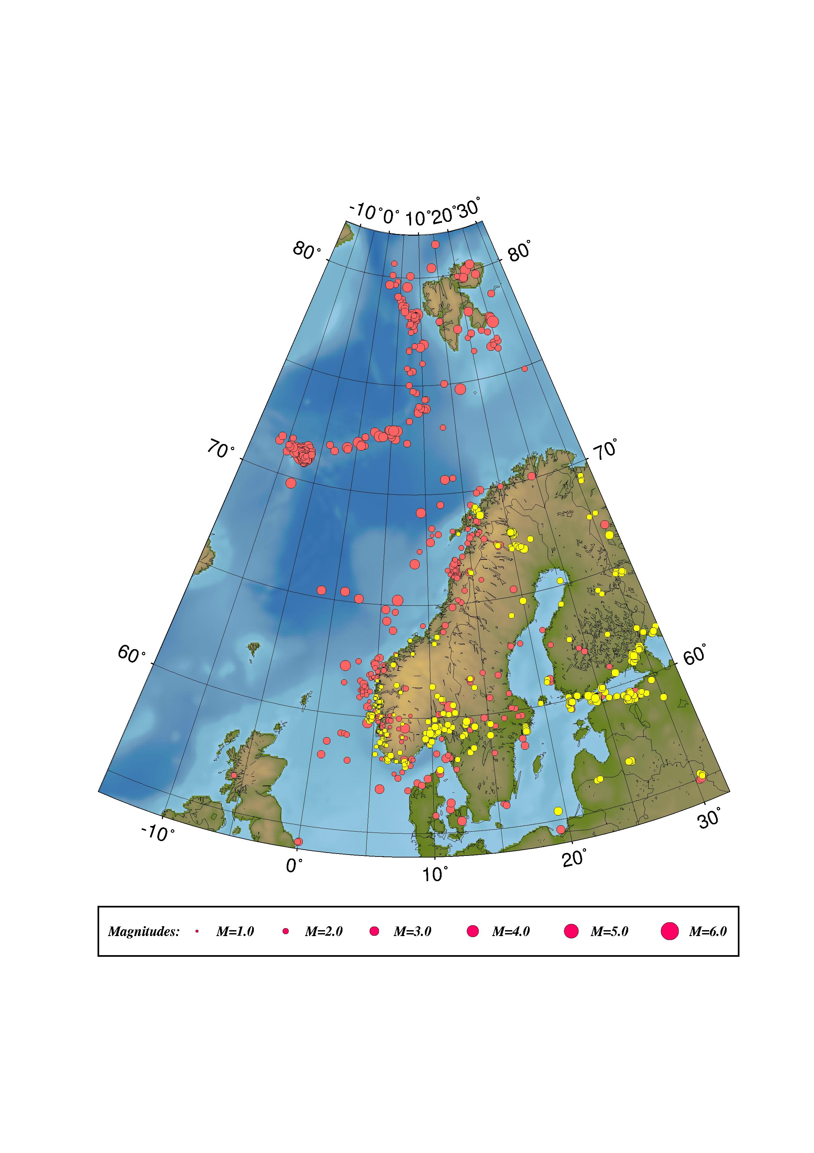

Figure 1. Epicentre distribution of located events recorded during January – June 2003.
Earthquakes are plotted in red and presumed and known explosions in yellow.

