Progress Report No. 1-2005



for

Norwegian National Seismic Network

January 1st to June 30 ^{th}, 2005.

Supported by

University of Bergen, Faculty of Mathematics and Natural Sciences

and

Norwegian Oil Industry Organization

Prepared by

Department of Earth Science
University of Bergen
Allegaten 41, N-5007 Bergen

October 2005

1. Introduction

This progress report, under the project Norwegian National Seismic Network (NNSN), covers the first half of 2005. The purpose is to describe the current technical operation of the stations and the data recorded for the first half of 2005. The costs will be given up to October 15.

2. Operation

The operational stability for each station is shown in Table 1. The stations have been divided into high priority and low priority stations. The average downtime for all stations during this reporting period is 5.2 %, compared to 1.6 % for 2004. This is higher than the goal of average downtime below 2%. The high average is mainly caused exceptional problems at Molde, Karmøy and Kings Bay.

Table 1a. Downtime in % for the period 1/1-30/6 2005 for the high priority stations of the NNSN.

Station | Downtime in %
Karmøy (KMY) | 12.0
Odda (OOD1) | 0
Blåsjø (BLS) | 0.5
Kongsberg (KONO) | 4.0
Rundemanen (RUND) | 0
Høyanger (HYA) | 0
Sulen (SUE) | 2.0
Molde (MOL) | 12.0
Florø (FOO) | 5.0
Namsos (NSS) | 0
Mo i Rana (MOR8) | 0
Lofoten (LOF) | 1.0
Tromsø (TRO) | 0
Kautokeino (KTK) | 5.0
Jan Mayen BB (JMI) | 0
Kings Bay (KBS) | 25.0
Average | 4.1

Table 1b. Downtime in % for the period 1/1-30/6 2005 for the low priority stations of the NNSN.

Station | Downtime in %
Oslo (OSL) | 0
Stavanger (STAV) | 0
Espegrend (EGD) | 0
Askøy (ASK) | 0
Bergen (BER) | 0
Dombås (DOMB) | 0
Bjørnøya (BJO) | 75.0
Jan Mayen SP (JMI) | 0
Jan Mayen (JNE) | 0
Jan Mayen (JNW) | 0
Stokkvågen (STOK) | 11.0
Snartemo (SNART) | 2.0
Trondheim (TRON) | 2.0
Hopen (HOPEN) | 0.0
Average | 6.4

Table 1c. The average downtime in % for all stations.

Total average | 5.2

3. Field stations and technical service

The technical changes for each seismic station are listed below. It is noted if these changes are not related to a visit from the technical staff at the University of Bergen. When a station stops working, tests are made to locate the problem. Sometimes the reason cannot be found and the cause of the problem will be marked as unknown.

Bjørnøya (BJO1)
From 15.02.05. No data was received from the digitizer. The local operator observed that due to a weather change with heavy rain and snow melting on the frozen ground, the aluminium box was flooded with water. The box contains the sensor, digitiser and breakout box, and the water damaged the digitizer and maybe the sensor.
Station down for 135 days. (The instruments will be reinstalled in September).

Blåsjø (BLS)
13.01.05 The PC was restarted. The station was down for 1 day.

Florø (FOO)
03.02.05. The PC was restarted. Station down for 2 days
04.02.05. The PC was restarted. Station down for 1 day
09.02.05. The PC was restarted. Station down for 1.5 days
08.03.05. The PC was restarted. Station down for 1 day
05.04.05. The PC was restarted. Station down for 1 day
26.05.05. The PC was restarted. Station down for 2.5 days

Høyanger (HYA)
No visit or technical changes.

Karmøy (KMY)
From 15.01.05. No data was received due to the last pair of the phone lines were broken (see report 2001). Karmøy municipality, the owner of this part of the phone lines, started in 2001 to transmit data wireless and had no intention of repairing the line. The estimated cost for replacing a new phoneline was kr. 100 000.
07.02.05. Tromsø Geophysical Observatory (Nordlysobservatoriet) and Department of Earth Science installed a GSM GPRS modem for data transmission.
Station down for 22 days.

Lofoten (LOF)
24.04.05. Station down for 2 days due to a broken UPS (uninterruptible power supply). The UPS was removed and a new one was not installed since there has been problems with UPS’s

Mo i Rana (MOR8)
No visit or technical changes.

Molde (MOL)
21.01.05. A new digitiser and telecommunication protector was installed. Station was down for 17 days due to lightning.
28.01.05. A new PC and Ciscobox was installed. Station down for 4 days due to lightning.

Namsos (NSS)
No visit or technical changes.

Odda (ODD1)
No visit or technical changes.

Tromsø (TRO)
No visit or technical changes.

Sulen (SUE)
04.01.04. The PC was restarted. Station down for 3 days
12.01.05. The PC was restarted. Station down for 1 day
08.06.05. Visit. Accelerometer reinstalled.

Kautokeino (KTK)
28.06.05. Digitiser restarted with use of remote control. Station down for 9 days. Reason unknown.

Stavanger (STAV)
No visit or technical changes.

WNN network: stations: Bergen (BER), Espegrend (EGD), Ask (ASK)

No visit or technical changes.

Rundemanen (RUND)
No visit or technical changes.

Trondheim (TRON)
30.01.05. The PC was restarted. Station down for 3 days

Oslo (OSL)
No visit or technical changes.

Dombås (DOMB)
No visit or technical changes.

Jan Mayen (JMI)
30.03 - 05.04.05. Visit
The 3 stations have worked properly since last visit in 2004.
A new AD converter SADC20 was installed. Since the new AD converter has 6 channels, signals from all seismometers will be recorded.
A new windmill was installed and tested. The windmill was operating well in strong wind.

Kongsberg (KONO)
Visit 18.02 – 10.03.05. A new fibre optic link for the GPS was installed. The GPS antenna was installed at a building at the mine. There was already a fibre optics cable, belonging to the mine, installed between the entrance building and the Museum train station inside the mine. A new fibre cable (125m) extends this link from the Museum train station over to the data acquisition room.
The installation was done by people from USGS and the local operator.

Kings Bay (KBS)
Visit 14.02 – 17.02.05. For the previous weeks there was a communication link problem between the vault and the data acquisition room. This was partly caused by a water leakage into the vault. In order to fix the station, it was necessary with a technical visit from USA and replacement of several parts. It was decided that the warm internal temperature was causing the permafrost around the vault to melt and water was seeping in around the vault. The temperature was set down to around zero Celsius. Unfortunately, the decrease of the temperature has not worked so far.
The STS-1 sensors were calibrated.

Stokkvågen (STOK)
08.02.05. A new Mauro 24bits digitizer installed by the local operator. Station down for 20 days due to a bad digitizer.
22-26.06.05. Visit. The GPS cable was grounded to prevent 50 Hz. During the visit two temporary stations were installed in the area, in Konsvik (STOK1) and Flostrand (STOK2) to monitor the high seismicity. Examples of data from these stations are shown in section 4.

Snartemo (SNART)
10.01.05. Digitizer restarted by the local operator. Station down for 2 days.
28.01.05. PC restarted due to bad timing – ok.
08.04.05. PC restarted due to software problems. Station down for 2 days.
Visit. 06.05.05. PC and digitizer were changed. PC had problem reading both Com1 and Com2 at same time. New PC setup for ADSL, VPN client. This is our first ADSL station. Old digitizer SeisAD18 had to be restarted by pressing reset button a couple of times.

Hopen (HOPEN) No visit or technical changes.
4. Data

The data recorded by the seismic stations were collected and monthly bulletins were prepared and distributed. Figure 1 shows earthquakes and explosions recorded during the first half of 2005 and located within the shown area. Most events are recorded by NNSN stations but also data from NORSAR and the British Geological Survey (BGS) are included.

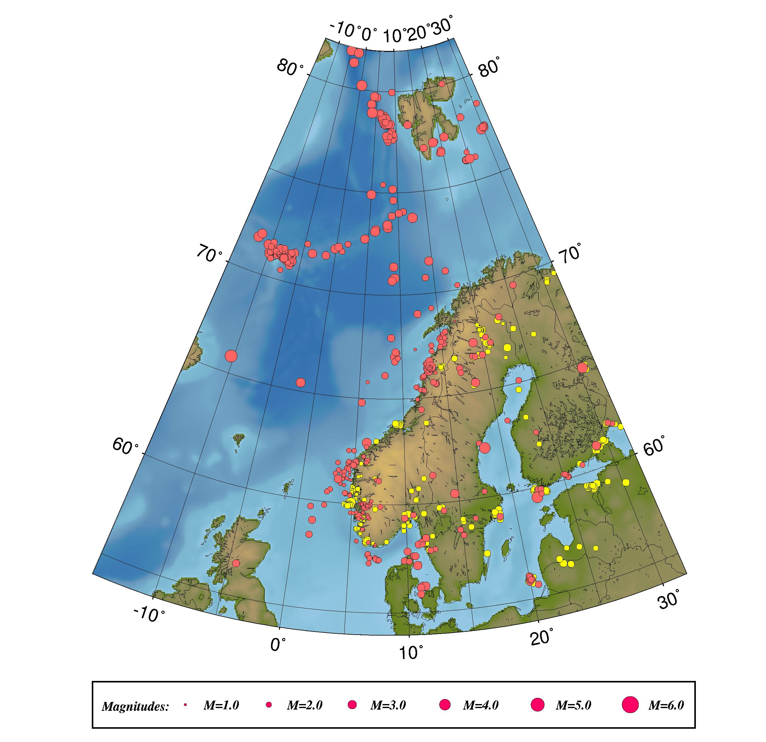

Figure 1. Epicentre distribution of located events recorded during January – June 2005.
Earthquakes are plotted in red and presumed and known explosions in yellow.

In June 2005 two temporary stations were installed in the area near the NNSN station STOK. During the first month of operation, this small network registered 133 earthquakes in the region. Most events are located within 5 km distance of the station STOK2 at a depth of 5 km. Figure 2 shows the location of events recorded during the first month of operation. Figure 3 shows an example of a recorded earthquake.

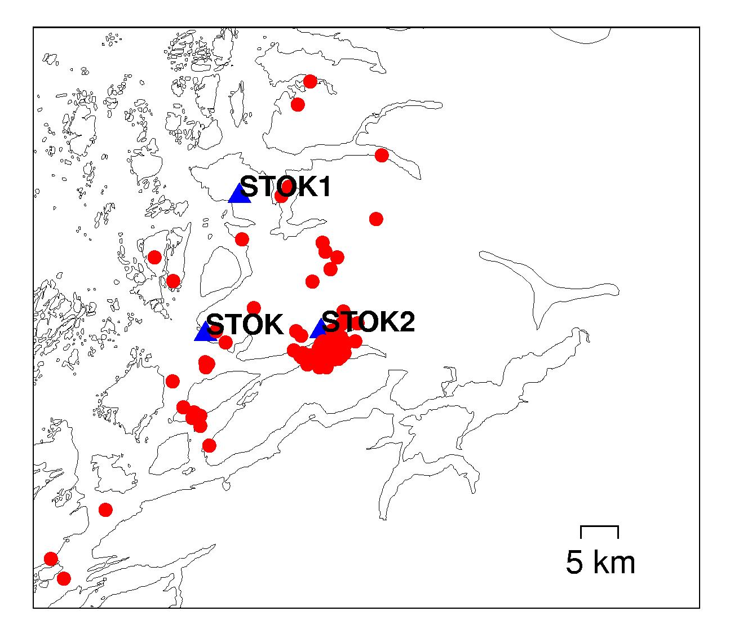
Figure 2. Location of earthquakes recorded by the temporary STOK network during the first month of operation. A total of 133 events have been recorded of which 118 could be located. Red doth are earthquakes, blue triangles are the stations.

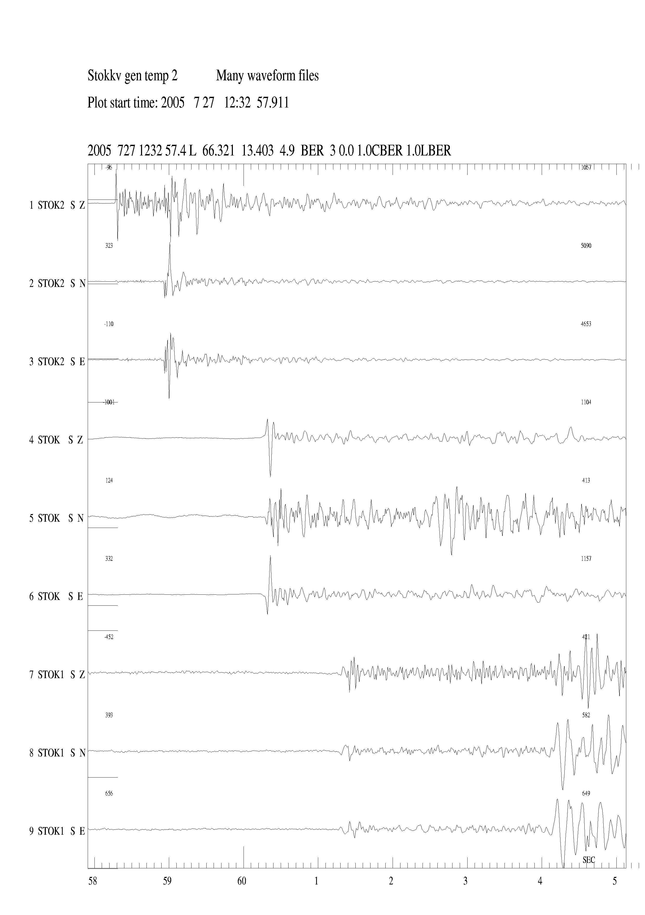
Figure 3. Example of earthquake recording from the temporary STOK network. Stations are: STOK2: Flostrand, STOK: Stokkvågen, STOK1: Konsvik.

