Progress Report No. 1-2006



for

Norwegian National Seismic Network

January 1st to June 30 ^{th}, 2006.

Supported by

University of Bergen, Faculty of Mathematics and Natural Sciences

and

Norwegian Oil Industry Organization

Prepared by

Department of Earth Science
University of Bergen
Allegaten 41, N-5007 Bergen

November 2006

1. Introduction

This progress report, under the project Norwegian National Seismic Network (NNSN), covers the first half of 2006. The purpose is to describe the current technical operation of the stations and the data recorded for the first half of 2006. The costs will be given up to November 12

2. Operation

The operational stability for each station is shown in Table 1. The average downtime for all stations during this reporting period is 0.6% compared to 5.2 % in the same time period of 2005. This is acceptable since the goal of average downtime which is below 2%.

Table 1a. Downtime in % for the period 1/1-30/6 2006 for all stations of the NNSN.

Station | Downtime in %
Askøy (ASK) | 0
Bergen (BER) | 0
Bjørnøya (BJO) | 0
Blåsjø (BLS) | 0
Dombås (DOMB) | 0
Espegrend (EGD) | 0
Florø (FOO) | 1.5
Hopen (HOPEN) | 0
Høyanger (HYA) | 2.0
Jan Mayen BB (JMI) | 0
Jan Mayen SP (JMI) | 0
Jan Mayen (JNE) | 0
Jan Mayen (JNW) | 0
Karmøy (KMY) | 0
Kautokeino (KTK) | 0
Kings Bay (KBS) | 0.5
Kongsberg (KONO) | 0
Lofoten (LOF) | 0
Mo i Rana (MOR8) | 0
Molde (MOL) | 0.5
Namsos (NSS) | 0
Odda (OOD1) | 0
Oslo (OSL) | 0
Rundemanen (RUND) | 0
Snartemo (SNART) | 0
Stavanger (STAV) | 0
Stokkvågen (STOK) | 0
Sulen (SUE) | 0.5
Trondheim (TRON) | 0
Tromsø (TRO) | 13.0
Average | 0.6

3. Field stations and technical service

The technical changes for each seismic station are listed below. It is noted if these changes are not related to a visit from the technical staff at the University of Bergen. When a station stops working, tests are made to locate the problem. Sometimes the reason cannot be found and the cause of the problem will be marked as unknown.

Bjørnøya (BJO1)
No visit or technical changes.

Blåsjø (BLS)
No visit or technical changes.

Florø (FOO)
30.01.06. The PC was restarted. Station down for 2 days.
20.03.06. The PC was restarted. Station down for 0.5 days.
26.04.06. The PC was restarted. Station down for 0.5 days.
08.06.06. Visit
A new PC, Seislog for Windows, using ADSL was installed.

Høyanger (HYA)
16.01.06. The PC was restarted. Station down for 3.5 days
08.06.06. Visit
Replaced the old Sprengnether 3 comp. sensor with 3 SS-1 Ranger seismometers.
Before disconnection the Sprengnether sensor, a polarity test was done, the polarity was wrong. For the SS-1 Ranger the polarity is ok.

Karmøy (KMY)
18.04.06. Seislog QNX PC setup with Garmin GPS with no PPS (pulse pr. second). Probably like this since GPRS network started (07.02.06). Changed to Garmin PPS in parameterfile.

Lofoten (LOF)
No visit or technical changes.

Mo i Rana (MOR8)
No visit or technical changes.

Molde (MOL)
06.02.06. The PC was restarted. Station down for 0.5 day
04.05.06. Visit
The old QNX – PC, RD3 digitizer and 3 SS-1 Ranger sensors were disconnected and brought back to Bergen.
A new Guralp BB sensor and a PC (Seislog for Windows) was installed and connected to ADSL.

Namsos (NSS)
No visit or technical changes.

Odda (ODD1)
No visit or technical changes.

Tromsø (TRO)
23.03.06. Visit.
A new digitizer was installed, station was down for 24 days due to a malfunctioning digitizer.
14.05.06. The PC was restarted. Station down for 1 day.

Sulen (SUE)
31.01.06. The PC was restarted. Station down for 1 day.

Kautokeino (KTK)
No visit or technical changes.

Stavanger (STAV)
No visit or technical changes.

WNN network: stations: Bergen (BER), Espegrend (EGD), Ask (ASK)

No visit or technical changes.

Rundemanen (RUND)
No visit or technical changes.

Trondheim (TRON)
04.05.06. The building housing the station was torn down and the station was closed.

Oslo (OSL)
No visit or technical changes.

Dombås (DOMB)
No visit or technical changes.

Jan Mayen (JMI)
No visit or technical changes.

Kongsberg (KONO)
No visit or technical changes.

Kings Bay (KBS)
No visit or technical changes.

Stokkvågen (STOK)
No visit or technical changes.

Snartemo (SNART)
No visit or technical changes.

Hopen (HOPEN)
17.02.06. The GPS cable broke, repaired by the local operator.
20.02.06. A new GPS antenna was sent from Bergen.

4. Data
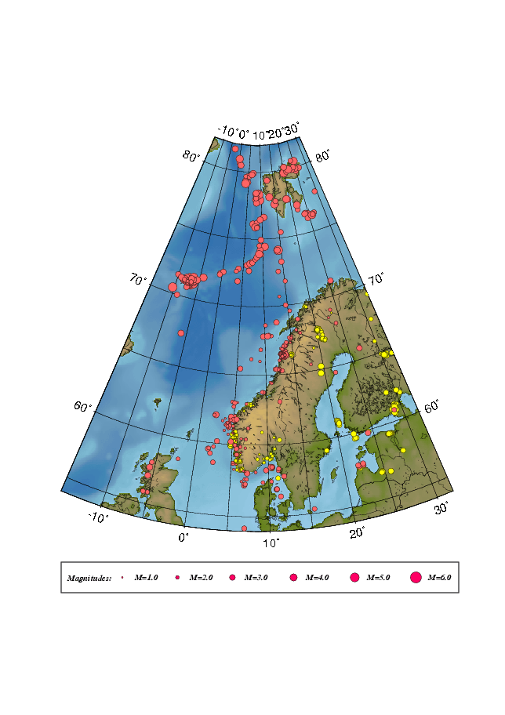
The data recorded by the seismic stations were collected and monthly bulletins were prepared and distributed. Figure 1 shows earthquakes and explosions recorded during the first half of 2006 and located within the shown area. Most events are recorded by NNSN stations but also data from NORSAR and the British Geological Survey (BGS) are included.

Figure 1. Epicentre distribution of located events recorded during January – June 2006.
Earthquakes are plotted in red and presumed and known explosions in yellow.

