

Operation of the

Norwegian National Seismic Network

2007

Supported by

University of Bergen, Faculty of Mathematics and Natural Sciences

and

Norwegian Oil Industry Association

Prepared by

Department of Earth Science
University of Bergen
Allegaten 41, N-5007 Bergen

May 2008

CONTENTS

1. Introduction 3

2. Operation of field stations 3

3. Field stations and technical service 4

4. Technical changes and plans 7

5. Economy 8

Appendix 1
Seismicity of Norway and surrounding areas

Appendix 2
The NORSAR regional arrays

1. Introduction

This annual report describes the operation of the Norwegian National Seismic Network (NNSN) for the year 2007. It covers operational aspects as well as a financial report for all seismic stations operated by the Department of Earth Science at the University of Bergen (UiB), which has the responsibility of the NNSN.

The network is supported by the oil industry through the Norwegian Oil Industry Association (“Oljeindustriens Landsforening” (OLF)) and the Faculty of Mathematics and Natural Sciences, University of Bergen (UiB).

The seismicity of Norway and surrounding areas is presented in Appendix 1. The seismic arrays operated by NORSAR are covered in Appendix 2 of this report. NORSAR is subcontracted to deliver data of interest to NNSN.

2. Operation

The operational stability for each station is shown in Table 1. The average downtime for all stations during this reporting period is 1.8 % compared to 1.5 % for 2006. It should however be noted that for the stations KTK and FOO have had periods where they were not operating optimal. During these time periods there have not been any significant earthquakes so no data has been lost. The goal of average downtime is below 2%.

Table 1. Downtime in % for the period 2007 for the NNSN stations.

Station | Downtime in %
Askøy (ASK) | 0
Bergen (BER) | 0
Bjørnøya (BJO) | 2
Blåsjø (BLS) | 0
Dombås (DOMB) | 0
Espegrend (EGD) | 0
Florø (FOO) | 0
Flostrand (FLOS) | 2
Hopen (HOPEN) | 17
Høyanger (HYA) | 0
Jan Mayen BB (JMI) | 0
Jan Mayen SP (JMI) | 0
Jan Mayen (JNE) | 0
Jan Mayen (JNW) | 0
Karmøy (KMY) | 0
Kautokeino (KTK) | 0
Kings Bay (KBS) | 0
Kongsberg (KONO) | 3
Konsvik (KONS) | 8
Lofoten (LOF) | 1
Mo i Rana (MOR8) | 0
Molde (MOL) | 0
Namsos (NSS) | 0
Odda (ODD1) | 0
Oslo (OSL) | 22
Rundemanen (RUND) | 0
Snartemo (SNART) | 0
Stavanger (STAV) | 0
Steigen (STEI) | 0
Stokkvågen (STOK) | 0
Sulen (SUE) | 7
Tromsø (TRO) | 1
Average | 2,0

3. Field stations and technical service

The technical changes for each seismic station are listed below. It is noted if these changes are not related to a visit from the technical staff at the University of Bergen. When a station stops working, tests are made to locate the problem. Sometimes the reason cannot be found and the cause of the problem will be marked as unknown.

Bjørnøya (BJO1)
30.09. – 01.10.07. Visit.
Inspected the aluminium box – ok. Recording equipment is working well.
02.11.07. Station down for 3 days. Reason unknown.
11.10.07. Due to a software problem data lost for 6 days.

Blåsjø (BLS)
No visit or technical changes.

Florø (FOO)
21-22.06.07. Visit. A damping resistance was installed.
12.07.07. A new ADSL connection was installed. It was not possible to identify the local communication problem by the staff in Bergen. No data has been lost, since the local PC was running.
18.10.07. New temporary PC (laptop) and digitizer (ED-2400) were installed by local operator.

Flostrand (FLOS)
11.06.07. Visit. The station was upgraded with GSM communication. The station code was changed from STOK2 to FLOS.
27.09.07. A new and better GSM (EDGE) antenna was installed by the local operator.

Høyanger (HYA)
No visit or technical changes.

Karmøy (KMY)
No visit or technical changes.

Konsvik (KONS)
11.06.07. Visit. Station upgraded eith new equipment. Changed station
Code from STOK1 to KONS. Equipment: SARA SR04/53
(digitizer/geophone). One new GPS antenna, Dell PC
01.11.07. Due to lightning no connection with station.
17.11.07. A new GPS router was installed, still not able to login 29.11.07. A new SARA SRD/S3 (24 bit) was installed, still no login. Local operator moved input signal from COM1 to COM2 on PC. Station now ok.

Lofoten (LOF)
23-30.03.07. Power failure. Station was down for 7 days.
15.05.07. Visit. Replaced accelerometer.
27.11.07. Station down for 1 day. Reason unknown
11.12.07. Station down for 1 day. Reason unknown
17.12.07. Station down for 2 days. Reason unknown
27.12.07. Station down for 1 day. Reason unknown

Mo i Rana (MOR8)
No visit or technical changes.

Molde (MOL)
16.01-22.02.07. Bad timing
05-12.04.07. Communication problems.
17.03.07. Communication problems. No data lost.

Namsos (NSS)
No visit or technical changes.

Odda (ODD1)
No visit or technical changes.

Tromsø (TRO)
14.05.07. Visit. Installed Linux system.
15.10.07. Station down for 2 days. Reason unknown
Sulen (SUE)

1-12.02.07. data lost due to no free space on disk.
29.07.07. Station down for 1 day. Reason unknown
02.08.07. Due to a software problem the ringbufferfiles shut down, new ringbufferfiles generated using re_initi. Data lost for 1 days.
12.08.07. Due to a software problem the ringbufferfiles shut down, new ringbufferfiles generated using re_initi. Data lost for 8 days.
27.08.07. Due to a software problem the ringbufferfiles shut down, new ringbufferfiles generated using re_initi. Data lost for 10 days.
19.10.07. Due to a software problem the ringbufferfiles shut down, new ringbufferfiles generated using re_initi. Data lost for 6 days.

Steigen (STEI)
17.07.07. Station installed. Equipment: Sprtngnether S-6000 sensor, 1
SARA SR04 digitizer, Dell PC with Seislog for Windows, 15” LSD
screen

Kautokeino (KTK)
23.09.07. Visit: A new Guralp CMG 40T BB sensor, Earth Data Digitizer (ED 2400), Dell PC Seislog for Linux, was installed.
During the installation of the sensor, it turned out that the EW component was unable to centre, several efforts were made to correct it.
The installation of The BB sensor is temporary. The measurement will be a part of the POLENET/LAPNET temporary research during the International Polar Year 2007-2009. Installation was done in cooperation with University of Oulu Finland.
17.10.07. Due to various technical problems it was decided not to extract trigger data from KTK until a new sensor and digitizer was installed.
01.11.07. Visit: A new Guralp CMG 40T BB sensor, belonging to NNSN, was installed by people from University of Oulu Finland. The signal was checked ok.
02.11.07. Z component hanging (out of range) and NS and EW noisy due a malfunction digitizer.
08.11.07. New digitizer (ED-2400) installed by the local operator. NS and EW are working properly.

Stavanger (STAV)
No visit or technical changes.

WNN network: Bergen (BER), Espegrend (EGD), Ask (ASK)
No visit or technical changes.

Rundemanen (RUND)
23.07.07. Station down for 1 day. Reason unknown

Trondheim (TRON)
04.05.06. Station was closed due to constructions at NGU. The station will be reinstalled.
An additional location at Blussvoll skole is also being prepared in parallel. Expected start time for new station is spring 2008.

Oslo (OSL)
31.07.07. Station down for 9 days. Reason unknown
05.11.07. Due to a broken Digitizer and PC, station down for 72 days.
New Nanometrics Digitizer (RD3) and Dell PC vers. Seislog for windows was installed by the local operator.

Dombås (DOMB)
No visit or technical changes.

Jan Mayen (JMI)
No visit or technical changes.

Kongsberg (KONO)
23.05.07. Replaced the CPU Board s/n 1220164.
05.06.07. Replaced new tape drives.MT0 s/n AA160452, MT1 s/n AA105018.

Kings Bay (KBS)
No visit or technical changes.

Stokkvågen (STOK)
12.06.07. Visit
New Sara digitizer (SR04 s/n 041) installed.

Snartemo (SNART)
No visit or technical changes.

Hopen (HOPEN)
07.03.07. Local operator installed new digitizer (SRO 4). After installation the PC was not restarted locally. Data lost between 07.03-10.05.07.
02.-04.10.07. Visit.
1 new Streckeisen STS-2 BB sensor, 1 ED 2400 Digitizer, 1 Dell Pc Seislog for windows, was installed.
29.11.07. 1 ED 2400 Digitizer, 1 Dell Pc Seislog for windows, was sent for spare.

4. Technical changes and plans

The network now has 10 broadband stations where continuous data is collected. The move to get more continuous data on line is progressing and different systems for real time monitoring are being tested. By the end of 2007, 12 stations are operating in real time mode enabling the network to make faster earthquake locations and a better real time operational monitoring.

5. Economy

The National Seismic Network is supported economically by the University of Bergen through the Faculty of Natural Sciences and by OLF. In addition, UiB pays for the 3 positions needed for the network operation.

APPENDIX 1

Seismicity of Norway and surrounding areas
in 2007.

Seismicity of Norway

and surrounding areas

for

2007

Prepared by

Department of Earth Science
University of Bergen
Allegt. 41
N-5007 Bergen

e-mail: seismo@geo.uib.no
Phone: (+47) 55 58 36 00
Fax: (+47) 55 58 36 60

May 2008

CONTENTS

- Introduction 4

- Velocity models and magnitude relations 5

- Events recorded by the Norwegian stations 8

- The seismicity of Norway and adjacent areas 9

- Felt earthquakes 20

- Use of NNSN data during 2007 21

- References 23
1. Introduction

This annual report on the seismicity of Norway and adjacent areas encompasses the time period January 1st - December 31st, 2007. The earthquake locations have been compiled from all available seismic stations operating on the Norwegian territory including the Arctic islands of Spitsbergen, Bjørnøya, Hopen and Jan Mayen. In addition, stations from neighbouring countries have been included for large or well-recorded events.

In Norway, the University of Bergen (UiB) operates the Norwegian National Seismic Network (NNSN) consisting of 31 seismic stations where 10 have broad band sensors. NORSAR operates 3 seismic arrays and one seismic station (Figure 1). Data from temporarily installed local networks are also included whenever data are made available. In 2006 two temporary stations (STOK1 and STOK2) were installed in northern Norway in the Stokvågen area. These stations changed station code to KONS and FLOS and are still in operation.

The Steigen area in Troms is a location where a significant number of small earthquakes have been registered previously (Atakan et al., 1994). A seismic station, STEI, was in June 2007 located in the area to monitor the seismic activity. Since an increase in the seismic activity was observed late autumn, a temporary station (LEINS) was installed.

Phase data from arrays in Russia (Apatity), Finland (Finess), Sweden (Hagfors) and from stations operated by the British Geological Survey (BGS) are also included when available. All phase data are collected by UiB, and a monthly bulletin is prepared and distributed. All earthquakes with magnitude ≥ 2.0 on mainland Norway and M ≥ 3.0 around Jan Mayen and the midatlantic-ridge, are presented on the web pages and also e-mailed to European-Mediterranean Seismological Centre (EMSC). A brief overview of the events published in the monthly bulletins is given in this annual report. Macroseismic data for the largest felt earthquakes in Norway are collected, and macroseismic maps are presented.

Local, regional and teleseismic events that are detected by the UiB network are included. The merging of data between NORSAR and UiB is based on the following principles:
i) All local and regional events recorded by NORSAR that are also detected by the NNSN network are included.
ii) All local and regional events with local magnitude larger than 2.0 detected by NORSAR and not recorded by the NNSN are included.
iii) All teleseismic events recorded by NORSAR and also detected by the NNSN are included.
iv) All teleseismic events with NORSAR magnitude M_{b}≥5.0 are included.

Data from British Geological Survey (BGS) are included in the database in Bergen following similar criteria as mentioned above, however only events located in the prime area of interest, shown in Figure 1, are included.

Data availability to the public

All the data stored in the NNSN database is also available to the public via Internet, e-mail or manual request. The main web-portal for earthquake information is www.skjelv.no. It is possible to search interactively for specific data, display the data locally (waveforms and hypocenters) and then download the data. Data are processed daily and updated lists of events recorded by Norwegian stations are available soon after recording. All events with an estimated local magnitude ≥ 2.0 are plotted on individual maps shown on the web pages.

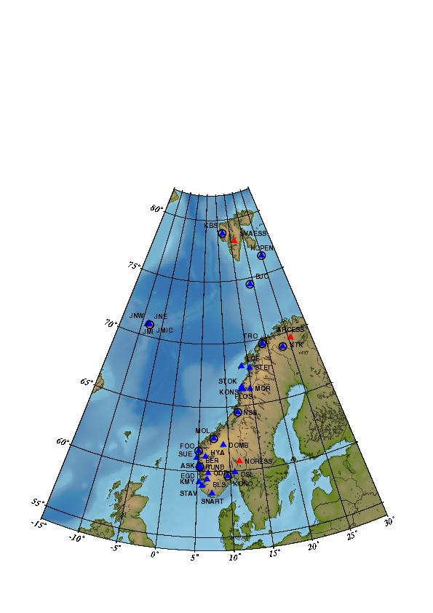
Figure 1: Norwegian seismic stations. UiB operates the 31 stations (blue triangles) in the National Seismic Network (NNSN) and NORSAR operates the 3 arrays and the station JMIC (red triangles). Circles identify broad band stations.

2. Velocity models and magnitude relations

The velocity model used for locating all local and regional events, except for the local Jan Mayen events, is shown in Table 1 (Havskov and Bungum, 1987). Event locations are performed using the HYPOCENTER program (Lienert and Havskov, 1995) and all processing is performed using the SEISAN data analysis software (Havskov and Ottemöller, 1999).

Table 1: Velocity model used for locating all local and
regional events, except for the local Jan Mayen
events, (from Havskov and Bungum, 1987).

P-wave velocity (km/sec) | Depth to layer interface (km)
6.2 | 0.0
6.6 | 12.0
7.1 | 23.0
8.05 | 31.0
8.25 | 50.0
8.5 | 80.0

Magnitudes are calculated from coda duration, amplitudes or seismic spectra. The coda magnitude relation was revised in 2006 (Havskov & Sørensen 2006). The coda wave magnitude scale (M_{C}) is estimated through the relation

M_{C} = -4.28 + 3.16 ⋅ log10(T) +0.0003 ⋅ D

where T is the coda length in seconds and D is the epicentral distance in km. The new scale made M_{C} more consistent with M_{L} since M_{C} in general is reduced. For this report all data are updated using the new magnitude scale. When instrument corrected ground amplitudes A (nm) are available, local magnitude M_{L} is calculated using the equation given by Alsaker et al. (1991):

M_{L}= 1.0 ⋅ log(A) + 0.91 ⋅ log(D) + 0.00087 ⋅ D - 1.67

where D is the hypocentral distance in km.

The moment magnitude M_{w} is calculated from the seismic moment M₀ using the relation (Kanamori, 1977)

M_{w} = 0.67 ⋅ log(M₀) – 6.06

The unit of M₀ is Nm. The seismic moment is calculated from standard spectral analysis assuming the Brune model (Brune, 1970) and using the following parameters:

Density: 3.0 g/cm²
Q = 440 ⋅ f ^{0.7}
P-velocity = 6.2 km/s
S velocity = 3.6 km/s

For more computational details, see Havskov and Ottemöller, (2003).

For the Jan Mayen area, a local velocity model (see Table 2) and coda magnitude scale is used (Sørnes and Navrestad, 1975).

Table 2: Velocity model used for locating local
Jan Mayen events.

P-wave velocity (km/sec) | Depth to layer interface (km)
3.14 | 0
6.33 | 3
8.27 | 18

The coda magnitude scale for Jan Mayen which is used in this report is given by Havskov & Sørensen (2006). This scale was implemented in 2006 but all events used in this report are updated during April/May 2006.

M_{C} = 3.27 ⋅ log(T) 2.74 + 0.001 ⋅ D

where T is the coda duration and D is the epicentral distance in km.

The regional and teleseismic events recorded by the network are located using the global velocity model IASPEI91 (Kennett and Engdahl, 1991).

Body wave magnitude is calculated using the equation by Veith and Clawson (1972):

Mb = log(A/T) + Q(D,h)

Here h is the hypocentre depth (km), A is the amplitude (microns), T is period in seconds and Q(D,h) is a correction for distance and depth.

Surface wave magnitude Ms is calculated using the equation (Karnik et al., 1962):

Ms = log(A/T) + 1.66 ⋅ log(D) + 3.3

where A is the amplitude (microns), T is period in seconds and D is the hypocentral distance in degrees.

Starting from January 2001, the European Macroseismic Scale, EMS98, (Grünthal, 1998) has been used. All macroseismic intensities mentioned in the text will refer to the EMS98 instead of the previously used Modified Mercalli Intensity scale. The two scales are very similar at the lower end of the scale for intensities less than VII.

3. Events recorded by the Norwegian stations

Based on the criteria mentioned in section 1 and above, a total of 3630 local and regional events, were detected by the Norwegian seismic stations during 2007. Of these local and regional events analysed, 54% were large enough to be recorded by several stations and hence could be located reliably. The number of local/regional and teleseismic events, recorded per month in 2007 is shown in Figure 2. The average number of local and regional events recorded per month is 302.

A total of 918 teleseismic events were recorded between January and December 2007, of which 96% were located. In addition to the locations determined at UiB, also preliminary locations published by the USGS (United States Geological Survey) based on the worldwide network are included in the UiB database whenever the earthquake is recorded with Norwegian stations. The monthly average of teleseismic earthquakes recorded by NNSN is 77.

Figure 2: Monthly distribution of local/regional and distant events, recorded during 2007.

UiB, as an observatory in the global net of seismological observatories, reports as many secondary phases as possible from the teleseismic recordings. All events (teleseismic, regional and local) recorded from January to December 2007 with M ≥ 3 are plotted on Figure 3.

Monthly station recording statistics from January to December 2007 are given in Table 3. This table shows, for each station, the number of local events that were recorded only at one station, local events recorded on more than one station and recorded teleseismic events. It must be observed that Table 3 shows both earthquakes and explosions, and that the large number of detections at KTK mainly is due to explosions at the Kirruna/Malmberget mines in Sweden. The MOR station also records the Kirruna/Malmberget explosions but in addition the station also records a large number of local earthquakes. Since 2003 a new seismic station, STOK, was located close to the existing MOR station and in 2006 this is further extended by two more stations (FLOS and KONS). Therefore the number of recorded local earthquakes increased.
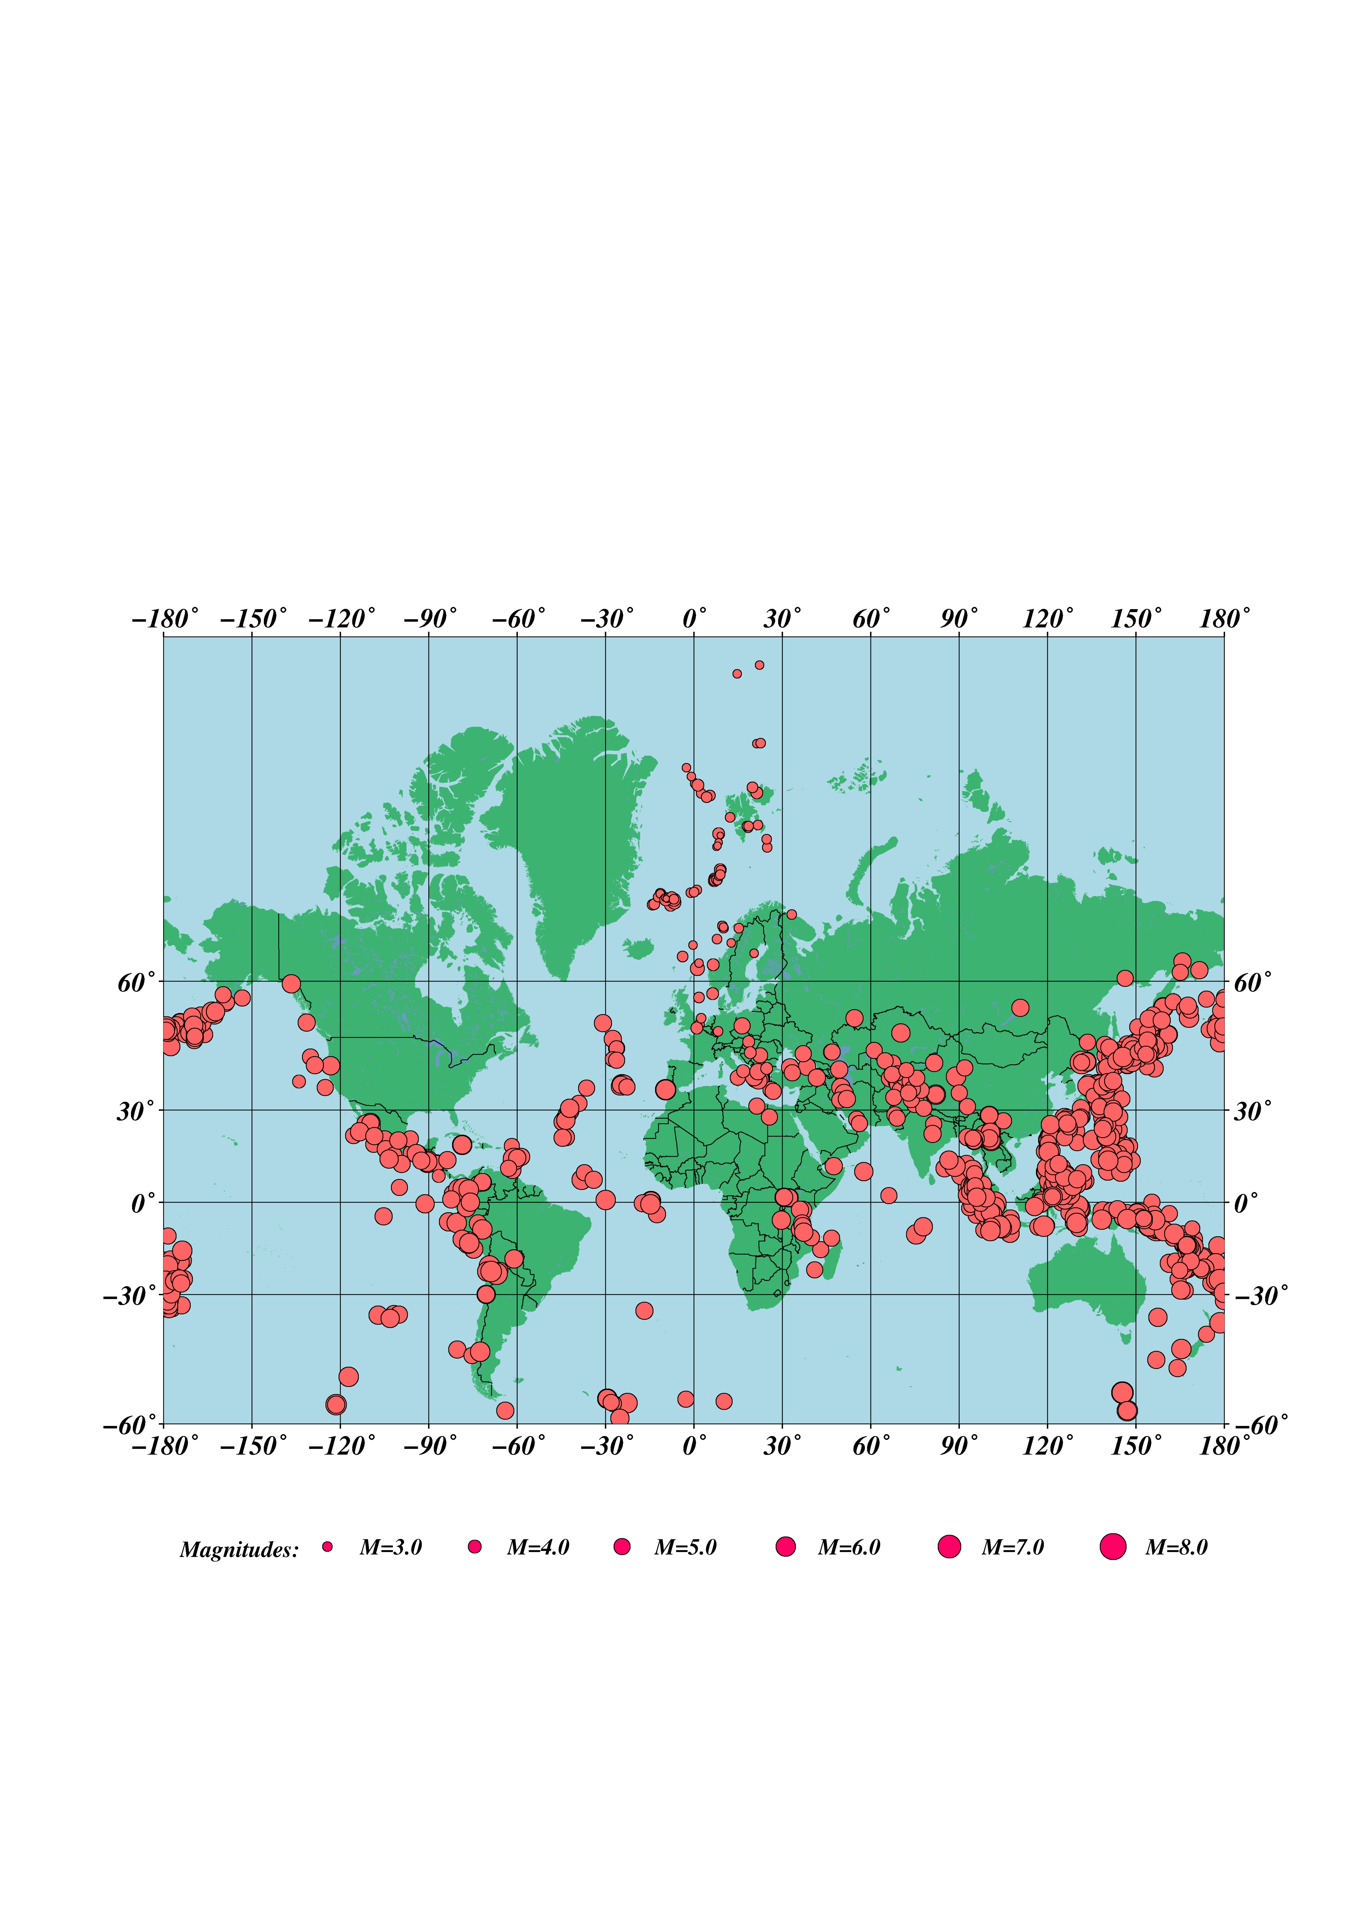
Figure 3: Epicentre distribution of earthquakes with M≥3.0, located by the Norwegian Seismic Network from January to December 2007. Teleseismic events recorded only by NORSAR have M≥5.0.

4. The seismicity of Norway and adjacent areas

A total of 1934 of the recorded events are located inside the NNSN prime area, 54°N-82°N and 15°W-32°E. During analysis and using the explosion filter (Ottemöller, 1995), 34% of these events were identified as probable explosions. Figure 4 shows all local/regional events in the prime area, analyzed and located during 2007.

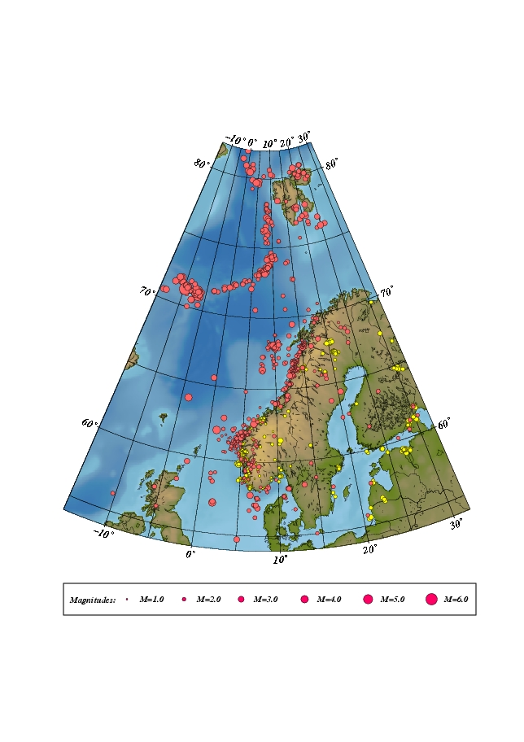

Figure 4: Epicentre distribution of events analyzed and located from January through December 2007. Earthquakes are plotted in red and probable and known explosions in yellow. For station locations, see Figure 1.
Table 3a: Monthly statistics of events recorded at each station for January-June 2007. Abbreviations are: LM = Number of local events recorded at more than one station, LS = Number of local events recorded at only one station and D = Number of teleseismic events. The station STEI was installed during June and then also the STOK1 and STOK2 seismic stations changed station code to KONS and FLOS respectively.
 | JANUARY |  |  | FEBRUARY |  |  | MARCH |  |  | APRIL |  |  | MAY |  |  | JUNE
STATION | LM | LS | D | LM | LS | D | LM | LS | D | LM | LS | D | LM | LS | D | LM | LS | D
ASK | 39 | 0 | 10 | 40 | 0 | 1 | 58 | 0 | 13 | 24 | 0 | 8 | 46 | 0 | 10 | 35 | 0 | 3
BER | 13 | 2 | 17 | 8 | 0 | 8 | 10 | 2 | 25 | 7 | 0 | 38 | 12 | 0 | 23 | 11 | 0 | 23
BJO1 | 4 | 0 | 13 | 15 | 0 | 7 | 7 | 1 | 18 | 8 | 8 | 21 | 5 | 1 | 6 | 4 | 0 | 11
BLS5 | 31 | 0 | 15 | 39 | 0 | 10 | 48 | 0 | 19 | 28 | 0 | 15 | 39 | 0 | 12 | 34 | 0 | 4
DOMB | 9 | 0 | 16 | 13 | 0 | 9 | 13 | 0 | 15 | 8 | 0 | 19 | 11 | 0 | 9 | 8 | 0 | 3
EGD | 29 | 0 | 8 | 25 | 0 | 1 | 34 | 0 | 12 | 15 | 0 | 5 | 36 | 0 | 9 | 28 | 0 | 1
STOK2/FLOS | 26 | 0 | 0 | 4 | 0 | 0 | 24 | 0 | 0 | 10 | 0 | 0 | 18 | 0 | 0 | 5 | 0 | 0
FOO | 20 | 0 | 4 | 31 | 0 | 0 | 21 | 0 | 3 | 13 | 0 | 1 | 34 | 0 | 1 | 17 | 0 | 0
HOPEN | 1 | 0 | 0 | 5 | 4 | 0 | 0 | 0 | 0 | 0 | 0 | 0 | 1 | 0 | 0 | 0 | 0 | 0
HYA | 35 | 1 | 10 | 45 | 0 | 0 | 48 | 0 | 15 | 29 | 0 | 7 | 46 | 0 | 10 | 32 | 0 | 3
JMI | 19 | 0 | 0 | 20 | 0 | 0 | 14 | 0 | 0 | 11 | 0 | 0 | 28 | 0 | 0 | 26 | 0 | 0
JMIC | 1 | 0 | 14 | 3 | 0 | 8 | 5 | 0 | 12 | 0 | 0 | 29 | 1 | 0 | 18 | 3 | 0 | 20
JNE | 21 | 0 | 0 | 18 | 0 | 0 | 16 | 0 | 0 | 11 | 0 | 0 | 28 | 0 | 0 | 26 | 0 | 0
JNW | 21 | 0 | 0 | 20 | 0 | 0 | 18 | 0 | 0 | 11 | 0 | 1 | 28 | 0 | 1 | 28 | 1 | 0
KBS | 11 | 0 | 22 | 28 | 0 | 9 | 26 | 3 | 22 | 11 | 2 | 41 | 18 | 1 | 24 | 17 | 6 | 24
KMY | 30 | 0 | 3 | 48 | 0 | 0 | 55 | 0 | 11 | 29 | 0 | 1 | 43 | 0 | 7 | 44 | 1 | 3
KONO | 12 | 0 | 19 | 6 | 0 | 7 | 2 | 1 | 23 | 3 | 0 | 39 | 6 | 0 | 20 | 5 | 0 | 21
STOK1/KONS | 39 | 0 | 0 | 9 | 0 | 0 | 30 | 0 | 0 | 15 | 0 | 0 | 23 | 0 | 0 | 7 | 0 | 0
KTK1 | 25 | 1 | 26 | 36 | 3 | 20 | 24 | 3 | 23 | 16 | 0 | 10 | 12 | 0 | 11 | 26 | 0 | 7
LOF | 16 | 1 | 15 | 35 | 3 | 7 | 21 | 0 | 9 | 16 | 2 | 8 | 25 | 3 | 12 | 27 | 1 | 6
MOL | 9 | 0 | 9 | 6 | 0 | 4 | 15 | 0 | 11 | 9 | 0 | 18 | 16 | 0 | 11 | 8 | 0 | 10
MOR8 | 49 | 0 | 26 | 47 | 2 | 17 | 52 | 3 | 25 | 35 | 1 | 29 | 41 | 4 | 16 | 33 | 0 | 9
NSS | 21 | 4 | 16 | 33 | 6 | 16 | 38 | 2 | 28 | 16 | 2 | 26 | 3 | 0 | 1 | 5 | 0 | 9
ODD1 | 35 | 0 | 13 | 47 | 0 | 4 | 57 | 0 | 17 | 30 | 0 | 6 | 30 | 0 | 10 | 19 | 0 | 2
OSL | 3 | 0 | 6 | 0 | 0 | 2 | 0 | 0 | 3 | 0 | 0 | 8 | 0 | 0 | 5 | 1 | 0 | 3
RUND | 18 | 0 | 8 | 30 | 0 | 5 | 22 | 0 | 10 | 20 | 0 | 10 | 29 | 0 | 9 | 21 | 0 | 3
SNART | 25 | 0 | 8 | 29 | 1 | 2 | 39 | 0 | 9 | 27 | 1 | 8 | 34 | 0 | 6 | 27 | 1 | 2
STAV | 11 | 0 | 3 | 6 | 0 | 2 | 24 | 0 | 5 | 14 | 0 | 6 | 11 | 0 | 4 | 7 | 0 | 1
STEI | - | - | - | - | - | - | - | - | - | - | - | - | - | - | - | 8 | 0 | 2
STOK | 59 | 2 | 10 | 39 | 0 | 3 | 50 | 0 | 11 | 32 | 2 | 10 | 40 | 3 | 9 | 35 | 0 | 3
SUE | 16 | 0 | 3 | 33 | 0 | 0 | 24 | 0 | 4 | 19 | 0 | 2 | 26 | 0 | 0 | 22 | 0 | 0
TRO | 14 | 0 | 31 | 30 | 0 | 23 | 20 | 0 | 32 | 13 | 0 | 49 | 14 | 2 | 27 | 16 | 0 | 23
NORSAR | 19 | 0 | 78 | 26 | 0 | 56 | 21 | 0 | 74 | 18 | 0 | 106 | 25 | 0 | 55 | 27 | 0 | 48
ARCES | 32 | 0 | 0 | 61 | 0 | 0 | 52 | 0 | 0 | 41 | 0 | 0 | 43 | 0 | 0 | 45 | 0 | 0
SPITS | 17 | 0 | 0 | 36 | 0 | 0 | 29 | 0 | 0 | 25 | 0 | 0 | 25 | 0 | 0 | 21 | 0 | 0

Table 3b: Monthly statistics of events recorded at each station for July-December 2007. Abbreviations are: LM = Number of local events recorded at more than one station, LS = Number of local events recorded at only one station and D = Number of teleseismic events.
 | JULY |  |  | AUGUST |  |  | SEPTEMBER |  |  | OCTOBER |  |  | NOVEMBER |  |  | DECEMBER
STATION | LM | LS | D | LM | LS | D | LM | LS | D | LM | LS | D | LM | LS | D | LM | LS | D
ASK | 23 | 0 | 4 | 30 | 0 | 4 | 34 | 0 | 5 | 49 | 0 | 7 | 43 | 0 | 8 | 23 | 0 | 2
BER | 5 | 0 | 33 | 3 | 0 | 31 | 3 | 0 | 29 | 4 | 0 | 21 | 14 | 0 | 15 | 5 | 0 | 13
BJO1 | 4 | 0 | 18 | 2 | 0 | 20 | 4 | 0 | 22 | 0 | 0 | 13 | 2 | 0 | 11 | 5 | 0 | 10
BLS5 | 20 | 0 | 12 | 34 | 0 | 11 | 32 | 0 | 15 | 48 | 0 | 13 | 42 | 0 | 14 | 26 | 0 | 10
DOMB | 11 | 0 | 15 | 2 | 0 | 13 | 10 | 0 | 10 | 11 | 0 | 12 | 11 | 0 | 12 | 9 | 0 | 13
EGD | 20 | 0 | 4 | 20 | 0 | 4 | 22 | 0 | 4 | 36 | 0 | 7 | 27 | 0 | 5 | 16 | 0 | 2
FOO | 3 | 1 | 0 | 0 | 0 | 0 | 1 | 0 | 0 | 2 | 0 | 0 | 0 | 0 | 2 | 0 | 0 | 0
FLOS | 31 | 0 | 3 | 57 | 0 | 6 | 44 | 1 | 8 | 32 | 0 | 3 | 74 | 0 | 3 | 79 | 0 | 1
HOPEN | 2 | 1 | 0 | 1 | 0 | 0 | 4 | 0 | 0 | 5 | 2 | 0 | 0 | 0 | 0 | 13 | 5 | 0
HYA | 20 | 0 | 7 | 18 | 0 | 6 | 29 | 0 | 8 | 42 | 0 | 7 | 46 | 2 | 8 | 30 | 3 | 2
JMI | 37 | 0 | 0 | 26 | 0 | 0 | 21 | 0 | 0 | 13 | 0 | 0 | 18 | 0 | 0 | 21 | 0 | 0
JMIC | 2 | 0 | 26 | 15 | 0 | 27 | 5 | 0 | 21 | 0 | 0 | 10 | 1 | 0 | 11 | 2 | 0 | 4
JNE | 34 | 0 | 0 | 42 | 0 | 0 | 21 | 0 | 0 | 12 | 0 | 0 | 21 | 0 | 0 | 20 | 0 | 0
JNW | 36 | 0 | 1 | 43 | 0 | 1 | 22 | 0 | 6 | 13 | 0 | 0 | 21 | 0 | 0 | 22 | 1 | 1
KBS | 25 | 9 | 46 | 13 | 4 | 35 | 17 | 4 | 29 | 11 | 0 | 22 | 9 | 0 | 13 | 31 | 2 | 20
KMY | 23 | 0 | 5 | 34 | 0 | 1 | 31 | 0 | 3 | 52 | 0 | 7 | 40 | 0 | 5 | 25 | 0 | 1
KONO | 7 | 0 | 38 | 4 | 0 | 30 | 5 | 0 | 33 | 8 | 0 | 22 | 10 | 0 | 15 | 5 | 0 | 18
KONS | 34 | 4 | 3 | 65 | 1 | 5 | 50 | 0 | 8 | 31 | 0 | 2 | 12 | 0 | 0 | 102 | 0 | 3
KTK1 | 20 | 1 | 33 | 22 | 5 | 23 | 20 | 2 | 23 | 0 | 0 | 3 | 21 | 3 | 20 | 25 | 7 | 18
LOF | 18 | 1 | 19 | 28 | 2 | 14 | 27 | 2 | 21 | 17 | 3 | 4 | 43 | 1 | 7 | 80 | 2 | 3
MOL | 12 | 0 | 26 | 2 | 0 | 29 | 13 | 0 | 29 | 15 | 1 | 17 | 10 | 0 | 15 | 10 | 0 | 11
MOR8 | 31 | 0 | 33 | 52 | 2 | 30 | 48 | 1 | 30 | 44 | 4 | 13 | 89 | 1 | 18 | 116 | 5 | 21
NSS | 21 | 2 | 33 | 15 | 0 | 31 | 14 | 0 | 36 | 15 | 1 | 21 | 41 | 15 | 20 | 21 | 4 | 20
ODD1 | 11 | 0 | 5 | 26 | 0 | 2 | 24 | 0 | 9 | 43 | 0 | 8 | 38 | 0 | 15 | 25 | 0 | 9
OSL | 0 | 0 | 6 | 0 | 0 | 4 | 0 | 0 | 0 | 0 | 0 | 0 | 0 | 0 | 8 | 0 | 0 | 3
RUND | 18 | 0 | 7 | 12 | 0 | 6 | 24 | 0 | 4 | 26 | 0 | 6 | 26 | 0 | 4 | 13 | 0 | 4
SNART | 16 | 0 | 8 | 26 | 1 | 10 | 21 | 0 | 4 | 32 | 2 | 9 | 25 | 0 | 3 | 12 | 0 | 4
STAV | 7 | 0 | 6 | 8 | 0 | 6 | 8 | 0 | 3 | 5 | 0 | 3 | 4 | 0 | 4 | 1 | 0 | 2
STEI | 13 | 0 | 24 | 13 | 0 | 11 | 11 | 0 | 7 | 4 | 0 | 1 | 41 | 2 | 4 | 93 | 6 | 8
STOK | 40 | 0 | 26 | 64 | 0 | 17 | 53 | 0 | 20 | 34 | 0 | 9 | 88 | 0 | 10 | 98 | 2 | 10
SUE | 16 | 0 | 5 | 7 | 0 | 2 | 7 | 0 | 2 | 20 | 0 | 1 | 24 | 0 | 4 | 13 | 0 | 2
TRO | 14 | 0 | 49 | 14 | 0 | 47 | 13 | 0 | 42 | 6 | 0 | 19 | 14 | 0 | 22 | 16 | 0 | 27
NORSAR | 24 | 0 | 82 | 15 | 0 | 79 | 32 | 0 | 80 | 21 | 0 | 61 | 27 | 0 | 68 | 32 | 0 | 79
ARCES | 42 | 0 | 0 | 27 | 0 | 0 | 55 | 0 | 0 | 42 | 1 | 0 | 43 | 0 | 0 | 56 | 0 | 0
SPITS | 18 | 0 | 0 | 9 | 0 | 0 | 11 | 0 | 0 | 15 | 0 | 0 | 15 | 0 | 0 | 29 | 0 | 0

Figure 5 and Table 4 show the 95 local and regional events, located in the prime area, with one of the calculated magnitudes greater than or equal to 3.0. Among these, 42 are located in the vicinity of the Jan Mayen Island. Depth is checked for the earthquakes with magnitude equal or above 3.5.

It should be emphasized that it is often difficult to get a good magnitude estimate for the earthquakes located on the oceanic ridge in the Norwegian sea, since distances are too large to compute a proper M_{L}, too short for M_{b} and coda magnitudes for these locations are often unreliable. Most of the recorded earthquakes in this area have magnitudes above 3.0 if they are recorded on Norwegian mainland stations.
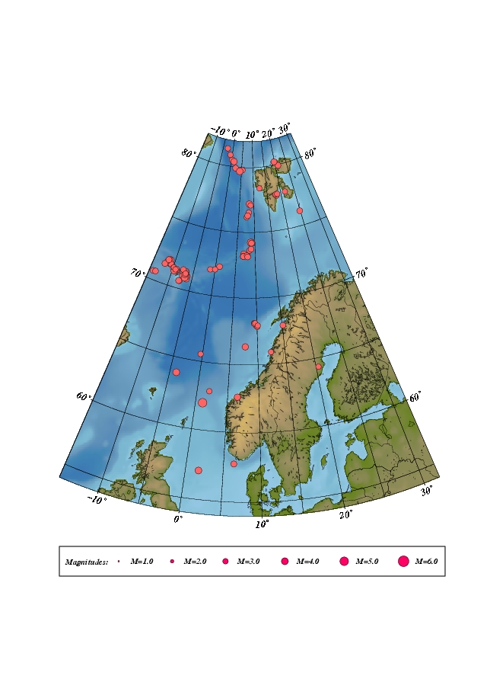

Figure 5: Epicentre distribution of located events with one of the calculated magnitudes above or equal to 3.0. All earthquakes are listed in Table 2. For station location, see Figure 1.

The largest local or regional earthquake in 2007, recorded on Norwegian stations and within the prime area, occurred on January 7th at 01:50 (UTC) west of Florø. The earthquake had a magnitude of M_{L}=4.2 (BER) and M_{L}=4.9 (BGS). The difference in estimated magnitude between BER and BGS is caused by the wave path toward East pass through geological structures causing damping of the amplitudes of the seismic signals. The earthquake was felt on the Statfjord oil platforms, on the Shetland island and also on mainland Norway.

Table 4: Local and regional events in prime area with any magnitude above or equal to 3.0 for the time period January through December 2007. Only magnitudes reported by the University of Bergen are included. In cases where all BER magnitudes are below 3 but the event still is included in the list, NORSAR has reported a magnitude of 3.0 or larger.
Abbreviations are: HR = hour (UTC), MM = minutes, Sec = seconds, L = distance identification (L=local, R=regional, D=teleseismic), Latitud = latitude, Longitud = longitude, Depth = focal depth (km), F = fixed depth, AGA = agency (BER=Bergen), NST = number of stations, RMS = root mean square of the travel-time residuals, Mc = coda magnitude, Ml = local magnitude and Mw = moment magnitude.

Year Date HRMM Sec L Latitud Longitud Depth FF AGA NST RMS Mc Ml Mb Ms Mw
2007 1 4 0851 12.3 L 71.312 -9.171 16.3 BER 3 0.1 3.0 2.6 2.5
2007 1 7 0150 55.0 L 61.999 1.126 10.0 F BER 57 2.0 3.9 4.2 4.8
2007 1 9 1956 11.6 L 71.050 -6.952 12.8 F BER 3 0.1 3.3 3.6 2.9
2007 121 1345 23.1 L 62.611 6.560 10.0 F BER 34 1.2 3.5 3.6 3.3
2007 122 0356 17.9 L 77.845 21.584 15.0 F BER 5 1.5 3.1 2.9 3.2
2007 123 1302 49.2 L 71.175 -9.189 23.4 F BER 3 0.1 3.3 3.0 2.7
2007 126 0305 40.6 L 71.579 -10.959 10.0 F BER 3 0.1 3.0 2.7 2.5
2007 128 1030 54.8 L 57.736 6.377 20.0 F BER 50 1.3 3.2 3.6 3.1
2007 212 0646 39.0 L 71.234 -6.548 11.0 F BER 3 0.1 3.2 2.8 2.8
2007 216 0752 56.1 L 71.456 -9.984 15.0 F BER 3 0.0 3.2 3.0
2007 217 2226 45.7 L 70.848 -6.277 6.0 F BER 9 0.9 3.3 3.1 3.2
2007 220 0834 10.9 L 77.199 8.423 7.0 F BER 5 0.4 2.9 3.7 2.5
2007 221 0005 51.4 L 63.877 -3.928 10.0 F BER 44 1.5 3.2 3.2 3.4
2007 224 0346 34.8 L 79.907 2.322 10.0 F BER 7 2.2 3.1 3.3
2007 224 0718 12.9 L 77.665 18.291 13.0 F BER 6 1.0 3.1 3.0
2007 225 0913 56.7 L 73.258 7.772 10.0 F BER 17 1.5 3.1 3.1 3.2
2007 225 0921 54.6 L 73.264 8.003 10.0 F BER 13 1.6 2.4 3.0 3.1
2007 225 2013 41.9 L 73.380 6.938 10.0 F BER 22 1.6 3.3 4.8 4.4 3.5
2007 225 2153 14.6 L 73.197 6.903 22.0 F BER 27 0.9 3.1 3.8 5.3 5.1 3.7
2007 225 2312 26.8 L 73.181 6.880 10.0 F BER 18 1.5 3.2 3.0 4.8 3.3
2007 225 2330 16.6 L 73.273 7.785 10.0 F BER 16 1.8 3.2 4.7 3.0
2007 3 6 1445 26.3 L 65.546 -0.343 4.7 BER 20 1.2 3.0 2.6 2.6
2007 3 9 2213 31.0 L 78.390 12.248 15.0 BER 3 0.4 3.0 2.9
2007 310 1703 37.9 L 74.235 8.915 10.0 F BER 21 1.4 3.7 4.4 4.3
2007 310 1818 56.2 L 74.231 9.215 15.0 BER 11 1.5 2.7
2007 310 2148 53.6 L 74.188 9.021 10.0 F BER 15 1.8 2.9
2007 314 1605 6.6 L 76.545 8.308 10.0 F BER 6 1.4 3.1 2.2
2007 320 1703 39.4 L 72.259 1.004 10.0 F BER 17 1.6 3.1
2007 323 0749 57.8 L 79.944 21.222 23.0 F BER 3 0.6 2.5 3.5 3.4
2007 324 1505 52.0 L 67.925 9.816 0.1 BER 9 1.2 3.0 1.9
2007 327 1334 59.3 L 77.096 8.867 12.9 BER 3 0.5 3.0 1.9
2007 4 9 1516 12.0 L 76.185 7.567 10.0 F BER 3 1.1 3.0 2.3
2007 422 1136 40.7 L 71.079 -7.167 13.8 BER 3 0.0 3.4 2.9
2007 5 8 0716 20.9 L 71.893 -11.057 10.0 F BER 3 0.2 3.6 2.8 2.7
2007 5 8 0725 7.3 L 71.723 -11.759 15.5 BER 3 0.2 3.0 2.5
2007 510 0457 7.8 L 71.148 -6.697 12.7 BER 4 0.1 2.8 3.4
2007 520 1019 15.1 L 70.578 -7.755 15.0 F BER 3 0.5 3.3 2.4 2.8
2007 520 1113 15.6 L 77.762 17.876 18.7 BER 8 1.3 2.8 3.1
2007 521 0658 8.6 L 77.789 18.046 13.6 BER 6 1.0 2.6 2.9
2007 522 0636 14.5 L 64.356 20.398 0.0 BER 11 1.5 3.0 2.6
2007 522 1554 4.8 L 67.850 10.068 1.2 BER 17 1.3 3.0 2.9
2007 6 4 1734 46.4 L 57.069 1.728 5.0 F BER 75 0.9 3.5 3.3 3.1
2007 6 7 0553 21.4 L 66.357 7.721 8.0 F BER 21 1.4 3.7 3.1 3.3
2007 610 1627 21.6 L 71.593 -10.711 14.9 BER 3 0.1 3.4 2.4
2007 626 1102 44.0 L 70.657 -14.124 3.9 BER 20 1.5 3.4 4.7
2007 627 0248 44.2 L 76.133 24.772 15.0 BER 11 1.8 3.4 3.0
2007 627 1410 29.2 L 70.685 -13.611 10.0 F BER 10 1.5 3.4 4.7 4.3
2007 7 4 0208 22.2 L 71.376 -9.975 12.1 BER 3 0.6 3.0 1.8
2007 7 9 0002 2.0 L 80.502 0.331 10.0 F BER 4 1.4 3.3 2.9
2007 711 0729 28.3 L 71.328 -9.369 15.4 BER 3 0.1 3.1 2.1
2007 713 0908 29.7 L 76.300 7.890 10.0 F BER 3 0.9 3.3 2.2
2007 716 1322 11.9 L 80.878 -0.836 10.0 F BER 8 1.3 3.0 2.5
2007 723 1526 21.1 L 77.798 18.591 15.0 BER 4 1.3 3.0
2007 728 1213 48.7 L 71.740 -11.774 15.0 BER 3 0.1 3.0 2.3
2007 730 0033 58.2 L 80.403 1.251 10.0 F BER 16 1.5 3.1 3.5 4.3 3.5
2007 731 0911 44.0 L 71.118 -7.471 16.5 BER 3 0.0 3.0 2.4
2007 8 2 2246 55.1 L 71.946 -1.177 10.0 F BER 17 1.7 2.9 3.0
2007 820 1434 18.0 L 71.321 -9.129 10.0 F BER 3 0.4 3.2 2.5
2007 830 1656 54.5 L 71.276 -8.973 10.0 F BER 3 0.1 3.5 2.8 3.2
2007 9 1 0056 2.5 L 71.308 -9.136 16.7 BER 3 0.1 3.1 2.4
2007 9 1 0123 9.2 L 71.320 -8.992 10.0 F BER 3 0.4 3.4 2.9
2007 9 2 0207 7.8 L 71.065 -6.151 8.1 BER 3 0.1 3.1 2.7
2007 9 3 2116 40.0 L 80.269 19.741 10.0 F BER 7 1.4 3.4
2007 9 7 1809 32.3 L 68.141 9.412 7.6 BER 15 1.2 3.1 2.7
2007 9 7 2030 35.3 L 68.101 9.425 2.1 BER 16 1.1 3.1 2.5
2007 910 1459 24.3 L 71.099 -6.355 14.8 BER 3 0.0 3.0
2007 913 0013 43.7 L 68.125 9.648 10.0 F BER 21 1.2 3.2 3.0
2007 918 1142 18.7 L 71.024 -7.423 16.4 BER 3 0.1 3.0 2.6
2007 918 2223 19.7 L 70.591 -7.889 10.0 F BER 3 0.5 3.6 3.1
2007 927 0700 18.6 L 73.154 8.028 10.0 F BER 17 1.2 2.9 2.7
2007 928 2334 50.6 L 71.418 -6.737 13.3 BER 7 0.4 3.2 2.7
2007 10 5 1434 18.5 L 81.341 -2.683 15.0 BER 4 0.9 3.0 2.8
2007 10 6 1057 22.2 L 71.916 -11.445 15.0 BER 3 0.1 3.4 2.9
2007 10 6 1251 31.4 L 71.479 -12.184 10.0 F BER 3 0.4 3.6 3.0 3.0
2007 1011 1250 27.7 L 71.347 -9.572 15.0 F BER 3 0.1 3.4 2.8 2.9
2007 1012 1217 58.0 L 71.851 -11.570 10.0 F BER 3 0.0 3.6 2.6 3.0
2007 1027 0630 57.3 L 62.901 1.973 10.0 F BER 21 1.8 3.0 2.7
2007 11 4 1358 15.7 L 79.804 5.409 10.0 F BER 8 1.1 3.2 4.4
2007 1119 1137 54.3 L 71.332 -6.729 18.1 BER 3 0.1 3.1 2.9
2007 1119 1211 30.7 L 71.161 -6.732 12.0 F BER 3 0.1 3.3 3.6 3.2
2007 1121 0526 9.3 L 70.907 -6.738 10.0 F BER 14 1.3 3.8 3.9 3.3
2007 1121 1909 32.7 L 67.943 10.131 10.0 F BER 16 1.3 3.0 2.6
2007 1124 2031 37.3 L 71.186 -6.810 11.0 F BER 3 0.1 3.3 3.9 3.4
2007 12 1 1458 56.2 L 73.633 8.480 10.0 F BER 17 1.4 2.8 2.9
2007 12 1 2245 10.2 L 73.744 8.889 12.0 BER 12 1.9 3.3 2.9
2007 12 6 1052 33.3 L 71.176 -9.560 20.0 F BER 26 2.2 3.7 3.7 5.2 4.7 3.7
2007 12 7 1035 17.1 L 71.426 -9.848 15.0 BER 3 0.1 3.1 2.4
2007 12 9 1541 2.6 L 65.921 12.439 10.0 F BER 16 1.8 3.2 2.6
2007 1210 1358 17.4 L 71.393 -9.128 10.0 F BER 3 0.3 3.2 2.7
2007 1212 1319 59.8 L 71.473 -7.519 15.0 BER 4 0.3 3.3
2007 1216 1005 5.9 L 72.008 -0.053 10.0 F BER 14 1.2 2.9 4.0
2007 1220 1118 59.2 L 67.837 15.151 7.0 F BER 14 1.4 2.8 2.9
2007 1222 2025 51.1 L 79.695 4.312 10.0 F BER 12 1.9 3.0 3.3 3.9
2007 1227 1904 29.6 L 71.239 -6.769 15.0 BER 3 0.2 2.8 3.1
2007 1230 1517 45.2 L 71.318 -9.357 17.2 BER 3 0.1 3.0 2.1

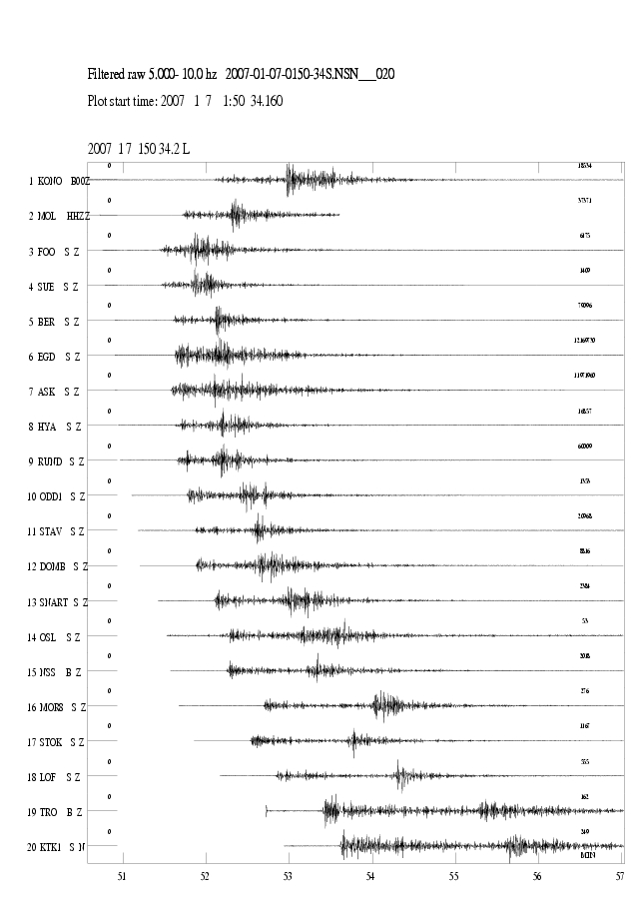
Figure 6: Seismograms for the earthquake on January 1st 2007 at 01:50(UTC). This earthquake is located northwest of Florø, at 61.99N and 1.13E. The seismograms are filtered between 5-10 Hz. The horizontal time scale is minutes, first marking at 01:51 (UTC). The station abbreviations are: KONO: Kongsberg, MOL: Molde, FOO: Florø, SUE: Sulen, BER: Bergen, EGD: Espegrend, ASK: Askøy, HYA: Høyanger, RUND: Rundemannen, ODD: Odda, STAV: Stavanger, DOMB: Dombås, SNART: Snartemo, OSL: Oslo, NSS: Namsos, MOR8: Mo i Rana, STOK: Stokkvågen, LOF: Lofoten, TRO: Tromsø , KTK1: Kautokeino.

Earthquake recordings in the Stokkvågen area

The temporary network around Stokkvågen had continued operation in most of 2007. The seismic activity is reduced compared to 2006. During 2007, 203 seismic events were located in the area shown on Figure 8. There is a renewed research interest in the area and independent funding might be needed for additional monitoring of seismicity and crustal motions.

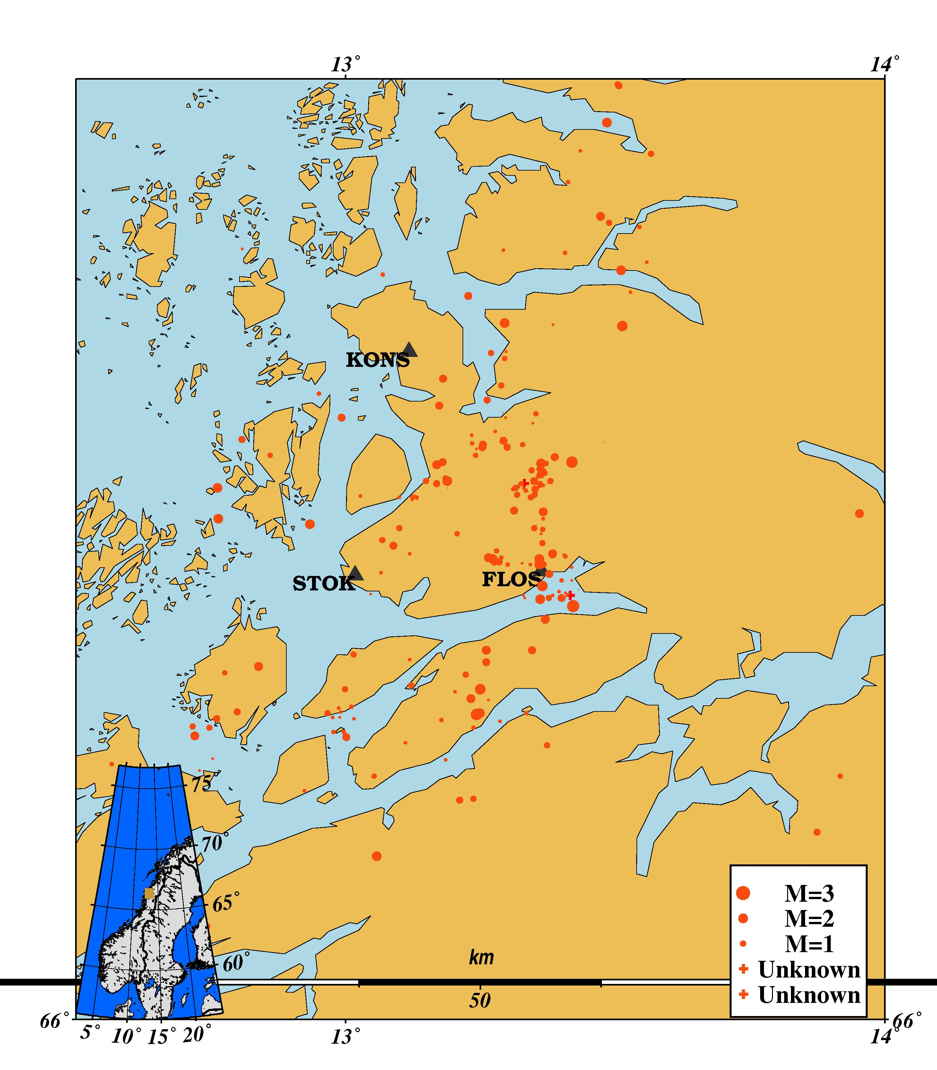
Figure 8: Events located in the Stokkvågen area during 2007.

Earthquake recordings in the Steigen area

A new seismic station (STEI) was in June 2007, installed in the Steigen area in Nordland. This seismic station is recording small local earthquakes and also the larger earthquakes occurring offshore Lofoten. During 2007 a total of 156 events is recorded by STEI and located to the area shown in Figure 9. During 2007 the seismic activity

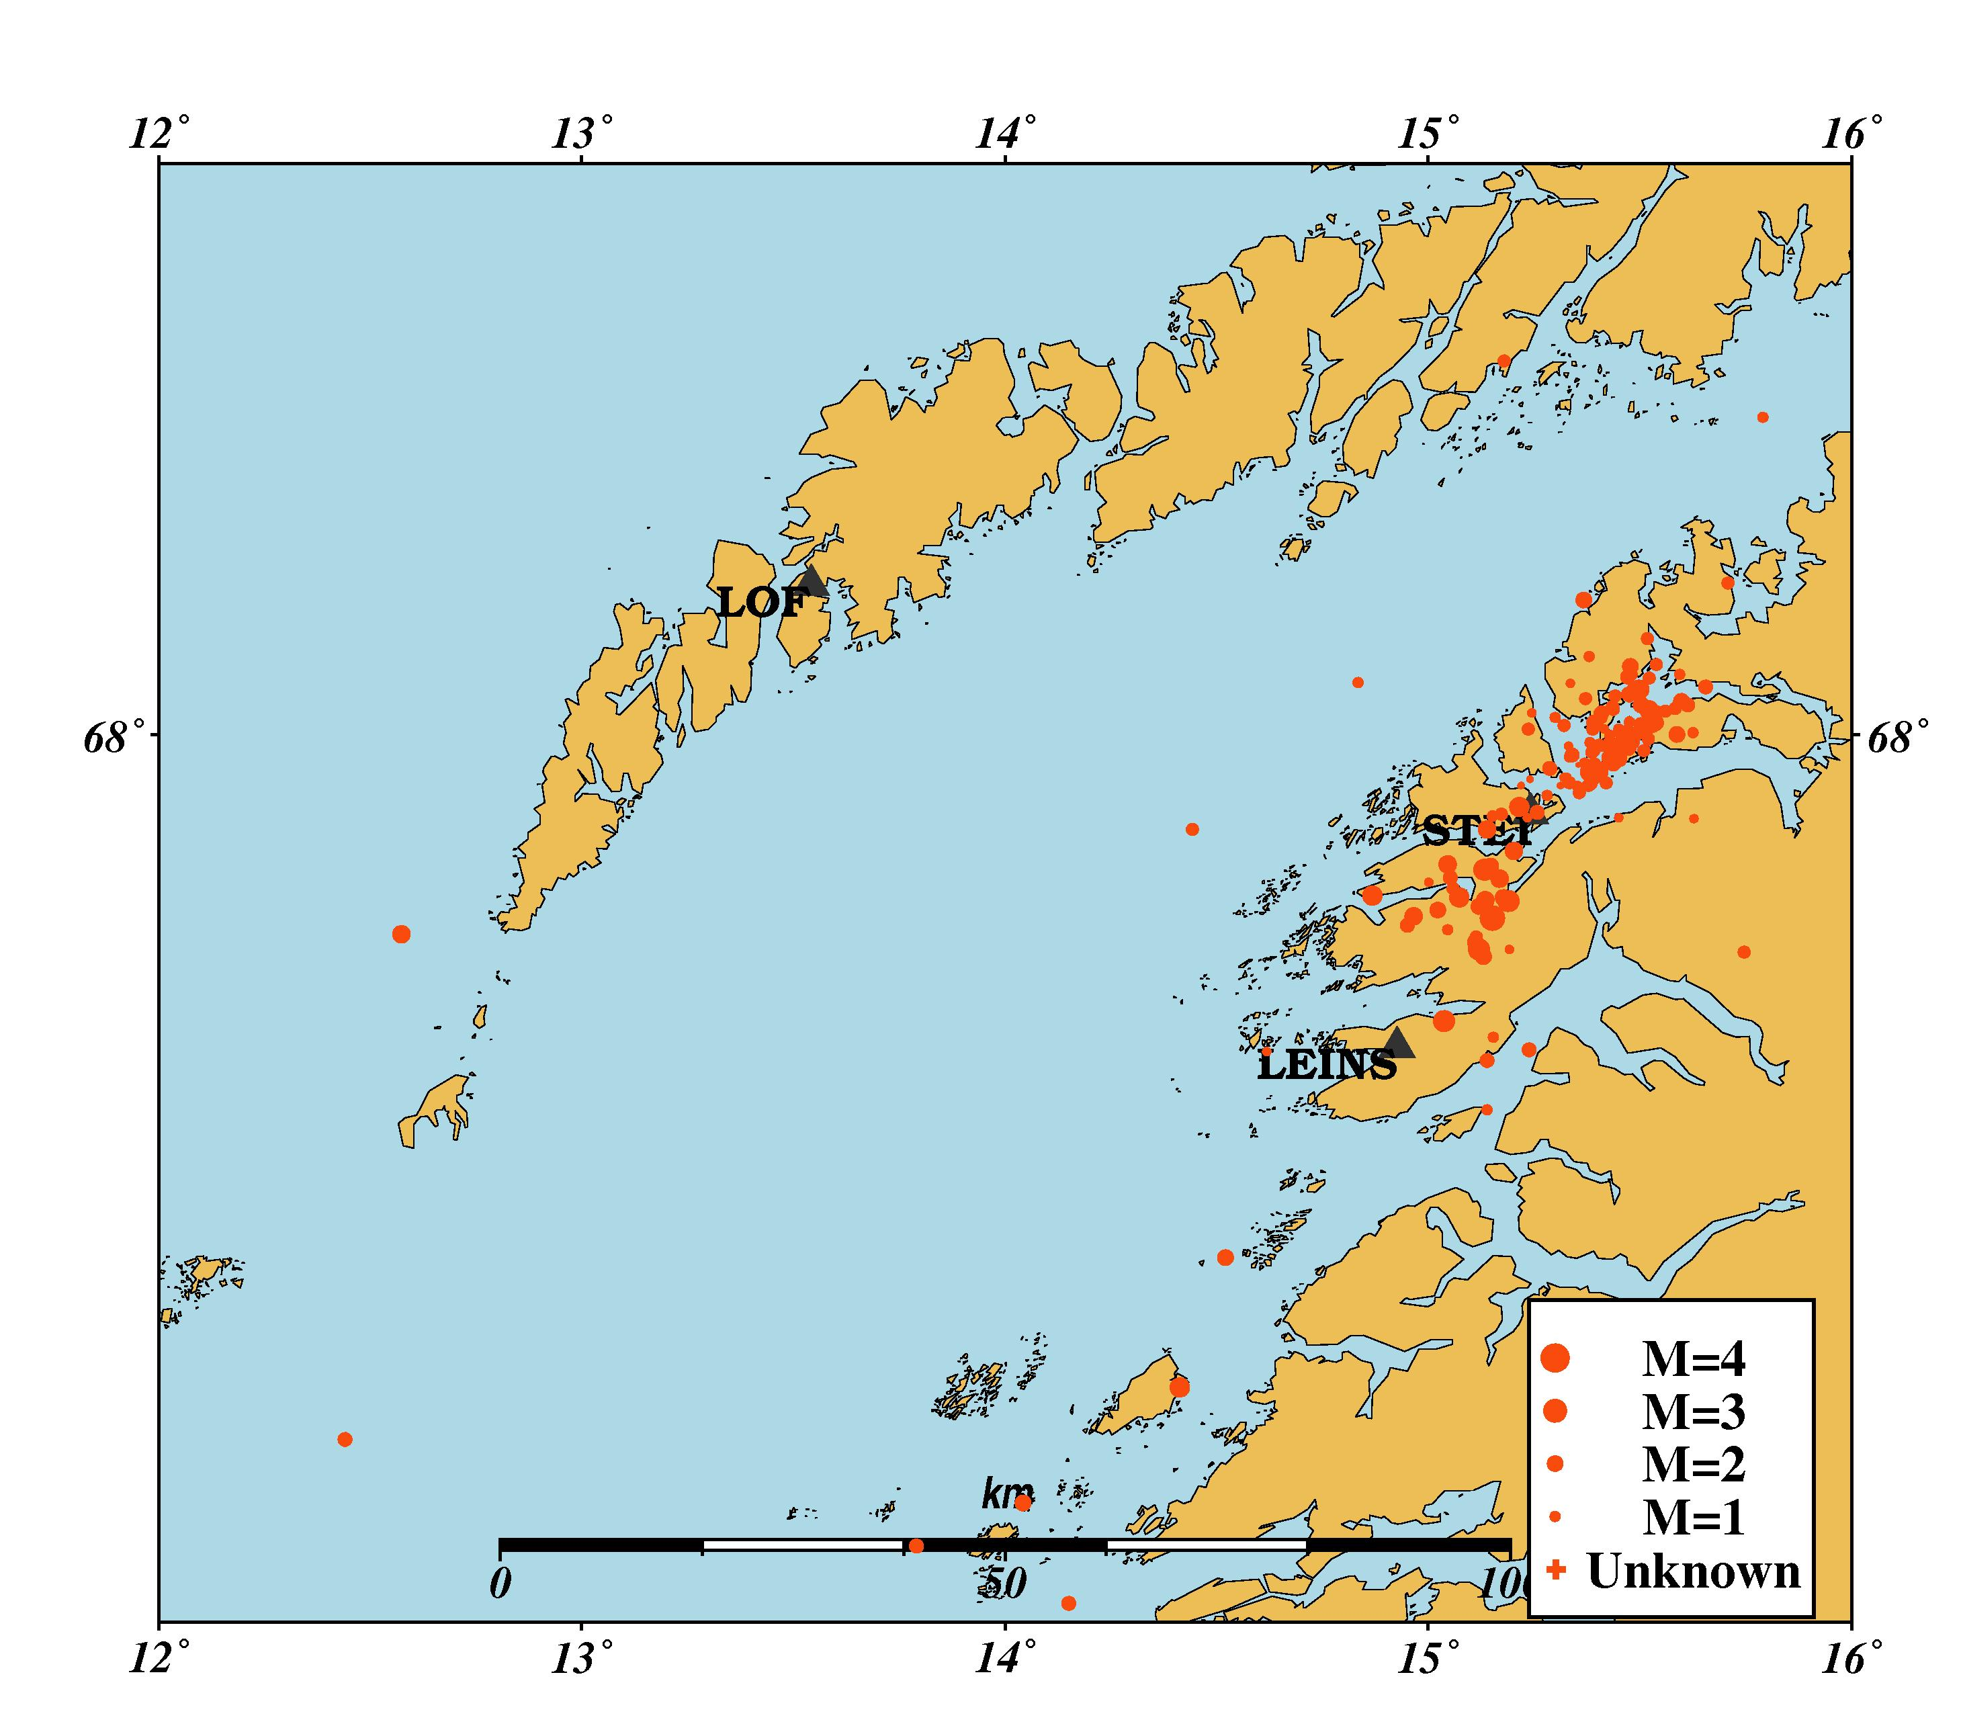
Figure 9. Events located in the Steigen area during 2007.

in the area intensified in the late Autumn, and it was decided to install an additional temporary station in Leines, south of STEI. This choice of location was based on the previous earthquake swarm. The data from this station is received on memory sticks and have not yet been included in the regular processing. These are therefore not shown in Figure 9. It is evident that the distribution of epicentres follows a NE-trend, which is known to coincide with a previously known zone of weakness (Atakan et. al. 1994). However, the activity now seems to be more concentrated in the NE when compared to the 1993 earthquake swarm.

The earthquake January 7th 2007

On 7th January 2007, an earthquake occurred in the northern North Sea. The earthquake was located to 61.99 N, 1.13 E at 01:50 (UTC) and with magnitude 4.8 (BGS). This earthquake was reported felt by people on the Shetland island. In addition, one phone call was received from western Norway. The earthquake was also felt at the Statfjord oil platform. Reported description of the earthquake corresponds to EM98 (European Macroseismic Scale (Grünthal, 1998)) intensity of IV of this location. The preliminary regional moment tensor inversion shows a NE trending reverse faulting which is in line with the general stress tensor in the region (pers. comm., L. Ottemöller).

Jan Mayen

The Jan Mayen Island is located in an active tectonic area with two major structures, the Mid Atlantic ridge and the Jan Mayen fracture zone, interacting in the vicinity of the island. Due to both tectonic and magmatic activity in the area, the number of recorded earthquakes is higher than in other areas covered by Norwegian seismic stations. During 2007 a total of 255 earthquakes were located as seen on Figure 8 and of these, 42 were calculated to have a magnitude equal to or above 3.0.
The largest earthquake in the Jan Mayen region occurred November 21st at 05:26 (UTC). This earthquake was located to 70.88N and 6.69W with magnitude 3.8.

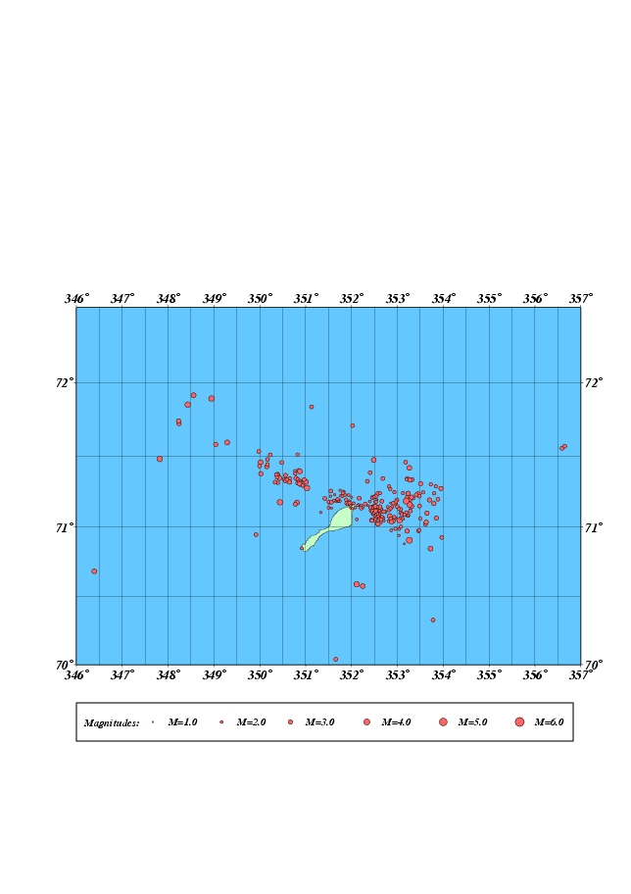
Figure 8: Earthquakes located in the vicinity of the Jan Mayen Island during 2007

The number of recorded earthquakes in the Jan Mayen area has varied over the last years, see Figure 9. The number of relative strong earthquakes show smaller time variation than smaller earthquakes. The apparent increase in 2004 and 2005 is due to the M=6.0 earthquake in 2004 and its aftershocks (Sørensen et al., 2007).

Figure 9: Yearly distribution of earthquakes located in the Jan Mayen area.

5. Felt earthquakes

From 2006 it is possible to report felt earthquakes using the internet. On the site www.skjelv.no., questionnaires are available for the public. In total, 18 earthquakes were reported felt during 2007 (see Table 5 and Figure 12).

Table 5: Earthquakes reported felt in the BER database in 2007. Abbreviations are: M_{c} = coda magnitude, M_{L} = local magnitude and M_{w} = moment magnitude, Q: questionnaires sent (Y/N), W: questionnaires received on web.

Nr | Date | Time (UTC) | Max.  Intensity  (MMI) | Magnitude (BER) | Instrumental epicentre location | Q | W
1 | 07.01.07 | 01:50 | IV | M_{c}=3.9, M_{L}=4.2 Mw=4.8 (BGS) | 61.99N / 01.13E | Y | Y
2 | 21.01.07 | 13:45 | VI | M_{c}=3.6, M_{L}=3.6, MW=3.5 | 62.61N / 06.57E | N | Y
3 | 28.01.07 | 10:30 | V | M_{c}=3.2, M_{L}=3.6 | 57.74N / 06.37E | N | Y
4 | 22.02.07 | 07:22 | III | M_{c}=1.8, M_{L}=2.0 | 62.78N / 07.12E | N | Y
5 | 23.04.07 | 20:10 | III | M_{c}=1.8, M_{L}=1.7 | 62.01N / 05.12E | N | N
6 | 10.05.07 | 04:57 | III | M_{c}=2.8, M_{L}=3.4 | 71.15N / 06.70W | N | N
7 | 19.05.07 | 10:02 | III | M_{c}=2.5, M_{L}=2.7 | 67.81N / 15.12E | N | N
8 | 21.05.07 | 20:22 | III | M_{c}=2.1, M_{L}=2.3 | 61.66N / 04.65E | N | N
9 | 04.06.07 | 17:34 | III | M_{c}=3.5, M_{L}=3.3, M_{L}=3.9 (BGS) | 57.06N / 01.73E | N | N
10 | 18.07.07 | 17:29 | III | M_{c}=2.6, M_{L}=2.2 | 68.30N / 18.26E | N | N
11 | 12.09.07 | 22:56 | III | M_{c}=2.7, M_{L}=2.8 | 61.60N / 04.76E | N | Y
12 | 03.10.07 | 21:28 | III | M_{c}=1.6, M_{L}=2.1 | 60.18N / 04.98E | N | Y
13 | 06.11.07 | 09:07 | III | M_{c}=2.5, M_{L}=2.5 | 59.69N / 07.43E | N | Y
14 | 07.11.07 | 05:16 | III | M_{c}=2.2, M_{L}=2.1 | 66.31N / 13.42E | N | Y
15 | 22.11.07 | 21:00 | III | M_{c}=2.4, M_{L}=2.5 | 67.85N / 15.19E | N | N
16 | 24.11.07 | 15:47 | III | M_{c}=2.7, M_{L}=2.4 | 67.88N / 15.13E | N | N
17 | 09.12.07 | 15:41 | III | M_{c}=3.2, M_{L}=2.6 | 65.92N / 12.44E | N | N
18 | 20.12.07 | 11:18 | III | M_{c}=2.8, M_{L}=2.9 | 67.84N / 15.15E | N | Y

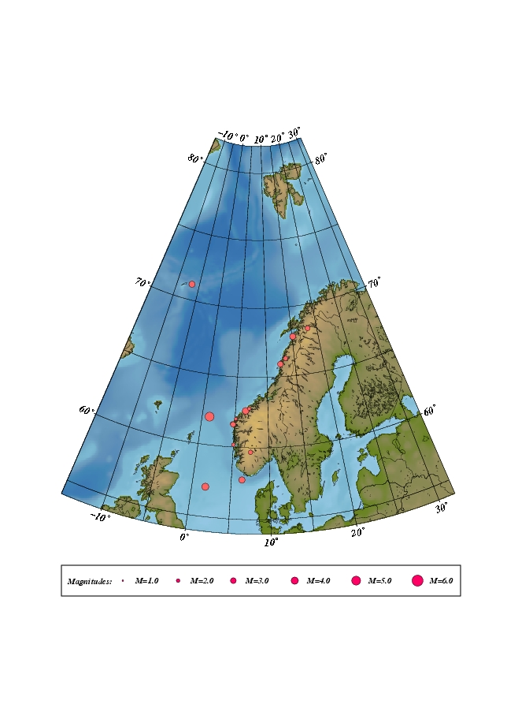
Figure 12: Location of the 18 earthquakes reported felt during 2007.

6. Use of NNSN data during 2007

Data collected by Norwegian seismic stations are made available through the Internet and are provided on request to interested parties. The use and publication of this data is beyond our control.

Publications and reports

Bungum, H. & C. Lindholm (2007): Tsunamigenic Seismic Sources in the North Sea, the Norwegian Continental Margin and the Norwegian-Greenland Sea. Report for NGI within the EU Transfer project, 18 pp.
Chabassier, J. & J. Schweitzer (2007): Single small array regional localization using PMCC (ELOSV2). In: Semiannual Technical Summary, 1 January - 30 June 2007, NORSAR Sci. Rep. 2-2007, Kjeller.
Chatelain, J-L., Guillier, B., Cara, F., Duval, A-M., Atakan, K., Bard, P-Y., and the WP02 SESAME Team. 2007. Evaluation of the influence of experimental conditions on H/V results from ambient noise recordings. Bulletin of Earthquake Engineering, doi: 10.1007/s10518-007-9040-7. 42p.
Gibbons, S.J., M. Bøttger Sørensen, D.B. Harris & F. Ringdal (2007): The detection and location of low magnitude earthquakes in northern Finland using multi-channel waveform correlation at regional distances. Phys. Earth Planet. Inter., 160, 285-309.
Guillier, B., Atakan, K., Chatelain, J-L., Havskov, J., Ohrnberger, M., Cara, F., Duval, A-M., Zacharapoulos, S., Teves-Costa, P., and the SESAME Team. 2007. Influence of instruments on H/V spectral ratios of ambient vibrations. Bulletin of Earthquake Engineering, doi: 10.1007/s10518-007-9039-0. 29p.
Kværna, T, F. Ringdal & U. Baadshaug (2007): North Korea’s nuclear test: the capability for seismic monitoring of the North Korean test site. Seism. Res. Lett., 78/5, 487-496.
NORSAR (2007): Seismic Hazard Assessment for the Fredrikstad (Øra) LNG Project, Norway. Report for Statoil ASA, 36 pp.
Schweitzer, J. & B.L.N. Kennett (2007): Comparison of location procedures – The Kara Sea event of 16 August 1997
Bulletin Seismological Society America, 97, 2, 389-400, 2007, doi: 10.1785/0120040017
Svenningsen, L., N. Balling, B.H. Jacobsen, R. Kind, J. Schweitzer and K. Wylegalla (2007): Crustal thickness beneath the highlands of southern Norway from teleseismic receiver functions. Geophys. J. Int., 170, 1129-1138, 2007, doi: 10.1111/j.1365-246X.2007.03402.x
Svenningsen, L., N. Balling, B.H. Jacobsen, R. Kind, K. Wylegalla & J. Schweitzer (2007): Accurate depth to Moho beneath the highlands of southern Norway resolved by teleseismic receiver functions.Geophys. Res. Abs., 9, 02719 (abstract)
SRef-ID: 1607-7962/gra/EGU2007-A-02719
Sørensen, M.B., Ottemöller, L., Havskov, J., and Atakan, K., Hellevang, B., Pedersen, R.B. 2007. Tectonic processes in the Jan Mayen Fracture Zone based on earthquake occurrence and bathymetry. Bulletin of the Seismological Society of America, Vol.97 No.3, 772-779, doi: 10.1785/0120060025.
Weidle, Ch., V. Maupin, J. Ritter, T. Kværna, J. Schweitzer, N. Balling, H. Thybo and J.I. Faleide (2007): MAantle investiGations of Norwegian Uplift Structure (MAGNUS) - a flying start into Topo Europe. Geophys. Res. Abs., 9, 03820 (abstract)
SRef-ID: 1607-7962/gra/EGU2007-A-03820

7. References

Alsaker A., Kvamme, L.B., Hansen, R.A., Dahle, A. and Bungum, H. (1991): The ML scale in Norway. Bull. Seism. Soc. Am., Vol. 81, No. 2, pp.379-398.

Atakan,K., Lindholm,C.D., and Havskov,J. 1994. Earthquake swarm in Steigen, northern Norway: An unusual example of intraplate seismicity. Terra Nova 6, 180-194.

Brune J.N. (1970): Tectonic stress and spectra of seismic shear waves. Journal of Geophysical Research, 75, 4997-5009.

Grünthal, G. (1998): "European Macroseismic Scale 1998". Cahiers du Centre Européen de Géodynamique et de Séismologie Volume 15, Luxembourg.

Havskov J., and Bungum, H. (1987): Source parameters for earthquakes in the northern North Sea. Norsk Geologisk Tidskrift,Vol.67, pp 51-58.

Havskov, J. and Ottemöller, L. (1999): SEISAN earthquake analysis software. Seism. Res. Letters, Vol. 70, pp. 532-534.

Havskov, J. and Ottemöller, L. (2001): SEISAN: The earthquake analysis software. Manual for SEISAN v. 8.0, Department of Earth Science, University of Bergen, Norway.

Havskov, J. and Sørensen, M.B. (2006): New coda magnitude scales for mainland Norway and the Jan mayen region. NNSN Technical report no. 19.

Kanamori, H. (1977): The energy release in great earthquakes. Journal of Geophysicsl Research 82; 20, pp. 2981-2987.

Karnik, V., Kondorskaya, N.V., Riznichenko, Y. V., Savarensky, Y. F., Solovev, S.L., Shebalin, N.V., Vanek, J. and Zatopek, A. (1962): Standardisation of the earthquake magnitude scales. Studia Geophys. et Geod., Vol. 6, pp. 41-48.

Kennett, B.L.N. and Engdahl, E.R. (1991): Traveltimes for global earthquake location and phase identification. Geophys. J. Int., Vol. 105, pp. 429-465.

Kradolfer, U. (1996): AuroDRM – The First Five Years. Seismological Research Letters, vol. 67, no. 4, 30-33.

Lienert, B.R. and Havskov, J. (1995): HYPOCENTER 3.2 A computer program for locating earthquakes locally, regionally and globally. Seismological Research Letters, Vol. 66, 26-36.

Moreno, B, Ottemöller, L., Havskov, J. and Olesen, K.A. (2002): Seisweb: A Client-Server-Architecture-Based Interactive Processing Tool for Earthquake Analysis. Seism. Res. Letters. Vol.73, No.1.

Ottemöller, L. (1995): Explosion filtering for Scandinavia. Technical Report No. 2, Institute of Solid Earth Physics, University of Bergen, Norway.

Sørensen, M.B., Ottemöller, L., Havskov, J., and Atakan, K., Hellevang, B., Pedersen, R.B. 2007. Tectonic processes in the Jan Mayen Fracture Zone based on earthquake occurrence and bathymetry. Bulletin of the Seismological Society of America, Vol.97 No.3, 772-779, doi: 10.1785/0120060025.

Sørnes A. and Navrestad, T. (1975): Seismic survey of Jan Mayen. Norsk Polarinstitutt, Årbok 37-52.

Veith K.F., and Clawson, G.E. (1972): Magnitude from short-period P-wave data. Bull. Seism. Soc. Am., Vol. 62, pp.435-452.

Westre S. (1975): Richter's lokale magnitude og total signal varighet for lokale jordskjelv på Jan Mayen. Cand. real thesis., Seismological Observatory, University of Bergen, Norway.

APPENDIX 2

The NORSAR Regional Arrays
The NORSAR Regional Arrays
NORSAR operates the two regional seismic arrays, ARCES (near Karasjok, Finnmark) and SPITS (on Svalbard). In addition, data from NORSAR (the original large aperture array in southern Norway), FINES (in Finland), HAGFORS (southern Sweden), KBS (Kings Bay on Svalbard), KONO (Kongsberg, southern Norway) and JMIC (Jan Mayen) are collected and analyzed. All data are openly available and the interested layman can see daily data on www.norsar.no/NDC/data.
The NORES array, which was damaged by lightening in 2002, represents a significant loss in the regional monitoring capability. Alternative processing algorithms for the NORSAR array have been developed, and the reconstruction of the NORES array as a broader research facility is now in progress.
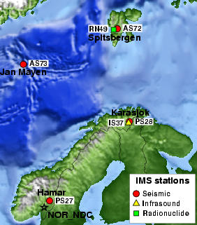
Fig. 1. Seismic arrays (and a planned infrasound station) currently operated by NORSAR.
- Systems Recording Performance
The arrays have continuous data recording. In 2007 the average recording time for the SPITS array was 91.89%, for the ARCES array 98.13%, and for the NORSAR array 99.24%.
The recording performance in terms of monthly uptime statistics is shown in Table 1.
 | ARCES | SPITS | NORSAR
January | 96.259% | 99.679% | 99.480%
February | 88.839% | 99.994% | 99.998%
March | 98.050% | 99.992% | 99.999%
April | 99.994% | 99.994% | 99.999%
May | 100% | 99.991% | 99.991%
June | 99.365% | 99.996% | 97.966%
July | 99.702% | 97.633% | 99.455%
August | 97.014% | 95.238% | 99.862%
September | 98.474% | 53.101% | 99.208%
October | 100% | 99.999% | 98.298%
November | 99.923% | 83.338% | 98.251%
December | 99.982% | 73.768% | 98.405%
Table 1. Systems recording performance (uptime in % of theoretical) for three arrays operated by NORSAR in 2007.
- Detections
The NORSAR analysis results are based on automatic phase detection and automatic phase associations which produce the automatic bulletin. Based on the automatic bulletin a manual analysis of the data is done, resulting in the reviewed bulletin (which is available under the NORSAR web pages). This procedure is often referred to as the Regional Monitoring System (RMS), and has been in operation since 1989. To reduce the work load on the analyst, the Generalized Beam Forming (GBF) is used as a pre-processor to RMS, so that only phases associated with selected events in northern Europe are considered in the automatic RMS phase association. However, all detections are available for analyst screening and review.
Table 2 gives a summary of the phase detections and events declared by the RMS.

 | Jan. | Feb. | March | April | May | June
Phase detections | 156259 | 125636 | 130577 | 142538 | 147430 | 142146
Associated phases | 4550 | 4369 | 4737 | 4181 | 4345 | 4547
Un-associated phases | 151709 | 121267 | 125840 | 138357 | 143085 | 137599
Events automatically declared by RMS | 927 | 798 | 870 | 780 | 824 | 813
No. of events defined by the analyst | 39 | 72 | 60 | 47 | 60 | 56
 | July | Aug. | Sep. | October | Nov. | Dec.
Phase detections | 156264 | 203836 | 157498 | 154224 | 133318 | 165404
Associated phases | 5036 | 8349 | 5814 | 6421 | 5196 | 5458
Un-associated phases | 151228 | 195487 | 151684 | 147803 | 128122 | 159946
Events automatically declared by RMS | 1031 | 1952 | 1288 | 1456 | 1079 | 1129
No. of events defined by the analyst | 48 | 39 | 60 | 53 | 57 | 62
Table 2. RMS phase detections and event summary.
The phase arrival time data from the arrays processed by NORSAR is provided to the UiB processing centre and merged with UiB readings, and a location based on all data is computed and published in the monthly bulletins.

- The use of Norwegian data
Data collected on Norwegian seismic stations is made available through the Internet and is provided on request to interested parties. The use and publication of this data is beyond our control.
Several investigations make use of the data from the Norwegian National Seismic Network. Only one investigation is described in the Appendix which deals with the rather rare analysis of a meteorite. This analysis is based on data from ARCES and in particular from the the seismic station in Tromsø.
A particular use of the NNSN data is for the Åknes slide monitoring project in which local seismicity is associated with data from NNSN. For details see: http://www.norsar.no/seismology/research/aaknes/ and
http://www.aknes-tafjord.no/artikkel.aspx?AId=182&back=1&MId1=568

