Seismicity of Norway and
surrounding areas during 2000
- a short summary

Prepared by

Institute of Solid Earth Physics
University of Bergen
Allégt.41
N-5007 Bergen, NORWAY

Phone: +47-55-583420
Fax: +47-55-589669
E-mail: seismo@ifjf.uib.no
Web: www.ifjf.uib.no

July 2001

Seismicity of Norway and surrounding areas during 2000
- a short summary

The seismic stations in Norway are operated by the University of Bergen (UiB) and the Norwegian Seismic Array (NORSAR). The stations are sponsored by various organizations. The UiB operates the Norwegian National Seismic Network (NNSN), which comprises 13 stations. In addition, there are 10 other seismic stations operated by the UiB (including two IRIS, i.e. Incorporated Research Institutions for Seismology, stations), and four seismic arrays (NORSAR, NORESS, SVAESS and ARCESS) operated by NORSAR. Locations of the seismic stations in Norway are shown in Figure 1. Phase data collected by UiB are included in a monthly bulletin, and distributed to national and international agencies. In the monthly bulletins, macroseismic data for all felt events in Norway are also collected and macroseismic maps are presented if available.
During 2000, a total of 5869 events were recorded and included in the database prepared by the UiB. Among these, 4778 were local/regional and 1087 were distant events. Out of the local events registered during 2000, a total of 1673 were located. Figure 2 displays the monthly distribution of number of local/regional and distant (teleseismic) events registered by the Norwegian seismic stations during 2000.
Figure 3 shows the distribution of epicentres for all local/regional events located by the Norwegian seismic stations with magnitude M≥3.0. There is a clear concentration of epicentres along the well-known regional structures, such as the Jan Mayen Fracture Zone, the Mohn's Ridge and the extension of the active plate margin west of Spitsbergen. Further do sporadic events occur along the offshore structures related to the Norwegian continental shelf and the North Sea.
Twenty-three earthquakes were reported felt during 2000 (Table 1), all occurring in areas where earthquakes have been felt before. Eight of the felt events occurred in the areas around Jan Mayen. An unusual situation occurred during 2000 when 5 earthquakes were reported felt during a period of only 13 days (November 26th to December 8th). For earthquakes felt by a sufficient number of people, questionnaires were sent and isoseismal maps are made. These maps are shown in Figure 4. Isoseismal maps are not made for the earthquakes felt on Jan Mayen due to the small population.
The largest local/regional earthquakes, occurring in 2000 and recorded on Norwegian stations, are, as in previous years, located near the spreading ridge in the Norwegian Sea. The largest earthquake was recorded on May 24th at 01:10 (UTC) with an estimated magnitude of Ml=4.6 and located northwest of the Jan Mayen Beerenberg volcano. The largest local/regional earthquake closer to the mainland of Norway is located between Stord and Bømlo in western Norway. The earthquake was recorded on August 12th at 14:27 (UTC) with an estimated magnitude of ML=4.5. On the isoseismal map (Figure 4) it is seen that the earthquake was felt in most of southern Norway.
Due to difficulties reading enough polarities, fault plane solutions were not determined for any of the earthquakes recorded during the first half of 2000. In the last half of 2000 only five events had enough number of polarities that could be reliably determined. The focal mechanisms of these five events are shown in Figure 5. All these events were also felt.

For more information, please contact:

Institute of Solid Earth Physics
University of Bergen
Allégt.41
N-5007 Bergen

Phone:+47-55-583420
Fax: +47-55-589669
E-mail: seismo@ifjf.uib.no
Web: www.ifjf.uib.no

Table 1. List of earthquakes felt in Norway during 2000
Date | Time (UTC) | Max.Intensity  (on MMI scale) | Magnitude (BER) | Instrumental Epicenter Location
01.02.00 | 12:42 | III | Mc=2.1, Ml=2.3  Mw=2.3 | 61.61N / 4.72E
10.02.00 | 06:17 | IV | Mc=3.4, Ml=3.6  Mw=3.3 | 61.77N / 4.52E
13.03.00 | 05:20 | III | Mc=2.1, Ml=2.2  Mw=2.4 | 62.17N / 6.25 E
07.04.00 | 03:38 | III | Mc=3.4, Ml=3.4  Mw=2.9 | 66.45N / 13.47E
27.04.00 | 21:44 | III | Mc=2.9, Ml=3.2  Mw=3.0 | 61.44N / 3.88E
19.05.00 | 16:59 | III | Mc=4.3, Ml=3.9 | 70.99N / 9.8W
21.05.00 | 19:58 | III | Mc=5.1, Ml=4.5 | 71.11N / 8.37W
21.05.00 | 23:42 | III | Mc=4.3, Ml=3.9 | 71.12N / 9.45W
22.05.00 | 11:57 | III | Mc=4.2, Ml=3.8 | 71.13N / 9.11W
24.05.00 | 01:10 | IV | Mc=5.9, Ml=4.6  Ms=3.9 | 71.14N / 8.75W
25.05.00 | 04:09 | V | Mc=5.5, Ml=4.4  Ms=3.6 | 71.02N / 7.84W
01.06.00 | 17:08 | V | Mc=3.6, Ml=3.7  Mw=3.5 | 61.84N / 6.89E
05.07.00 | 17:58 | III | Mc=2.3, Ml=2.2  Mw=2.1 | 62.01N / 6.21E
19.07.00 | 17:28 | III | Mc=4.8, Ml=3.5 | 71.27N / 9.13W
12.08.00 | 14:27 | V | Mc=3.6, Ml=4.5  Mw=4.1 | 59.76N / 5.34 E
15.08.00 | 05:00 | III | Ml=3.8 | 71.14N / 8.58W
01.09.00 | 11:48 | III | Mc=2.8, Ml=2.6 | 59.10N / 5.74E
19.10.00 | 10:27 | IV | Mc=3.5, Ml=3.3  Mw=3.1 | 57.67N / 7.2E
26.11.00 | 00:17 | III | Mc=2.7, Ml=2.6  Mw=2.5 | 60.04N / 5.48E
29.11.00 | 02:22 | III | Mc=2.7, Ml=2.7  Mw=2.5 | 59.85N / 6.98E
29.11.00 | 09:59 | IV | Mc=2.7, Ml=2.4  Mw=2.5 | 60.05N / 5.51E
29.11.00 | 22:07 | V | Mc=3.8, Ml=3.8  Ms=3.4 | 58.89N / 11.29E
08.12.00 | 00:48 | V | Mc=3.3, Ml=3.8  Ms=3.6 | 60.13N / 4.79E

Abbreviations: M_{L}: Richter's local magnitude, M_{C}: Local magnitude based on duration, M_{b}: Body wave magnitude MMI: Modified Mercalli's Intensity scale UTC: Universal time coordinated BER: Seismological Observatory in Bergen, PDE: Preliminary Determination of Epicenters from USGS.

Figure 1. Seismic stations in Norway. NORSAR operates the NORSAR arrays and UiB operates the remaining stations.

Figure 2. Histogram showing the monthly number of local/regional and teleseismic events detected by the Norwegian seismic stations during 2000.

Figure 3. Epicenter distribution of events with M≥3.0 located by the Norwegian seismic stations in 2000. Known and presumed explosions are not included.

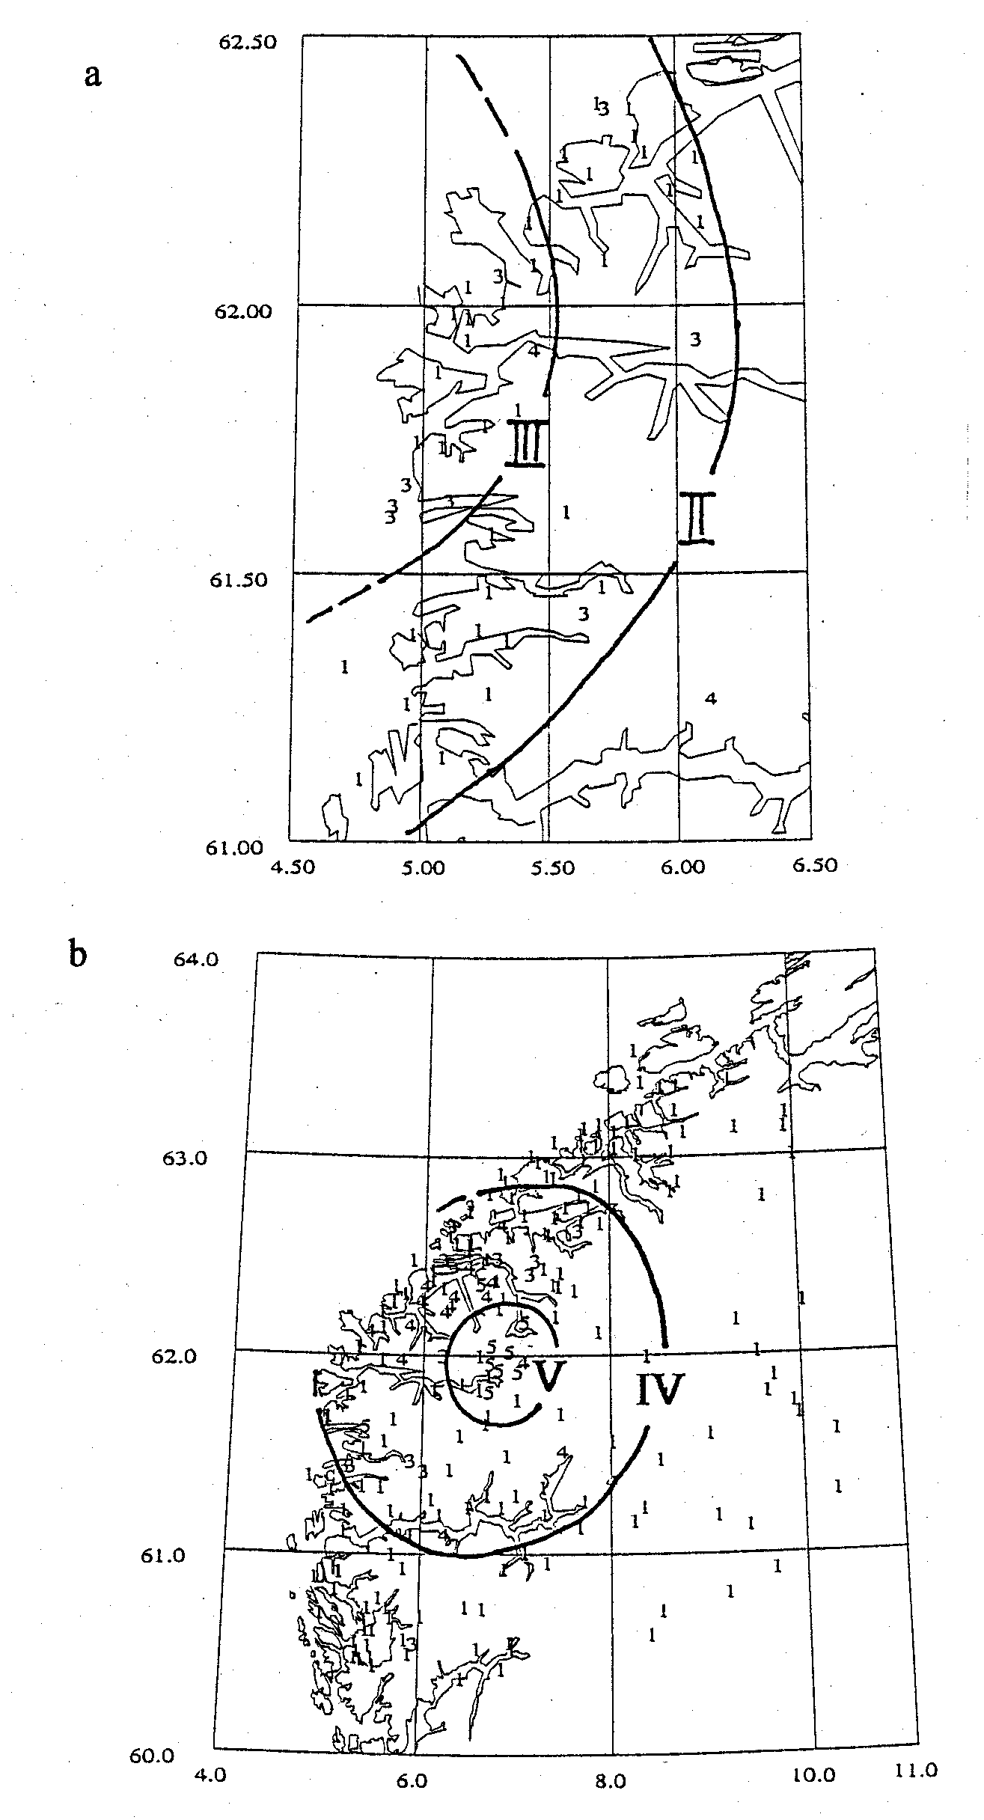

Figure 4. Macroseismic maps showing iso-contours of Modified Mercalli Intensity for the earthquakes occurred on (a) February 10th at 06:17 (UTC), (b) June 1st at 17:08 (UTC), (c) August 12th at 14:27 (UTC), (d) October 19th at 10:27 (UTC), (e) November 29th at 09:59 (UTC), (f) November 29th at 22:07 (UTC) and (g) December 8th at 00:48 (UTC).

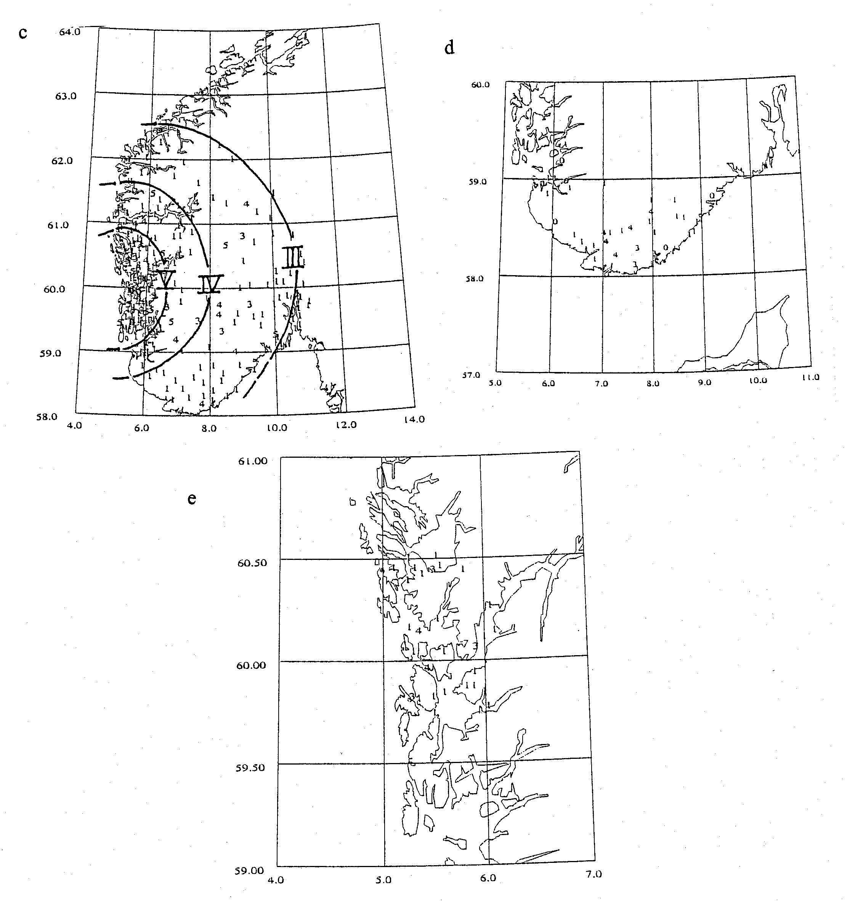

Figure 4 continued Macroseismic maps showing iso-contours of Modified Mercalli Intensity for the earthquakes occurred on (a) February 10th at 06:17 (UTC), (b) June 1st at 17:08 (UTC), (c) August 12th at 14:27 (UTC), (d) October 19th at 10:27 (UTC), (e) November 29th at 09:59 (UTC), (f) November 29th at 22:07 (UTC) and (g) December 8th at 00:48 (UTC).

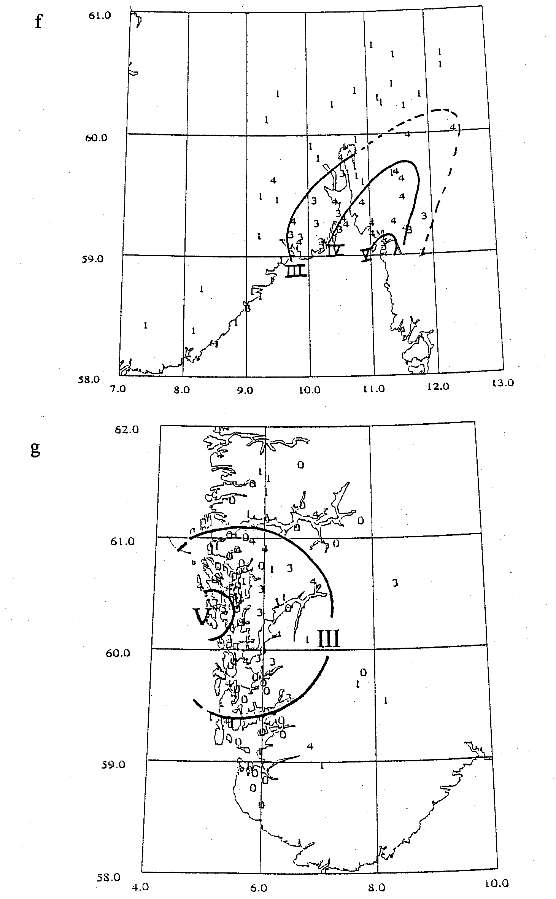

Figure 4 continued Macroseismic maps showing iso-contours of Modified Mercalli Intensity for the earthquakes occurred on (a) February 10th at 06:17 (UTC), (b) June 1st at 17:08 (UTC), (c) August 12th at 14:27 (UTC), (d) October 19th at 10:27 (UTC), (e) November 29th at 09:59 (UTC), (f) November 29th at 22:07 (UTC) and (g) December 8th at 00:48 (UTC).

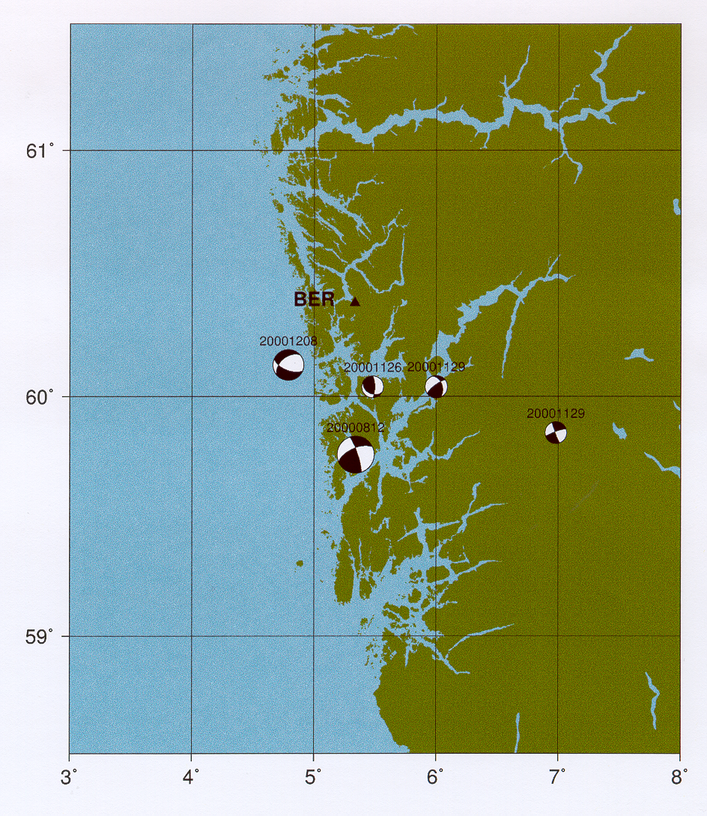

Figure 5 Earthquakes with focal mechanism. Note that the smallest earthquake dated 20001129 is located at the same location as the earthquake dated 20001126.

