

Seismicity of Norway

and surrounding areas

for the period

January 1st to June 30th, 2000.

Institute of Solid Earth Physics
University of Bergen
Allegt. 41
N-5007 Bergen

e-mail: seismo@ifjf.uib.no
Phone: (+47) 55 58 34 20
Fax: (+47) 55 58 96 69

September 2000

CONTENTS

- Introduction

- Velocity models and magnitude relations

- Events recorded by the Norwegian stations

- The seismicity of Norway and adjacent areas

- Well recorded earthquakes

- Felt earthquakes

- Unusual activity near Jan Mayen

1. Introduction

This semi-annual report on the seismicity of Norway and adjacent areas encompasses the time period January 1st - June 30th, 2000. The earthquake locations have been compiled from all available seismic stations operating on Norwegian territory including the Arctic islands of Spitsbergen, Bjørnøya and Jan Mayen. In addition, stations from neighbouring countries have been included for large or well recorded events.

In Norway, the University of Bergen (UiB) and the Norwegian Seismic Array (NORSAR) operate seismic stations (Figure 1). These stations are sponsored by different organisations. The UiB operates the Norwegian National Seismic Network (NNSN) which comprises 13 stations. In addition, 10 other seismic stations operated by UiB (including two IRIS i.e. Incorporated Research Institutions for Seismology stations), and four seismic arrays (SPITS, NORES, NORSAR and ARCES) operated by NORSAR. Data from the temporarily installed local networks are also included whenever such networks are operated. Phase data from arrays in Russia (Apatity), Finland (Finess), Sweden (Hagfors) and from stations operated by the British Geological Survey (BGS) are also included when available. All phase data are collected by UiB, and a monthly bulletin is prepared and distributed. A brief overview of the events published in the monthly bulletins is given in this semi annual report. Macroseismic data for most felt earthquakes in Norway are collected, and macroseismic maps are presented. In cases were only very few people have felt the earthquake macroseismic information are not collected (questionaries are not sent).
All local and regional events with magnitude larger than 1.5 and all teleseismic events that are detected by the Bergen network are included. The merging of data between NORSAR and UiB is done on the following principles:
i) All local and regional events recorded by NORSAR that are also detected by the Bergen network are included.
ii) All local and regional events with local magnitude larger than 2.0 detected by NORSAR and not recorded by the Bergen network are included.
iii) All teleseismic events recorded by NORSAR and also detected by the Bergen network are included.
iv) All teleseismic events with NORSAR magnitude M_{b}≥5.0 are included.

The data from British Geological Survey (BGS) are included in the database in Bergen following the same criteria as for NORSAR data. The only exception is that no teleseismic events are included.

All data from the network is available through an anonymous ftp-account: ftp.ifjf.uib.no directory pub/seismo.

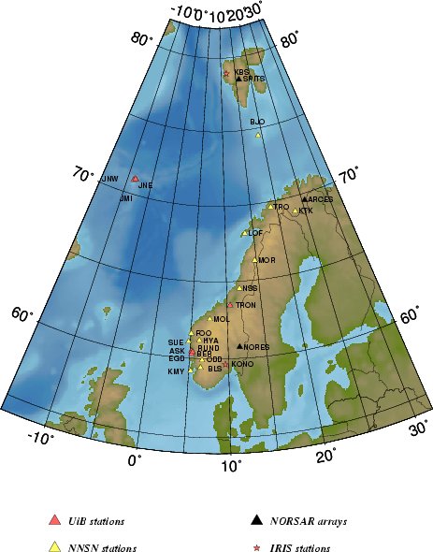

Figure 1. Norwegian seismic stations. NORSAR operates the NORSAR arrays and UiB operates the remaining stations shown in the figure.
2. Velocity models and magnitude relations

The velocity model used for locating all local and regional events, except for the local Jan Mayen events, is shown in the table below (Havskov and Bungum, 1987). Event locations are performed using the HYPOCENTER program (Lienert and Havskov, 1995) and all processing is performed using the SEISAN data analysis software (Havskov, 1997).

P-wave velocity (km/sec) | Depth to layer interface (km)
6.2 | 0.0
6.6 | 12.0
7.1 | 23.0
8.05 | 31.0
8.25 | 50.0
8.5 | 80.0

Magnitudes are calculated from coda duration and/or amplitudes. The coda wave magnitude scale (M_{C}) is estimated through the relation:

M_{C} = -3.0 + 2.6 * log10(T) +0.001 * D.

where T is the coda length in seconds and D is the epicentral distance in km. The coda magnitude is recognised to be higher than local magnitude calculated at NORSAR and at IFJ, UiB. When instrument corrected ground amplitudes A (nm) are available, local magnitude M_{L} is calculated using the equation given by Alsaker et al. (1991):

M_{L}= 1.0 * log(A) + 0.91 * log(D) + 0.00087 * D - 1.67

where D is the hypocentral distance in km.

For the Jan Mayen area, a local model and coda magnitude scale are used (Sørnes and Navrestad, 1975)

P-wave velocity (km/sec) | Depth to layer interface (km)
3.14 | 0
6.33 | 3
8.27 | 18

The coda magnitude for Jan Mayen is given by Westre (1975):

M_{C} = 3.27log(T)-3.24+0.001*D

where T is the coda duration and D is the epicentral distance in km.

The regional and teleseismic events recorded by the network are located using the global velocity model IASPEI91 (Kennett and Engdahl, 1991).

Body wave magnitude is calculated using the equation by Veith and Clawson (1972):

Mb = log(A/T) + Q(D,h)

here h is the hypocentre depth (km), A is the amplitude (microns), T is period in seconds and Q(D,h) is the correction for distance and depth.

Surface wave magnitude Ms is calculated using the equation (Karnik et al., 1962):

Ms = log(A/T) + 1.66log(D) + 3.3

where A is the amplitude (microns), T is period in seconds and D is the hypocentral distance in degrees.

3. Events recorded by the Norwegian stations

A total of 2826 local and regional events, based on the criteria mentioned in section 1, were detected by the Norwegian seismic stations during the first half of 2000. Compared to the previous half year there has been an increase of 16%. This increase is partly due to the increase in the earthquake activity around Jan Mayen were there are recorded 118 more earthquakes than previous half year.
Of the local and regional events analysed during the first six months of 2000, 32% were located. It has been decided to reduce the time and effort used on locating obvious explosions from January 1st, 2000. As a consequence the explosions at the Kiruna and Malmberget mines are no longer located unless they are recorded on more than 4 stations or also are recorded on the arrays operated by NORSAR. This reduced the number of located explosions from 506 during the last half of 1999 to 131 the first half of 2000. However, one phase is picked from every recording, so these events still contribute in the overall statistics.
The number of local/regional and teleseismic events, recorded per month in this period is shown in Figure 2. The average number of local and regional events analysed per month is 471.
Figure 2. Monthly distribution of local and teleseismic events, recorded during the first six months of 2000.
A total of 607 teleseismic events were recorded during the first half of 2000, of which 61% were located. In addition to the locations determined at UiB, also preliminary locations published by the USGS (United States Geological Survey) based on the world wide network are included in the Bergen database whenever the earthquake is recorded on Norwegian stations. The monthly average of teleseismic earthquakes recorded by NNSN is 101. All events (432 teleseismic, regional and local) recorded from January to June 2000 with M ≥ 3 are plotted on Figure 3.
The station recording statistics for each month from January to June and in total for the first half of 2000 are given in Table 1. This table shows the number of local events that were recorded only at one station, local events recorded on more than one station and recorded teleseismic events. It must be observed that Table 1 shows both earthquakes and explosions, and that the large number of detections at KTK is mainly due to explosions.

4. The seismicity of Norway and adjacent areas

The number of located events, in the area 54°N-82°N and 15°W-32°E, including NORSAR and BGS readings, decreased from 1110 in the last six months of 1999 to 838 in the first six months of 2000. Using the explosion filter (Ottemöller, 1995) more than 40% of these events were identified as probable explosions. The number of located events has decreased mainly due to the reduced effort in locating explosions. This is also reflected in the reduction of located events identified as probably explosions after using the explosion filter. Figure 4 shows all local and regional events analysed and located during the first half of 2000.
Figure 5 and Table 2 shows the 58 local and regional events with any of the reported magnitudes larger than or equal to 3.0. It is emphasized that it is often difficult to get a good magnitude estimate for the earthquakes located on the oceanic ridge in the Norwegian sea, since distances are too large to compute proper M_{L}, too short for M_{B} and coda magnitudes for these locations are often unreliable. Most of the recorded earthquakes in this area have magnitudes above 3.0 if the earthquakes are recorded on Norwegian mainland stations. During May many earthquakes occurred close to the Jan Mayed island. For these earthquakes the local magnitude is considered the more reliable.

The largest local or regional earthquakes, occurring between January through June 2000 and recorded on Norwegian stations are, as in previous years, located near the spreading ridge in the Norwegian Sea. The largest earthquake was recorded on May 24th at 01:10(UTC) with an estimated magnitude of 4.6 and located northwest of the Jan Mayen Beerenberg volcano.

In the vicinity of the Norwegian main land the largest earthquake was recorded on June 1st at 17:08(UTC) and located in the Stryn area, Nordfjord. The magnitude of this earthquake was estimated to 3.7 and was felt at 200 km distance from the epicentre. Seismograms for this earthquake are shown in Figure 6 and the isoseismal map is shown in Figure 9b
Figure 3. Epicentre distribution of earthquakes with M ≥ 3.0, located by the Norwegian seismic stations from January to June 2000. Teleseismic events recorded only by NORSAR have M≥5.0.

Table 1 Monthly statistics of events recorded at each station for the first half of 2000. The high number of detection on KTK is mainly due to explosions. Abbreviations are: Event types: LM=Number of local events recorded at more than one station, LS=local events recorded at only one station and D=teleseismic events per month in the time period January to December, 2000.
 | JANUARY |  |  | FEBRUARY |  |  | MARCH |  |  | APRIL |  |  | MAY |  |  | JUNE |  |  | JANUARY-JUNE
STATION | LM | LS | D | LM | LS | D | LM | LS | D | LM | LS | D | LM | LS | D | LM | LS | D | LM | LS | D
ASK | 10 | 0 | 4 | 16 | 0 | 3 | 21 | 0 | 2 | 39 | 0 | 0 | 51 | 0 | 1 | 23 | 0 | 12 | 160 | 0 | 22
BER | 5 | 0 | 5 | 8 | 0 | 4 | 6 | 0 | 2 | 11 | 0 | 0 | 30 | 0 | 1 | 6 | 0 | 11 | 65 | 0 | 23
BJO1 | 3 | 0 | 7 | 13 | 3 | 4 | 4 | 0 | 11 | 7 | 1 | 0 | 9 | 2 | 17 | 3 | 0 | 19 | 39 | 6 | 58
BLS5 | 13 | 1 | 8 | 17 | 0 | 5 | 4 | 0 | 2 | 5 | 0 | 0 | 27 | 0 | 4 | 15 | 0 | 13 | 81 | 1 | 32
EGD | 12 | 0 | 4 | 18 | 0 | 4 | 21 | 0 | 2 | 30 | 0 | 0 | 50 | 0 | 1 | 23 | 0 | 12 | 154 | 0 | 23
FOO | 6 | 0 | 1 | 16 | 1 | 0 | 5 | 1 | 1 | 23 | 2 | 0 | 35 | 3 | 2 | 14 | 2 | 9 | 99 | 9 | 13
HYA | 12 | 0 | 2 | 24 | 0 | 2 | 15 | 0 | 3 | 26 | 0 | 2 | 38 | 0 | 1 | 8 | 0 | 2 | 123 | 0 | 12
JMI | 11 | 0 | 20 | 10 | 0 | 7 | 19 | 0 | 7 | 30 | 0 | 0 | 153 | 0 | 0 | 31 | 0 | 0 | 254 | 0 | 34
JNE | 19 | 0 | 0 | 21 | 0 | 0 | 25 | 0 | 0 | 63 | 0 | 0 | 277 | 1 | 0 | 52 | 0 | 0 | 457 | 1 | 0
JNW | 19 | 0 | 0 | 22 | 1 | 0 | 26 | 1 | 0 | 88 | 15 | 0 | 289 | 13 | 3 | 61 | 9 | 8 | 505 | 39 | 11
KBS | 10 | 0 | 32 | 24 | 6 | 26 | 27 | 17 | 40 | 90 | 17 | 128 | 30 | 12 | 53 | 20 | 13 | 77 | 201 | 65 | 356
KMY | 13 | 0 | 4 | 16 | 0 | 1 | 21 | 2 | 3 | 54 | 0 | 0 | 60 | 16 | 1 | 31 | 5 | 1 | 195 | 23 | 10
KONO | 9 | 1 | 34 | 13 | 2 | 14 | 7 | 2 | 33 | 23 | 2 | 117 | 21 | 3 | 46 | 9 | 2 | 65 | 82 | 12 | 309
KTK1 | 315 | 172 | 19 | 385 | 208 | 16 | 278 | 142 | 23 | 340 | 129 | 31 | 134 | 81 | 9 | 94 | 24 | 19 | 1546 | 756 | 117
LOF | 50 | 1 | 11 | 77 | 0 | 5 | 62 | 0 | 11 | 136 | 4 | 10 | 66 | 10 | 9 | 75 | 5 | 22 | 466 | 20 | 68
MOL | 10 | 5 | 12 | 28 | 8 | 5 | 22 | 13 | 9 | 22 | 4 | 0 | 22 | 7 | 1 | 15 | 6 | 0 | 119 | 43 | 27
MOR8 | 156 | 21 | 22 | 188 | 15 | 16 | 151 | 20 | 19 | 263 | 45 | 44 | 62 | 12 | 16 | 87 | 15 | 28 | 907 | 128 | 145
NORSAR | 0 | 0 | 46 | 1 | 0 | 41 | 0 | 0 | 54 | 1 | 0 | 64 | 0 | 0 | 54 | 1 | 0 | 94 | 3 | 0 | 353
NSS | 22 | 3 | 7 | 40 | 6 | 3 | 28 | 5 | 13 | 68 | 7 | 3 | 23 | 6 | 2 | 21 | 3 | 15 | 202 | 30 | 43
ODD1 | 12 | 1 | 3 | 19 | 0 | 0 | 19 | 0 | 4 | 46 | 0 | 2 | 14 | 0 | 0 | 1 | 0 | 0 | 111 | 1 | 9
RUND | 1 | 0 | 4 | 5 | 0 | 1 | 2 | 0 | 3 | 9 | 0 | 8 | 20 | 0 | 2 | 4 | 0 | 4 | 41 | 0 | 22
SUE | 6 | 0 | 2 | 14 | 0 | 0 | 5 | 0 | 1 | 23 | 0 | 0 | 38 | 0 | 0 | 15 | 1 | 2 | 101 | 1 | 5
TRO | 51 | 0 | 15 | 77 | 0 | 9 | 43 | 0 | 16 | 26 | 0 | 14 | 24 | 0 | 4 | 48 | 1 | 19 | 269 | 1 | 77
TRON | 0 | 0 | 0 | 0 | 0 | 0 | 0 | 0 | 1 | 0 | 0 | 0 | 5 | 0 | 1 | 4 | 0 | 5 | 9 | 0 | 7
NORES | 37 | 0 | 0 | 38 | 0 | 0 | 52 | 0 | 0 | 143 | 0 | 0 | 46 | 0 | 0 | 38 | 0 | 0 | 354 | 0 | 0
SPITS | 25 | 6 | 0 | 23 | 1 | 0 | 17 | 1 | 0 | 66 | 3 | 0 | 31 | 1 | 0 | 6 | 1 | 0 | 168 | 13 | 0
ARCES | 42 | 0 | 0 | 52 | 0 | 0 | 59 | 0 | 0 | 153 | 0 | 0 | 66 | 0 | 0 | 52 | 2 | 0 | 424 | 2 | 0

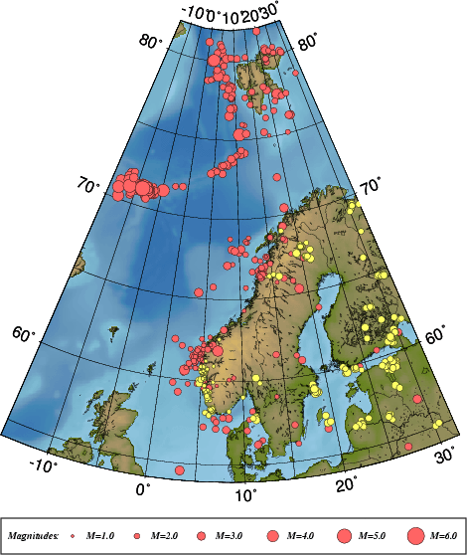

Figure 4. Epicentre distribution of events analysed and located January to June, 2000.
Earthquakes are plotted in red and probable and known explosions in yellow.
For station locations see Figure 1.

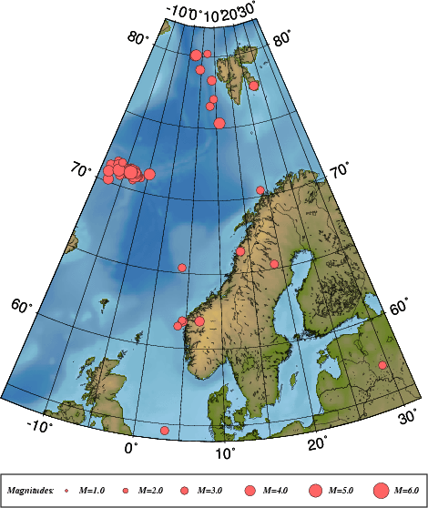

Figure 5. Epicentre distribution of located events with M ≥ 3 from January to June, 2000. All
earthquakes are listed in Table 2. For station locations see Figure 1.

Table 2. Local and regional events with any magnitude ≥ 3.0 for the time period January
to June, 2000, in the area between 54°N-82°N and 15°W-32°E. For depth determination see section 5.
year moda hrmi sec mde lat long depthF ns rms magnitudes
---------------------------------------------------------------------------
2000 1 2 1111 0.1 L 76.532 8.235 10.0F 8 2.0 3.4CBER 2.8LBER 3.2LNAO
2000 123 1308 43.3JL 70.916 -6.405 15.0F 5 0.5 2.7CBER 2.4LBER 3.0LNAO
2000 2 3 1553 16.3 L* 75.338 10.806 10.0F 25 2.4 4.3LBER 3.9SBER 4.4LNAO
2000 210 0617 57.1 L* 61.773 4.529 6.0F 21 1.4 3.4CBER 3.6LBER 3.3WBER
2000 210 1740 8.7 L* 61.844 4.433 15.0F 16 1.6 2.5CBER 3.0LBER 3.0LNAO
2000 211 0216 18.6 L 54.570 3.356 10.0F 17 0.5 2.4LBER 3.3LBGS
2000 212 0905 13.3 L 80.011 2.196 10.0F 15 3.0 4.1LBER 3.9LNAO
2000 216 1749 17.7JL 71.019 -6.988 12.0F 3 0.1 2.5CBER 3.3LBER
2000 3 1 0212 30.9JL 70.897 -7.290 10.0F 3 0.3 2.7CBER 3.3LBER
2000 313 2032 18.4 L 78.337 8.777 10.0F 6 1.5 2.7CBER 3.6LBER 3.1LNAO
2000 314 2216 53.9 L 77.602 22.527 15.0F 9 1.1 3.0CBER 3.6LBER 3.3LNAO
2000 317 1613 24.0 L 80.188 7.050 10.0F 7 1.1 2.9CBER 3.0LBER 2.8LNAO
2000 322 1058 58.3 L 65.369 3.801 15.0 2 2.1 3.1CBER
2000 324 0146 35.5JL 71.606 -12.121 10.0F 5 0.6 3.0CBER 3.2LBER 2.5LNAO
2000 329 0928 57.7 L* 70.432 18.656 15.0F 12 1.6 3.0CBER 3.1LBER 3.0LNAO
2000 4 7 0338 35.9 L* 66.459 13.474 15.0F 17 1.8 3.4CBER 3.4LBER 3.5LNAO
2000 4 8 2242 51.8JL 71.181 -13.294 10.0F 7 1.2 3.2LBER 3.6BNAO
2000 414 1646 44.8 L 77.027 9.300 10.0F 8 1.6 2.6CBER 2.5LBER 3.2LNAO
2000 423 0030 51.5JL 71.332 -4.837 10.0F 6 1.5 2.6CBER 2.5LBER 4.3BPDE
2000 427 2144 9.5 L* 61.449 3.886 15.0F 21 1.2 2.9CBER 3.2LBER 2.8LNAO
2000 5 1 2138 53.8 L 65.316 18.782 15.0F 11 2.2 3.4CBER 2.9LBER 2.9LNAO
2000 510 0937 43.6 L 80.059 2.471 10.0F 10 1.4 3.2CBER 4.1LBER 3.8LNAO
2000 519 1659 47.6JL 70.992 -9.986 10.0F 7 1.6 4.3CBER 3.9LBER
2000 521 1958 51.6JL 71.115 -8.370 10.0F 23 1.6 5.1CBER 4.5LBER 4.1LNAO
2000 521 2205 33.5JL 71.261 -9.040 16.0F 3 0.3 3.2CBER 3.1LBER
2000 521 2342 34.8JL 71.123 -9.449 10.0F 19 2.0 4.3CBER 3.9LBER 3.3LNAO
2000 521 2353 37.9JL 71.281 -8.908 10.0F 3 0.4 3.3CBER 3.2LBER
2000 522 0046 31.8JL 71.092 -9.902 10.0F 11 1.6 3.8CBER 3.6LBER 2.6LNAO
2000 522 0059 39.7JL 71.405 -9.017 10.0F 3 0.2 3.5CBER 3.2LBER
2000 522 0121 52.7JL 70.644 -7.921 10.0F 3 0.5 3.0CBER 2.6LBER
2000 522 0903 23.7JL 71.295 -9.790 10.0F 4 1.3 3.2CBER 3.3LBER
2000 522 1157 6.9JL 71.136 -9.110 10.0F 14 1.3 4.2CBER 3.8LBER
2000 522 1739 34.6 L 79.051 4.494 10.0F 11 1.3 2.9CBER 3.6LBER 2.3LNAO
2000 523 0400 37.4JL 71.371 -11.933 10.0F 4 0.4 3.5CBER 3.3LBER
2000 523 1245 13.5JL 71.142 -8.387 22.0F 6 0.0 3.6CBER 3.3LBER 2.3LNAO
2000 523 1411 58.1JL 71.159 -8.420 23.0F 3 0.0 2.6CBER 3.0LBER
2000 524 0110 55.0JL 71.138 -8.756 10.0F 22 1.3 5.9CBER 4.6LBER 3.9SBER
2000 525 0358 52.9JL 71.186 -7.722 18.0F 3 0.1 2.7CBER 3.1LBER
2000 525 0409 5.4JL 71.020 -7.852 10.0F 24 1.3 5.5CBER 4.4LBER 3.3LNAO
2000 525 0414 52.2JL 71.146 -7.550 23.0F 6 0.3 3.5LBER 3.7LNAO
2000 525 0415 58.2JL 71.365 -7.886 10.0F 3 0.5 3.1LBER
2000 525 0419 11.5JL 71.164 -7.244 14.0F 3 0.3 2.5CBER 3.2LBER
2000 525 1135 9.8JL 71.266 -7.607 16.0F 3 0.2 2.4CBER 3.0LBER
2000 526 0216 2.0JL 71.096 -7.413 16.0F 3 0.0 2.6CBER 3.1LBER
2000 526 0801 10.3JL 71.212 -7.526 20.0F 3 0.1 2.5CBER 3.1LBER
2000 526 2242 34.3JL 71.173 -8.397 24.0F 3 0.1 2.6CBER 3.1LBER
2000 527 0915 59.3JL 71.369 -8.649 15.0F 6 0.9 3.5CBER 3.6LBER
2000 530 1348 8.7JL 71.314 -9.051 15.0F 3 0.2 3.0CBER 3.1LBER
2000 6 1 1708 18.8 L* 61.839 6.897 10.0F 20 1.8 3.6CBER 3.7LBER 3.8LNAO
2000 610 0115 0.4 L 56.893 29.336 0.0 5 1.8 3.2LNAO
2000 612 1200 55.0JL 71.192 -8.179 13.0F 3 0.1 3.1CBER 3.1LBER
2000 613 0532 29.3JL 70.682 -10.777 10.0F 3 0.2 3.3CBER 2.7LBER
2000 613 1601 44.6JL 70.180 -12.777 10.0F 3 0.3 4.0CBER 3.6LBER
2000 614 1046 40.2JL 70.712 -13.268 10.0F 9 0.5 4.1CBER 3.7LBER 2.9LNAO
2000 617 1540 52.3 R 64.212 -19.531 10.0F 17 2.2 5.1LBER 6.2SBER 6.6SPDE
2000 621 1456 34.6JL 71.019 -11.327 10.0F 10 1.7 4.6CBER 4.0LBER
2000 630 0137 49.1JL 71.122 -8.798 10.0F 15 1.8 5.2CBER 3.8LBER 3.2LNAO
2000 630 1342 58.6JL 71.589 -11.107 10.0F 3 0.3 3.1CBER 2.8LBER

Abbreviations are:
date: year, mo = month, da = day, origin time UTC: hr = hour, mi = minutes, sec = seconds
m= model identification (blank=standard model, J=Jan Mayen model, L=only nearest stations used)
d = distance identification (L=local, R=regional, D=teleseismic)
e=event identification (*=well recorded, P=probable explosion, E=known explosion)
location: lat = latitude, long=longitude, depth = focal depth (km) F: fixed depth
ns = number of stations, rms = root mean square of the travel-time residuals
magnitudes: magnitude type (C=coda, L=local, B=body wave, W=moment) and magnitude reporting agency (BER=Bergen, NAO=NORSAR, PDE=Preliminary Determination of Epicentres)

Figure 6. Seismograms for the earthquake on June 1st 2000 at 17:08 (UTC). The seismograms are
filtered between 5-10 Hz. The station abbreviations are: BER=Bergen, ASK=Askøy, EGD=Espegrend FOO=Florø, MOL=Molde, LOF=Lofoten, , SUE=Sulen, HYA=Høyanger, TRON=Trondheim, BLS=Blåsjø, KMY=Karmøy, NSS=Namsos, RUND=Rundemannen and MOR8=Mo i Rana
5. Well recorded earthquakes

Since January, 1995, well recorded earthquakes have been selected during the daily analysis and specially marked in the NNSN data base. The event selection is based on signal to noise ratio and the number of recording stations, which entails that both small events near the network and large events further away have been selected. In a few cases also location has been a qualification to mark an event as an event of special interest. These events are studied in greater detail than the other events. Additional phase readings and waveform data are collected if available, mainly from NORSAR and BGS. Particularly the location and the depth estimates are checked. For each event the rms-vs-depth plot is checked and if possible the event is located using only the nearest stations (D< 200 km) to check if this gives a better location with a well constrained depth. If this is the case, the depth is fixed and the event is relocated using all stations. If no reasonable depth can be determined, the depth is fixed at 15 km for continental earthquakes and at 10 km for oceanic. The same principle for depth determination is also used for the local and regional events with magnitude equal to or above 3.0. For this report 12 special events have been analysed (see Table 3). The locations of these events are shown in Figure 7.
Due to difficulties reading enough polarities, fault plane solutions were not determined for any of the earthquakes recorded during these 6 months.
Table 3. List of 12 well recorded events in the first half of 2000.

Year Date HRMM Sec L Latitud Longitud Depth FF AGA NS RMS Mc BER Ml BER Mw BER STRIK DIP RAKE Mo St f0 r
------------------------------------------------------------------------------------------------------------------------------
2000 123 0902 13.3 L 59.591 5.972 15.0 F BER 16 1.7 1.8 BER 2.0 BER 2.1 BER 12.2 2.4 8.38 0.15
2000 2 1 1242 21.1 L 61.618 4.729 10.0 F BER 13 1.7 2.1 BER 2.3 BER 2.3 BER 12.5 3.3 7.77 0.16
2000 2 3 1553 16.3 L 75.338 10.806 10.0 F BER 25 2.4 4.3 BER 4.4 BER 15.7 24.7 1.21 1.06
2000 210 0617 57.1 L 61.773 4.529 6.0 F BER 21 1.4 3.4 BER 3.6 BER 3.3 BER 14.0 20.4 3.81 0.35
2000 210 1740 8.7 L 61.844 4.433 15.0 F BER 16 1.6 2.5 BER 3.0 BER 2.8 BER 13.3 5.3 4.70 0.27
2000 313 0520 32.1 L 62.177 6.253 15.0 F BER 12 1.4 2.1 BER 2.2 BER 2.5 BER 12.8 4.0 6.29 0.20
2000 329 0928 57.7 L 70.432 18.656 15.0 F BER 12 1.6 3.0 BER 3.1 BER 3.0 BER 13.5 10.4 5.14 0.25
2000 4 7 0338 35.9 L 66.459 13.474 15.0 F BER 17 1.8 3.4 BER 3.4 BER 2.9 BER 13.5 9.5 4.34 0.29
2000 427 2144 9.5 L 61.449 3.886 15.0 F BER 21 1.2 2.9 BER 3.2 BER 3.0 BER 13.6 31.7 7.24 0.17
2000 5 5 0452 17.6 L 60.566 2.836 10.0 F BER 27 1.8 2.7 BER 2.8 BER 3.6 BER 320 84 -7 14.4 34.9 3.87 0.34
2000 5 5 0509 11.9 L 60.740 4.164 15.0 F BER 12 1.4 1.9 BER 1.9 BER 12.0 0.2 4.59 0.28
2000 6 1 1708 18.8 L 61.839 6.897 10.0 F BER 20 1.8 3.6 BER 3.7 BER 3.5 BER 14.3 8.8 2.61 0.51

Abbreviations are:
date: year mo = month da = day, origin time given in UTC: hr = hour mi = minutes sec = seconds, m= model identification (blank=standard model, J=Jan Mayen model, L=only nearest stations used); d = distance identification (L=local, R=regional, D=teleseismic), e=event identification (*=well recorded, P=probable explosion, E=known explosion); location: latitud = latitude, longitud=longitude depth = focal depth (km); FF= fixed depth and location; NS = number of stations; RMS = root mean square of the travel-time residuals, magnitudes: magnitude type (C=coda, L=local, B=body wave, W=moment) and magnitude reporting agency (BER=Bergen, NAO=NORSAR, BGS=British Geological Survey, PDE=Preliminary determination of epicenters),
MO = log of seismic moment in Nm, ST = stress drop in bar, f0 = corner frequency in Hz, R = source radius in km.
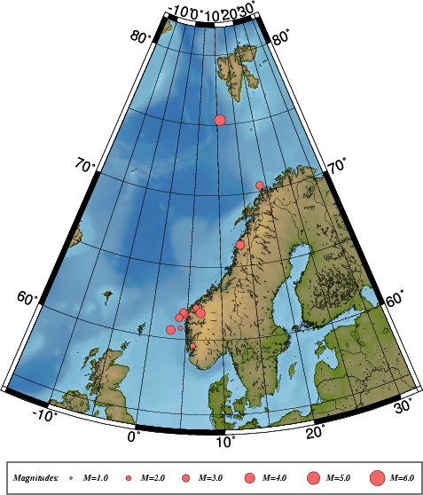

Figure 7. Epicentre distribution of well recorded events in the first half of 2000. For station
locations, see Figure 1.
6. Felt earthquakes

Twelve earthquakes were reported felt during the first half of 2000 (see Table 4 and Figure 8), all occurring in areas where earthquakes have been felt before. Six of the felt events occurred in the areas around Jan Mayen, among these also the strongest. Isoseismal maps are made for earthquakes felt by a sufficient number of people so that questionnaires are sent. These maps are shown in Figure 9. Isoseismal maps are not made for the earthquakes felt on Jan Mayen due to the small population. It should be noted that whether an earthquake is registered as felt in the NNSN database totally depends on reports from the population, therefore the number of felt earthquakes, especially from Jan Mayen, might be higher than reported.

Table 4 Earthquakes felt in Norway during the time period January through June, 2000.
Abbreviations: Mc; Coda magnitude, Ml; Local magnitude and Mw; Moment magnitude.

Date | Time (UTC) | Max. Intensity (on MMI scale) | Magnitude (BER) | Instrumental Epicenter Location
01.02.00 | 12:42 | III | Mc=2.1, Ml=2.3  Mw=2.3 | 61.61N / 4.72E
10.02.00 | 06:17 | IV | Mc=3.4, Ml=3.6  Mw=3.3 | 61.77N / 4.52E
13.03.00 | 05:20 | III | Mc=2.1, Ml=2.2  Mw=2.4 | 62.17N / 6.25 E
07.04.00 | 03:38 | III | Mc=3.4, Ml=3.4  Mw=2.9 | 66.45N / 13.47E
27.04.00 | 21:44 | III | Mc=2.9, Ml=3.2  Mw=3.0 | 61.44N / 3.88E
19.05.00 | 16:59 | III | Mc=4.3, Ml=3.9 | 70.99N / 9.8W
21.05.00 | 19:58 | III | Mc=5.1, Ml=4.5 | 71.11N / 8.37W
21.05.00 | 23:42 | III | Mc=4.3, Ml=3.9 | 71.12N / 9.45W
22.05.00 | 11:57 | III | Mc=4.2, Ml=3.8 | 71.13N / 9.11W
24.05.00 | 01:10 | IV | Mc=5.9, Ml=4.6  Ms=3.9 | 71.14N / 8.75W
25.05.00 | 04:09 | V | Mc=5.5, Ml=4.4  Ms=3.6 | 71.02N / 7.84W
01.06.00 | 17:08 | V | Mc=3.6, Ml=3.7  Mw=3.5 | 61.84N / 6.89E

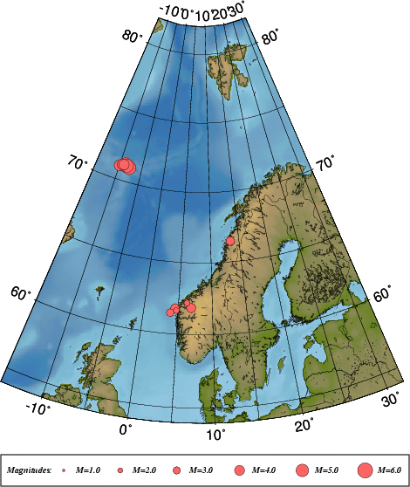

Figure 8. Locations of the twelve earthquakes felt during first half of 2000.

Figure 9. Isoseismal maps for the earthquakes A: 10.02.2000 and B: 01.06.2000.
7. Unusual earthquake activity near Jan Mayen.
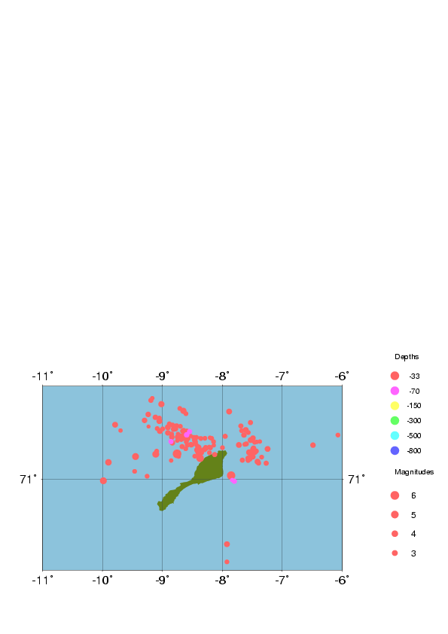
During May there occurred several earthquakes in the Norwegian Sea, close to the Jan Mayen island. Some of these earthquakes were felt by the people staying on Jan Mayen, and a large activity of fore and after shocks were recorded on the three seismic stations on the island. Figure 10 show the monthly distribution of the 236 earthquakes recorded on at least one of the stations at Jan Mayen during the first 6 months of 2000.

Figure 10. Monthly distribution of earthquakes recorded on Jan Mayen during the first 6 months of 2000.

During May 2000, 145 earthquakes were recorded and located inside 70.5-71.5° and 6-11°W. The locations of the earthquakes are shown on Figure 11. Most of the earthquakes are located to the transform fault and spreading ridge passing the Jan Mayen island. It is though interesting to notice that the largest earthquakes are located off the zone mentioned above.

Figure 11. Location of earthquakes recorded during May 2000 on Jan Mayen.
9. References

Alsaker A., L.B. Kvamme, R.A. Hansen, A. Dahle and H. Bungum 1991. The ML scale in Norway, Bull. Seism. Soc. Am., Vol. 81, No. 2, pp.379-398.

Brune J.N. 1970. Tectonic stress and spectra of seismic shear waves. Journal of Geophysical Research, 75, 4997-5009.

Havskov J. 1997 The SEISAN earthquake analysis software for the IBM PC and SUN, version 6.0.
Users Manual, Institute of Solid Earth Physics, University of Bergen, Norway.

Havskov J., and H. Bungum 1987. Source parameters for earthquakes in the northern North Sea,
Norsk Geologisk Tidskrift,Vol.67, pp 51-58.

Karnik, V., Kondorskaya, N.V., Yu. V. Riznichenko, Ye. F. Savarensky, S.L. Solovev., N.V. Shebalin, J. Vanek, and A. Zatopek 1962. Standardisation of the earhquake magnitude scales.
Studia Geophys. et Geod., Vol. 6, pp. 41-48.

Kennett, B.L.N. and E.R. Engdahl 1991. Traveltimes for global earthquake location and phase
identification, Geophys. J. Int., Vol. 105, pp. 429-465.

Kvamme, L.B., Hansen, R.A. and Bungum H., 1995. Seismic-source and wave-propagation effects of Lg waves in Scandinavia. Geophys. J. Int., Vol 120, 525-536.

Lay, T. and Wallace, T.C., 1995. Modern global seismology. Academic Press, International Geophysics Series, Vol. 58

Lienert, B.R. and Havskov, J., 1995. HYPOCENTER 3.2 A computer program for locating earthquakes locally, regionally and globally. Seismological Research Letters, Vol. 66, 26-36.

Lindholm, C, H. Bungum, R.K. Bratli, B.S. Aadnøy, N. Dahl, B. Tørudbakken and K. Atakan 1995.
Crustal stress in the northern North Sea as inferred from borehole breakouts and earthquake
focal mechanisms, Terra Nova, Vol. 7, pp. 51-59.

Ottemöller, L., (1995). Explosion filtering for Scandinavia. Technical Report No. 2, Institute of Solid
Earth Physics, University of Bergen, Norway.

Sørnes A. and T. Navrestad 1975. Seismic survey of Jan Mayen. Norsk Polarinstitutt, Årbok 37-52.

Veith K.F., and G.E. Clawson 1972. Magnitude from short-period P-wave data. Bull. Seism. Soc.
Am., Vol. 62, pp.435-452.

Westre S. 1975. Richter's lokale magnitude og total signal varighet for lokale jordskjelv på Jan
Mayen. Cand. real thesis., Seismological Observatory, University of Bergen, Norway.

