

Seismicity of Norway

and surrounding areas

for 2001

Prepared by

Institute of Solid Earth Physics
University of Bergen
Allegt. 41
N-5007 Bergen

e-mail: seismo@ifjf.uib.no
Phone: (+47) 55 58 34 20
Fax: (+47) 55 58 96 69

March 2002

CONTENTS

- Introduction 3

- Velocity models and magnitude relations 5

- Events recorded by the Norwegian stations 6

- The seismicity of Norway and adjacent areas 7

- Well recorded earthquakes 15

- Felt earthquakes 22

- Use of NNSN data during 2001 24

- References 28

1. Introduction

This annual report on the seismicity of Norway and adjacent areas encompasses the time period January 1st - December 31st, 2001. The earthquake locations have been compiled from all available seismic stations operating on Norwegian territory including the Arctic islands of Spitsbergen, Bjørnøya and Jan Mayen. In addition, stations from neighbouring countries have been included for large or well recorded events.

In Norway, the University of Bergen (UiB) operates the Norwegian National Seismic Network (NNSN) consisting of 25 seismic stations and NORSAR operates 4 seismic arrays (Figure 1) sponsored by different organisations. Data from temporarily installed local networks are also included whenever data is made available. Phase data from arrays in Russia (Apatity), Finland (Finess), Sweden (Hagfors) and from stations operated by the British Geological Survey (BGS) are also included when available. All phase data are collected by UiB, and a monthly bulletin is prepared and distributed. A brief overview of the events published in the monthly bulletins is given in this annual report. Macroseismic data for most of the felt earthquakes in Norway are collected, and macroseismic maps are presented. In cases where only very few people have felt the earthquake macroseismic information is not collected (questionaries are not sent).
All local and regional events with magnitude larger than 1.5 and all teleseismic events that are detected by the UiB network are included. The merging of data between NORSAR and UiB is based on the following principles:
i) All local and regional events recorded by NORSAR that are also detected by the UiB network are included.
ii) All local and regional events with local magnitude larger than 2.0 detected by NORSAR and not recorded by the UiB network are included.
iii) All teleseismic events recorded by NORSAR and also detected by the UiB network are included.
iv) All teleseismic events with NORSAR magnitude M_{b}≥5.0 are included.

The data from British Geological Survey (BGS) are included in the database in Bergen following the same criteria as for NORSAR data. The only exception is that no teleseismic events are included.

Data availability to the public

All the data stored in the NNSN data base (currently 100 Gb), is also available to the public via internet, e-mail or manual request. It is possible to search interactively for specific data, display the data remotely (waveforms and hypocenters) and then download the data. The various forms of access are:

ftp server: ftp.ifjf.uib.no
The user logs in to address above, manually move to the directory containing the data of interest (directory organized in year-month) and copy the data.

AutoDrm to address
The user sends an e-mail with a request coded with the AutoDrm syntax (autodrm@ifjf.uib.no) and receives the data by e-mail.

Web access: User connects to http://www.ifjf.uib.no//seismo/seisweb/seisweb.html, and start the SEISWEB access system (Moreno et al, 2001).
Through this system the user can select data by area and magnitude and display the results.

Figure 1. Norwegian seismic stations. NORSAR operates the four arrays and UiB operates the 25 stations in the national seismic network.
2. Velocity models and magnitude relations

The velocity model used for locating all local and regional events, except for the local Jan Mayen events, is shown in the table below (Havskov and Bungum, 1987). Event locations are performed using the HYPOCENTER program (Lienert and Havskov, 1995) and all processing is performed using the SEISAN data analysis software (Havskov and Ottemoller, 1999).

P-wave velocity (km/sec) | Depth to layer interface (km)
6.2 | 0.0
6.6 | 12.0
7.1 | 23.0
8.05 | 31.0
8.25 | 50.0
8.5 | 80.0

Magnitudes are calculated from coda duration, amplitudes or seismic spectra. The coda wave magnitude scale (M_{C}) is estimated through the relation:

M_{C} = -3.0 + 2.6 * log10(T) +0.001 * D.

where T is the coda length in seconds and D is the epicentral distance in km. The coda magnitude is recognised to be higher than local magnitude calculated at NORSAR and at IFJ, UiB. When instrument corrected ground amplitudes A (nm) are available, local magnitude M_{L} is calculated using the equation given by Alsaker et al. (1991):

M_{L}= 1.0 * log(A) + 0.91 * log(D) + 0.00087 * D - 1.67

where D is the hypocentral distance in km.
The moment magnitude M_{w} is calculated from the seismic moment M₀ using the relation (Kanamori, 1977)

M_{w} = 0.67 * log(M₀) – 6.06

The unit of M₀ is Nm. The seismic moment is calculated from standard spectral analysis assuming the Brune model (Brune, 1970) and using the following parameters:
Density: 3.0 g/cm²
Q = 440 * f^{0.7}
P-velocity = 6.2 km/s
S velocity = 3.6 km/s

For more computational details, see Havskov and Ottemöller, 2001.

For the Jan Mayen area, a local velocity model and coda magnitude scale are used (Sørnes and Navrestad, 1975)

P-wave velocity (km/sec) | Depth to layer interface (km)
3.14 | 0
6.33 | 3
8.27 | 18

The coda magnitude for Jan Mayen is given by Westre (1975):

M_{C} = 3.27log(T)-3.24+0.001*D

where T is the coda duration and D is the epicentral distance in km.

The regional and teleseismic events recorded by the network are located using the global velocity model IASPEI91 (Kennett and Engdahl, 1991).

Body wave magnitude is calculated using the equation by Veith and Clawson (1972):

Mb = log(A/T) + Q(D,h)

here h is the hypocentre depth (km), A is the amplitude (microns), T is period in seconds and Q(D,h) is the correction for distance and depth.

Surface wave magnitude Ms is calculated using the equation (Karnik et al., 1962):

Ms = log(A/T) + 1.66log(D) + 3.3

where A is the amplitude (microns), T is period in seconds and D is the hypocentral distance in degrees.

3. Events recorded by the Norwegian stations

A total of 4267 local and regional events, based on the criteria mentioned in section 1, were detected by the Norwegian seismic stations during 2001. Of these local and regional events analysed, 34% were located.
The number of local/regional and teleseismic events, recorded per month in 2001 is shown in Figure 2. The average number of local and regional events recorded per month is 356.
Figure 2. Monthly distribution of local and teleseismic events, recorded during 2001.

A total of 1013 teleseismic events were recorded during 2001, of which 76% were located. In addition to the locations determined at UiB, also preliminary locations published by the USGS (United States Geological Survey) based on the worldwide network are included in the UiB database whenever the earthquake is recorded on Norwegian stations. The monthly average of teleseismic earthquakes recorded by NNSN is 84. All events (898 teleseismic, regional and local) recorded from January to December 2001 with M ≥ 3 are plotted on Figure 3. It is also important for UiB, as one observatory in the global web of seismological observatories, to read and report as many secondary phases as possible from the teleseismic recordings.
The station recording statistics for each month from January to December and in total for 2001 are given in Table 1. This table shows the number of local events that were recorded only at one station, local events recorded on more than one station and recorded teleseismic events. It must be observed that Table 1 shows both earthquakes and explosions, and that the large number of detections at KTK is mainly due to explosions.

4. The seismicity of Norway and adjacent areas

A total of 1334 of the recorded events are located inside the area 54°N-82°N and 15°W-32°E. Using the explosion filter (Ottemöller, 1995) 43% of these events were identified as probable explosions. Figure 4 shows all local and regional events analysed and located during 2001.
Figure 5 and Table 2 shows the 121 local and regional events, where 51 are located in the vicinity of Jan Mayen with magnitudes greater or equal to 3.0. It is emphasized that it is often difficult to get a good magnitude estimate for the earthquakes located on the oceanic ridge in the Norwegian sea, since distances are too large to compute a proper M_{L}, too short for M_{b} and coda magnitudes for these locations are often unreliable. Most of the recorded earthquakes in this area have magnitudes above 3.0 if the earthquakes are recorded on Norwegian mainland stations.
The largest local or regional earthquake, occurring between January and December 2001 and recorded on Norwegian stations, was located in the vicinity of the Jan Mayen island. The earthquake was recorded on July 19th at 12:01(UTC) with an estimated magnitude of 4.7. Offshore Norway and near the Ekofisk oil field an earthquake occurred on May 7th at 09:43 (UTC). This earthquake was strongly felt on the platforms at the Ekofisk field in the North Sea and are hereafter referred to as the Ekofisk earthquake. The earthquake was located to the northwestern corner of the Ekofisk field and was estimated to have a instrumental magnitude of 4.6 and an intensity of VI. The most accurate location was made using only selected British and Norwegian seismic stations. Some of the recorded seismograms are shown in Figure 6. A special report on the Ekofisk earthquake is given in Appendix 3
Figure 3. Epicentre distribution of earthquakes with M ≥ 3.0, located by the Norwegian seismic stations from January to December 2001. Teleseismic events recorded only by NORSAR have M≥5.0.
Table 1a. Monthly statistics of events recorded at each station for January-June 2001. Abbreviations are: Event types: LM=Number of local events recorded at
more than one station, LS=local events recorded at only one station and D=teleseismic events per month

 | JANUARY |  |  | FEBRUARY |  |  | MARCH |  |  | APRIL |  |  | MAY |  |  | JUNE |  |  | JAN-JUN.
STATION | LM | LS | D | LM | LS | D | LM | LS | D | LM | LS | D | LM | LS | D | LM | LS | D | LM | LS | D
ASK | 31 | 0 | 6 | 20 | 0 | 5 | 30 | 0 | 6 | 23 | 0 | 7 | 23 | 0 | 3 | 20 | 0 | 7 | 147 | 0 | 34
BER | 15 | 0 | 6 | 12 | 0 | 6 | 8 | 0 | 4 | 17 | 0 | 6 | 11 | 0 | 6 | 18 | 0 | 11 | 81 | 0 | 39
BJO1 | 3 | 1 | 12 | 9 | 0 | 22 | 6 | 1 | 13 | 5 | 2 | 11 | 0 | 0 | 6 | 0 | 0 | 0 | 23 | 4 | 64
BLS5 | 25 | 1 | 11 | 18 | 0 | 7 | 23 | 0 | 4 | 16 | 0 | 8 | 26 | 0 | 6 | 11 | 0 | 6 | 119 | 1 | 42
EGD | 27 | 0 | 5 | 20 | 0 | 5 | 26 | 0 | 6 | 22 | 0 | 6 | 28 | 0 | 5 | 26 | 0 | 11 | 149 | 0 | 38
FOO | 14 | 0 | 4 | 8 | 0 | 1 | 13 | 0 | 1 | 12 | 2 | 3 | 15 | 2 | 2 | 16 | 1 | 7 | 78 | 5 | 18
HYA | 23 | 0 | 3 | 18 | 0 | 3 | 20 | 0 | 1 | 13 | 0 | 2 | 14 | 0 | 2 | 21 | 0 | 8 | 109 | 0 | 19
JMI | 17 | 0 | 5 | 9 | 0 | 12 | 8 | 0 | 12 | 14 | 0 | 16 | 19 | 0 | 18 | 20 | 0 | 36 | 87 | 0 | 99
JNE | 22 | 0 | 0 | 11 | 0 | 0 | 14 | 0 | 0 | 19 | 0 | 0 | 25 | 0 | 0 | 22 | 0 | 0 | 113 | 0 | 0
JNW | 24 | 2 | 4 | 11 | 0 | 1 | 15 | 1 | 1 | 19 | 0 | 2 | 25 | 0 | 0 | 33 | 10 | 3 | 127 | 13 | 11
KBS | 14 | 3 | 54 | 17 | 2 | 21 | 27 | 17 | 42 | 24 | 8 | 65 | 23 | 15 | 49 | 21 | 10 | 63 | 126 | 65 | 294
KMY | 32 | 1 | 1 | 20 | 0 | 2 | 36 | 3 | 0 | 25 | 0 | 0 | 36 | 1 | 2 | 23 | 1 | 4 | 172 | 6 | 9
KONO | 20 | 0 | 53 | 9 | 0 | 34 | 8 | 0 | 41 | 12 | 1 | 50 | 9 | 0 | 50 | 14 | 0 | 67 | 72 | 1 | 295
KTK1 | 228 | 127 | 17 | 222 | 147 | 15 | 288 | 168 | 15 | 220 | 112 | 25 | 100 | 37 | 11 | 139 | 60 | 19 | 1197 | 651 | 102
LOF | 62 | 2 | 12 | 67 | 0 | 12 | 76 | 0 | 5 | 104 | 13 | 18 | 78 | 16 | 14 | 88 | 8 | 21 | 419 | 39 | 68
MOL | 31 | 10 | 12 | 23 | 12 | 14 | 35 | 12 | 11 | 4 | 1 | 4 | 3 | 0 | 2 | 23 | 7 | 41 | 119 | 42 | 84
MOR8 | 118 | 31 | 16 | 37 | 8 | 2 | 122 | 30 | 17 | 198 | 109 | 23 | 0 | 0 | 0 | 13 | 0 | 26 | 488 | 178 | 84
NORSAR | 0 | 0 | 66 | 0 | 0 | 54 | 0 | 0 | 46 | 0 | 0 | 67 | 1 | 0 | 55 | 0 | 0 | 63 | 1 | 0 | 351
NSS | 40 | 8 | 13 | 30 | 4 | 11 | 56 | 7 | 4 | 45 | 5 | 7 | 21 | 4 | 4 | 28 | 4 | 15 | 220 | 32 | 54
ODD1 | 30 | 0 | 6 | 24 | 0 | 2 | 25 | 0 | 0 | 25 | 0 | 3 | 5 | 0 | 0 | 1 | 0 | 0 | 110 | 0 | 11
OSL | 0 | 0 | 3 | 1 | 0 | 8 | 4 | 0 | 8 | 2 | 0 | 12 | 0 | 0 | 5 | 3 | 0 | 3 | 10 | 0 | 39
RUND | 7 | 0 | 12 | 9 | 0 | 10 | 0 | 0 | 0 | 12 | 0 | 18 | 15 | 0 | 18 | 16 | 0 | 37 | 49 | 0 | 95
STAV | - | - | - | - | - | - | 1 | 0 | 0 | 3 | 0 | 0 | 0 | 0 | 1 | 5 | 0 | 1 | 9 | 0 | 2
SUE | 21 | 0 | 3 | 15 | 0 | 2 | 14 | 0 | 0 | 17 | 0 | 1 | 15 | 0 | 0 | 7 | 0 | 2 | 89 | 0 | 8
TRO | 28 | 0 | 21 | 31 | 0 | 20 | 31 | 0 | 18 | 29 | 0 | 0 | 31 | 0 | 14 | 46 | 0 | 33 | 196 | 0 | 106
TRON | 1 | 0 | 3 | 2 | 0 | 3 | 4 | 0 | 1 | 2 | 0 | 4 | 0 | 0 | 2 | 5 | 0 | 6 | 14 | 0 | 19
NORES | 53 | 0 | 0 | 45 | 0 | 0 | 62 | 0 | 0 | 51 | 0 | 0 | 75 | 0 | 0 | 43 | 0 | 0 | 329 | 0 | 0
SPITS | 19 | 0 | 0 | 27 | 1 | 0 | 19 | 1 | 0 | 28 | 0 | 0 | 17 | 1 | 0 | 17 | 0 | 0 | 127 | 3 | 0
ARCES | 53 | 0 | 0 | 54 | 0 | 0 | 68 | 0 | 0 | 61 | 0 | 0 | 76 | 0 | 0 | 47 | 0 | 0 | 359 | 0 | 0

Table 1b. Monthly statistics of events recorded at each station for July-December 2001. Abbreviations are: Event types: LM=Number of local events recorded at
more than one station, LS=local events recorded at only one station and D=teleseismic events per month

 | JULY |  |  | AUGUST |  |  | SEPTEMBER |  |  | OCTOBER |  |  | NOVEMBER |  |  | DECEMBER |  |  | JULY-DEC.
STATION | LM | LS | D | LM | LS | D | LM | LS | D | LM | LS | D | LM | LS | D | LM | LS | D | LM | LS | D
ASK | 27 | 0 | 5 | 20 | 0 | 8 | 21 | 0 | 8 | 23 | 0 | 7 | 19 | 0 | 5 | 13 | 0 | 6 | 123 | 0 | 39
BER | 14 | 0 | 11 | 7 | 0 | 8 | 12 | 0 | 8 | 5 | 0 | 9 | 12 | 0 | 5 | 8 | 0 | 7 | 58 | 0 | 48
BJO1 | 0 | 0 | 0 | 0 | 0 | 0 | 0 | 0 | 0 | 0 | 0 | 0 | 1 | 0 | 0 | 2 | 2 | 0 | 3 | 2 | 0
BLS5 | 18 | 0 | 14 | 14 | 1 | 12 | 14 | 0 | 12 | 14 | 1 | 9 | 19 | 0 | 6 | 16 | 0 | 8 | 95 | 2 | 61
EGD | 27 | 0 | 8 | 19 | 0 | 7 | 21 | 0 | 7 | 22 | 0 | 6 | 14 | 0 | 4 | 11 | 0 | 5 | 114 | 0 | 37
FOO | 19 | 1 | 4 | 13 | 0 | 3 | 13 | 0 | 3 | 21 | 3 | 4 | 18 | 0 | 4 | 14 | 3 | 6 | 98 | 7 | 24
HYA | 21 | 0 | 3 | 15 | 0 | 0 | 16 | 0 | 2 | 22 | 0 | 4 | 20 | 0 | 4 | 12 | 0 | 1 | 106 | 0 | 14
JMI | 57 | 0 | 10 | 40 | 0 | 21 | 12 | 0 | 19 | 12 | 0 | 10 | 10 | 0 | 4 | 7 | 0 | 3 | 138 | 0 | 67
JNE | 63 | 0 | 0 | 41 | 3 | 0 | 21 | 0 | 0 | 17 | 0 | 0 | 10 | 0 | 0 | 10 | 0 | 0 | 162 | 3 | 0
JNW | 77 | 2 | 1 | 43 | 1 | 3 | 21 | 0 | 0 | 18 | 1 | 4 | 10 | 0 | 0 | 10 | 0 | 0 | 179 | 4 | 8
KBS | 14 | 1 | 46 | 26 | 12 | 62 | 8 | 1 | 44 | 6 | 0 | 43 | 6 | 0 | 28 | 21 | 4 | 30 | 81 | 18 | 253
KMY | 11 | 0 | 4 | 3 | 0 | 3 | 18 | 0 | 8 | 7 | 3 | 0 | 19 | 0 | 3 | 18 | 1 | 1 | 76 | 4 | 19
KONO | 13 | 0 | 55 | 12 | 0 | 60 | 8 | 1 | 51 | 6 | 0 | 44 | 10 | 1 | 26 | 1 | 0 | 13 | 40 | 2 | 249
KTK1 | 155 | 69 | 8 | 181 | 68 | 11 | 162 | 72 | 14 | 208 | 117 | 24 | 211 | 103 | 17 | 217 | 74 | 14 | 1134 | 503 | 88
LOF | 96 | 9 | 11 | 111 | 12 | 33 | 91 | 9 | 11 | 80 | 3 | 21 | 47 | 1 | 11 | 87 | 3 | 9 | 512 | 37 | 96
MOL | 32 | 3 | 20 | 21 | 6 | 27 | 19 | 8 | 32 | 37 | 18 | 27 | 27 | 4 | 13 | 27 | 14 | 13 | 163 | 53 | 132
MOR8 | 1 | 0 | 16 | 3 | 0 | 5 | 12 | 4 | 0 | 50 | 13 | 20 | 123 | 20 | 24 | 167 | 32 | 18 | 356 | 69 | 83
NORSAR | 2 | 0 | 72 | 2 | 0 | 56 | 0 | 0 | 49 | 0 | 0 | 66 | 0 | 0 | 48 | 0 | 0 | 47 | 4 | 0 | 338
NSS | 24 | 4 | 4 | 17 | 5 | 5 | 28 | 4 | 8 | 37 | 10 | 11 | 1 | 0 | 1 | 0 | 0 | 3 | 107 | 33 | 32
ODD1 | 6 | 0 | 1 | 1 | 0 | 0 | 3 | 0 | 0 | 5 | 0 | 0 | 5 | 0 | 0 | 15 | 0 | 0 | 35 | 0 | 1
OSL | 0 | 0 | 3 | 0 | 0 | 6 | 0 | 0 | 1 | 0 | 0 | 5 | 1 | 0 | 9 | 0 | 0 | 7 | 1 | 0 | 31
RUND | 15 | 0 | 26 | 0 | 0 | 8 | 0 | 0 | 0 | 0 | 0 | 0 | 1 | 0 | 6 | 6 | 0 | 6 | 24 | 0 | 46
STAV | 2 | 0 | 0 | 0 | 0 | 0 | 1 | 0 | 0 | 1 | 0 | 0 | 1 | 0 | 0 | 2 | 0 | 2 | 7 | 0 | 2
SUE | 11 | 0 | 1 | 14 | 0 | 0 | 16 | 0 | 1 | 18 | 0 | 2 | 14 | 0 | 2 | 11 | 0 | 1 | 84 | 0 | 7
TRO | 41 | 1 | 16 | 55 | 0 | 41 | 20 | 0 | 17 | 39 | 0 | 31 | 26 | 0 | 19 | 36 | 0 | 13 | 217 | 1 | 137
TRON | 5 | 0 | 3 | 0 | 0 | 2 | 0 | 0 | 0 | 1 | 0 | 1 | 1 | 0 | 2 | 2 | 0 | 5 | 11 | 0 | 13
NORES | 46 | 0 | 0 | 44 | 0 | 0 | 0 | 0 | 0 | 5 | 0 | 0 | 74 | 0 | 0 | 57 | 0 | 0 | 226 | 0 | 0
SPITS | 22 | 1 | 0 | 28 | 0 | 0 | 7 | 0 | 0 | 16 | 2 | 0 | 16 | 1 | 0 | 26 | 0 | 0 | 115 | 4 | 0
ARCES | 49 | 0 | 0 | 75 | 1 | 0 | 91 | 1 | 0 | 47 | 1 | 0 | 84 | 0 | 0 | 58 | 0 | 0 | 404 | 30 | 0

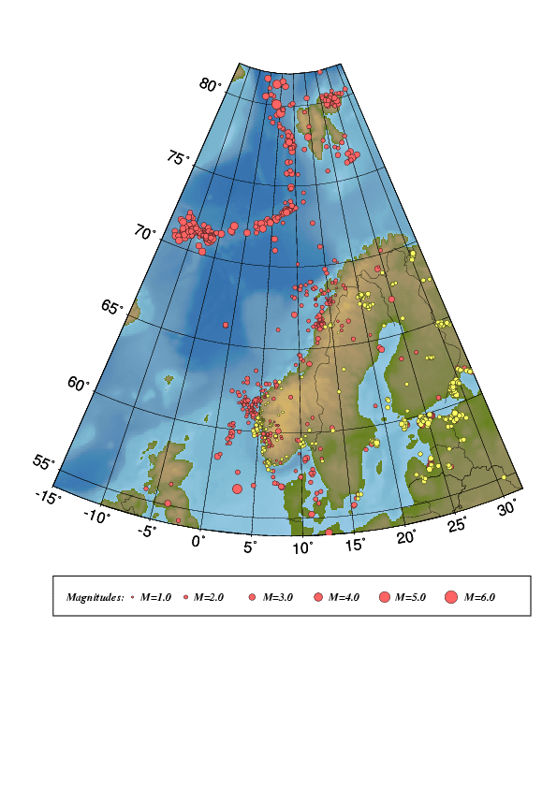
Figure 4. Epicentre distribution of events analysed and located January to December, 2001.
Earthquakes are plotted in red and probable and known explosions in yellow.
For station locations see Figure 1.

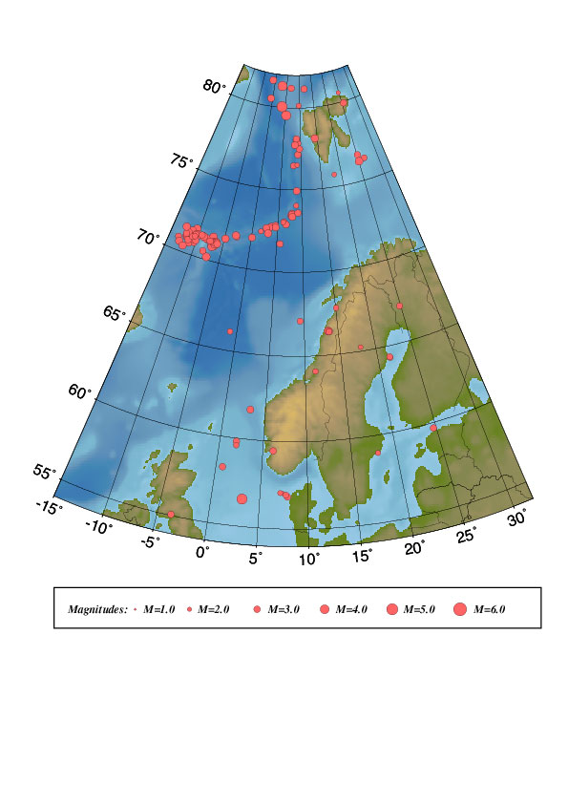Figure 5. Epicentre distribution of located events with one of the calculated magnitudes above or equal

to 3.0. All earthquakes are listed in Table 2. For station locations see Figure 1.

Table 2. Local and regional events with any magnitude ≥ 3.0 for the time period January
to December, 2001, in the area between 54°N-82°N and 15°W-32°E. For depth determination see section 5.

Year MODA HRMM Sec mde Latitud Longitud Depth F AGA NST RMS Mc Ml Mb Mw
------------------------------------------------------------------------------------
2001 1 4 2131 18.7 L 59.828 1.899 22.9 BER 23 1.2 3.0 2.9
2001 1 6 0530 60.0 L 72.729 3.720 10.0 F BER 13 1.2 3.0 4.4
2001 1 6 0906 25.7 JL 70.973 -6.860 14.3 BER 3 0.1 2.9 3.4
2001 110 0225 27.0 L 76.609 25.107 15.0 BER 9 2.2 3.1 2.9
2001 117 1612 26.0 L* 59.595 1.913 12.0 F BER 21 1.0 3.0 2.6 2.7
2001 120 1154 50.8 L 58.971 17.963 17.3 BER 7 1.1 3.3 2.4
2001 128 1101 48.6 L 78.097 14.308 10.0 F BER 6 1.9 3.1 3.3
2001 2 1 1057 24.9 L 73.453 7.627 10.0 F BER 13 1.5 3.0 3.0 4.8
2001 2 1 1421 47.8 L 73.563 7.881 10.0 F BER 8 0.9 3.1 2.9
2001 2 1 1521 1.0 L 73.507 7.791 10.0 F BER 14 1.6 3.0 2.9 4.4
2001 2 4 0655 58.4 L 76.466 8.053 10.0 F BER 12 1.4 3.6 2.7 4.8
2001 214 0713 12.4 L 73.599 9.107 10.0 F BER 4 0.7 3.1 3.0
2001 219 1245 22.9 L* 59.441 6.164 22.0 F BER 22 1.0 3.0 3.0 3.0
2001 3 2 2215 42.6 L 72.629 3.339 7.8 BER 10 1.0 3.2
2001 3 4 0608 55.5 L 71.694 5.637 10.0 F BER 12 1.2 3.8 3.0
2001 314 2220 43.5 L* 58.266 0.718 15.0 F BER 37 1.1 3.3 2.9 2.6
2001 325 2111 18.7 L 57.014 7.380 15.0 BER 11 1.7 3.0 1.9
2001 330 0720 17.5 JL 71.011 -6.935 10.7 BER 3 0.1 2.8 3.2
2001 330 1452 52.6 L* 67.749 15.069 15.0 F BER 11 1.5 3.3 2.6 2.5
2001 331 1130 55.3 L* 66.426 13.521 10.0 F BER 25 1.3 4.0 3.6 3.4
2001 4 5 0925 38.8 JL 71.333 -9.026 10.0 F BER 3 0.3 2.5 3.0
2001 416 0328 40.5 L* 66.409 13.643 10.0 F BER 16 1.3 3.7 3.2 2.7
2001 417 0157 17.2 L 75.746 18.236 10.9 BER 6 1.2 3.1 2.2
2001 420 0750 57.9 JL 71.128 -6.296 8.2 BER 3 0.0 3.0 3.4
2001 421 0553 42.8 JL 71.187 -6.593 14.9 BER 3 0.2 2.6 3.0
2001 422 0011 58.1 JL 71.208 -6.531 15.0 BER 3 0.4 3.0 2.7
2001 426 1306 34.9 JL 71.053 -6.892 13.9 BER 3 0.0 3.0 2.8
2001 428 2128 54.4 JL 71.209 -6.872 17.9 BER 3 0.2 2.4 3.3
2001 430 1900 17.5 L 77.852 9.077 10.0 F BER 9 1.6 3.0 3.1
2001 5 2 1559 46.7 L 67.145 24.818 15.0 F BER 10 1.9 3.0 2.8
2001 5 3 1913 8.6 JL 71.265 -7.085 14.9 BER 3 0.2 3.2 3.1
2001 5 5 0946 24.4 JL 71.532 -4.864 15.0 BER 13 1.4 3.4 3.3 4.3
2001 5 7 0247 38.1 L 76.515 9.023 10.0 F BER 3 1.3 3.1 2.1
2001 5 7 0943 33.8 gL* 56.565 3.182 6.0 F* BER 51 1.0 4.4 4.9
2001 513 0827 0.8 L 55.062 -3.658 15.0 F BER 27 1.1 3.6 3.0
2001 515 1852 43.7 JL 71.636 -10.553 15.0 BER 3 0.1 3.1 3.3
2001 515 2033 1.4 JL 71.464 -11.249 15.0 BER 3 0.2 2.9 3.0
2001 516 0431 11.3 L 77.140 9.189 15.0 BER 7 1.3 3.0 2.9 4.0
2001 520 1630 32.8 L 81.605 -0.922 10.0 F BER 7 1.2 3.6 3.1 4.4
2001 521 0409 21.7 JL 70.989 -11.991 10.0 F BER 16 1.7 4.4 3.5 3.8
2001 6 1 0618 6.9 L* 61.735 3.124 4.0 F BER 30 1.5 3.2 3.1 2.8
2001 6 2 0044 50.2 L* 56.827 7.889 8.0 F BER 37 1.3 3.4 2.9 2.5
2001 6 6 0637 10.9 L 78.038 8.612 10.0 F BER 3 0.9 3.1 2.5
2001 6 6 0849 44.7 JL 70.809 -13.337 15.0 BER 4 0.1 3.7 2.8 4.0
2001 6 8 2156 23.5 L 73.057 6.257 10.0 F BER 13 1.6 3.8 2.5 4.8
2001 612 0956 58.7 L 66.380 13.632 10.0 F BER 12 1.8 3.1 2.8
2001 613 1959 33.6 L 80.593 24.737 12.1 BER 2 0.2 3.0 1.9
2001 619 0810 45.5 JL 71.203 -8.145 17.4 BER 3 0.0 2.8 3.1
2001 7 8 0958 32.7 L 76.315 26.536 22.1 BER 8 1.4 3.4 2.8
2001 7 8 1552 17.7 L 67.093 9.364 12.6 BER 12 1.1 3.1 2.7
2001 7 9 1128 6.6 L 77.487 9.675 10.0 F BER 7 1.4 2.9 2.9
2001 716 1409 32.5 L 79.543 5.306 10.0 F BER 14 1.3 4.2 4.2 5.0
2001 717 1258 30.7 L 76.209 25.087 15.0 BER 8 1.8 3.1 3.5
2001 718 2117 52.2 L 57.037 7.106 10.0 F BER 13 1.0 3.2 2.3
2001 719 1201 37.6 JL 70.999 -6.797 0.0 * BER 21 1.0 4.7 4.9 4.5
2001 719 1244 26.2 JL 70.852 -6.942 10.0 F BER 12 1.2 4.5 3.6
2001 721 1022 8.2 L 64.306 21.662 15.0 F BER 9 1.2 3.5 2.5
2001 721 1635 56.8 L 54.003 12.593 15.0 BER 8 1.2 4.0 2.5 3.3
2001 722 0240 34.6 L* 64.090 11.367 15.0 F BER 18 1.4 3.3 2.5 2.8
2001 725 0501 12.5 JL 71.465 -7.129 10.9 BER 5 0.5 2.9 3.3
2001 727 1427 8.0 JL 71.249 -8.389 10.0 F BER 3 0.3 3.3 3.5
2001 730 0502 55.8 JL 70.561 -12.928 15.0 BER 5 1.1 4.1 3.3 4.2
2001 730 0637 16.4 JL 70.906 -10.982 8.2 BER 3 0.1 3.7
2001 730 0933 58.9 JL 70.642 -11.163 14.9 BER 10 0.8 4.8 3.1
2001 730 1941 4.6 JL 70.739 -10.278 15.1 BER 3 0.6 3.5 2.5
2001 731 0033 13.7 JL 70.906 -11.812 18.2 BER 7 0.1 3.5 2.7
2001 731 0247 45.7 JL 70.911 -10.646 18.1 BER 3 0.1 3.6 2.7
2001 731 0747 42.3 JL 71.065 -11.880 18.0 BER 3 0.0 3.9 3.3
2001 731 1318 13.8 JL 71.290 -10.069 18.0 BER 3 0.8 4.0
2001 731 1819 33.7 L 65.249 17.924 15.0 F BER 7 1.6 3.3 2.2
2001 731 1926 13.0 JL 70.183 -7.387 17.9 BER 6 1.1 5.2 3.5
2001 8 1 0312 58.1 JL 71.321 -10.344 10.0 F BER 8 1.6 3.1 4.7
2001 8 1 0725 12.9 L 79.905 25.536 15.0 BER 6 0.7 2.9
2001 8 1 0920 17.3 JL 71.082 -11.392 15.0 BER 9 0.9 5.0 3.2 5.0
Year MODA HRMM Sec mde Latitud Longitud Depth F AGA NST RMS Mc Ml Mb Mw
------------------------------------------------------------------------------------
2001 8 1 2118 4.6 JL 71.105 -11.020 15.0 BER 8 1.2 4.6 3.0 4.7
2001 8 2 1419 24.8 JL 70.380 -12.037 15.0 BER 5 0.9 4.8 3.3 4.7
2001 8 2 1644 8.1 JL 71.172 -10.933 15.0 BER 7 0.0 4.6 2.7 4.7
2001 8 2 2218 2.3 JL 71.244 -11.874 15.0 BER 8 0.4 3.9 3.3 4.6
2001 8 3 1640 7.3 JL 70.821 -11.468 18.0 BER 3 0.4 3.6 2.9 4.2
2001 8 4 2205 56.5 JL 70.924 -10.104 18.1 BER 8 0.2 3.8 2.9 4.5
2001 8 5 2159 12.6 JL 71.076 -10.912 15.0 BER 7 0.7 4.4 2.7 4.2
2001 8 5 2329 52.9 JL 71.292 -10.445 18.1 BER 6 0.5 4.8 2.7 4.5
2001 8 6 0529 7.3 JL 71.147 -12.171 14.9 BER 8 0.0 5.4 3.0 4.8
2001 8 7 0639 46.6 JL 71.157 -10.475 15.0 BER 8 0.8 3.3 2.5 3.6
2001 8 8 0956 17.0 L 80.146 9.546 15.0 BER 3 1.0 3.0 2.3
2001 816 0708 25.0 L 72.594 2.756 10.0 F BER 15 1.8 3.3 3.1 4.7
2001 817 0253 45.1 L 71.760 -2.776 10.0 F BER 11 1.3 3.3 2.6 4.6
2001 817 0258 49.9 JL 71.858 -2.993 10.0 F BER 17 2.2 5.1 3.3 4.6
2001 826 1828 22.9 L 80.050 3.729 10.0 F BER 17 1.5 4.0 4.6 5.0 5.0
2001 830 1541 18.4 JL 71.298 -8.908 10.0 F BER 4 0.2 3.8 3.5
2001 913 0531 2.4 L 74.040 8.759 15.0 BER 5 0.9 3.3 2.3
2001 923 0444 13.2 JL 71.528 -12.585 15.0 BER 8 0.5 3.6 3.3 3.2
2001 10 6 0228 1.3 JL 71.138 -6.890 14.1 BER 3 0.0 2.7 3.4
2001 10 8 1138 58.8 JL 71.353 -9.297 18.0 BER 3 0.1 3.4 2.9
2001 1021 0031 26.3 L 56.923 7.719 10.0 F BER 20 1.8 2.8
2001 1021 1708 20.0 L 66.137 -0.969 3.0 F BER 15 1.2 3.2 2.5
2001 1025 0730 4.0 JL 71.224 -6.382 18.0 BER 3 0.9 2.8 3.2
2001 1029 0532 31.7 JL 71.034 -6.582 18.0 BER 3 0.1 2.7 3.4
2001 1030 0018 22.2 JL 71.150 -6.861 15.0 BER 3 0.3 2.7 3.0
2001 1030 1916 2.7 L 64.364 21.606 15.0 F BER 10 1.6 3.5 2.7
2001 11 5 1713 37.4 L 80.485 -0.652 15.0 BER 11 1.0 3.2 4.4
2001 11 8 0200 11.8 L* 72.273 3.182 10.0 F BER 18 2.2 3.5 3.3 4.9 3.4
2001 11 8 1845 38.1 JL 71.129 -6.594 10.5 BER 3 0.0 2.0 3.0
2001 1110 0201 41.2 JL 71.173 -6.187 14.6 BER 3 0.0 2.7 3.0
2001 1113 1614 4.1 L 77.730 8.370 10.0 F BER 6 1.7 2.9 3.1
2001 1114 0346 11.4 JL 71.149 -7.526 16.4 BER 3 0.0 2.5 3.0
2001 1114 2008 43.3 L 59.696 24.688 0.0 BER 5 1.4 3.0
2001 1116 1619 38.7 L 74.937 8.856 11.9 BER 16 2.0 3.5 3.1 4.8
2001 1120 0808 5.1 L 78.114 8.808 10.0 F BER 3 0.6 2.4 3.0
2001 12 5 1152 8.3 L 73.364 7.951 10.0 F BER 14 1.5 3.3 3.2 4.9
2001 12 8 0644 21.9 L 81.315 3.098 19.1 BER 14 1.6 4.2 5.1
2001 1211 0851 30.7 L 72.348 1.716 10.0 F BER 8 1.3 3.6 2.3
2001 1212 0137 21.1 L 81.212 6.720 15.0 BER 4 0.9 3.0 2.9
2001 1212 0501 15.1 L 81.174 11.843 15.0 BER 7 1.9 3.4 2.9 3.9
2001 1212 1944 25.3 L 72.890 6.649 9.5 BER 15 1.7 3.6 3.2 4.5
2001 1220 0041 22.2 L 73.025 6.069 10.0 F BER 3 0.8 3.3 2.4
2001 1220 2116 9.3 JL 71.103 -6.104 6.6 BER 3 0.0 2.9 3.2
2001 1221 1622 24.2 L 72.172 -2.631 15.0 BER 5 0.8 3.8
2001 1221 2158 31.4 L 71.905 0.121 10.0 F BER 3 0.6 3.1
2001 1222 0813 43.4 L 72.813 4.540 10.0 F BER 13 1.4 3.3 2.8
2001 1228 0920 50.4 L 72.674 4.585 10.0 F BER 3 1.6 3.2

Abbreviations are: date: year, mo = month, da = day, origin time UTC: hr = hour, mi = minutes, sec = seconds, m= model identification (blank=standard model, J=Jan Mayen model, L=only nearest stations used), d = distance identification (L=local, R=regional, D=teleseismic)
e=event identification (*=well recorded, P=probable explosion, E=known explosion)
location: lat = latitude, long=longitude, depth = focal depth (km) F: fixed depth
agency: (BER=Bergen, NAO=NORSAR, PDE=Preliminary Determination of Epicentres)
nst = number of stations, rms = root mean square of the travel-time residuals
magnitudes: magnitude type (C=coda, L=local, B=body wave, W=moment)

Figure 6. Seismograms for the earthquake on May 7th 2001 at 09:43 (UTC). The seismograms are
not filtered. The station abbreviations are: KMY=Karmøy, BLS=Blåsjø, FOO=Florø, ODD=Odda, RUND=Rundemannen, SUE=Sulen, MOL=Molde and KONO=Kongsberg.

Jan Mayen

The Jan Mayen island is located in an active tectonic area with both the mid Atlantic ridge and the Jan Mayen fracture zone in the vicinity of the island. Due to the tectonic activity in the area, the number of recorded earthquakes is higher than in other areas covered by Norwagian seismic stations. During 2001 a total of 184 earthquakes were located as seen on Figure 7 and of these 53 were calculated to have magnitude equal to or above 3.0. One earthquake was felt with intensity III in 2001.

Figure 7. Earthquakes recorded in the vicinity of the Jan Mayed island during 2001.

5. Well recorded earthquakes

Since January, 1995, well recorded earthquakes have been selected during the daily analysis and specially marked in the NNSN data base. The event selection is based on signal to noise ratio and the number of recording stations, which entails that both small events near the network and large events further away have been selected. In a few cases also location has been a qualification to mark an event as an event of special interest. These events are studied in greater detail than the other events. Additional phase readings and waveform data are collected if available, mainly from NORSAR and BGS. Particularly the location and the depth estimates are checked. For each event the rms-vs-depth plot is checked and if possible the event is located using only the nearest stations (D< 200 km) to check if this gives a better location with a well constrained depth. If this is the case, the depth is fixed and the event is relocated using all stations. If no reasonable depth can be determined, the depth is fixed at 15 km for continental earthquakes and at 10 km for oceanic. The same principle for depth determination is also used for the local and regional events with magnitude equal to or above 3.0. For this report 28 special events have been analysed (see Table 3). The locations of these events are shown in Figure 8.

Focal Mechanisms

Of the 28 well-recorded events, focal mechanism could only be determined for two. These two events are shown in Figure 9.
Table 3. List of 28 well recorded events in 2001.

Year MoDa HrMi Sec d Latitud Longitud Depth FF AGA NS RMS Mc Ml Mw STRIK DIP RAKE Mo St f0 r
---------------------------------------------------------------------------------------------------------------------
2001 117 1612 26.1 L 59.574 1.968 12.0 F BER 21 1.3 3.0 2.6 2.7 13.1 2.8 4.7 4.27 45
2001 123 1004 32.0 L 69.172 23.924 10.0 F BER 11 1.6 2.9 2.8
2001 2 3 2119 44.2 L 59.455 5.829 13.0 F BER 12 0.6 1.9 1.8 1.9 12.0 1.8 9.2 8.14 88
2001 2 9 2145 21.9 L 62.888 3.126 7.0 F BER 21 1.1 2.9 2.3 2.4 12.6 1.6 5.5 0.23 64
2001 213 1159 40.6 L 60.086 4.751 7.0 F BER 8 0.4 1.5 1.3 1.6 11.4 1.3 12.2 8.10 56
2001 219 1245 22.9 L 59.440 6.160 22.0 F BER 22 1.0 3.0 3.0 3.0 13.6 41.1 6.7 0.20 33
2001 314 2220 43.3 L 58.310 0.636 15.0 F BER 38 1.5 3.3 2.9 2.6 13.0 3.9 5.2 2.25 94
2001 325 1044 12.5 L 61.047 4.567 10.0 F BER 16 1.5 2.7 2.3 2.3 12.5 3.0 6.4 6.20 35
2001 330 1452 53.1 L 67.732 15.017 15.0 F BER 11 1.7 3.2 2.6 2.5 12.8 8.1 7.8 3.16 66
2001 331 1130 55.3 L 66.435 13.505 10.0 F BER 26 1.5 4.0 3.6 3.4 14.1 19.9 3.9 3.40 43
2001 4 4 0100 48.6 L 61.751 4.459 6.0 F BER 17 1.4 2.8 2.4 2.4 12.6 3.6 6.8 8.18 72
2001 416 0328 40.4 L 66.406 13.617 10.0 F BER 17 1.4 3.7 3.2 2.7 13.2 6.2 5.6 1.22 52
2001 428 2120 23.4 L 59.868 6.108 4.0 F BER 13 1.2 2.1 1.7 1.7 11.7 1.5 10.3 6.12 52
2001 5 7 0943 33.8 L 56.565 3.182 6.0 F BER 51 1.0 3.0 4.9 16.50.311 0.1 6.93 44
2001 516 1358 42.9 L 63.132 3.059 8.0 F BER 16 1.3 2.7 2.4 2.2 12.4 3.5 8.3 4.17 46
2001 6 1 0618 6.9 L 61.735 3.124 4.0 F BER 30 1.5 3.2 3.1 2.8 13.3 94.4 11.9 9.14 23
2001 6 2 0044 50.2 L 56.827 7.889 8.0 F BER 37 1.3 3.4 2.9 2.5 12.9 4.0 6.6 0.20 93
2001 622 2245 27.2 L 60.092 7.406 15.0 F BER 16 1.3 2.8 2.6 2.5 310 81 -3 12.9 13.0 8.7 7.14 77
2001 722 0240 34.3 L 64.111 11.431 15.0 F BER 17 2.1 3.3 2.5 2.8 13.20.716 2.6 1.48 28
2001 723 2011 50.1 L 60.087 4.871 15.0 F BER 15 1.4 2.4 1.8 2.0 12.00.353 5.2 7.24 65
2001 731 1313 22.6 L 59.909 5.582 23.0 F BER 12 0.7 1.9 2.0 2.1 12.2 2.3 8.4 8.15 77
2001 918 0558 43.7 L 62.052 2.283 10.0 F BER 18 1.0 2.9 2.2 2.2 12.4 6.7 9.9 8.13 18
2001 11 2 1159 21.8 L 59.532 9.741 7.0 F BER 15 1.3 2.4 2.1 2.2 12.4 3.0 7.4 0.17 84
2001 11 8 0200 11.8 L 72.273 3.182 10.0 F BER 18 2.2 3.5 3.3 3.4 14.1 10.3 2.9 7.43 49
2001 1114 0115 32.5 L 61.774 4.487 15.0 F BER 12 0.9 2.0 1.6 1.9 11.9 1.5 8.9 2.14 61
2001 1129 1300 24.9 L 60.446 5.371 3.0 F BER 8 0.2 1.2 1.3 1.4 11.2 0.3 9.9 5.23 97
2001 1130 0316 55.3 L 60.324 4.945 10.0 F BER 10 0.3 1.8 1.5 1.7 11.7 1.6 11.0 8.11 58
2001 1221 0934 58.2 L 59.412 1.503 10.0 F BER 14 1.0 2.6 2.2 2.1 12.3 1.7 6.9 6.19 19

Abbreviations are:
date: year mo = month da = day, origin time given in UTC: hr = hour mi = minutes sec = seconds, d = distance identification (L=local, R=regional, D=teleseismic);
location: latitud = latitude, longitud=longitude depth = focal depth (km); FF= fixed depth and location; AGA=reporting agency; NS = number of stations; RMS = root mean square of the travel-time residuals, magnitudes: magnitude type (C=coda, L=local, B=body wave, W=moment); focal mechanism (strike, dip and rake);
MO = log of seismic moment in Nm, ST = stress drop in bar, f0 = corner frequency in Hz, R = source radius in km.

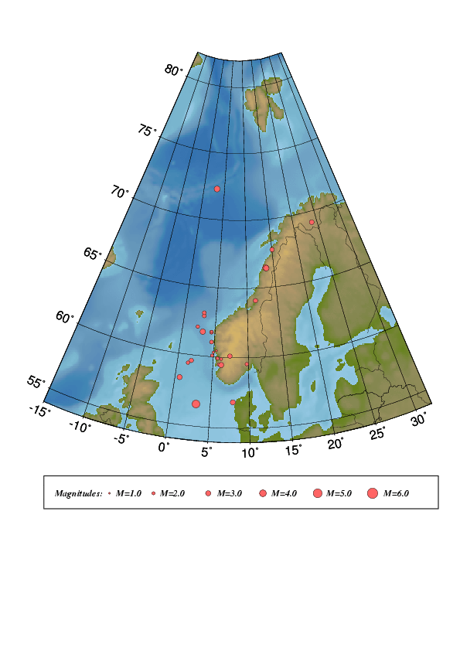

Figure 8. Epicentre distribution of well recorded events in 2001. For station
locations, see Figure 1.

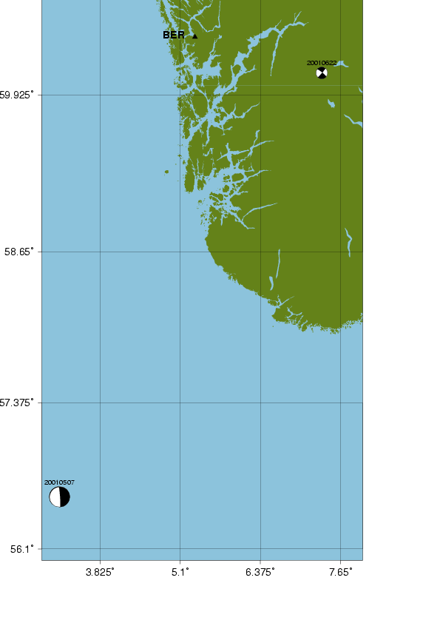

Figure 9. Earthquakes with computed focal mechanisms.
6. Felt earthquakes

Eight earthquakes were reported felt during 2001 (see Table 4 and Figure 9) and seven occurred in areas where earthquakes have been felt before. None of the earthquakes were felt by a sufficient number of people for questionnaires to be distributed as basis for isoseismal maps.

Table 4 Earthquakes felt in Norway during the time period January through December, 2001.
Abbreviations: Mc; Coda magnitude, Ml; Local magnitude and Mw; Moment magnitude.

Date | Time (UTC) | Max. Intensity (on MMI scale) | Magnitude (BER) | Instrumental Epicenter Location
23.01.01 | 10:04 | III | M_{C} =2.9, M_{L}=2.8  M_{W}=2.4 | 69.17N / 23.92E
19.02.01 | 12:45 | IV | M_{C}=3.0, M_{L}=3.0  M_{W}=3.0 | 59.46N / 6.16E
30.03.01 | 14:53 | III | M_{C} =3.1, M_{L}=2.6  M_{W}=2.5 | 67.73N / 15.06E
31.03.01 | 11:31 | III | M_{C} =4.0, M_{L}=3.7  M_{W}=3.4 | 66.43N / 13.52E
16.04.01 | 03:28 | III | M_{C} =3.2, M_{L}=3.1  M_{W}=2.7 | 66.41N / 13.62E
05.07.01 | 09:43 | VI | M_{S}=4.6, M_{L}=3.0  M_{W}=4.9 | 56.56N / 3.182E
19.07.01 | 12:01 | III | M_{C} =3.7, M_{L}=3.9 | 70.99N / 6.79W
22.07.01 | 02:40 | III | M_{C} =3.3, M_{L}=2.5  M_{W}=2.8 | 64.11N / 11.43E

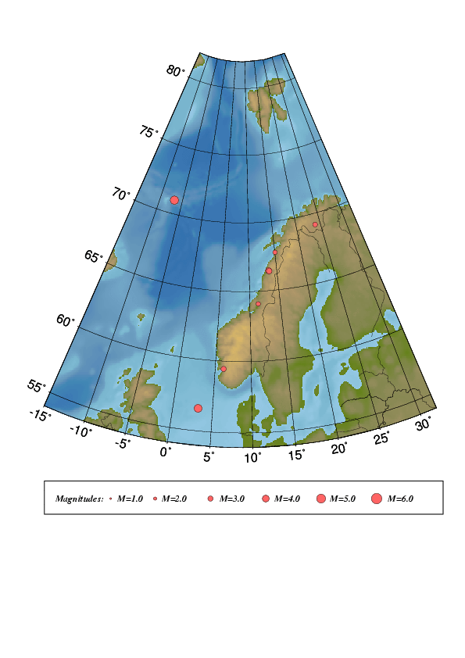
Figure 9. Locations of the eight earthquakes felt during 2001.

7. Use of NNSN data during 2001

Publications and reports

Atakan, K., 2001. Jordskjelv dreper ikke, men bygninger gjør. Populærvitenskapelig manuskript P2-Akademiet, Engers Boktrykkeri as., Otta, pp. 68-77.

Atakan, K., 2001. The Norwegian National Seismic Network. Scandinavian Oil and Gas Magazine, Vol. 29, no. 7/8 2001, 28-32.

Atakan, K., Ottmöller, L., Jensen, S.L., Braunmiller, J., and Ojeda, A., 2001. The Ekofisk earthquake on 7th May 2001: Preliminary report. Institute of Solid Earth Physics, University of Bergen, Norway, 34p.

Atakan, K., Ottmöller, L., Jensen, S.L., Braunmiller, J., and Ojeda, A., 2001. The Ekofisk earthquake on 7th May 2001. Report prepared for PPCoN. Institute of Solid Earth Physics, University of Bergen, Norway, 58p.

Dietrich, K., J. Schweitzer & Th. Meier: S-velocities in the crust and uppermost mantle of
northern Fennoscnadia deduced from dispersion analysis of Rayleigh waves, In:
Tech. Summ., 1 Oct 2000 - 30 Jun 2001, NORSAR Sci. Rep. 1-2001, Kjeller, Norway.

Gudmestad O. T. og C. D. Lindholm (2001): Liten sannsynlighet for jordskjelv-katastrofe
i Norge. GEO/Bergverksnytt, No. 5, pp48-50

Hicks, E.C. and L. Ottemöller (2001): The ML 4.5 Stord/Bømlo, southwestern Norway,
earthquake of August 12, 2000. Norsk Geologisk Tidsskrift, 81, 293 - 304.

Hicks, E.C., F. Ringdal & H. Bungum (2001): Earthquake location accuracies in Norway
based on a comparison between local and regional networks. Pure and Applied Geophysics,
158, 129-141.

Kennett B. L. N. and F. Ringdal (2001): Locating events in the CTBT context. Pure and
Applied Geophysics, 158, 7-18.

Kremenetskaya E., V. Asming and F. Ringdal (2001): Seismic location calibration of the
European Arctic. Pure and Applied Geophysics, 158, 117-128.

Kremenetskaya, E., S. Baranov, Y. Filatov, V.E. Asming & F. Ringdal (2001): Study of
seismic activity near the Barentsburg mine (Spitsbergen), In: Tech. Summ., 1 Oct
2000 - 30 Jun 2001, NORSAR Sci. Rep. 1-2001, Kjeller, Norway.

Kværna, T. (2001): Annual Scientific Report. Contract DTRA01-00-C-0107, Regional
Seismic Threshold Monitoring, NORSAR, Kjeller, Norway.

Kværna, T., E. Hicks & J. Schweitzer (2001): Online databases for the European Arctic—
New developments of the NORSAR web site, In: Tech. Summ., 1 Oct 2000 - 30 Jun
2001, NORSAR Sci. Rep. 1-2001, Kjeller, Norway.

Kværna, T. (2001): Experimental threshold monitoring of the area surrounding the site of
the Kursk submarine accident, In: Tech. Summ., 1 Oct 2000 - 30 Jun 2001, NORSAR
Sci. Rep. 1-2001, Kjeller, Norway.

Lindholm C. (2001): Seismotectonics and Earthquake Hazard. A disseration for the degree
of Doctor Philosphiae. ISBN 82-92220-04-6

Molina, S., C.D. Lindholm & H. Bungum (in press): Probabilistic seismic hazard analysis:
Zoning free versus zoning methodology. Boll. Geofis. Teor. ed Appl.

NORSAR (2001): Ormen Lange Geohazards Study, Task 9. Earthquake Hazards Considerations.
Report for Norwegian Geotechnical Institute (NGI) and Norsk Hydro a.s.,
94 pp.

Ringdal, F., T. Kværna, J. Schweitzer & A. Hafslund (2001): Automatic reprocessing of
events from the Khibiny Massif, In: Tech. Summ., 1 Oct 2000 - 30 Jun 2001, NORSAR
Sci. Rep. 1-2001, Kjeller, Norway.

Schweitzer, J. (2001): Slowness corrections - one way to improve IDC products. Pure
appl. geophys. 158, 375-396.

Oral and poster presentations

Tvedt, E., Hellevang, B., Pedersen, R.B., and Atakan, K., 2001. Seismicity and volcanism along the Mohn’s and Knipovic rides. Norwegian Geological Society, Winter Meeting, Oslo, Norway. Jan 2001.

Atakan, K., 2001. Jordskjelv: opprinnelse og konsekvenser. Populærvitenskapelig foredrag. Atlanten Videregående Skole, Kristiansund. 15. Jan 2001.

Atakan, K., 2001. Jordskjelvsrisiko i Norge og konsekvenser for forsikringsbransjen. Foredrag for Norsk Naturskadepool. IFJ, Universitetet i Bergen. 31. Jan 2001.09.11

Bungum, H. (2001): Earthquakes and submarine slides: Seismotectonic models and ideas.
Seminar on `Ormen Lange, Slope Stability and Submarine Slides’, Voksenåsen,
Oslo, 13-14 February.

Bungum, H. (2001): Postglacial (Holocene) seismicity: What do we know between 10
kybp and the present? Seminar on `Ormen Lange, Slope Stability and Submarine
slides’, Voksenåsen, Oslo, 13-14 February.
Ojeda, A., Pascal, C., Gabrielsen, R., Atakan, K., 2001. Seismological and rheological constrains on the brittle deformation along the Møre Trøndelag Fault Complex, mid-Norway. European Geophysical Society (EGS) XXVI General Assembly, Nice, France, 25-30 March 2001.

Kværna, T. and F. Ringdal (2001): Seismic events in the Barents Sea at and near the site of
the Kursk submarine accident on 12 August 2000. 61 Jahrestagung der Deutchen
Geophysikalishen Gesellshaft, Frankfurt am Main, 19-23 March. (oral)

Kværna, T. & F. Ringdal (2001): Seismic events in the Barents Sea at and near the site of
the Kursk submarine accident on 12 August 2000. 61 Jahrestagung der Deutchen
Geophysikalishen Gesellshaft, Frankfurt am Main, 19-23 March.

Schweitzer, J. (2001): Beobachtungen von Reflexions- und Refraktionsexperimenten mit
dem seismischen Array auf Spitzbergen 61. Jahrestagung der Deutschen Geopysikalischen
Gesellschaft (DGG), Frankfurt 19 - 23 March.

Schweitzer, J. (2001): P-phase travel times from ground truth events observed at the IMS
auxiliary station SPITS Third Workshop on IMS Location Calibration, Oslo 23 - 27
April.

Atakan, K., 2001 (invited). Jordskjelvsaktiviteter i Norge. Kan skjelv ramme oss like sterkt som i Tyrkia? Historiske skjelv og sannsynlighet for nye Tverrfaglig brukerkonferanse om risiko, hendelser og forebygging av naturkatastrofer i Norge. Flåm, 26-27 April 2001.

Atakan, K., 2001. Seismisitet langs Mohn’s og Knipovitch Ryggen med innvirkninger til Svalbard. Geological Institute, University of Bergen. 3 May 2001.

Atakan, K., 2001 (invited). Uncertainties in the data collection and treatment in the seismic hazard calculation. Institutt de Physique du Globe de Strasbourg, France. 31 May 2001.

Tvedt, E., and Atakan, K., 2001 (invited). Seismisk aktivitet langs Kolbeinsey, Mohns og Knipovich rygene. ’Fra Mantle til Microber’. SUBMAR-Seminar. Geological Institute, University of Bergen, 14 June 2001.

Bungum, H. (2001): Holocene seismicity at the Norwegian continental margin; Temporal
variations and sources of stress. IAGA-IASPEI Joint Scientific Assembly, Hanoi,
Vietnam, 19-31 August.

Roth M., R.A.W. Haddon & H. Bungum (2001): Modelling of the August 17, 1999, Kola
Peninsula earthquake, DGG-Meeting, Frankfurt/Main, Germany.

Schweitzer, J. (2001): Recent profiling experiments in the Spitsbergen area - calibration
data for the SPITS array IAGA - IASPEI Joint Scientific Assembly, Hanoi, Vietnam,
19 - 31 August.

Höhne, J., K. Dietrich, F. Krüger, J. Schweitzer & Th. Meier (2001): Untersuchung der
Geschwindigkeitsstruktur der Kruste und des oberen Mantels der Finnmark aus den
Daten des MASI 99 Projektes AG Seismologie, Daun, September.

Kværna, T., S. Mykkeltveit, E. Hicks, F. Ringdal & J. Schweitzer (2001): Regional Seismic
Threshold Monitoring (Poster), 23rd Seismic Research Review, Worldwide
Monitoring of Nuclear Explosions, Jackson Hole, Wyoming, October 2-5.

Ringdal, F., E.O. Kremenetskaya, V. Asming, T Kværna, J.I.Faleide, S. Mykkeltveit & J.
Schweitzer (2001): Research in Regional Seismic Monitoring, Poster Presentation,
DOD/DOE Seismic Research Review, Jackson Hole, Wyoming, October

8. References

Alsaker A., L.B. Kvamme, R.A. Hansen, A. Dahle and H. Bungum 1991. The ML scale in Norway, Bull. Seism. Soc. Am., Vol. 81, No. 2, pp.379-398.

Brune J.N. 1970. Tectonic stress and spectra of seismic shear waves. Journal of Geophysical Research, 75, 4997-5009.

Havskov J., and H. Bungum 1987. Source parameters for earthquakes in the northern North Sea,
Norsk Geologisk Tidskrift,Vol.67, pp 51-58.

Havskov,J. and Atakan,K. 1991. Seismicity and Volcanism of Jan Mayen Island, Norway. Terra
Nova 3, 517-526.

Havskov, J. and L. Ottemöller, 1999. SEISAN earthquake analysis software, Seism. Res. Letters, Vol. 70, pp. 532-534.

Havskov, J. and L. Ottemöller, 2001. SEISAN: The earthquake analysis software, version 7.2, manual, Univeristy of Bergen, pp. 255.

Hicks,E. and Ottemöller,L. (in press). Magnitude 4.5 Stord/Bømlo earthquake of 12th August 2000. Submitted to the Norsk Geologisk Tidsskrift.

Karnik, V., Kondorskaya, N.V., Yu. V. Riznichenko, Ye. F. Savarensky, S.L. Solovev., N.V. Shebalin, J. Vanek, and A. Zatopek 1962. Standardisation of the earhquake magnitude
scales. Studia Geophys. et Geod., Vol. 6, pp. 41-48.

Kennett, B.L.N. and E.R. Engdahl 1991. Traveltimes for global earthquake location and phase
identification, Geophys. J. Int., Vol. 105, pp. 429-465.

Kvamme, L.B., Hansen, R.A. and Bungum H., 1995. Seismic-source and wave-propagation effects of Lg waves in Scandinavia. Geophys. J. Int., Vol 120, 525-536.

Lay, T. and Wallace, T.C., 1995. Modern global seismology. Academic Press, International Geophysics Series, Vol. 58

Lienert, B.R. and Havskov, J., 1995. HYPOCENTER 3.2 A computer program for locating earthquakes locally, regionally and globally. Seismological Research Letters,
Vol. 66, 26-36.

Lindholm, C, H. Bungum, R.K. Bratli, B.S. Aadnøy, N. Dahl, B. Tørudbakken and K. Atakan , 1995. Crustal stress in the northern North Sea as inferred from borehole breakouts and earthquake focal mechanisms, Terra Nova, Vol. 7, pp. 51-59.

Ottemöller, L., (1995). Explosion filtering for Scandinavia. Technical Report No. 2, Institute of

Solid Earth Physics, University of Bergen, Norway.

Sørnes A. and T. Navrestad 1975. Seismic survey of Jan Mayen. Norsk Polarinstitutt, Årbok

37-52.

Veith K.F., and G.E. Clawson 1972. Magnitude from short-period P-wave data. Bull. Seism.
Soc. Am., Vol. 62, pp.435-452.

Westre S. 1975. Richter's lokale magnitude og total signal varighet for lokale jordskjelv på Jan
Mayen. Cand. real thesis., Seismological Observatory, University of Bergen, Norway.

