Norwegian National Seismic Network Operation in 2004

In Norway, the University of Bergen (UiB) operates the Norwegian National Seismic Network (NNSN) consisting of 29 seismic stations. The network has the purpose of monitoring all seismic activity in Norway and surrounding areas and covers mainland Norway and the arctic areas.
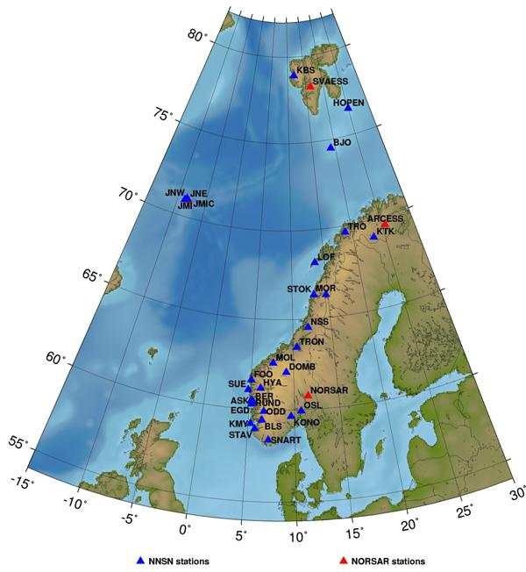

Norwegian seismic stations. UiB operates the 29 stations in the Norwegian National Seismic Network (NNSN) whereas NORSAR operates the arrays and the station JMIC.

Oil producing areas are particularly well covered due to the requirement of the Norwegian Petroleum Directorate to monitor seismicity near the oil fields.

NNSN is supported economically from UiB and from the Norwegian Oil Industry Association (OLF).

The contribution from the two sources for operational costs in 2004 was:
OLF 500 000 NOK
University of Bergen 457 000 NOK
Total: 957 000 NOK

In addition, UiB pays for the 3 positions needed for the network operation. For 2004, the operational costs were within the allocated funds without any large deviations from the detailed budget.
The average downtime for the stations were 2.8 % as compared to 2-2.5 % for previous years. The slightly elevated downtime was mainly caused by the 35 % downtime of the Svalbard station KBS, which is rather difficult to service. 15 stations were visited and one new station was installed at Hopen Island, due to the high seismicity in that area.

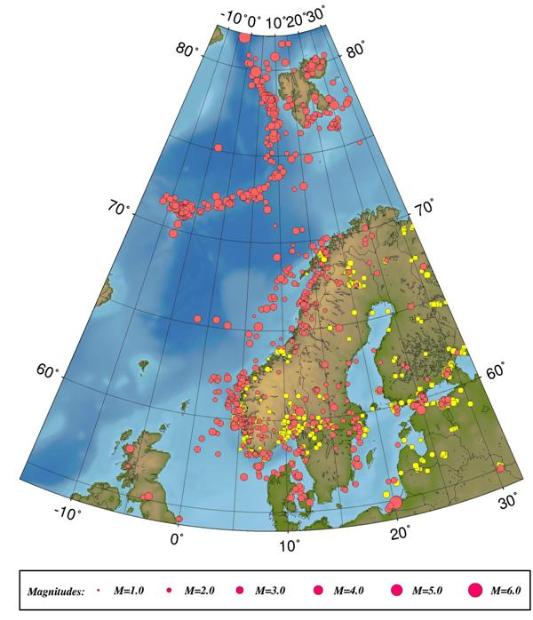
Epicentre distribution of events analyzed and located in 2004. Earthquakes are plotted in red and probable and known explosions in yellow.

A total of 4756 local and regional events and 998 global events were detected by the Norwegian seismic stations during 2004.
.
The largest local or regional earthquake in 2004, recorded on Norwegian stations, occurred on April 14th 2004 at 23:07 (UTC) east of the northern tip of Jan Mayen. The earthquake had a magnitude of Mb = 6.0 and was felt at Jan Mayen and mainland Norway.

The largest earthquake in the vicinity of the Norwegian mainland occurred on April 7th at 8:53 (UTC). The earthquake was located in southeast Norway at 60.5°N, 11.6°E and had a moment magnitude of M_{w} = 3.6.

17 earthquakes were reported felt in Norway during 2004.

