Norwegian National Seismic Network

Technical Report No. 10

REVISION OF FAULT PLANE SOLUTIONS IN THE UIB
SEISMIC DATABASE, 1959-2001.

Prepared by

MATHILDE BØTTGER SØRENSEN

Institute of Solid Earth Physics, University of Bergen
Allégt.41, N-5007 Bergen, Norway
Tel: +47-55-583420 Fax: +47-55-589669 E-mail: seismo@ifjf.uib.no

October 2002

Introduction

The database of earthquakes at IFJF, UiB (BER) contains fault plane solutions. Most of these solutions are made locally, however they have only recently been made in a systematic way. Some solutions, not made by BER, have been given without reference. No work has been done on estimating the quality of the fault plane solutions in the database.
The aim of this study is to examine the fault plane solutions in the BER database, to estimate the quality and to calculate new solutions if necessary. Besides, fault plane solutions from other studies have been included in the database.

Initial information in the database

Before revising the database, a search was made for events with a fault plane solution already in the database.
The result was 56 events, which are listed with the initial solutions in Appendix 1.
A plot of these fault plane solutions is given in Figures 1 and 2.
For these solutions, little information is available and it is therefore difficult to find out how and when a solution has been determined, and by whom, except for the last few years.

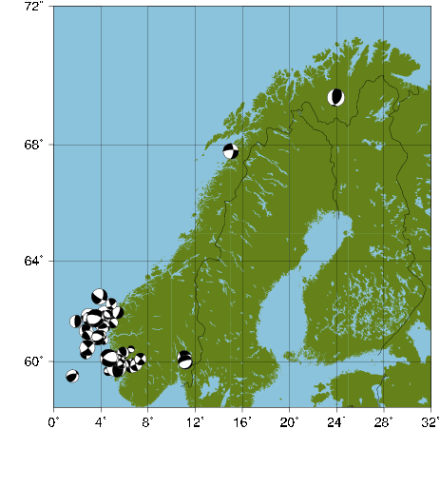
Figure 1: Fault plane solutions before revision of the database.

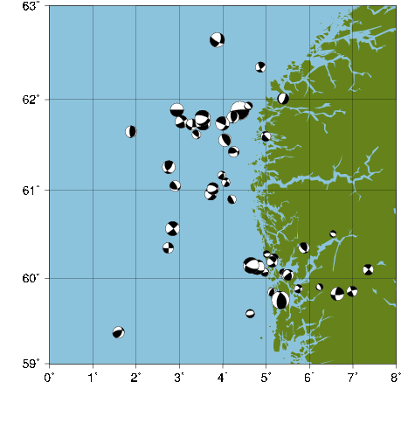
Figure 2: Fault plane solutions in western Norway before revision of the database.

Revision of database

The revision of the database included two steps. First, all events initially in the database have been checked, in some cases recalculated and in other cases deleted from the database. The deleted solutions are left as commented out. Secondly, fault plane solutions available from other studies have been included in the database.
A quality factor has been given to all solutions. The quality factor is based on the one used in the World Stress Map study (Zoback and Zoback 1989). The quality definitions are given in Appendix 2. This is a new field in the fault plane solution line in SEISAN, placed in column 78.
During the checking, 13 fault plane solutions were removed without calculation of a new solution. This was mainly done in cases with few polarity readings or when the solutions calculated with FOCMEC showed no consistency. 12 events were left in the database with their initial solution and 30 events had their solution modified. The modified solutions were either calculated with FOCMEC or provided by one of the references listed in Appendix 3.
One event was deleted from the database since it was registered twice (December 8th 2000 at 00:48).
The new solutions included in the database mainly come from a list provided by Erik Hicks, NORSAR. The references to the solutions are listed in Appendix 3. In cases where both a solution from this list and a solution already in the database has been available, the solution from the list has been chosen, since these solutions are better documented than the ones in the database. This was the case for 23 events.
Besides, 104 new solutions from this list have been included. For all events in the database, comments and references have been included in the S-file of the event.

Information in database after revision

After the revision of the database, 146 fault plane solutions are available. Plots of these solutions are shown in Figures 3 and 4, and the solutions are listed in Appendix 4.

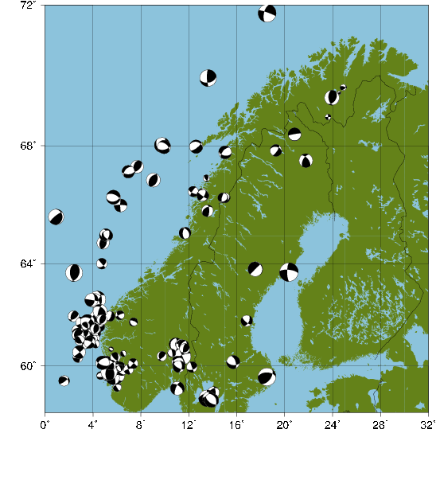
Figure 3: Fault plane solutions in the database after revision.

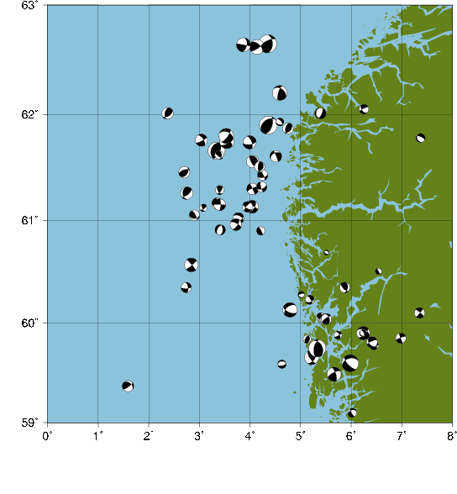
Figure 4: Fault plane solutions in western Norway after revision of the database.

As is seen from Figures 3 and 4, the revision of the database has lead to a much better fault plane solution coverage in the Norwegian Sea and in South-east Norway.
A large amount of new information about fault plane solutions has been included in the database. The introduction of a quality factor gives the possibility of searching for solutions based on quality.

Appendix 1: List of fault plane solutions in the BER database before revision.

Year Date HRMM Sec Latitud Longitud Depth FF NST GAP Mc Ml STRIK DIP RAKE CHA
1989 123 1406 29.2 61.880 4.390 31.0 55 91 4.8 62 9 67 M
1990 4 4 1253 18.7 61.645 1.881 9.1 7 297 3.0 20 20 110 R
1992 1 1 0803 57.6 67.789 15.022 11.0 F 8 109 3.6 3.1 267 76 -26 M
1992 11 8 1912 34.7 61.890 2.941 28.3 15 210 3.4 3.4 90 0 90 R
1993 1 2 2204 47.7 61.604 4.990 17.0 F 8 219 2.5 315 90 55 R
1993 1227 0520 44.3 61.264 2.748 10.0 F 57 158 3.3 3.3 152 48 31 M
1994 727 0942 42.2 62.641 3.866 13.0 F 16 199 3.7 3.7 19 54 -19 M
1994 1119 0907 31.2 60.159 11.056 15.0 17 162 3.3 3.3 246 66 –147 M
1995 317 2343 59.7 61.815 4.228 22.9 15 192 2.8 3.1 169 62 67 R
1995 620 2122 14.8 61.736 3.993 15.0 29 155 3.2 3.5 112 84 40 M
1995 822 0141 6.6 60.354 2.738 23.0 F 13 254 2.7 2.3 360 84 -7 M
1995 1113 0122 3.4 59.975 11.172 14.0 F 19 167 3.3 3.0 254 70 -78 M
1995 1113 0809 21.8 61.565 4.049 15.0 F 20 152 3.2 3.3 150 70 90 K
1995 1120 0401 59.4 60.064 5.400 5.0 FF 12 152 2.3 2.0 116 36 31 K
1995 12 8 0741 17.4 72.686 4.200 10.0 F 18 195 3.8 3.7 150 40 0 R
1995 1223 0555 18.8 60.900 4.211 11.0 F 10 227 2.3 2.0 150 10 90 K
1996 111 0100 34.8 60.066 4.967 14.0 F 10 183 2.1 1.7 350 20 0 R
1996 121 0216 33.3 69.449 23.926 10.0 F 22 162 4.1 3.6 174 54 64 M
1996 2 8 0441 45.2 61.051 2.897 24.0 F 16 217 2.7 2.6 86 36 31 M
1996 317 0328 20.4 60.227 5.176 7.1 F 13 179 2.3 2.4 328 74 -43 M
1996 330 1414 56.8 60.277 5.006 5.0 F 10 212 1.8 1.6 123 28 -42 K
1996 416 1027 4.0 62.006 5.393 13.0 F 19 153 2.7 2.8 24 70 -78 M
1996 6 7 1325 29.1 59.841 5.126 12.0 F 12 177 2.2 1.9 8 41 75 M
1996 625 0337 29.4 61.763 3.040 17.0 F 35 157 3.0 3.2 327 62 -10 M
1996 815 2341 13.2 59.881 5.744 6.0 F 12 126 2.1 1.6 327 62 -10 K
1996 1030 0346 10.0 61.090 4.067 10.0 F 13 240 2.0 2.2 300 60 0 R
1996 1031 1252 11.5 61.790 3.533 20.0 F 37 146 3.4 3.7 313 66 -32 M
1996 1031 1257 44.0 61.749 3.541 20.0 F 35 145 3.3 3.8 312 61 -27 M
1996 1031 2347 39.5 61.799 3.531 20.0 F 32 126 3.7 3.9 286 64 -55 M
1996 1216 0409 4.6 61.018 3.773 20.0 F 26 136 3.0 2.8 297 52 -50 K
1997 1 1 1151 45.9 62.348 4.866 5.0 F 12 256 2.6 2.1 153 76 27 R
1997 114 1013 14.0 60.160 4.547 0.0 F 8 207 1.6 1.8 127 71 -68 R
1997 318 0553 52.8 66.380 -2.223 10.0 F 37 141 3.7 3.2 356 64 -15 K
1997 513 2207 9.8 60.961 3.720 19.0 F 26 135 3.1 2.9 296 71 -23 M
1997 812 0814 24.0 59.816 6.645 12.0 F 14 99 2.7 2.8 184 64 16 R
1997 915 1558 48.4 60.188 5.145 9.0 F 14 171 2.6 2.7 318 80 -28 R
1998 124 1652 18.5 59.590 4.634 10.0 F 7 263 2.2 1.4 260 30 -89 K
1998 310 0223 12.1 60.512 6.536 3.0 F 9 190 1.7 1.3 141 36 -53 M
1998 516 2354 56.0 53.002 2.414 15.0 F 30 185 3.8 3.1 256 71 36 K
1998 1128 0908 8.7 60.347 5.867 10.0 F 17 61 2.4 2.8 134 64 56 M
1999 124 1927 22.1 61.730 3.283 8.0 F 17 231 2.9 2.7 6 77 -37 R
1999 2 2 1730 56.8 61.622 3.387 12.0 F 12 264 2.3 1.8 124 64 56 K
1999 315 0228 6.4 61.165 3.967 7.0 F 12 264 2.1 1.5 340 44 22 R
1999 4 5 0313 31.7 59.368 1.589 15.0 F 27 128 3.0 2.6 25 45 45 M
1999 411 1811 11.1 61.429 4.254 6.5 F 17 231 2.6 2.7 75 70 52 M
1999 615 0112 57.3 61.926 4.585 15.0 15 249 2.1 2.0 321 62 -66 M
1999 1226 1359 31.0 59.903 6.228 5.0 F 13 91 1.5 1.8 334 70 -78 K
2000 5 5 0452 17.6 60.566 2.836 10.0 F 27 116 2.7 2.8 320 84 -7 M
2000 812 1427 26.2 59.748 5.329 18.0 F* 55 163 3.8 4.5 333 40 58 M
2000 1126 0017 16.0 60.038 5.478 11.0 F 16 143 2.7 2.6 116 36 31 M
2000 1129 0222 16.1 59.850 6.981 15.0 F 16 115 2.7 2.6 160 87 -8 M
2000 1129 0959 27.7 60.045 5.512 7.0 F 14 138 2.7 2.4 340 44 22 M
2000 12 8 0048 5.6 60.131 4.788 4.0 F 33 84 3.3 3.8 112 62 -49 M
2000 12 8 0048 5.5 60.153 4.652 4.0 F 10 205 3.3 4.0 112 62 -49 D
2001 5 7 0943 33.8 56.565 3.182 6.0 F* 51 67 356 85 -94 K
2001 622 2245 27.1 60.105 7.352 15.0 FF 16 105 2.8 2.6 310 81 -3 M

FF: Fix indicators. First F indicates fix of depth, second F indicated fix of location. NST: Number of stations with data for the event in the BER database. GAP: Largest gap with no data coverage. Mc: Coda magnitude. Ml: Local magnitude. STRIK: Strike. DIP: Dip. RAKE: Rake. CHA: Change done to solution, R: Removed, M: Modified, K: Original solution kept, D: Event deleted.
Blanks indicates that no information is available.

Appendix 2: Quality definitions for fault plane solutions

Quality Ranking for Focal Mechanism

A-Quality
- Average P-axis or formal inversion of four or more single event solutions in close geographic proximity (at least one event M>=4.0, other events M>=3.0).
B-Quality
- Well constrained single event solution (M>=4.5) or average of two well-constrained single event solutions (M>=3.5) from first motions and other methods (moment tensor wave-form modelling, or inversion).
C-Quality
- Single event solution (constrained by first motions only, often based on authors quality assignment) (M>=2.5).
- Average of several well-constrained composites (M>2.0).
D-Quality
- Single composite solution.
- Poorly constrained single event solution.
- Single event solution for M<2.5 event.
E-Quality
- Large historic event with no reliable focal mechanism.
- Event with P, T, B axes all plunging 25-40°.
- Event with P and T axes both plunging 40-50°.

From:
http://www-wsm.physik.uni-karlsruhe.de/pub/stress_data/stress_data_frame.html

Appendix 3: References for solutions included in the database

Lazareva, A. P. and L. A. Misharina, Stresses in earthquake foci in the Arctic seismic belt, Izv. Earth Phys. Ser., 2, 5-10, 1965.

Savostin, L. A. and A. M. Karasik, Recent plate tectonics of the Arctic Basin and of northwestern Asia, Tectonophysics, 74, 111-145, 1981.

Bungum, H. and J. Fyen, Hypocentral distribution, focal mechanisms and tectonic implications of Fennoscandian earthquakes, 1954-1978, Geol. Forh., 101, 261-273, 1979.

Bungum, H. and Y. Kristoffersen, A microearthquake survey of the Svalbard region, Final report, Phase I, NORSAR Tech. Rep. 1/80, NTNF/NORSAR, Kjeller, Norway, 28pp., 1980.

Kibsgaard, A., Focal mechanism studies of/by the SV to P amplitude ratio, Cand. Sci. thesis, 115pp., Univ. of Oslo, 1985.

Havskov, J. and H. Bungum, Source parameters for earthquakes in the northern North Sea, Nor. Geol. Tidsskr., 67, 51-58, 1978.

Hansen, R. A. et al: Three recent larger earthquakes offshore Norway, Terra Nova, 1, 284-295, 1989.

Bungum, H. et al: Seismicity and Seismotectonics of Norway and Nearby Continental Shelf Areas, JGR, 96, B2, 2249-2265, 1991.

Kola report, NORSAR, 1994.

L. Engell-Soerensen, pers. comm. with Erik Hicks, 1994.

Lindholm, C. D. et al: Crustal Stress in the Northern North Sea as inferred from borehole breakouts and earthquake focal mechanisms, Terra Nova, 7, 51-59, 1995.

Arvidsson, R. and Kulhanek, O.: Seismodynamics of Sweden deduced from earthquake focal mechanisms, Geophys. J. Int, 116, 377-392, 1994.

Mario Villagran under the DNM study, 1994.

Hicks, E: Crustal stresses in Norway and surrounding areas as derived from earthquake focal mechanism solutions and in-situ stress measurements. Cand. Scient thesis, 1996.

Inst. of Solid Earth Phys., Univ. of Bergen.

Hicks, E. et al, Seismic activity, inferred crustal stresses and seismotectonics in the Rana region, northern Norway. In: Steward, I. S., Sauber, J. and Rose, J. (eds); Glacio-seismitectonics: Ice Sheets, Crustal Deformation and Seismicity, Quaternary Science Reviews, 19, 1423-1436.

Hicks, E. et al: Stress inversion of earthquake focal mechanism from onshore and offshore Norway, Norsk Geologisk Tidsskrift, 80, 235-250.

Hicks and Ottemoller: The ML 4.5 Stord/Bomlo, Southern Norway, earthquake of August 12, 2000, Norsk Geol. Tidssk., 81, 293-304.

Bungum, H and C. Lindholm: Seismo- and neotectonics in Finnmark, Kola and the Southern Barents Sea, part 2: Seismological analysis and seismotectonics, Tectonophysics 270, 15-28, 1996.

Atakan, K. et al: Earthquake swarm in Steigen, northern Norway: an unusual example of intraplate seismicity, Terra Nova, 6, 180-194, 1994.

Clement, I: Fault plane solutions of two recent events located in the Norwegian Sea. Report delivered to IFJF, November 1996.
Appendix 4: List of fault plane solutions in the BER database after revision.

Year Date HRMM Sec Latitud Longitud Depth FF NST GAP Mc Ml STRIK DIP RAKE CHA Q
1959 0129 2324 30.0 70.90 7.30 33.0 FF 0 5.6 86 83 21 N ?
1959 0301 74.80 8.10 33.0 FF 0 69 70 -22 N ?
1967 413 0846 18.2 68.345 20.821 22.9 9 129 260 85 -89 N B
1968 1 3 0738 21.1 72.488 4.864 31.0 120 67 20 55 70 N A
1970 1021 0814 32.1 74.363 15.505 31.0 210 139 29 66 -31 N D
1971 531 0347 15.1 72.331 4.940 31.0 250 67 141 59 –139 N C
1971 0719 60.72 10.73 31.0 FF 0 170 70 -39 N B
1973 1123 0657 0.5 63.694 20.354 31.0 9 169 180 74 -20 N D
1975 120 1047 44.6 71.795 18.528 30.7 139 93 4.2 289 83 –151 N C
1975 811 1828 12.0 67.531 21.903 15.0 8 97 350 85 -89 N B
1976 118 446 24.4 77.871 18.636 33.0 F* 347 32 108 85 8 N ?
1977 1211 2146 60.89 10.90 15.0 F* 0 3.6 360 70 -96 N D
1979 329 1212 32.6 60.581 9.765 15.0 3 278 10 60 -70 N A
1979 614 2124 14.2 60.394 11.476 10.0 F 9 94 3.1 158 88 -14 N B
1979 1223 1409 18.4 59.541 18.513 18.9 11 151 3.2 36 54 51 N B
1980 1118 1542 16.9 60.889 11.325 18.7 28 66 2.9 108 79 106 N B
1981 213 0639 10.4 58.874 14.060 10.0 F 28 109 3.3 359 62 61 N B
1981 6 7 2013 34.7 60.597 11.219 15.0 9 151 167 66 -45 N B
1981 622 438 13.9 65.663 0.923 10.0 F* 59 232 78 106 N D
1981 9 3 1839 37.6 70.018 13.597 15.0 44 243 4.7 178 80 45 N C
1982 729 0017 6.3 60.209 1.850 23.0 79 169 6 81 -26 N C
1982 1018 0258 10.2 60.649 11.236 23.0 27 92 4 50 78 N A
1983 0308 60.53 10.69 15.0 FF 0 122 64 -152 N B
1983 3 8 1843 58.1 59.658 5.225 23.0 85 71 3.8 145 67 42 N B
1983 929 0503 28.9 63.801 17.550 23.0 29 119 4.1 225 88 -81 N B
1984 3 1 0403 6.9 60.535 10.679 8.9 5 323 359 88 -18 N B
1985 125 2317 37.1 61.159 3.357 20.9 12 153 3.1 2.3 345 75 130 N C
1985 516 1739 0.2 60.910 3.415 19.4 12 136 2.7 360 50 -110 N C
1985 615 0040 20.8 56.304 12.038 17.8 14 310 4.4 48 76 21 N B
1985 9 8 1231 58.8 61.146 3.399 17.5 19 211 3.1 272 86 -15 N D
1985 10 1 1331 10.2 61.301 4.054 16.0 17 144 3.1 335 89 -167 N D
1985 1027 0436 20.5 61.323 4.230 15.0 15 139 2.7 165 77 -147 N D
1985 1130 1905 13.5 61.613 4.507 10.0 F 11 238 3.1 337 85 -130 N D
1986 0125 61.83 16.83 27.0 FF 0 130 70 -145 N B
1986 2 5 1753 34.0 62.655 4.348 15.0 19 160 4.8 239 63 128 N B
1986 4 1 0956 53.6 56.401 12.369 15.0 10 313 3.9 227 74 -52 N B
1986 714 1350 39.1 58.625 13.508 10.0 F 12 276 4.6 180 90 -44 N B
1986 714 1445 36.7 58.632 13.670 15.0 8 303 3.5 2.9 180 90 -19 N B
1986 920 2215 11.3 60.164 15.696 15.0 6 302 3.7 340 60 -44 N B
1986 1026 1134 41.1 61.660 3.343 15.0 21 147 4.5 24 57 93 N B
1986 11 2 0747 57.3 58.526 13.905 10.0 F 11 301 3.9 124 57 -107 N B
1986 1216 0130 5.9 60.532 10.560 10.0 F 7 211 2.3 1.7 352 77 -74 N B
1987 4 4 0729 13.9 67.333 7.683 15.9 11 223 3.6 42 50 109 N D
1987 419 1239 53.3 67.846 19.271 18.1 25 126 3.3 3.2 33 74 -126 N B
1987 0723 61.86 17.48 20.0 FF 0 75 90 -34 N B
1987 725 0530 58.1 59.951 12.255 10.0 F 10 260 3.0 2.7 340 90 -39 N B
1987 9 4 0838 19.5 61.457 2.697 31.0 19 164 3.0 252 57 113 N C
1987 1031 1009 13.3 61.131 4.041 14.8 19 114 3.4 293 77 -31 N A
1987 1226 1657 42.3 59.777 6.449 10.0 F 14 90 2.4 324 62 -39 N B
1988 131 1851 45.5 68.017 9.761 31.0 15 220 4.2 25 75 -59 N C
1988 516 2350 22.1 67.530 21.761 15.0 19 118 3.8 3.0 320 60 40 N B
1988 6 2 1135 55.0 62.005 2.371 15.0 19 171 3.1 193 51 56 N B
1988 630 1326 51.4 61.782 7.366 10.0 F 8 167 2.4 294 67 -106 N B
1988 8 8 1959 33.4 63.663 2.424 15.0 F 53 71 4.8 4.8 176 51 75 N B
1988 1020 2143 49.9 59.901 6.243 14.6 18 63 3.5 3.4 48 69 -130 N A
1988 1027 1422 15.9 66.898 9.029 15.0 F 13 209 3.9 216 48 99 N D
1989 1 9 0018 24.6 69.586 24.543 12.1 5 272 1.1 247 62 101 N C
1989 120 0933 49.7 57.866 8.232 15.0 F 16 286 3.1 3.9 153 81 -55 N C
1989 123 1406 29.1 61.895 4.357 31.0 55 91 4.8 4.7 20 55 70 M A
1989 129 1638 22.5 59.600 5.976 15.0 24 94 4.4 136 67 -54 N A
1989 214 2044 20.8 61.129 3.952 15.0 12 174 2.8 219 72 -153 N A
1989 0410 60.61 11.40 22.0 FF 0 117 64 34 N A
1989 713 0811 11.8 69.747 24.891 10.0 FS 4 284 1.8 288 66 129 N C
1989 725 1044 57.8 67.173 6.941 15.0 F 6 242 3.5 90 57 -56 N B
1989 0901 61.34 4.20 33.0 FF 0 31 64 114 N C
1989 9 2 0008 48.4 61.117 3.082 5.8 6 290 2.0 57 70 150 N D
1989 9 2 0017 46.0 61.292 3.399 19.8 9 217 2.4 35 61 140 N C
1989 920 1621 50.4 59.103 6.016 15.9 9 217 2.4 150 80 -49 N A
1989 1102 60.68 11.54 33.0 FF 0 155 75 35 N B
1989 1116 1837 5.3 68.883 23.620 10.0 F 5 244 1.6 270 90 -179 N D
1990 226 2030 19.7 57.668 6.862 2.5 13 296 3.5 18 82 50 N C
1990 516 1159 46.8 66.054 6.308 15.0 F 13 196 3.6 180 84 -7 N C
1990 524 0951 59.9 56.580 12.167 10.0 F 7 313 3.6 1.5 62 86 40 N B
1991 413 2118 36.5 69.424 24.078 15.0 18 152 3.0 2.6 171 52 64 N C
1991 9 1 0650 51.2 79.805 -1.349 10.0 F 12 268 4.3 309 90 -179 N C
1991 1212 1129 19.4 60.691 5.515 15.0 6 110 1.3 120 50 -89 N C
1991 1216 1535 10.1 67.965 9.928 29.7 7 224 3.7 78 57 -125 N C
1992 1 1 0803 57.6 67.789 15.022 11.0 F 8 109 3.6 3.1 220 60 –129 M C
1992 219 0639 33.1 59.047 11.036 22.7 12 219 3.8 3.3 203 71 -35 N C
1992 414 1310 8.9 59.491 5.659 15.0 14 133 3.7 3.5 243 69 158 N B
1992 630 1504 40.1 60.862 11.561 12.2 9 256 2.8 219 51 -75 N B
1992 814 0457 23.4 67.974 12.596 21.0 4 222 3.7 2.5 53 71 -111 N B
1993 120 0444 50.5 64.748 4.835 13.5 14 192 3.5 2.9 195 45 90 N C
1993 626 1355 25.1 62.619 4.139 16.7 15 173 3.9 55 74 37 N B
1993 913 0525 14.3 66.335 5.704 11.0 18 177 3.9 290 56 -71 N B
1993 1018 1624 52.2 65.029 5.061 29.8 17 154 3.5 3.0 340 60 -59 N D
1993 1227 0520 44.3 61.264 2.748 10.0 F 57 158 3.3 3.3 51 68 118 M C
1994 727 0942 42.2 62.641 3.866 13.0 F 16 199 3.7 3.7 10 50 0 M C
1994 8 1 0252 3.4 60.402 9.738 5.0 F 7 266 2.7 1.8 51 64 123 N C
1994 1119 0907 31.1 60.158 11.055 15.2 17 162 3.3 3.3 118 69 -57 M B
1995 2 6 1700 40.4 59.807 6.412 15.0 12 83 2.5 2.8 246 75 –131 N ?
1995 620 2122 14.8 61.736 3.993 15.0 29 155 3.2 3.5 338 63 -30 M C
1995 724 1423 1.5 65.015 5.188 10.0 F 13 220 3.0 2.4 17 62 -49 N C
1995 822 0141 6.5 60.355 2.737 23.0 F 13 254 2.7 2.3 349 60 -17 M D
1995 1113 0122 3.4 59.975 11.172 14.0 F 19 167 3.3 3.0 119 68 –133 M B
1995 1113 0809 21.8 61.565 4.049 15.0 F 20 152 3.2 3.3 150 70 90 O D
1995 1120 0401 59.4 60.064 5.400 5.0 FF 12 152 2.3 2.0 116 36 31 O D
1995 1223 0555 18.8 60.900 4.211 11.0 F 10 227 2.3 2.0 150 10 90 O D
1996 121 0216 33.3 69.449 23.926 10.0 F 22 162 4.1 3.6 174 53 66 M B
1996 2 8 0441 45.2 61.051 2.897 24.0 F 16 217 2.7 2.6 87 36 31 M C
1996 3 3 0609 37.4 60.712 11.653 28.6 11 127 2.9 2.2 189 68 63 N B
1996 317 0328 20.4 60.227 5.176 7.1 F 13 179 2.3 2.4 328 74 -43 M C
1996 317 2318 50.6 63.999 4.742 12.0 F 14 227 3.0 2.2 140 90 40 N C
1996 330 1414 56.8 60.277 5.006 5.0 F 10 212 1.8 1.6 123 28 -42 O D
1996 416 1027 4.0 62.006 5.393 13.0 F 19 153 2.7 2.8 24 70 -77 M B
1996 6 7 1325 29.1 59.841 5.126 12.0 F 12 177 2.2 1.9 8 41 75 M D
1996 625 0337 29.4 61.763 3.040 17.0 F 35 157 3.0 3.2 327 62 -10 M B
1996 815 2341 13.2 59.881 5.744 6.0 F 12 126 2.1 1.6 327 62 -10 O D
1996 1031 1252 11.5 61.790 3.533 20.0 F 37 146 3.4 3.7 312 65 -32 M B
1996 1031 1257 44.0 61.749 3.541 20.0 F 35 145 3.3 3.8 312 61 -28 M B
1996 1031 2347 39.5 61.799 3.531 20.0 F 32 126 3.7 3.9 291 44 -21 M B
1996 1216 0409 4.6 61.018 3.773 20.0 F 26 136 3.0 2.8 297 52 -50 O C
1997 318 0553 52.8 66.380 -2.222 10.0 F 37 140 3.7 3.2 356 64 -15 O D
1997 513 2207 9.8 60.961 3.720 19.0 F 26 135 3.1 2.9 296 71 -23 M C
1997 1121 1800 10.6 66.452 13.137 0.0 9 170 2.9 2.2 252 75 -25 N B
1997 1125 2224 16.8 66.518 12.358 14.5 9 190 2.9 2.5 213 75 -153 N B
1997 1128 1922 53.3 66.305 15.006 91.7 3 233 2.8 1.6 193 71 -110 N C
1997 1128 1929 10.1 66.313 14.839 88.6 3 230 2.8 1.7 193 71 -110 N C
1997 1208 59.82 6.65 12.0 FF 0 87 75 154 N C
1997 1226 1521 57.5 66.376 13.266 15.0 3 166 2.7 65 50 60 N C
1998 1 8 0804 48.4 66.383 13.208 0.1 9 149 2.9 2.0 158 81 -141 N B
1998 124 1652 18.5 59.590 4.634 10.0 F 7 263 2.2 1.4 260 30 -89 O D
1998 2 9 1259 6.1 66.391 13.142 5.0 F 11 148 3.2 2.7 126 83 -155 N B
1998 3 9 1419 58.8 65.873 13.553 3.4 F 19 134 3.3 2.7 1 64 56 N B
1998 310 0223 12.1 60.512 6.536 3.0 F 9 190 1.7 1.3 150 85 -84 M D
1998 516 2354 56.0 53.002 2.414 15.0 F 30 185 3.8 3.1 256 71 36 O D
1998 1128 0908 8.7 60.347 5.867 10.0 F 17 61 2.4 2.8 134 64 56 M C
1999 2 2 1730 56.8 61.622 3.387 12.0 F 12 264 2.3 1.8 124 64 56 O D
1999 4 5 0313 31.7 59.368 1.589 15.0 F 27 128 3.0 2.6 54 78 55 M D
1999 4 9 1112 15.3 66.962 13.457 15.0 1 360 1.9 142 58 52 N C
1999 411 1811 11.1 61.429 4.254 6.5 F 17 231 2.6 2.7 75 53 16 M D
1999 529 0031 43.6 62.204 4.593 15.0 F 32 147 3.2 3.9 197 72 129 N B
1999 615 0112 57.3 61.926 4.585 15.0 15 249 2.1 2.0 321 62 -66 M B
1999 8 2 0511 40.2 61.513 4.186 21.5 16 232 2.6 2.6 185 61 78 N B
1999 8 7 0528 26.2 62.050 6.246 15.0 F 18 143 2.5 2.2 245 77 -141 N B
1999 823 1411 17.4 65.103 11.677 13.0 F 26 147 3.3 3.1 184 57 -65 N B
1999 9 2 1958 46.2 61.865 4.750 19.0 F 15 241 2.2 2.1 193 52 71 N C
1999 1226 1359 31.0 59.903 6.228 5.0 F 13 91 1.5 1.8 334 70 -78 O C
2000 5 5 0452 17.6 60.566 2.836 10.0 F 27 116 2.7 2.8 320 84 -6 M C
2000 812 1427 26.2 59.748 5.329 18.0 F* 55 163 3.8 4.5 192 57 114 M A
2000 1126 0017 16.0 60.038 5.478 11.0 F 16 143 2.7 2.6 116 36 31 M C
2000 1129 0222 16.1 59.850 6.981 15.0 F 16 115 2.7 2.6 160 87 -7 M C
2000 1129 0959 27.7 60.045 5.512 7.0 F 14 138 2.7 2.4 340 44 22 M C
2000 12 8 0048 5.6 60.131 4.788 4.0 F 33 84 3.3 3.8 112 62 -48 M C
2001 5 7 0943 33.8 56.565 3.182 6.0 F 51 67 356 85 -94 O C
2001 622 2245 27.1 60.105 7.352 15.0 FF 16 105 2.8 2.6 310 81 -3 M B

FF: Fix indicators. First F indicates fix of depth, second F indicated fix of location. NST: Number of stations with data for the event in the BER database. If NST=0, no readings are available for the event. GAP: Largest gap with no data coverage. Mc: Coda magnitude. Ml: Local magnitude. STRIK: Strike. DIP: Dip. RAKE: Rake. CHA: Change done to solution, N: New solution, O: Old solution, M: Modified solution. Q: Quality factor, ? indicates that no quality factor is available.
Blanks indicate that no information is available.

