Norwegian National Seismic Network

Technical Report No. 14

The July 4th 2003 Svalbard earthquake

Prepared by

MATHILDE BØTTGER SØRENSEN, ANDREAS FETTIG
AND JENS HAVSKOV

Dept. of Earth Science, University of Bergen
Allégt.41, N-5007 Bergen, Norway
Tel: +47-55-583600 Fax: +47-55-583660 E-mail: seismo@geo.uib.no

October 2003

Introduction

On July 4th 2003, a Mw = 5.3 (Mb=5.7) earthquake occurred in the Southeastern part of the Svalbard region. This is a region, which has earlier experienced earthquakes of similar size, latest in 1976 when a magnitude Mb = 5.5 event occurred (Bungum, 1977).
This report gives a description of the July 4th 2003 event and the work that has been done in relation to the event.

The event on July 4th 2003

Location and depth

The event has been analyzed using data from the Norwegian National Seismic Network (NNSN), supplemented by data from the station HSP (Figure 1) run by The Institute of Geophysics of the Polish Academy of Sciences. For locating the event, only stations within 1000 km of the epicentre have been used. A map of the station locations is shown in Figure 1. In addition to the location obtained by using data from NNSN (BER), locations are available from USGS (PDE) and NORSAR (NAO). The event locations obtained by these three agencies are listed in Table 1 and shown in Figure 2.

Figure 1: Location of the NNSN stations used for locating the July 4th 2003 event.
Stations are shown as triangles, circle indicates event location.
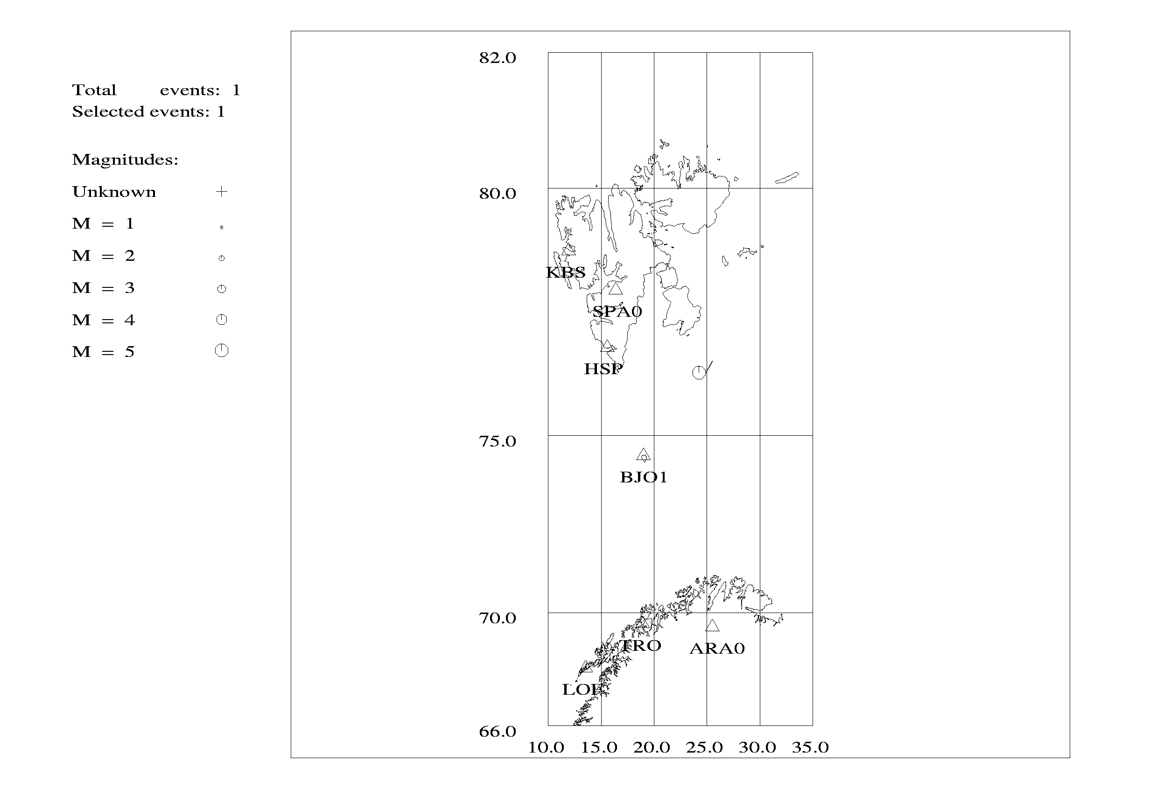

Table 1: Locations of July 4th 2003 Svalbard earthquake determined by NNSN (BER), USGS(PDE) and NORSAR(NAO). The NAO location with fixed depth is has been made with the Bergen model.

Agency | BER | PDE | NAO | NAO
Origin time | 2003/07/04 07:16:46.4 | 2003/07/04 07:16:44.7 | 2003/07/04 07:16:49.3 | 203/07/040  07:16:47.4
Latitude | 76.470°N | 76.372°N | 76.253°N | 76.225°N
Longitude | 24.254°E | 23.282°E | 22.745°E | 23.078°E
Depth | 10 km (fixed) | 10 km (fixed) | 44.8 km | 10 km (fixed)

Figure 2: Location of the July 4th 2003 Svalbard event. 1 - BER location, 2 - NAO location, 3 - PDE location, 4 - Location of mb=5.5 event on January 18th 1976.

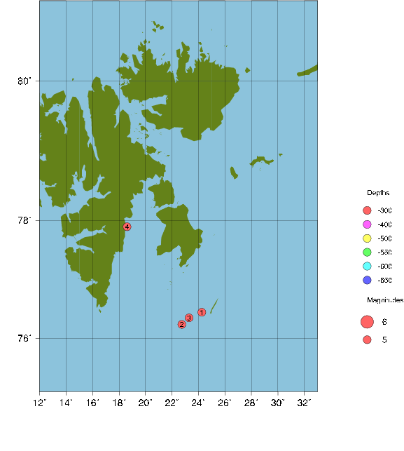
It is seen that the above locations agree well in origin time and latitude, whereas some variation is seen in the longitude determinations. This is expected considering the station configuration in the region with all stations used in the locations aligned in the NS direction.
The BER solution has been obtained using data from 7 stations within 1000 km of the epicentre (Figure 2). The station KTK operated by NNSN in Northern Norway was out of service at the time of the event and has therefore not provided data. For each station, the phases read have been re-evaluated and reread if necessary. The velocity model used in the location is the model used by the NNSN for locations in all of the Norwegian area except near Jan Mayen. This model is expected to be valid also for the region around Svalbard since the continental shelf is believed to extend to this region. Only the nearest stations have been used because using readings from Mid- and Southern Norway may introduce a bias in a location due to the distance.
The PDE location provided by USGS is based on teleseismic recordings of the event using a global velocity model. This location places the event ca. 27 km west of the BER location.
The location given by NAO is 40 km west of the BER location. This location is based on readings from 6 stations/arrays distributed on Svalbard, Mainland Norway, in Russia and in Finland. For the arrays, azimuths have been determined for both P and S phases and used in the location. The most distant station used in the NAO location is at a distance of 1834 km from the epicentre. This long distance may introduce a bias in the location. The azimuths determined from different phases at the same station also show significant differences in some cases. The worst case is station APA0 where the determined azimuths differ by 19.8°. Such a difference may also introduce errors in the location. The azimuths provided by NORSAR have not been used in the BER location.
As already mentioned, all of the above locations have uncertainties in the EW direction due to a NS alignment of the stations used for the location. The BER location does, however, include the station BJO1, which is located close to the event and at an angle of 45° to the NS direction. Data from this stations gives a much better constraint on the event location than can be expected from NAO and PDE.
Based on the above considerations it seems that the location determined by BER is more reliable than the ones determined by PDE and NAO. One should, however, bear in mind the problems in station configuration, which are present for all three locations.
The depth of the event is poorly constrained from the NNSN data. Analyzing the variation of RMS with changing event depth indicates that the event has occurred at 0-10 km depth. Also the tectonics of the region indicates that an event here should be shallow. For these reasons the event depth has been fixed to 10 km. The depth determined by NORSAR (44.8 km) is not realistic. A relocation using the NNSN model with a fixed depth of 10 km moves the epicenter 10 km closer to the BER location (Table 1).

The region in which the event is located has seen earthquakes of similar size earlier, latest in 1976 where an Mb = 5.5 event occurred at 77.9°N and 18.6°E (Figure 2). Also smaller events are seen in the Svalbard region. Figure 3 shows earthquakes with magnitude greater than 4.0 reported by ISC in the time period 1963-2003. Figure 4 shows earthquakes with magnitude greater than 4.0 available in the NNSN data base in the same time period.
The two maps are expected to be similar since they are showing nearly the same events. In the time period 1963-1979, the events in the BER database are taken mainly from ISC, but also a few from NAO. For the time after 1980, data from NNSN and NORSAR are merged in the BER database whereas ISC data are no longer included. The two maps do show a high degree of similarity with the maximum seismicity near the epicentre of the 1976 event (Figures 2, 3 and 4).

Figure 3: Events with M > 4.0 reported by ISC in the time period 1904-2003.
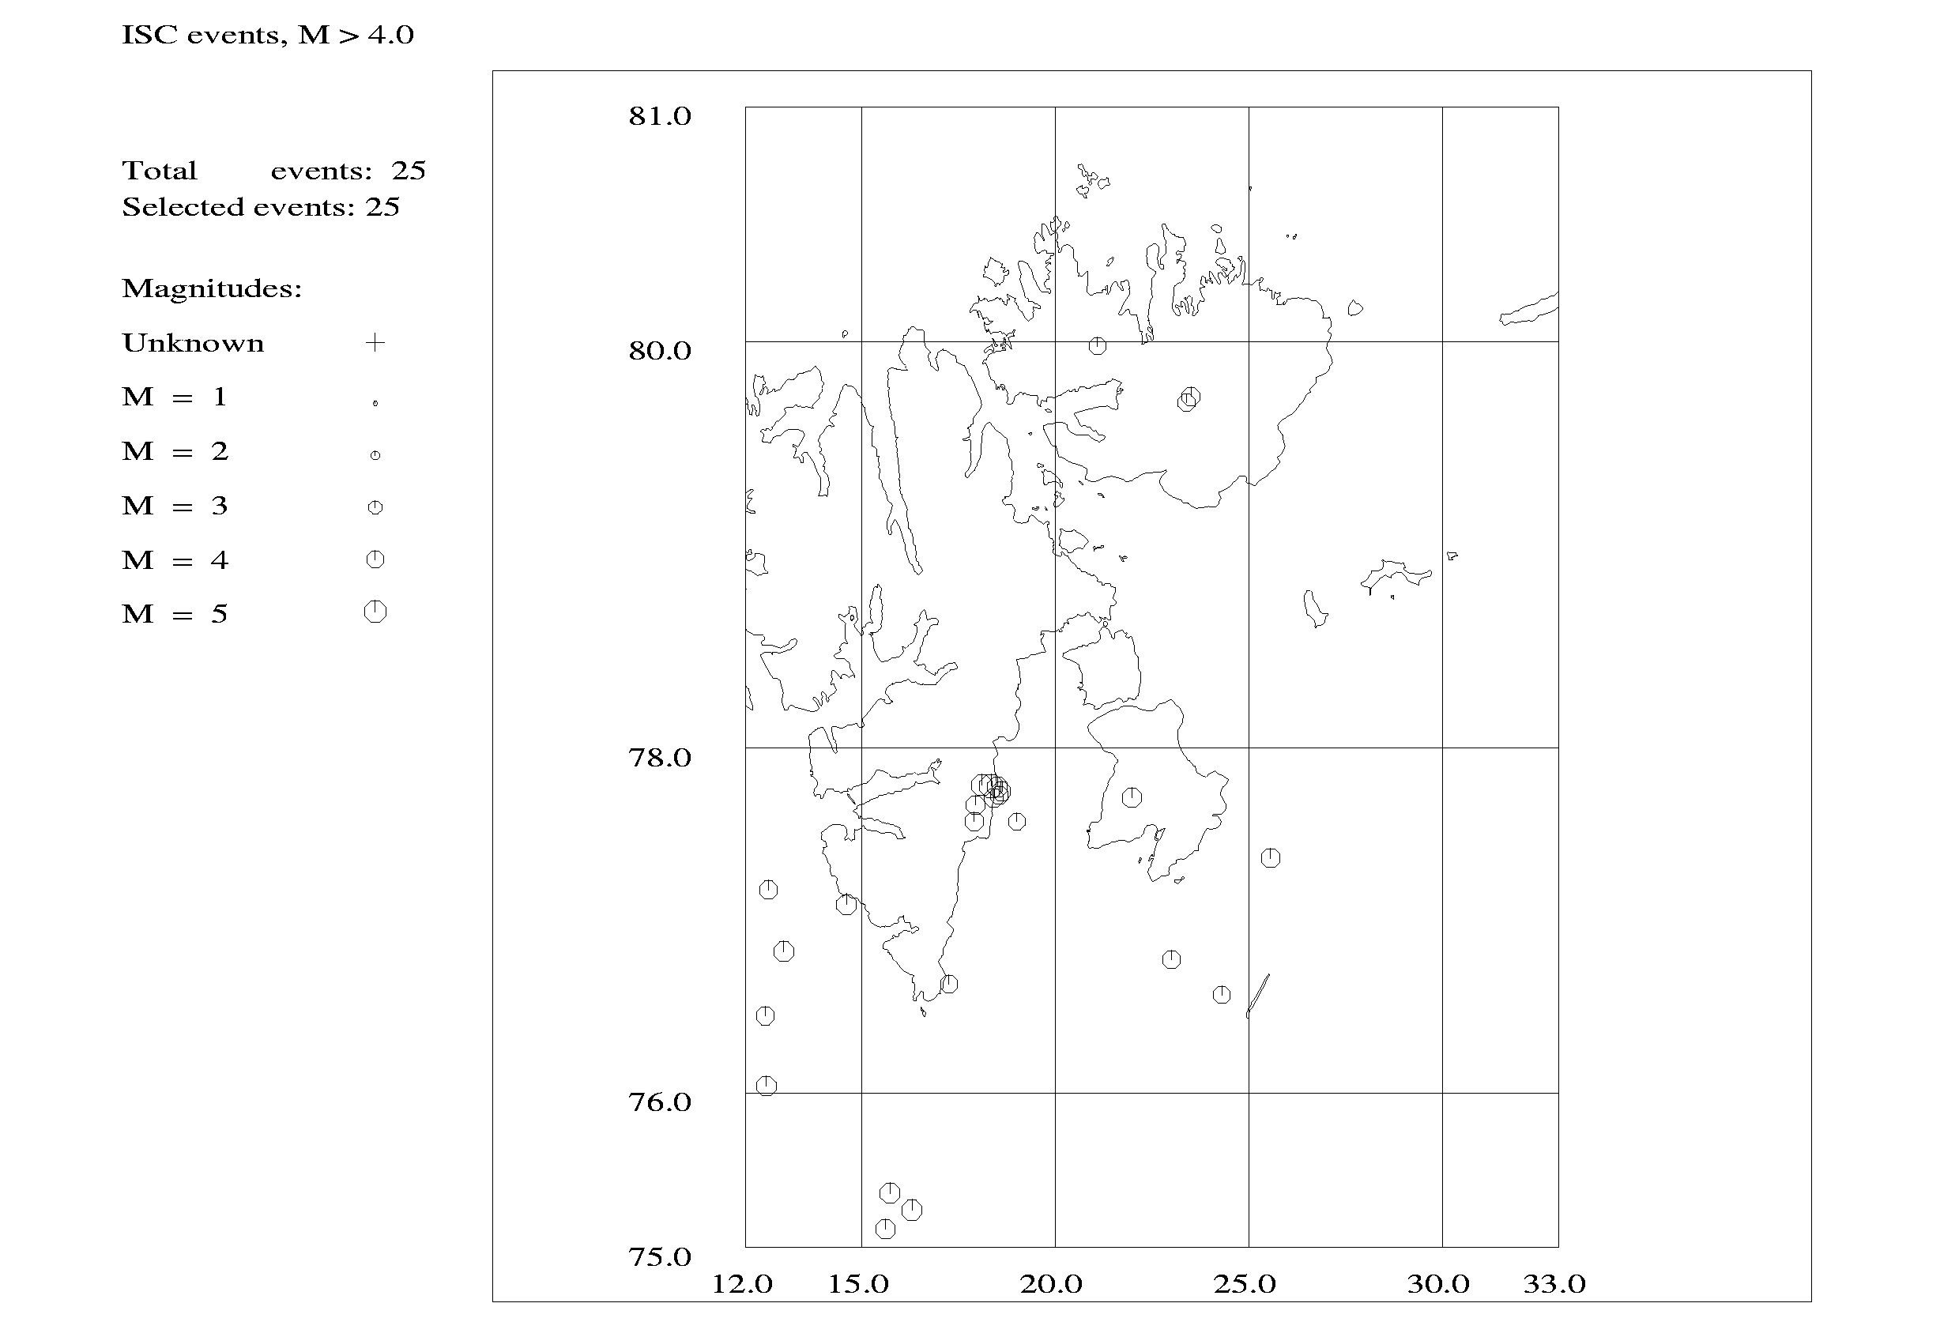

Figure 4: Events with M > 4.0 in BER catalog for the time period 1900-2003.
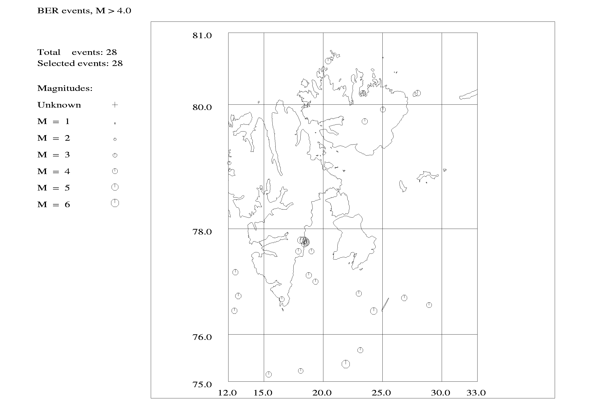

Magnitude

Four different magnitude types have been determined from the NNSN data as listed in Table 2:

Table 2: Magnitudes for the July 4th 2003 Svalbard earthquake determined from NNSN data and stations used in the magnitude calculations. In comparison the PDE magnitudes are also shown.

Magnitude type | Magnitude  by PDE | Magnitude  by NNSN | Stations used in magnitude calculation  by NNSN
Mw | 5.4 | 5.3 | MOR, NSS, KONO, JMI, TRON, TRO, LOF, KBS
Ml | - | 4.9 | BJO, KBS, TRO, LOF, JMI, MOR, NSS
Mc | - | 5.1 | KMS, TRO
Ms | 5.1 | 4.2 | TRO, JMI, KONO
Mb | 5.7 | - | -

The moment magnitude is based on spectral analysis of the signals recorded at stations in the epicentral area and in mainland Norway. This magnitude is in good agreement with the Mw = 5.4 determined by PDE. The resulting three magnitudes are based on amplitudes/durations read on the recorded signals. The magnitudes are calculated as described in the monthly bulletins published by the NNSN.
PDE have calculated a Ms = 5.1. This is considerably higher than the magnitude determined by NNSN. The reason for this is most probably that the NNSN magnitude is determined at stations at a much shorter distance from the event than is the case for the PDE surface wave magnitude, introducing a bias to the determined magnitude. It is seen that the only magnitude giving consistent results using both local and global data is Mw.

The event was felt at Hopen, an island close to the epicentre. There are no felt reports from other places.

Fault plane solution.

Reading polarities of first arrivals for the NNSN data is in most cases difficult since the first arrivals are not clear onsets. Also, the geographical distribution of stations relative to the event location is limited which makes it impossible to determine a well-constrained fault plane solution. It has therefore not been attempted to determine a fault plane solution for the event from these data.

The CMT solution for the event, determined by Harvard, is:

Strike: 276
Dip: 46
Slip: -104
This solution has been tested with the polarities read for the NNSN data. The result is shown in Figure 5. It is seen that most polarities agree with the CMT solution, but also that the read polarities would be satisfied by many other fault plane solutions because of the lack of geographical spread in the readings.

Figure 5: CMT solution given by Harvard and polarities read from the NNSN data. Open circles represent dilatation, black circles represent compression.

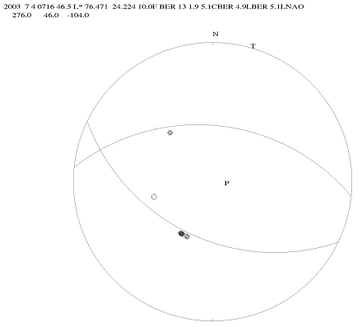

The CMT solution indicates an almost pure normal faulting with tension in the NS direction and vertical compression.
Bungum (1977) has determined a fault plane solution for the Mb=5.5 event that occurred in the same region on January 18th 1976. This solution indicates an almost pure strike-slip mechanism with compression in the EW direction and tension in the NS direction.
So for both events, maximum tension is in the NS direction whereas maximum compression is in the EW direction for the 1976 event and vertical for the 2003 event.
To get a deeper insight to this problem we have looked at the stress field in the region. The stress distribution in the region as given by the World Stress Map (Reinecker et al., 2003) is shown in Figure 6.

Figure 6: Stress distribution in the Svalbard region as given by the World Stress Map (Reinecker et al., 2003). Bars indicate direction of P-axis.
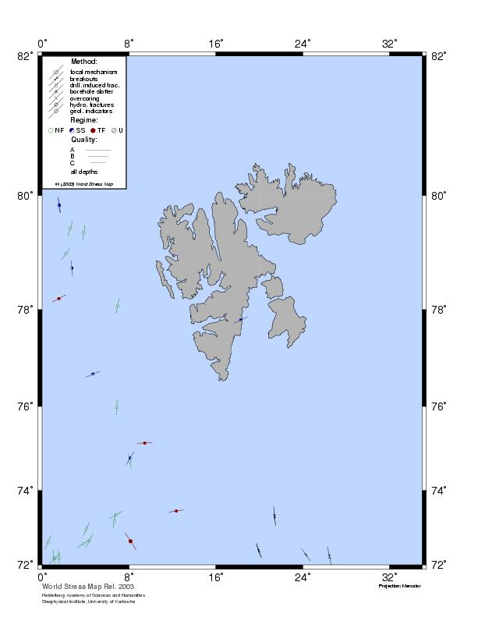

Very few data are included in the World Stress Map for the Svalbard region, but the 1976 event is shown with the mechanism from Bungum (1977). The tectonics of the region with the Mid Atlantic Ridge to the west (see Figure 7) indicates that horizontal compression should be maximum for the EW direction as is the case for the 1976 event. South of the study area it is seen that the stress field changes to maximum compression is in the NS direction.
All in all, it can be concluded that the fault plane solution for the 2003 event require further studies of the stress field in the region.

Figure 7: Seismicity of Europe. The aligned events in the left corner indicate the Mid Atlantic Rigde (from http://neic.usgs.gov). The Svalbard region is just outside of the map, indicate by an arrow.

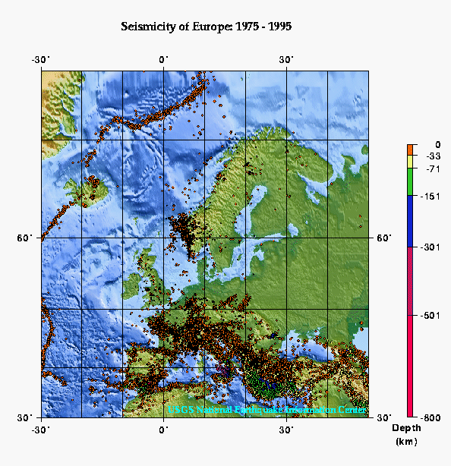

Aftershocks

A number of aftershocks have been registered by NAO and BER after the July 4th 2003 event. The largest 31, given by NAO, are listed in Table 3. Figure 8 shows the epicentres determined by NAO.
Table 3: The largest 31 aftershocks given by NAO for the July 4th 2003 Svalbard earthquake at 07:16. For the events marked with grey, waveform data were available for several stations. The events printed in bold type were used for the Master Event Technique. The event number is used in Figure 8.

No | Year Date HRMM Sec Latitude Longitude Depth(km) Ml
1 | 2003 0704 0716 49.3 76.253 22.745 44.8 5.1
2 | 2003 0704 0727 47.8 76.206 21.647 41.7 3.0
3 | 2003 0704 0741 47.7 76.435 24.498 8.0 1.9
4 | 2003 0704 0745 01.6 76.571 23.795 37.7 1.6
5 | 2003 0704 0748 31.5 76.253 22.979 7.9 2.2
6 | 2003 0704 0754 04.1 76.226 23.464 2.9
7 | 2003 0704 0800 14.3 76.730 22.970 1.6
8 | 2003 0704 0805 42.9 76.127 23.012 3.2
9 | 2003 0704 0824 52.9 76.448 24.732 37.9 2.9
10 | 2003 0704 0847 08.4 76.381 24.174 2.3
11 | 2003 0704 0935 11.7 76.647 23.092 21.8 2.3
12 | 2003 0704 1027 17.4 76.180 23.663 2.5
13 | 2003 0704 1204 44.1 76.182 22.820 32.5 1.9
14 | 2003 0704 1228 32.4 76.171 22.882 2.0
15 | 2003 0704 1407 12.6 76.168 23.612 1.6
16 | 2003 0704 1850 06.6 76.183 22.286 2.1
17 | 2003 0704 1908 49.1 76.208 23.866 1.8
18 | 2003 0704 2223 01.4 76.287 24.020 29.5 2.8
19 | 2003 0705 0030 49.2 76.158 21.356 45.0 1.7
20 | 2003 0705 0246 30.1 76.086 22.812 1.6
21 | 2003 0705 0312 45.0 76.337 24.054 1.8
22 | 2003 0705 1023 27.5 76.269 23.622 1.9
23 | 2003 0705 1034 03.1 76.169 22.005 2.0
24 | 2003 0705 1158 32.7 76.087 23.359 1.6
25 | 2003 0705 1551 28.1 76.266 22.609 41.2 1.7
26 | 2003 0705 1704 07.4 76.190 21.643 46.9 2.9
27 | 2003 0705 1948 27.8 76.117 22.137 37.3 1.8
28 | 2003 0706 1459 54.3 76.308 23.128 48.7 2.6
29 | 2003 0710 0644 06.9 76.268 22.677 1.8
30 | 2003 0710 0645 41.7 76.343 23.220 32.8 2.6
31 | 2003 0716 2308 08.3 76.282 22.684 41.9 2.7
32 | 2003 0721 0430 25.5 79.210 20.091 2.4

Figure 8: Locations of the main shock (#1) and the 31 aftershocks as located by NAO. The event numbers refer to Table 3.
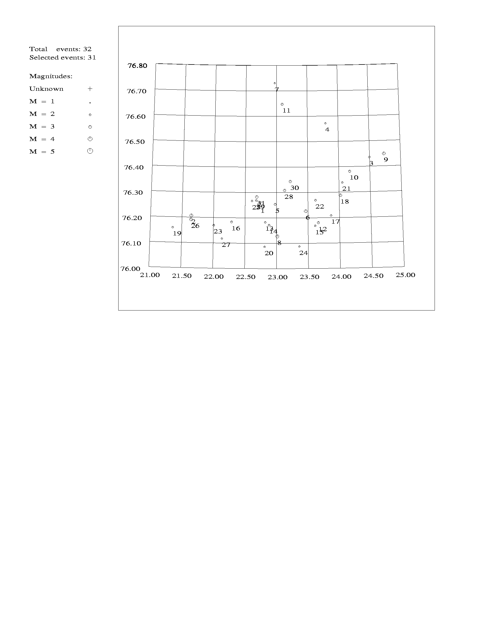

For 18 of these aftershocks, waveform data were available in the Bergen database for one or both of the near stations BJO and KBS. Additional data were obtained from the stations HSP and SPA. However, as seen from Table 4, waveform data were not available for all events and all stations.
After picking/checking the phases read for these 18 events, a re-location was done (Figure 9) with the idea to get good aftershock locations by using only the nearest stations. Two events were not locatable because of too bad data (events #15 and #29). Unfortunately, the locations were very scattered and much worse than the original NAO array locations. The next step was to try to relocate the events using the master event technique. Seven of the 18 events (including the main shock) with at least 3 available waveforms were chosen for this analysis (Table 4).
Because the waveform data from the station BJO were of low quality for most of the events, these were not used. The location of the 3 stations used are:

Latitude Longitude Elevation
KBS: 78.9256 11.9417 74 m
HSP: 77.0106 15.5725 0 m
SPA3: 78.1773 16.3588 339 m

Figure 9: Aftershock locations after re-location (before using Master Event Technique) – two events are not locatable because of too bad data. Event number #1 is the main shock. The 7 events used for the estimation of the relative location are marked in bold type.
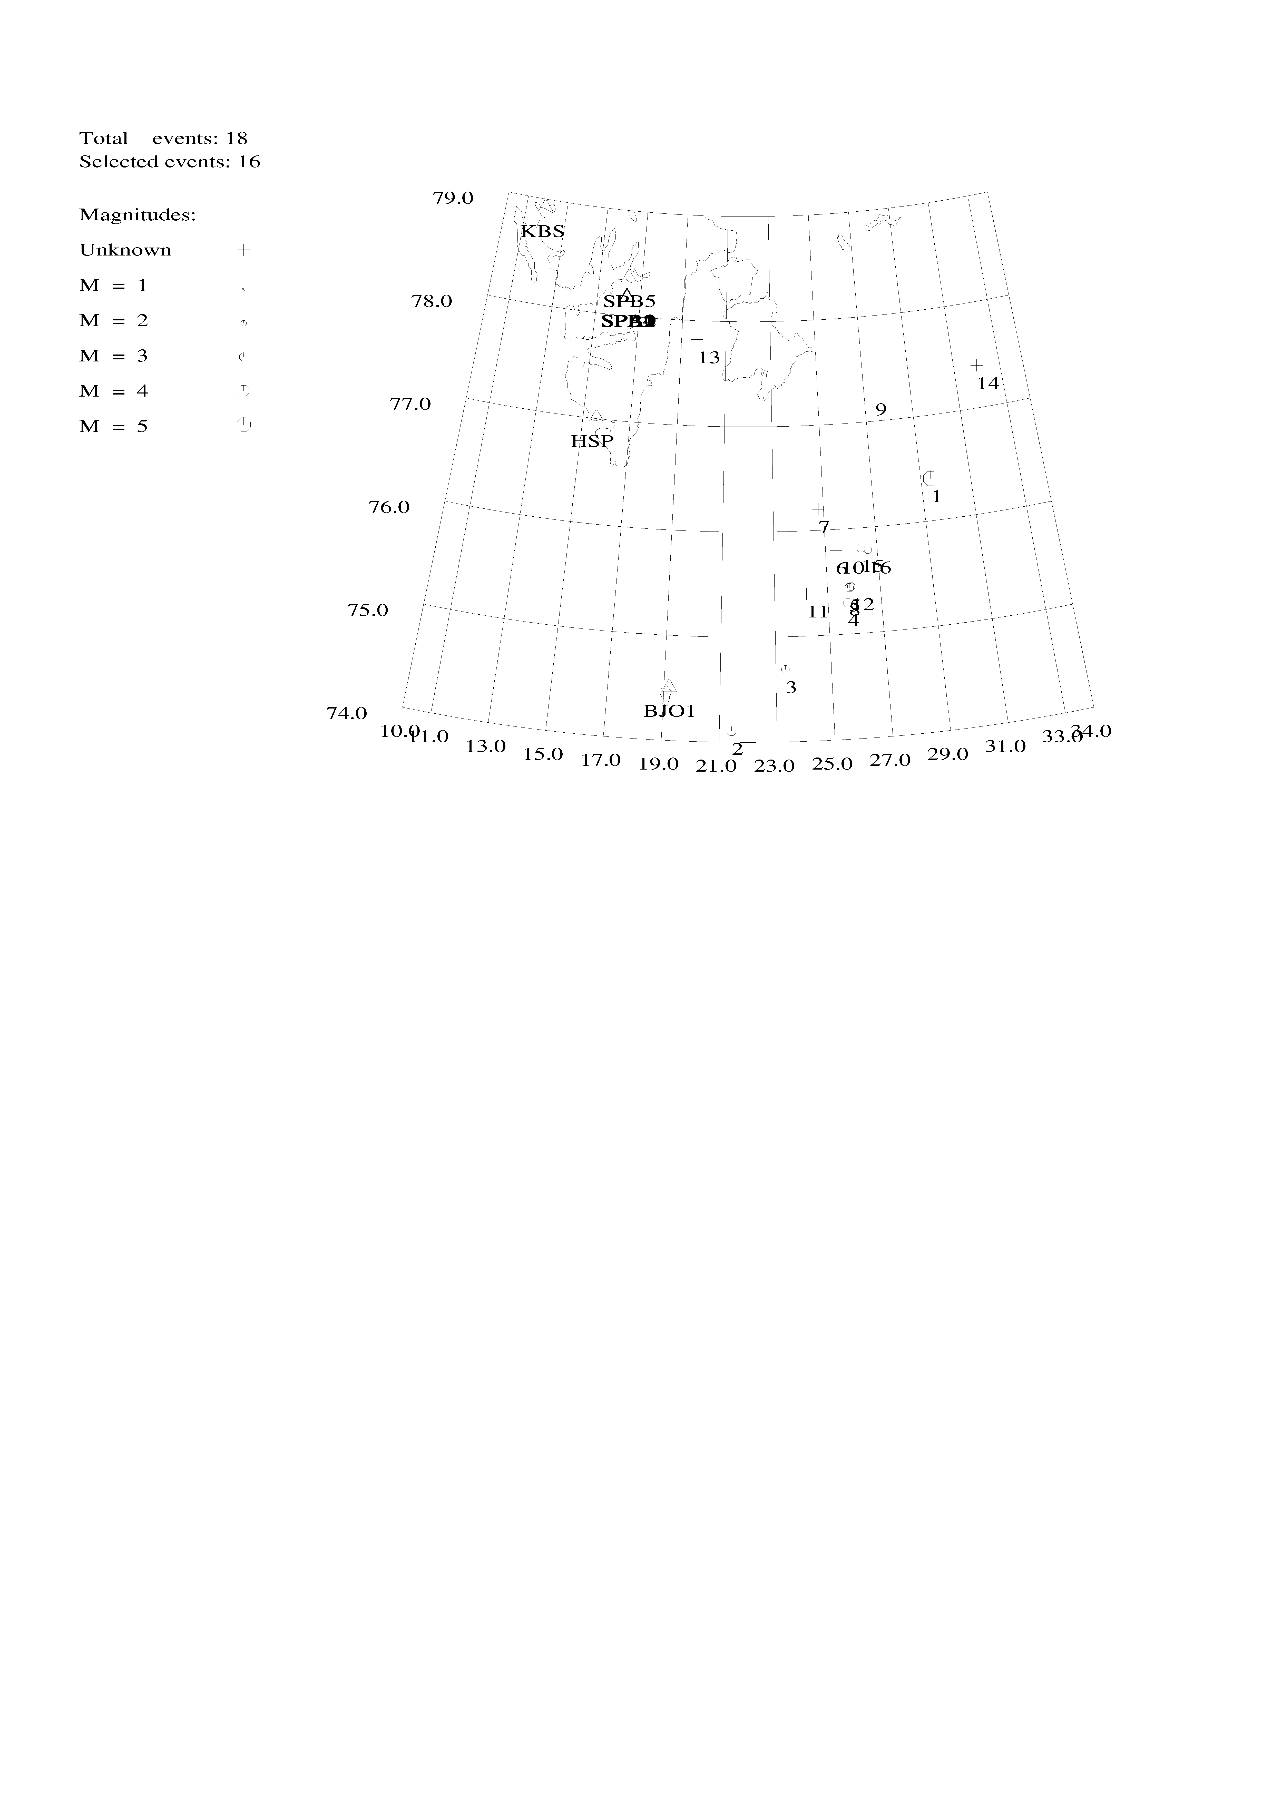
No Event-date Location

1 2003 7 4 0716 35.3 L* 76.400 29.400 18.8 TES 4 5.0
2 2003 7 4 0727 22.2 L 74.105 21.424 15.0 TES 2 0.0
3 2003 7 4 0753 50.7 L 74.689 23.343 15.7 TES 3 2.2
4 2003 7 4 0805 31.0 L 75.298 25.744 15.0 TES 4 1.8
5 2003 7 4 0824 38.1 L 75.440 25.826 0.0 TES 4 1.8
6 2003 7 4 0847 01.2 L 75.800 25.400 0.0 TES 2 0.6
7 2003 7 4 0935 5.5 L 76.200 24.800 21.8 TES 2 0.5
8 2003 7 4 1027 6.5 L 75.400 25.800 15.0 TES 2 0.7
9 2003 7 4 1135 15.0 L 77.276 27.494 15.0 TES 1 0.0
10 2003 7 4 1228 24.8 L 75.800 25.600 0.0 TES 2 0.8
11 2003 7 4 1849 57.2 L 75.400 24.200 15.8 TES 2 1.3
12 2003 7 4 2222 47.6 L 75.450 25.901 0.0 TES 4 1.8
13 2003 7 4 2352 25.4 L 77.821 19.706 15.0 TES 1 0.0
14 2003 7 5 1033 51.7 L 77.400 32.000 15.0 TES 1 0.5
15 2003 7 5 1703 52.1 L 75.806 26.375 0.0 TES 3 1.7
16 2003 7 6 1459 39.5 L 75.787 26.639 0.0 TES 2 1.6

Table 4: Availability of waveform data for aftershock study. The seven events marked with grey were used in the Master Event Technique. A parenthesis around the ‘x’, indicates the same waveform file as the event before.

Event | BJO | HSP | KBS | SPA
0704 0716 | x | x | x | x
0704 0727 | x | x | x | (x)
0704 0753 | x | x | x | (x)
0704 0805 | x | x | x | x
0704 0824 | x | x | x | (x)
0704 0847 |  | x |  | (x)
0704 0935 |  | x |  | x
0704 1027 |  | x |  | x
0704 1135 |  | x
0704 1228 |  | x |  | x
0704 1407 |  | x
0704 1849 |  | x |  | x
0704 2222 | x | x | x | x
0704 2352 |  | x
0705 1033 |  |  |  | x
0705 1703 | x | x | x | x
0706 1459 |  |  | x | x
0710 0644 |  |  | x

The idea of the master event technique, is to use one event as a master event and locate the other events relative to the master event. This is done by using the residuals of the master event as station corrections for the other events assuming that the same phases have been used for all locations. In principle this should be possible to do with the readings used for the locations shown in Figure 9. However, the arrival onsets were very emergent (see Figure 10), so it was not possible to ensure the reading of the same phase for each event by looking at the events individually. The traces were therefore aligned using the P-onset and arrival times were picked on the aligned traces. This means that absolute arrival times were not available and only S-P times were used. Figure 10 shows an example of the aligned traces (all are seen in Appendix A) and Table 5a the phase times read. The first aftershock (event #2) was chosen as the master event since is resembled the other aftershocks better then the main event. From Table 5a, it is seen that changes in S-P times are between 0 and 2 sec and nearly all changes are positive for all stations. This indicates that the aftershocks are spread out over a distance range of less than 20 km in the NE-SW direction. Next the aftershocks are relocated as follows:

- Locate the master event fixed to the location of the aftershock as given by NAO using only S-P times
- Subtract the P and S residuals (Table 5b) for the master events from the arrival times of aftershocks (Table 5c).
- Locate the aftershocks using a fixed depth of 10 km and the master event as start location using only S-P times.

Table 5a: Arrival times for the aligned aftershocks. P is the P-time on the aligned trace and only has absolute relevance for the master event. S is the same as P for S-waves. S-P is the S-P time. D(S-P) is the change in S-P time relative to the master event. For the stations KBS and HSP the North-South component (N) was used and for the station SPA3 the vertical component (Z) was used. The numbers refer to event number and below is given the day, hour and minute. #1 is the main event.

 |  | #2 | #1 | #3 | #4 | #5 | #6 | #7
Station | Times | 04 0727 | 04 0716 | 04 0754 | 04 0805 | 04 0824 | 04 2223 | 05 1704
Component |  | Master
KBS | P | 41,28 | 41,28 | 41,28 | 41,28 | 41,28 | 41,28 | 41,28
 | S | 98,11 | 98,38 | 99,97 | 100,24 | 99,61 | 100,01 | 99,34
N | S – P | 56,83 | 57,1 | 58,69 | 58,96 | 58,33 | 58,73 | 58,06
 | D(S - P) |  | 0,27 | 1,86 | 2,13 | 1,5 | 1,9 | 1,23
HSP | P | 19,68 | 19,68 | 19,68 | 19,68 | 19,68 | 19,68 | 19,68
 | S | 48,14 | 48,12 | 49,31 | 50,1 | 49,11 | 50,26 | 49,97
N | S – P | 28,46 | 28,44 | 29,63 | 30,42 | 29,43 | 30,58 | 30,29
 | D(S - P) |  | -0,02 | 1,17 | 1,96 | 0,97 | 2,12 | 1,83
SPA3 | P | 26,2 | 26,2 | 26,2 | 26,2 | 26,2 | 26,2 | 26,2
 | S | 62,66 | 62,73 | 64,49 | 64,24 | 64,17 | 64,81 | 64,24
Z | S – P | 36,46 | 36,53 | 38,29 | 38,04 | 37,97 | 38,61 | 38,04
 | D(S - P) |  | 0,07 | 1,83 | 1,58 | 1,51 | 2,15 | 1,58

Table 5b: Residuals of master event when located fixed to the location of the aftershock.

Station | Phase | Residual(s)
HSP | P | -2,25
 | S | 2,25
SPA3 | P | -5,08
 | S | -4,26
KBS | P | -5,6
 | S | -4,09

Table 5c: Arrival times corrected for master event residuals. The numbers refer to event numbers where #1 is the main event.

Station | Phase | #1 | #3 | #4 | #5 | #6 | #7
HSP | P | 21,93 | 21,93 | 21,93 | 21,93 | 21,93 | 21,93
 | S | 45,87 | 47,06 | 47,85 | 46,86 | 48,01 | 47,72
SPA3 | P | 31,28 | 31,28 | 31,28 | 31,28 | 31,28 | 31,28
 | S | 66,99 | 68,75 | 68,5 | 68,43 | 69,07 | 68,5
KBS | P | 46,88 | 46,88 | 46,88 | 46,88 | 46,88 | 46,88
 | S | 102,47 | 104,06 | 104,33 | 103,7 | 104,1 | 103,43

The new locations are seen in Table 6 and in Figure 10. Since the master event was the location of 2. aftershock as located by NORSAR, the new locations are relative to that location. The aftershocks occupy an area of about 12 km x 12 km with the events mainly aligned NE-SW as expected. Due to the station geometry, errors in location are also expected to be largest in that direction. However, considering the clear shifts in the S-P times, the errors in location are considered to be smaller than the distance between the aftershocks and the distribution of aftershocks is considered representative of the real distributions. The aftershock area is also reasonable considering the size of the earthquake, which is expected to have a fault area of a maximum of about 10 by 10 km . Note that the main event and the first known aftershock are located practically at the same place. These locations give a large improvement over the original best (array based) locations which covered an area of about 100 by 100 km.
Although the aftershocks are located within an area of the expected size, due to lack of precision in particularly the depth, it is not possible to use the aftershock locations to indicate which of the two possible fault planes ruptured.

Acknowledgements

The stay of Andreas Fettig was supported by University of Bergen through an IAESTE scholarship.
Figure 10: Aligned P-phases for station KBS. Shown are events #1 (main shock) to #7. Event #2 is the master event. There is no filter used.

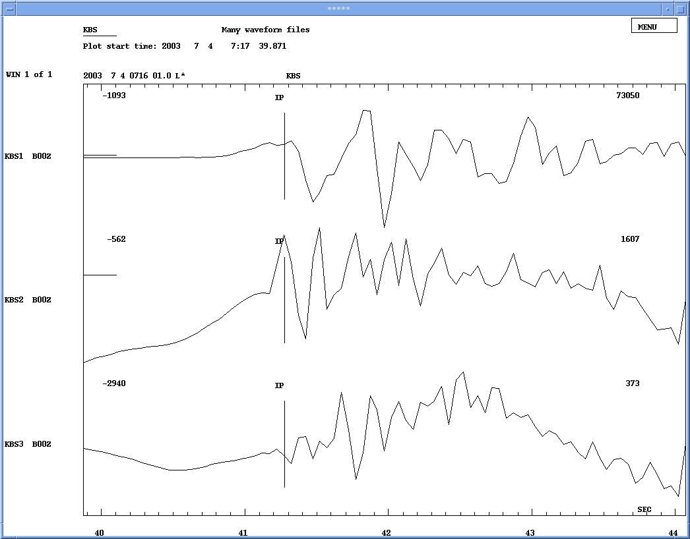
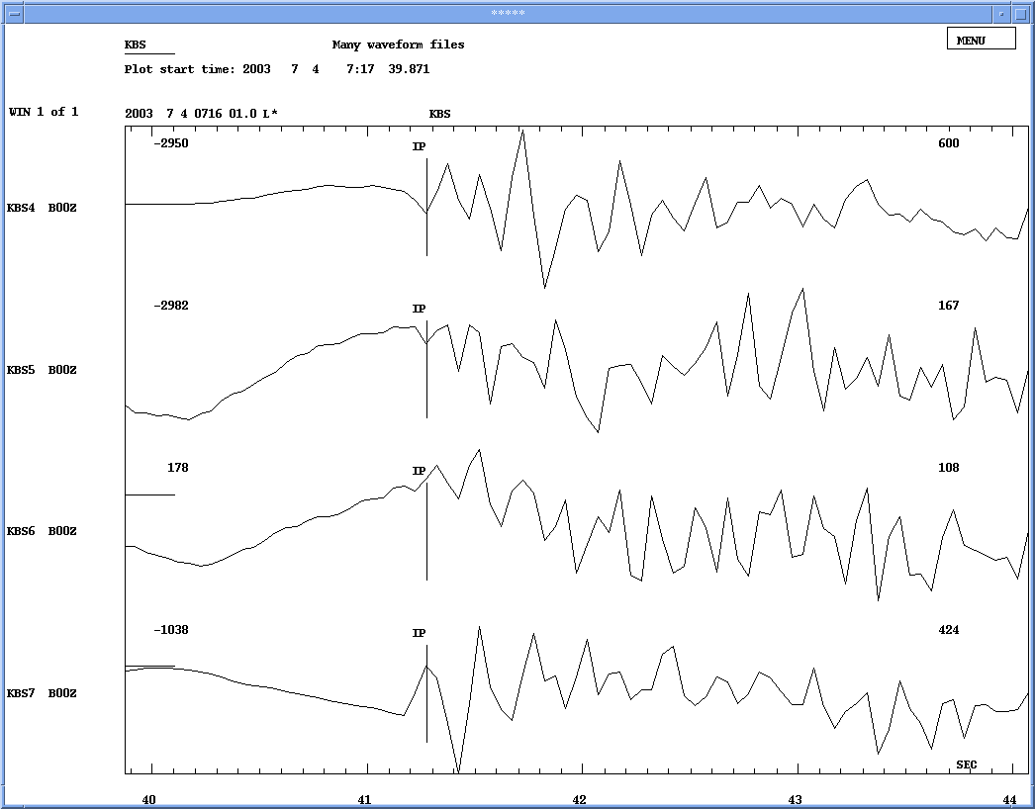

Table 6: Locations and residuals of events used for master event location. The table gives data in Nordic format. Note that the main shock is #1 and the master event #2.

2003 7 3 1359 55.0 L* 76.206 21.651 10.0FSTES 3 0.0 1
GAP=331 0.41 5.4 30.6 0.0 0.1522E+03 0.0000E+00 0.0000E+00E
event #1 = mainshock; corrected with event#2 res 3
ACTION:UP 03-10-15 13:58 OP:af STATUS: ID:20030703071611d I
STAT SP IPHASW D HRMM SECON CODA AMPLIT PERI AZIMU VELO AIN AR TRES W DIS CAZ7
HSP EN IP 1400 21.93 50 0.010 181 303
HSP EN ISg 1400 45.87 93 0.010 181 303
SPA3 SZ IP 9 1400 31.28 50 0.0 0 256 332
SPA3 SZ ISg 1401 06.99 92 0.110 256 332
KBS BN IP 9 1400 46.88 50 0.0 0 382 327
KBS BN ISg 1401 42.47 91 0.310 382 327

2003 7 3 1359 55.1 L* 76.206 21.647 10.0FFTES 3 0.0 1
GAP=331 0.27 3.6 20.3 0.0 0.6717E+02 0.0000E+00 0.0000E+00E
event #2 = masterevent; corrected with event#2 res 3
ACTION:UP 03-10-15 13:59 OP:af STATUS: ID:20030703071621d I
STAT SP IPHASW D HRMM SECON CODA AMPLIT PERI AZIMU VELO AIN AR TRES W DIS CAZ7
HSP EN IP 1400 21.93 50 0.010 181 303
HSP EN ISg 1400 45.89 93 0.010 181 303
SPA3 SZ IP 9 1400 31.28 50 0.0 0 256 332
SPA3 SZ ISg 1401 06.92 49 0.010 256 332
KBS BN IP 9 1400 46.88 50 0.0 0 382 327
KBS BN ISg 1401 42.20 49 0.010 382 327

2003 7 3 1359 54.1 L* 76.084 21.645 10.0FSTES 3 0.0 1
GAP=333 0.29 3.9 23.6 0.0 0.8670E+02 0.0000E+00 0.0000E+00E
event #3; corrected with event#2 res 3
ACTION:UP 03-10-15 14:00 OP:af STATUS: ID:20030703071631d I
STAT SP IPHASW D HRMM SECON CODA AMPLIT PERI AZIMU VELO AIN AR TRES W DIS CAZ7
HSP EN IP 1400 21.93 50 0.010 189 306
HSP EN ISg 1400 47.06 93 0.010 189 306
SPA3 SZ IP 9 1400 31.28 50 -0.5 0 268 333
SPA3 SZ ISg 1401 08.75 49 -0.110 268 333
KBS BN IP 9 1400 46.88 50 -0.5 0 393 328
KBS BN ISg 1401 44.06 49 0.110 393 328

2003 7 3 1359 53.4 L* 76.142 22.058 10.0FSTES 3 0.0 1
GAP=332 0.49 6.7 37.4 0.0 0.2327E+03 0.0000E+00 0.0000E+00E
event #4; corrected with event#2 res 3
ACTION:UP 03-10-15 14:00 OP:af STATUS: ID:20030703071641d I
STAT SP IPHASW D HRMM SECON CODA AMPLIT PERI AZIMU VELO AIN AR TRES W DIS CAZ7
HSP EN IP 1400 21.93 50 0.010 194 303
HSP EN ISg 1400 47.85 93 0.010 194 303
SPA3 SZ IP 9 1400 31.28 50 0.2 0 267 331
SPA3 SZ ISg 1401 08.50 49 -0.210 267 331
KBS BN IP 9 1400 46.88 50 0.2 0 394 327
KBS BN ISg 1401 44.33 49 0.310 394 327

2003 7 3 1359 54.0 L* 76.130 21.770 10.0FSTES 3 0.1 1
GAP=332 0.28 2.0 9.3 0.0 0.8491E+01 0.0000E+00 0.0000E+00E
event #5; corrected with event#2 res 3
ACTION:UP 03-10-14 18:22 OP:af STATUS: ID:20030703071651d I
STAT SP IPHASW D HRMM SECON CODA AMPLIT PERI AZIMU VELO AIN AR TRES W DIS CAZ7
HSP EN IP 1400 21.93 50 0.110 188 304
HSP EN ISg 1400 46.86 93 -0.110 188 304
SPA3 SZ IP 1400 31.28 50 -0.110 265 332
SPA3 SZ ISg 1401 08.43 92 0.010 265 332
KBS BN IP 1400 46.88 50 -0.110 391 327
KBS BN ISg 1401 43.70 91 0.010 391 327

2003 7 3 1359 53.4 L* 76.122 22.009 10.0FSTES 3 0.0 1
GAP=333 0.38 5.2 29.2 0.0 0.1407E+03 0.0000E+00 0.0000E+00E
event #6; corrected with event#2 res 3
ACTION:UP 03-10-15 14:02 OP:af STATUS: ID:20030703071701d I
STAT SP IPHASW D HRMM SECON CODA AMPLIT PERI AZIMU VELO AIN AR TRES W DIS CAZ7
HSP EN IP 1400 21.93 50 0.010 194 304
HSP EN ISg 1400 48.01 93 0.010 194 304
SPA3 SZ IP 9 1400 31.28 50 0.0 0 269 331
SPA3 SZ ISg 1401 09.07 49 0.110 269 331
KBS BN IP 9 1400 46.88 50 0.0 0 395 327
KBS BN ISg 1401 44.10 49 -0.210 395 327

2003 7 3 1359 53.7 L* 76.169 22.048 10.0FSTES 3 0.0 1
GAP=332 0.47 6.3 35.1 0.0 0.2065E+03 0.0000E+00 0.0000E+00E
event #7; corrected with event#2 res 3
ACTION:UP 03-10-14 18:32 OP:af STATUS: ID:20030703071711d I
STAT SP IPHASW D HRMM SECON CODA AMPLIT PERI AZIMU VELO AIN AR TRES W DIS CAZ7
HSP EN IP 1400 21.93 50 0.010 192 302
HSP EN ISg 1400 47.72 93 0.010 192 302
SPA3 SZ IP 9 1400 31.28 50 0.3 0 265 331
SPA3 SZ ISg 1401 08.50 49 0.210 265 331
KBS BN IP 9 1400 46.88 50 0.2 0 391 326
KBS BN ISg 1401 43.43 49 -0.210 391 326

2003 7 3 1359 54.0 L* 76.130 21.770 10.0FSTES 3 0.1 1
GAP=332 0.28 2.0 9.3 0.0 0.8491E+01 0.0000E+00 0.0000E+00E
event #5; corrected with event#2 res 3
ACTION:UP 03-10-14 18:22 OP:af STATUS: ID:20030703071651d I
STAT SP IPHASW D HRMM SECON CODA AMPLIT PERI AZIMU VELO AIN AR TRES W DIS CAZ7
HSP EN IP 1400 21.93 50 0.110 188 304
HSP EN ISg 1400 46.86 93 -0.110 188 304
SPA3 SZ IP 1400 31.28 50 -0.110 265 332
SPA3 SZ ISg 1401 08.43 92 0.010 265 332
KBS BN IP 1400 46.88 50 -0.110 391 327
KBS BN ISg 1401 43.70 91 0.010 391 327

2003 7 3 1359 53.4 L* 76.122 22.009 10.0FSTES 3 0.0 1
GAP=333 0.38 5.2 29.2 0.0 0.1407E+03 0.0000E+00 0.0000E+00E
event #6; corrected with event#2 res 3
ACTION:UP 03-10-15 14:02 OP:af STATUS: ID:20030703071701d I
STAT SP IPHASW D HRMM SECON CODA AMPLIT PERI AZIMU VELO AIN AR TRES W DIS CAZ7
HSP EN IP 1400 21.93 50 0.010 194 304
HSP EN ISg 1400 48.01 93 0.010 194 304
SPA3 SZ IP 9 1400 31.28 50 0.0 0 269 331
SPA3 SZ ISg 1401 09.07 49 0.110 269 331
KBS BN IP 9 1400 46.88 50 0.0 0 395 327
KBS BN ISg 1401 44.10 49 -0.210 395 327

2003 7 3 1359 53.7 L* 76.169 22.048 10.0FSTES 3 0.0 1
GAP=332 0.47 6.3 35.1 0.0 0.2065E+03 0.0000E+00 0.0000E+00E
event #7; corrected with event#2 res 3
ACTION:UP 03-10-14 18:32 OP:af STATUS: ID:20030703071711d I
STAT SP IPHASW D HRMM SECON CODA AMPLIT PERI AZIMU VELO AIN AR TRES W DIS CAZ7
HSP EN IP 1400 21.93 50 0.010 192 302
HSP EN ISg 1400 47.72 93 0.010 192 302
SPA3 SZ IP 9 1400 31.28 50 0.3 0 265 331
SPA3 SZ ISg 1401 08.50 49 0.210 265 331
KBS BN IP 9 1400 46.88 50 0.2 0 391 326
KBS BN ISg 1401 43.43 49 -0.210 391 326

Figure 11: Locations after using master event technique. Event #1 is the main shock and event #2 is the master event. Note that #1 and #2 are at the same location so only #2 is seen. The event numbers refer to Table 5c.
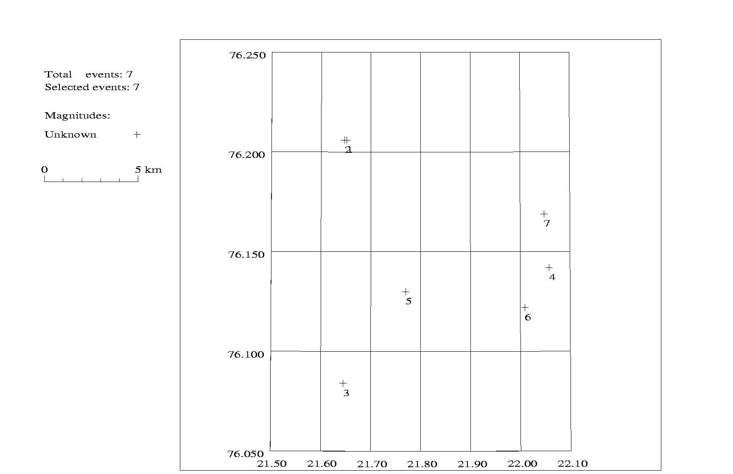

References

Bungum, H.: Two focal-mechanism solutions for earthquakes from Iceland and Svalbard, Tectonophysics, 41, T15-T18.

Reinecker, J., Heidbach, O. and Mueller, B. (2003): The 2003 release of the World Stress Map (available online at www.world-stress-map.org)

Appendix A

The following figures show the aligned traces for every station and all events used with the master event technique. Also the picked P- and S-phases are seen. The traces were aligned with the P-phases. For a correct solution it’s necessary to always use the same phase for each event. Also the same filter must be used.
Further the traces are named with the label of the station, the number of the event (last digit) and the component: SPA35 SH Z is station SPA3, event #5 and the vertical component (Z), for example. Event #1 is the main shock and event #2 the master event. The filter used is written in the second line, right of the plot start time, if it was necessary to use one.

For the stations HSP and KBS, the P-phases were picked on the vertical component (Z), because it was seen most clearly here. But in some cases the phases were seen most clearly on the NS component.
The station BJO is also shown, but it wasn’t used because of too low quality.

Figure A1: Station HSP – general view.

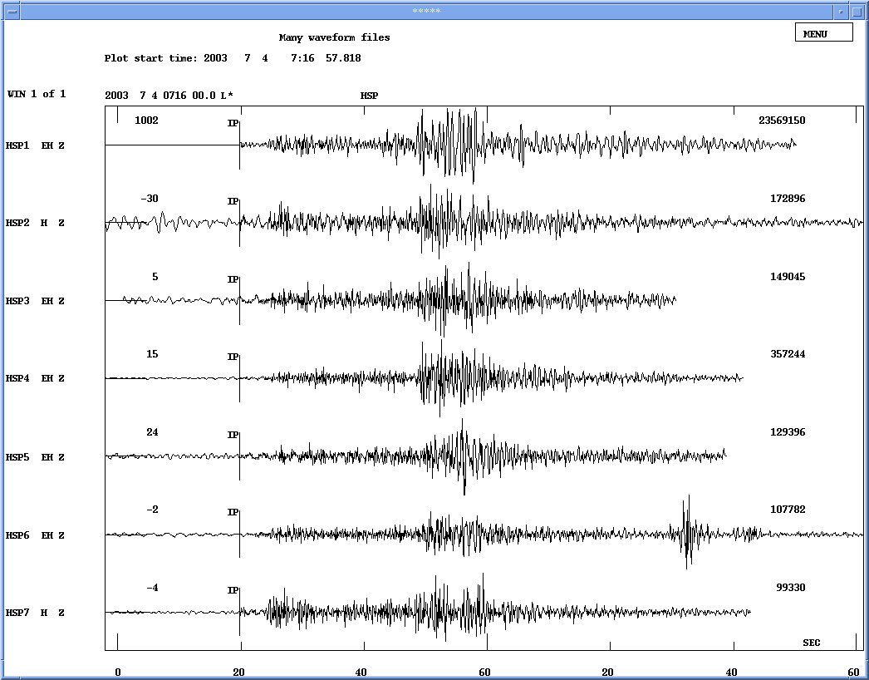
Figure A2: Station HSP - Picked P-phases.

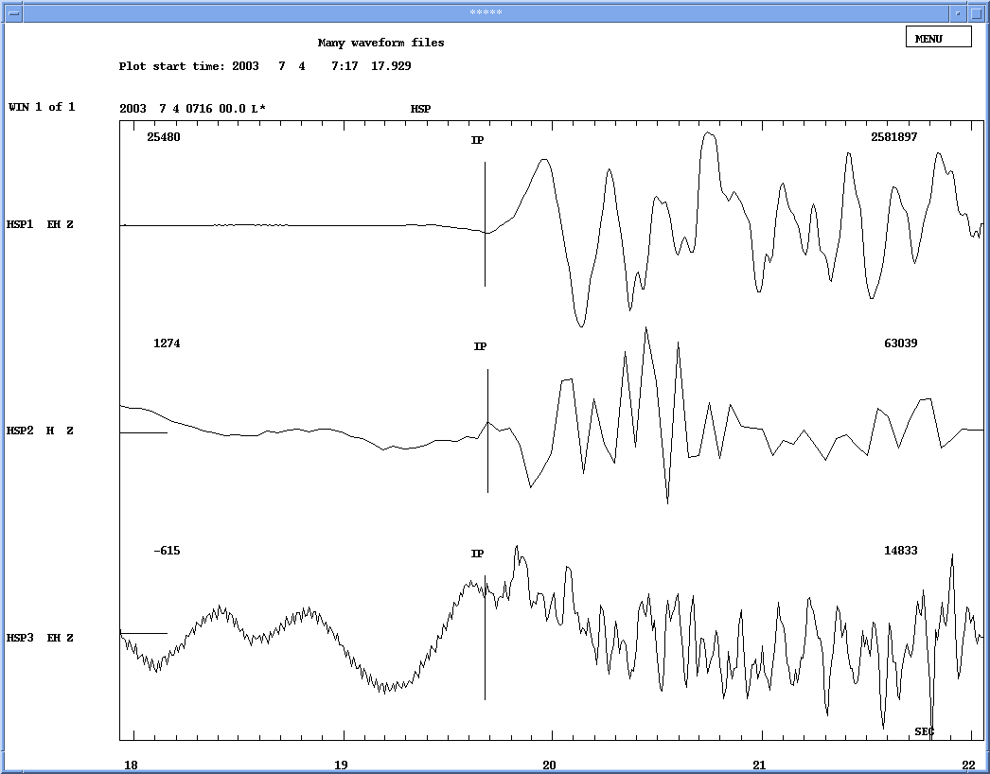

Figure A3: Station HSP - Picked P-phases.

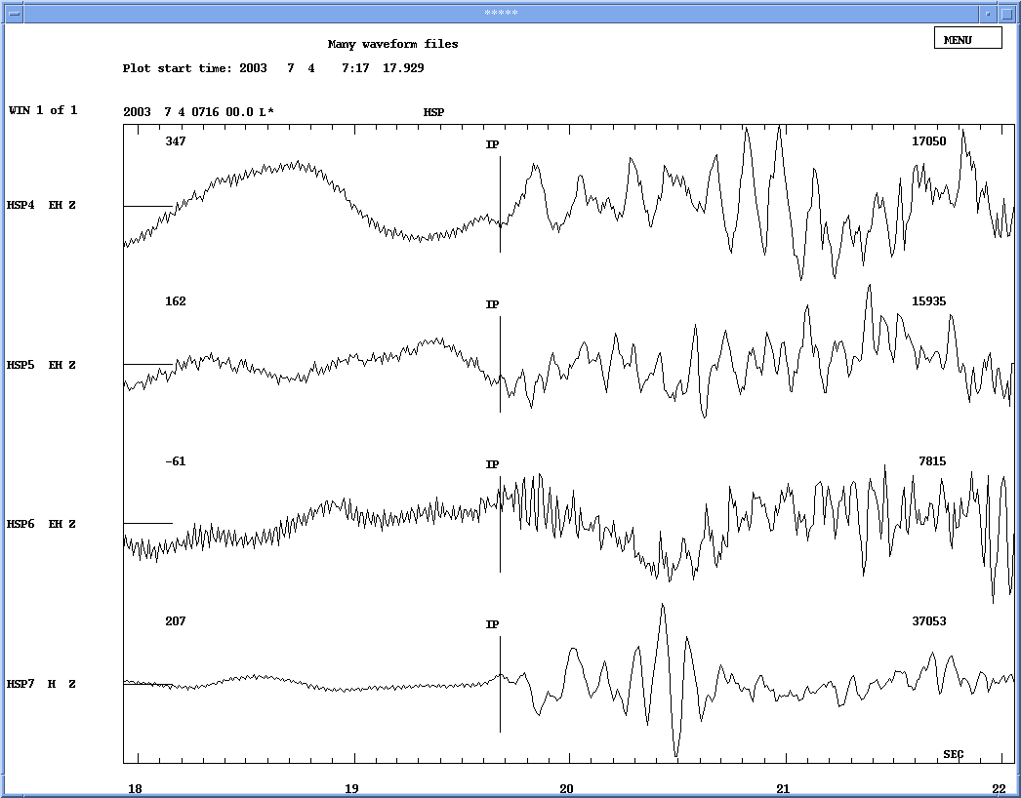
Figure A4: Station HSP – general view.

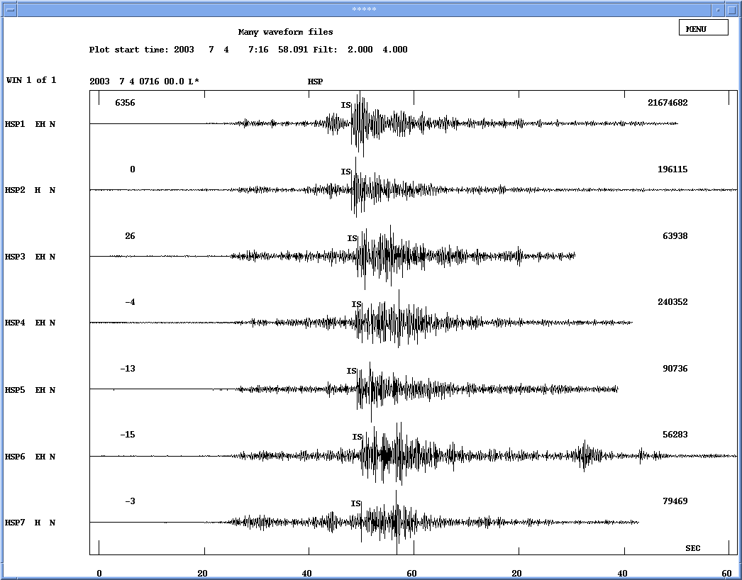
Figure A5: Station HSP - Picked S-phases.

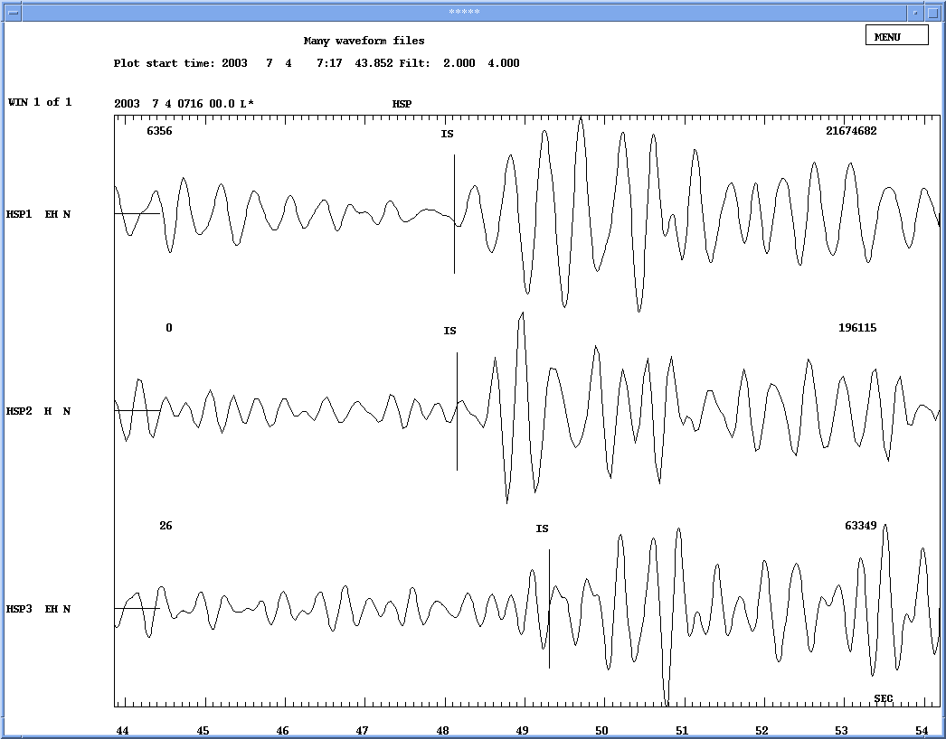

Figure A6: Station HSP - Picked S-phases.

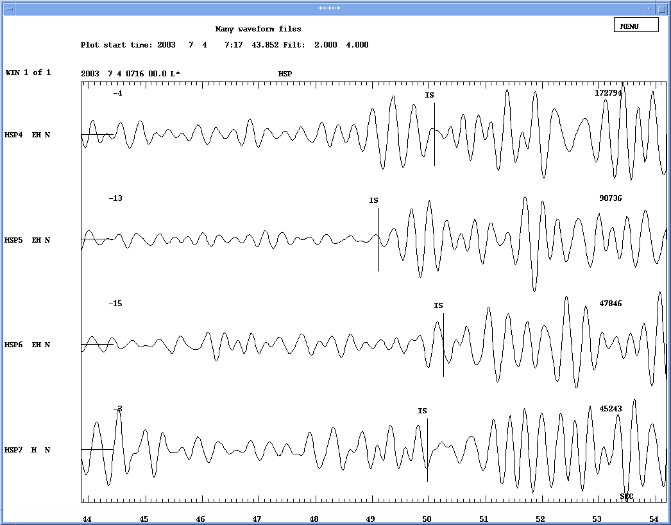
Figure A7: Station KBS – general view.

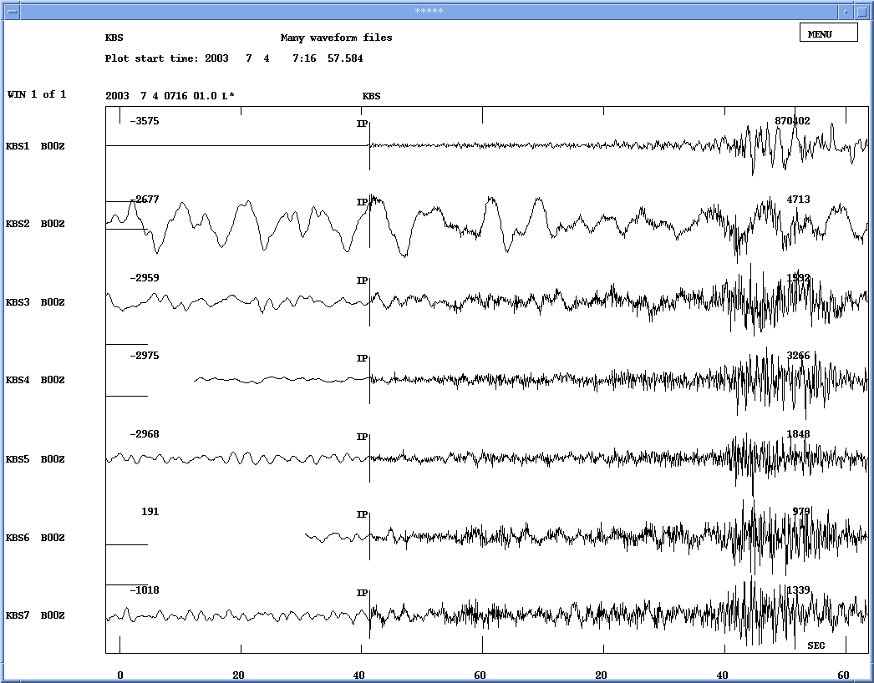
Figure A8: Station KBS – picked P-phases.

Figure A9: Station KBS – picked P-phases.

Figure A10: Station KBS – general view.

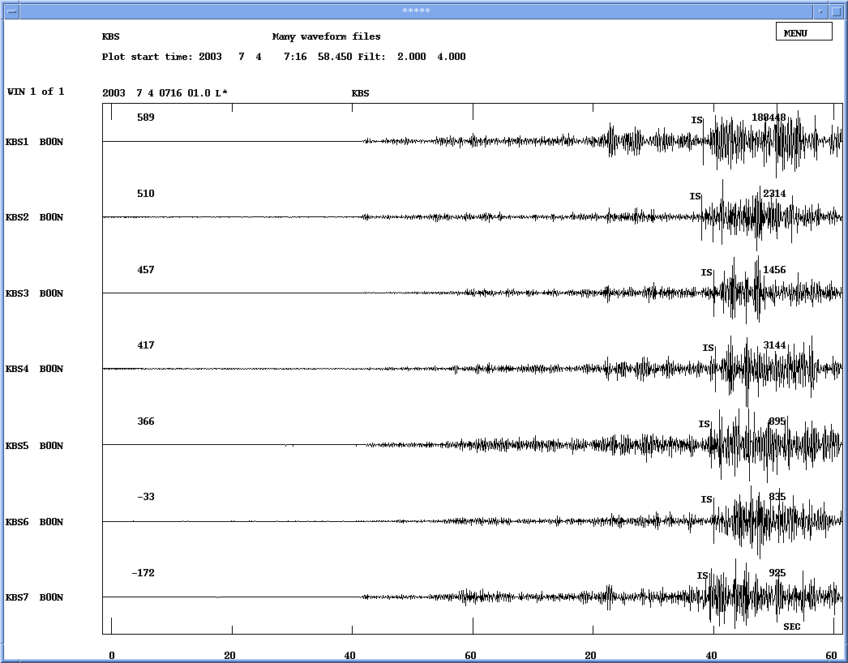
Figure A11: Station KBS – picked S-phases.

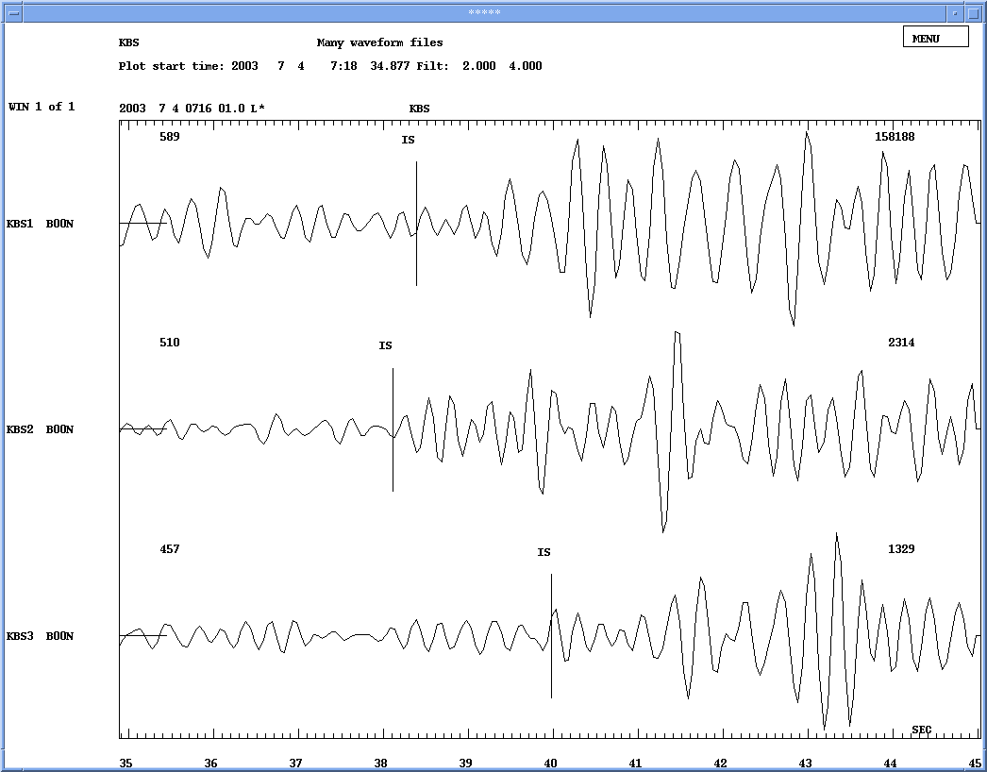

Figure A12: Station KBS – picked S-phases.

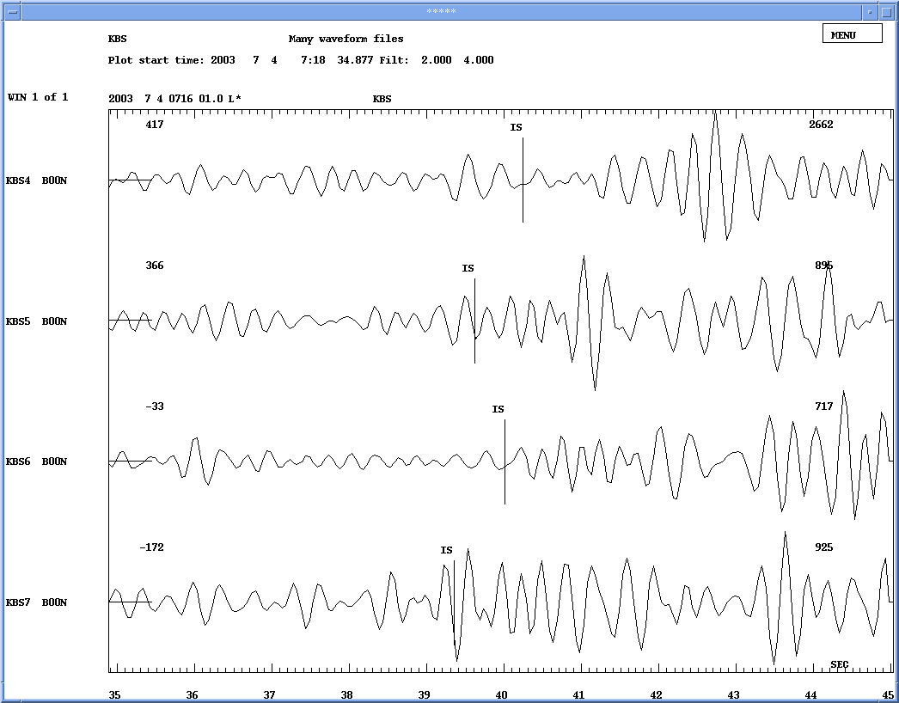
Figure A13: Station SPA3 – general view.

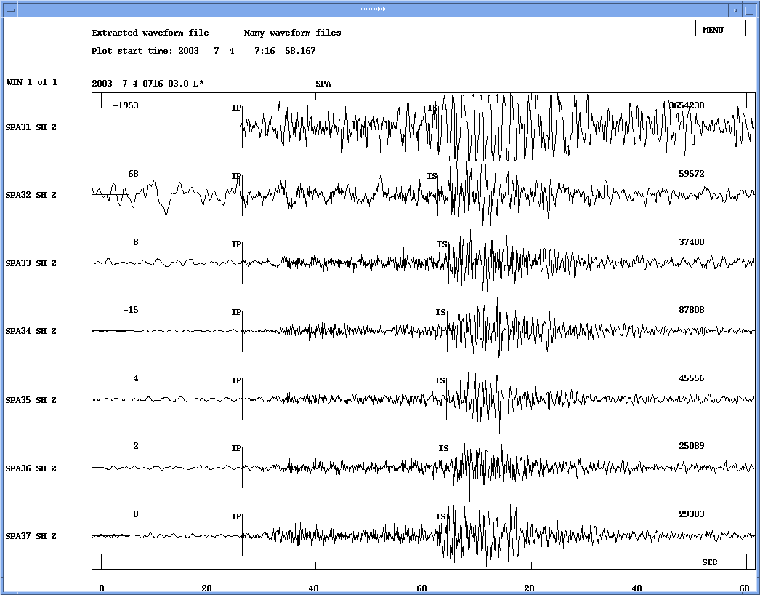
Figure A14: Station SPA3 – picked P-phases.

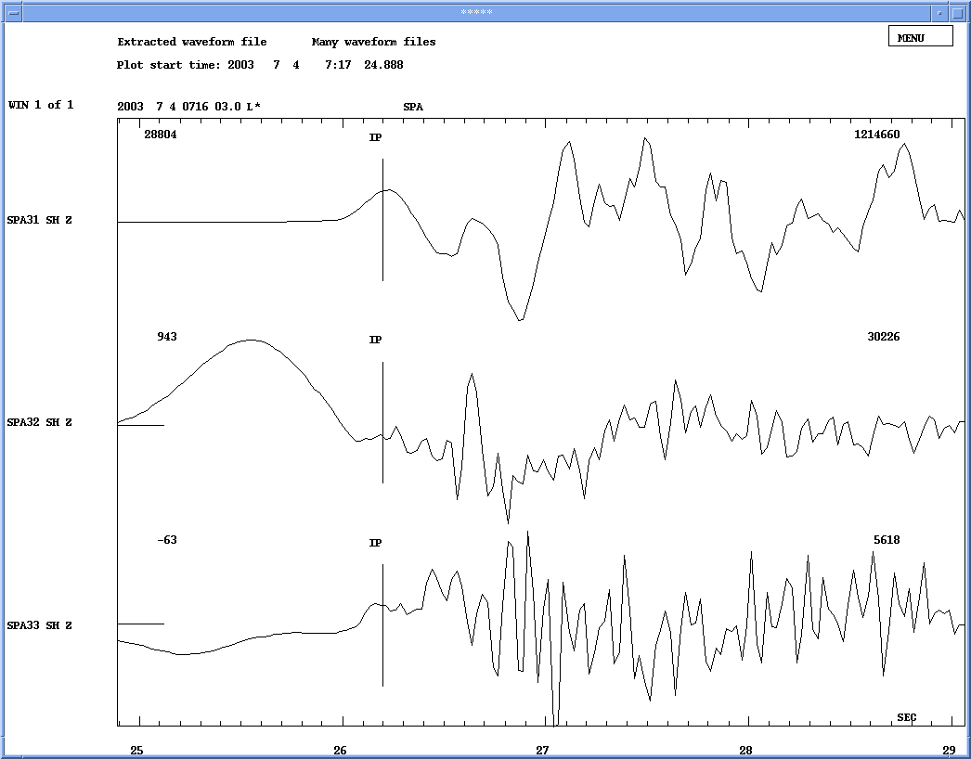

Figure A15: Station SPA3 – picked P-phases.

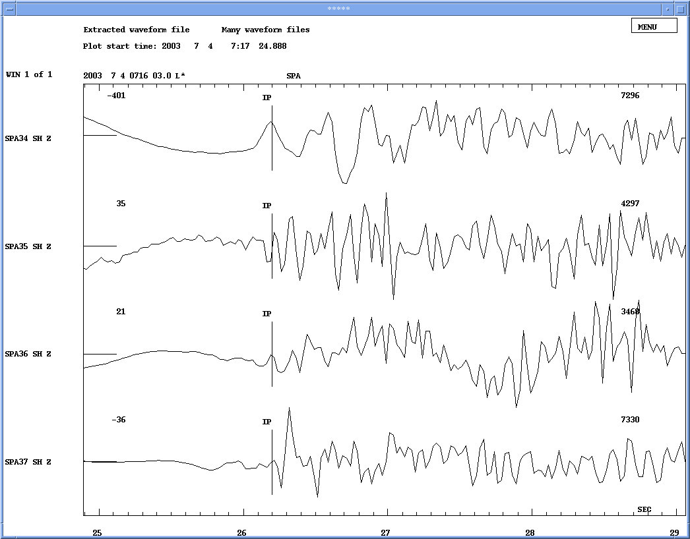
Figure A16: Station SPA3 – picked S-phases.

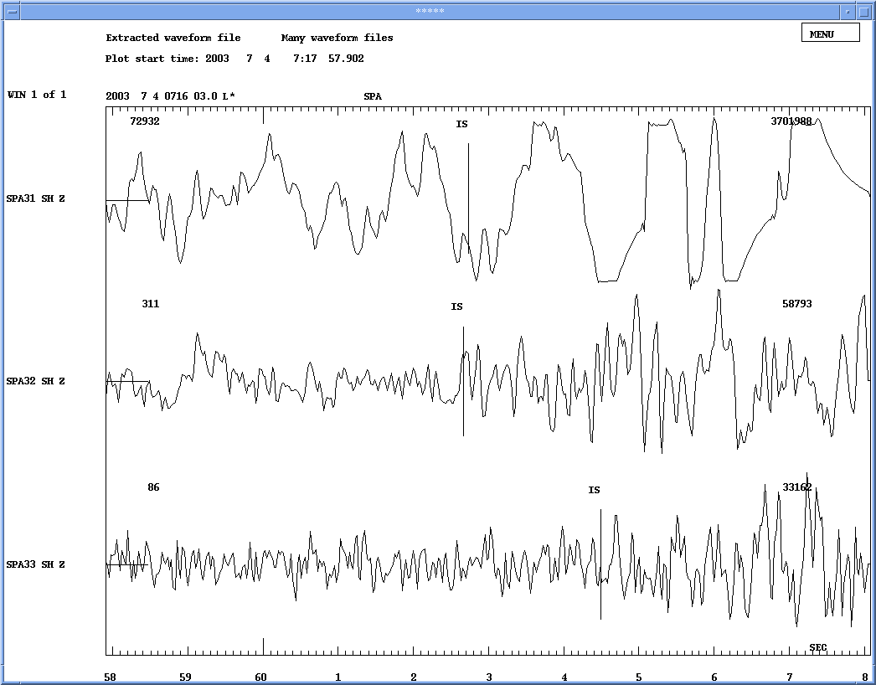

Figure A17: Station SPA3 – picked S-phases.

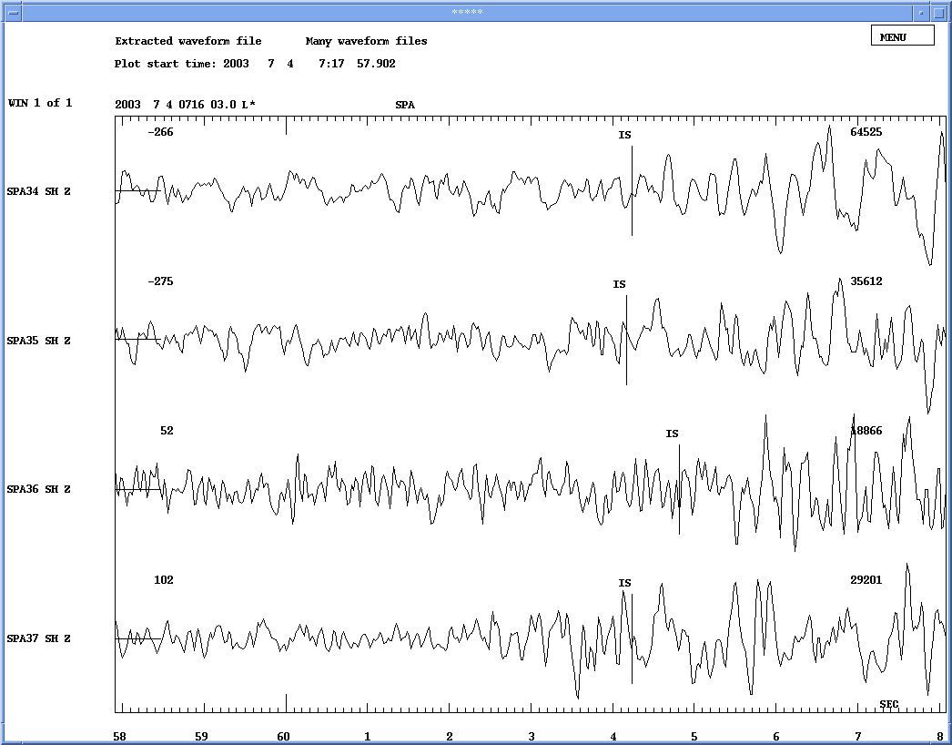

Figure A18: Station BJO – vertical component (Z).

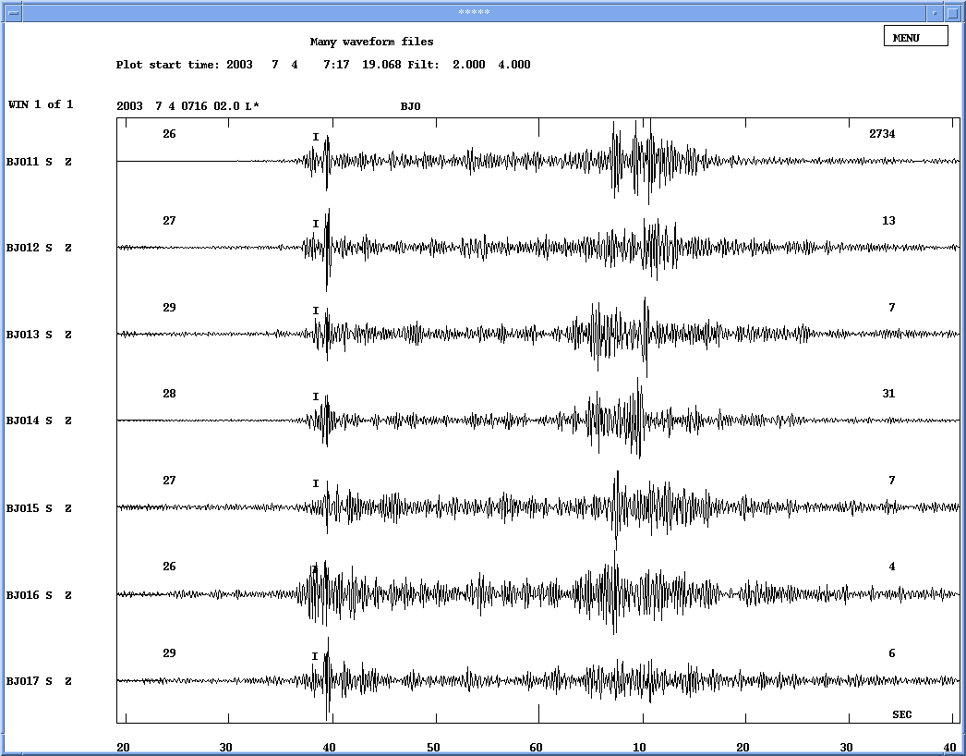

Figure A19: Station BJO – north-south component (N).
There is no filter to get a better view to the data.

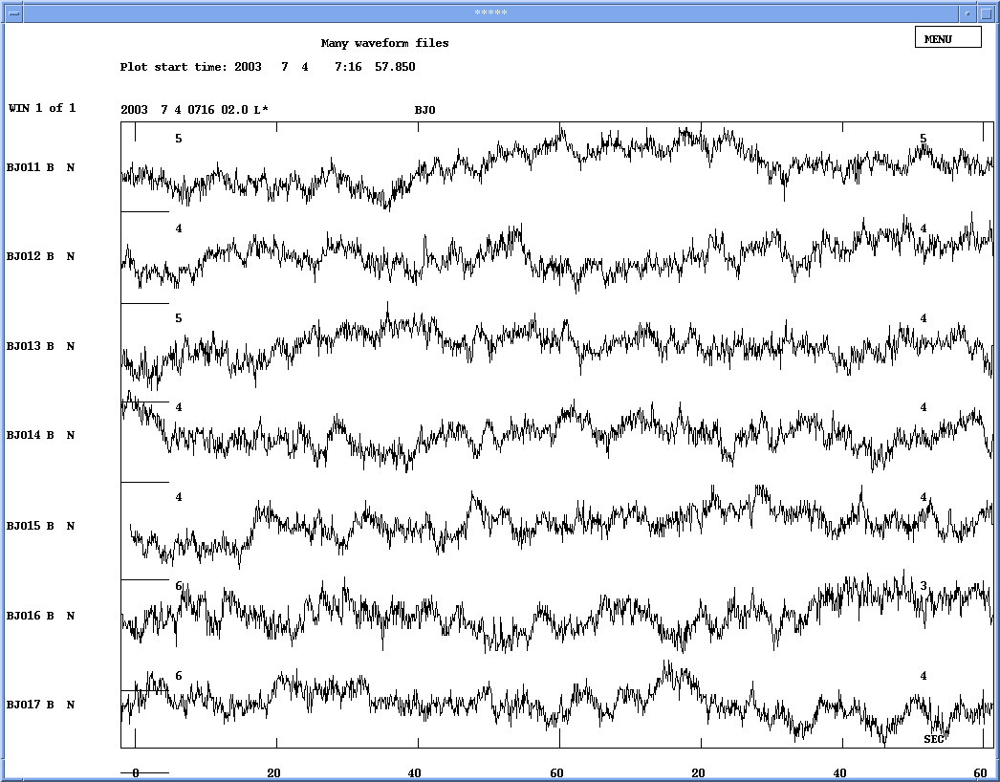
Figure A20: Station BJO – east-west component (E).
There is no filter to get a better view to the data.

