Introduction

Norwegian National Seismic Network

Technical Report No. 15

Earthquake swarms
off the west coast of Norway

Prepared by

ANDREAS FETTIG

Dept. of Earth Science, University of Bergen
Allégt.41, N-5007 Bergen, Norway
Tel: +47-55-583600 Fax: +47-55-583660 E-mail: seismo@geo.uib.no

October 2003

Since the beginning of the registration of earthquakes at the west coast of Norway, many events have occurred with varying positions and magnitudes. Sometimes a series of events occurs with similar locations and magnitudes, but without any main shock. They can occur over an interval of time, which may extend to some days or some weeks. That kind of series is called an earthquake swarm.
This report analyzes one of the swarms that occurred at the west coast of Norway. The basis is the Bergen database and SEISAN was used for analysis.

Identified swarms

For searching for swarms, the program SWARM was used in a time interval from Oct 1982 to Oct 2003, where waveform data are available in the Bergen database. Figure 1 shows all the registered events at the west coast of Norway in that time period.

Figure 1: Registered events in the Bergen database at the west coast of Norway. You see a time interval from Oct1982 to Oct2003.
NOTE: You cannot see any swarms, because the time interval is too big.

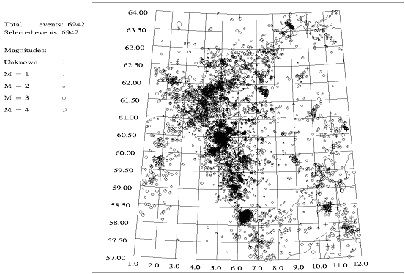
Following parameters were used for searching:

Latitude range and grid size (degree): 61 64 0.2
Longitude range and grid size (degree): 1 5 0.2
Radius of cell and back ground cell (degree): 0.2 0.8
Time window (days): 7
Minimum number of events in window: 10
Ratio cell activity – back ground cell activity: 5

So a grid of 61 to 64 degree latitude and 1 to 5 degree longitude was searched for swarms. The limits in the latitude and longitude were set to exclude possible explosions at the coast of Norway. The grid size is the interval, in which the location for searching is changed. A swarm is found if the events of the swarm appear in the given time window and in the given radius of cell. The back ground cell is used to recognize, that there is a bigger seismic activity inside the swarm than outside, since this is a requirement for a swarm.
In this way two different swarms were identified. Figure 2 shows the locations of the swarms. Swarm #1 (see Table 1) was chosen for further analysis, also swarm #2 should be analyzed in another report.

Figure 2: Identified swarms. See the text for searching parameters. Swarm #1 was used for further analysis.

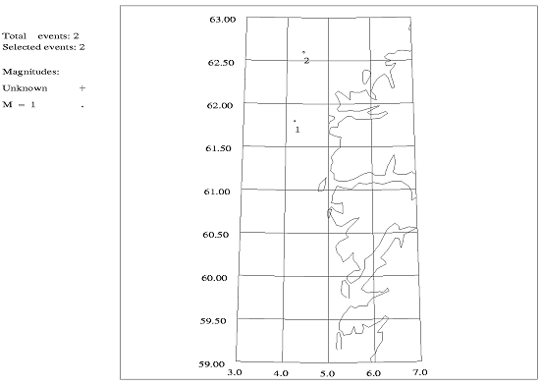
Table 1: List of events in swarm number 1.
#1 1995 9 5 2013 14.8 L* 61.799 4.240 10.0F BER 11 1.0 2.4CBER 2.0LBER 1.8LNAO1
#2 1995 9 8 0949 23.9 L* 61.625 4.333 11.0F BER 16 2.1 2.8CBER 2.6LBER 2.6LNAO1
#3 1995 9 8 1004 34.9 L 61.858 4.224 3.6 BER 5 0.7 2.3CBER 1.8LBER 1
#4 1995 9 8 1205 26.1 L 61.828 4.189 4.3 BER 5 0.4 1.9CBER 1.5LBER 1
#5 1995 9 8 1725 39.6 L 61.853 4.210 0.1 BER 3 0.6 1.4CBER 1
#6 1995 9 8 1957 23.4 L* 61.831 4.042 15.0 BER 22 1.1 3.0CBER 2.8LBER 2.9LNAO1
#7 1995 9 8 2051 45.1 L 61.811 4.099 7.1 BER 13 1.1 2.5CBER 2.3LBER 2.2LNAO1
#8 1995 9 8 2114 27.2 L 61.840 4.296 15.0 BER 6 0.6 1.9CBER 1.5LBER 1
#9 1995 9 9 1214 49.2 L 61.848 4.236 15.0 BER 7 0.6 2.2CBER 2.0LBER 1
#10 1995 9 9 1350 37.8 L 61.817 4.046 13.8 BER 23 1.7 3.0CBER 3.0LBER 3.2LNAO1
#11 1995 9 9 1530 12.5 L 61.850 4.311 7.5 BER 6 0.7 2.0CBER 1.5LBER 1

1993 626 1355 25.1 L 62.600 4.400 16.7 1.4NSWM 1
Swarm No 2 Number of events: 14 Background: 0.03442 3
1993 626 1355 25.1 L 62.619 4.139 16.7 BER 15 1.3 3.9CBER 1
1993 626 1430 4.4 L 62.584 4.300 12.1 BER 3 0.1 2.2CBER 1
1993 626 1447 12.3 L 62.508 4.344 12.2 BER 6 0.9 2.3CBER 1
1993 626 1506 24.1 L 62.582 3.999 13.0 BER 15 1.4 3.8CBER 1
1993 626 1549 53.1 L 62.640 4.664 22.8 BER 3 1.0 2.2CBER 1
1993 626 1758 12.6 L 62.481 4.344 15.0 BER 6 1.0 2.2CBER 1
1993 626 1801 30.4 L 62.560 4.170 12.1 BER 5 1.0 2.4CBER 1
1993 626 1850 51.7 L 62.645 4.498 15.8 BER 4 1.3 2.0CBER 1
1993 626 1956 3.7 L 62.593 4.661 0.0 BER 3 0.4 1.9CBER 1
1993 627 0036 37.7 L 62.526 4.228 12.1 BER 7 0.7 2.4CBER 1
1993 627 0146 2.1 L 62.476 4.138 15.0 BER 4 1.3 2.0CBER 1
1993 627 0222 57.3 L 62.497 4.244 12.1 BER 6 0.7 2.3CBER 1
1993 627 0345 3.9 L 62.520 4.615 0.0 BER 5 0.9 2.6CBER 1
1993 629 0418 35.4 L 62.534 4.250 0.0 BER 4 0.9 1.8CBER 1

Swarm # 1

Waveforms

Table 2 gives the availability of waveform data in the Bergen database for all 11 events. For further analysis, only the nearest stations with the highest availability were chosen:

FOO, SUE, ASK (because of the better data quality in comparison to the stations BER and EGD) and MOL.

Table 2: Availability of waveform data for the 11 events in the swarm #1. The event numbers refer to Table 1. The stations marked with gray were used for further analysis.

Event  Station | #1 | #2 | #3 | #4 | #5 | #6 | #7 | #8 | #9 | #10 | #11
FOO | x | x | x | x | x | x | x | x | x | x | x
HYA | x | x |  | x |  | x | x | x | x | x | x
SUE | x |  |  | x | x | x | x | x | x | x | x
BER | x | x | x | x |  | x | x | x | x | x | x
EGD | x | x | x | x |  | x | x | x | x | x | x
ASK | x | x | x | x |  | x | x | x | x | x | x
MOL | x | x | x | x | x | x | x | x | x | x | x
ODD | x | x | x |  |  | x | x |  | x | x | x
KMY | x | x |  |  |  | x | x |  |  | x
BLS | x | x |  |  |  | x | x |  |  | x
KONO |  | x |  |  |  | x |  |  |  | x
OSG |  |  |  |  |  | x |  |  |  | x
NSS |  |  |  |  |  | x | x |  |  | x
NRA |  |  |  |  |  | x
Figure 3 gives a general view about the positioning of the stations. It is seen that there is an alignment in north-south direction of the stations. This may cause some problems in constraining event locations in the east-west direction while it should be better in the north-south direction.

Figure 3: Locations of available stations. The stations FOO, SUE, ASK and MOL were used for further analysis.

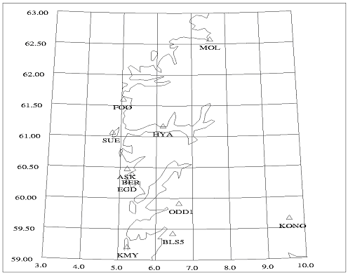

Relocating and magnitudes

At first a checking/picking of the phases, recorded for the events in swarm #1, was done to relocate the events to get well-determined locations. Figure 4 shows the events before relocation and Figure 5 shows the events after. Only the four stations, mentioned above, were used. It is seen that the events spread over an area of about 15km x 6 km before relocating and 9km x 6km after relocating. Event #2, which is far outside in Figure 4, is now located inside the swarm.

Figure 4: Events of the swarm #1 before relocating. The event numbers refer to Table 1.

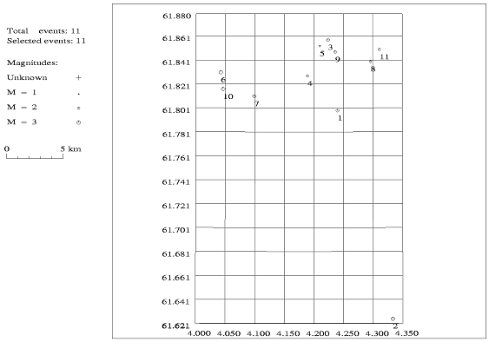

Figure 5: Events of the swarm #1 after relocating. The event numbers refer to Table 1. The scale is the same as in Figure 4.

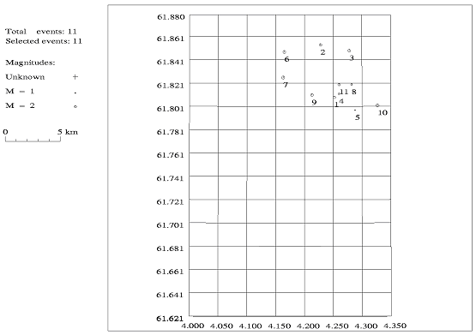
Further the magnitudes were re-estimated, because only the 4 nearest stations were used for analyzing. Table 3 shows the new magnitudes in comparison with the old ones.

Table 3: Original magnitudes before re-locating at the left side. At the right side the re-estimated values. The event numbers refer to Table 1.

Original magnitudes | Re-estimated magnitudes
  Event | Mc | Ml | Agency
  #1 | 2.4  - | 2.0  1.8 | BER  NAO
  #2 | 2.8  - | 2.7  2.6 | BER  NAO
  #3 | 2.3 | 1.8 | BER
  #4 | 1.9 | 1.5 | BER
  #5 | 1.4 | - | BER
  #6 | 3.0  - | 2.8  2.9 | BER  NAO
  #7 | 2.5  - | 2.3  2.2 | BER  NAO
  #8 | 1.9 | 1.5 | BER
  #9 | 2.2 | 2.0 | BER
  #10 | 3.0  - | 3.0  3.2 | BER  NAO
  #11 | 2.0 | 1.5 | BER
  Event | Mc | Ml
  #1 | 2.2 | 1.8
  #2 | 2.2 | 2.7
  #3 | 2.3 | 1.5
  #4 | - | 1.4
  #5 | - | 0.7
  #6 | 2.4 | 3.1
  #7 | 2.6 | 2.2
  #8 | - | 1.5
  #9 | 2.4 | 1.7
  #10 | 2.5 | 3.2
  #11 | 1.9 | 1.3

Master Event Technique

To get better-determined locations, the Master Event Technique was used. The idea is to choose one event as a master event and locate the other events relative to this one. This is done by using the residuals of the master event as station corrections for the other events assuming that the same phases have been used for all locations. Because of the good data quality, as seen in Figure 6, it is easy to find the same phase for each station.

Figure 6: Traces of event #10 (= master event) with the picked phases used for Master Event Technique. Only the four nearest stations was used: FOO, SUE, ASK and MOL. The picks were made with a filter (see Appendix A).

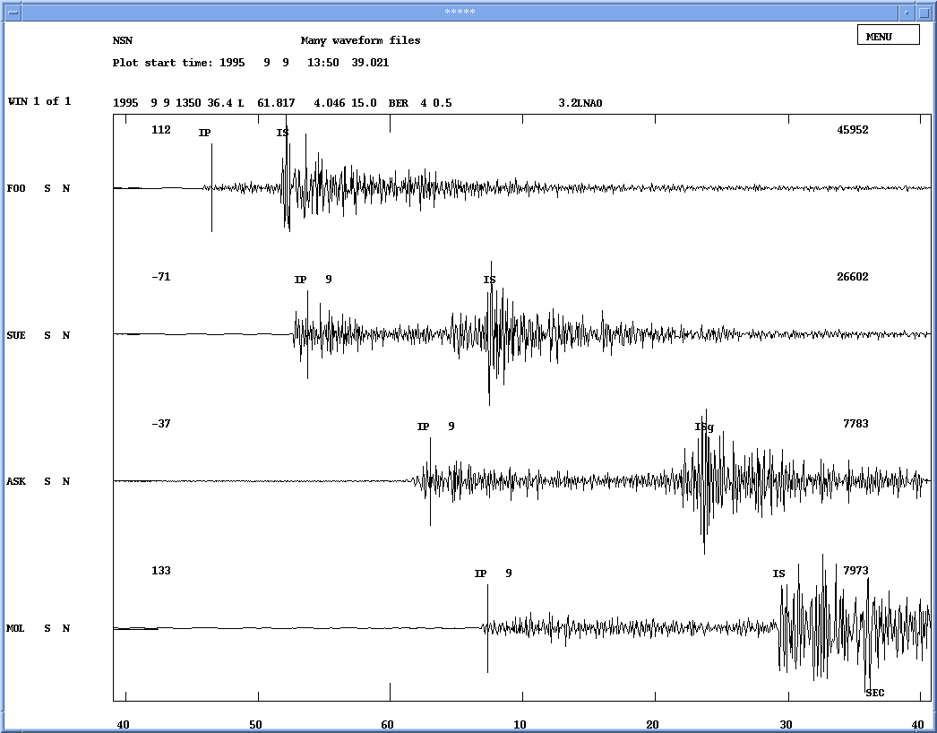
For a better identification the traces were aligned (see Appendix A) and the picking on the original traces were done with the help of the aligned traces. Phases picked were clear and with large amplitudes and not necessarily the first movement (see Appendix A). The type of the phase was selected to be first arrival (P or S) so the location program automatically determines which kind of phase is read (Pn, Pg, Sn or Sg). However, for station ASK the phase was fixed to Sg, because it resulted in better residuals.
For calculation event #10 was chosen as the master event and the depth was fixed to 15 km. The location of event #10 was used as a start location for the other events. In Table 4 ((a) to (c)) you can see the arrival times (also shown in Table 5), the calculated residuals and the relative locations. Figure 7 shows a map with all events, relocated by Master Event Technique, with absolute location for event #10 (master event; location calculated by BER) and locations relative to this event for the other events of the swarm.
Also Table 4 clearly shows that changes in S-P times is so small at all stations (less than 0.06 s) that the events in the swarm must be located within a few hundred m of each other.
In Figure 7 it is seen that all events are located within an area of about 380m x 440m. Without events #9 and #11, which seem to be slightly outside of the main area, the area is about 220m x 320m, where 50m is the shortest and 100m is the biggest distance between the events. Note that S-P times have been used to eliminate any possible timing errors.

Figure 7: Locations after using Master Event Technique. Event #10 is the master event. Note that #1 and #7 are at the same location so only #7 is seen. The event numbers refer to Table 1 and Table 5 respectively.

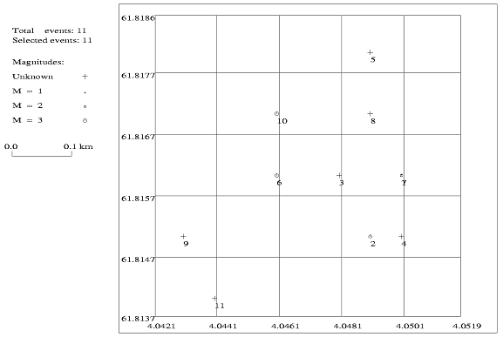
Table 4: (a) Arrival times used for Master Event Technique. P is the P-time and only has absolute relevance for the master event. S is the same as P for S-waves. S-P is the S-P time. D(S-P) is the change in S-P time relative to the master event. For all stations the North-South component (N) was used. The numbers refer to event number, given in Table 1, and below is given the day, hour and minute. For the events #2, #3 and #5 only 3 stations were available.

 |  | #10 | #1 | #2 | #3 | #4 | #5
Station | Times | 09 1350 | 05 2013 | 08 0949 | 08 1004 | 08 1205 | 08 1725
 |  | Master
FOO | P | 46,48 | 22,95 | 28,92 | 44,52 | 35,05 | 48,61
 | S | 52,43 | 28,92 | 34,88 | 50,47 | 41,01 | 54,58
N | S – P | 5,95 | 5,97 | 5,96 | 5,95 | 5,96 | 5,97
 | D(S – P) |  | 0,02 | 0,01 | 0 | 0,01 | 0,02
SUE | P | 53,77 | 29,49 | - | - | 41,84 | 55,5
 | S | 67,97 | 43,65 | - | - | 55,99 | 69,7
N | S – P | 14,2 | 14,16 | - | - | 14,15 | 14,2
 | D(S – P) |  | -0,04 | - | - | -0,05 | 0
ASK | P | 62,99 | 39,43 | 45,44 | 61,01 | 51,54 | -
 | S | 84,02 | 60,43 | 66,42 | 82,01 | 72,52 | -
N | S – P | 21,03 | 21 | 20,98 | 21 | 20,98 | -
 | D(S – P) |  | -0,03 | -0,05 | -0,03 | -0,05 | -
MOL | P | 67,33 | 43,89 | 49,73 | 65,28 | 55,75 | 69,13
 | S | 89,88 | 66,41 | 72,26 | 87,82 | 78,25 | 91,65
N | S – P | 22,55 | 22,52 | 22,53 | 22,54 | 22,5 | 22,52
 | D(S – P) |  | -0,03 | -0,02 | -0,01 | -0,05 | -0,03

 |  | #10 | #6 | #7 | #8 | #9 | #11
station | times | 09 1350 | 08 1957 | 08 2051 | 08 2114 | 09 1214 | 09 1530
 |  | Master
FOO | P | 46,48 | 32,09 | 54,18 | 35 | 57,44 | 20,78
 | S | 52,43 | 38,06 | 60,13 | 40,98 | 63,41 | 26,74
N | S - P | 5,95 | 5,97 | 5,95 | 5,98 | 5,97 | 5,96
 | D(S - P) |  | 0,02 | 0 | 0,03 | 0,02 | 0,01
SUE | P | 53,77 | 39,26 | 61,21 | 42,05 | 64,24 | 28,09
 | S | 67,97 | 53,44 | 75,37 | 56,22 | 78,43 | 42,26
N | S - P | 14,2 | 14,18 | 14,16 | 14,17 | 14,19 | 14,17
 | D(S - P) |  | -0,02 | -0,04 | -0,03 | -0,01 | -0,03
ASK | P | 62,99 | 48,62 | 70,63 | 51,54 | 73,94 | 37,3
 | S | 84,02 | 69,63 | 91,63 | 72,56 | 94,95 | 58,3
N | S - P | 21,03 | 21,01 | 21 | 21,02 | 21,01 | 21
 | D(S - P) |  | -0,02 | -0,03 | -0,01 | -0,02 | -0,03
MOL | P | 67,33 | 53,02 | 75,13 | 55,95 | 78,35 | 41,7
 | S | 89,88 | 75,56 | 97,65 | 78,44 | 100,91 | 64,26
N | S - P | 22,55 | 22,54 | 22,52 | 22,49 | 22,56 | 22,56
 | D(S - P) |  | -0,01 | -0,03 | -0,06 | 0,01 | 0,01

Table 4: (b) Residuals of master event when located fixed to the location as given in the Bergen catalogue (see Table 1). Note that the residuals of the master event are rather large since phase arrivals are not the first arrivals as used for the original location.

Station | Phase | Residual(s)
FOO | P | 0,54
 | S | -0,54
SUE | P | 2,57
 | S | 5,86
ASK | P | 2,43
 | S | 3,62
MOL | P | 2
 | S | 3,18

Table 4: (c) Arrival times corrected for master event residuals. The numbers refer to Table 1. For the events #2, #3 and #5, only 3 stations were available.

times - res |  | #1 | #2 | #3 | #4 | #5 | #6 | #7 | #8 | #9 | #11
FOO | P | 22,41 | 28,38 | 43,98 | 34,51 | 48,07 | 31,55 | 53,64 | 34,46 | 56,9 | 20,24
 | S | 29,46 | 35,42 | 51,01 | 41,55 | 55,12 | 38,6 | 60,67 | 41,52 | 63,95 | 27,28
SUE | P | 26,92 | - | - | 39,27 | 52,93 | 36,69 | 58,64 | 39,48 | 61,67 | 25,52
 | S | 37,79 | - | - | 50,13 | 63,84 | 47,58 | 69,51 | 50,36 | 72,57 | 36,4
ASK | P | 37 | 43,01 | 58,58 | 49,11 | - | 46,19 | 68,2 | 49,11 | 71,51 | 34,87
 | S | 56,81 | 62,8 | 78,39 | 68,9 | - | 66,01 | 88,01 | 68,94 | 91,33 | 54,68
MOL | P | 41,89 | 47,73 | 63,28 | 53,75 | 67,13 | 51,02 | 73,13 | 53,95 | 76,35 | 39,7
 | S | 63,23 | 69,08 | 84,64 | 75,07 | 88,47 | 72,38 | 94,47 | 75,26 | 97,73 | 61,08

Table 5: Locations and residuals of events used for master event location. The table gives data in Nordic format. Note that the master event #10.
1995 9 5 2013 13.0 L* 61.816 4.050 15.0FSBER 4 0.0 1.8LNAO1
GAP=267 0.26 1.7 4.8 0.0 0.3940E+01 0.0000E+00 0.0000E+00E
event #1; corrected with event #10 res 3
STAT SP IPHASW D HRMM SECON CODA AMPLIT PERI AZIMU VELO AIN AR TRES W DIS CAZ7
FOO SN IP C 2013 22.41 96 0.010 57.8 114
FOO SN IS 2013 29.46 96 0.010 57.8 114
SUE SN IP 9 2013 26.92 93 -0.8 0 92.6 155
SUE SN IS 2013 37.79 0.010 92.6 155
ASK SN IP 9 2013 37.00 55 -0.1 0 162 157
ASK SN ISg 2013 56.81 0.010 162 157
MOL SN IP 9 2013 41.89 55 0.0 0 201 64
MOL SN IS 2014 3.23 0.010 201 64

1995 9 8 0949 18.9 L* 61.815 4.049 15.0FSBER 3 0.0 2.6LNAO1
GAP=267 0.28 2.1 5.1 0.0 0.3851E+01 0.0000E+00 0.0000E+00E
event #2; corrected with event #10 res 3
STAT SP IPHASW D HRMM SECON CODA AMPLIT PERI AZIMU VELO AIN AR TRES W DIS CAZ7
FOO SN IP 949 28.38 96 0.010 57.9 114
FOO SN IS 949 35.42 96 0.010 57.9 114
ASK SN IP 9 949 43.01 55 0.0 0 162 157
ASK SN ISg 950 2.80 0.010 162 157
MOL SN IP 9 949 47.73 55 -0.1 0 201 64
MOL SN IS 950 9.08 0.010 201 64

1995 9 8 1004 34.5 L 61.816 4.048 15.0FSBER 3 0.0 1
GAP=267 0.27 2.1 5.1 0.0 0.3791E+01 0.0000E+00 0.0000E+00E
event #3; corrected with event #10 res 3
STAT SP IPHASW D HRMM SECON CODA AMPLIT PERI AZIMU VELO AIN AR TRES W DIS CAZ7
FOO SN IP 10 4 43.98 96 0.010 57.9 114
FOO SN IS 10 4 51.01 96 0.010 57.9 114
ASK SN IP 9 10 4 58.58 55 0.0 0 162 157
ASK SN ISg 10 5 18.39 0.010 162 157
MOL SN IP 9 10 5 3.28 55 -0.1 0 201 64
MOL SN IS 10 5 24.64 0.010 201 64

1995 9 8 1205 25.1 L 61.815 4.050 15.0FSBER 4 0.0 1
GAP=267 0.26 1.8 4.9 0.0 0.4052E+01 0.0000E+00 0.0000E+00E
event #4; corrected with event #10 res 3
STAT SP IPHASW D HRMM SECON CODA AMPLIT PERI AZIMU VELO AIN AR TRES W DIS CAZ7
FOO SN IP 12 5 34.51 96 0.010 57.8 114
FOO SN IS 12 5 41.55 96 0.010 57.8 114
SUE SN IP 9 12 5 39.27 93 -0.5 0 92.6 156
SUE SN IS 12 5 50.13 0.010 92.6 156
ASK SN IP 9 12 5 49.11 55 0.0 0 162 157
ASK SN ISg 12 6 8.90 0.010 162 157
MOL SN IP 9 12 5 53.75 55 -0.2 0 201 64
MOL SN IS 12 6 15.07 0.010 201 64

1995 9 8 1725 38.6 L 61.818 4.049 15.0FSBER 3 0.0 1
GAP=268 0.28 2.5 5.1 0.0 0.3501E+01 0.0000E+00 0.0000E+00E
event #5; corrected with event #10 res 3
STAT SP IPHASW D HRMM SECON CODA AMPLIT PERI AZIMU VELO AIN AR TRES W DIS CAZ7
FOO SN IP 1725 48.07 96 0.010 58.0 115
FOO SN IS 1725 55.12 96 0.010 58.0 115
SUE SN IP 9 1725 52.93 93 -0.4 0 92.9 156
SUE SN IS 1726 3.84 0.010 92.9 156
MOL SN IP 9 1726 7.13 55 -0.3 0 200 64
MOL SN IS 1726 28.47 0.010 200 64

1995 9 8 1957 22.1 L* 61.816 4.046 15.0FSBER 4 0.0 2.9LNAO1
GAP=267 0.26 1.7 4.7 0.0 0.3853E+01 0.0000E+00 0.0000E+00E
event #6; corrected with event #10 res 3
STAT SP IPHASW D HRMM SECON CODA AMPLIT PERI AZIMU VELO AIN AR TRES W DIS CAZ7
FOO SN IP 1957 31.55 96 0.010 58.0 114
FOO SN IS 1957 38.60 96 0.010 58.0 114
SUE SN IP 9 1957 36.69 93 -0.1 0 92.7 155
SUE SN IS 1957 47.58 0.010 92.7 155
ASK SN IP 9 1957 46.19 55 0.0 0 162 157
ASK SN ISg 1958 6.01 0.010 162 157
MOL SN IP 9 1957 51.02 55 0.1 0 201 64
MOL SN IS 1958 12.38 0.010 201 64

1995 9 8 2051 44.2 L 61.816 4.050 15.0FSBER 4 0.0 2.2LNAO1
GAP=267 0.26 1.7 4.8 0.0 0.3880E+01 0.0000E+00 0.0000E+00E
event #7; corrected with event #10 res 3
STAT SP IPHASW D HRMM SECON CODA AMPLIT PERI AZIMU VELO AIN AR TRES W DIS CAZ7
FOO SN IP 2051 53.64 96 0.010 57.8 114
FOO SN IS 2052 0.67 96 0.010 57.8 114
SUE SN IP 9 2051 58.64 93 -0.3 0 92.7 156
SUE SN IS 2052 9.51 0.010 92.7 156
ASK SN IP 9 2052 8.20 55 -0.1 0 162 157
ASK SN ISg 2052 28.01 0.010 162 157
MOL SN IP 9 2052 13.13 55 0.1 0 201 64
MOL SN IS 2052 34.47 0.010 201 64

1995 9 8 2114 25.0 L 61.817 4.049 15.0FSBER 4 0.0 1
GAP=267 0.27 1.8 4.9 0.0 0.4114E+01 0.0000E+00 0.0000E+00E
event #8; corrected with event #10 res 3
STAT SP IPHASW D HRMM SECON CODA AMPLIT PERI AZIMU VELO AIN AR TRES W DIS CAZ7
FOO SN IP 2114 34.46 96 0.010 58.0 115
FOO SN IS 2114 41.52 96 0.010 58.0 115
SUE SN IP 9 2114 39.48 93 -0.3 0 92.8 156
SUE SN IS 2114 50.36 0.010 92.8 156
ASK SN IP 9 2114 49.11 55 0.0 0 162 157
ASK SN ISg 2115 8.94 0.010 162 157
MOL SN IP 9 2114 53.95 55 0.1 0 201 64
MOL SN IS 2115 15.26 0.010 201 64

1995 9 9 1214 47.4 L 61.815 4.043 15.0FSBER 4 0.0 1
GAP=267 0.26 1.7 4.7 0.0 0.3819E+01 0.0000E+00 0.0000E+00E
event #9; corrected with event #10 res 3
STAT SP IPHASW D HRMM SECON CODA AMPLIT PERI AZIMU VELO AIN AR TRES W DIS CAZ7
FOO SN IP 1214 56.90 96 0.010 58.1 114
FOO SN IS 1215 3.95 96 0.010 58.1 114
SUE SN IP 9 1215 1.67 93 -0.5 0 92.8 155
SUE SN IS 1215 12.57 0.010 92.8 155
ASK SN IP 9 1215 11.51 55 0.0 0 162 157
ASK SN ISg 1215 31.33 0.010 162 157
MOL SN IP 9 1215 16.35 55 0.0 0 201 64
MOL SN IS 1215 37.73 0.010 201 64

1995 9 9 1350 36.5 L 61.817 4.046 15.0FFBER 4 0.0 3.2LNAO1
GAP=267 0.26 1.7 4.7 0.0 0.3798E+01 0.0000E+00 0.0000E+00E
event #10 = masterevent; corrected with event #10 res 3
STAT SP IPHASW D HRMM SECON CODA AMPLIT PERI AZIMU VELO AIN AR TRES W DIS CAZ7
FOO SN IP 1350 45.95 96 0.010 58.1 114
FOO SN IS 1350 52.97 96 0.010 58.1 114
SUE SN IP 9 1350 51.20 93 0.0 0 92.9 155
SUE SN IS 1351 2.11 0.010 92.9 155
ASK SN IP 9 1351 0.56 55 0.0 0 162 157
ASK SN ISg 1351 20.40 0.010 162 157
MOL SN IP 9 1351 5.33 55 0.0 0 201 64
MOL SN IS 1351 26.70 0.010 201 64

1995 9 9 1530 10.8 L 61.814 4.044 15.0FSBER 4 0.0 1
GAP=267 0.26 1.7 4.7 0.0 0.3817E+01 0.0000E+00 0.0000E+00E
event #11; corrected with event #10 res 3
STAT SP IPHASW D HRMM SECON CODA AMPLIT PERI AZIMU VELO AIN AR TRES W DIS CAZ7
FOO SN IP 1530 20.24 96 0.010 58.0 114
FOO SN IS 1530 27.28 96 0.010 58.0 114
SUE SN IP 9 1530 25.52 93 0.0 0 92.6 155
SUE SN IS 1530 36.40 0.010 92.6 155
ASK SN IP 9 1530 34.87 55 0.0 0 162 157
ASK SN ISg 1530 54.68 0.010 162 157
MOL SN IP 9 1530 39.70 55 0.0 0 201 64
MOL SN IS 1531 1.08 0.010 201 64

1995 9 8 1205 25.1 L 61.815 4.050 15.0FSBER 4 0.0 1
GAP=267 0.26 1.8 4.9 0.0 0.4052E+01 0.0000E+00 0.0000E+00E
event #4; corrected with event #10 res 3
STAT SP IPHASW D HRMM SECON CODA AMPLIT PERI AZIMU VELO AIN AR TRES W DIS CAZ7
FOO SN IP 12 5 34.51 96 0.010 57.8 114
FOO SN IS 12 5 41.55 96 0.010 57.8 114
SUE SN IP 9 12 5 39.27 93 -0.5 0 92.6 156
SUE SN IS 12 5 50.13 0.010 92.6 156
ASK SN IP 9 12 5 49.11 55 0.0 0 162 157
ASK SN ISg 12 6 8.90 0.010 162 157
MOL SN IP 9 12 5 53.75 55 -0.2 0 201 64
MOL SN IS 12 6 15.07 0.010 201 64

1995 9 8 1725 38.6 L 61.818 4.049 15.0FSBER 3 0.0 1
GAP=268 0.28 2.5 5.1 0.0 0.3501E+01 0.0000E+00 0.0000E+00E
event #5; corrected with event #10 res 3
STAT SP IPHASW D HRMM SECON CODA AMPLIT PERI AZIMU VELO AIN AR TRES W DIS CAZ7
FOO SN IP 1725 48.07 96 0.010 58.0 115
FOO SN IS 1725 55.12 96 0.010 58.0 115
SUE SN IP 9 1725 52.93 93 -0.4 0 92.9 156
SUE SN IS 1726 3.84 0.010 92.9 156
MOL SN IP 9 1726 7.13 55 -0.3 0 200 64
MOL SN IS 1726 28.47 0.010 200 64

1995 9 8 1957 22.1 L* 61.816 4.046 15.0FSBER 4 0.0 2.9LNAO1
GAP=267 0.26 1.7 4.7 0.0 0.3853E+01 0.0000E+00 0.0000E+00E
event #6; corrected with event #10 res 3
STAT SP IPHASW D HRMM SECON CODA AMPLIT PERI AZIMU VELO AIN AR TRES W DIS CAZ7
FOO SN IP 1957 31.55 96 0.010 58.0 114
FOO SN IS 1957 38.60 96 0.010 58.0 114
SUE SN IP 9 1957 36.69 93 -0.1 0 92.7 155
SUE SN IS 1957 47.58 0.010 92.7 155
ASK SN IP 9 1957 46.19 55 0.0 0 162 157
ASK SN ISg 1958 6.01 0.010 162 157
MOL SN IP 9 1957 51.02 55 0.1 0 201 64
MOL SN IS 1958 12.38 0.010 201 64

1995 9 8 2051 44.2 L 61.816 4.050 15.0FSBER 4 0.0 2.2LNAO1
GAP=267 0.26 1.7 4.8 0.0 0.3880E+01 0.0000E+00 0.0000E+00E
event #7; corrected with event #10 res 3
STAT SP IPHASW D HRMM SECON CODA AMPLIT PERI AZIMU VELO AIN AR TRES W DIS CAZ7
FOO SN IP 2051 53.64 96 0.010 57.8 114
FOO SN IS 2052 0.67 96 0.010 57.8 114
SUE SN IP 9 2051 58.64 93 -0.3 0 92.7 156
SUE SN IS 2052 9.51 0.010 92.7 156
ASK SN IP 9 2052 8.20 55 -0.1 0 162 157
ASK SN ISg 2052 28.01 0.010 162 157
MOL SN IP 9 2052 13.13 55 0.1 0 201 64
MOL SN IS 2052 34.47 0.010 201 64

1995 9 8 2114 25.0 L 61.817 4.049 15.0FSBER 4 0.0 1
GAP=267 0.27 1.8 4.9 0.0 0.4114E+01 0.0000E+00 0.0000E+00E
event #8; corrected with event #10 res 3
STAT SP IPHASW D HRMM SECON CODA AMPLIT PERI AZIMU VELO AIN AR TRES W DIS CAZ7
FOO SN IP 2114 34.46 96 0.010 58.0 115
FOO SN IS 2114 41.52 96 0.010 58.0 115
SUE SN IP 9 2114 39.48 93 -0.3 0 92.8 156
SUE SN IS 2114 50.36 0.010 92.8 156
ASK SN IP 9 2114 49.11 55 0.0 0 162 157
ASK SN ISg 2115 8.94 0.010 162 157
MOL SN IP 9 2114 53.95 55 0.1 0 201 64
MOL SN IS 2115 15.26 0.010 201 64

1995 9 9 1214 47.4 L 61.815 4.043 15.0FSBER 4 0.0 1
GAP=267 0.26 1.7 4.7 0.0 0.3819E+01 0.0000E+00 0.0000E+00E
event #9; corrected with event #10 res 3
STAT SP IPHASW D HRMM SECON CODA AMPLIT PERI AZIMU VELO AIN AR TRES W DIS CAZ7
FOO SN IP 1214 56.90 96 0.010 58.1 114
FOO SN IS 1215 3.95 96 0.010 58.1 114
SUE SN IP 9 1215 1.67 93 -0.5 0 92.8 155
SUE SN IS 1215 12.57 0.010 92.8 155
ASK SN IP 9 1215 11.51 55 0.0 0 162 157
ASK SN ISg 1215 31.33 0.010 162 157
MOL SN IP 9 1215 16.35 55 0.0 0 201 64
MOL SN IS 1215 37.73 0.010 201 64

1995 9 9 1350 36.5 L 61.817 4.046 15.0FFBER 4 0.0 3.2LNAO1
GAP=267 0.26 1.7 4.7 0.0 0.3798E+01 0.0000E+00 0.0000E+00E
event #10 = masterevent; corrected with event #10 res 3
STAT SP IPHASW D HRMM SECON CODA AMPLIT PERI AZIMU VELO AIN AR TRES W DIS CAZ7
FOO SN IP 1350 45.95 96 0.010 58.1 114
FOO SN IS 1350 52.97 96 0.010 58.1 114
SUE SN IP 9 1350 51.20 93 0.0 0 92.9 155
SUE SN IS 1351 2.11 0.010 92.9 155
ASK SN IP 9 1351 0.56 55 0.0 0 162 157
ASK SN ISg 1351 20.40 0.010 162 157
MOL SN IP 9 1351 5.33 55 0.0 0 201 64
MOL SN IS 1351 26.70 0.010 201 64

1995 9 9 1530 10.8 L 61.814 4.044 15.0FSBER 4 0.0 1
GAP=267 0.26 1.7 4.7 0.0 0.3817E+01 0.0000E+00 0.0000E+00E
event #11; corrected with event #10 res 3
STAT SP IPHASW D HRMM SECON CODA AMPLIT PERI AZIMU VELO AIN AR TRES W DIS CAZ7
FOO SN IP 1530 20.24 96 0.010 58.0 114
FOO SN IS 1530 27.28 96 0.010 58.0 114
SUE SN IP 9 1530 25.52 93 0.0 0 92.6 155
SUE SN IS 1530 36.40 0.010 92.6 155
ASK SN IP 9 1530 34.87 55 0.0 0 162 157
ASK SN ISg 1530 54.68 0.010 162 157
MOL SN IP 9 1530 39.70 55 0.0 0 201 64
MOL SN IS 1531 1.08 0.010 201 64

1995 9 9 1214 47.4 L 61.815 4.043 15.0FSBER 4 0.0 1
GAP=267 0.26 1.7 4.7 0.0 0.3819E+01 0.0000E+00 0.0000E+00E
event #9; corrected with event #10 res 3
STAT SP IPHASW D HRMM SECON CODA AMPLIT PERI AZIMU VELO AIN AR TRES W DIS CAZ7
FOO SN IP 1214 56.90 96 0.010 58.1 114
FOO SN IS 1215 3.95 96 0.010 58.1 114
SUE SN IP 9 1215 1.67 93 -0.5 0 92.8 155
SUE SN IS 1215 12.57 0.010 92.8 155
ASK SN IP 9 1215 11.51 55 0.0 0 162 157
ASK SN ISg 1215 31.33 0.010 162 157
MOL SN IP 9 1215 16.35 55 0.0 0 201 64
MOL SN IS 1215 37.73 0.010 201 64

1995 9 9 1350 36.5 L 61.817 4.046 15.0FFBER 4 0.0 3.2LNAO1
GAP=267 0.26 1.7 4.7 0.0 0.3798E+01 0.0000E+00 0.0000E+00E
event #10 = master event; corrected with event #10 res 3
STAT SP IPHASW D HRMM SECON CODA AMPLIT PERI AZIMU VELO AIN AR TRES W DIS CAZ7
FOO SN IP 1350 45.95 96 0.010 58.1 114
FOO SN IS 1350 52.97 96 0.010 58.1 114
SUE SN IP 9 1350 51.20 93 0.0 0 92.9 155
SUE SN IS 1351 2.11 0.010 92.9 155
ASK SN IP 9 1351 0.56 55 0.0 0 162 157
ASK SN ISg 1351 20.40 0.010 162 157
MOL SN IP 9 1351 5.33 55 0.0 0 201 64
MOL SN IS 1351 26.70 0.010 201 64

1995 9 9 1530 10.8 L 61.814 4.044 15.0FSBER 4 0.0 1
GAP=267 0.26 1.7 4.7 0.0 0.3817E+01 0.0000E+00 0.0000E+00E
event #11; corrected with event #10 res 3
STAT SP IPHASW D HRMM SECON CODA AMPLIT PERI AZIMU VELO AIN AR TRES W DIS CAZ7
FOO SN IP 1530 20.24 96 0.010 58.0 114
FOO SN IS 1530 27.28 96 0.010 58.0 114
SUE SN IP 9 1530 25.52 93 0.0 0 92.6 155
SUE SN IS 1530 36.40 0.010 92.6 155
ASK SN IP 9 1530 34.87 55 0.0 0 162 157
ASK SN ISg 1530 54.68 0.010 162 157
MOL SN IP 9 1530 39.70 55 0.0 0 201 64
MOL SN IS 1531 1.08 0.010 201 64

Depths

In the previous section, the depths were fixed to 15 km to get well-determined locations. Since the data set has a mixture of phases such as Pg or Pn and Sg or Sn, it should be possible to also get an estimate of the depth variation. This will, however, introduce increased uncertainty in the locations since an additional unknown has to be determined.
Now the absolute P- and S-times have been used, which means that small timing errors at the stations could have an influence on the solutions. A station with a possible time error is SUE, because it has caused a rms-value of about 0.2s. Using only S-P-times at SUE, the rms dropped to 0s. The rest of the calculation was done in the same way as above, with the event #10 as the master event and a fixed location and a depth of 13.8 km. Table 6 shows the calculated residuals for this event.

Table 6: Calculated residuals for the master event #10. The location was fixed to the location by BER (including the depth of 13.8 km).

Station | Phase | Residual(s)
FOO | P | -1,57
 | S | -2,63
SUE | P | 0,46
 | S | 3,75
ASK | P | 0,21
 | S | 3,32
MOL | P | -0,22
 | S | 0,88

In Figure 8 the new locations are seen without fixed depths. Now the swarm is located in an area of about 270m x 1200m (without event #5), a larger area as expected. The depths are seen in Table 7.

Figure 8: Event locations, determined by Master Event Technique, without fixed depths. The depths you can see in Table 7. The event numbers refer to Table 1. Event #10 is the master event.

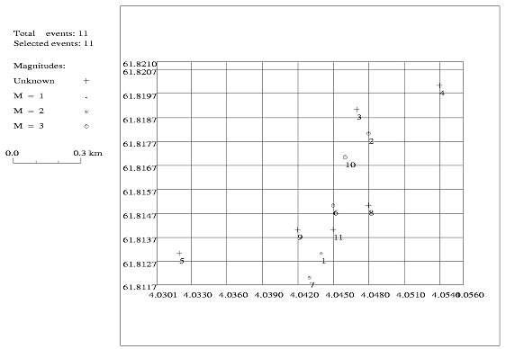

Table 7: Calculated depths for the events listed in Table 1. Calculation by Master Event Technique. The event numbers refer to Table 1 and the locations are seen in Figure 8. Event #10 is the master event.

Event | Depth in km
#1 | 13.9
#2 | 14.1
#3 | 14.2
#4 | 14.7
#5 | 16.5
#6 | 13.7
#7 | 13.9
#8 | 13.8
#9 | 13.7
#10 | 13.8
#11 | 13.7

It seems, that the depth increases from event #1 to event #5 and then is constant at about 13.8 km.

Discussion

Comparing the seismograms, it is clear, due to their similarity, that these events must occur within a very small volume. This is also seen from the very small changes in the S-P times between the events. The relocated events are within a few hundred meters spatially. Probably the events are even closer together, but the resolution of the data makes it difficult to obtain more accurate readings since the sample interval is only 0.05 s, which is of the same order as the largest time changes observed.
Also all events in this swarm must have same focal mechanism since polarities and P to S amplitude ratios are the same.
In order to obtain even better relative locations, the signals must be resampled at a higher sample rate and cross-correlated.

Acknowledgement

The author thanks the University of Bergen for the IAESTE scholarship, which made this work possible.

Appendix A

The following figures show the aligned traces for every station and all events used with the master event technique. Also the picked P- and S-phases are seen. The traces were aligned with the P-phases. For a correct solution it is necessary to always use the same phase for each event. Also the same filter must be used.
Further the traces are named with the label of the station, the number of the event (last digit) and the component: FOO5 N is station FOO, event #5 and the north-south component (N), for example. Event #10 is the master event. The filter used is written in the second line, right of the plot start time, if it was necessary to use one.

Figure A1: Station ASK, north-south component. General view without filter.

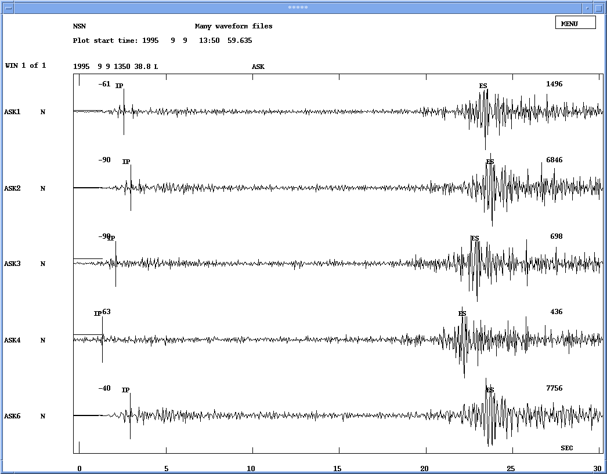

Figure A2: Station ASK, north-south component. General view without filter.

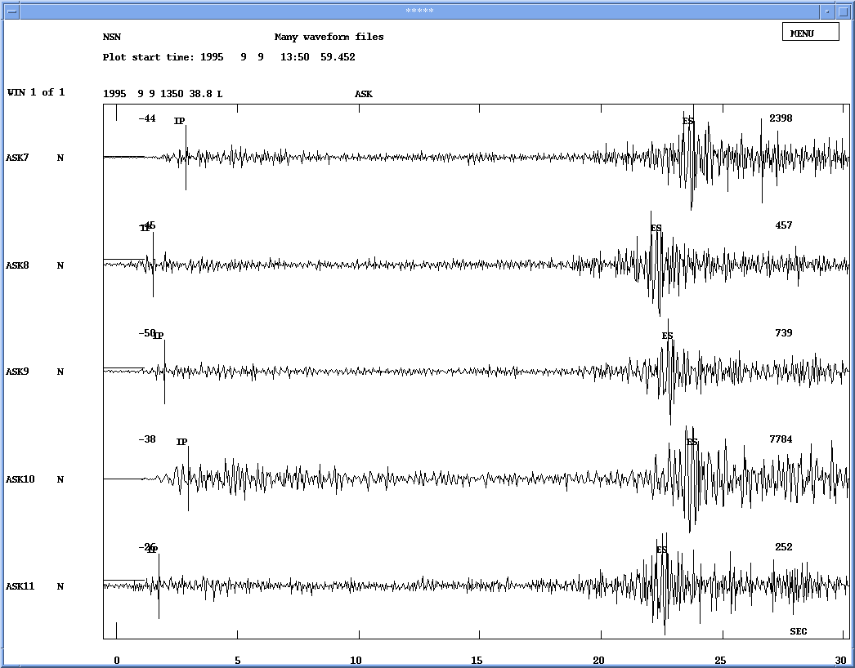

Figure A3: Station ASK, north-south component. Picked P-phase.

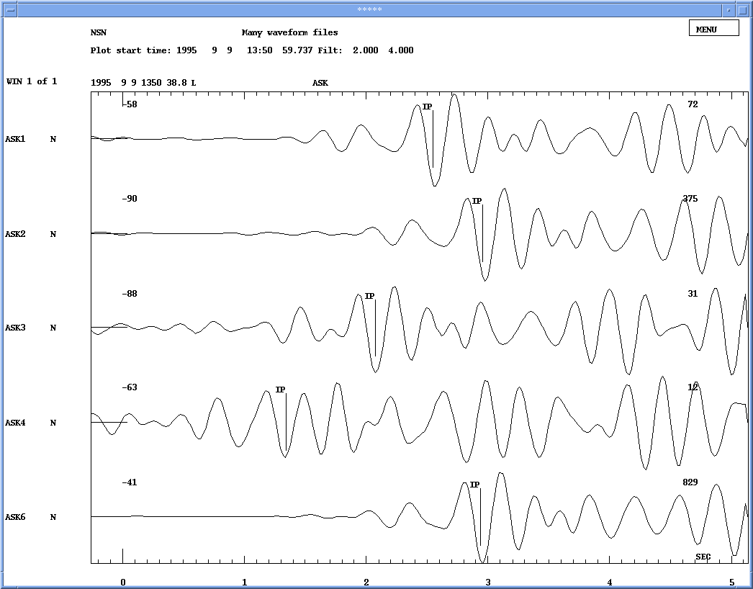

Figure A4: Station ASK, north-south component. Picked P-phase.

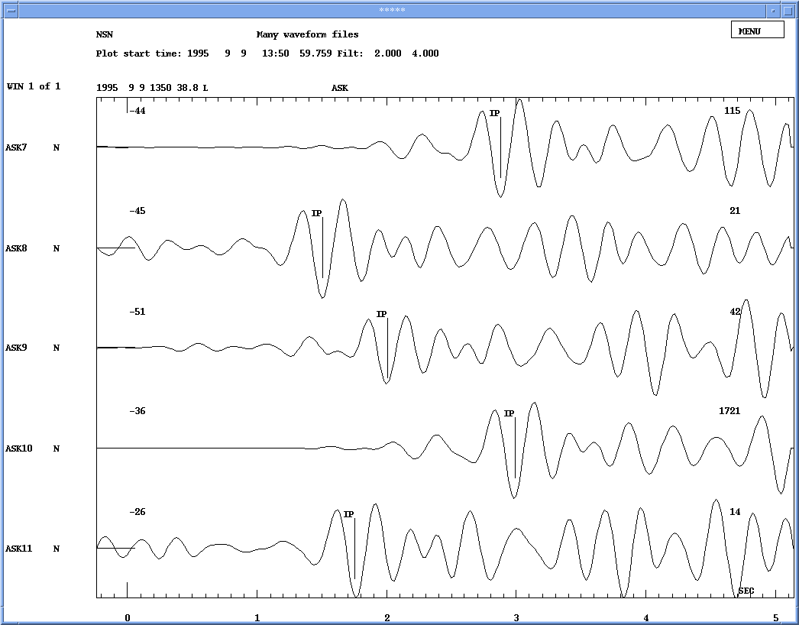

Figure A5: Station ASK, north-south component. Picked S-phase.

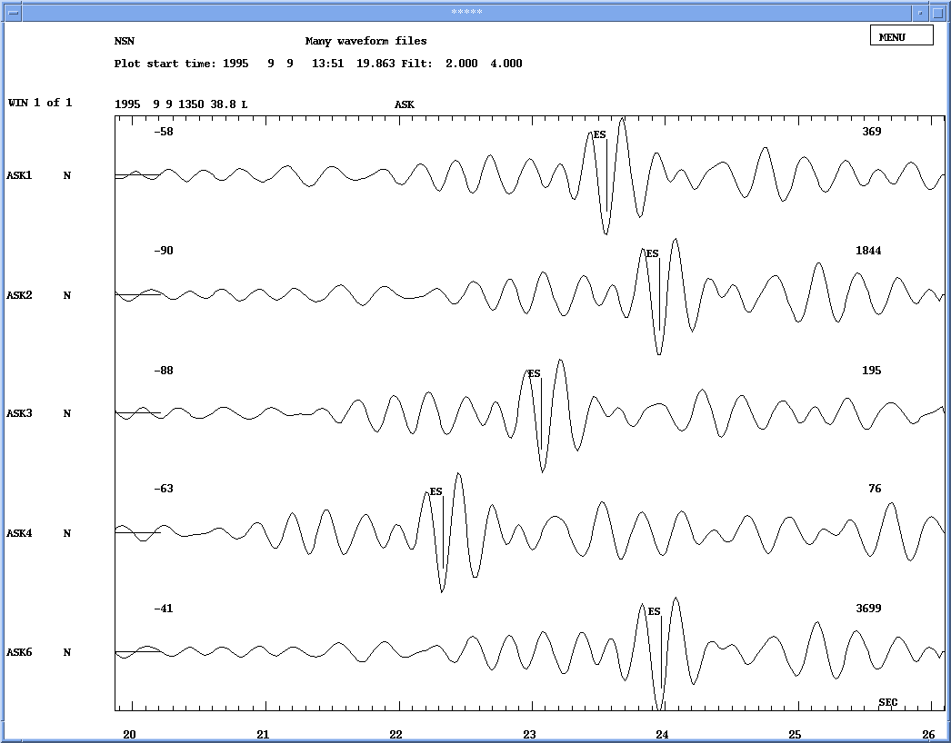

Figure A6: Station ASK, north-south component. Picked S-phase.

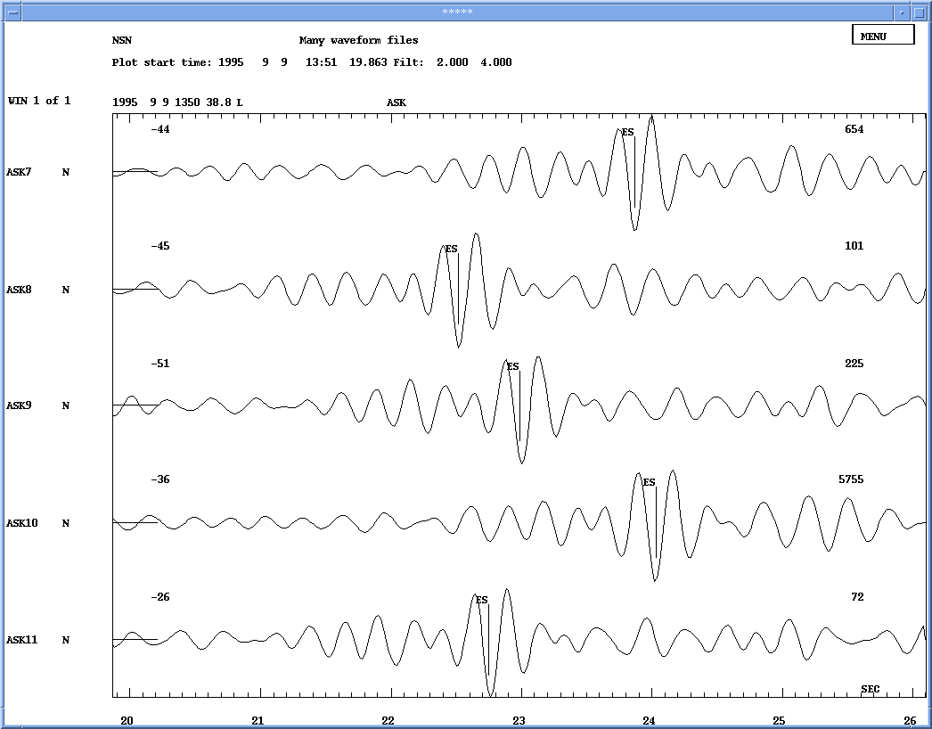

Figure A7: Station FOO, north-south component. General view without filter.

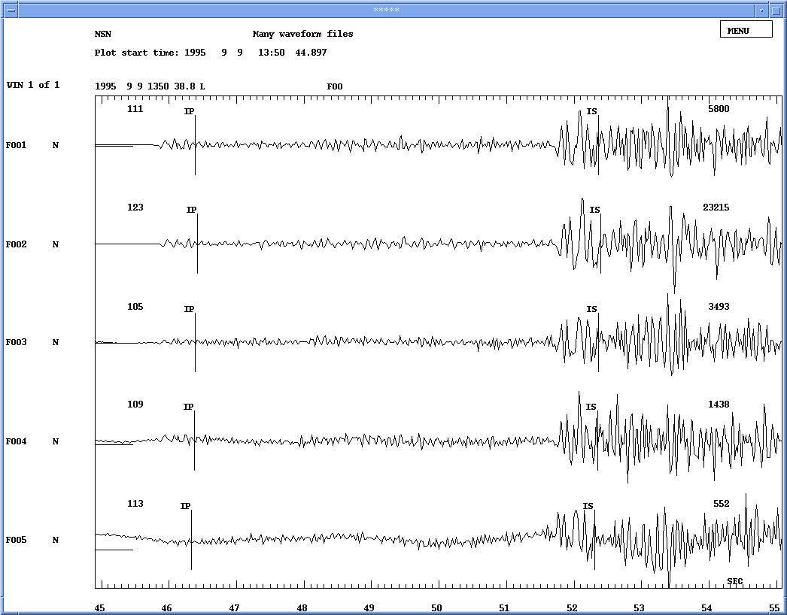

Figure A8: Station FOO, north-south component. General view without filter.

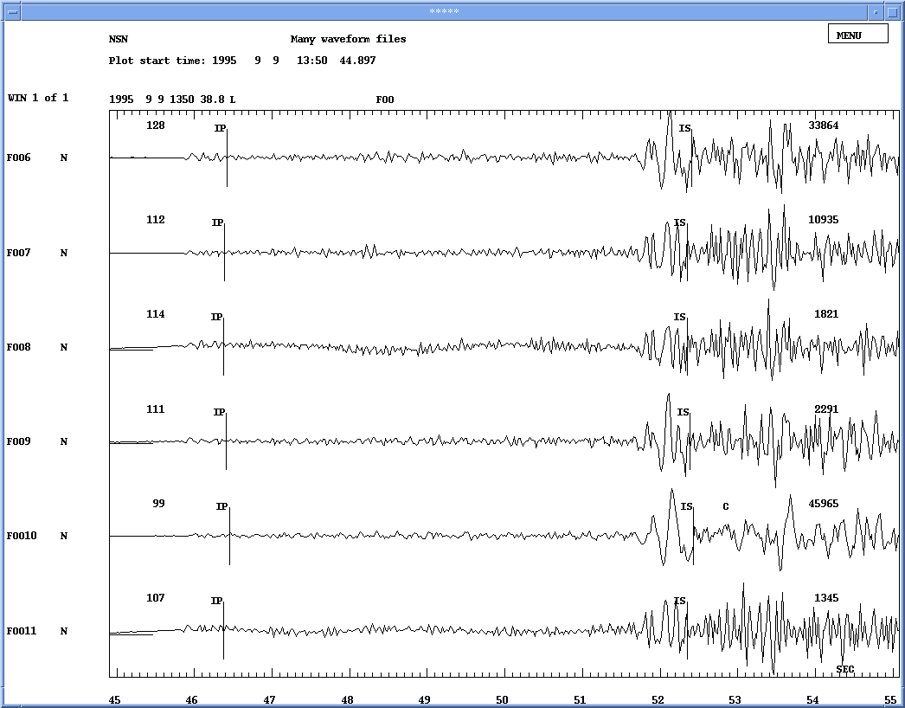
Figure A9: Station FOO, north-south component. Picked P-phase.

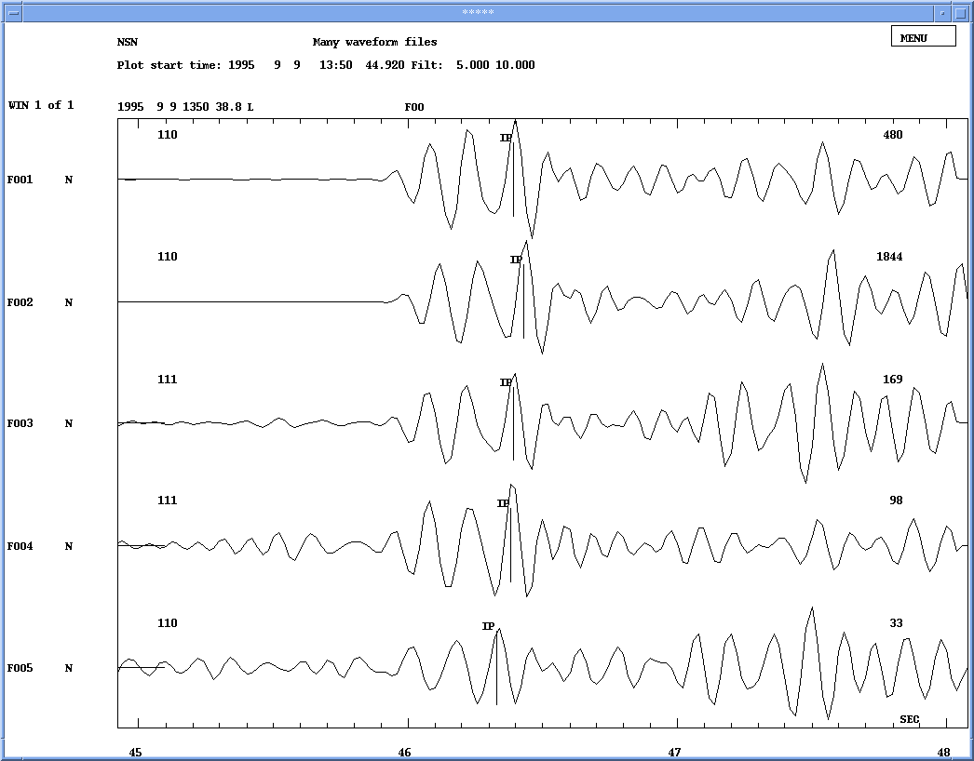

Figure A10: Station FOO, north-south component. Picked P-phase.

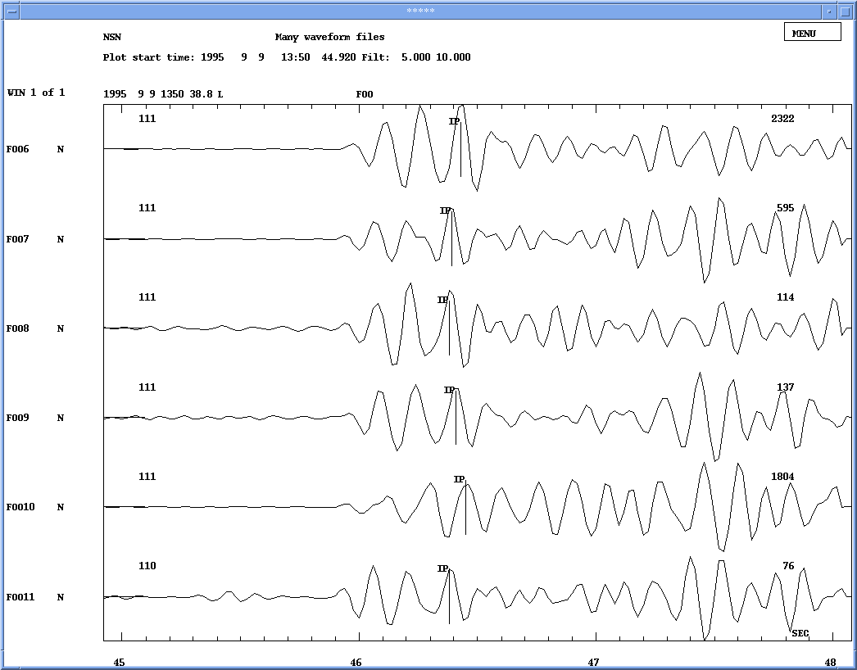
Figure A11: Station FOO, north-south component. Picked S-phase.

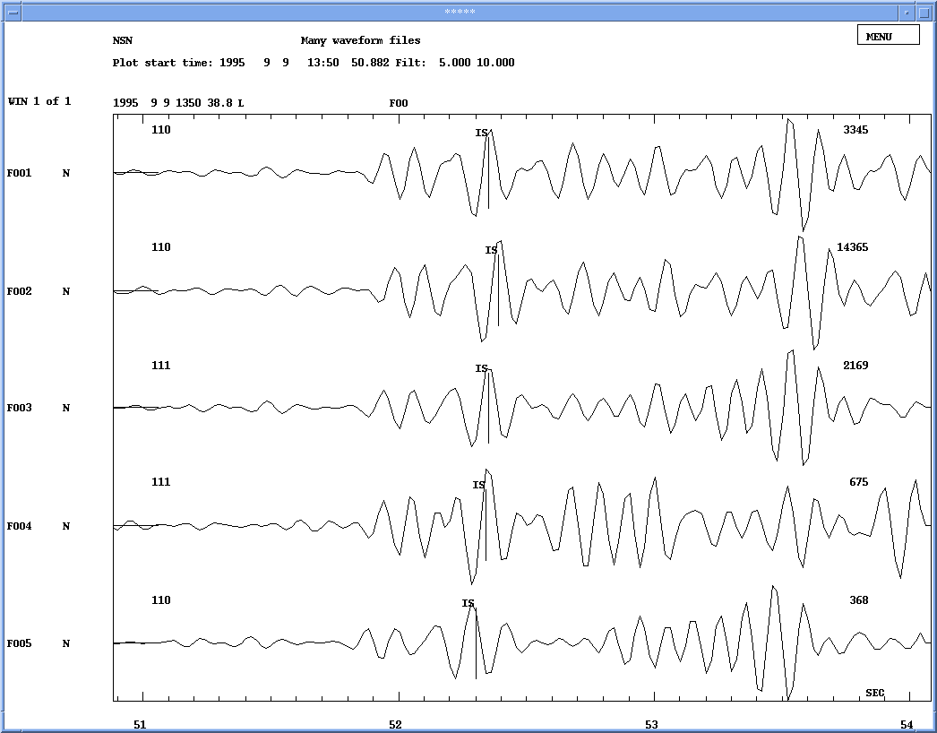

Figure A12: Station FOO, north-south component. Picked S-phase.

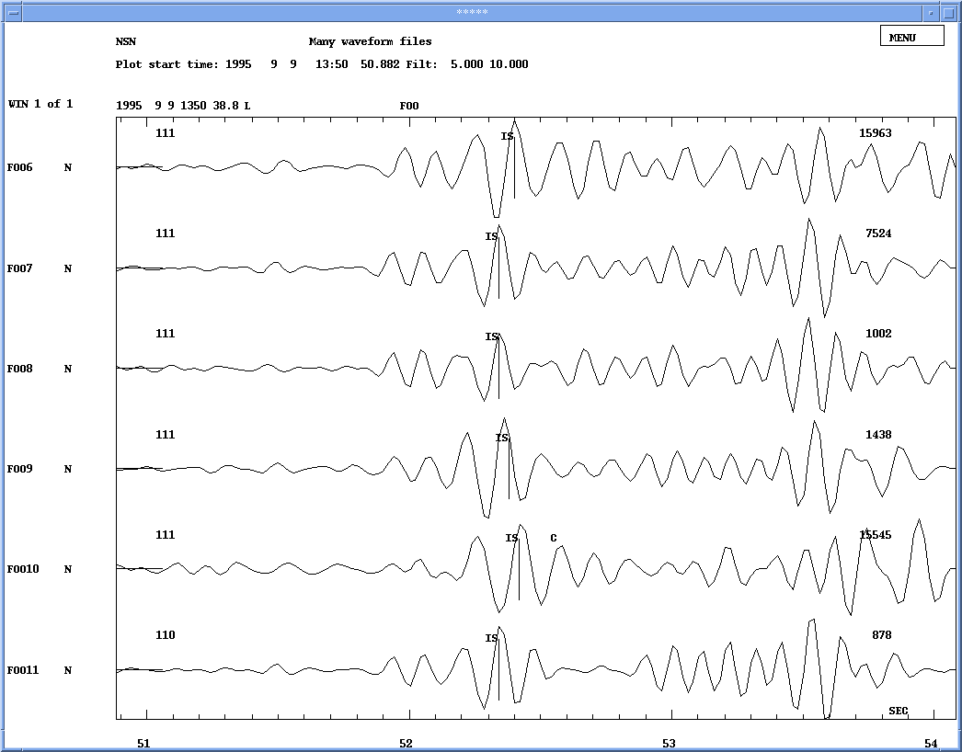
Figure A13: Station MOL, north-south component. General view without filter.

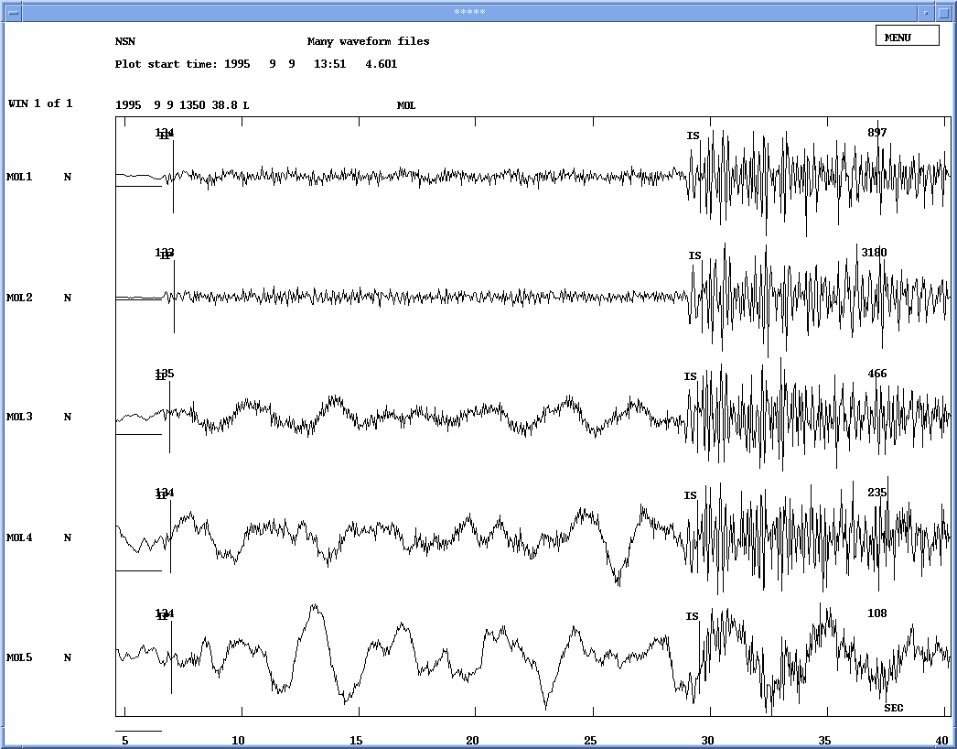

Figure A14: Station MOL, north-south component. General view without filter.

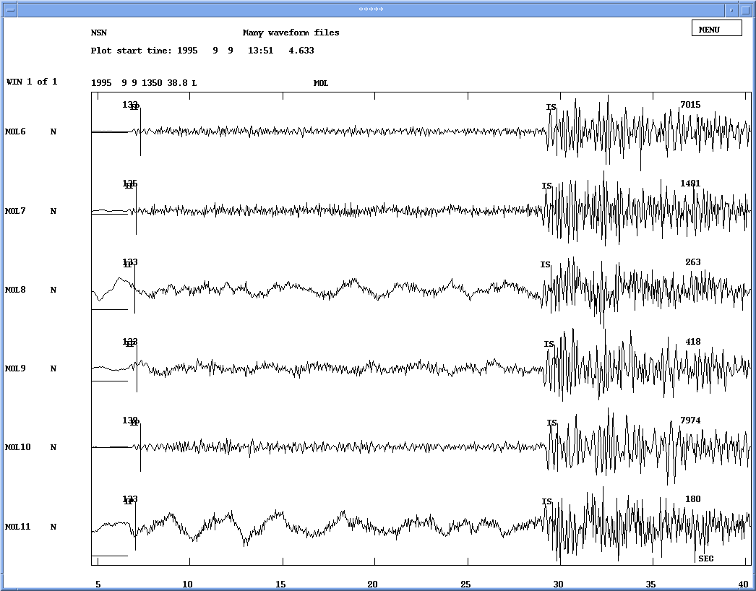
Figure A15: Station MOL, north-south component. Picked P-phase.

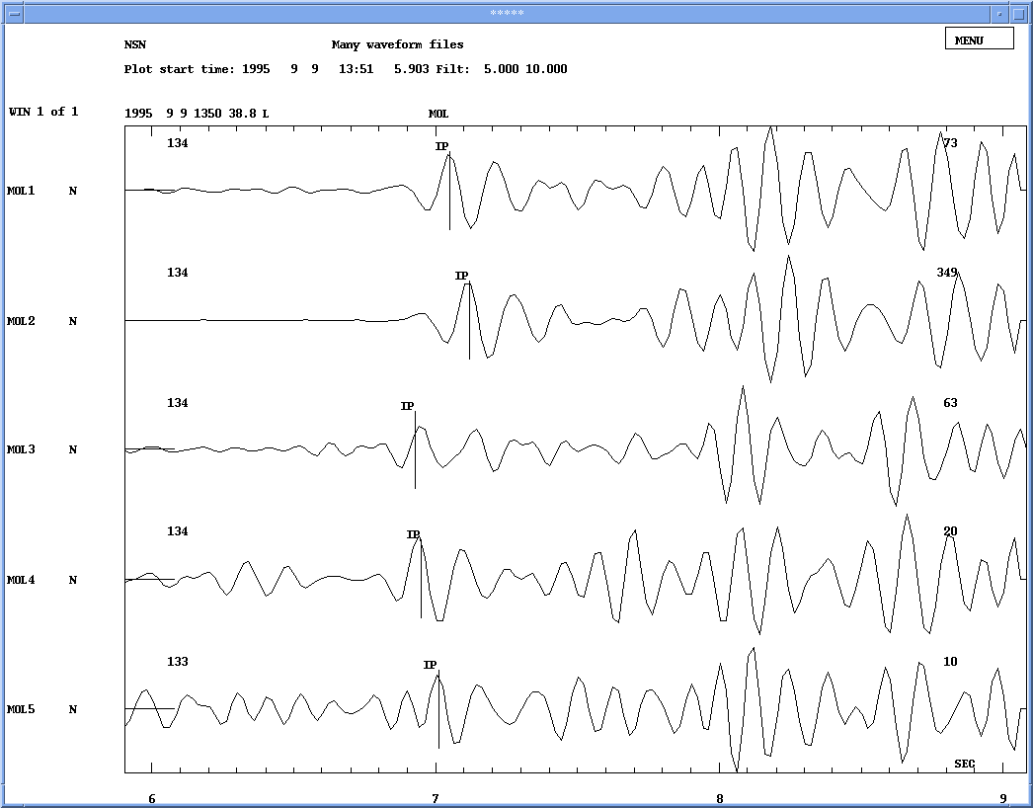

Figure A16: Station MOL, north-south component. Picked P-phase.

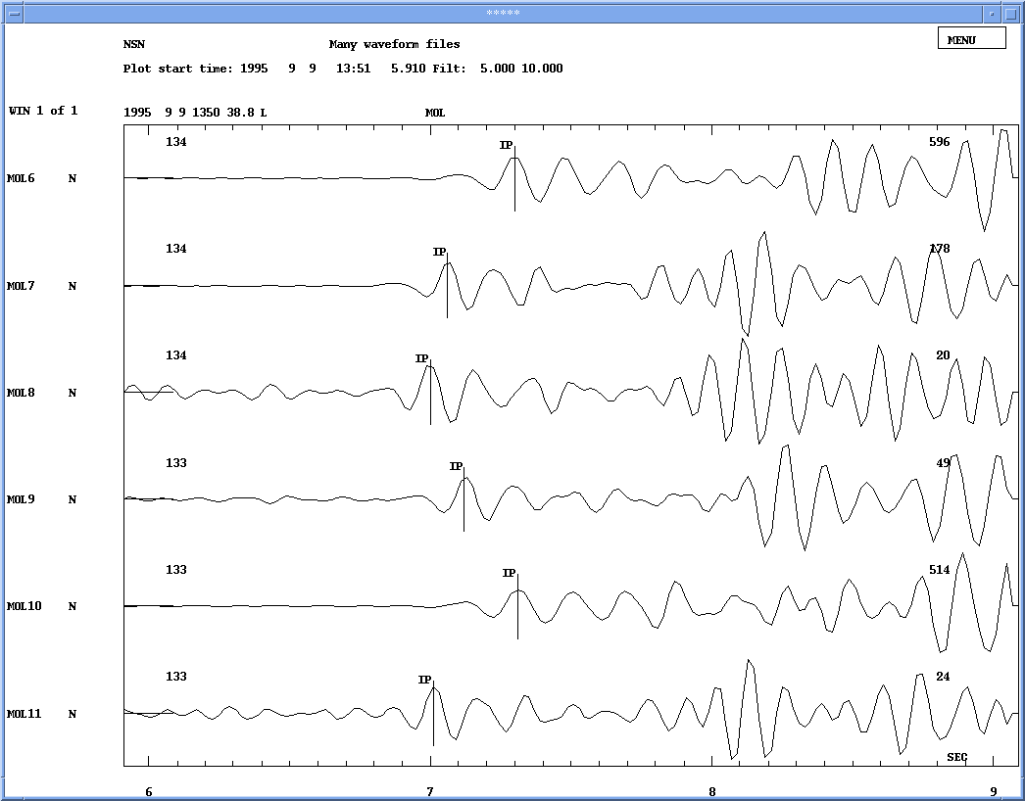

Figure A17: Station MOL, north-south component. Picked S-phase.

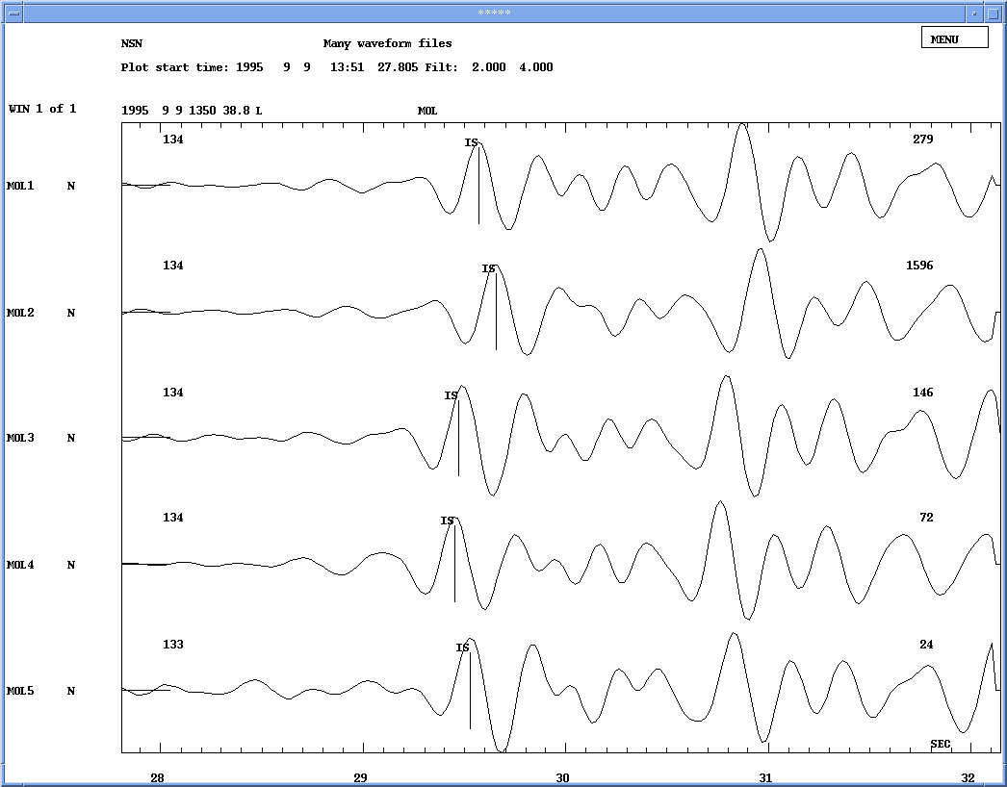

Figure A18: Station MOL, north-south component. Picked S-phase.

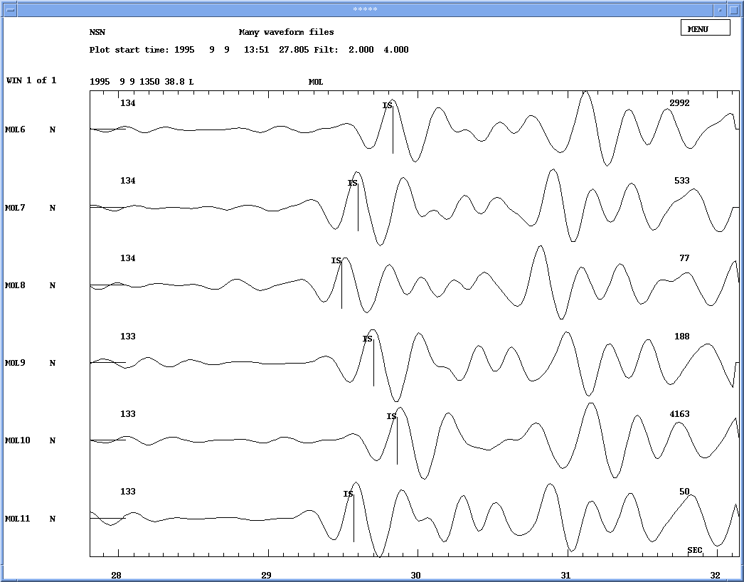
Figure A19: Station SUE, north-south component. General view without filter.

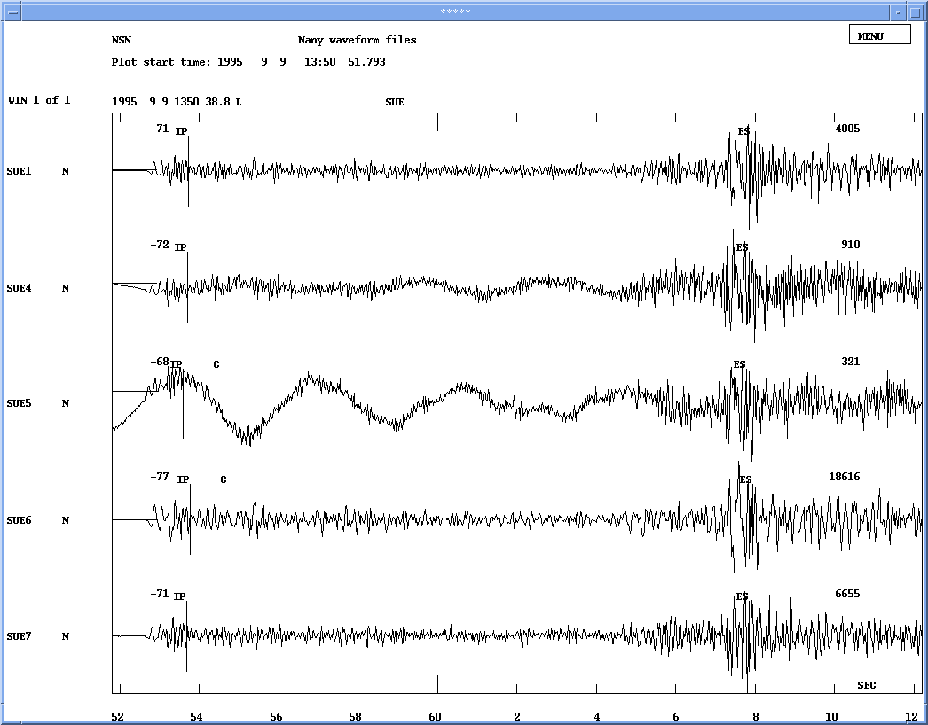

Figure A20: Station SUE, north-south component. General view without filter.

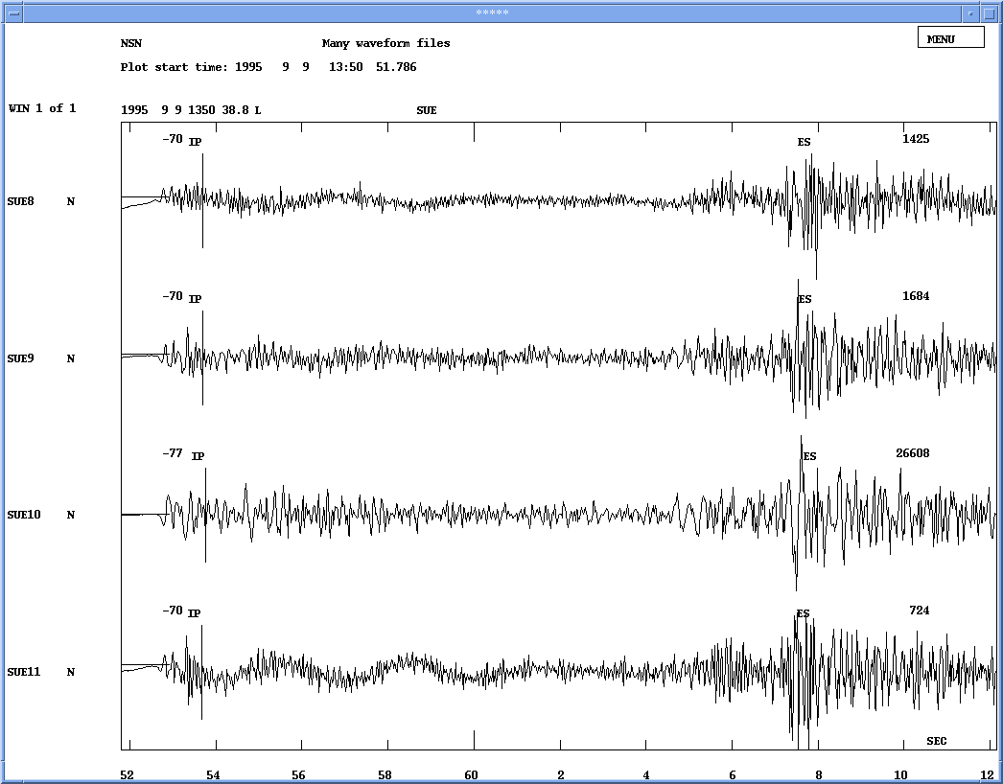

Figure A21: Station SUE, north-south component. Picked P-phase.

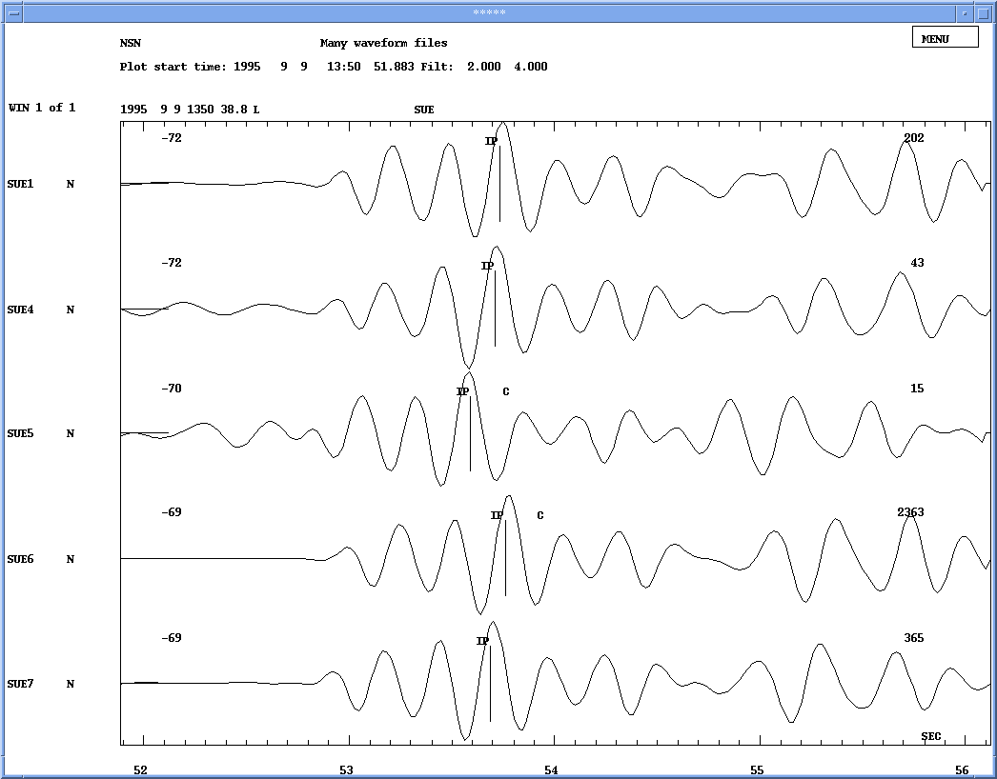

Figure A22: Station SUE, north-south component. Picked P-phase.

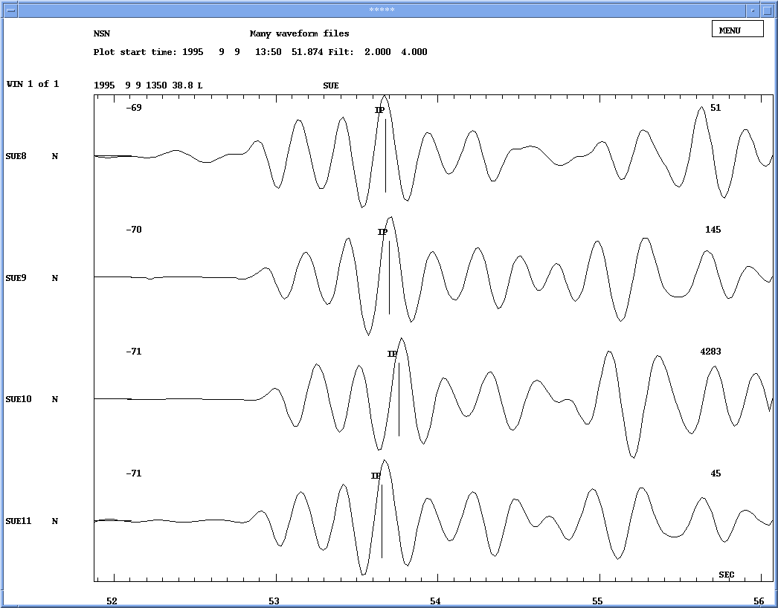

Figure A23: Station SUE, north-south component. Picked S-phase.

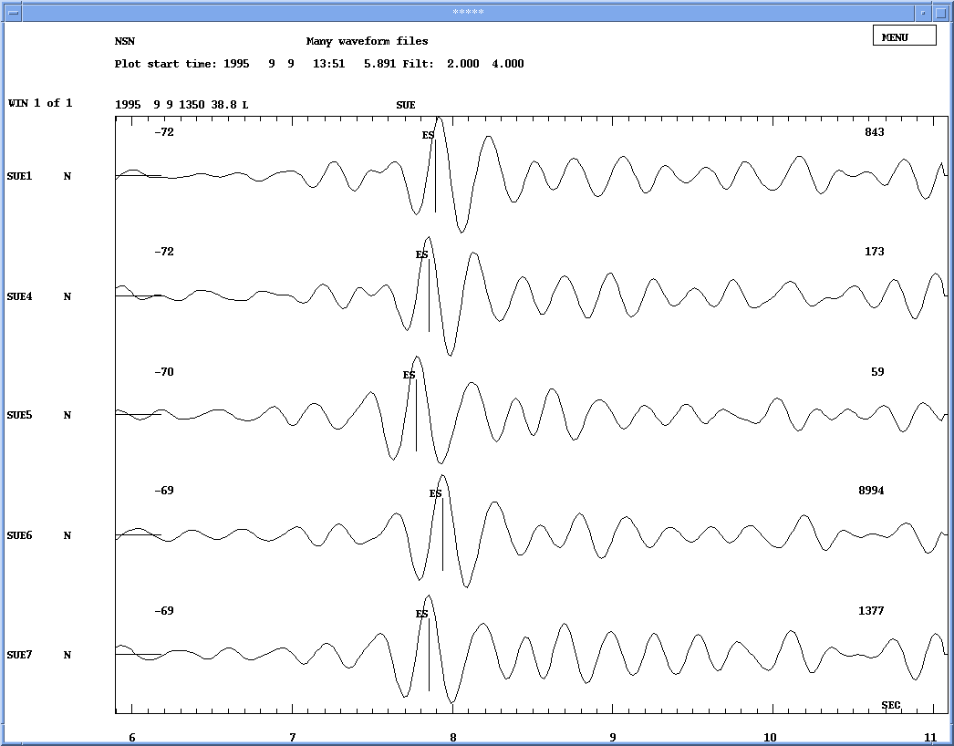

Figure A24: Station SUE, north-south component. Picked S-phase.

