Norsk Nasjonalt Seismisk Nettverk
Teknisk Rapport Nr. 17

Seismic events 19th of January 2004 related to M/S Rocknes accident

Seismology group

Institutt for geovitenskap

Universitetet i Bergen
Allégt.41, N-5007 Bergen, Norge
Tel: +47-55-583600 Fax: +47-55-583660 E-mail: seismo@geo.uib.no

January 2004

The earthquake observatory at the Department of Earth Science, University of Bergen has recorded seismic events that very likely originate from the M/S Rocknes accident. The University of Bergen operates 4 stations around Bergen: Espegrend (south of Flesland airport), Bergen centre (at Univ. of Bergen), mountain Rundmannen, and Ask on Askøy. The distance from the seismic events to the closest station, Espegrend, is 7 km. The events are recorded on all 4 stations, see Figure 1.

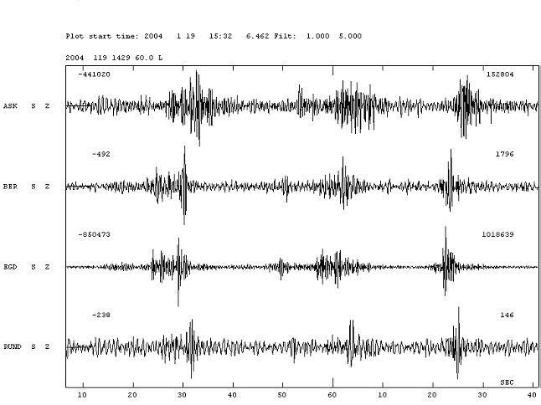

Figure 1: Seismograms that show records of the strongest recorded seismic events at the stations ASK: Askøy, BER: University of Bergen, EGD: Espegrend and RUND: Rundemannen. First timemark is 15:32:10 GMT or 16:32:10 local time. Timescale is seconds.

It is seen that the first event starts 16:32:25 local time. The event is best seen on EGD. Three major events are recorded within the next minute.

The seismic events (Figure 2) are located to
Latitude: 60°19.7’N
Longitude: 5°11.1’E

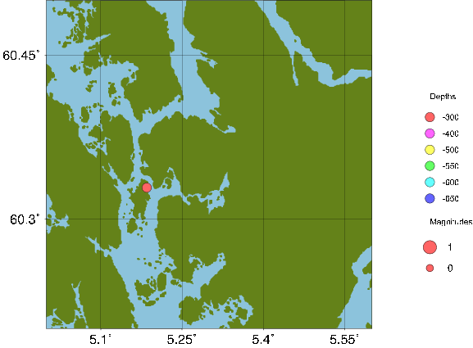

Figure 2: Location of seismic events recorded the 19th of January 2004 at 16:32 local time.

The estimated error of location of the seismic events is about 1 km. The strength of the events is comparable with explosions on major building projects. The signals do not look like explosions, either in shape nor repeatability (explosions tends to be more of a continuous in time). Due to this, location and time of event, we conclude that the events are related to the M/S Rocknes accident.

Today there is uncertainty about when the coastal radio stations received the first Mayday call from the ship. The timing of the seismic events are accurate. The clocks are synchronized against the time.

Joint Rescue Coordination Centre Southern Norway (RCC) claims to have received the mayday at 16:30 and the first event occurred 16:32:25. The events can then be caused by grounding after the mayday, or the rocks sliding out of the boat and hitting the bottom. If the event are related to the rocks falling out, the cargo hatches must have failed at different times (intervals 20 seconds) and the rock must have been emptied out in 5-10 seconds. We cannot distinguish between the possibilities.

Bergen Coastal Radio claims the mayday was received 16:34. The events can then be related to a grounding before the mayday.
Before 16:30 we can also see a seismic registration at 16:28:32 (figure 3 and 4). This event can only be seen on the closest seismic station, and it is also close to Espegrend. More precise location cannot be done. This event may be related to the ship accident, but it can also be an unidentified explosion.

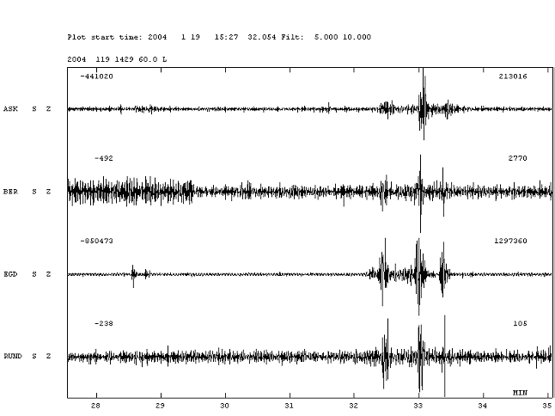

Figure 3: Seismograms showing registrations at the seismic stations ASK: Askøy, BER: University of Bergen, EGD: Espegrend, and RUND: Rundemannen. First time mark is 15:28 GMT or 16:28 local time. Time scale is minutes. The first event is seen 16:28:32 (easier seen on figure 4), the second event that is located is seen at 16:32:20.

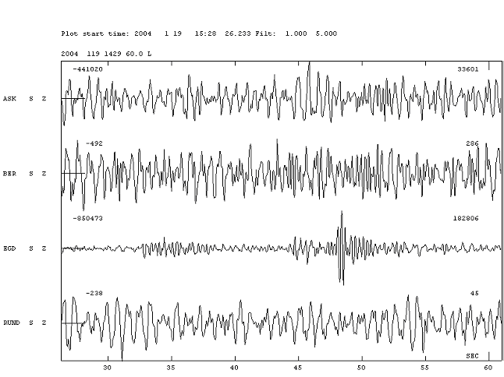
Figure 4: Same recording as in Figure 3, using a smaller time window. Zoomed in on horizontal axes. The first time mark is 16:28:30 local time. Time scale is seconds. This seismic event is only recorded at Espegrend.

There are no seismic events recorded within the first hour after 16:34.

