Norwegian National Seismic Network

Technical Report No. 19

New coda magnitude scales for
mainland Norway and the Jan Mayen region

Prepared by

Jens Havskov and Mathilde B. Sørensen

Dept. of Earth Science, University of Bergen
Allégt.41, N-5007 Bergen, Norway
Tel: +47-55-583600 Fax: +47-55-583660 E-mail: seismo@geo.uib.no

March 2006

Contents

Introduction

The coda magnitude scale, which is currently in use for Norway, overestimates Mc relative to Ml and a new scale must therefore be made. The present report will give a description of the original coda magnitude scale and describe the methods applied to obtain a new, more correct scale. Due to the extremely large noise level, the Jan Mayen region has its own coda magnitude scale and a separate analysis has been made for this region.

Why have a coda magnitude scale

The coda magnitude provides an easy way to estimate magnitude independently of knowing instrument corrections and serves as an independent estimate. In addition, there is a large amount of early data from the Norwegian National Seismic Network (NNSN), which only have coda magnitudes (although Ml could be calculated now for much of the data). In this respect, using coda magnitude makes it possible to have a consistent magnitude estimate for the whole data set in the NNSN database.

How coda is read today

The coda is read as the time from the P arrival to when the unfiltered signal disappears in the noise. This coda length will be dependent on the type of station and the noise level at the station. Thus, ideally there should be a coda relation for each station and for each time period where filter characteristics have been different. However, it was chosen to make an average scale since this is more feasible, and since the coda magnitudes are only an approximate measure complementing the more reliable magnitude Ml. Only for Jan Mayen has a separate scale been defined because of the extreme high noise level in this region.

The coda magnitude scale

Coda magnitude is calculated as

Mc = a·log(coda) + b·dist + c

where a, b and c are constants, coda is coda length in seconds and dist is hypocentral distance in km. By using coda, dist and Ml from a large dataset and assuming that Ml=Mc, we get a large number of equations with 3 unknowns and we can invert for a, b and c. Since b is small, it is often badly determined and the inversion is often done for a fixed b, calculating only a and c. The relation is then

Mc = a·[log(coda) + (b/a) ·dist] + c.

Mainland Norway

For mainland Norway, the following coda magnitude scale has been used previously:

Mc = 2.6·log(coda) + 0.001·dist – 3.0 (Engell-Sørensen, personal communication)

Local magnitudes are calculated using the relation of Alsaker et al. (1991):

Ml = 1.0·log(A) + 0.91·log(dist) + 0.00087·dist – 1.67

where A is the maximum ground displacement in nm and dist is hypocentral distance as above.

Data

Data from mainland Norway was selected for a 10-year period (1995-2005). Only events in the area close to mainland Norway were used, since it is observed that magnitudes of more distant events have abnormal Ml and Mc values, and therefore should be treated differently. Despite of this, only events in the Jan Mayen region have their own Mc magnitude relation at the moment, whereas events in the rest of the Norwegian Sea/Barents Sea region are treated as events in mainland Norway. In order to use only well-recorded events and to eliminate the use of too many small events, we included only events which were recorded at a minimum of 6 stations. This provided a total of 2280 events for the analysis, which are located as shown in Figure 1. A comparison of the original Mc and Ml for this data set is shown in Figure 2. The data set used to recalculate the coda magnitude relation consists of 11549 coda readings.

Distance dependence

Using a 3D inversion, a distance factor of 6·10⁻⁵ was obtained which means almost no distance dependence. Most relations have a distance term, partly to compensate for the inaccuracy of measuring the coda length from the P- arrival instead of from the origin time. The original relation used a distance term of 8.7·10⁻⁴, or about 0.001, which is a common value. The value 6·10⁻⁵ seems too small and other values were tested. When inverting with a fixed distance term, the results are quite different when using b/a=0.001 (Figure 3) or b/a=0.0001 (Figure 4), however b/a=0.0001 gives the best correlation coefficient when plotting the corrected coda (log(coda) + b/a · dist) versus Ml. Looking at figures using b/a=0.001 and b/a=0.0001, it also seems that b/a=0.0001 gives the least spread of the data and b/a=0.0001 has been chosen.

Events with larger magnitudes may possibly provide data at larger distances and therefore give a better distance correction term. A new test including only events with Ml>2.5 gave a distance term of –4·10⁻⁴, which is obviously no improvement. From this analysis it seems that the distance correction is very uncertain. It is, however, important that magnitudes of large events are reasonably correct, even though the many small events have much more weight in the calculations than the larger events.

Using b/a=0.0001 (and thereby b=0.0003, assuming a=3), gave a maximum likelihood based relation of

Mc = 3.18·log(coda) + 0.0003·dist – 4.29.

Calculating new coda magnitudes using this relation and averaging in different magnitude ranges gave the result shown in Table 1. We se that on average, Mc values are slightly overestimated, and that tendency is more pronounced for the larger events, indicating that a is slightly too large. By changing a by trial and error, the best fit was found with a = 3.16 giving the values in Table 2.

Table 1: a=3.18
All events | All events | Ml < 2.5 | Ml > 2.5
Ml | 1.74 | 1.61 | 2.55
Mc | 1.77 | 1.64 | 2.62

Table 2: a=3.16
All events | All events | Ml < 2.5 | Ml > 2.5
Ml | 1.74 | 1.61 | 2.55
Mc | 1.71 | 1.59 | 2.55

By adjusting c to –4.28, all averages agree within ±0.02.

The final, new coda magnitude relation for mainland Norway is:

Mc = 3.16·log(coda) + 0.0003·dist – 4.28

Figure 5 shows the correlation between the new Mc and Ml

Jan Mayen

On Jan Mayen, the following local magnitude scale, which is of unknown origin, has been used:

Ml = 0.925·log(A) + 0.91·log(dist) + 0.00087·dist – 1.31

The Mc scale used today is

Mc = 3.27·log(coda) + 0.001·dist – 3.24 (Westre, 1975)

This scale was based on Ml as calculated by the original definition of Richter.

Data

Data was again selected in the time span 1995-2005, and only events within 200 km from Jan Mayen were used. Only data from the stations on Jan Mayen were used meaning that for many larger events, there was no Ml since records were clipped. In total, 2294 events with 5485 coda readings were selected. Figure 6 shows the epicentres of events used in the analysis.

Since the origin of the Ml scale in use for Jan Mayen is unknown, it was chosen to instead use the scale for mainland Norway. A comparison of Ml calculated from this scale and Mc is shown in Figure 7. The two scales have the same linear trend and Ml is on average 0.07 larger than Mc. A new Mc scale for Jan Mayen was made by adding 0.07 to the constant term in the old scale, giving the following scale:

Mc = 3.27·log(coda) + 0.001·dist – 2.74

Conclusions

By performing a new regression based on data from the NNSN in the time period 1995-2005, a new coda magnitude relationship has been determined for mainland Norway. The new relation provides a much better fit to the calculated Ml values and reads:

Mainland Norway:
Mc = 3.16·log(coda) + 0.0003·dist – 4.28

For the Jan Mayen region, Ml was calculated based on a relation of unknown origin. After changing to the Ml scale used for mainland Norway, a constant deviation between the scales was observed, and a new relation was established:

Jan Mayen region:
Mc = 3.27·log(coda) + 0.001·dist - 2.74

References

Alsaker, A., Kvamme, L.B., Hansen, R.A., Dahle, A. And Bungum, H., 1991. The ML scale in Norway, Bull. Seism. Soc. Am., 81, 2, 379-398.

Westre, S., 1975. Richter’s lokale magnitude og total signal varighet for lokale jordskjelv på Jan Mayen, Cand. Real thesis, Seismological Observatory, University of Bergen, Norway.

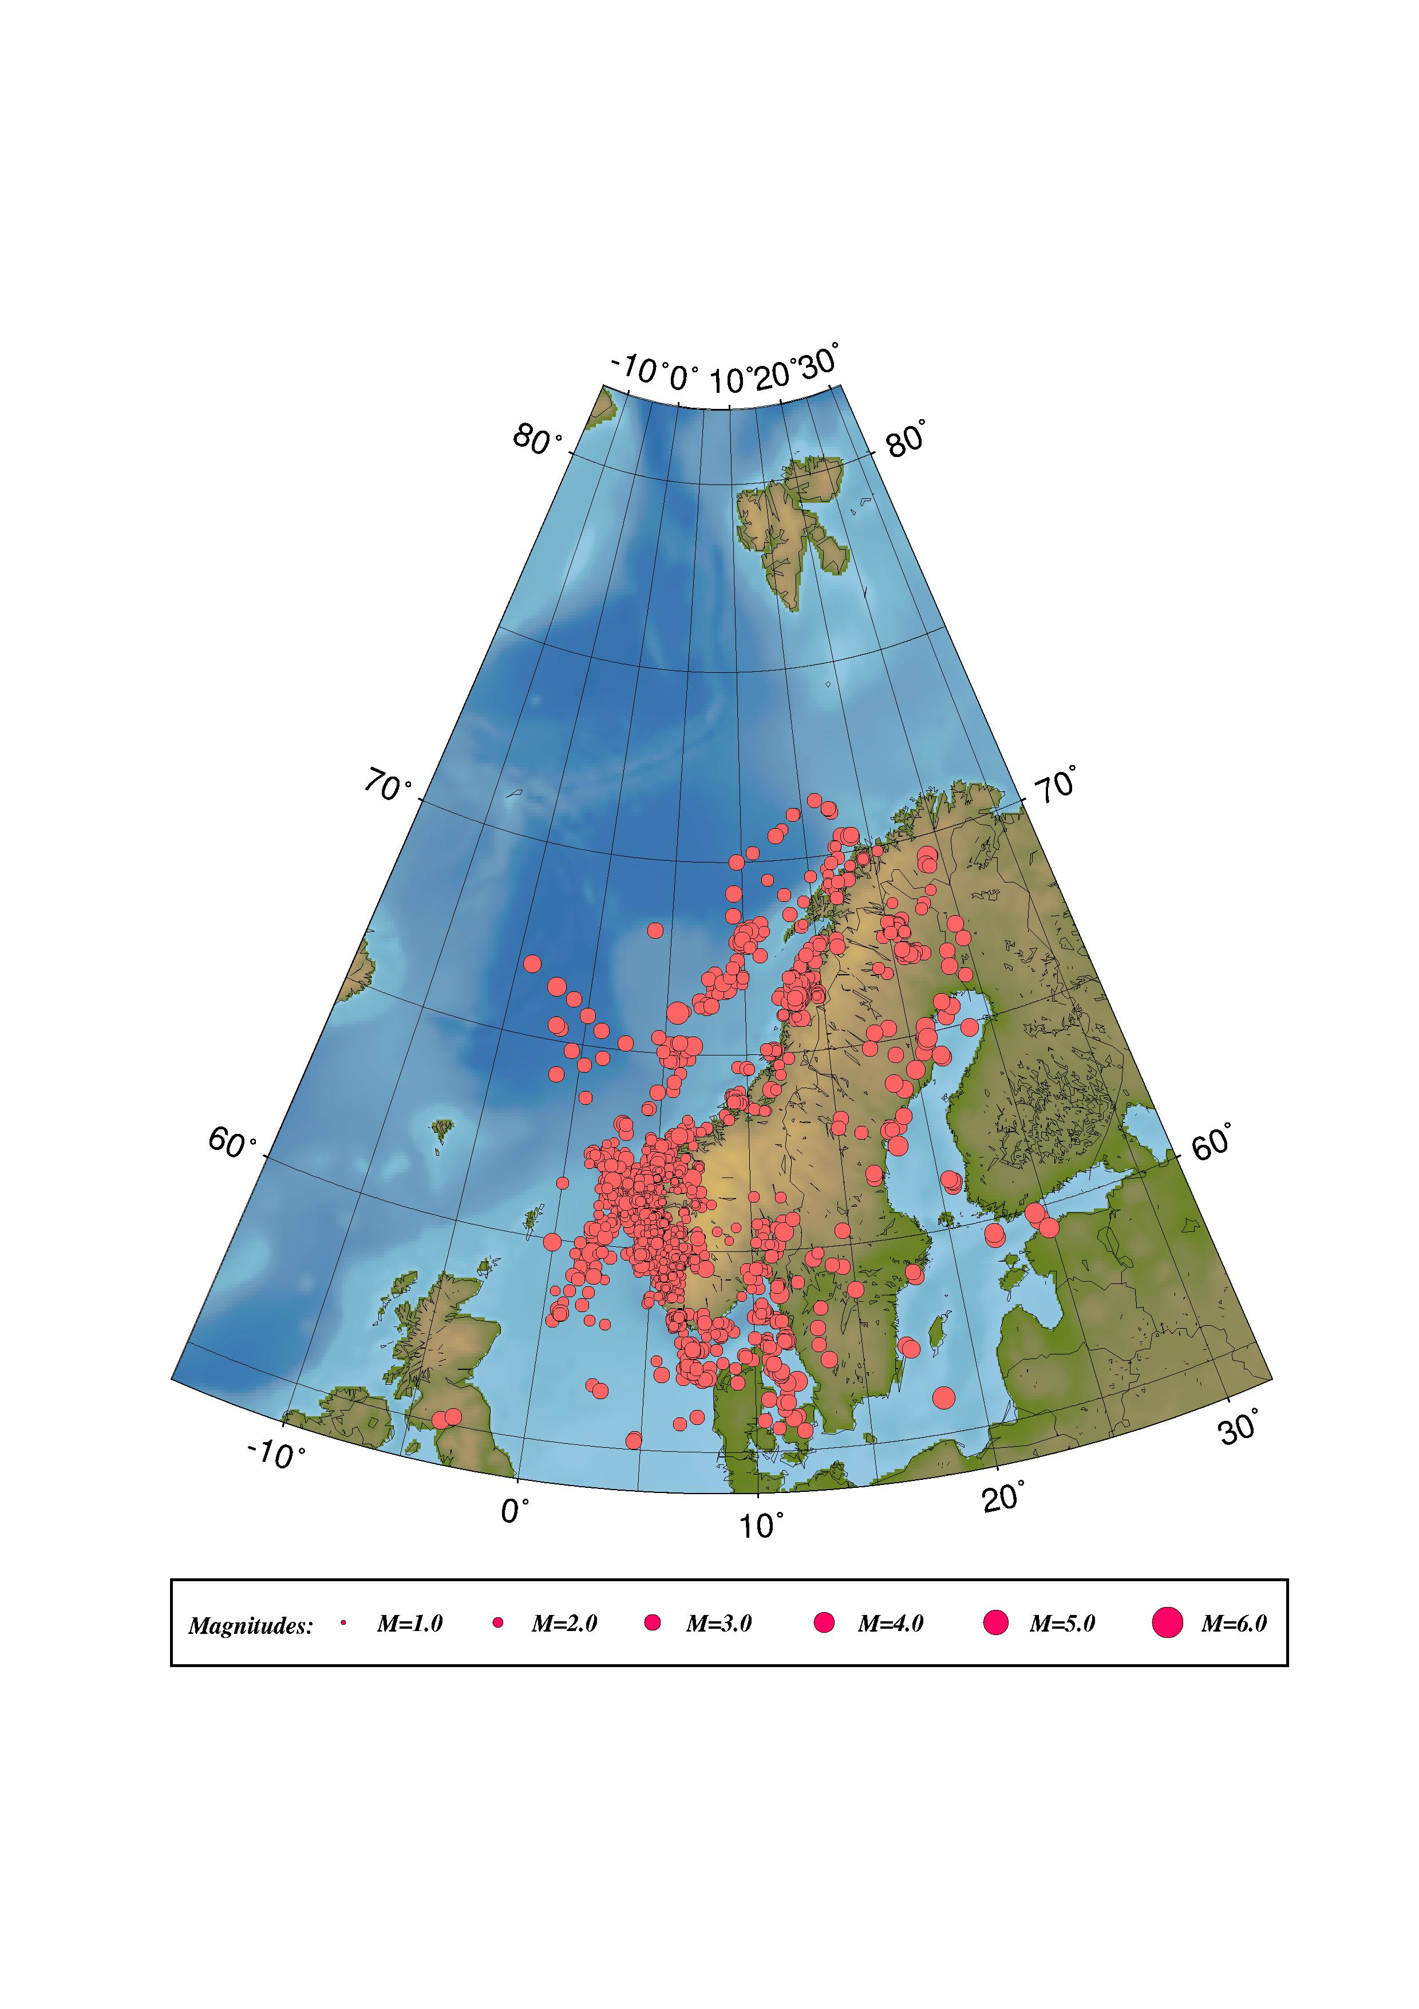
Figure 1. Distribution of earthquakes used in regression for a new coda magnitude scale for mainland Norway.

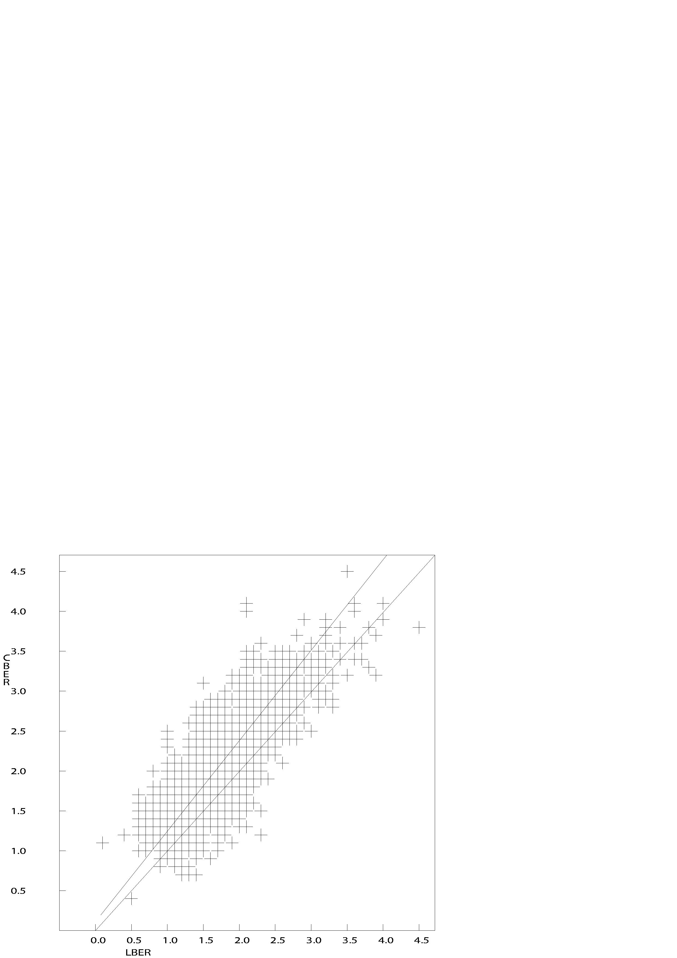
Figure 2. Comparison of original Mc and Ml for the events used in the regression for mainland Norway. The lowermost line, showing 1:1 correlation, is shown for comparison.

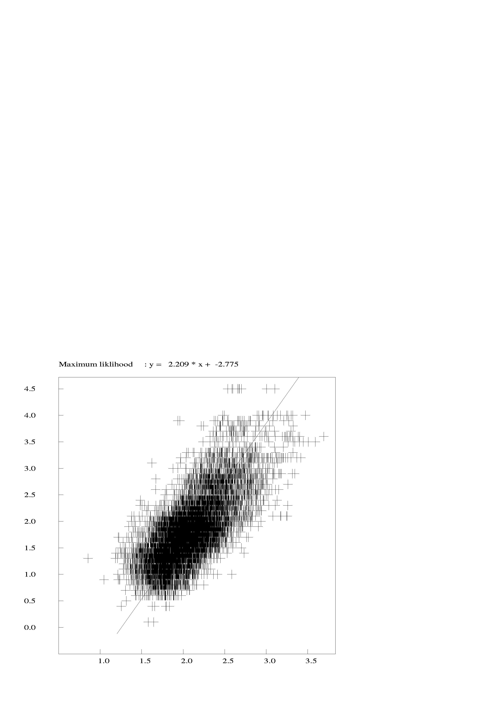
Figure 3. Mc vs. corrected coda using a fixed distance term of b/a=0.001. The maximum likelihood line is shown.

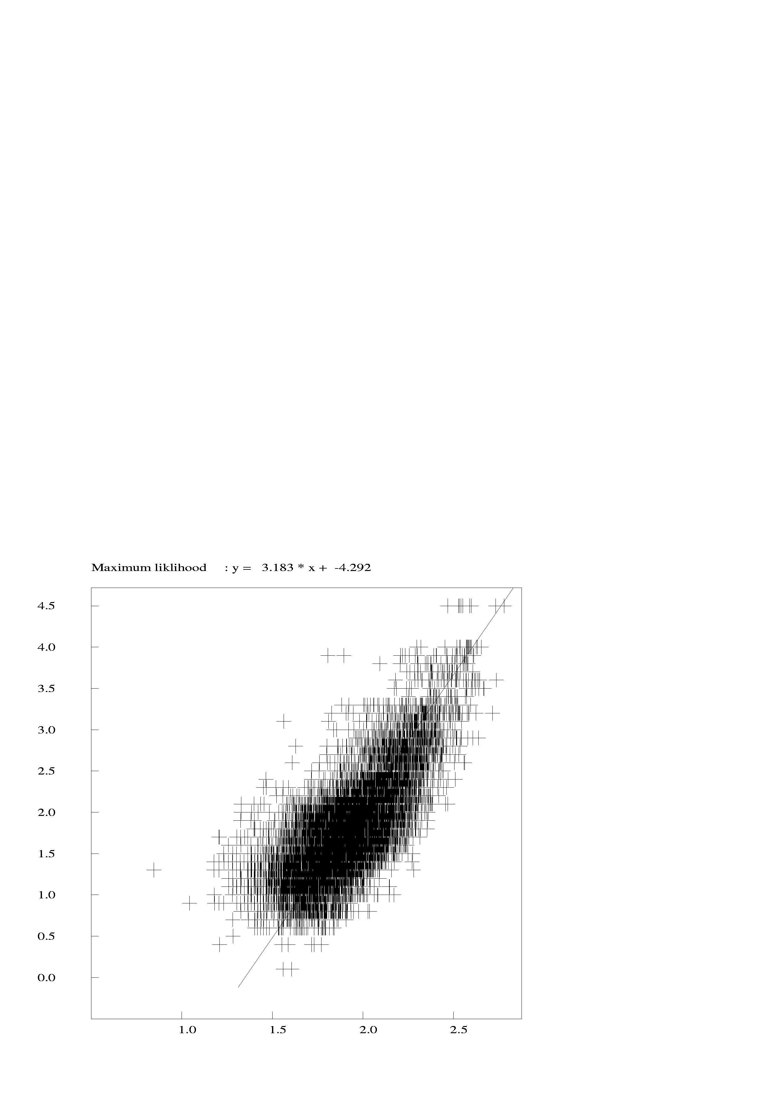
Figure 4. Mc vs. corrected coda using a fixed distance term of b/a=0.0001. The maximum likelihood line is shown.

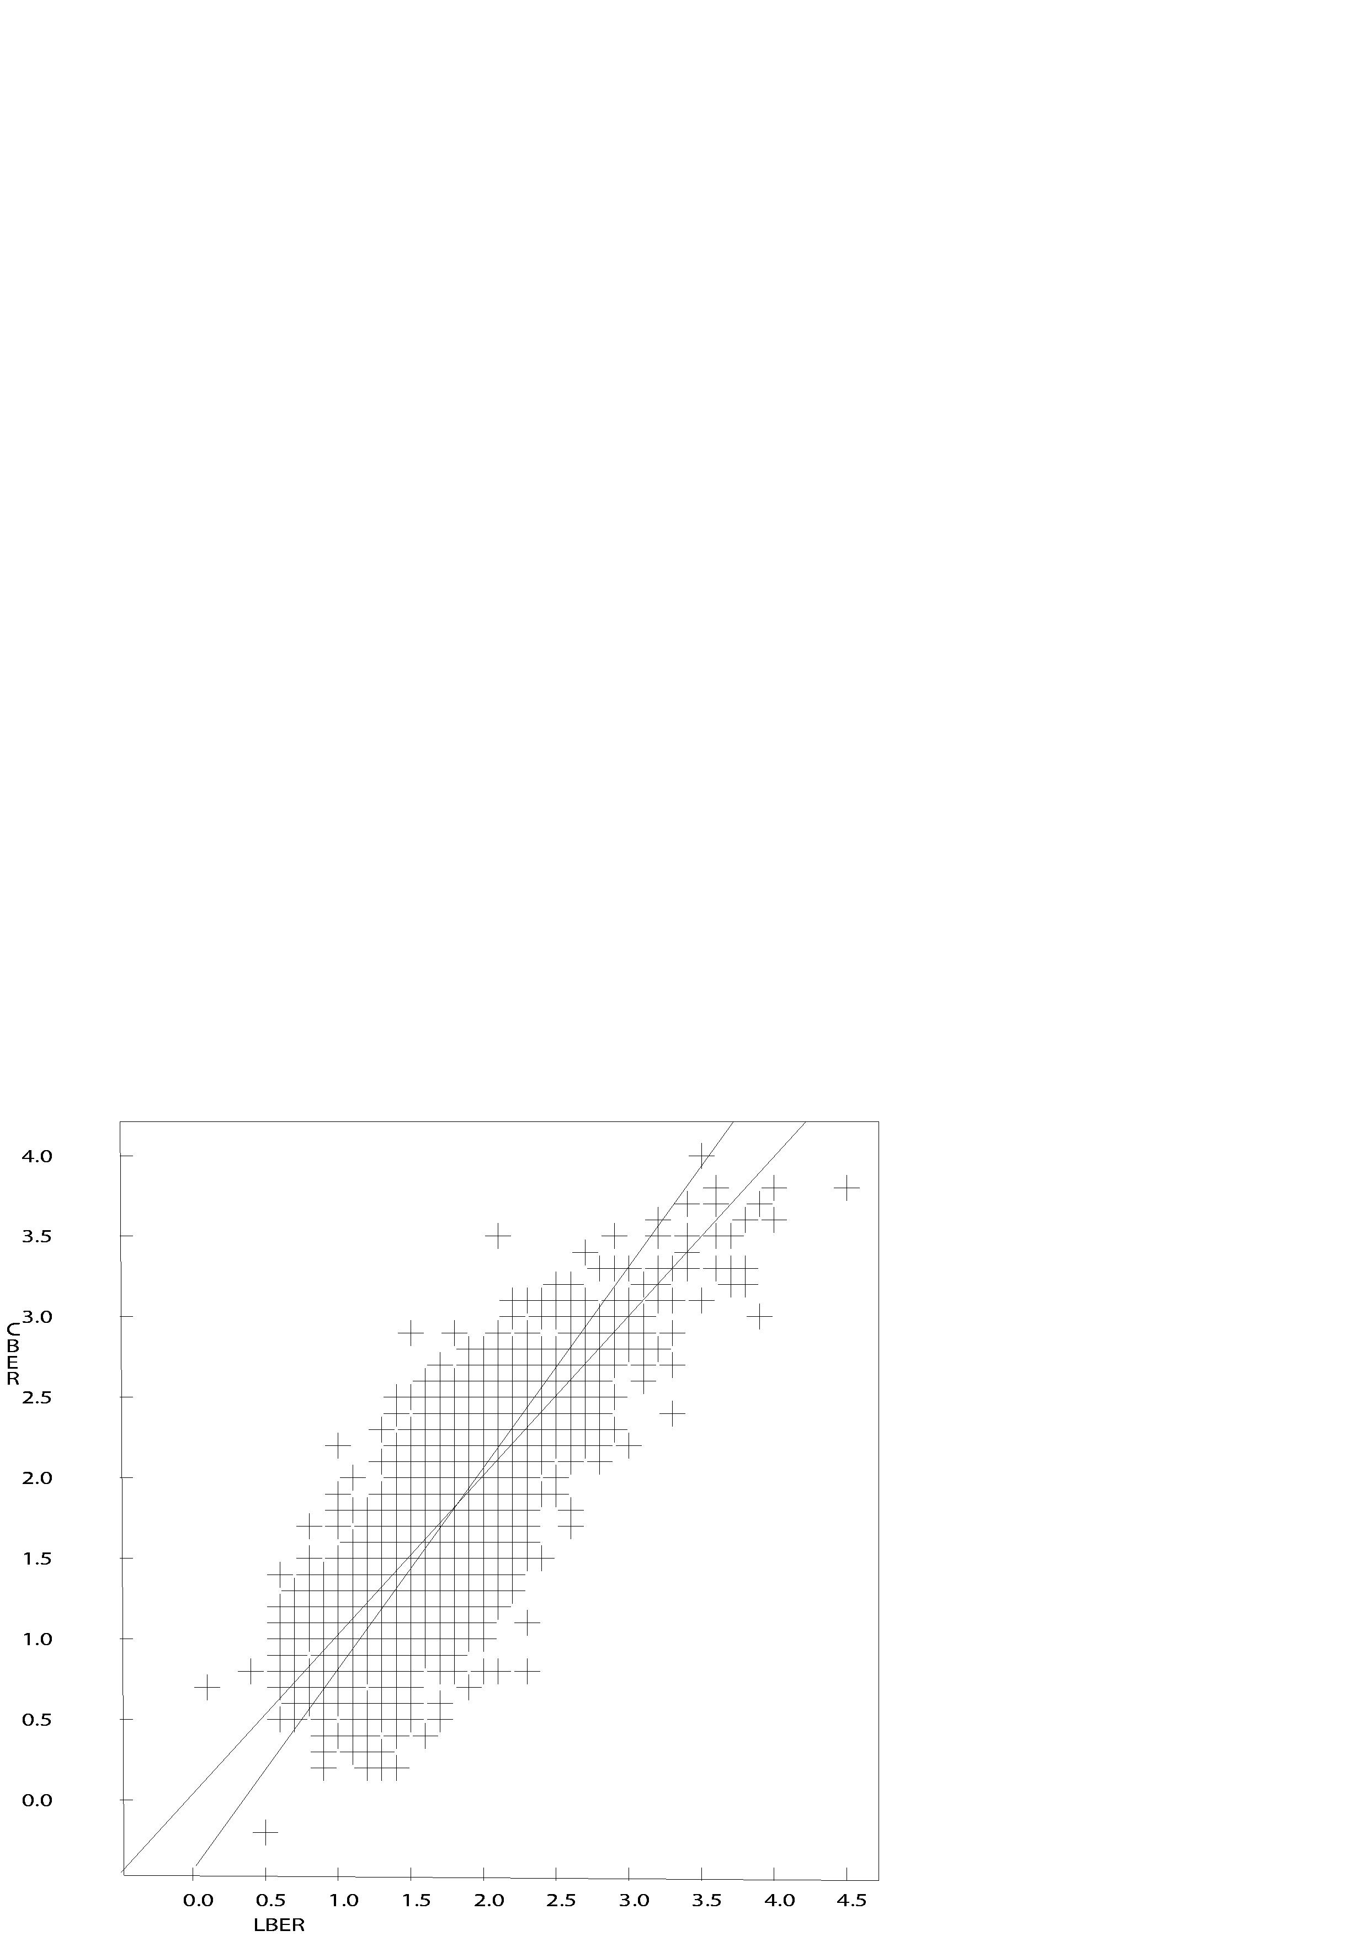
Figure 5. Comparison of new Mc and Ml for the events used in the regression for mainland Norway. A line showing 1:1 correlation is shown for comparison (the line cutting through the lowermost, left corner).

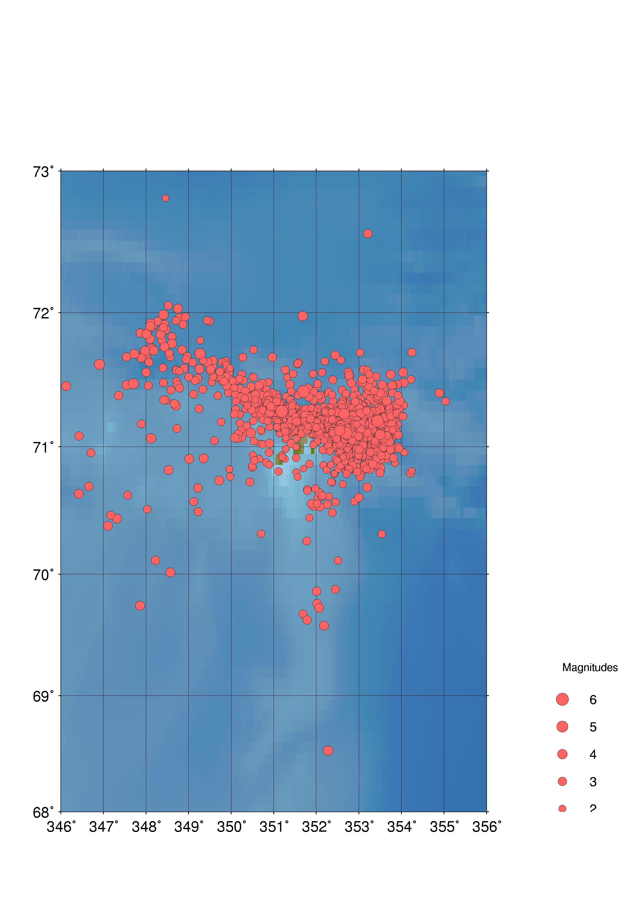
Figure 6. Distribution of earthquakes used in regression for a new coda magnitude scale for the Jan Mayen region.

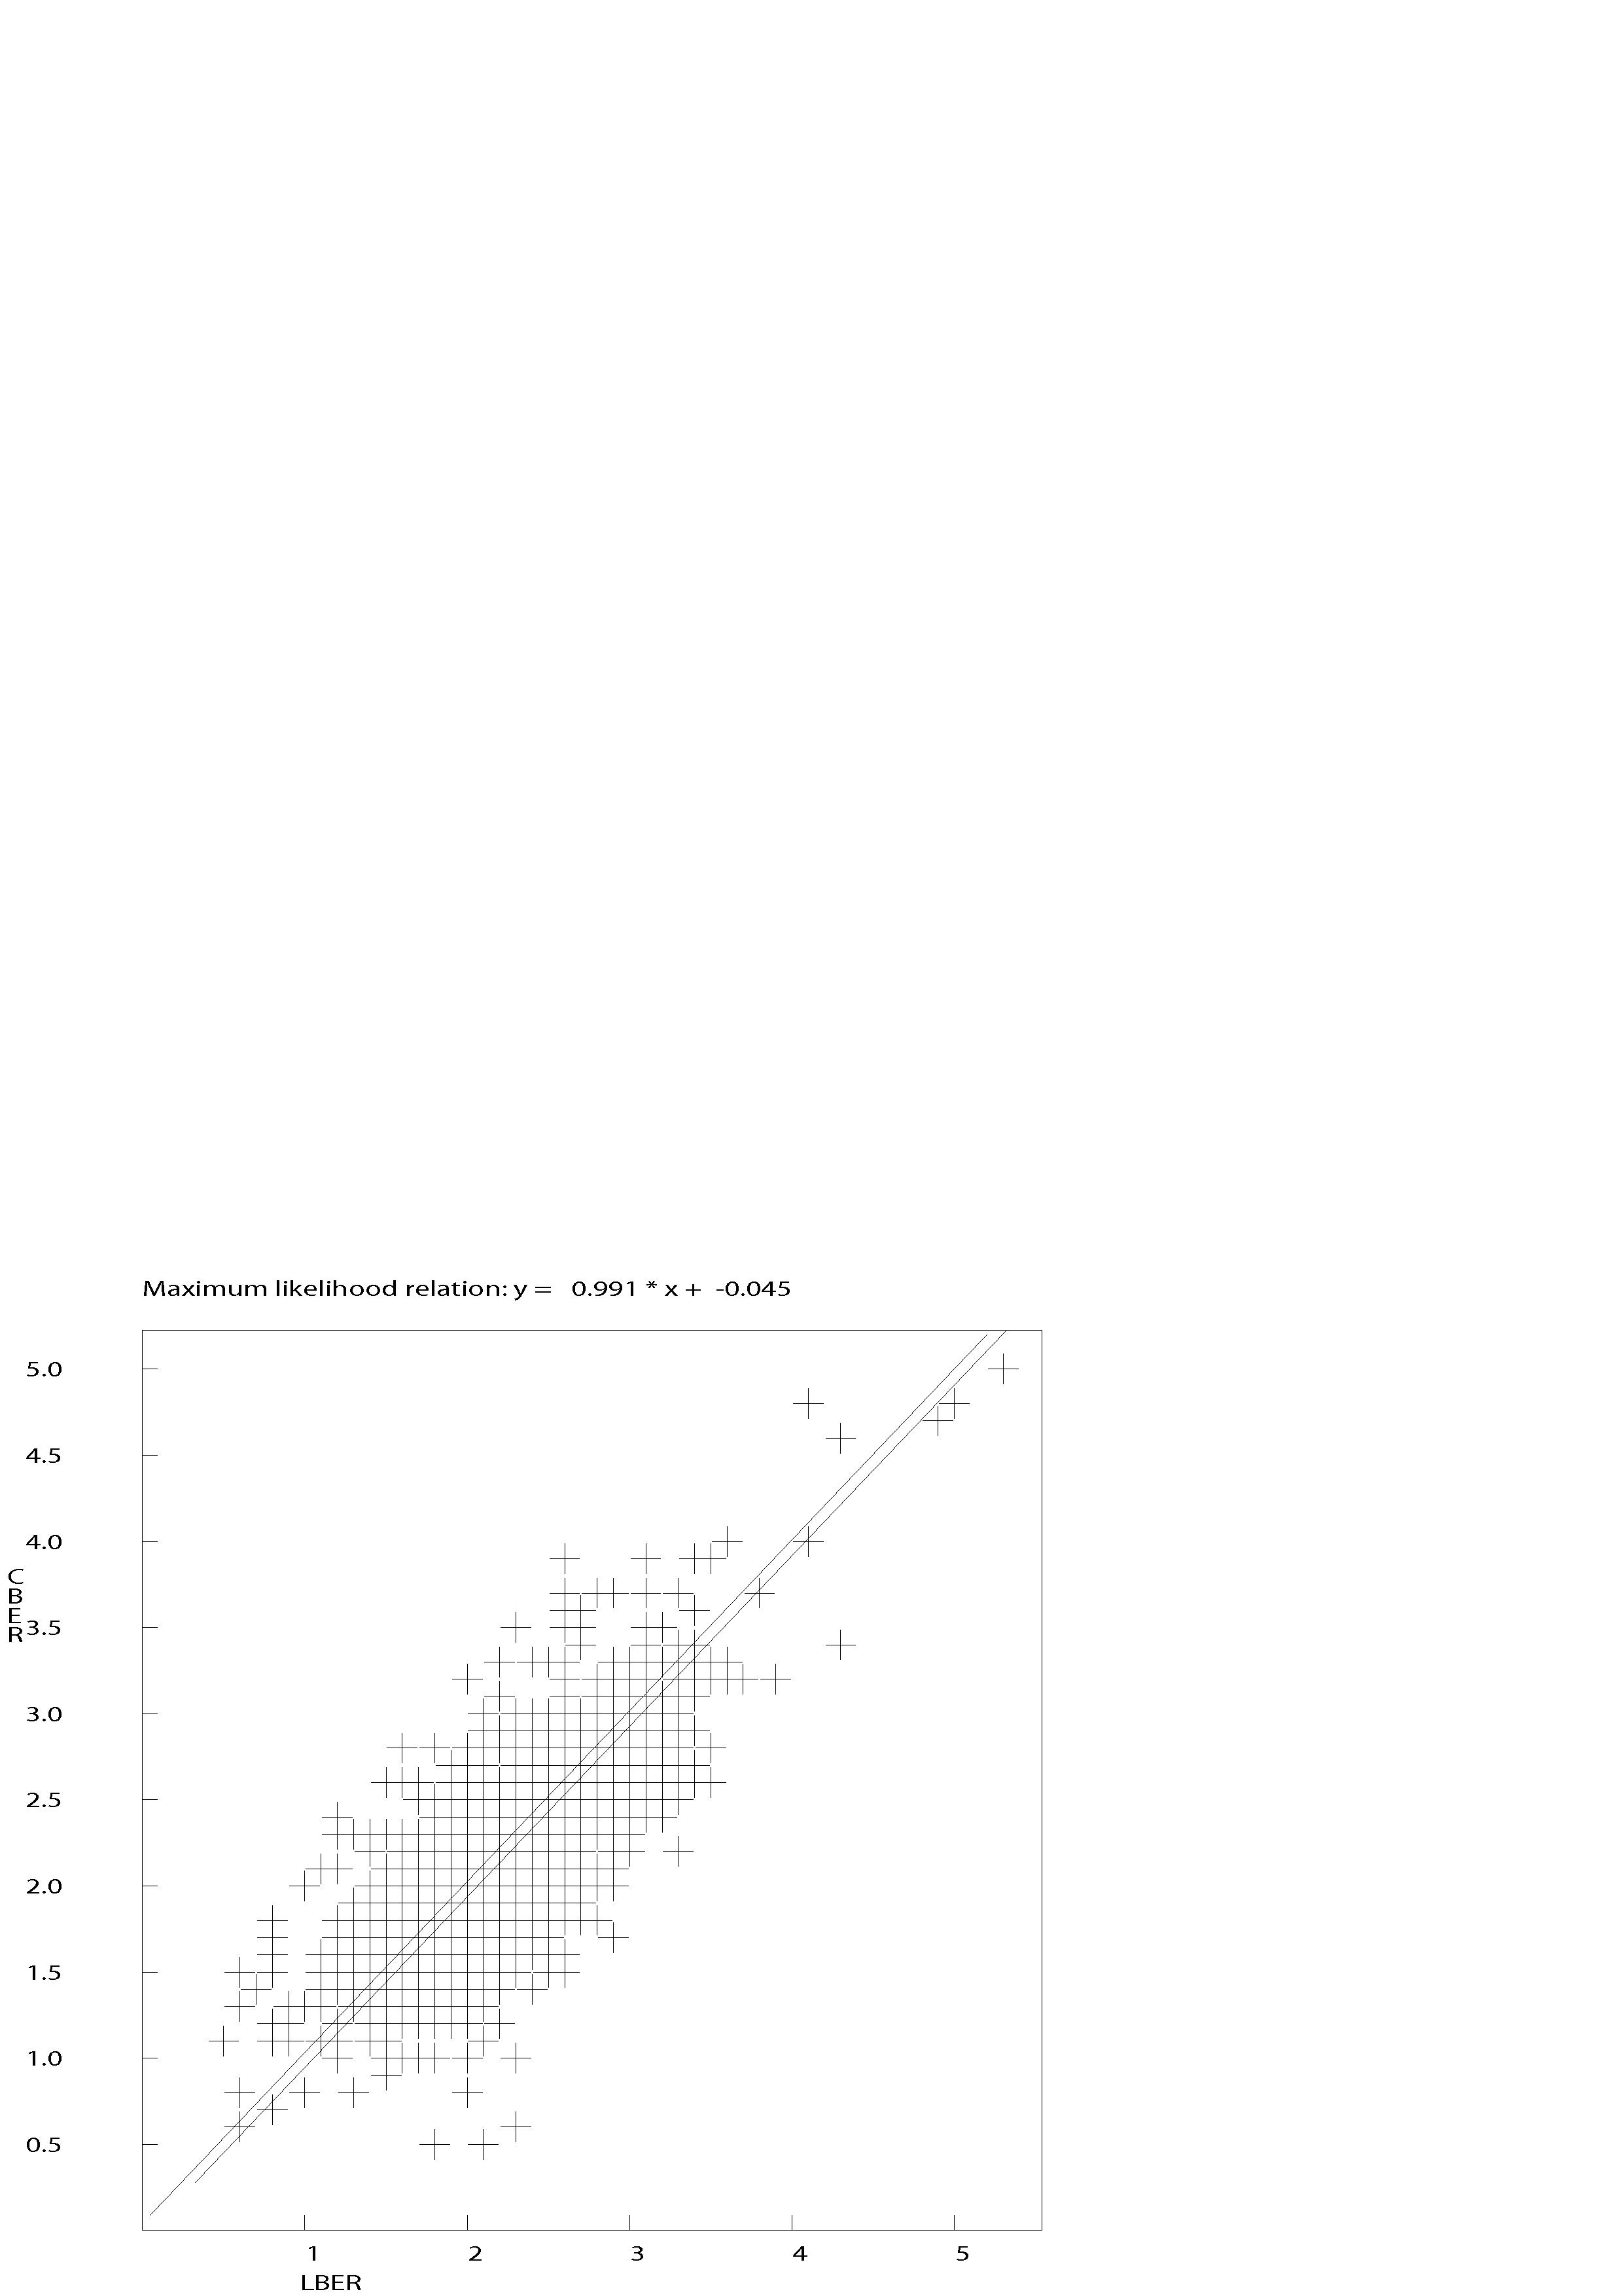
Figure 7. Comparison of original Mc and Ml (using scale for mainland Norway) for the events used in the regression for the Jan Mayen region. The uppermost line, showing 1:1 correlation, is shown for comparison.

