Norwegian National Seismic Network

Technical Report No. 23

Seismic swarms in the Steigen- Rana area in the period 1980- 2006

Prepared by

Ana Ivković

Dept. of Earth Science, University of Bergen
Allégt.41, N-5007 Bergen, Norway
Tel: +47-55-583600 Fax: +47-55-583660 E-mail: seismo@geo.uib.no

December 2006

List of contents

Summary | 4
1. Introduction | 4
2. Content of the database | 4
3. Explosion filtering | 7
3.1 Area 1 | 10
3.2 Area 2 | 11
3.3 Area 3 | 13
3.4 Area 4 | 16
3.5 Area 5 | 17
4. Seismicity in the study area | 19
5. Search for swarms by using the swarm program | 22
5.1 Steigen swarm area | 25
5.2 Meløy swarm area | 27
5.3 Stokvågen swarm area | 31
6. Manual search for swarms | 35
6.1 Steigen swarm area | 35
6.2 Meløy swarm area | 36
6.3 Stokvågen swarm area | 37
7. Conclusion | 45
Acknowledgements | 48
References | 48
Appendix 1 | 49
Appendix 2 | 54

Seismic swarms in the Steigen- Rana area in the period 1980- 2006

Summary
The aim of this study was to examine the seismicity catalog (1980-2006) for the area from Rana in the south to north of Bodø. Since that region has experienced earthquake swarms in the past, it was expected that some swarm areas could have been reactivated and/ or new swarm areas could be detected. First, the seismic catalog has been cleaned from explosions by the Exfilter program. After cleaning the catalog from explosions, the Swarm program and manual search were used in order to identify possible earthquake swarms. The Steigen swarm area has been reactivated in 2001, nine years after the Steigen swarm (1992). The Meløy swarm area has not been reactivated since 1978 when the Meløy swarm occurred. The Stokvågen area has shown high swarm activity since 1997. 8 swarms that took place in the Stokvågen area were identified in this study.

1. Introduction
Northern Norway has experienced periods with seismic swarms in the past. Recently swarm activity has been detected in the Stokvågen area (Novak, 2006). The purpose of this study is to examine the seismicity catalog (1980- 2006) for the area from Rana in the south to the north of Bodø, in order to identify how swarm areas have been reactivated and/ or if new swarm areas can be detected. The work will consist of two parts. First the catalog will have to be cleaned for known and possible explosions and then analysis will have to be made to identify swarms.

2. Content of the data base
During the time period studied, 2303 events were located within the area of interest. All locations are plotted on Figure 1. As we can see, there are five large clusters of events in this area (surrounded by red circles on Figure 1). From previous studies it is known that area 5 is related to the Steigen swarm (Atakan, Lindholm and Havskov,1994), area 2 is east of the 1978 Meløy swarm area (Bungum et al., 1979), area 3 is the Mo i Rana mines (Geo 2004) and area 4 is the high seismicity area of Stokvågen (Novak, 2006). In the database confirmed explosions and analyst identified explosions are marked. These events are shown on Figure 2. All these explosions should be removed from data.

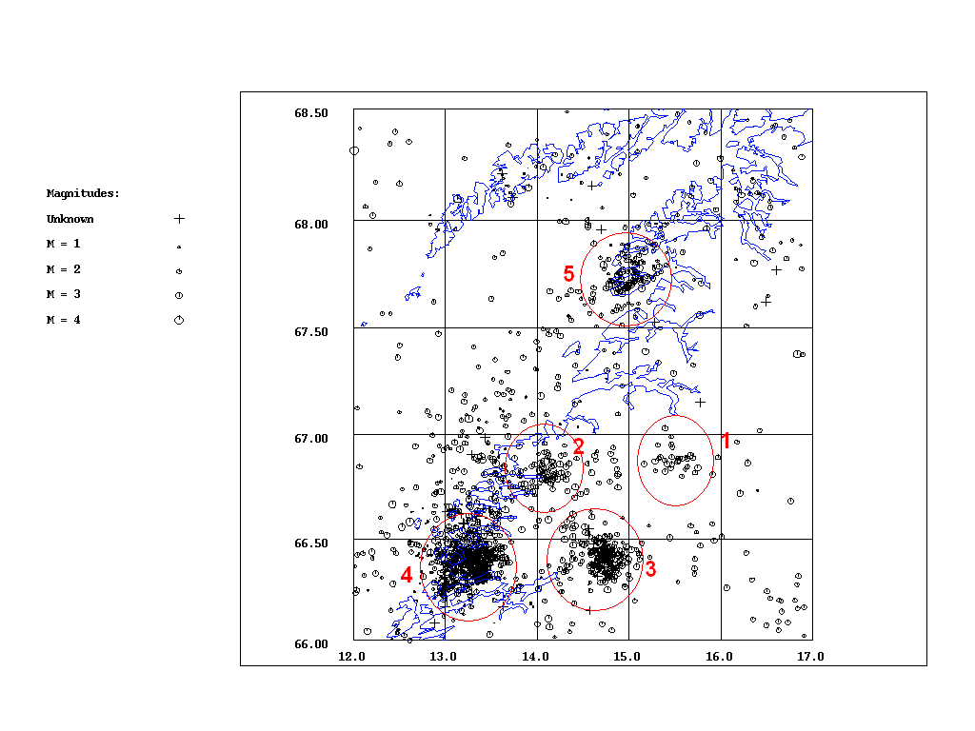
Figure 1. All events recorded in this area in the period 1980.-2006/06. Number of events: 2303. Clusters are surrounded by red circles and numbered.

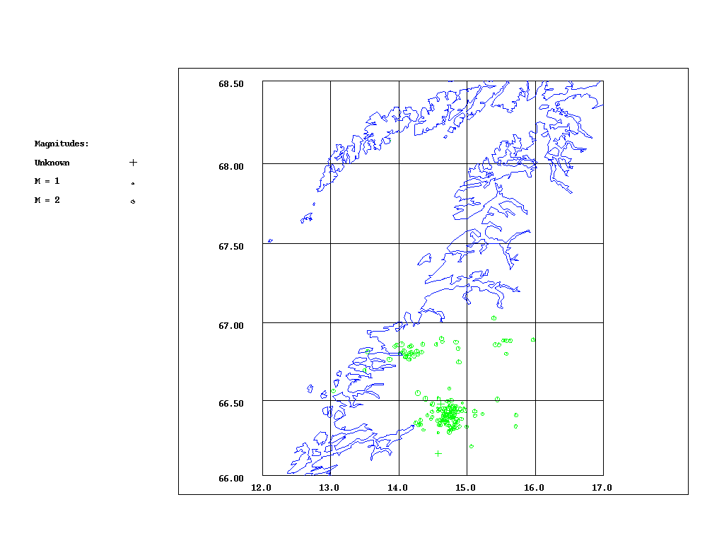

Figure 2. All known explosions in the area. Number of events: 167.

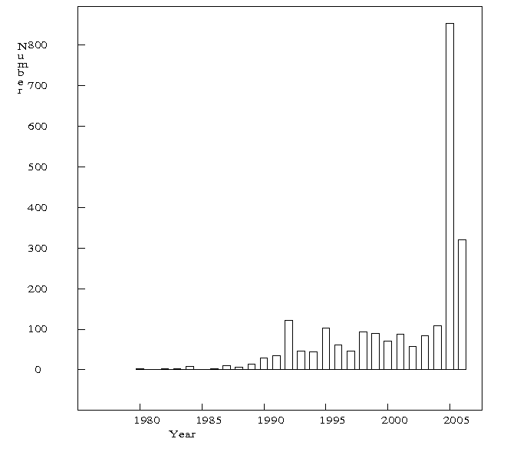
Figure 3. Time of year distribution for the whole area. All data including explosions.

The number of recorded events has been increasing during the time period 1980- 2006 (Figure 3). This is to be expected, since new stations were installed in Northern Norway around 1990 (Havskov et al.). In 2005 two temporary stations were installed in the Stokvågen area. Due to the increased station network density, the number of recorded events, in the area of interest, has increased dramatically after 2005.
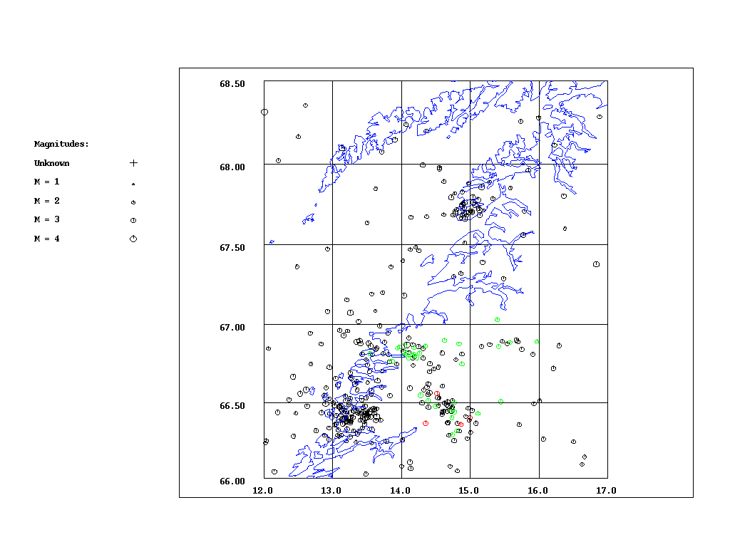
Figure 4. All events with magnitude larger than 2.5. Number of events: 349. Number of known explosions: 33. Number of probable explosions: 4. Green dots are known explosions, red dots are probable explosions and black dots are all other events.

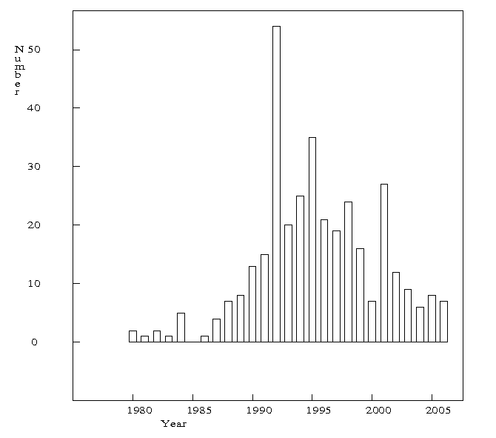
Figure 5. Time of year distribution for the whole area. Magnitude larger than 2.5.

The events with magnitude larger or equal to 2.5 represent approximately the detection threshhold from 1990, when the network was expanded (Havskov, Communication). Comparing Figure 3 and 5 it is seen that in terms of significant seismic activity, the maximum activity was in 1992. It corresponds to the Steigen swarm and the activity has gone down since then. The apparent high activity seen in Figure 3, since 2005, is caused by the low magnitude events in the Stokvågen area which are now recorded due to the higher density of stations in that area.

3. Explosion filtering
In order to get a complete picture of the seismicity, it is important to remove all the events known as explosions and events considered as explosions, also called probable explosions. Some of the events in the existing database have already been marked as explosions and some as probable explosions. The program Exfilter will be used to identify additional events that could be considered as explosions and such events will be removed from the database.

Description of the Exfilter program
Exfilter is a simple filtering program made by Lars Ottemöller (Ottemöller, 1995) which detects probable explosions in the given database. The method is based on normalizing the time of day distribution of seismic event occurrence as a function of the area. The aim of the filter is to identify as many explosions as possible without loosing too many earthquakes. The filter parameters are: the definition of the area, the maximum depth, the maximum magnitude, a time of day interval defined by lower and upper limit and year interval. The program works on the following principle: Areas where explosions occur are defined. If an event is located in one of these areas, with a magnitude below a given maximum magnitude, with shallower depth than a given maximum depth, within a given time of day interval and within a given year interval, it is identified and marked as a probable explosion.
The time of day distribution is one of the critical parameters, which can be used in the explosion filtering. It is expected that the earthquake occurance is a random process in time, not exhibiting any specific time of day distribution.
The magnitude is a parameter used in the explosion filter, since explosions have a limited magnitude. While defining the filter, a different maximum magnitude has been used for each area. The maximum magnitude has to be large enough to include most assumed explosions, but small enough not to include large earthquakes.
The location of the events is defined by the depth, latitude and longitude. Due to the fact that the accuracy of depth for the events in Scandinavia is not satisfactory, it is impossible to use the depth as parameter for filtering, although the explosions occur near the surface. Therefore the maximum depth is set to 100 km for all areas.
Northern Scandinavia was divided into eleven different areas. The numbering and locations of the filter areas are shown in Figure 6.

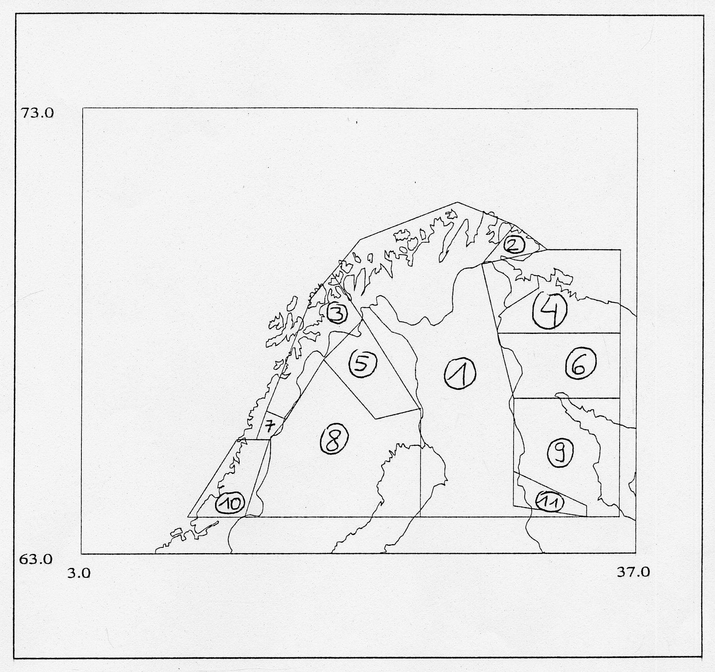
Figure 6. Numbering and locations of filter areas in Northern Scandinavia.

The area that is observed in this study corresponds to the defined filter areas 3, 7 and 8.
For Norway and surrounding areas, the Exfilter program uses an input parameter file, see Appendix 1.

There are 13 events marked as ”probable explosions” in the existing database. After using the explosion filter there are 92 more events marked as ”probable explosions”. The locations of all probable explosions, including the ones that already exist in the database, are shown on Figure 7.

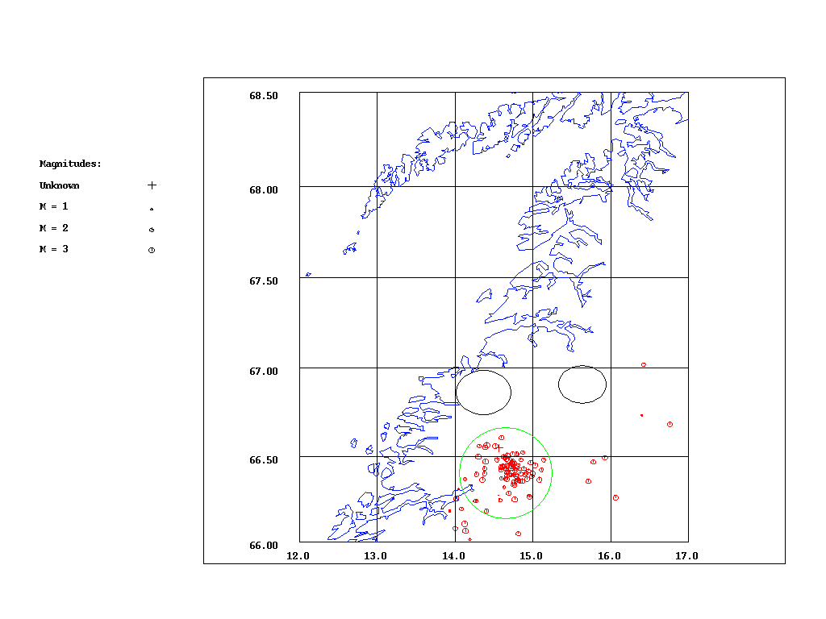
Figure 7. All events marked as ”probable explosions” and events detected as probable explosions after using Exfilter. Number of events: 105.

As we have expected, the majority of probable explosions (green circle, Figure 7.) corresponds to the great cluster of known explosions, as shown on Figure 2. However, we expected that some events would be detected as probable explosions in the areas surrounded by black circles (areas of known explosions) (Figure 7). Some events appearing outside the marked circles were not expected to be marked as probable explosions. This could mean that some earthquakes have been misidentified, or that some probable explosions have not been identified.
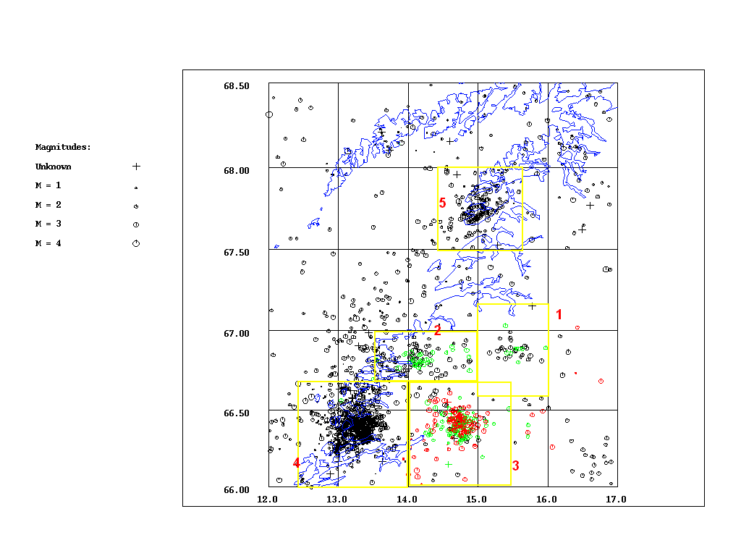
Figure 8. Map of all events. Green dots are known explosions, red dots are probable explosions and black dots are all other events. Yellow rectangles are the areas made to analyze the clusters (see the text below).

In order to analyze the clusters of events, 5 areas were defined (Figure 8 and Table 1). Each area contains only one cluster.

Table 1 The areas within the study area defined in order to analyze clusters of events.
AREA NUMBER | LATITUDE RANGE | LONGITUDE RANGE
1 | 66.6- 67.2 | 15.0- 16.0
2 | 66.7- 67.0 | 13.5- 15.0
3 | 66.0- 66.7 | 14.0- 15.4
4 | 66.0- 66.7 | 12.4- 14.0
5 | 67.5- 68.0 | 14.4- 15.6

3.1 Area 1.
After using Exfilter for the Area 1 there were no events identified as probable explosions (Figure 9). Area 1 corresponds to the filter area 3 (Figure 6). Filter area 3 was not set up for filtering out explosions.

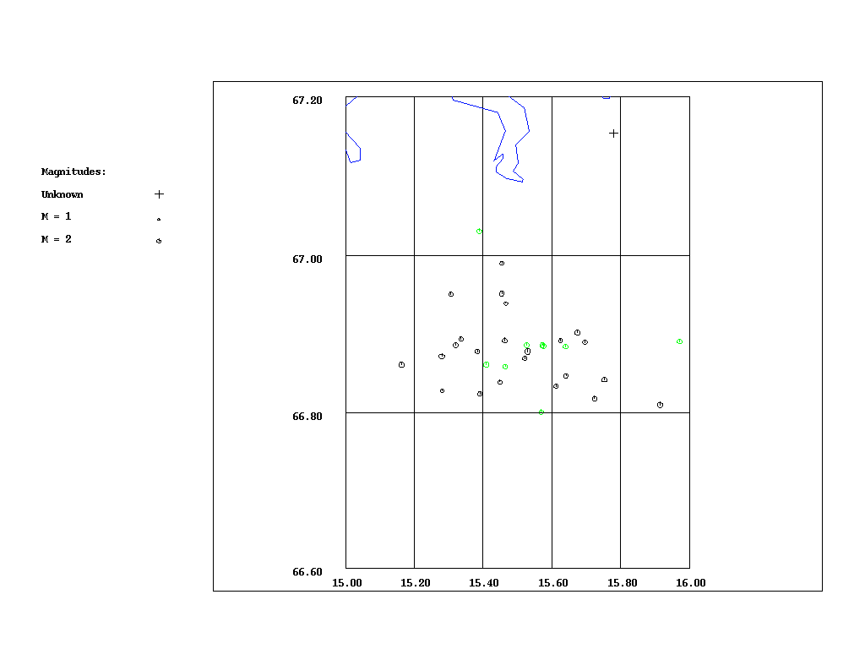
Figure 9. All events recorded in the Area 1. Number of events: 33. Green dots are known explosions. Number of known explosions: 9.

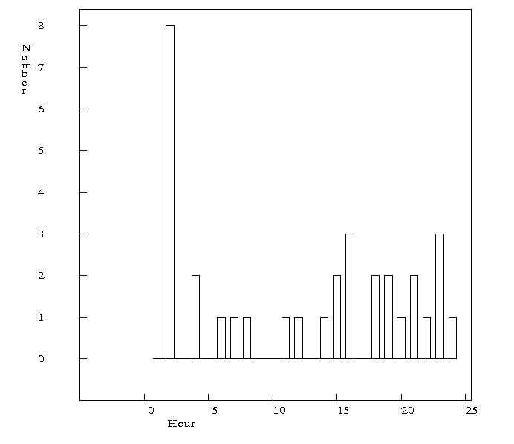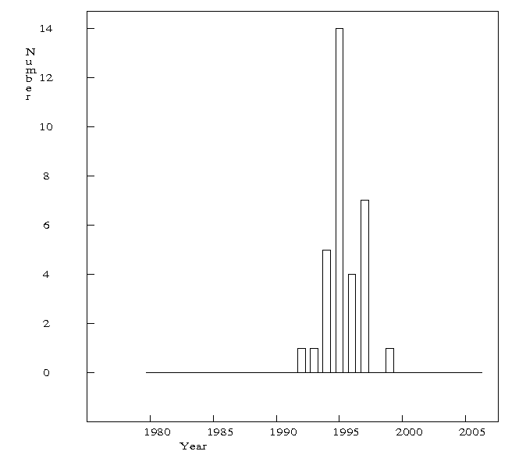
a b
Figure 10. a) Time of day distribution for Area 1. b) Yearly number of events for Area 1.

This cluster contains 9 known explosions. Time of day distribution can be considered uniform except for the events around 1 a.m. (Figure 10a). The yearly distribution shows that this seismic activity is time limited (Figure 10b). All events occurred in the time interval 1992- 1999. Since 9 out of the 33 events are known explosions, we are probably dealing with explosions only. The whole cluster should be removed.
A new filter area that will correspond to Area 1 is defined. The parameters for the new filter area, named area 3a, are defined in Table 2.

Table 2 The parameters for the filter area 3a.
Latitude- longitude pairs | 66.78 15.00; 66.78 16.00;  67.10 16.00; 67.10 15.00
Maxdepth | 100.0
Maxmag | 3.5
Lhour | 0
Hhour | 24
Btime | 199201
Etime | 199912

3.2 Area 2.
The cluster contains 28 confirmed explosions. All explosions are related to the temporary construction work at Svartisen, coordinates: 66.8 14.1. Known explosions outside this area are probably mislocated.
After using Exfilter for this area there were no events identified as probable explosions, since no filter has been defined for the western part of area 2 and since eastern part of area 2 is a part of filter area which has not been used for filtering out the explosions.

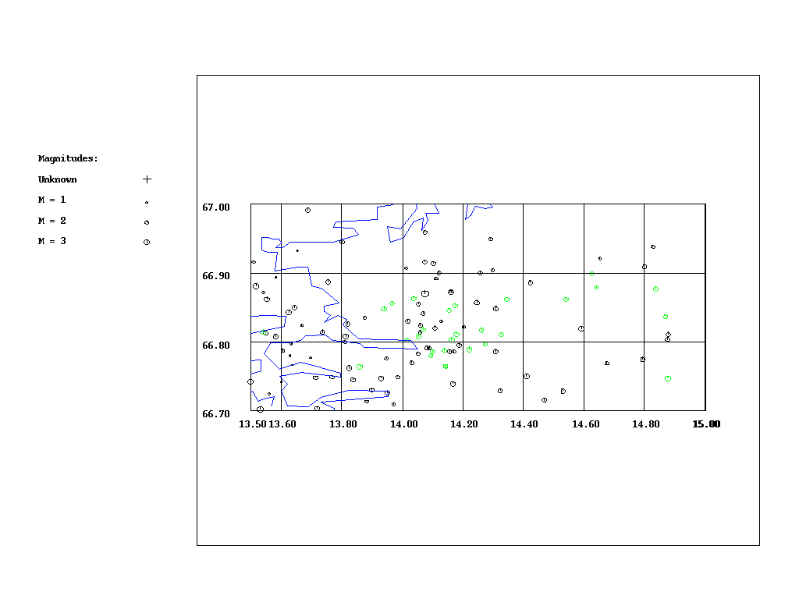
Figure 11. All events recorded in the Area 2. Number of events: 112. Green dots are known explosions. Number of known explosions: 28.

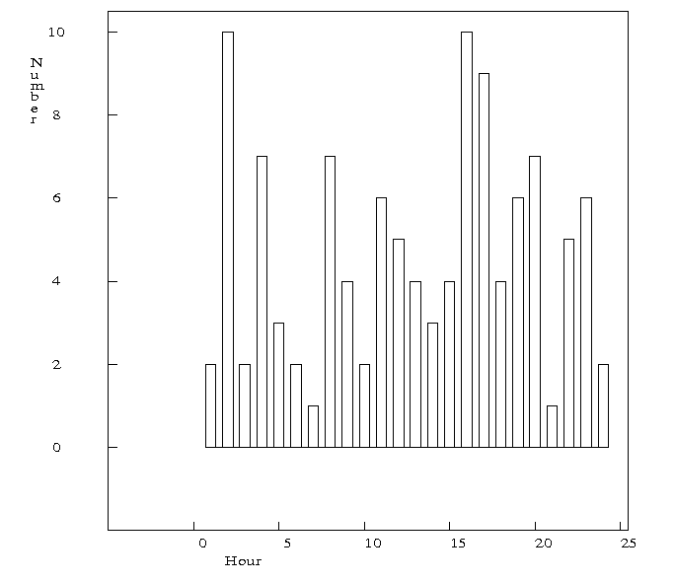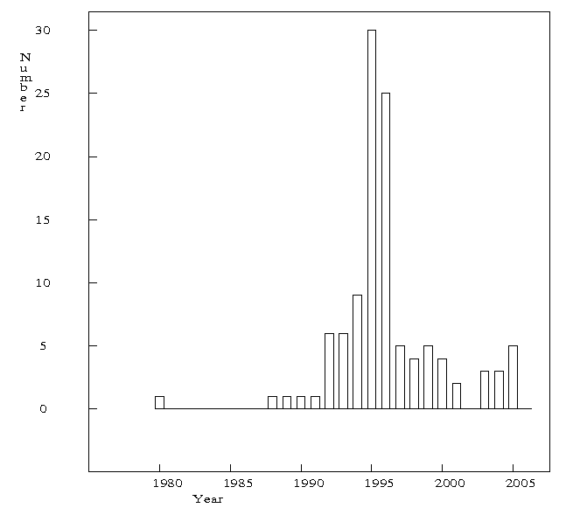
a b
Figure 12. a)Time of day distribution for the Area 2. b) Yearly number of events for Area 2.

Time of day distribution could be considered uniform (Figure 12a), however events predominate around 01 a.m. and 16 p.m. Yearly distribution is not uniform at all. It shows that the number of events suddenly increased in the time period 1995-1996 (Figure 12b).
This could be caused by an earthquake swarm, however 24 out of 28 known explosions occurred in the time period 1995- 1996. It could also be that Svartisen`s explosion activity was higher than reported.
Due to the lack of stations in the area, there are no events recorded in the time period 1981- 1987. Normal level of events for the time period 1988- 2006 is 5 per a year. In the time period 1995- 1996, 55 events have been recorded, 45 events more than expected. The conclusion is that most of these events are explosions and should be removed.
Maximum magnitude of all events is 3.1. Maximum magnitude of explosions is 2.9. Only 6 out of 31 events (that haven’t been marked as explosions in the time period 1995- 1996) have magnitude larger than 2.9, but still below 3.1. Due to the fact that most events have magnitude lower than 2.9, most events in the time period 1995- 1996 are probably explosions.
A filter area that will correspond to the Area 2 should be defined.

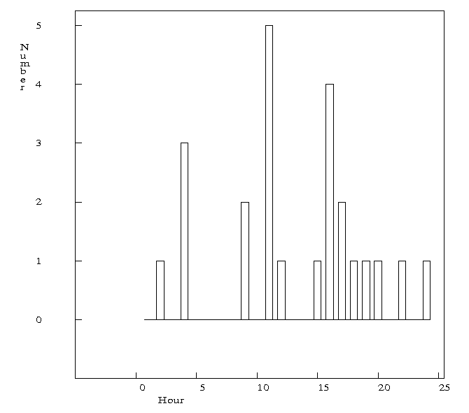
Figure 13. Time of day distribution for the confirmed explosions in the time period 1995- 1996.

The time of day distribution of known explosions is almost uniform (Figure 13). The lower and upper limit of the time interval used for filtering should be 0- 24.

The parameters for the new filter area, which will be named area 3b, are in the Table 3.

Table 3 The parameters for the filter area 3b.
Latitude- longitude pairs | 66.70 13.50; 66.70 15.00;  67.00 15.00; 67.00 13.50
Maxdepth | 100.0
Maxmag | 2.9
Lhour | 0
Hhour | 24
Btime | 199501
Etime | 199612

3.3 Area 3.
Almost half of the events (124 out of 264) recorded in this area are known explosions and 13 of them are already marked as probable explosions in the existing data base. All known explosions are coming from Rana Gruber mine. By applying the Exfilter program to the events in this area, 97 events were marked as probable explosions. Location of all events and explosions are shown on Figure 14.
Area 3 corresponds to the filter area 7. The filter area 7 has been defined by the parameters shown in the Table 4

Table 4 The parameters for the filter area 7.
Latitude- longitude pairs | 66.00 13.7; 66.70 14.30;  66.50 15.50; 66.00 14
Maxdepth | 100.0
Maxmag | 3.4
Lhour | 7
Hhour | 16
Btime | 197001
Etime | 201012

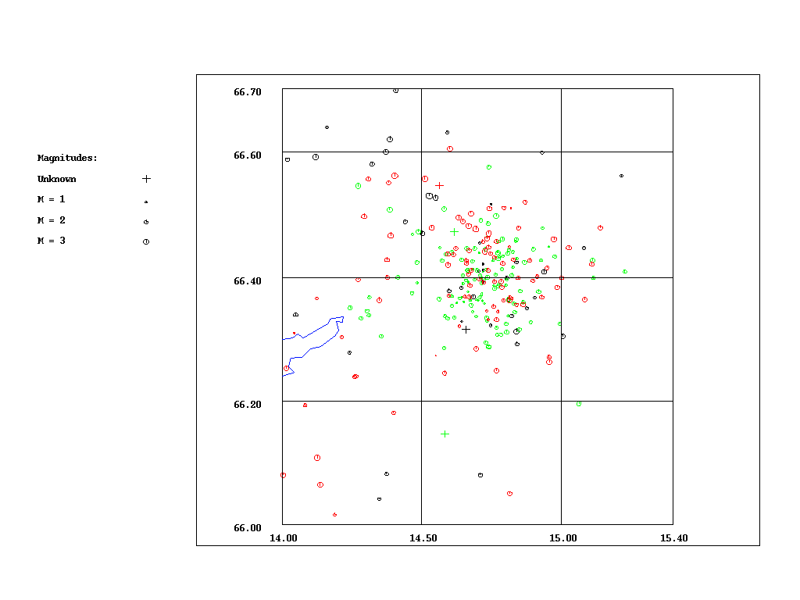
Figure 14. All events recorded in the Area 3. Number of events: 264. Green dots are known explosions. Number of known explosions: 124. Red dots are probable explosions (all events marked as probable explosions, before and after filtering). Number of probable explosions: 97 (13 before and 84 after filtering).

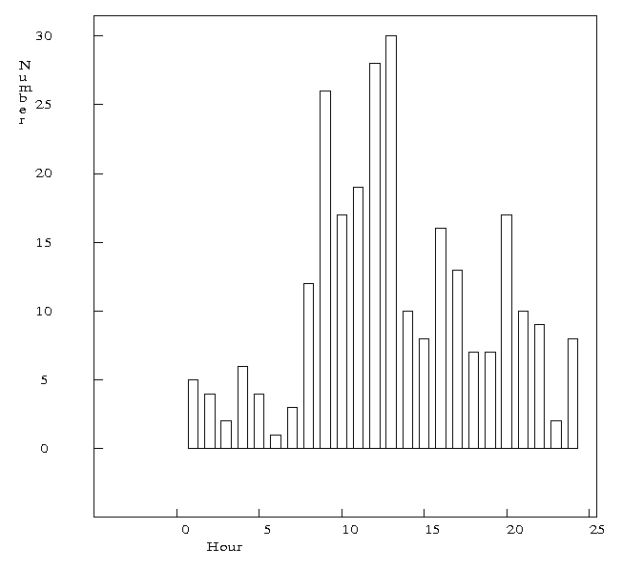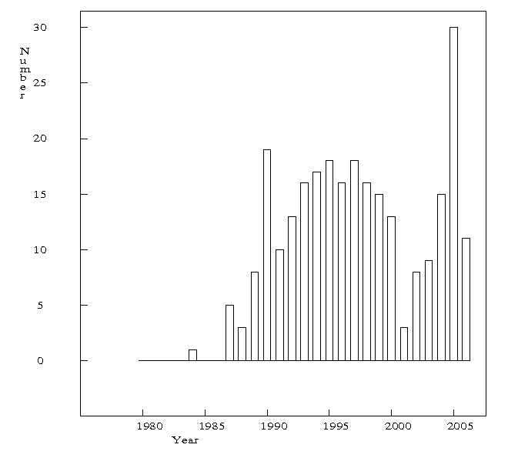
a b
Figure 15.a) Time of day distribution for the Area 3. b) Yearly number of events for the Area 3.
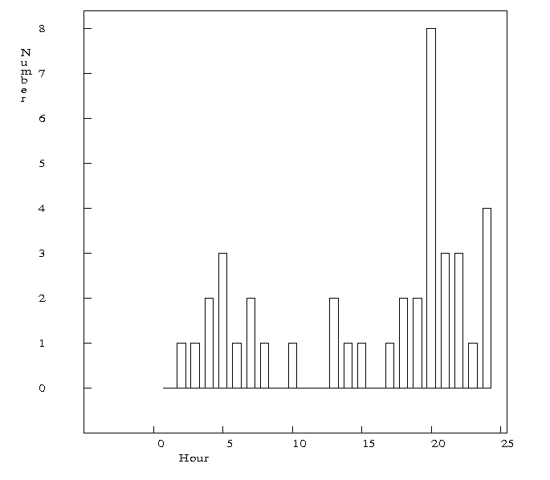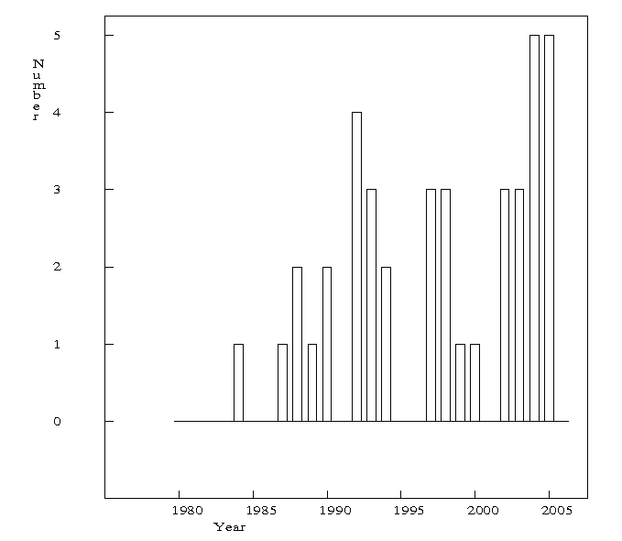
a b
Figure 16 a) Time of day distribution for the Area 3 after removing all known and probable explosions with existing explosion filter. b) Yearly number of events for the Area 3 after removing all known and probable explosions.

After using the already existing filter, it is seen that the time of day distribution is almost uniform (Figure 16a). All events that occurred at 9 a. m., from 10 to 12 a. m. and at 16 p. m. have been removed by the filter (Figure 16a). The yearly number of events distribution contains some gaps as well (Figure 16b). It could mean that some earthquakes have been identified as explosions and removed or that some explosions have not been recognized by the filter.

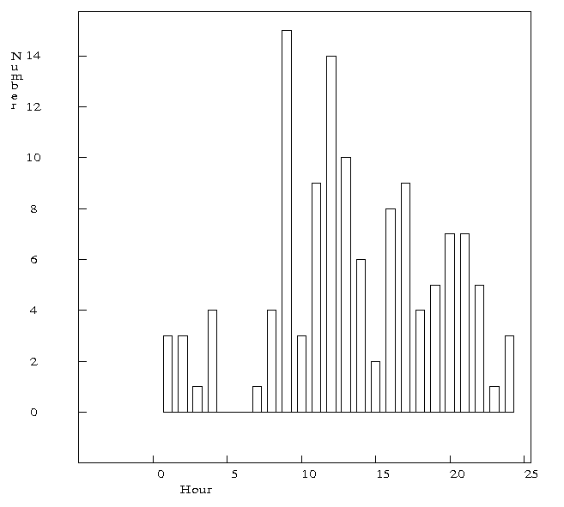
Figure 17. Time of day distribution of all known explosions.

It seems like the explosions have been occurring during 24 hours (Figure 17). The conclusion, that all events are probably explosions, is reached by comparing the time of day distribution of all known explosions (Fig. 17) to the time of day distribution of all events (Fig. 15a). The parameters Lhour and Hhour should be changed and instead existing parameters, the parameters: Lhour: 0 and Hhour: 24 should be used for the filtering.

Instead of the existing filter for the area 7, a new filter area is defined. The new filter for area 7 will have the shape and the size of the Area 3. The parameters for the new filter area are given in the Table 5.

Table 5 The parameters for the filter area 7.
Latitude- longitude pairs | 66.00 14.00; 66.00 15.40;  66.70 15.40; 66.70 14.00
Maxdepth | 100.0
Maxmag | 3.4
Lhour | 0
Hhour | 24
Btime | 197001
Etime | 201012

3.4 Area 4.
Locations of the events taking place in this area are shown on Figure 18. After using the program Exfilter for this area, there were no events identified as probable explosions, since there is no filter area defined for the Area 4.

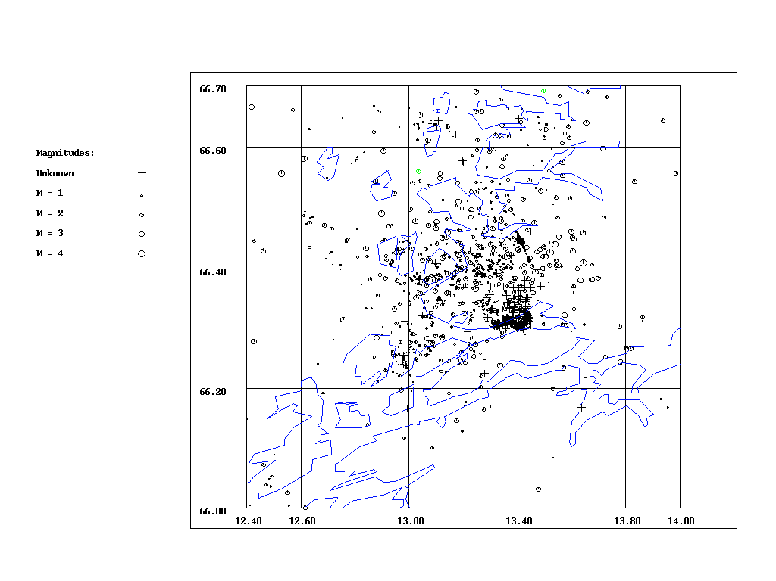
Figure 18. All events recorded in the Area 4. Number of all events: 1447. Green dots- known explosions. Number of known explosions: 2.

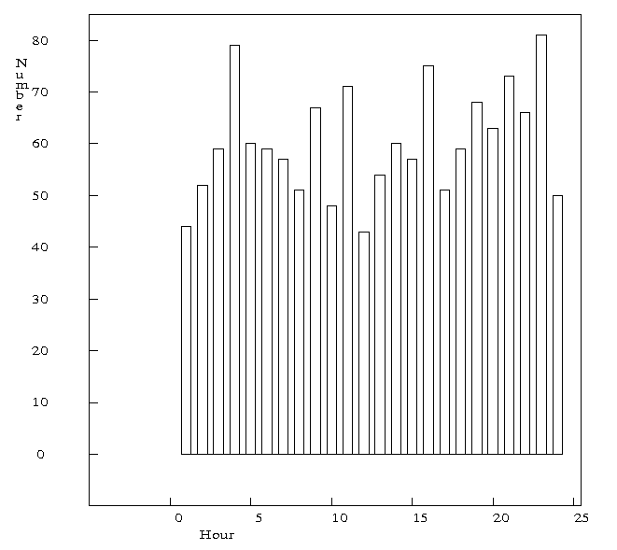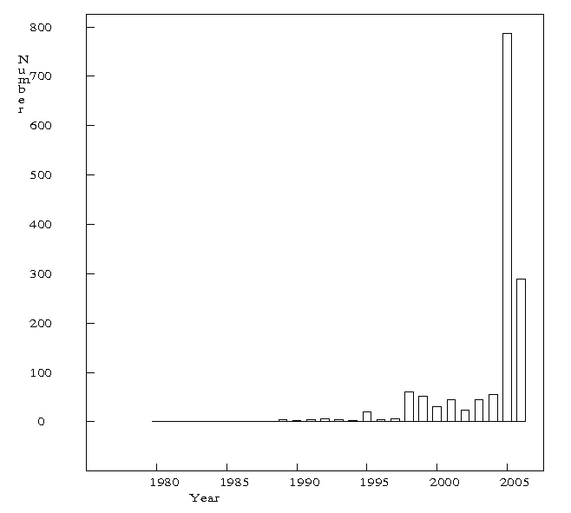
a b
Figure 19 a) Time of day distribution for the Area 4. b) Yearly number of events for the Area 4.

Majority of events occurred in the time period 2005- 2006. (Figure 19b). But, that was expected, since in 2005 two temporary stations were installed in this area and the number of recorded events (most of them with low magnitude) has been increased. Since the time of day distribution is uniform (Figure 19a), it is likely that we have earthquakes in this area.
Therefore, no explosion filter is made for the Area 4.

3.5 Area 5.
Locations of the events that are taking place in this area are shown on Figure 18. After using the Exfilter for this area there were no events identified as probable explosions, since no explosion filter is defined for the Area 5.
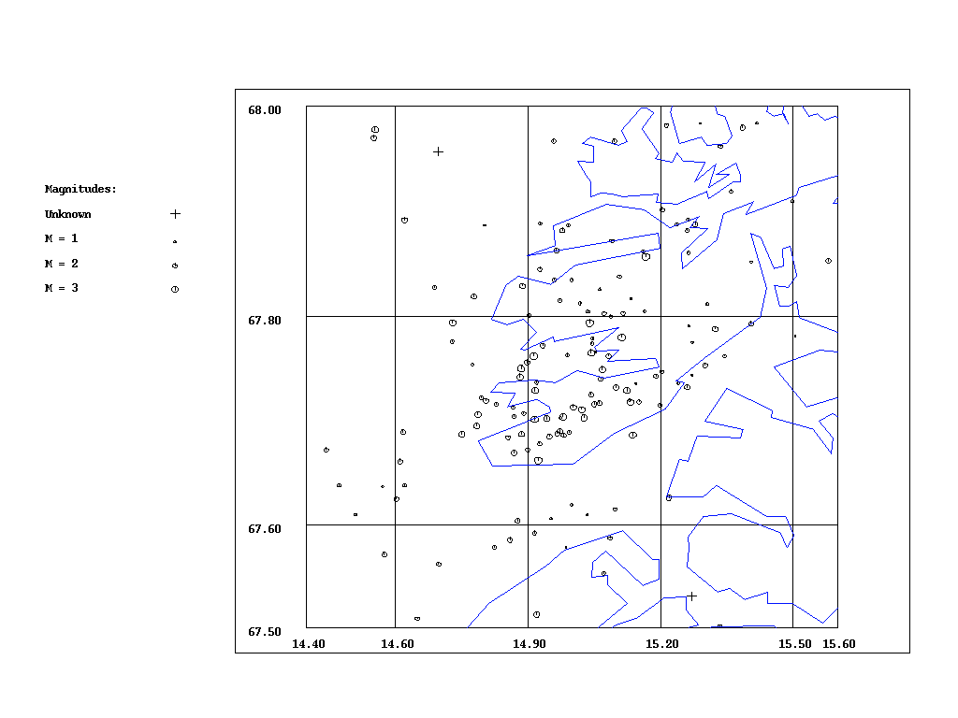
Figure 20. All events recorded in the Area 5. Number of all events: 143.

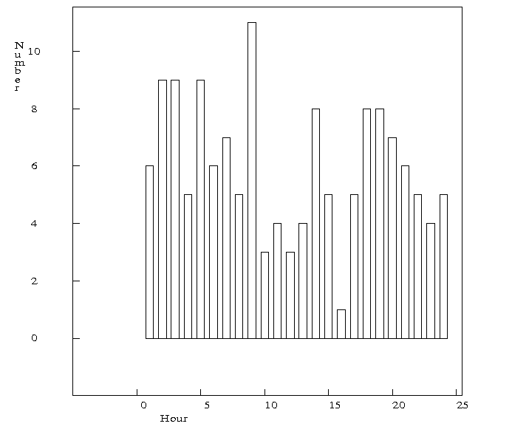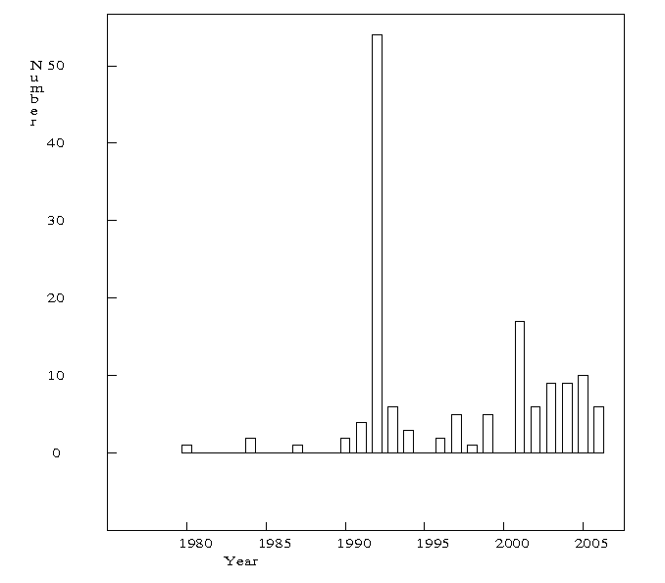
a b
Figure 21 a) Time of day distribution for the Area 5. b). Yearly number of events for the Area 5.

Since time of day distribution is uniform (Figure 21a) and most of the events occurred in the year 1992 (Figure 21b), when there was a swarm in this area, we assume the events to be earthquakes.
There is no need to define the filter area that would correspond to the Area 5.
There is also an additional area. That area corresponds to the filter area 8. But events appearing in that area are not of our interest and will not be analyzed in this study.
After changing parameters for filter area 7 and defining two new filter areas 3a and 3b, the program Exfilter has been used for filtering. Figure 28 shows the result.
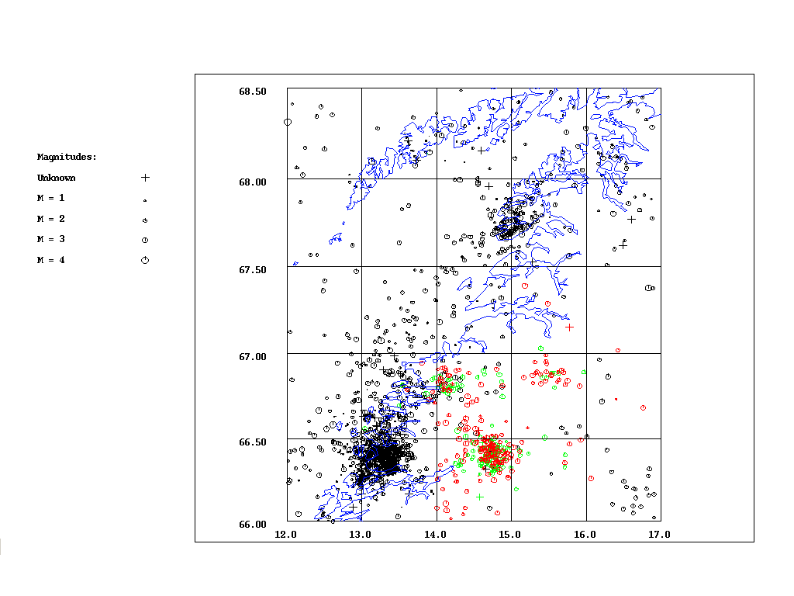
Figure 22. Map of all events after using the Exfilter with new parameters. Green dots are known explosions (167), red dots are probable explosions (191) and black dots are all other events (1945).

4. Seismicity in the study area
After using the Exfilter with new defined parameters and removing all confirmed and probable explosions, the seismic activity in the study area looks as on Figure 23.

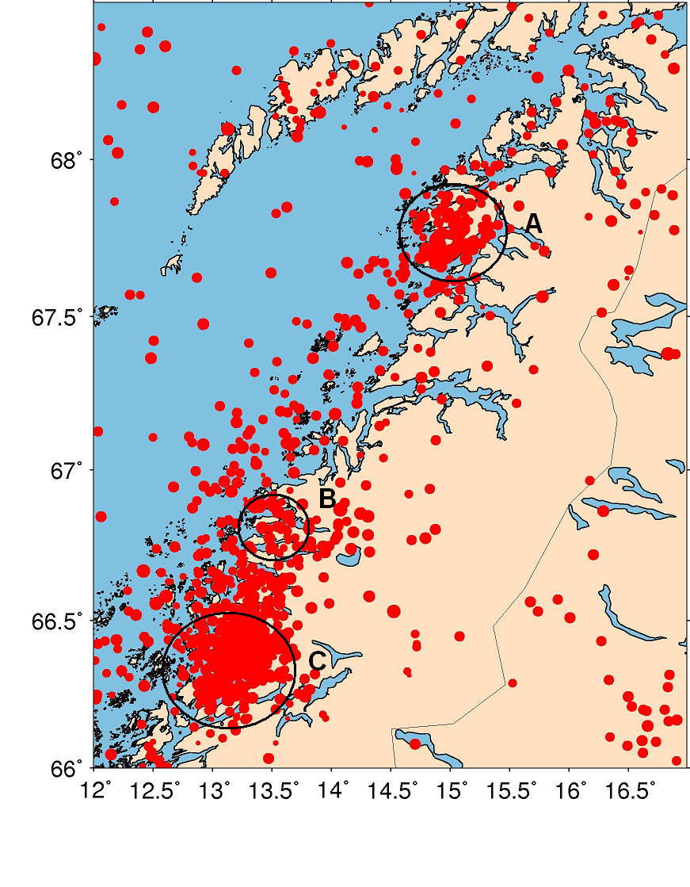
Figure 23 Seismicity in the study area after explosion filtering. Number of events (earthquakes): 1929. (Script for this map see in Appendix 2.)

We can notice that there is high seismic activity along the coast line, onshore and offshore as well (Figure 23). We can easily note the two large clusters of earthquakes surrounded by black circles and marked by letters A and C. The cluster A is in the area in which Steigen swarm took place in January 1992 (Atakan et al., 1994). The C cluster corresponds to the swarms in the Stokvågen area. During the period July 1997- January 1999, when the local seismic network in this area was temporarily expanded, there were detected earthquakes that occurred in five groups or swarms (Hicks, 2000). It seems that there have been three swarms in the time period 2005/07- 2006/07 (Novak, 2006.) There is no significant seismic activity along the coastline between the A and C cluster, although it is known that in the year of 1978, the Meløy swarm occurred in the area marked by the letter B (Bungum et al., 1979).

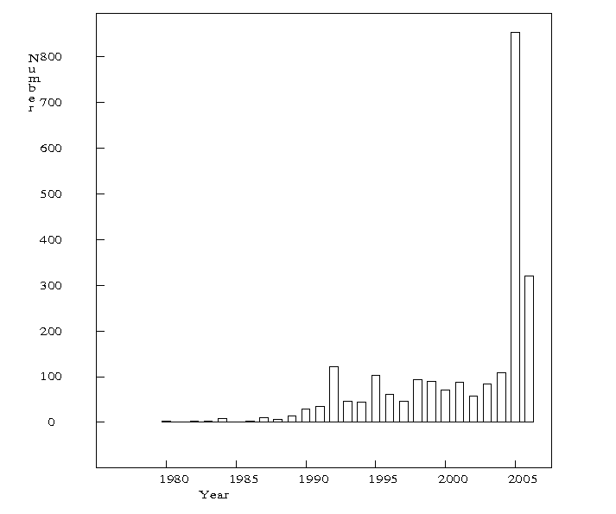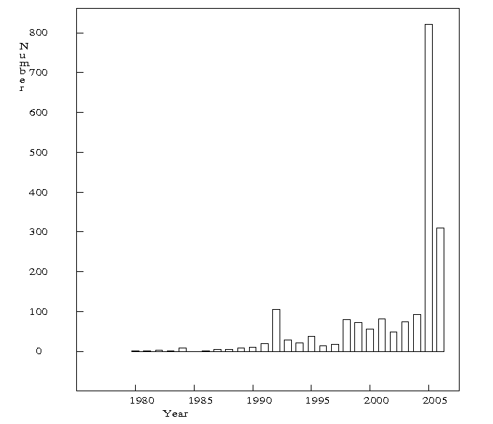
a b
Figure 24. Yearly number of events for the study area before (a) and after (b) filtering.

Comparing yearly number of events for the study area before and after filtering (Figure 24) it is seen that there is no significant difference between the two. Most of the events that have been removed by filtering occurred in the time period 1993-1997, because in 1997 Rana Gruber iron ore mine ceased to operate (Geo, April 2004). The number of recorded events suddenly increased after 1997 when new stations were installed (Hicks et al., 2000). Therefore, it is possible that the increased number of recorded events since 1998 is due to the increasing network density.

It is obvious that the number of recorded events depends on the network density in a certain area or in a certain period that has been observed. So, it does not have to mean that the areas with large number of recorded events are seismically more active. It could be that the most of the recorded events have small magnitudes and that they are recorded only because they appear in the vicinity of the stations. That is why it is important to use the detection threshold as a criteria to distinguish the events that would be recorded, no matter how far from station they appear. The magnitude constraint has to be taken into consideration. Figures 25 and 26 are showing the spatial and time distribution of the events with magnitude above 2.5 that has been set as a detection threshold. We can notice that Stokvågen area and Steigen area are pretty active and that most of the events recorded in Stokvågen area have small magnitude. Still, the events with magnitude above 2.5 are showing spatial distribution similar to space distribution of all events.
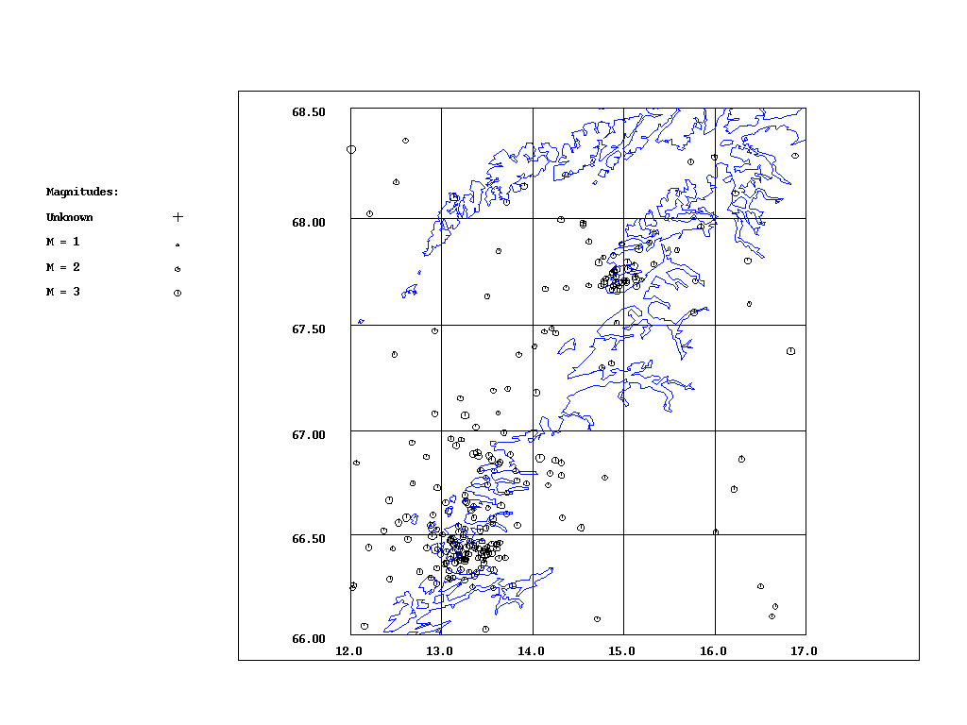
Figure 25 All earthquakes with magnitude equal or larger than 2.5. Number of events: 232.

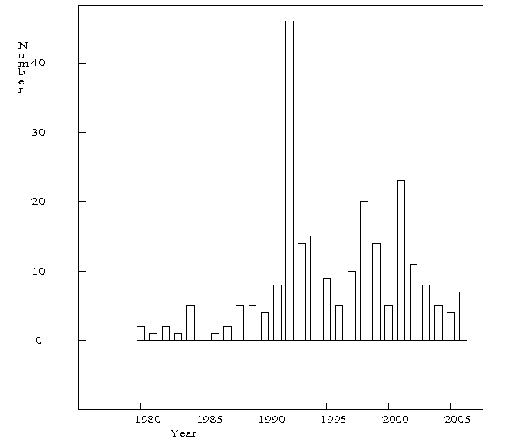
Figure 26. Yearly number of events with magnitude larger or equal 2.5.

However, the time distribution of events with magnitude above 2.5 is quite different than the time distribution of all events (Figures 24b and 26). The main peak is in 1992 (Steigen swarm) and there are two smaller peaks in the years 1998 and 2001.

In order to describe the seismicity in this area, it is important to identify possible earthquake swarms. So far, the spatial and time distributions point out that possible swarms could have occurred in Stokvågen or Steigen area in the years 1992, 1998, 2001, 2005 or 2006. The program Swarm (Havskov and Ottemöller, 2005) will be used to identify possible swarms.
5. Search for swarms by using the Swarm program
Description of the program Swarm
The program is used to identify seismic swarms in a catalog. Input to the program is a file with many events and some manually entered parameters. Output is identified swarms.
Principle of selection: The area is divided into a lat- lon grid. Around each grid point there is a cell with a certain radius. The program first checks the number of events in each cell for the whole catalog. Than it checks each cell to find which has more than the minimum number of events to constitute a swarm under the condition that there are enough events within the time window. The minimum number of events considered to be sufficient to constitute a swarm in this study is 10. For each time window with enough events a swarm is declared so that a swarm lasting e. g. twice the time window will be declared as two swarms. An additional condition is that the number of events is larger than the normalized background activity. The normalized activity is calculated as the activity in the large cell normalized for area to the small cell and normalized in the time window for the swarm (Havskov and Ottemöller, 2005).

In this study, the Swarm program was used with various input parameters to identify swarms in the data base. Three different sets of input parameters were used. As an input file, first the database that contains all recorded earthquakes was used and afterwards the data base containing only the events with magnitude larger than 2.5.

Table 6 The list of input parameters, used in the Swarm program for identifying swarms, that do not vary.
Latitude range and grid size (deg) | 66 68.5 0.1
Longitude range and grids size (deg) | 12 17 0.25
Radius of cell and radius of background cell (deg) | 0.1 0.2
Minimum number of events in time window | 10

All recorded earthquakes
Figures 27-29 are showing the results of the Swarm program search for earthquake swarms. As mentioned before, three different sets of input parameters were used. The symbols on the figures are representing the centres of the identified swarms.

1)
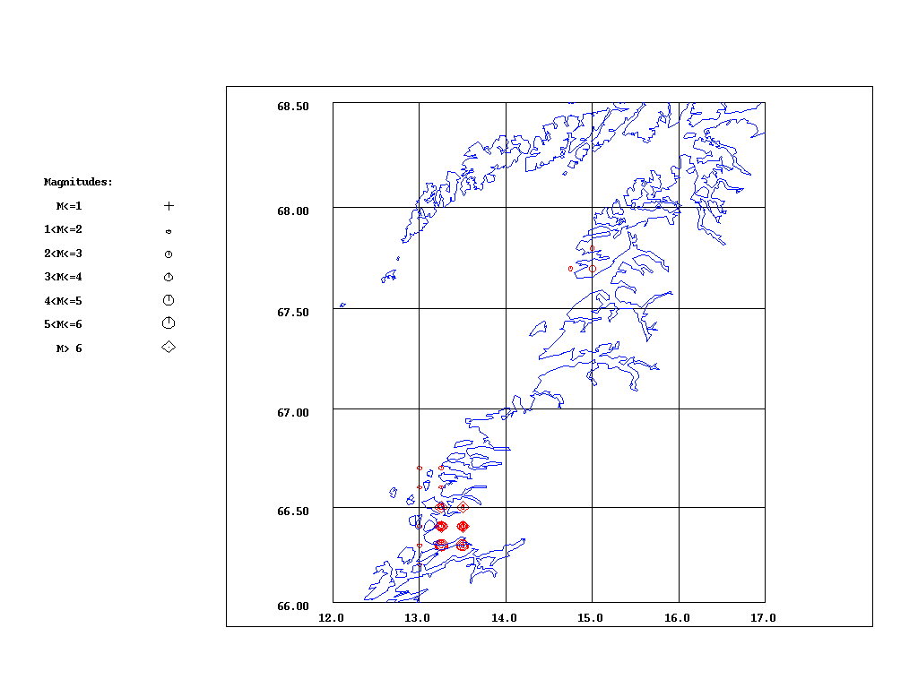
Figure 27. Earthquake swarm centers identified by the Swarm program. Number of swarms: 81. Time window in days: 20. Minimum ratio of number of events to background activity: 10. The size of the symbols is proportional with the number of events in the swarm.

2)
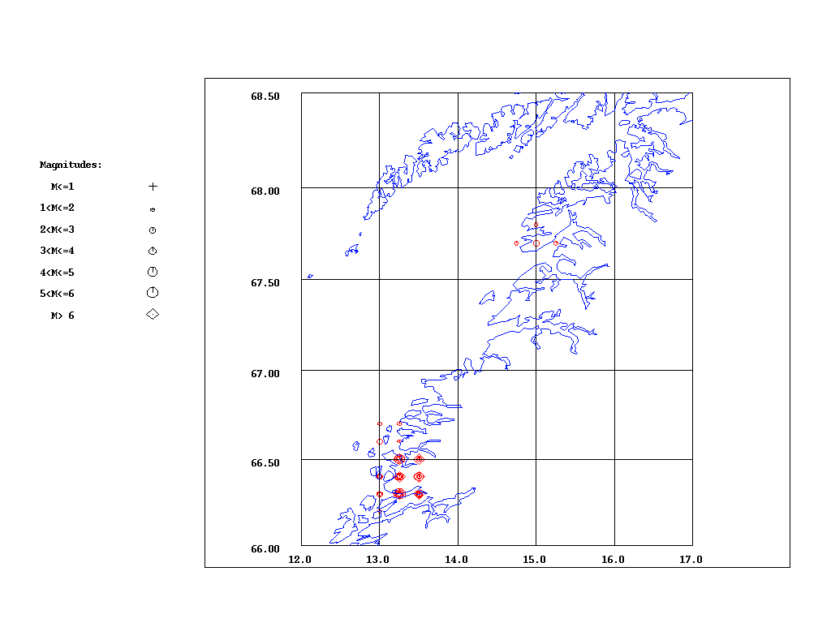
Figure 28. Earthquake swarm centers identified by the Swarm program. Number of swarms: 79. Time window in days: 30. Minimum ratio of number of events to background activity: 10

3)
Figure 29. Earthquake swarm centers identified by the Swarm program. Number of swarms: 81. Time window in days: 20. Minimum ratio of number of events to background activity: 5.

All recorded earthquakes with magnitude equal or larger than 2.5
When we applied three different sets of parameters to the data containing events with magnitude above 2.5 there was only one swarm identified, as shown on Figure 30.
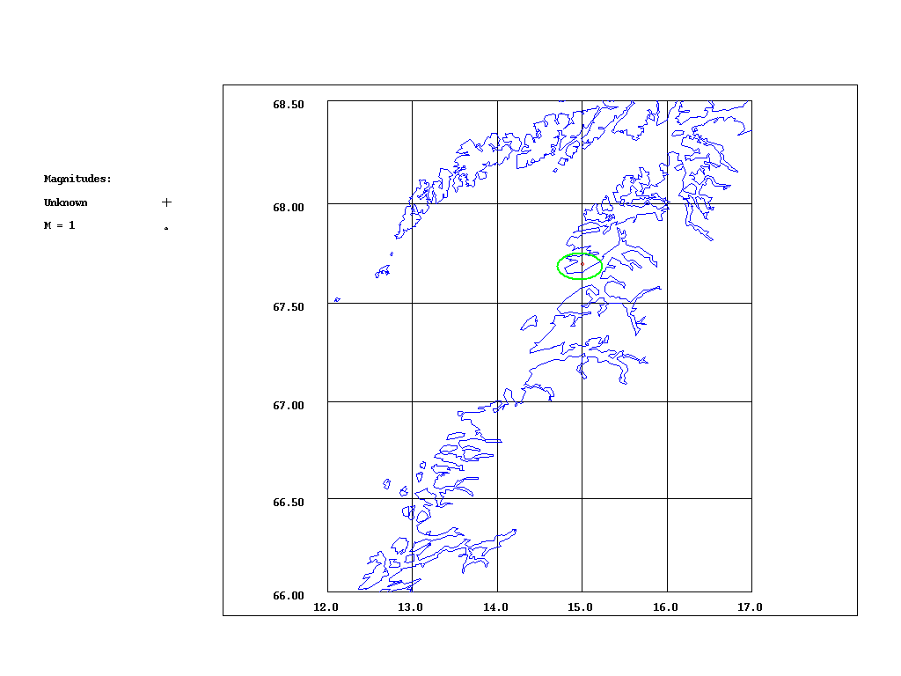
Figure 30. Earthquake swarm center (surrounded by green circle) identified by the Swarm program. Number of swarms: 1. Time window in days: 30. Minimum ratio of number of events to background activity: 10.

After using different parameters for identifying swarms we can notice that the number of swarms was almost not depended on the parameters we used (Figures 27-29). Due to that we will not investigate each case (set of parameters) separately. After applying the swarm program to the events with magnitude above 2.5 we found only one swarm.

It can be noticed that there are three potential swarm areas: The one that is the same as the area where Steigen swarm took place, the one that is the same as the Stokvågen swarms area and the one that is in the vicinity of the Meløy swarm. We will analyze the results of Swarm program search for each of those areas separately.

5.1 Steigen swarm area
As mentioned before, in this area the Steigen swarm took place in 1992. The Steigen swarm is an example of an intraplate swarm. The earthquake activity in Steigen started with the first event on 1st of January 1992. The seismic activity occurred in several separate pulses during the 1992 with last event recorded on 8th of December 1992. All events have been concentrated in a small region in the Brenevika Bay (67.8°N, 14.9°E) (Atakan et al., 1994).
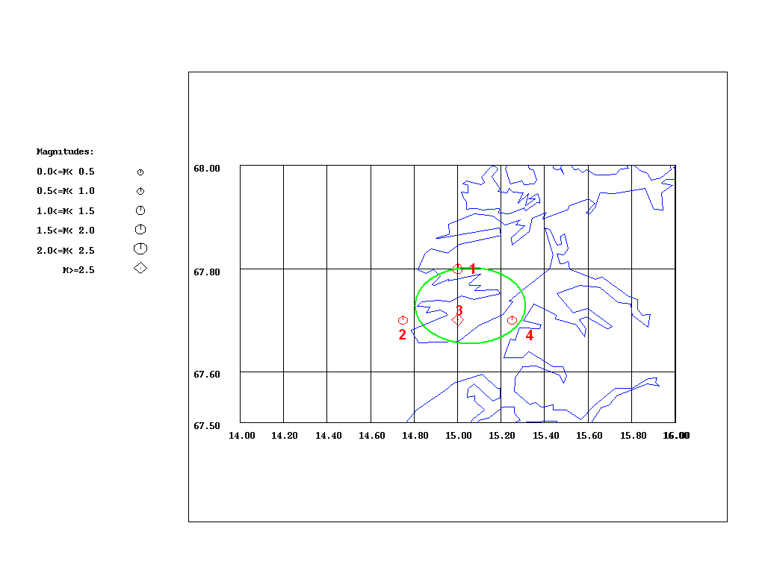
Figure 31 Green circle stands for Steigen swarm area and red symbols stand for swarms identified by the Swarm program.
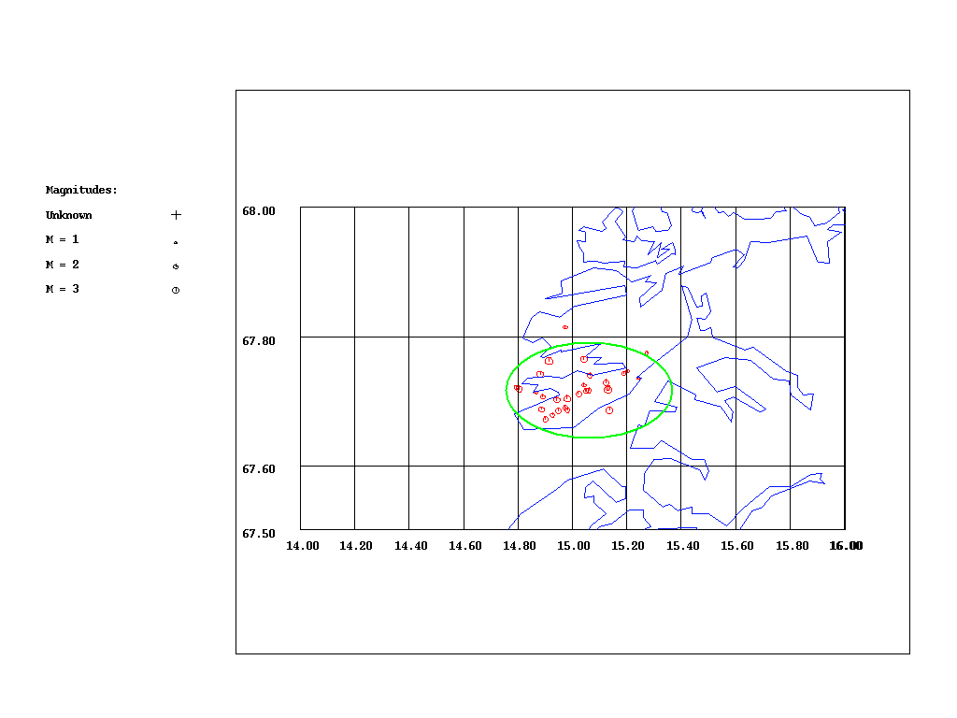
Figure 32 Green circle stands for Steigen swarm and red symbols stand for earthquakes that constitute swarms identified by the Swarm program.

The number of all swarms identified by the Swarm program using 3 different sets of input parameters is 4 (Figure 31). They are all concentrated in a small region within the Steigen swarm area. Their spatial distribution implicates that all of them could belong to the Steigen swarm. In order to find out whether these swarms belong to the Steigen swarm we will check their time distributions as well.

Swarm 1
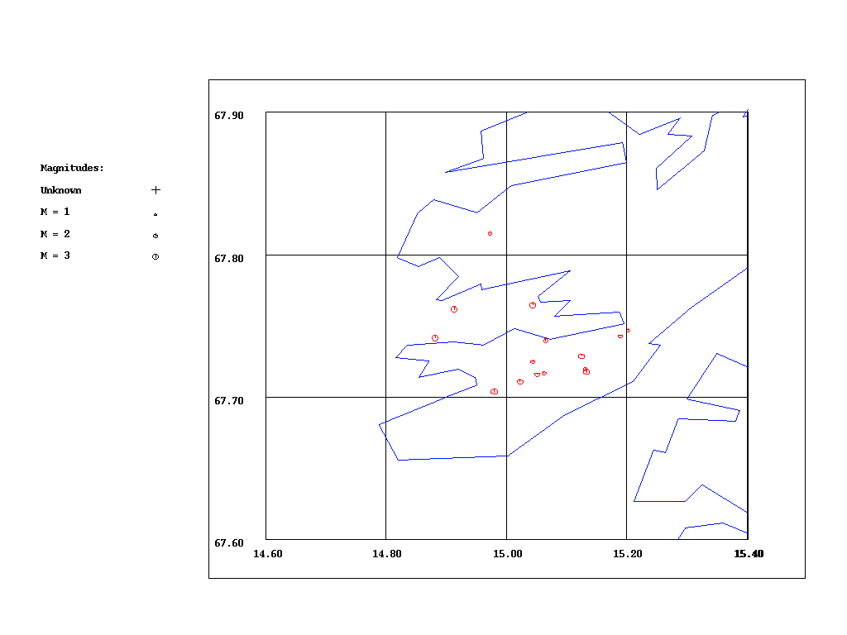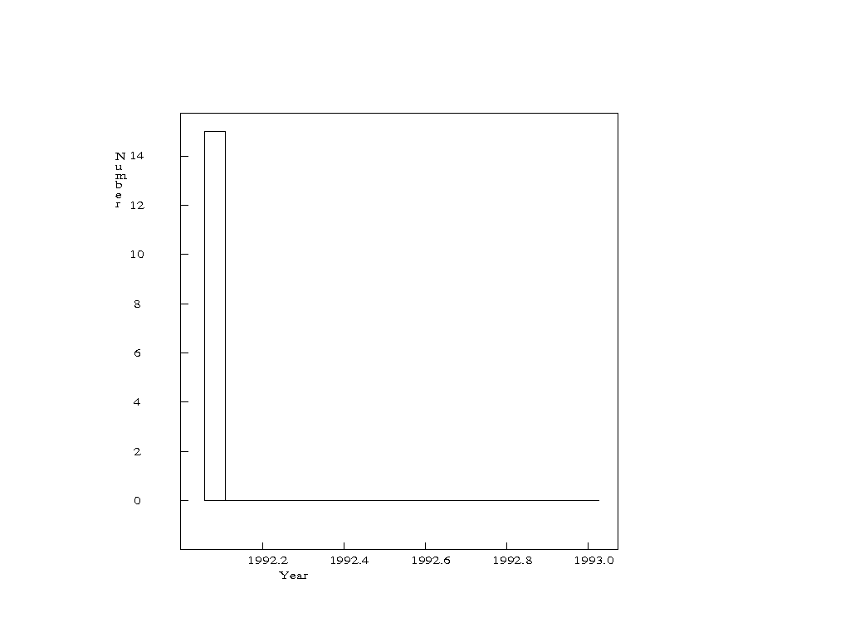
a) b)
Figure 33 a) Map of earthquakes that constitute Swarm 1 (red dots). Number of events: 15. b) Monthly number of events that constitute Swarm 1.

Swarm 2
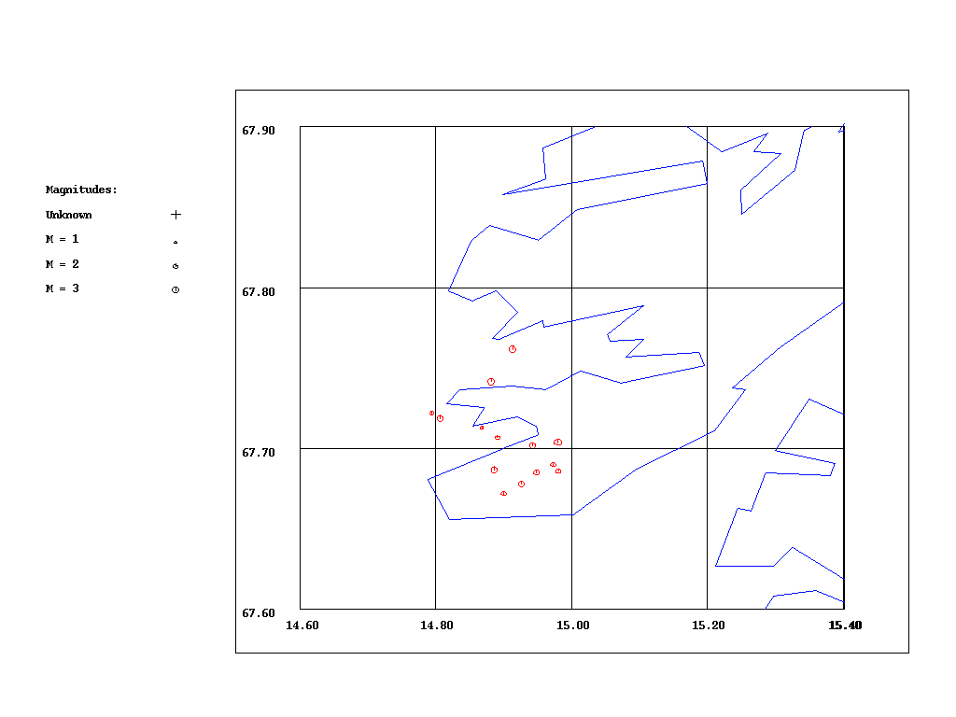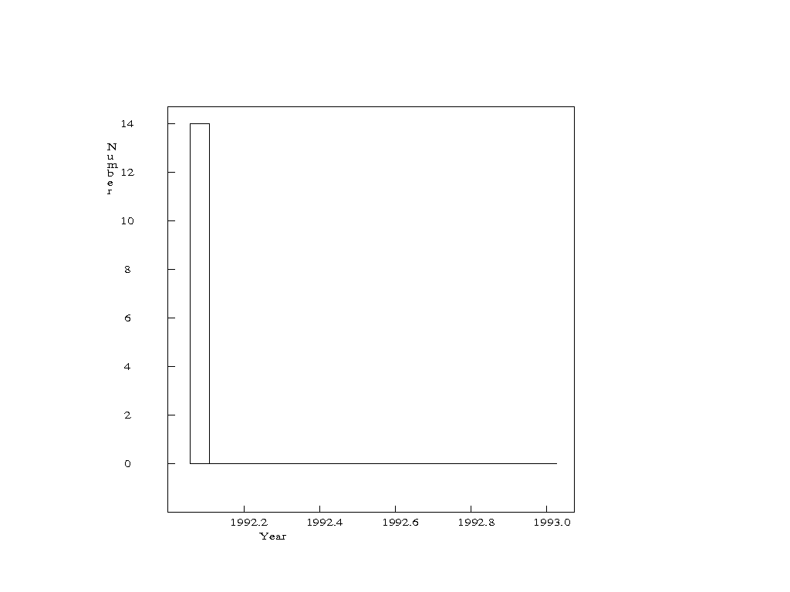
a) b)
Figure 34 a) Map of earthquakes that constitute Swarm 2 (red dots). Number of events: 14. b) Monthly number of events that constitute Swarm 2.

Swarm 3
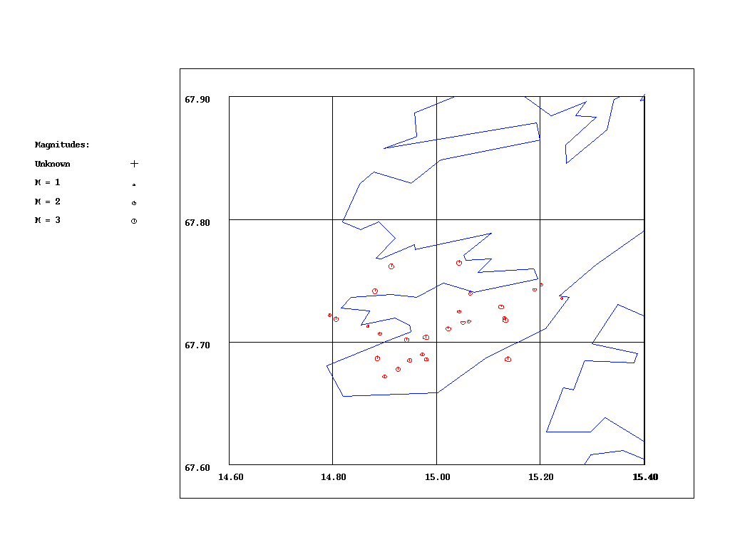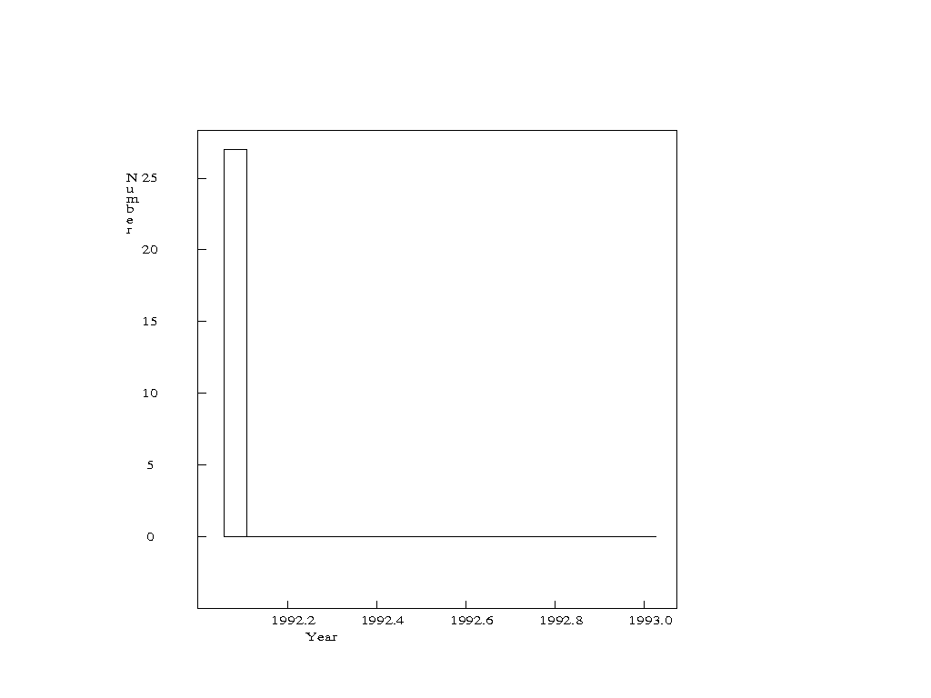
a) b)
Figure 35 a) Map of earthquakes that constitute Swarm 3 (red dots). Number of events: 27. b) Monthly number of events that constitute Swarm 3.

Swarm 4
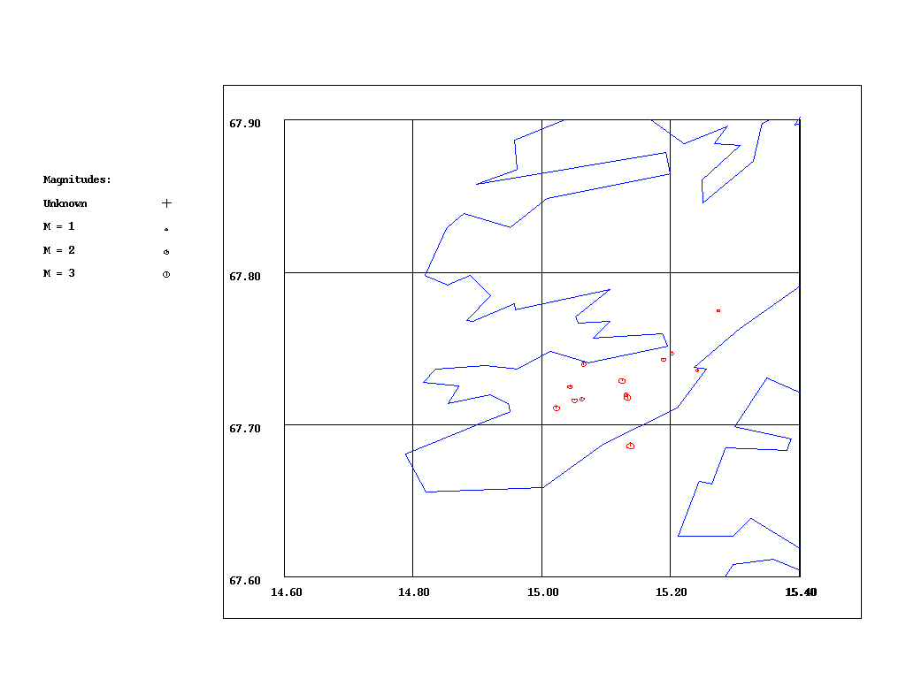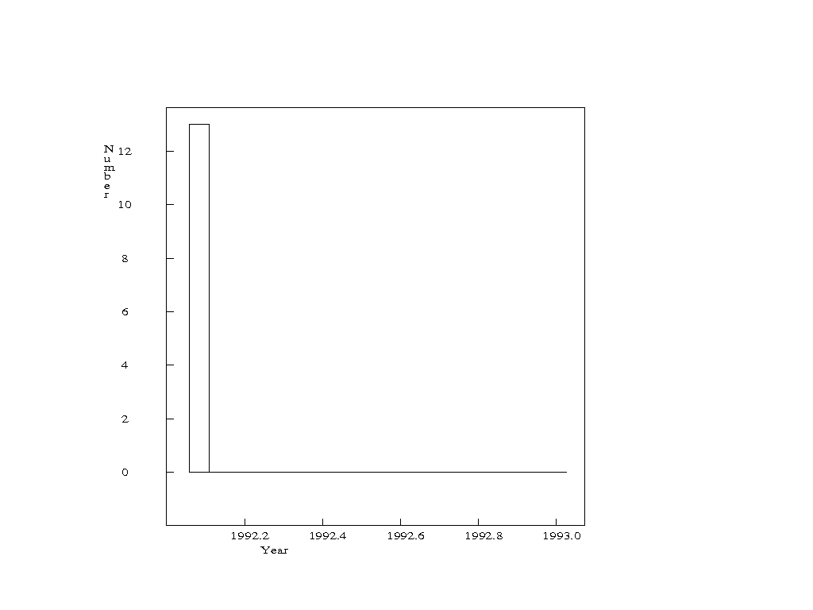
a) b)
Figure 36 a) Map of earthquakes that constitute Swarm 4 (red dots). Number of events: 13. b) Monthly number of events that constitute Swarm 4.

The spatial distribution of all events that constitute swarms identified by the swarm program corresponds to the spatial distribution of the Steigen swarm. The time distributions of those swarms show that all of them occurred in January 1992, at the same time as Steigen swarm. It is most likely that all of the swarms identified by the Swarm program belong to the same earthquake sequence in Steigen, already known as Steigen swarm 1992. It looks like that there has not been any swarm activity in this area after the Steigen swarm.

5.2 Meløy swarm area
Even though the Meløy area has shown swarm activity outside the time period of our interest, it has been included in the search for swarms, because it was in our interest to see if there has been swarm activity afterwards. The seismic activity in Meløy (66.8°N, 13.4°E) started in November 1978 and lasted for several months. About 10 000 shocks were recorded during the first ten weeks (Bungum et al., 1979).
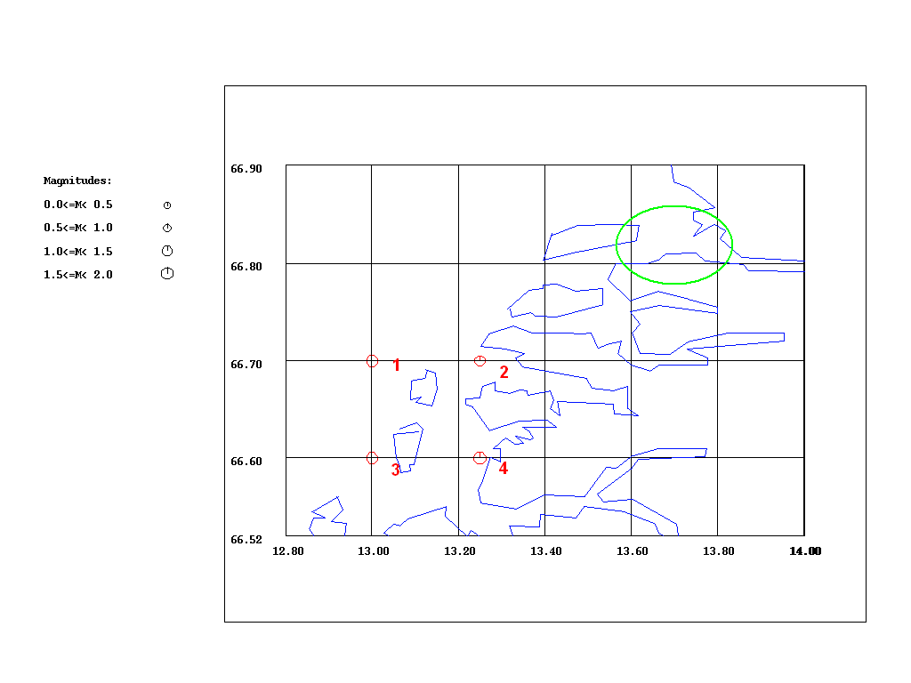
Figure 37 Green circle stands for Meløy swarm and red symbols stand for swarms identified by the Swarm program.

As shown on Figure 37, there are 4 earthquake swarms identified by the Swarm program that are taking place in the vicinity of Meløy swarm area. In order to find out whether those 4 swarms belong to the same earthquake activity and whether they are related to the area of the Meløy swarm 1978, we have checked their spatial and time distributions as well.
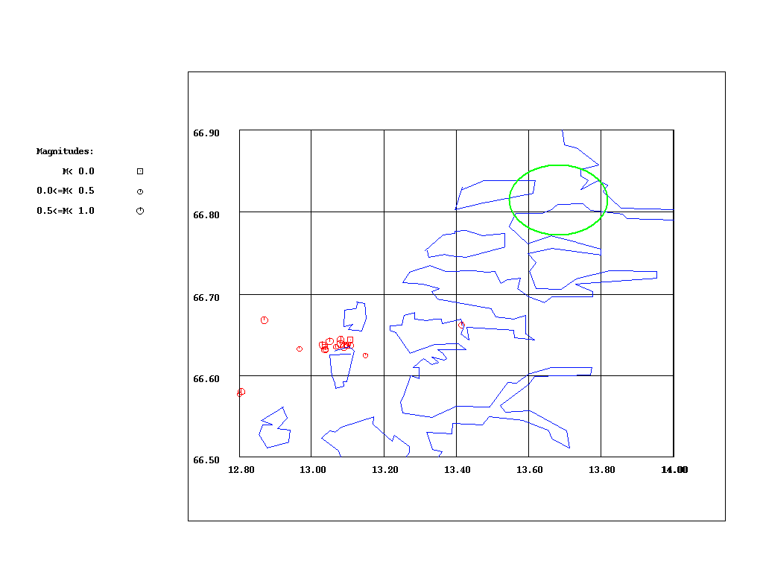
Figure 38 Green circle stands for Meløy swarm and red symbols stand for earthquakes that constitute swarms identified by the Swarm program.

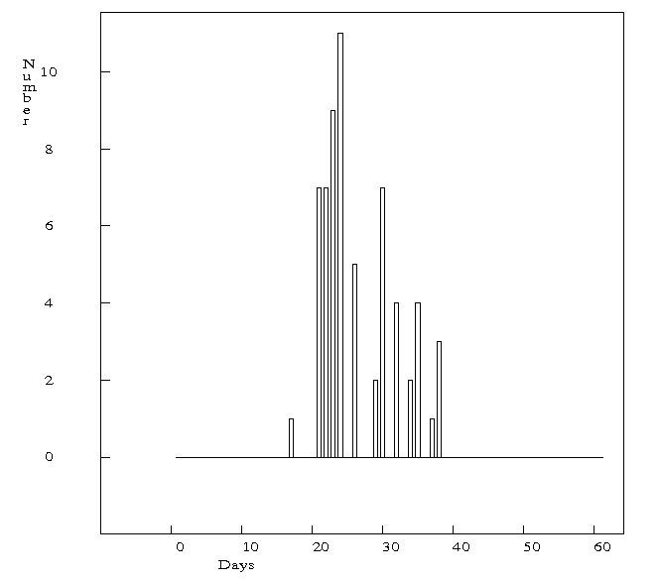
Figure 39. Daily number of events that constitute all of the swarms in this area identified by the Swarm program, starting from 2006/05/01 to 2006/06/30.

Swarm 1
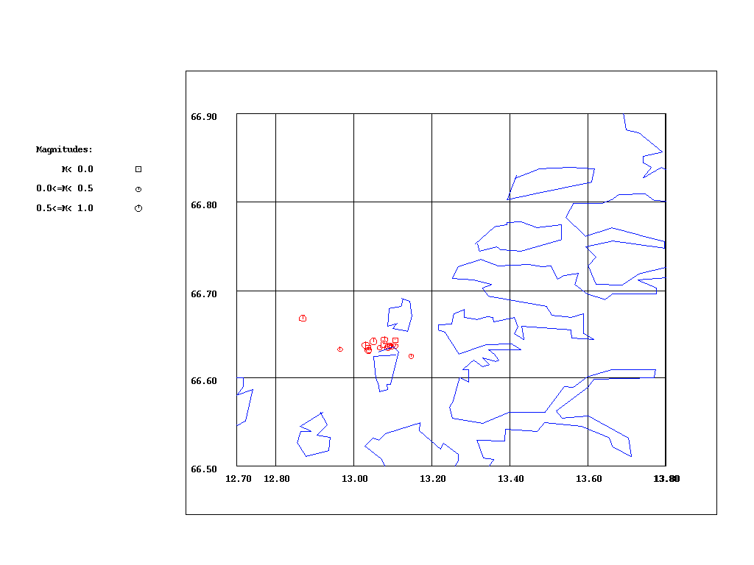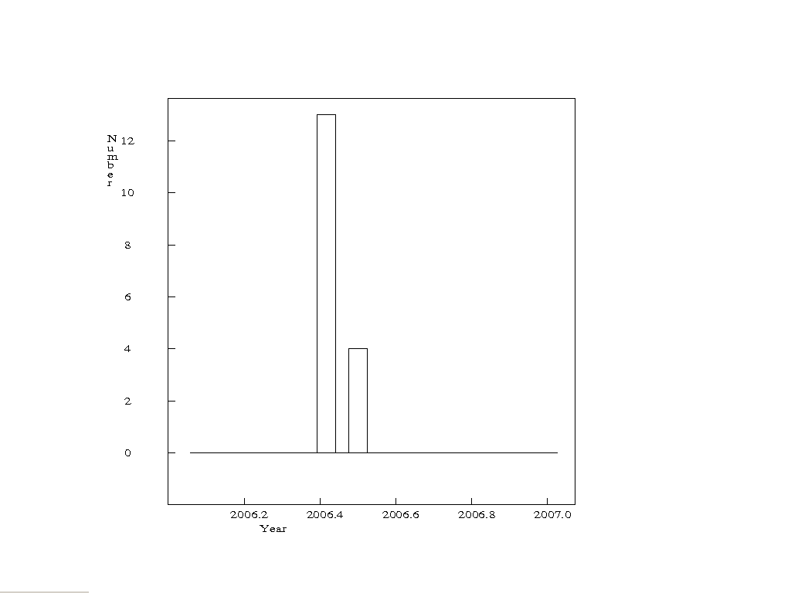
a) b)
Figure 40 a) Map of earthquakes that constitute Swarm 1 (red dots). Number of events: 17. b) Monthly number of events that constitute Swarm 1.

Swarm 2
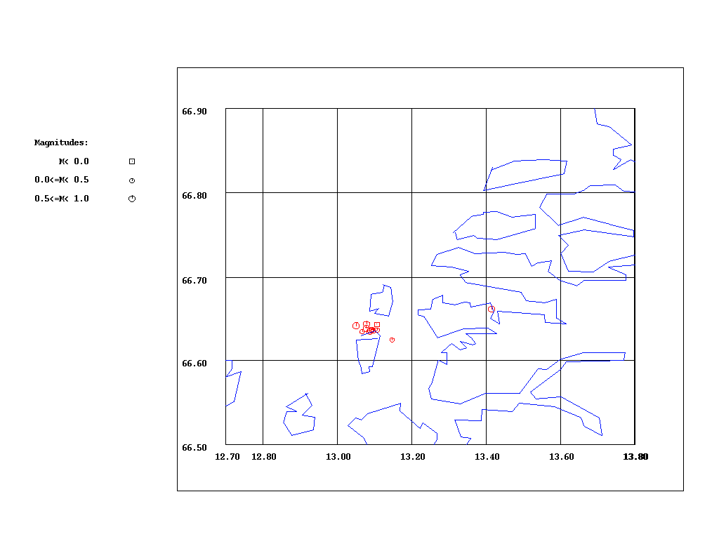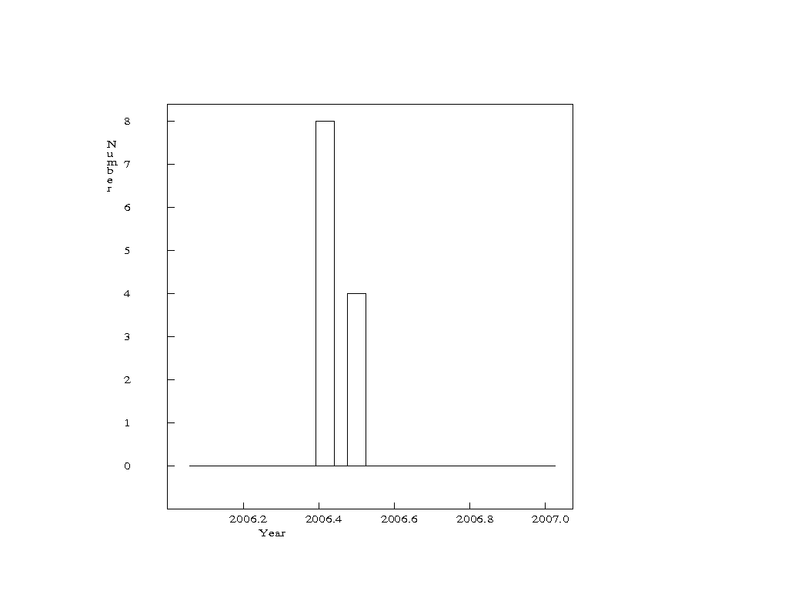
a) b)
Figure 41 a) Map of earthquakes that constitute Swarm 2 (red dots). Number of events: 12. b) Monthly number of events that constitute swarm 2

Swarm 3
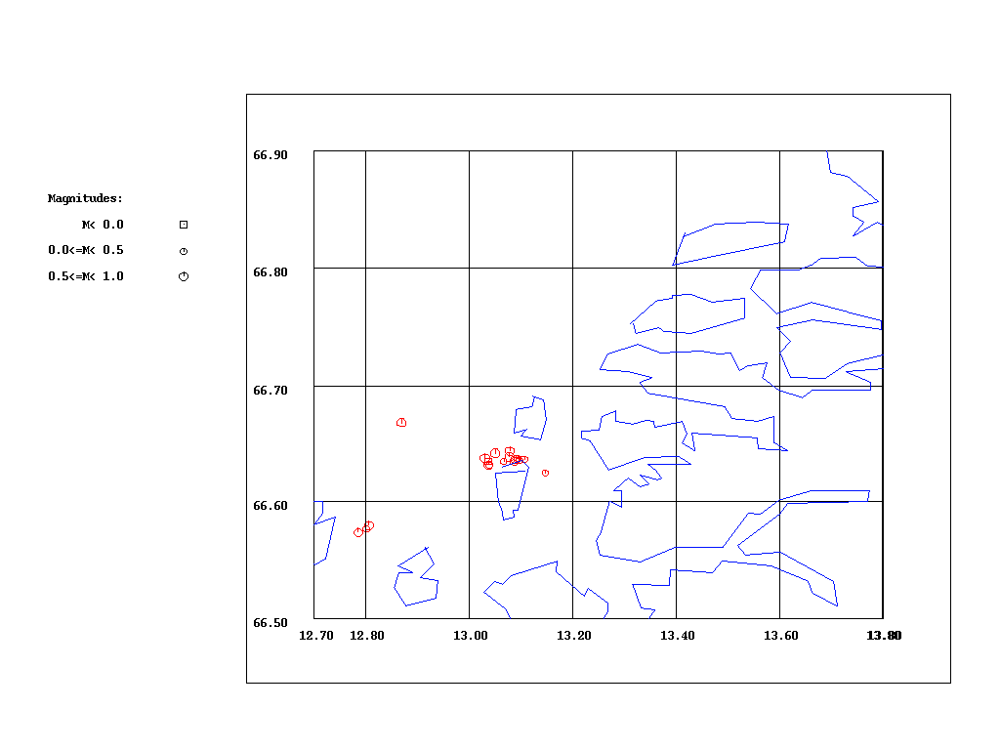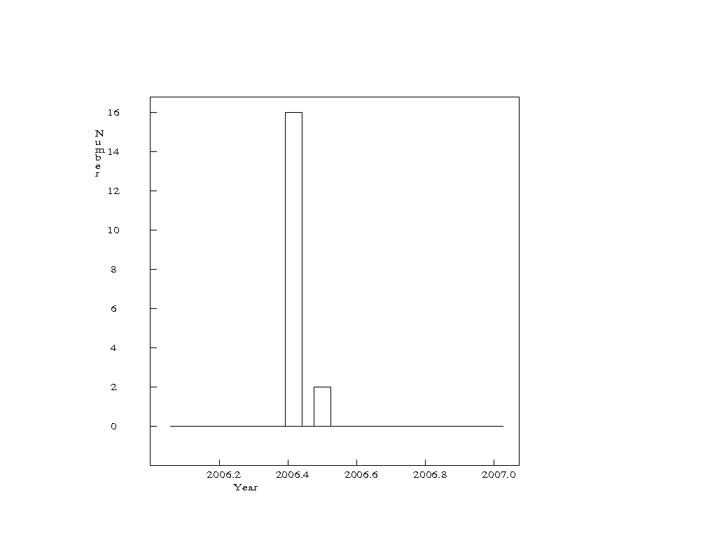
a) b)
Figure 42 a) Map of earthquakes that constitute Swarm 3 (red dots). Number of events: 18. b) Monthly number of events that constitute Swarm 3.

Swarm 4
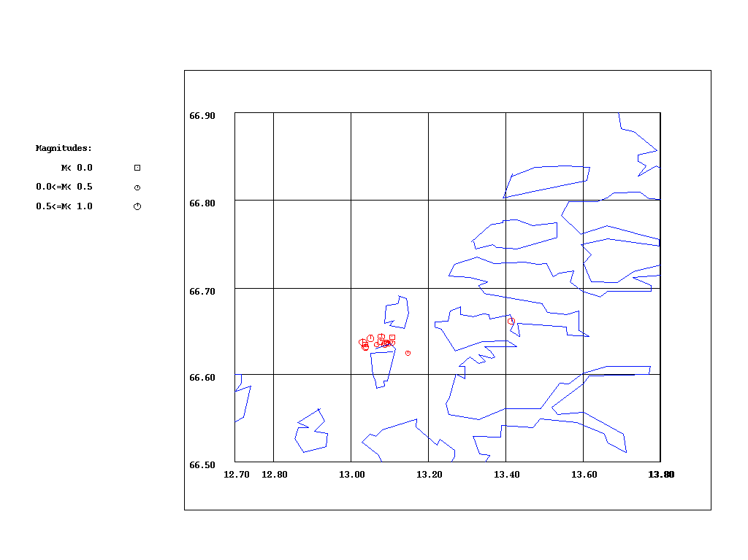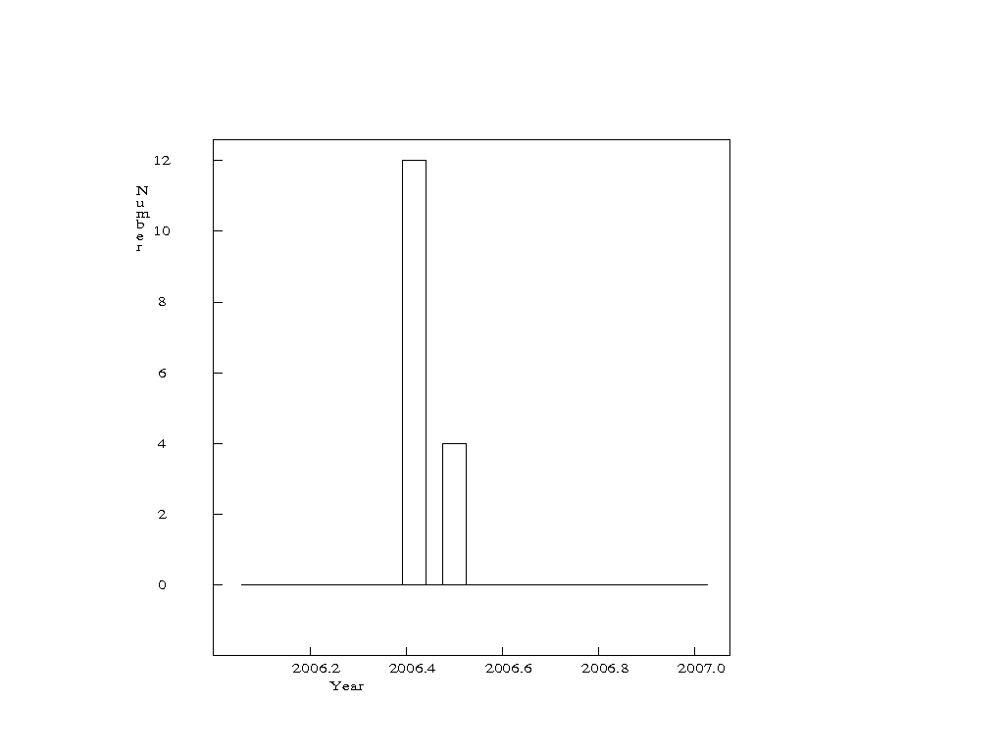
a) b)
Figure 43 a) Map of earthquakes that constitute Swarm 3 (red dots). Number of events: 18. b) Monthly number of events that constitute Swarm 3.

All of the events that constitute those swarms occurred in May and June 2006, so they should be put together. During the summer of 2005, two temporary stations STOK1 and STOK2 were installed in the Stokvågen area to investigate high seismic activity in that area. The Stokvågen area has recently shown earthquake swarm actvity. Since all of the swarms (identified by the swarm program, next to the Meløy area) occurred in 2006, it is most likely that they belong to the Stokvågen earthquake sequence. The Meløy area has not shown earthquake swarm activity in the time period observed in this study.

Since all of the swarms occurred in the same time period, approximately from 2006/05/17 to 2006/06/07, we can consider them as one swarm. Most of the events constituting the swarm took place in an area with radius not larger than 10 km. However, the accuracy of their locations is questionable because most of them are recorded only by STOK1. All of the events have magnitude smaller than or equal to 1.2.

5.3 Stokvågen swarm area
In this area, most of the swarms identified by the swarm program occurred in time period 2005/07- 2006/07. This area should be analyzed separately for two time periods, one before July 2005 (when temporary stations STOK1 and STOK2 were installed) and one afterwards.

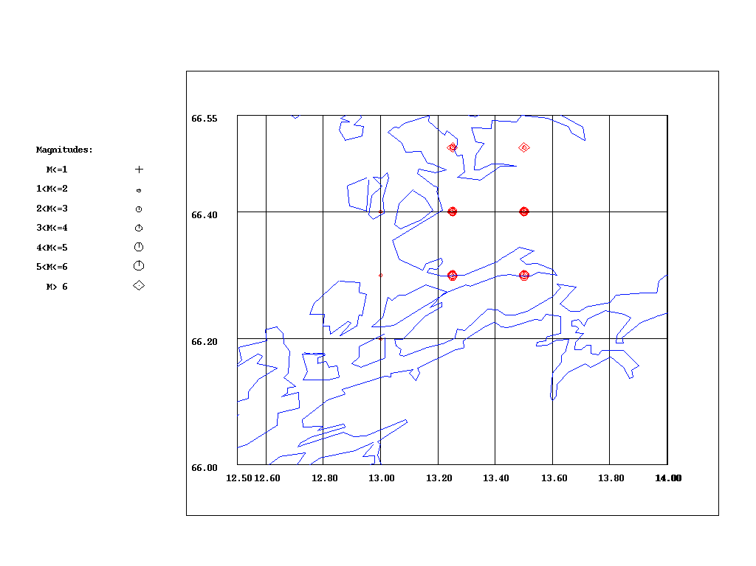
Figure 44 Red symbols stand for swarm centers identified by the swarm program. Number of swarms: 74.

There are 7 swarms identified by the Swarm program that occurred before July 2005.
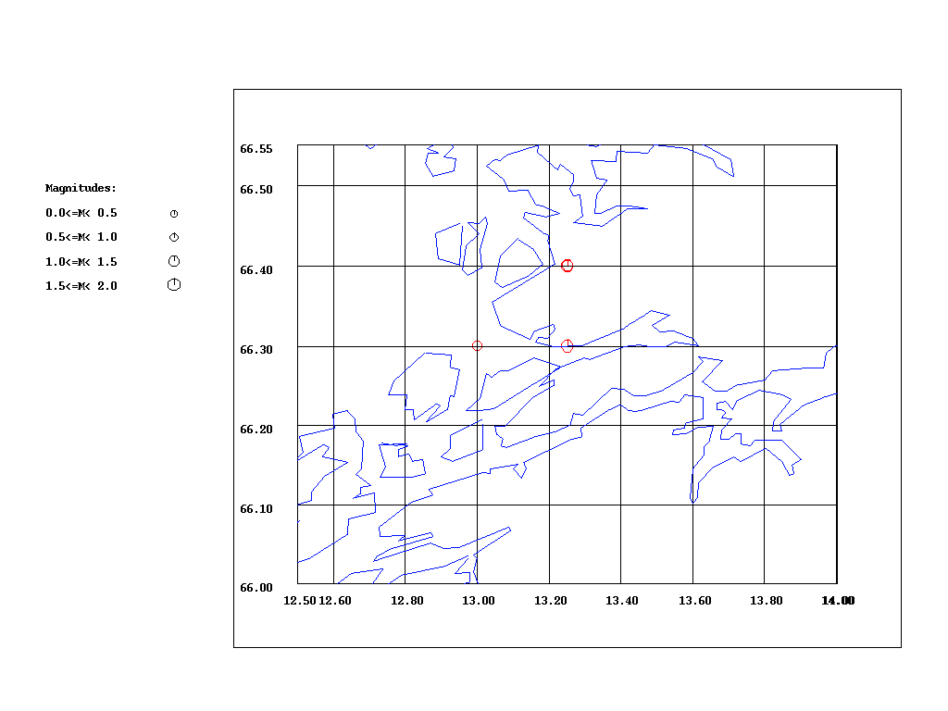
Figure 45 Red characters stand for centers of the swarms identified by the Swarm program for the time period 1980/01- 2005/07. Number of swarms: 7.

Table 7. Spatial and time distributions of the swarms that occurred before July 2005.
Swarm number | Beginning time | End time | Latitude | Longitude | Number of events
1 | 1998/11/27 | 1998/12/16 | 66.30 | 13.00 | 14
2 | 1998/12/06 | 1998/12/17 | 66.30 | 13.25 | 15
3 | 1998/12/06 | 1998/12/21 | 66.40 | 13.25 | 13
4 | 2004/03/09 | 2004/03/23 | 66.40 | 13.25 | 12
5 | 2005/04/07 | 2005/04/25 | 66.40 | 13.25 | 17
6 | 2005/04/13 | 2005/04/30 | 66.40 | 13.25 | 19
7 | 2005/05/04 | 2005/05/23 | 66.40 | 13.25 | 11

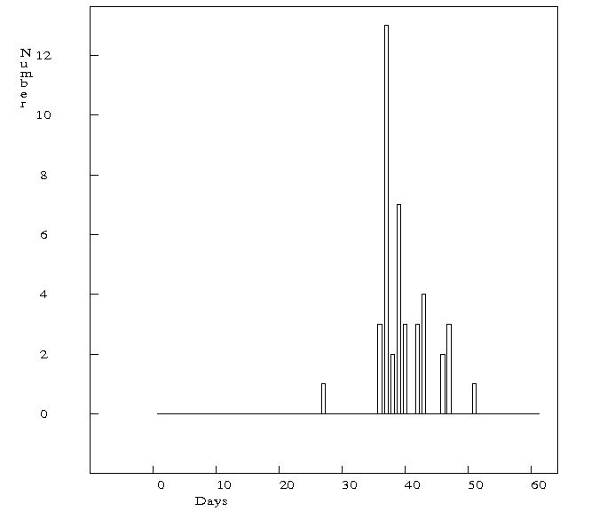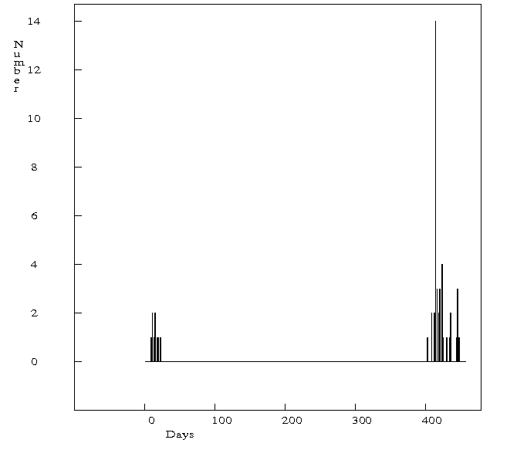
a b
Figure 46 Daily number of events that constitute swarms identified by the swarm program. a) From 1998/11/01 to 1998/12/31.b) From 2004/03/01 to 2005/05/31.

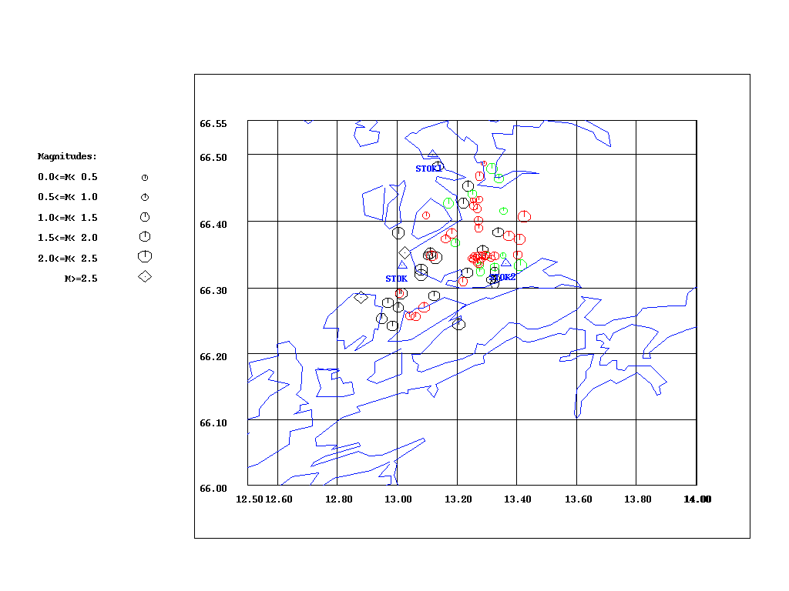
Figure 47 All earthquakes that constitute swarms identified by the Swarm program in this area. Black symbols are events that constitute swarms in 1998, green symbols show events that constitute the swarm in 2004, red symbols show swarms in April and May 2005.

First three swarms occurred almost at the same time near each other (Table 7). It is most likely that all of them belong to the same swarm activity. The fifth and sixth swarm occurred at the same time in the same area, so the two of them constitute one swarm. Since the seventh swarm occurred only 4 days after the sixth swarm, it is likely that seventh swarm belongs to the same swarm activity as the fifth and sixth swarm. There is also a swarm that occurred in 2004 (Table 7).

The numbers of events that constitute swarms are low. Until then stations STOK, STOK1 and STOK2 have not been installed. Due to that, the number of recorded events before 2005 (when STOK1 and STOK2 were installed) is low.

According to Figure 47, it is seen that there are two wide swarm areas. The areas are wide because the accuracy of location of events is probably no better than ±10 km.

The first swarm area is the one in which swarms that occurred in 1998 took place. Those three swarms constitute one swarm. In July 1997 the local seismic network in this area was expanded in order to study this region in more detail. During the period July 1997- January 1999, the network detected earthquakes that occurred in five groups. (Figure 48) in the western parts of network (Hicks et al., 2000).
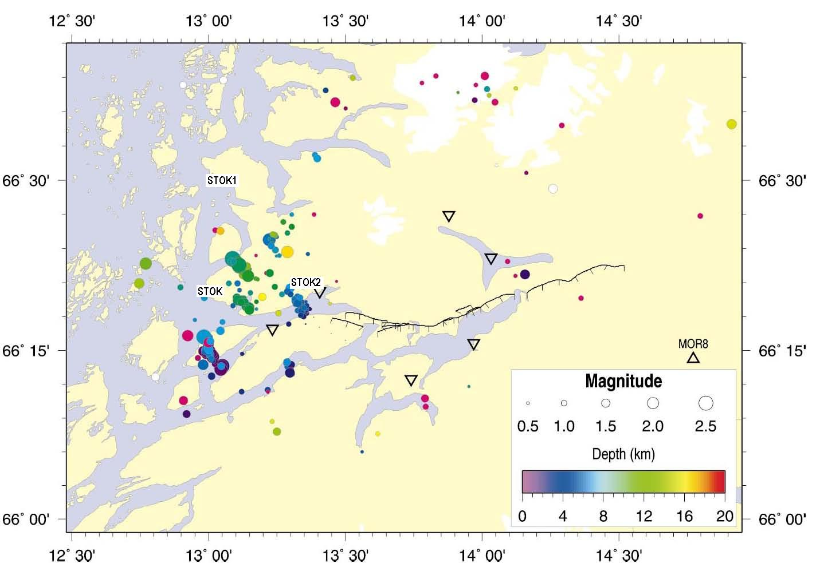
Figure 48 Earthquakes located by the temporary network (inverted triangles), installed as a part of NEONOR project, from August 1997 to January 1999, plotted with symbol size proportional to magnitude and color according to depth. By that time STOK, STOK1 and STOK2 were not installed, they are included in the map just for comparison.(Figure from Hicks et al., 2000)

The group located under the STOK2 station had the bulk of activity from August to October, 1997. The group in south- eastern part of the STOK station occurred mainly during November and December 1997. The group north- east of the STOK was active mainly in January and February 1998. A somewhat smaller group is located north of three previous groups. Fifth group consists of the earthquakes that occurred in October and December 1998 (Hicks et al., 2000).

Earthquakes that constitute the swarm, which has been identified in December 1998 by using the Swarm program, were recorded by the stations installed in July 1997 in this region. By comparing the time window of the swarm (identified by the Swarm program) with the time windows of the swarms already identified in the time period 1997- 1999, the conclusion is that the swarm (identified by the swarm program) corresponds to the group of earthquakes which appears on the south- western part of the map (Figure 48).

The second swarm area is the one in which swarms that occurred in 2004, April 2005 and May 2005 took place. The second swarm area is north- east of the first swarm area (Figure 47). Since swarms in the second swarm area occurred after the swarm in the first swarm area, it looks like the seismic activity has been moving northward along the coastline.

The conclusion is that we have clusters in time for sure, as shown on Figure 46. The areas in which the swarms that were detected by the Swarm program took place are large. Despite of the fact that the accuracy of location of events with small magnitude is low, we would prefer the swarm areas to be smaller. In order to find possible swarms that took place in smaller areas, we have run the Swarm program with different input parameters again (Table 8).

Table 8 The input parameters for the Swarm program.
Latitude range and grid size (deg) | 66 67 0.06
Longitude range and grids size (deg) | 12 14 0.12
Radius of cell and radius of background cell (deg) | 0.04 0.1
Minimum number of events in time window | 10
Time window in days | 30
Minimum ratio of number of events to background activity | 10

The file that contains events recorded in Stokvågen area was used as an inputfile. The program has identified 45 swarms and all of them occurred in time period 2005/07-2006/07.

Because of the large number of swarms identified by Swarm program in the time period 2005/07- 2006/06, I have decided not to analyze the detected swarms.

After using the Swarm program for identifying possible swarms manual inspection of the statistics of events should be done as well. The area division that will be used for manual search is the same as the area division used for analyzing the results of the Swarm program search. First, the time distribution for all earthquakes in a certain area will be checked in order to find earthquakes clustered in time. Then, the earthquakes clustered in time will be plotted to check whether they are clustered in space or not.

6. Manual search for swarms
6.1 Steigen swarm area

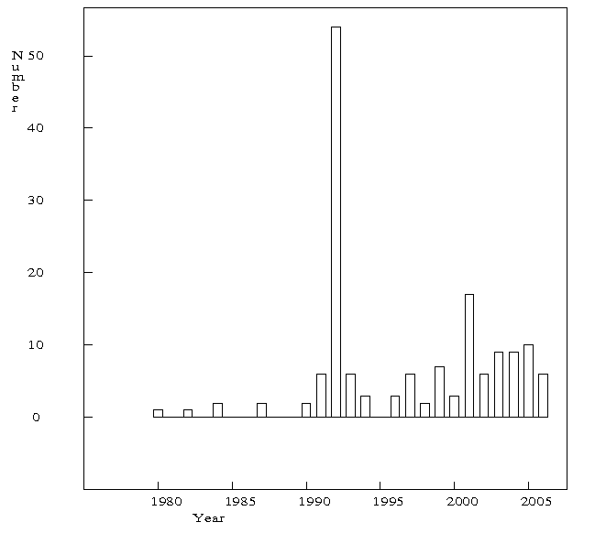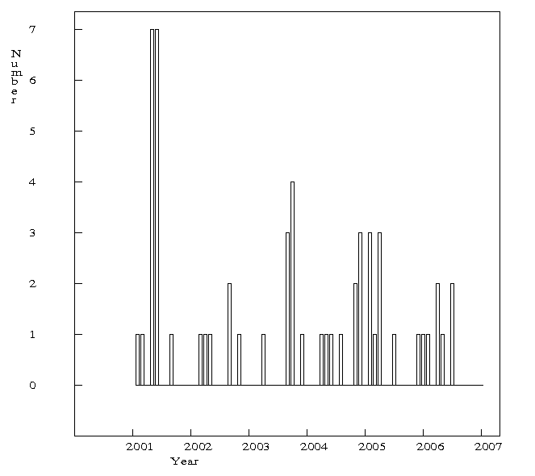
a) b)
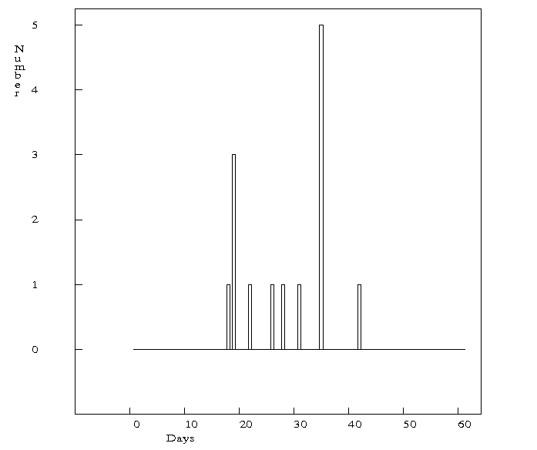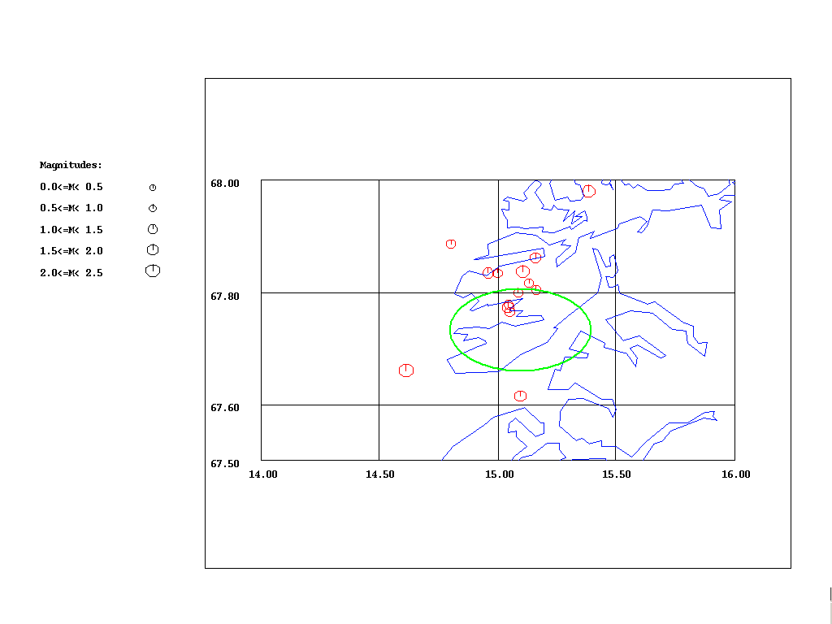
- d)
Figure 49 a) Yearly number of events for time period 1980-2006/06. b) Monthly number of events for time period 2001- 2006/06. c) Daily number of events from 2001/04/01 to 2001/05/31. d) Map of all events in this area from 2001/04/01 to 2001/05/31, number of events: 14. Green circle is area in which the Steigen swarm 1992 took place.

The time of year distribution was checked first for the period 1980- 2006/06 (Figure 49a). As expected, the majority of events occurred in 1992, the year Steigen swarm occurred. However, there is another peak that shows increased number of recorded events in the year 2001. Since than, the average number of events per year has been increased up to 10. The monthly distribution of the events for the time period 2001- 2006/06 was checked and it was noticed that there is increased number of events in April and May 2001 (Figure 49b). Then, the events that occurred in those two months were taken to check their daily distribution as well (Figure 49c). All events belong to the time window that is not larger than 30 days. It could be said that those events are clustered in time. Their spatial distribution shows that they are clustered in space as well (Figure 49d). Most of the events are clustered next to the Steigen swarm area. Four events appear outside of the small area in which most of the events are taking place. All of them (the ones outside the cluster area) are recorded by 2 or more stations, so their locations should not be so questionable. Most of the events that belong to the cluster have been recorded by only one station, LOF, so the question is: Are they mislocated? Maybe, if there were more stations in this area, more smaller events would have been recorded in this time period.
The conclusion is that Steigen area has been reactivated in April and May 2001.

6.2 Meløy swarm area

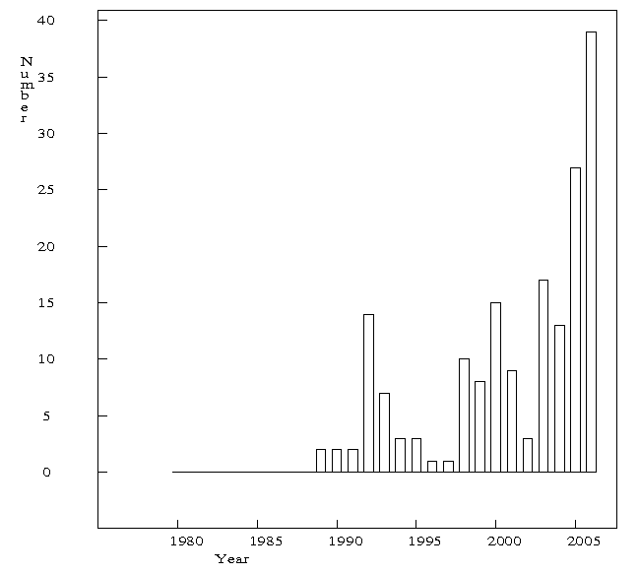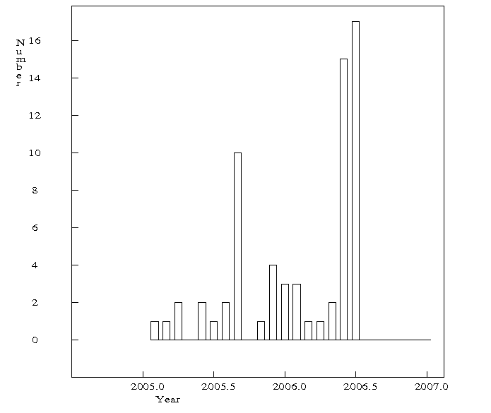
a b
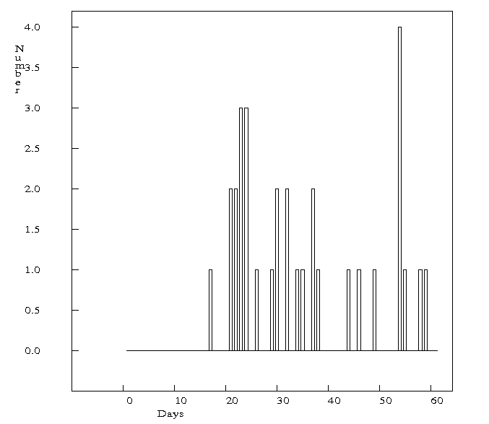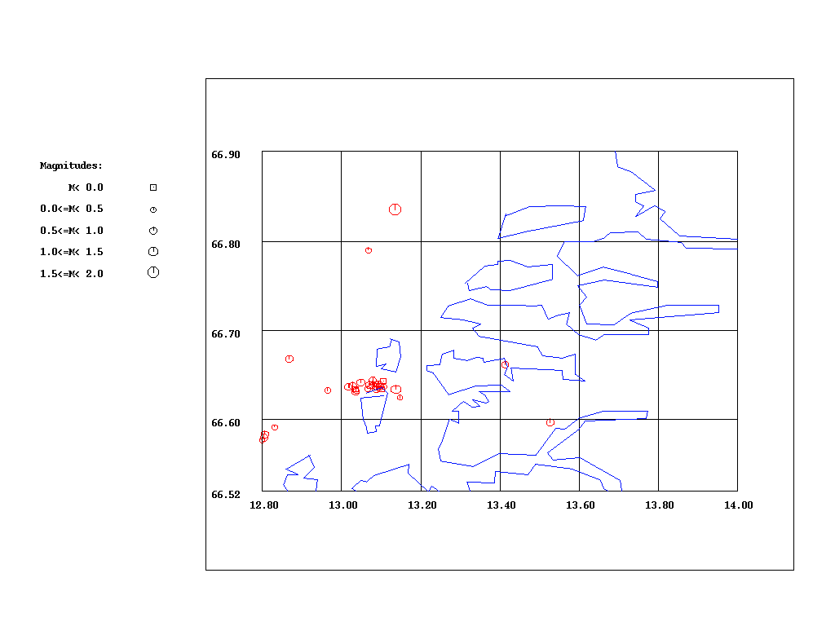
c d
Figure 50 a) Yearly number of events for the time period 1980-2006/06. b) Monthly number of events for the time period 2005/01- 2006/06. c) Daily number of events from 2006/05/01 to 2006/06/31. d) Map of all events in this area from 2006/05/01 to 2006/06/31, number of events: 32.

After observing the yearly distribution of events for time period 1980- 2006/06 (Figure 50a) and monthly distribution of events for time period 2005/01- 2006/06 (Figure 50b), a cluster in time was found in the time period 2006/05/01- 2006/06/31 (Figure 50c). The spatial distribution shows that those events are clustered in space as well (Figure 50d). That is the same swarm that has been identified in this area by the Swarm program.

6.3 Stokvågen area

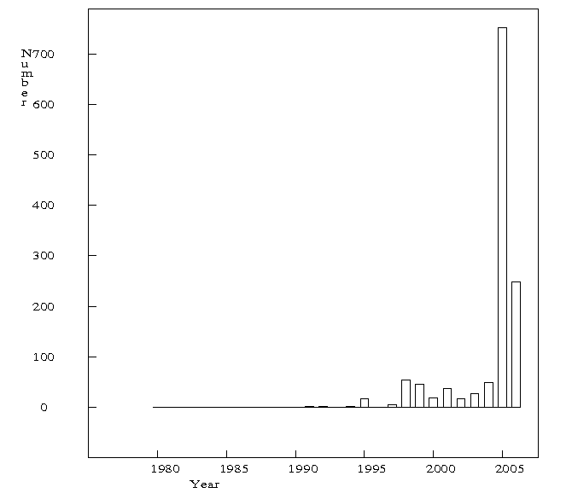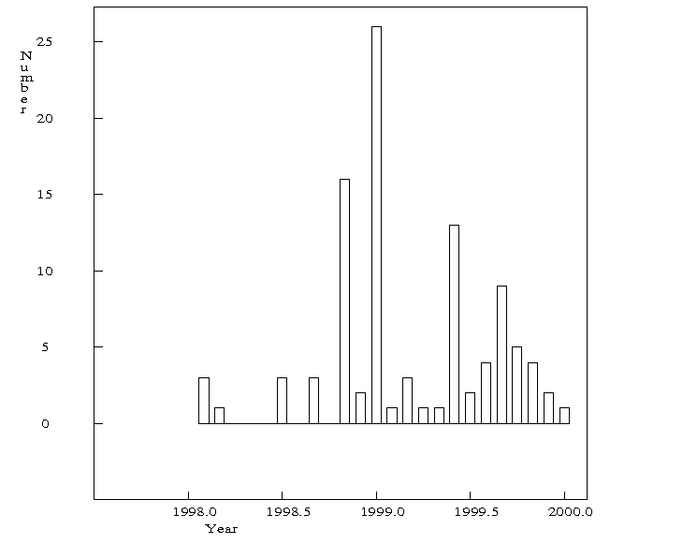
a b
Figure 51 a)Yearly number of events 1980-2006. b) Monthly number of events 1998-1999.

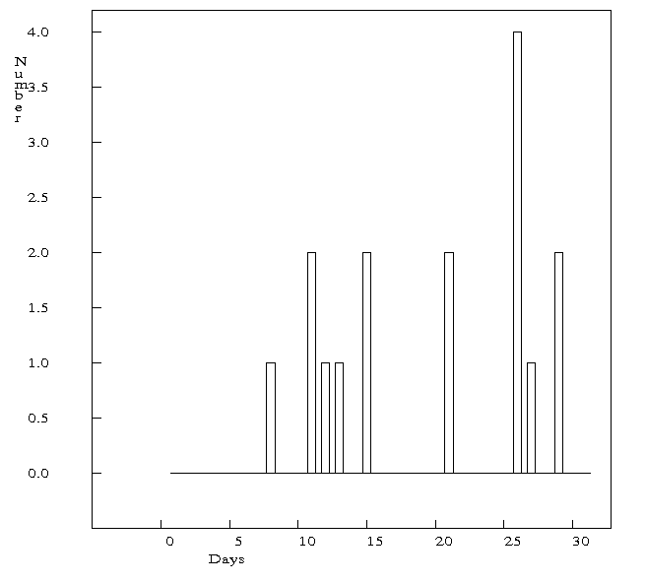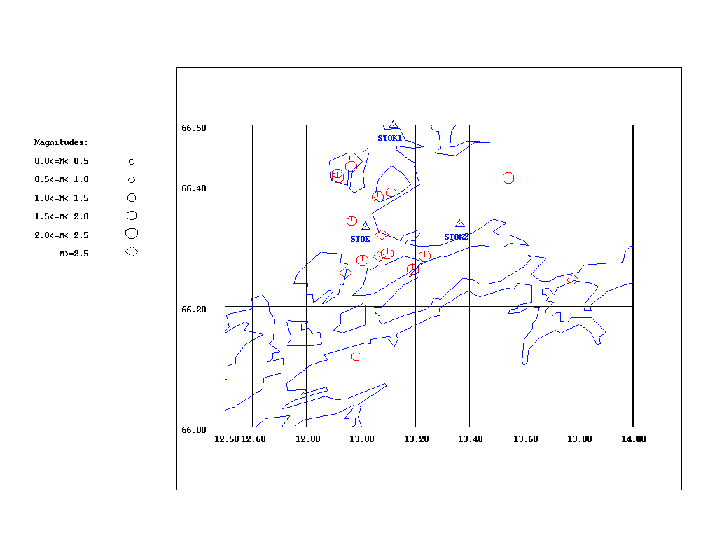
a b
Figure 52 a) Daily number of events October, 1998. b) Map of all events from October, 1998. Number of events: 16.

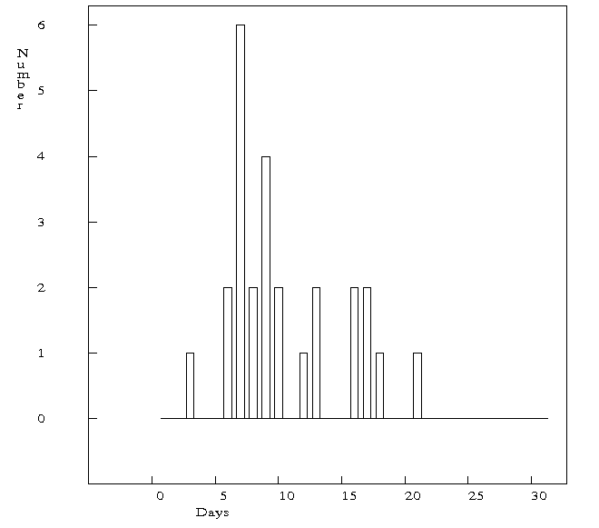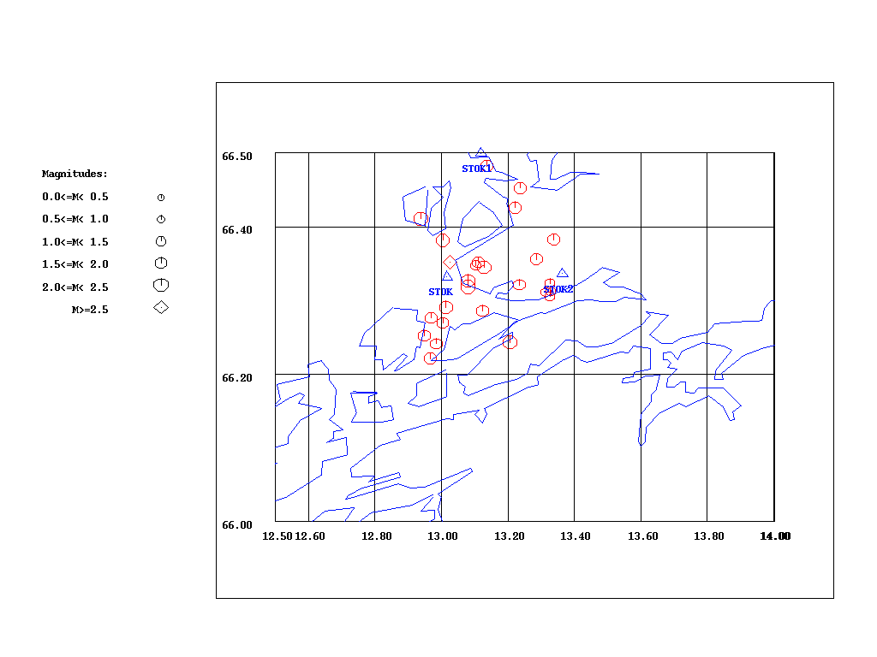
a b
Figure 53 a) Daily number of events December, 1998. b) Map of all events from December, 1998. Number of events: 26.

It can be noticed that there are two clusters in time, the one in October 1998 (Figure 52a) and the one in December 1998 (figure 53a). Events that constitute those clusters in time are taking place in wide areas (Figures 52b and 53b). We have expected them all to be concentrated in smaller area south of the STOK station, because that is the place that has showed high seismic activity in October and December 1998 (Hicks, 2000). Still, those seismic activities should be considered as swarms, because they have been recognized as swarms by using the Swarm program, and because during the manual search these activities were identified as extraordinary.
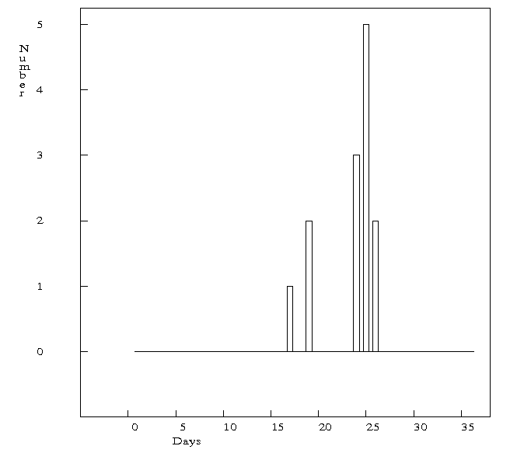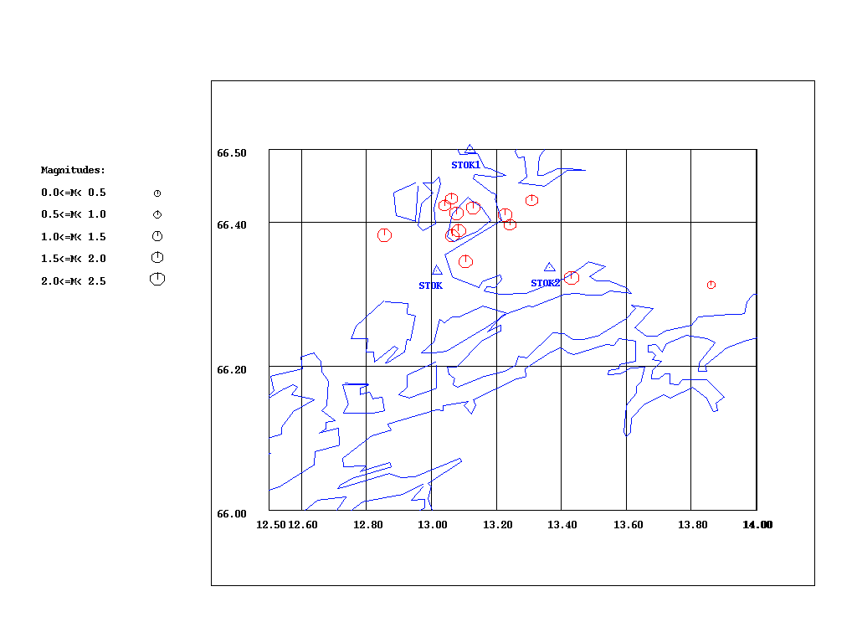
a b
Figure 54 a) Daily number of events, May, 1999. b) Map of all events from May, 1999. Number of events: 13.

This cluster has not been identified by the Swarm program. But the time and spatial distribution shows that those events are clustered in time and space in the same time (Figure 54). So this seismic activity can be considered as another earthquake swarm that occurred in May 1999.

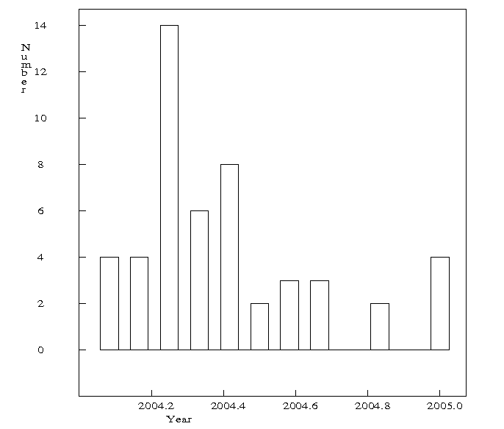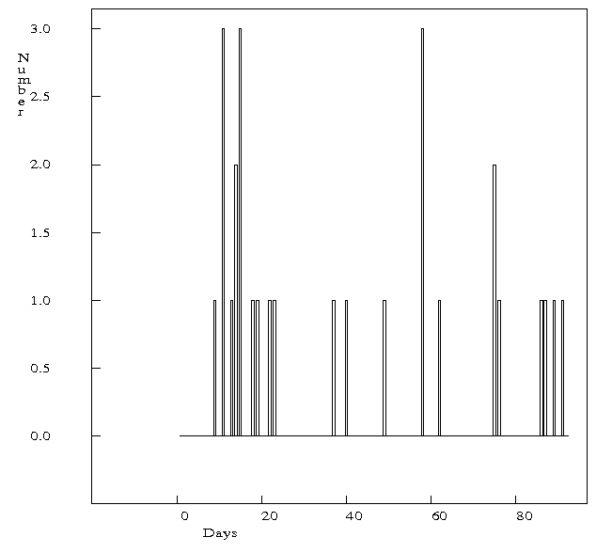
a b

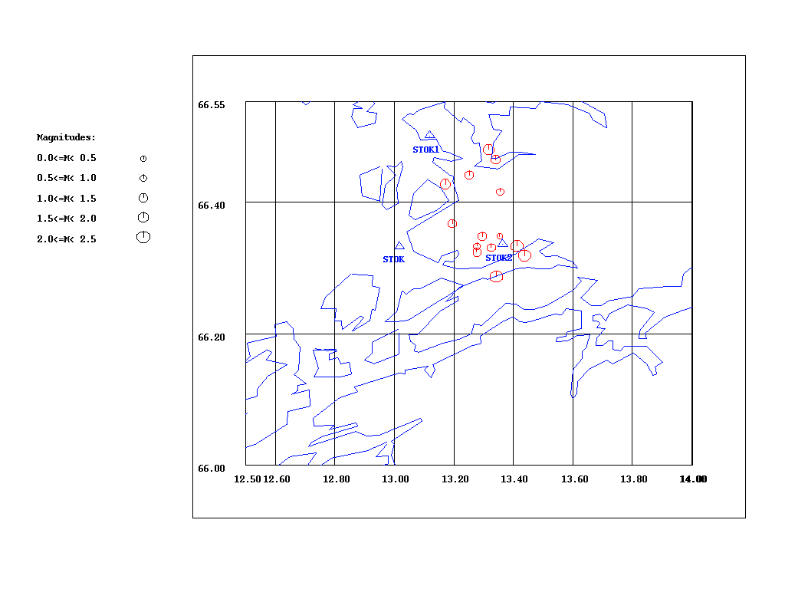
c
Figure 55 a) Monthly number of events 2004. b) Daily number of events from March to May 2004. c) Map of all events from March 2004. Number of events:14.

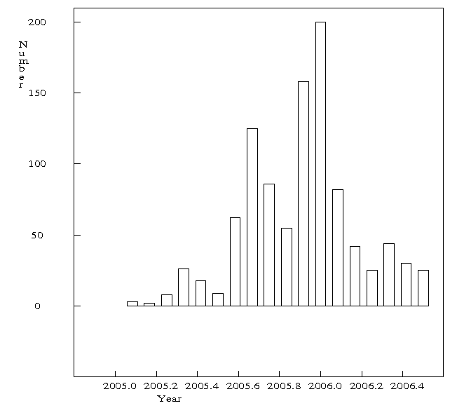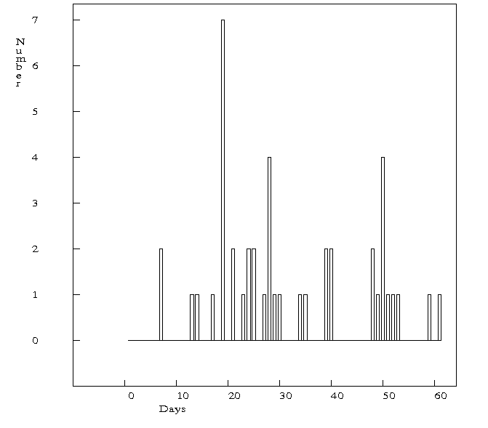
a b
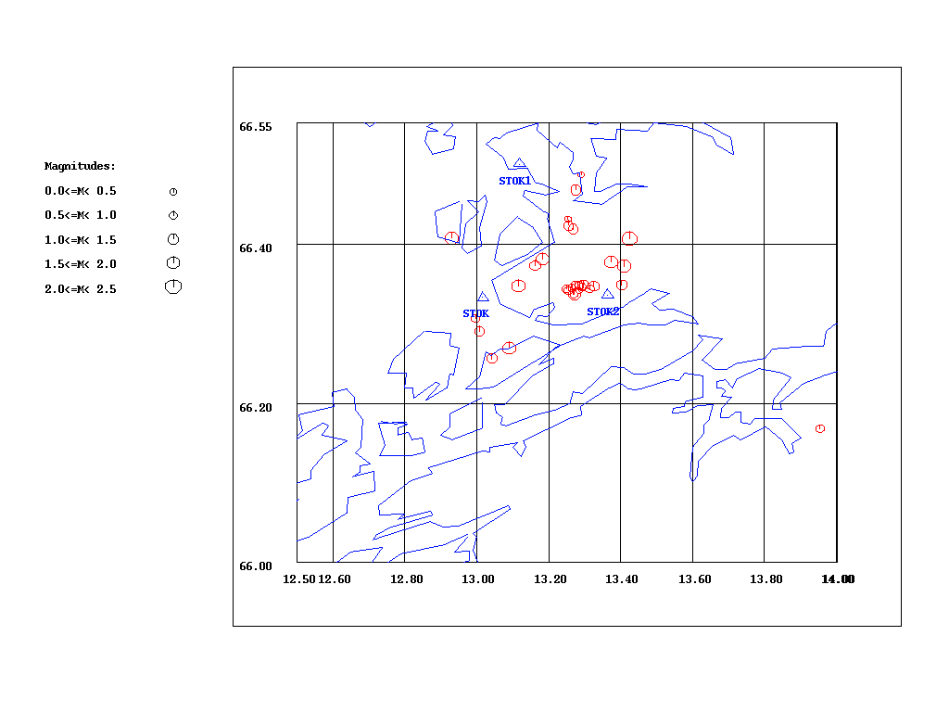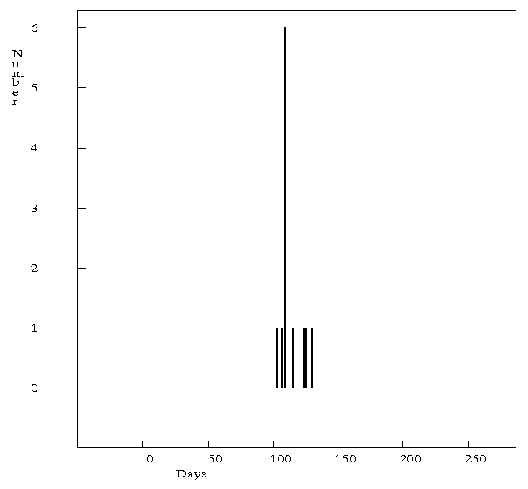
c d
Figure 56 a) Monthly number of events from 2005- 2006. b) Daily number of events April- May 2005. c) Map of all events from 2005/04/10- 2005/05/15. Number of events:30. d) Daily distribution of the cluster next to the STOK2 station in the map.

Previous time and spatial distributions have confirmed the existance of the swarms in March 2004 and April- May 2005 (figures 55 and 56).
After searching manually for the possible swarms the conclusion is that this area has been showing swarm activity continuously during the period 1997- 2005/05. Except for the swarms already recognized by the Swarm program, there are two more swarms that occurred in October 1998 and May 1999.

For the time period 2005/07- 2006/06 three swarms have been identified (Novak, 2006), as shown on the Figure 57.

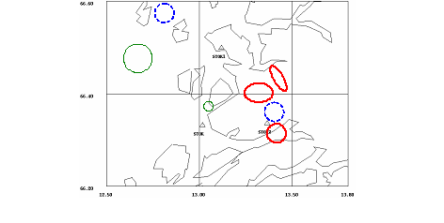
Fig 57 Location of swarms or clusters (Novak, 2006).

The red circles represent 3 clusters that can be considered as earthquake swarms. They also appear when events are located for the highly active time intervals (30 Nov-12 Dec, 6-9 Jan).
The group of events shown on figure as blue circle north of STOK2 has only single station locations from STOK and STOK2. It is likely that these events belong to the swarm south of STOK2, and only appear as a group north of STOK2 because of location errors. The fourth swarm might be present offshore, east of STOK1 (green circle), but its location is highly uncertain. The group located northeast of this group (blue colour) probably includes events with location errors (single station locations) and is most likely not a separate group.
The group indicated by the green colour north of the station STOK also has high uncertainty regarded as a swarm. Even though it appears as a group in the 30 Nov-12 Dec period, locations are uncertain because of single station locations (Novak, 2006).
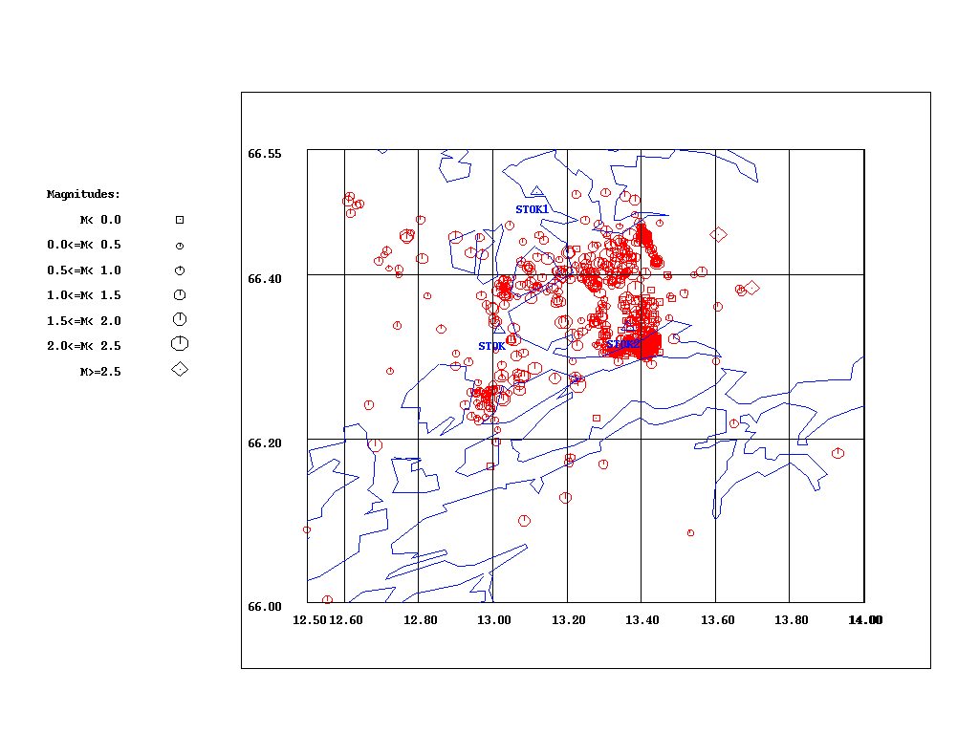
Figure 58 Map of all the events from 2005/07 to 2006/06. Number of events: 935.
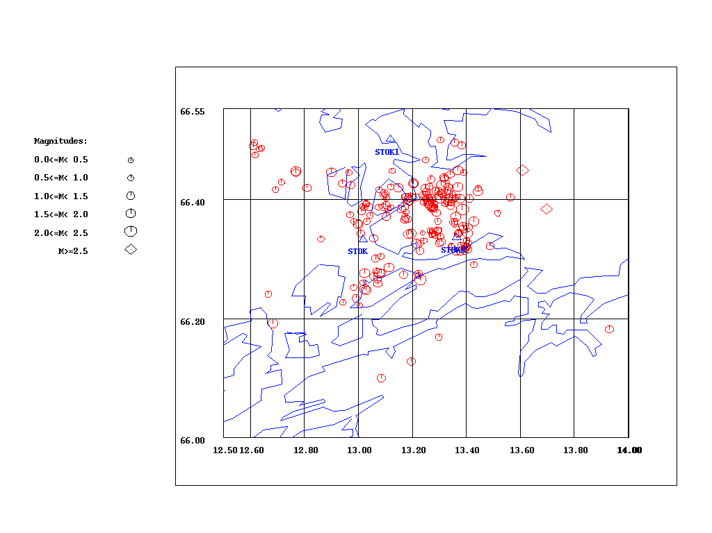
Figure 59 Map of the events recorded by two or more stations with magnitude above 0.5 from 2005/07 to 2006/06. Number of events: 206.

In order to get a reliable picture of the seismicity in this area we should work with events that are big enough to be recorded regardless of where they occur within the area. In the Stokvågen area the detection threshold is 0.5 for local magnitude (Novak, 2006). All events larger than this magnitude are expected to be recorded by at least one of the stations. We will also use the number of stations as a criteria to detect the events with reliable locations. We will work only with events that have been recorded by two or more stations. The location of those events can be considered reliable.

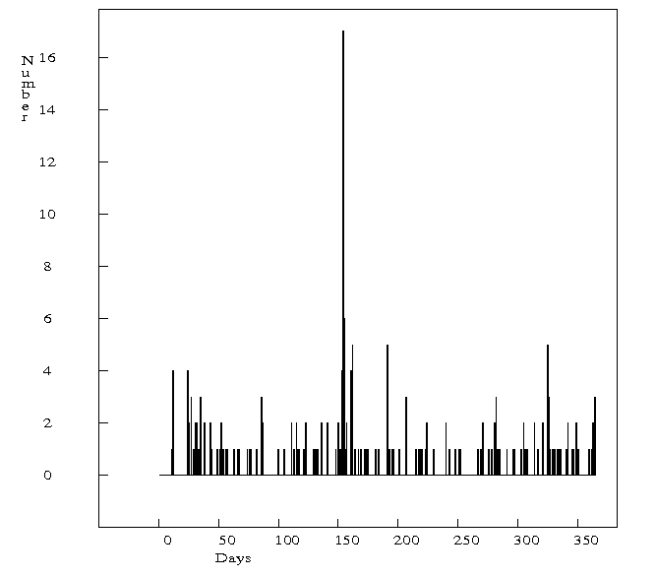
Figure 60 Daily number of events recorded by at least two stations with magnitude above 0.5 from 2005/07 to 2006/06.

As shown on Figure 60 the period that corresponds to the highest seismic activity is from 2005/11/25 to 2005/12/09. The spatial distribution for this period is shown on figure below.

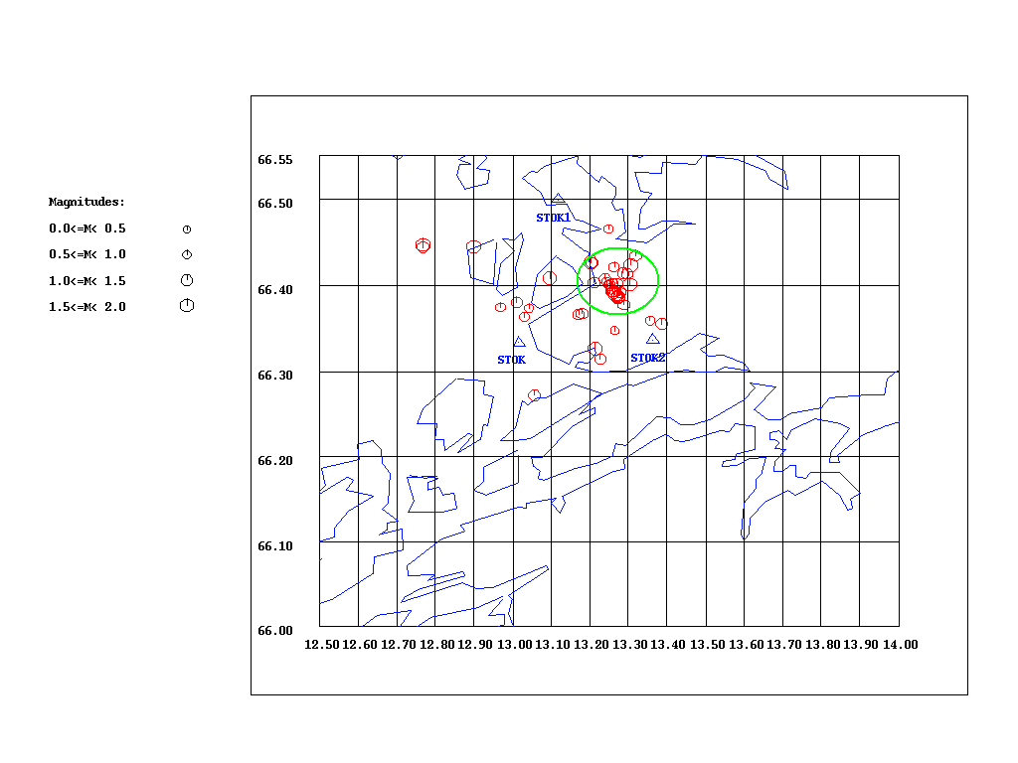
Figure 61 Events recorded by at least two stations with magnitude above 0.5 from 2005/11/25 to 2005/12/09. Number of events: 44.

It can be noticed that there is cluster in space as well (green circle, Figure 61).
Another cluster in time from 2006/05/20 to 2006/06/04 contains events that are very well clustered in space (Figure 62).
So, we can say that there are two swarms for sure. One of them in November- December 2005, and another one in May- June 2006.
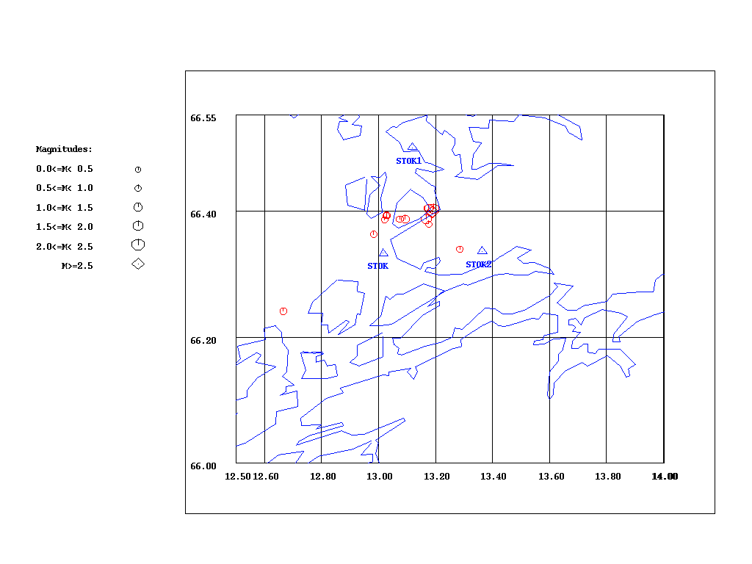
Figure 62 Events recorded by at least two stations with magnitude above 0.5 from 2006/05/20 to 2006/06/04. Number of events: 15.

Here, the opposite approach will be used to identify the swarms. First, clusters in space will be identified and than checked whether they are clustered in time as well.

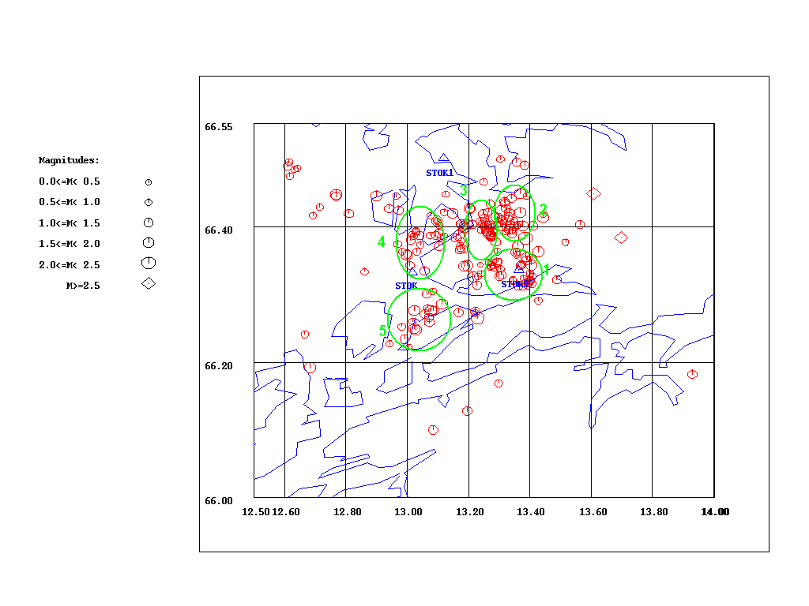

Figure 63 Spatial clusters of events recorded by at least two stations with magnitude above 0.5 in the time period 2005/07-2006/06.

The time distribution of the third cluster has shown that this cluster is limited in time as well, and corresponds to the already identified swarm in November- December 2005.

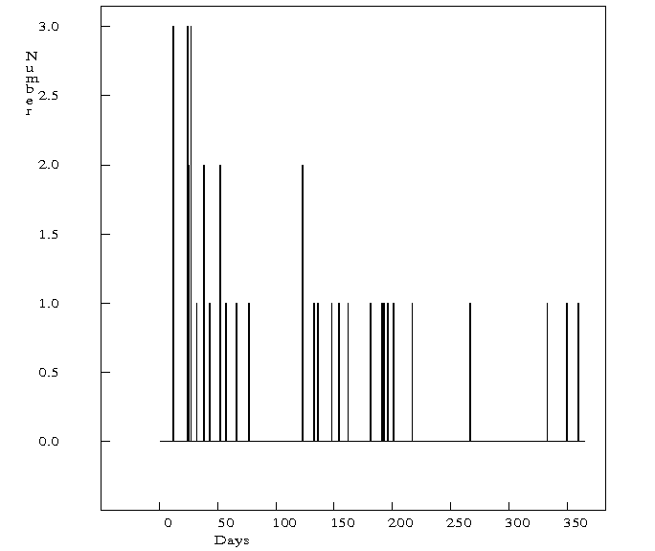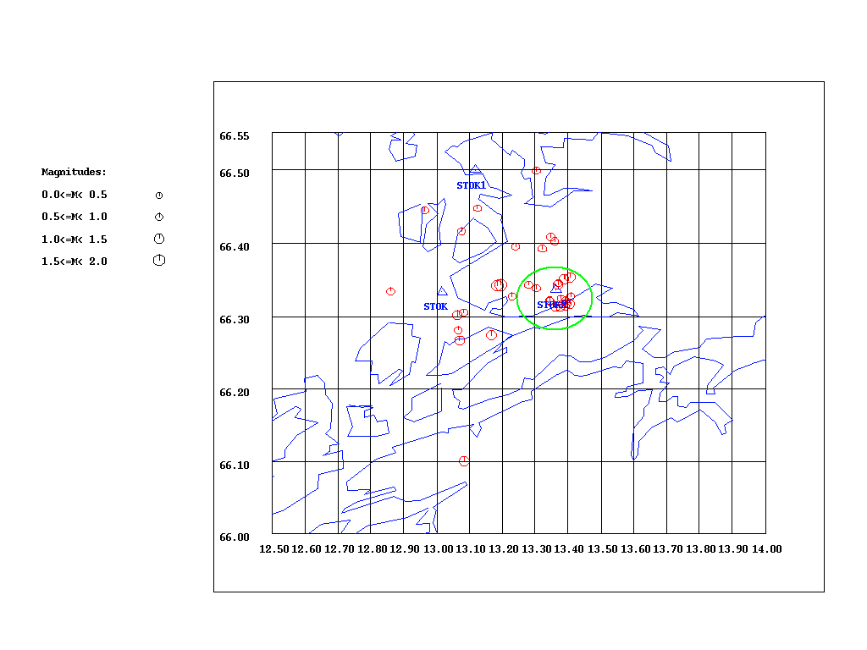

a b
Figure 64 a) Daily number of events that constitute Cluster 1 for the period 2005/07-23006/06. b) All events in Cluster 1 that occurred from 2005/07 to 2005/09. Number of events: 35

The first cluster has shown a bit higher and time limited activity in July and August 2005, so it could be considered a swarm (Figure 64a). However, it is good to notice the low seismic activity which is present in the whole period.

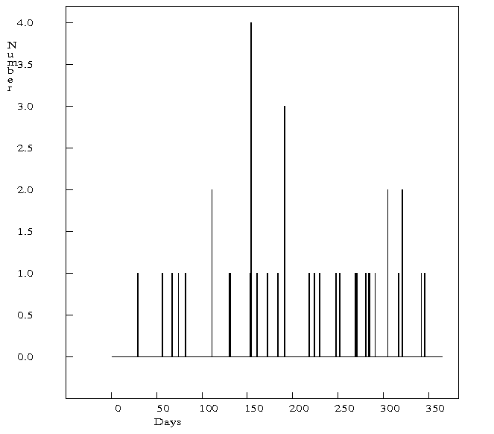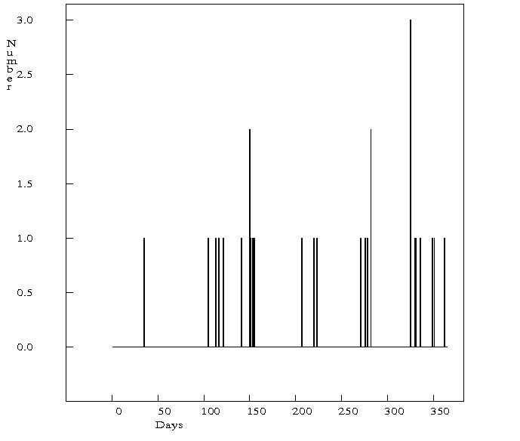
a b
Figure 65 a) Daily number of events that constitute Cluster 2 period 2005/07-23006/06.b) Daily number of events that constitute Cluster 4 period 2005/07-23006/06.

The events that constitute Clusters 2 and 4 are not clustered in the time (Figure 65). Their time distribution is quite uniform.

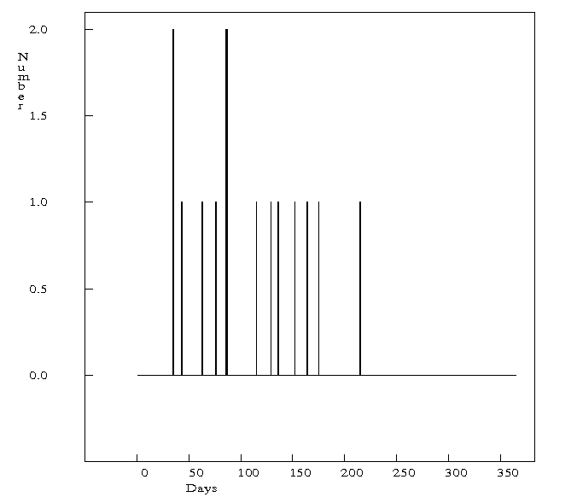
Figure 66 Daily number of events that constitute Custer 5 period 2005/07-23006/06.

The fifth cluster is limited in time (Figure 66), but the time window includes several months, the same months in which temporary station STOK2 was operating, Aug.- Dec. 2005. The time limitation is due to the lack of recorded events after STOK2 stopped operating. This data set is too weak to make any conclusion.

Because of the uniform time distribution, clusters 2, 4 and 5 should not be considered as swarms. Still, those clusters are pointing out the significance of seismic activity in this area.

7. Conclusion
The purpose of this study was to identify swarms in the Steigen-Rana area in the period 1980- 2006. We wanted to check especially whether known swarm areas have been reactivated. The known swarms are Steigen 1992 and Meløy 1978.
After using the Swarm program and manual search for identifying swarms, the following list of the swarms are identified (in chronological order):

Table 9. The list of the swarms that occurred in the area of interest in the time period 1980- 2006. The areas refer to the areas on the Figure 23.
SWARM NO. | AREA IN THE FIGURE 23 | TIME PERIOD
1 | A | January 1992
2 | C | August- October 1997
3 | C | November-December 1997
4 | C | February 1998
5 | C | October 1998
6 | C | November- December 1998
7 | C | May 1999
8 | A | April- May 2001
9 | C | March 2004
10 | C | April- May 2005
11 | C | July- August 2005
12 | C | November- December 2005
13 | C | May- June 2006
14 | C | May- June 2006
The list includes also the swarms (1, 2, 3 and 4) that had been identified before the search for swarms has started. The swarms 2, 3 and 4 were not identified neither by using the swarm program nor by a manual search. During the manual search for swarms in the Stokvågen area in the time period July 2005- June 2006, the events with magnitude equal to or larger than 2.5 were used. Most of the earthquakes that constitute swarms 2, 3 and 4 have magnitudes lower than 2.5 and therefore they were not included in manual search for swarms.

The biggest challenge during the swarm identification was to determine the size of the time window and area as the parameters for detecting and describing swarms. Some of the swarms are taking place in the very small areas, but some of them in large areas.
Epicenter location accuracy was another challenging aspect.

Steigen swarm was identified by the Swarm program and afterwards by using manual search. It looks like this area did not show any significant seismic activity since 1992, until 2001 when another swarm (identified by manual search) occurred. That swarm (swarm no. 8, Table 9) consist of low number of events and half of them are recorded by only one station, so their locations are not reliable. Still, it should not be ignored because in that period there was no station placed in the vicinity of Steigen, so small events, that may have occurred, could not have been recorded.

Despite our expectations, Meløy area has not been reactivated, even though there is one swarm that took place just about 30 km south-west of Meløy swarm area. But this swarm (14) belongs to the Stokvågen swarm sequence because it occurred at the same time as swarm 13 just 25 km north of it. Since all of the events in swarm 14 are recorded by only one station (STOK1), it could be that all of them belong to the swarm 13. However, the conclusion is that Steigen area has probably been reactivated and Meløy area has not.

The area in which most of the swarms took place is Stokvågen area. Most of the swarms in Stokvågen area are widely scattered in space, and some of them in time as well. As mentioned before, there are three swarms (occurred in 1997 and February 1998) that were not identified in this study because of their low magnitude. Those swarms will not be discussed here. Swarms that occurred before STOK1 and STOK2 were installed, took place in wide areas because of the lack of location accuracy (Figure 47); but it is not questionable whether they are time limited. The table below shows the space distribution of the swarms from December 1998 until STOK1 and STOK2 were installed.

Table 10 Swarms from December 1998 to July 2005.
SWARM NO. | AREA IN THE FIGURE 67 | TIME | NUMBER OF EVENTS
1 | 4, 5 | October 1998 | 16
2 | 1, 4, 5 | November-December 1998 | 30
3 | 4 | May 1999 | 13
4 | 1 | March 2004 | 14
5 | 1, 2, 3 | April- May 2005 | 30

It was difficult to determine space and time limitations for swarms that occurred after STOK1 and STOK2 were installed. Still, there are four (even though the last two could be considered as one swarm) swarms that were identified for this period in the study. The table below shows the space distribution of the swarms after STOK1 and STOK2 were installed.

Table 11 Swarms from July 2005 to July 2006.
SWARM NO. | AREA IN THE FIGURE 67 | TIME | NUMBER OF EVENTS
1 | 1 | July- August 2005 | 35
2 | 3 | November-December 2005 | 44
3 | 3, 4 | May- June 2006 | 35
4 | 6 | May- June 2006 | 32

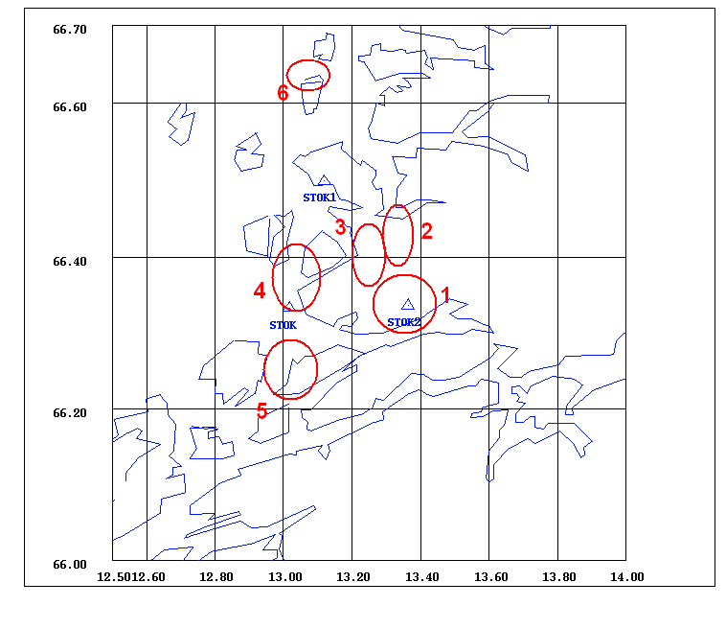
Figure 67 Stokvågen area. Red circles are areas in which swarms took place.

In the Stokvågen area it seemed like there are more than just four swarms in the time after STOK1 and STOK2 were installed. However, most of the events that are clustered in space are not clustered in time and their time distributions seem to be uniform (Clusters 2, 4, 5, Figure 67). The source of these activities is not known.

According to the Fgure 49d , the area in which swarm 8 (in Table 9) took place is north-east of the Steigen swarm 1992. In addition, the swarms that took place in Stokvågen area before July 2005 tend to move north-east parallel to the Ranafjorden. Location accuracy problem?

It is interesting to notice that between Steigen and Meløy areas there is no significant seismic activity in the past 26 years. It looks like swarm activity ”skips” that gap. First, it was Meløy swarm, than Steigen, than Stokvågen swarm, than Steigen again and recently Stokvågen again. The underlying processes that cause these swarms still remain to be understood. Further studies investigating the cause of swarm activity in this region are therefore recommended.

Acknowledgements
I am grateful to my supervisor Prof. Jens Havskov for giving me an opportunity and guiding me through my learning about seismology and the software SEISAN. I would like to thank also to Berit Mare Storheim and Prof. Kuvvet Atakan for a review of the script. Thanks also to IAESTE for their support during my traineeship at the Department of Earth science, UiB.

References
Atakan, K., Lindholm, C. D. and Havskov, J. (1994) Earthquake swarm in Steigen, Northern Norway: an unusual example of intraplate seismicity, Terra Nova, Vol. 6, 180- 194.

Bungum, H., Hokland, B. K., Husebye, E. S. and Ringdal, F. (1979) An exceptional intraplate earthquake sequence in Meløy, Northern Norway, Nature, 280, 32-35

Cartens, H. (April 2004) Geo, 27-32

Havskov, J. and Ottemöller, L. (2005) SEISAN: The earthquake analysis software, Version 8.1, Dept. of Earth Science, University of Bergen

Hicks,E. C., Bungum, H., Lindholm, C. D. (2000) Seismic activity, inferred crustal stresses and sesmotectonics in the Rana region, Northern Norway, Quaternary Science Reviews, 19, 1423-1436.

Novak, D. (2006) Seismicity in time and space for one year in the Stokvågen area, Northern Norway, Technical report, Dept. of Earth Science, University of Bergen

Ottemöller, L. (1995) Explosion Filtering for Scandinavia, Technical report, Dept. of Earth Science, University of Bergen

Tvedt, E. (2001) Earthquake swarms, Cand. Scient thesis, Institute of Solid Earth Physics, University of Bergen

Appendix 1

------------- Parameter file for program EXFILTER ---------------
-----------------------------------------------------------------
------- This file must follow the following format rules: __________
1. Any number of comment lines
2. Any line with first character # defines the parameters of that area
3. Any line with first character * defines the parameters of exceptions within
an alredy defined area. I.e. you can define an area around Mt. St. Helens,
and make an exeption for the very small St. Helens area.
4. In the first line of each parameter set the parameters are:
Maxdepth: Events with depth above this value are not explosions
Maxmag : Events with magnitude above this value are not explosions
Lhour : Lower limit of time interval for explosion time
Hhour : Upper limit of time interval for explosion time
Btime : Lower limit of yearly interval
Etime : Upper limit of yearly interval
N : Number of latitude-longitude pairs in polygon
5. From the second line the lat-long pairs are given
--------------------------------------------------------------
Last update: 12.09.1995 by L.O.
-------------------------------------------------------------
updates: 07.11.96 lo area 1 maxmag 3.6 -> 3.0
29.01.2002 alk : change end date to 201012
-------------------------------------------------------------
Area----------- Maxdepth Maxmag Lhour Hhour Btime Etime N e

# area 1 100.0 3.0 11 15 197001 201012 12
64.0 23.8 66.70 23.80 68.80 20.20 69.80 18.30
70.50 20.0 71.20 26.00 70.80 29.50 70.00 27.50
68.50 28.50 67.00 29.50 64.30 29.50 64.00 34.00

# area 2 100.0 2.5 10 19 197001 201012 3
70.80 29.50 70.30 31.50 70.00 27.50

# area 4 100.0 3.9 7 16 197001 201012 5
70.00 27.50 70.30 31.50 70.30 36.00 68.50 36.00
68.50 28.50

# area 5 100.0 3.8 15 20 197001 201012 4
67.90 17.80 68.80 20.20 66.70 23.80 66.50 21.00

# area 5 100.0 3.5 21 24 197001 201012 4
67.90 17.80 68.80 20.20 66.70 23.80 66.50 21.00

# area 5 100.0 3.5 0 1 197001 201012 4
67.90 17.80 68.80 20.20 66.70 23.80 66.50 21.00

# area 6 100.0 4.0 2 17 197001 201012 4
68.50 28.50 68.50 36.00 67.00 36.00 67.00 29.50

# area 7 100.0 3.4 0 24 197001 201012 4
66.00 14.00 66.00 15.40 66.70 15.40 66.70 14.00

# area 8 100.0 3.4 10 16 197001 201012 7
64.00 13.00 66.00 14.50 66.50 15.50 67.90 17.80
66.40 21.00 66.70 23.80 64.00 23.80

# area 11 100.0 3.7 8 13 197001 201012 4
64.30 29.50 65.20 29.50 64.30 34.00 64.00 34.00

# area 12 100.0 2.8 9 19 197001 201012 7
64.0 9.5 63.9 9.0 63.5 9.5 63.4 9.2
63.0 9.5 63.0 12.0 64.0 13.0

# area 13 100.0 2.4 9 21 197001 201012 4
63.9 9.0 63.5 9.5 63.4 9.2 63.7 8.5

# area 14 100.0 2.8 9 22 197001 201012 9
63.7 8.5 63.4 9.2 63.0 9.5 62.0 9.0
61.8 8.0 62.0 7.4 62.0 6.6 62.0 6.0
62.5 6.0

# area 15 100.0 2.7 18 20 197001 201012 4
62.0 9.0 63.0 9.5 61.0 12.0 62.0 12.0

# area 16 100.0 2.2 11 17 197001 201012 4
62.3 6.0 61.8 6.0 61.8 5.5 62.1 5.0

# area 17 100.0 2.8 7 20 197001 201012 4
62.0 6.6 62.0 7.4 61.8 8.0 61.5 7.5

# area 18 100.0 2.4 14 16 197001 201012 4
61.8 4.9 61.8 5.5 61.5 5.5 61.5 4.9

# area 19 100.0 2.6 10 17 197001 201012 19
62.0 9.0 62.0 12.0 61.6 11.0 61.6 10.0
60.8 9.0 61.0 8.0 61.4 8.5 61.4 8.0
61.3 7.5 61.5 7.0 61.3 6.5 61.5 6.3
61.5 5.5 61.8 5.5 61.8 6.0 62.0 6.0
62.0 6.6 61.5 7.5 61.8 8.0

# area 20 100.0 2.4 13 22 197001 201012 4
61.5 5.0 61.5 6.3 61.3 5.8 61.3 5.0

# area 21 100.0 2.4 15 20 197001 201012 4
61.5 7.0 61.3 7.5 61.1 7.0 61.3 6.5

# area 22 100.0 2.5 13 20 197001 201012 6
61.3 7.5 61.4 8.0 61.4 8.5 61.0 8.0
61.0 7.0 61.1 7.0

# area 23 100.0 2.6 11 18 197001 201012 4
61.6 10.0 61.6 11.0 60.8 10.0 60.8 9.0

# area 24 100.0 2.6 10 19 197001 201012 8
61.0 5.0 60.8 5.8 60.8 7.0 61.1 7.0
61.3 6.5 61.5 6.3 61.3 5.8 61.3 5.0

# area 25 100.0 2.5 6 21 197001 201012 4
60.8 4.6 61.0 5.0 60.8 5.8 60.4 5.8

# area 26 100.0 2.5 9 18 197001 201012 4
60.8 5.8 60.8 6.5 60.4 6.5 60.4 5.8

# area 27 100.0 2.7 11 17 197001 201012 21
59.2 9.5 60.0 8.5 60.0 9.5 60.8 10.0
60.8 9.0 61.0 8.0 61.0 7.0 60.8 7.0
60.8 6.5 60.4 6.5 59.8 7.0 59.2 7.5
59.0 7.0 59.2 6.3 58.7 6.3 58.7 5.2
58.5 6.0 58.5 7.0 58.0 6.5 58.0 8.0
58.6 9.2

# area 28 100.0 2.7 9 17 197001 201012 8
58.4 12.0 62.0 12.0 61.6 11.0 60.8 10.0
60.0 9.5 59.2 9.5 58.6 9.2 59.0 10.5

# area 29 100.0 2.5 6 20 197001 201012 4
60.8 4.6 60.4 5.8 60.1 5.2 60.4 4.6

# area 30 100.0 2.7 7 16 197001 201012 5
60.4 4.6 60.1 5.2 59.7 5.2 59.7 4.0
60.2 4.0

# area 31 100.0 2.3 12 15 197001 201012 8
60.1 5.2 59.2 5.2 59.2 5.9 59.5 5.9
59.5 6.3 59.8 7.0 60.4 6.5 60.4 5.8

# area 32 100.0 2.3 9 19 197001 201012 4
59.2 5.9 59.5 5.9 59.5 6.3 59.2 6.3

# area 33 100.0 2.8 3 23 197001 198712 5
59.2 6.3 59.5 6.3 59.8 7.0 59.2 7.5
59.0 7.0

# area 34 100.0 2.5 9 19 197001 201012 3
60.0 8.5 60.0 9.5 59.2 9.5

# area 35 100.0 2.9 10 20 197001 201012 4
59.2 5.2 59.2 6.3 58.7 6.3 58.7 5.2

# area 36 100.0 2.8 13 15 197001 201012 7
58.5 5.0 58.5 6.0 58.0 6.0 58.0 6.5
57.5 6.5 57.5 5.5 57.7 5.0

# area 37 100.0 3.1 12 17 197001 201012 4
58.5 6.0 58.0 6.0 58.0 6.5 58.5 7.0

# area 38 100.0 2.9 15 16 197001 201012 4
58.6 9.2 59.0 10.5 58.4 12.0 57.8 10.3

# area 39 100.0 2.9 7 13 197001 201012 3
57.8 10.3 58.4 12.0 57.3 12.0

# area 40 100.0 2.8 12 15 197001 201012 9
64.0 13.0 63.0 12.0 57.3 12.0 56.5 12.5
56.3 12.0 55.0 13.5 55.0 14.0 55.0 16.0
64.0 16.0

# area 41 100.0 0 0 0 0 0 5
58.0 16.0 58.0 18.0 59.5 18.0 64.0 22.0
64.0 16.0

# area 42 100.0 2.7 9 18 197001 201012 12
58.0 19.7 59.5 19.7 59.5 18.0 64.0 22.0
64.0 30.0 63.5 30.0 63.5 26.0 62.5 26.0
60.5 24.0 60.5 22.0 59.5 22.0 59.5 23.0

# area 43 100.0 2.7 9 11 197001 201012 5
63.5 30.0 64.0 30.0 64.0 36.0 62.5 36.0
62.5 34.0

# area 44 100.0 2.9 10 13 197001 201012 4
62.5 26.0 63.5 26.0 63.5 30.0 62.5 30.0

# area 45 100.0 2.9 8 13 197001 201012 7
63.5 30.0 62.5 34.0 61.0 34.0 61.0 32.0
61.5 31.0 61.5 29.0 62.5 30.0

# area 46 100.0 2.8 9 14 197001 201012 7
60.0 24.0 60.5 24.0 62.5 26.0 62.5 30.0
61.5 29.0 60.5 28.0 59.5 26.0

# area 47 100.0 2.9 8 16 197001 201012 5
61.0 34.0 62.5 34.0 62.5 36.0 61.0 36.0
61.0 36.0

# area 48 100.0 2.9 8 17 197001 201012 4
60.5 28.0 61.5 29.0 61.5 31.0 60.2 31.0

# area 49 100.0 3.1 7 16 197001 201012 5
59.5 22.0 60.5 22.0 60.5 24.0 60.0 24.0
59.5 23.0

# area 50 100.0 3.0 8 15 197001 201012 4
60.0 24.0 59.5 26.0 58.5 26.0 59.5 23.0

# area 51 100.0 3.2 8 14 197001 201012 4
58.5 26.0 59.5 26.0 60.5 28.0 58.5 29.5

# area 52 100.0 2.7 7 15 197001 201012 4
60.5 28.0 60.2 31.0 58.5 32.0 58.5 29.5

# area 53 100.0 2.8 8 13 197001 201012 6
60.2 31.0 61.5 31.0 61.0 32.0 61.0 36.0
58.5 36.0 58.5 32.0

# area 54 100.0 3.2 5 17 197001 201012 4
58.0 18.0 59.5 18.0 59.5 19.7 58.0 19.7

# area 55 100.0 3.1 7 16 197001 201012 7
55.0 16.0 58.0 16.0 58.0 19.7 59.5 23.0
58.5 26.0 58.0 22.0 55.0 20.0

# area 56 100.0 2.8 8 16 197001 201012 5
55.0 20.0 58.0 22.0 58.5 26.0 58.5 36.0 55.0 36.0

Appendix 2

GMT (Wessel and Smith, 2006) script for the map on Figure 23

#!/usr/bin/csh
gmtset PAPER_MEDIA = a4+

set outfile = ana.ps
\rm $outfile input.grd
set dlat = 66
set ulat = 68.49
set llon = 12
set rlon = 16.99
set TITLE =

set col1 = 255/0/0
set col2 = 0/255/0
set col3 = 0/0/255
set col4 = 255/0/255
set col5 = 0/255/50
set col6 = 255/255/0

set R = -R$llon/$rlon/$dlat/$ulat
echo -n " Paper size, e.g. 5 : "
set papers = $<
set J = -Jm"$papers"h
#set J = -Jm13.15/66.45/66.2/66.7/17c
set B = -B0.5f0.5m:."$TITLE":WSne

echo " Please give the name of the fil containing the epicenters. "
echo " It should contain lines like belw: "
echo " "
echo " Lon. Lat. Elev. Mag. "
echo " 12.770 66.447 -15.0 1.80000 "
echo " "
echo -n " Now give the name, say Events_min_stat2 : "
set evntfile = $<

echo $evntfile

#
# Create box in which the magnitudes are defined
#
psxy -R0/8.5/0/11 -Jx1 -O -K -P -W4 << END >> $outfile
1 2.0
7.5 2.0
7.5 2.5
1 2.5
1 2.0
END

psbasemap $R $J $B -K >! $outfile
pscoast $R $J $B -Dh -N1 -G255/224/192 -S128/192/224 -W2 -O -K >> $outfile

nawk '{if(NF==4 )print $1,$2,($4+1.5)*.02}' $evntfile | \
psxy $R $J $B -O -K -W3/$col1 -Sc -G$col1 >> $outfile

pstext $J $R -O -N << END >> $outfile
END

gs -dNOPAUSE -q -r300 -sDEVICE=jpeg -dBATCH -sOutputFile=$outfile".jpeg" $outfile

gv $outfile

