Norwegian National Seismic Network

Technical Report No. 26

Test of seismic recorders with 4.5 Hz sensors: GBV316 from GeoSig and SL07 from SARA.

Prepared by

Jens Havskov
jens@geo.uib.no

Dept. of Earth Science, University of Bergen
Allégt.41, N-5007 Bergen, Norway
Tel: +47-55-583600 Fax: +47-55-583660 E-mail: seismo@geo.uib.no

June 2007

Introduction

The Department of Earth Science has for some years been participating in developing low cost seismic recorders. The first such recorder released on the market was the GBV316 from GeoSig (www.geosig.com) which was available before year 2000. No new development has taken place at GeoSig since it was developed. A newer generation low cost recorder has been developed by SARA company (www.sara.pg.it). Both recorders are used by the Norwegian National Seismic Network.

The purpose of this test is to compare the GBV316 recorder from GeoSig to the SL07 from SARA. Both recorders use internal 4.5 Hz geophones. The GBV uses a 16 bit digitizer while SARA uses a 24 bit digitizer. The GBV has for some time been considered the best low cost combination on the market, however the new SARA should have the potential to match it.

The 4.5 Hz geophone has limited low frequency capability depending on type of geophone and sensitivity of geophone. Earlier it has been shown that for ‘average sites’, background noise can be resolved down to about 0.3 Hz (SESAME, 2002). A simple way to extend the sensitivity is to use a 2 Hz sensor and some preliminary tests have also been made also with the 2 Hz sensor deployed by SARA.

The GBV has been used extensively for noise measurements using the Nakamura method. Some test will therefore also be made doing spectral ratio for both systems.

In order to compare results in an absolute sense, all results are compared to the recording from a STS2 at the same site.

Test conditions

The GBV and the SARA instrument were both connected to a Seislog Windows system (www.geo.uib.no/seismo/SOFTWARE/SEISLOG/WIN/seislog_1.2.7.doc). The sensors were placed at the site of the University of Bergen permanent STS2 broad band sensor which is located in the basement of the university building. There was no absolute timing on the Seislog system, so comparison of traces has some small error (< 1-2 s). Sampling rate was 100 Hz for all systems.

Calibration data

The data shown in Table 1 gives the manufactures calibration data.

System | Period, seconds | Damping | Generator  Constant, V/m/s | Digitizer  Gain in c/V *10⁶ | LP filter  Frequency Hz | Number  of poles | Gain at  5 Hz  c/nm/s | Gain at  0.3 Hz  c/nm/s
GBV | 0.22 | 0.7 | 27.5 | 13.1 | 15 | 5 | 0.36 | 0.0016
SARA 4.5 Hz | 0.22 | 0.7 | 78.0 | 8.4 | 9 | 1 | 0.66 | 0.0032
SARA 2.0 Hz | 0.50 | 0.67 | 38.0 | 8.4 | 9 | 1 | 0.32 | 0.0070
BER BB | 120 | 0.7 | 1500 | 8.4 | - | - | 12.6 | 12.6

Table 1 Instrument specifications. The BER BB station uses an PS2400 Earth Data digitizer.

From the table it is seen that the SARA 4.5 Hz unit theoretically is the most sensitive in terms of least significant bit, however, the real sensitivity will depend on the internal noise.
The GBV has a 5 poles software antialias filter at 15 Hz. The SARA only has a one pole fixed analog filter at 9 Hz.

Digitizer internal noise and theoretical noise spectrum

In order to test the digitizer internal noise and calculate the theoretically lowest ground noise the units can resolve, the input was shorted and a signal recorded. Figure 1 shows the recorded signals

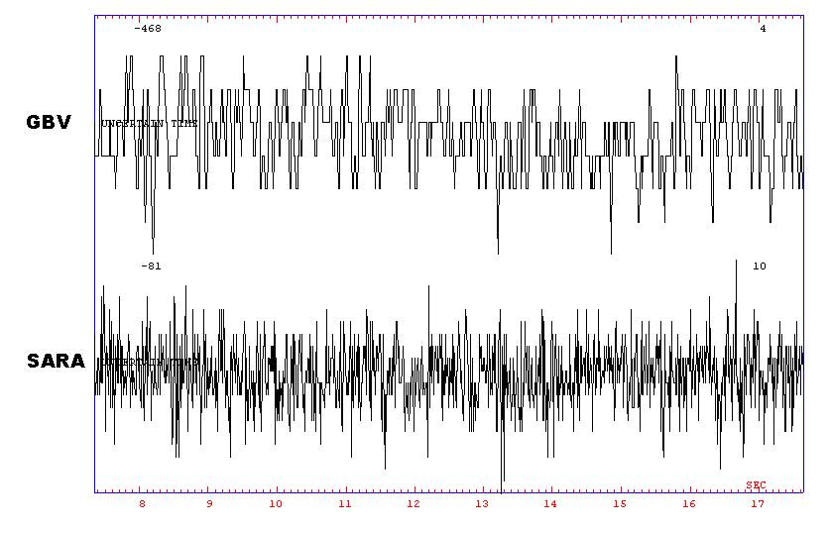

Figure 1 Signals recorded by the recorders with the input shorted. GBV is the GBV316 and SARA is the SARA recorder. The numbers in the upper right hand corner is maximum amplitude in counts.

From Figure 1 it is seen that the GBV typically has +- 2 counts of noise while the SARA has +- 5 counts. However it is also seen that SARA has more high frequency noise, probably due to the lack of antialias filter. The same signal as seen in Figure 1 was filtered in various bands to compare the noise, see Table 2.

Digitizer | 0.1 –1.0 Hz | 1- 5 Hz | 5-10 Hz | 15-25 Hz | 25-40 Hz
GBV | 1 | 2 | 2 | 1 | 1
SARA | 1 | 3 | 3 | 6 | 6

Table 2 Maximum noise (counts) of noise bandpass filtered at different frequencies.

It is seen that at low frequencies, the noise in counts is the same for both digitizers while at high frequencies, SARA has 6 times more noise. This again may partly be ascribed to the lack of filtering.

Using the nose data and the specifications for the sensors, the theoretical lowest ground noise can be calculated by calculating the instrument corrected power acceleration spectra, see Figure 2. For comparison, all spectra were calculated using a 60 s time window. The noise spectra are compared to the Peterson noise curves (Peterson, 1993).

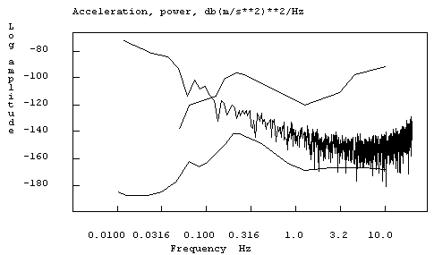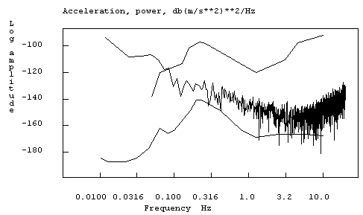
.
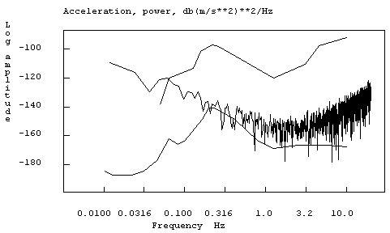

Figure 2 Noise spectra for lowest theoretical ground noise resolution for different sensors and digitizers. The Peterson New Low and High Noise models (smooth curves at top and bottom) are shown for comparison. Top: GBV, middle: SARA 4.5 Hz, bottom SARA 2.0 Hz. All channels are vertical.
It is seen that at low frequencies (<0.5 Hz) the SARA recorder has less noise than GBV, at middle frequencies they are about equal while at high frequencies (f > 10 Hz), the SARA unit has slightly more noise than the GBV. The SARA unit with a 2 Hz sensor has, as expected, a lower noise floor below 3 Hz, than the units with 4.5 Hz sensors while at frequencies about 4 Hz it has a higher noise level due to its lower sensitivity.

Tests with background noise signals

Background noise was recorded simultaneously on all systems and compared. The signals from the STS2 was considered as a reference. A noise window of about 100 s was used. Figure 3 shows the raw signals and Figures 4 to 6 show signals corrected for response in different filter bands.

It soon became apparent that the SARA 4.5 Hz sensor signals, once instrument corrected, gave too high amplitudes at low frequencies. The natural period was checked and found to be 0.25 s instead of 0.22 s. This small change was enough to give a significant change in amplitude at low frequencies so T = 0.25 s was used for the instrument correction.

The following figures show signal in progressive lower frequency bands in order to observe at what frequency deviation occurs from the ‘true STS2’ signal

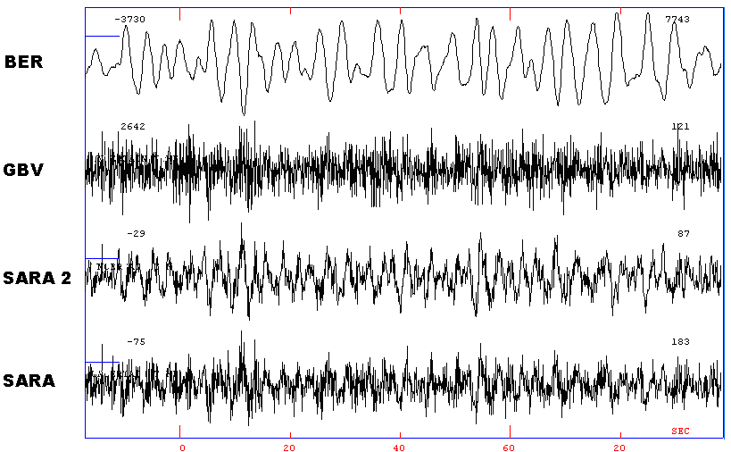

Figure 3 Raw signals. The maximum amplitude (counts) for each trace is given to the right above the trace. BER is the STS2, SARA 2 is the SARA 2 Hz unit and SARA is the 4.5 Hz sensor from SARA.

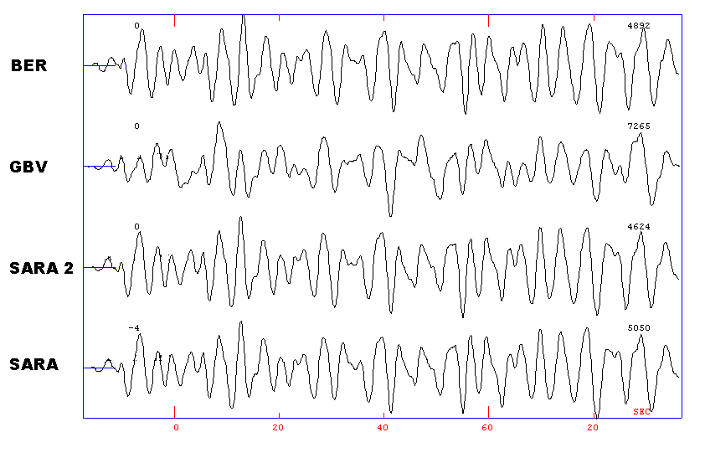

Figure 4 Velocity (nm/s) in the filter band 0.08 to 1.1 Hz.. The maximum amplitude (nm/s) for each trace is given to the right above the trace. BER is the STS2, SARA 2 is the SARA 2 Hz unit and SARA is the 4.5 Hz sensor from SARA.

The SARA systems and STS2 look very similar. The GBV signal can be recognized as similar to the STS2 but is quite distorted. Also note that the 2.0 and 4.5 Hz SARA systems are almost identical.

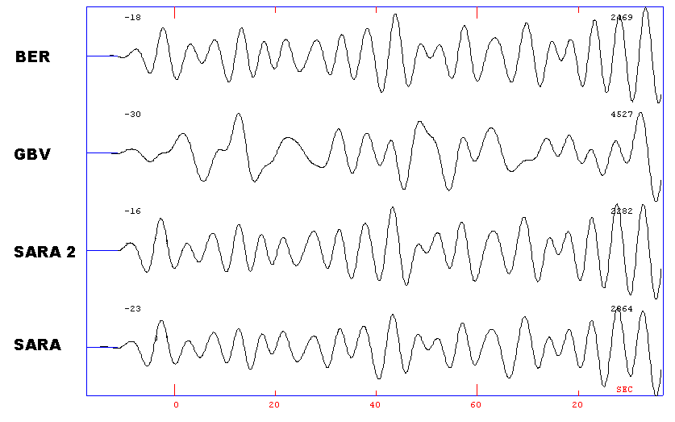

Figure 5 Velocity (nm/s) in the filter band 0.08 to 0.2 Hz.. The maximum amplitude (nm/s) for each trace is given to the right above the trace. BER is the STS2, SARA 2 is the SARA 2 Hz unit and SARA is the 4.5 Hz sensor from SARA.

The 2 Hz sensor mostly resembles the STS2 and the 4.5 Hz SARA is nearly as good in shape, however the amplitude is a bit too high. The GBV signal is now useless.

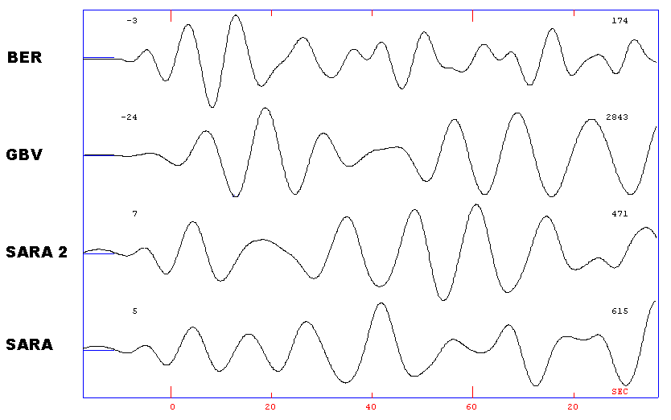

Figure 6 Velocity (nm/s) in the filter band 0.07 to 0.1 Hz.. The maximum amplitude for each trace is given to the right above the trace. BER is the STS2, SARA 2 is the SARA 2 Hz unit and SARA is the 4.5 Hz sensor from SARA.

By just moving down a bit in frequency, none of the geophones are capable of correctly reproducing the STS2 signal. The 2 Hz sensor is closest in amplitude.

For the same signals, the noise spectra were calculated, see Figure 7.

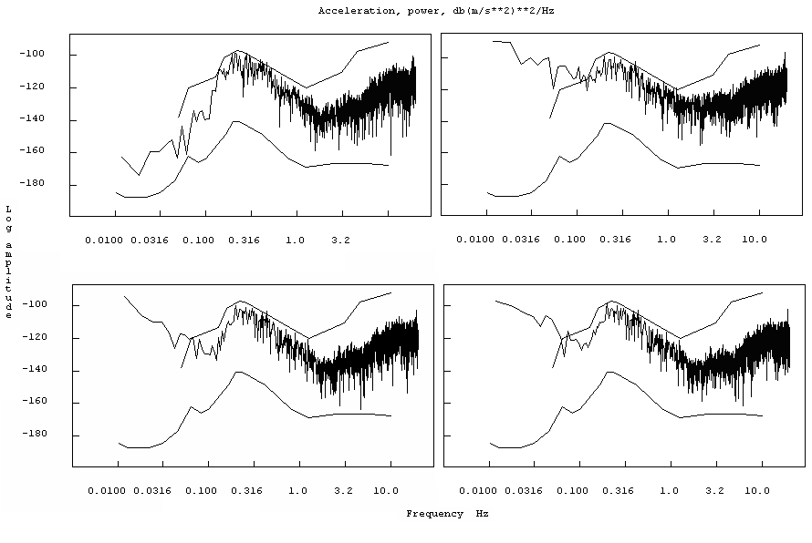

Figure 7 Noise spectra for the background noise signals seen in Figure 3 using the different sensors and digitizers. The Peterson New Low and High Noise models (smooth curves) are shown for comparison. Top left is the STS2, top right is GBV, bottom left is SARA 4.5 Hz and bottom right is SARA 2.0 Hz. All channels are vertical.

It is seen that the 2 Hz sensor resolve the noise down to 0.1 Hz, the 4.5 Hz SARA down to 0.15 Hz and the GBV down to 0.2 Hz. These results are what would be expected theoretically from the test for the digitizer noise, see Figure 3.

Spectral ratio

Since many instruments are used for determining spectral ratio, a test was also made calculating the spectral ratio of the noise signal used above. The ratios were calculated using 5 windows of window length 18 s and the spectra were smoothed 5 times. The results from the 3 sensors are shown in Figure 8. There has been no correction for the response so the wrong low frequency response of the SARA Z-sensor is not taken into account. However, there might also be wrong response for the horizontal components not taken into account.

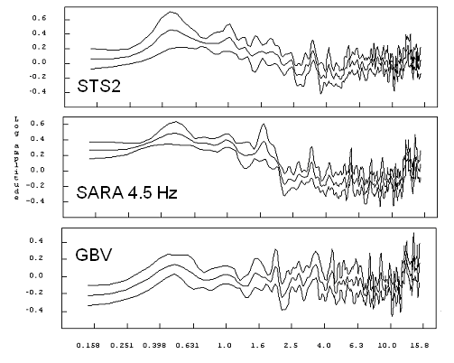
Figure 5 Spectral ratios of 3 the recorders. The horizontal axis is frequency in Hz and the vertical axis is log spectral ratio.

All systems clearly show a peak at 0.5 Hz and since the measurement is on hard rock, the spectral ratios are near 1.0. It is clear that the SARA system comes closer to the STS2 than the GBV, particularly in getting the correct spectral ratios of low versus high frequencies.
Considering that noise levels at real test sites, often in cities, are higher than at the UiB site, it is to be expected that the SARA instrument can be used for spectral ratio measurements down to frequencies as low as 0.1 Hz and for sure down to 0.2 Hz. No spectral ratio tests were made with the 2.0 Hz instruments. Although it has a slightly better signal to noise ratio at lower frequencies than the 4.5 Hz instrument, the difference is marginal and for most conditions, a 4.5 Hz sensor might be adequate.

Discussion

It is in general impressive how well the low frequency signals can be recovered from these inexpensive recorders. In our noise environment, signals down to 0.2 Hz can be recovered by the SARA 4.5 Hz while the GBV 4.5 Hz instrument is limited to ca 0.3 Hz. However, the experiment also shows how important it is to have correct calibration values for the geophones. These inexpensive devises often can have quite variable parameters which can have a significant influence on the low frequency response which in turn can make spectra ratios unreliable. This might explain the differences between the spectral ratios of the STS2 and the geophones. In order to get reliable measurements at low frequencies (about 2 Hz), each geophone should be calibrated and corresponding response information used for analysis. Ideally the manufacturer should provide this information.

The low frequency performance of the sensor mostly depends on the low frequency sensitivity of the digitizer and the generator constant of the geophone. The SARA digitizer has more sensitivity at low frequencies than the GBV digitizer. Combined with the use of a high output geophone this explains the better performance of the SARA 4.5 Hz system. Alternatively, the sensors can be connected to a preamplifier, possibly with negative feedback to stabilize the response. This electronic pre-shaping of the signal ensures good linearity and identical response for the 3 components and the response is similar to the response of a 1.0 Hz sensor. An example of this is the Lennartz LE-3D sensor (www.lennartz-electronic.de). However, the Lennartz sensor has no better low frequency sensitivity than the above sensors (actually a bit less due to a high pass filter used for stabilization), but the output resembles a 1 Hz sensor. In terms of price, the LE-3D sensors cost about as much as a GBV or SARA recorder, however the user get a very well calibrated 1 Hz sensor.

The 2 Hz sensor used only gives marginal improvement compared to the 4.5 Hz sensor. This is partly due to its lower sensitivity compared to the 4.5 Hz sensor used.

In conclusion, for average sites, a 4.5 Hz sensor with a good digitzer will resolve the ground noise down do about 0.2-0.3 Hz. With a lower noise digitizer, this limit might become even lower. However, to get accurate recordings, the sensor parameters must be known.

Acknowledgments
Berit Marie Storheim and Jose Ojeda read the text and gave valuable comments.

References

Peterson, J (1993). Observation and modeling of seismic background noise. U. S. Geological Survey Open File Report93-322, 95 pp.

SESAME (2002). Site effects using ambient excitations: Controlled instrumental specifications. Final report of the instrument workshop 22-26-October, University of Bergen, Norway. Www.geo.uib.no/seismo/REPORTS/SESAME/SESAME-instrument-report.pdf

