EC PROJECT
EVG1-CT-2002-00069

REL. I. E. F.



RELiable Information on Earthquake Faulting

Large Earthquake Faulting and Implications for the Seismic Hazard Assessment in Europe:

The Izmit-Duzce earthquake sequence of August-November 1999

(Turkey, Mw 7.4, 7.1)

ANNUAL REPORT

Second year

November 2004

WP 6: Integration of multidisciplinary data for seismic hazard assessment
WP 9: Multidisciplinary seismic hazard assessment

Prepared by K. Atakan and M. B. Sørensen

PARTNER 6: Institutt for Geovitenskap, Universitetet i Bergen



List of Contents

1. Introduction
2. Project participation from UiB and external collaboration
3. WP6: Integration of multidisciplinary data for Seismic Hazard Assessment
3.1. Earthquake catalogues
3.2. Ground motion scaling and attenuation
3.3. Local site effects: A detailed study in Ataköy
4. WP9: Multidisciplinary Seismic Hazard Assessment (SHA)
4.1. Probabilistic seismic hazard assessment (PSHA) in the Marmara Sea region
4.2. Ground motion simulations based on earthquake scenarios
5. WP10: Dissemination of the results
5.1. Development of the 3-D ground motion visualization software: GM3D
5.2. Dissemination of the results (publications, conference presentations etc.)
Acknowledgements
References

1. Introduction

Department of Earth Science (Institutt for Geovitenskap), University of Bergen (hereafter called UiB) is mainly responsible of the work packages WP6 (Integration of multidisciplinary datasets to seismic hazard assessment) and WP9 (Multidisciplinary seismic hazard assessment). In accordance with the project proposal, during the period December 2003 to November 2004, activities of the UiB were concentrated around these two work packages. Main focus has been on integration of collected field data in site effect estimation and a continuation of the work on seismic hazard computations using ground motion simulations for a scenario earthquake. In addition, UiB contribution to workpackage WP10 is given separately. Activities that are associated with these workpackages are described in the following sections.

2. Project participation from UiB and external collaboration:

Main participants from the UiB are: Kuvvet Atakan, Mathilde Bøttger Sørensen, Odd Johann Berland and Knut Andre Furuløkken. In addition, close collaboration is continued with Nelson Pulido (NIED, Japan) and Anibal Ojeda (INGEOMINAS, Colombia) in ground motion simulations, with Aybige Akinci and Gianluca Malagnini (INGV, Rome) in ground motion scaling and attenuation and with Caglar Yalciner (Osman Gazi University, Eskisehir, Turkey) in site effects study. New collaboration has been initiated with Ivo Oprsal and Martin Mai (ETH, Zurich) in 3D site effects modeling and with Sylvette Bonnefoy-Claudet and Pierre-Yves Bard (LGIT, Grenoble, France) in 1D modeling of ambient noise. There is also extended collaboration with a number of researchers from other institutions, especially with KOERI, Istanbul (Mustafa Erdik, Atilla Ansal, Eser Durukal, Mustafa Aktar) in different aspects of ground motion simulations. Several contributions from these individuals provide the basis for the present report.

3. WP6: Integration of multidisciplinary data for seismic hazard assessment

3.1. Earthquake catalogues

As part of WP06, a revised catalogue of earthquakes including both historical and instrumental events is prepared. This work is done partly by sub-contractor N. Ambraseys, IC London, and is summarized in RELIEF deliverable no. 16.
As described in the RELIEF 1st annual report from UiB, 2003, a large catalogue has been prepared by the UiB group, covering the instrumental period 1900-present. This catalogue contains more than 50 000 events and is complete down to M = 5 for the full time span and M = 3 after 1964.

The contribution from the sub-contractor has been focused mainly on the historical part (pre-1900). The sub-contractor has delivered a catalogue covering the time 1500-2001. The time before 1500 is being studied by INGV, Italy, through their sub-contractor SGA. In total, 1,393 earthquakes in the period 1500 to 2000 have been identified. Of these, 841 are 20th century instrumental events. Epicenters of one third of these, chiefly events of the fist five decades of the 20th century, are improved, positions are recalculated using macroseismic information for the first iteration and ISC procedures for the calculation of position with constrained depth. The remaining locations are reliable macroseismic estimates, locations reported by ISC or in special studies. For another 841 pre-instrumental earthquakes, epicentral locations are macroseismic with the associated magnitudes derived using a region-specific scaling formula.

Some last adjustments still need to be done to the sub-contractor catalogue and it must be merged with the pre-1500 catalogue from SGA when this is available. Afterwards, the resulting catalogue will be merged with the UiB catalogue to obtain a new, complete catalogue for the Marmara region.

3.2. Ground motion scaling and attenuation

As described in the RELIEF 1st annual report from UiB in 2003, a work was initiated in collaboration between UiB and INGV, Rome, on establishing an attenuation relationship for the Marmara Sea region. This was done using ground motion scaling on small earthquakes (see RELIEF deliverable no. 18 for details). By the end of 2003, the technique had been applied to a small dataset, which was unable to constrain the regressions, and it was concluded that more data are needed in order to obtain reliable results. Such a new dataset is now available, and work is now well under way to finalize the study. This work will continue over the next months and results will be available during the first half of 2005.

3.3. Local site effects: A detailed study in Ataköy

During 2004, intensive work has been done on estimating local site effects for the Istanbul area. As described in the RELIEF 1st annual report from UiB in 2003, microtremor data were collected at 30 sites in Ataköy, western Istanbul, during autumn 2003. These data have been analyzed in detail and combined with a number of other approaches to estimate the site effects. The efforts on site effect estimation can be divided into four separate studies; microtremor analysis, 1D modeling, weak motion analysis on records from temporary broadband stations and 3D modeling. These are described in the following.

Our study of local site effects for the Istanbul area is concentrated in the Ataköy area, which is located in the western part of the city. This area has been selected for several reasons. Figure 3.3.1 shows the geology of Istanbul. As it is seen from this figure, the city is dominated by a number of different geological formations. Roughly speaking the city can be divided into two parts by drawing a line diagonally from Northwest to Southeast. North of this line the geology is dominated by relatively firm bedrock with some alluvial systems running through. In the Southwestern part of town, the bedrock is much weaker, sedimentary rocks are dominating and there are more alluvial and delta systems. For this reason, the strongest site effects are expected in the southern part of town, and we have chosen our study area here. Also, ground motion simulations performed for a M = 7.5 scenario earthquake in the Marmara Sea (Pulido et al., 2004), predict the strongest ground motions from such an earthquake to be in the southern part of the city.

Southwestern Istanbul is a densely populated part of the city housing critical facilities such as the Atatürk international airport and several industrial areas. The study area covers mainly the Ataköy district of the Bakirköy Municipality, which lies to the east of the International Atatürk Airport of Istanbul. The main geological units in the area are shown in Figure 3.3.2. The area is covered mainly by the Bakirköy formation, which consists of alternating layers of limestone, marl and clay of Upper Miocene age. This formation is quite fragmented and altered at the surface. It overlies the Güngören formation of green colored plastic clay, marl and clayey siltstone of Upper Miocene age. Kusdili formation of Quaternary age outcrops only in a small areal extent and is composed of clay with molluscs, silt and mud. The overlying alluvium (Quaternary) is the result of fluvial activity and consists of unconsolidated sediments composed of gravel, sand, silt and clay. In some parts of the area, construction material is dumped over the alluvium and is overlain by a thin layer of gravel (20-30cm) and filled with soil on top (40-50 cm).

Ataköy is a relatively recent residential area dominated by three categories of buildings having ca. 15 stories, 5-6 stories or 1-2 stories, respectively. The area is quiet during daytime, it is flat and has large open areas such as parks and parking lots making it suitable for performing field measurements.

3.3.1. Microtremor analysis.

In October 2003, a field campaign was carried through in the Ataköy area by M. B. Sørensen, C. Yalciner and K. Atakan. In order to asses the predominant frequencies where local site amplifications occur, an experiment was set up to collect microtremor data with the digital portable seismograph stations of the UiB.

Microtremor measurements were performed on 30 sites approximately placed on a grid of 150 to 200-500 meters. At each point a minimum of 3 x 10 min of microtremor data were collected continuously using the GBV-316 (GeoSIG) portable digital seismographs. Each seismograph contains a 16-bit digitizer and a 4.5 Hz 3-compopnent built-in sensor. The technical specifications of the instruments used were tested extensively through previous studies (Atakan et al., 2004) and has a resolution down to 0.5 Hz (also down to 0.3 Hz under specific conditions). Communication was done using the Seislog program for Pocket PC (Ojeda et al., 2004).

The exact locations of the microtremor measurement sites are shown in Figure 3.3.3. It is seen that the majority of the sites are located on alluvium or Bakirköy formation, and only these two formations have been studied in detail. The method used in assessing the fundamental frequencies at each site is based on the H/V (Horizontal to vertical component of the recorded signal) spectral ratio technique (also known as ”Nakamura method”) (Nakamura, 1989).

The results of processing are presented in Figures 3.3.4 and 3.3.5. For the alluvial sites (Figure 3.3.4), a peak is observed around 1 Hz. An additional, more diffuse peak is indicated around 3-6 Hz. For the Bakirköy formation (Figure 3.3.5), there is again a clear peak around 1 Hz whereas no peak is observed for higher frequencies. This indicates that the 3-6 Hz peak observed for the alluvium is an effect of the alluvial layer whereas the 1 Hz peak is caused by deeper lying formations. In order to check these results further, recorded noise for a 1D model has been simulated and H/V spectral ratios are calculated for comparison. This is described in the following section.

3.3.2 1D modeling

In order to be able to check the H/V spectral ratio results for the recorded microtremors, ambient noise was simulated using a 1D model representative of sites in Ataköy. H/V spectral ratios for the simulated noise were then calculated for comparison with the H/V spectral ratios of the recorded microtremors. This work was performed in collaboration with Sylvette Bonnefoy-Claudet at LGIT, Université Joseph Fourier, Grenoble, France. The 1D models are based on available geological, geotechnical and geomorphological data. The noise simulations are performed as described in Bonnefoy-Claudet et al. (2004). For a given 1D structure, noise sources are modeled as point forces with delta-like source time functions located at fixed depths (4 and 8 m) and distributed randomly in space, direction, amplitude and time. Green’s functions for the medium are calculated using the method of Hisada (1994).

The simulations have been performed for three hypothetical sites, representing an average alluvial site, a site on the Bakirköy formation and a site on the Güngören formation. These sites are taken out of the 3D model used for hybrid modeling of site effects, and a detailed description of this model can be found in section 3.3.4. The sites in the 1D model are simplified from this model by using the average velocity of each layer. This was necessary to obtain reasonable computation times for the models. The 1D models are shown in Figures 3.3.6-3.3.8 and the velocities are given in Table 3.3.1.

The noise simulations from the three sites were processed in the same way as the recorded microtremors in order to be able to compare the results. The H/V spectral ratios calculated for the three sites are shown in Figures 3.3.9-3.3.11. In general, it should be noted that the absolute amplification levels are lower than expected. This is probably due to the shallow depth of the topmost layer where the velocity contrast is highest with the underlying formations (Bonnefoy-Claudet et al., 2004). However, the peak observed around 1 Hz in the microtremor data is also present in the simulation results for all three sites.

3.3.3. Weak motion data analysis

During the Istanbul field campaign in October 2003, three broadband seismic stations from the University of Bergen were installed temporarily for a 3 month period. The station locations are shown in Figure 3.3.12. Two of the stations (Ataköy and Zeytinburnu) were located on the Bakirköy formation whereas the third (ITU) was located at the bedrock in the northern part of Istanbul. Data have been stored in a continuous database (effectively for two months) and large events in the area have been extracted as independent event files.

Five events have been recorded with a sufficient signal-to-noise ratio to study spectral ratios using records from the Bakirköy formation stations with respect to the bedrock station (hereafter referred to as standard spectral ratio, SSR). The locations of these events are shown in Figure 3.3.13. As it is seen in this figure, there is a large variability in azimuth and distance to the stations, which may cause uncertainties in the results.

The spectral ratios were calculated using the program SPEC which is included in the SEISAN package (Havskov and Ottemöller, 2003). Recordings of a given earthquake at all three stations were merged into an event file and S-wave arrival times were picked. North-south and east-west components were analyzed separately. Optimal values of input parameters such as window length for calculating the spectra and the degree of smoothing of the spectra were found after some initial testing.

Despite the expected variability in path effects for the different events due to the differences in location, average spectral ratios were calculated for each of the horizontal components at each of the two studied stations. These spectral ratios are shown together with their standard deviations in Figure 3.3.14. As expected, the standard deviations are relatively large and some differences are seen between the plots, but some general trends are present. The NS component at the Ataköy station stands out, probably due to noise in the recordings. For the other three plots, peaks are seen for all components between 0.5-1 Hz, around 1.5 Hz and around 2.5 Hz. At higher frequencies there is higher variability, probably mainly due to differences in path effects. These peak frequencies are not in agreement with the microtremor and 1D modeling results. A possible explanation for this is the increased complexity introduced by studying earthquakes instead of microtremors. The amplification levels predicted by the SSR results are high, up to a factor of 10. In case of a large earthquake, lower amplification levels would be expected due to non-linearity effects.

In an attempt to reduce the differences in path effects, average spectra for events 2 and 4 in Figure 3.3.13 were calculated as well. These events are located very close to each other and are therefore expected to have been traveling along approximately the same path. The average spectral ratio results for these two events are shown in Figure 3.3.15. It is expected that using only two events will decrease the standard deviation, and this is also what is observed in the figure. Figure 3.3.16 shows an overlay of the SSR results for all events and for the events 2 and 4 only. The peak frequencies for events 2 and 4 are very similar to the peak frequencies obtained by averaging all events, indicating that the differences in path effect are not significant. There are, however, differences in amplification level.

Most of the events are located almost directly south of the stations and there is therefore not expected to be a large error in studying the recorded NS and EW components. However, to make sure this was not introducing errors, the seismograms were rotated to the great circle path and the radial (R) and transverse (T) components were studied. The results for these components are shown in Figure 3.3.17. Again, the peak frequencies are similar to what was found for the unrotated traces and there is a small effect on the results due to the rotation.

It seems that the peak frequencies obtained from the SSR study are a real feature of the data. The difference from the H/V ratio results may be due to the differences in the distance between the recording sites, even if the azimuths are the same.

3.3.4. 3D modeling

Another approach used for estimating the local site effects in Ataköy was a full 3D hybrid modeling of the site effects due to a scenario earthquake source. This work was carried out in collaboration with Ivo Oprsal and Martin Mai at ETH, Zurich, Switzerland. The work was started in March 2004 where M. B. Sørensen spent one week with the group in Zurich, discussing methodology, input model and work plan. The methodology is based on the one described by Oprsal and Zaradnik (2002) and Oprsal et al. (2002). This is a two-step procedure, which is illustrated in Figure 3.3.18. In the first step, ground motion time series are calculated on a double planed excitation box. These calculations are performed for a regional geological model using the methodology of Pulido et al. (2004). In the second step, ground motions inside the excitation box are computed by a finite-difference method on a fine grid. Local topography and geological structures are added inside the box. By using this two-step procedure, source and path effects are separated from the site effects, and thereby the needed computer memory and computation time is reduced.

The method used in the first step of the computations is a hybrid procedure combining a deterministic simulation at low frequencies (0.1-1 Hz) with a semi-stochastic simulation at high frequencies. A finite scenario earthquake source is assumed, which is embedded in a flat layered velocity structure. The source consists of a number of asperities, which are divided into subfaults assumed to be point sources. The total ground motion at a given site is obtained by summing the contributions from the different subfaults. For the low frequencies, subfault contributions are calculated using discrete wave number theory (Bouchon, 1981) and summed assuming constant rupture velocity. At high frequencies, subfault contributions are calculated using the stochastic method of Boore (1983) and summed using the empirical Green’s function method of Irikura (1986). The radiation pattern is changed from a theoretical double couple radiation pattern at low frequencies to a uniform radiation pattern at high frequencies following Pulido and Kubo (2004). The scenario earthquake used is the worst-case scenario determined by Pulido et al. (2004), which is combined rupture of the two segments of the North Anatolian Fault in the Marmara Sea (total fault length 150 km) with rupture initiation in the westernmost end. This event has Mw = 7.5. From this earthquake scenario, the ground motions are calculated on an excitation box surrounding the site of interest.

In the second step we use a 3D finite difference scheme on an irregular rectangular grid. The scheme uses the same finite difference approximation everywhere, making it easy to implement, thus the free surface is approximated by the vacuum formalism. As input in the modeling, a local geological model and the bedrock ground motions on the excitation box obtained in step 1 are used. The obtained output is amplification of ground motion relative to a bedrock site.

The local 3D geological input model has been created based on available geological, geotechnical and geomorphological data. The data sources are microtremor measurements, standard penetration test (SPT) data, cone penetration test (CPT) data, geological and geomorphological maps and empirical relations for rock characteristics, mainly taken from Schön (1996). The geometry of the model is determined from the geological and geomorphological maps of the area, and a number of assumptions have been made. The surface geometry is shown in Figure 3.3.19. The alluvial layer is assumed to be maximum 5m thick in all places except under the sea where it reaches 10 m. The alluvium is assumed to be deposited on the depression caused by erosion of the Bakirköy formation due to fluvial activity (i.e. no change of the Bakirköy formation occurs under the alluvium). The Bakirköy formation is assumed to be 20 m thick, thinning northwards as it erodes away. In the eastern part of the model, the formation is slightly thicker in order to incorporate the increased elevation. The Güngören formation is assumed to be 80 m thick, thinning in places where erosion occurs. A number of EW cross-sections of the resulting model are shown in Figure 3.3.20, and in Figure 3.3.21 is shown elevation maps of the different layers in the model.

The velocity model of the area is built on the geological model and gives Vp, Vs and density as a function of depth. For the alluvium, a low surface velocity and a low depth gradient is used. The chosen velocity is consistent with a NEHRP class E soil (soft soil) at the surface compacting to a class D soil (stiff soil) at 10 m depth. For the Bakirköy and Güngören formations, low surface velocities are chosen. For the upper 5 m there is a large velocity gradient for these formations whereas the gradient is much lower for depths larger than 5 m. The low surface velocities and high gradient for the uppermost meters are included to take into account the strong weathering taking place at the surface. For the bedrock, the velocity structure is chosen in order to be consistent with the velocity model used in step 1 of the modeling at depths larger than 150 m.

The above described velocity model has been used in the 3D finite difference scheme with the input ground motion computed in step 1. The resulting ground motion amplifications are shown for five frequency bands in Figure 3.3.22. This figure shows maximum amplification (left column) and average amplification (right column) for the five frequency bands 0-2 Hz, 2-4 Hz, 4-6 Hz, 6-8 Hz and 8-10 Hz. It is observed that amplification levels are relatively low, in most cases below a factor of 2. For the 0-2 Hz band, amplifications are low and highest amplification is in the central part of the model. This amplification is due to the thick layer of Güngören formation, which causes a low amplification of the ground motions. For higher frequencies, amplification is mainly seen for the alluvial systems. Figure 3.3.23 shows clear amplification between 0.8-1.2 Hz, which is distributed over most of the central parts of the area. This amplification around 1 Hz is in agreement with the microtremor data.

In Figure 3.3.22 it is clearly seen that numerical problems are present in the modeling. This is due to reflections from the transparent boundaries, which occurs because we are not modeling for a typical basin structure. Further efforts will be made to reduce this problem and the present results are of preliminary character, however, we do not expect to see any changes in the general trends of ground amplification predicted by the model.

3.3.5 Synthesis of results

The study area is covered mainly by the Bakirköy formation, which consists of alternating layers of limestone, marl and clay of Upper Miocene age. This formation is quite fragmented and altered at the surface. The underlying Güngören formation has similar characteristics with respect to the lithology. The alluvium, on the other hand, represents the most critical unit in terms of site amplifications and is restricted to the fluvial depositional centres. The coastal location of the area influences the lithological characteristics of both the sediments and sedimentary rocks. The gentle topography of the area with shallow synclines and anticlines plunging towards the Marmara Sea in the south represents an environment which is significantly different from classical alluvial valleys or closed sedimentary basins. In this respect the expected site effects also differ significantly. Modeling such an environment in 3D presents several challenges with respect to the seismic velocities and their lateral variations. The 3D model outlined in the previous section therefore introduces significant constraints in seismic wave propagation. In many respects the model resembles to a simplified 2D approximation due to the open-ended architecture of the system.

Individual results obtained from the empirical data and their comparison to 1D and 3D synthetic modeling show the following common features:

- Regarding the frequency content of the site effects, the clear peaks observed in the microtremor data around 1 Hz are comparable to 1D and 3D synthetic results.
- 3D synthetic results give an insight to the complexity of the site response, especially for higher frequencies where lateral variations become more visible. In this respect the response of the alluvium is clearly visible at frequencies higher than 2 Hz.
- Regarding the amplification factors, the different methodologies predict different values. The empirical data (microtremor and weak motion) have significantly higher amplification levels when compared to the synthetic data (1D and 3D).
- It is generally expected that the ground motion levels will have a direct influence on the site amplifications. Increasing the ground motion level from weak to strong motion causes a general decrease in the amplification levels due to non-linearity. On the other hand amplification factors have a tendency of increasing levels from microtremors to weak motion due to the increased level of energy in the spectra. Our results on the amplification factors follow a similar trend with increasing levels from microtremors to weak motion and decreasing levels from weak to strong motion.

Based on the above discussions it is clear that site effects in the Ataköy area will have significant consequences in case of future large earthquakes in the Marmara Sea. However, other factors such as construction practices, density of building stock and proximity to alluvial sediments will play an important role, especially when taking into account the frequency variations of the site effects. These results are naturally valid only for Ataköy area, however the similarity of the geological formations in the neighboring Bakirköy and Zeytinburnu districts may give an insight to possible concequences in these highly populated areas in Istanbul.

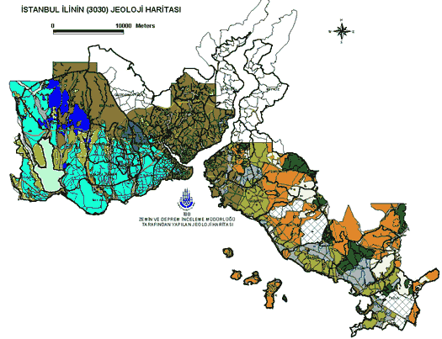

 | Figure 3.3.1. Geology of Istanbul. From Istanbul Metropolitan Municipality (www.ibb.gov.tr) . | Project No: EVG1-CT-2002-00069
 | Annual report 2004 (Partner # 6: UiB)
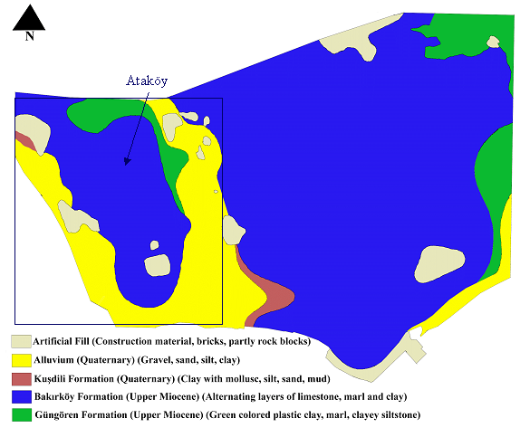

 | Figure 3.3.2. Geological map of Ataköy area. From I.T.Ü. Gelistirme Vakfi Iktisadi Isletmesi. Ataköy is located within the rectangle, to the east is Bakirköy. The Ataköy area is ca. 3 kilometers from North to South. | Project No: EVG1-CT-2002-00069
 | Annual report 2004 (Partner # 6: UiB)
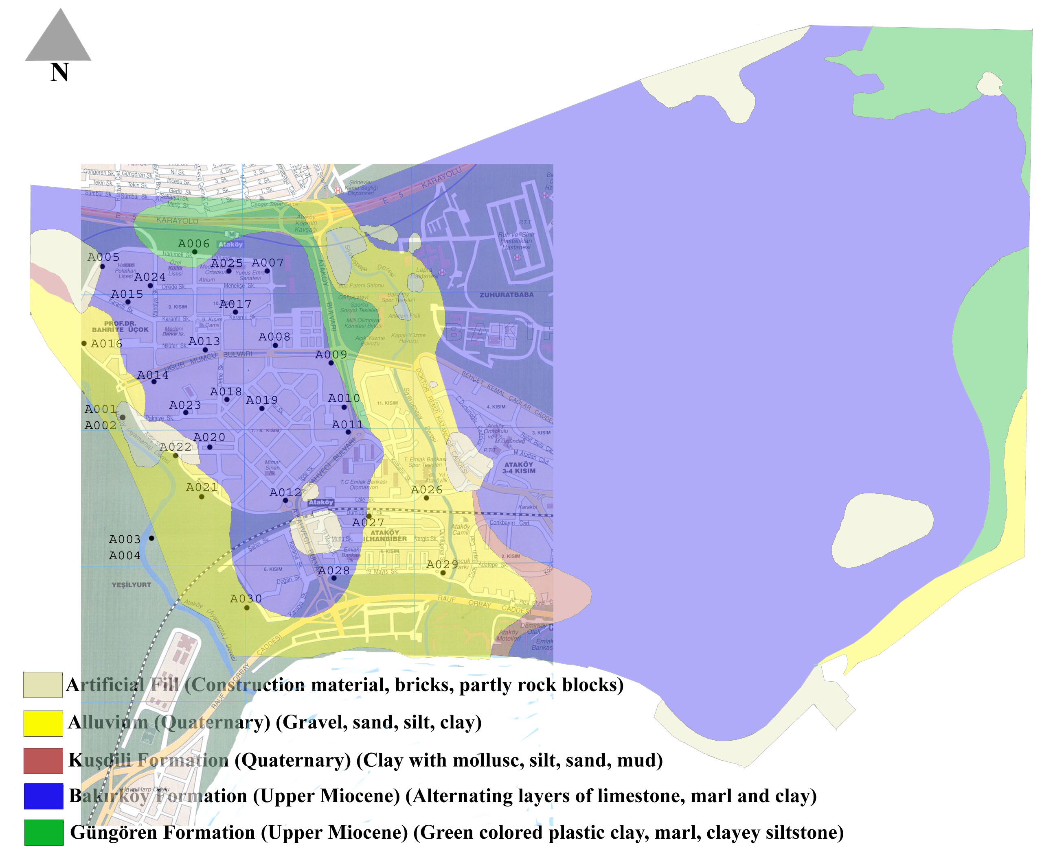

 | Figure 3.3.3. The location of the 30 sites where microtremor data were collected (black dots). The study area is indicated by the street map overlain on the geological map. The scale of the street map is 1km on the horizontal and 2km on the vertical direction. | Project No: EVG1-CT-2002-00069
 | Annual report 2004 (Partner # 6: UiB)
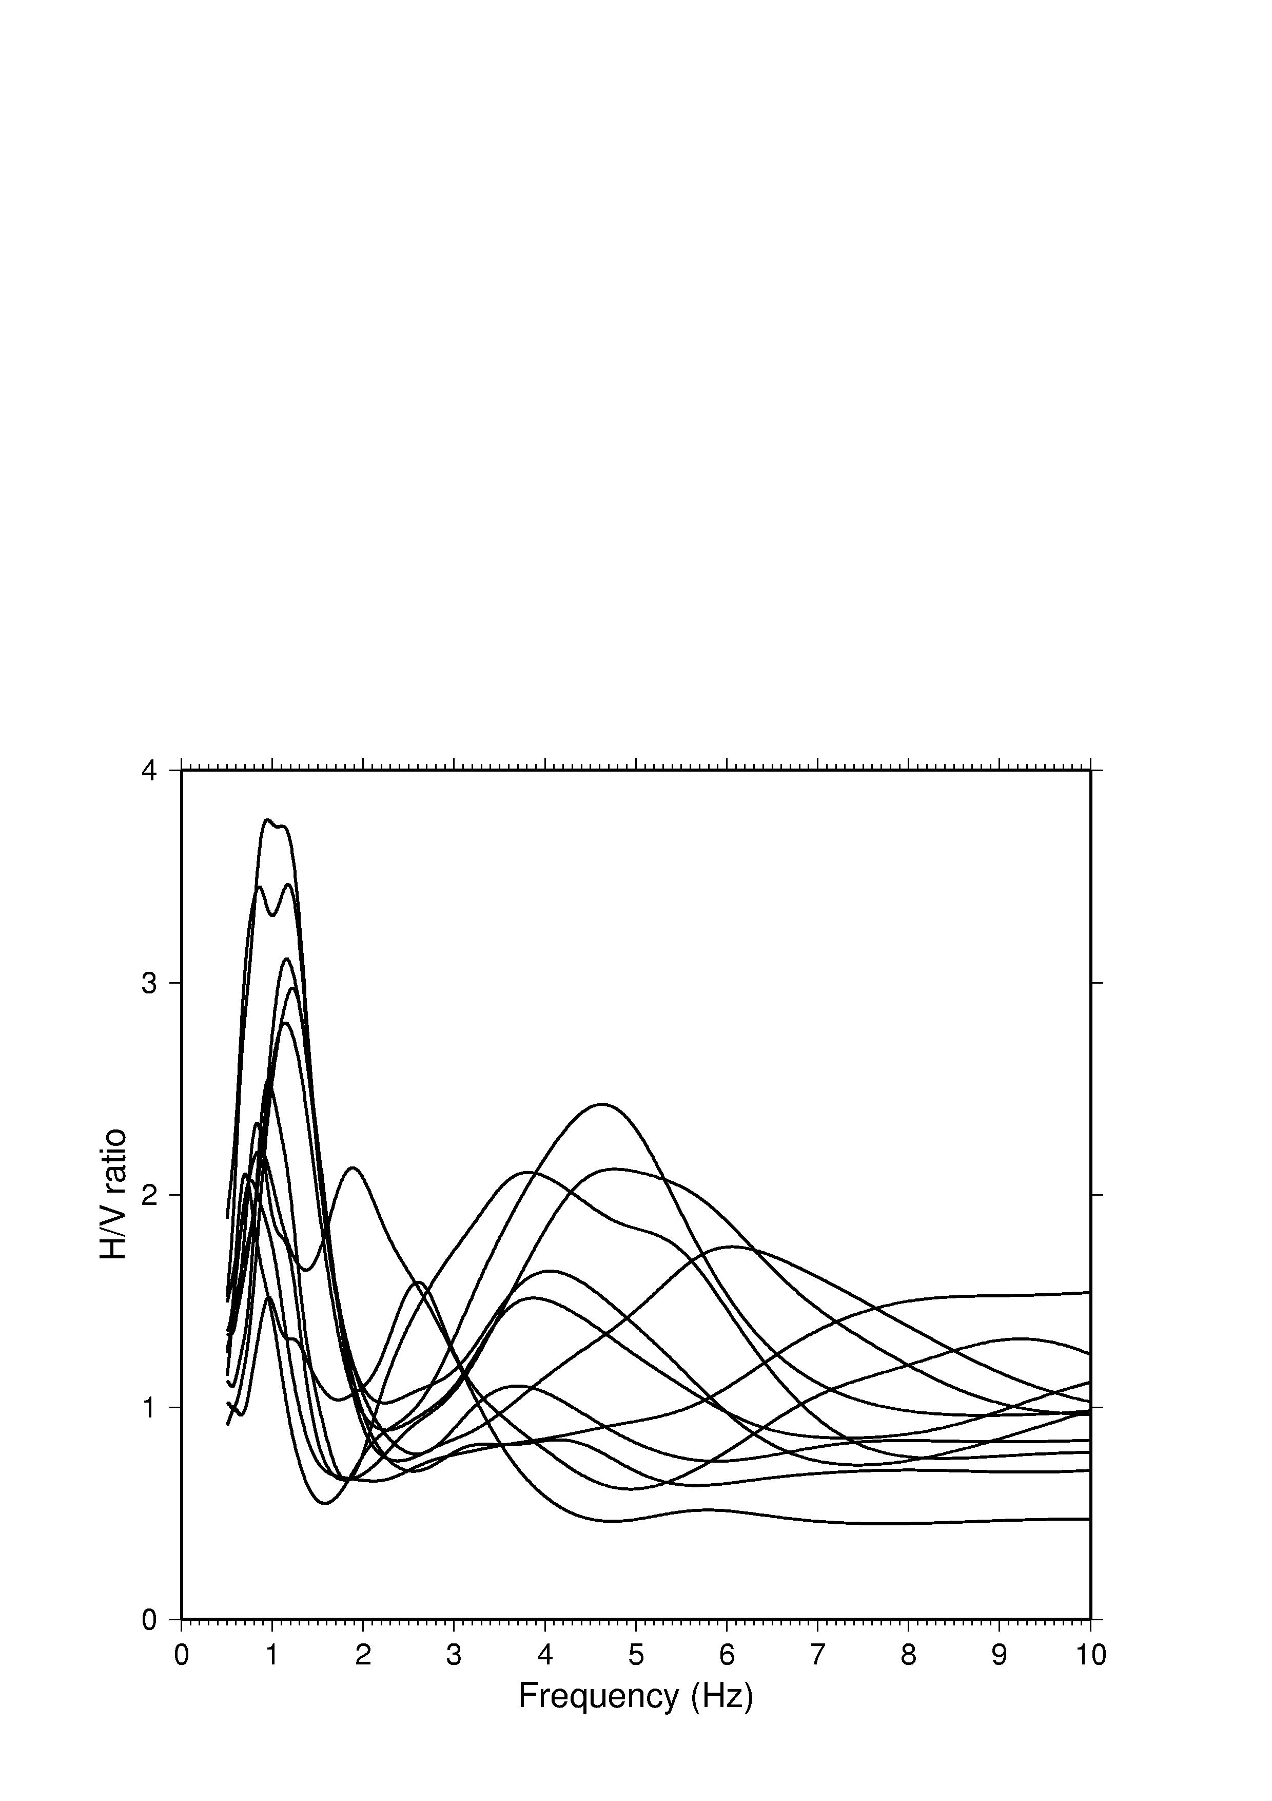

 | Figure 3.3.4. Average H/V spectral ratios for sites located on alluvium. | Project No: EVG1-CT-2002-00069
 | Annual report 2004 (Partner # 6: UiB)
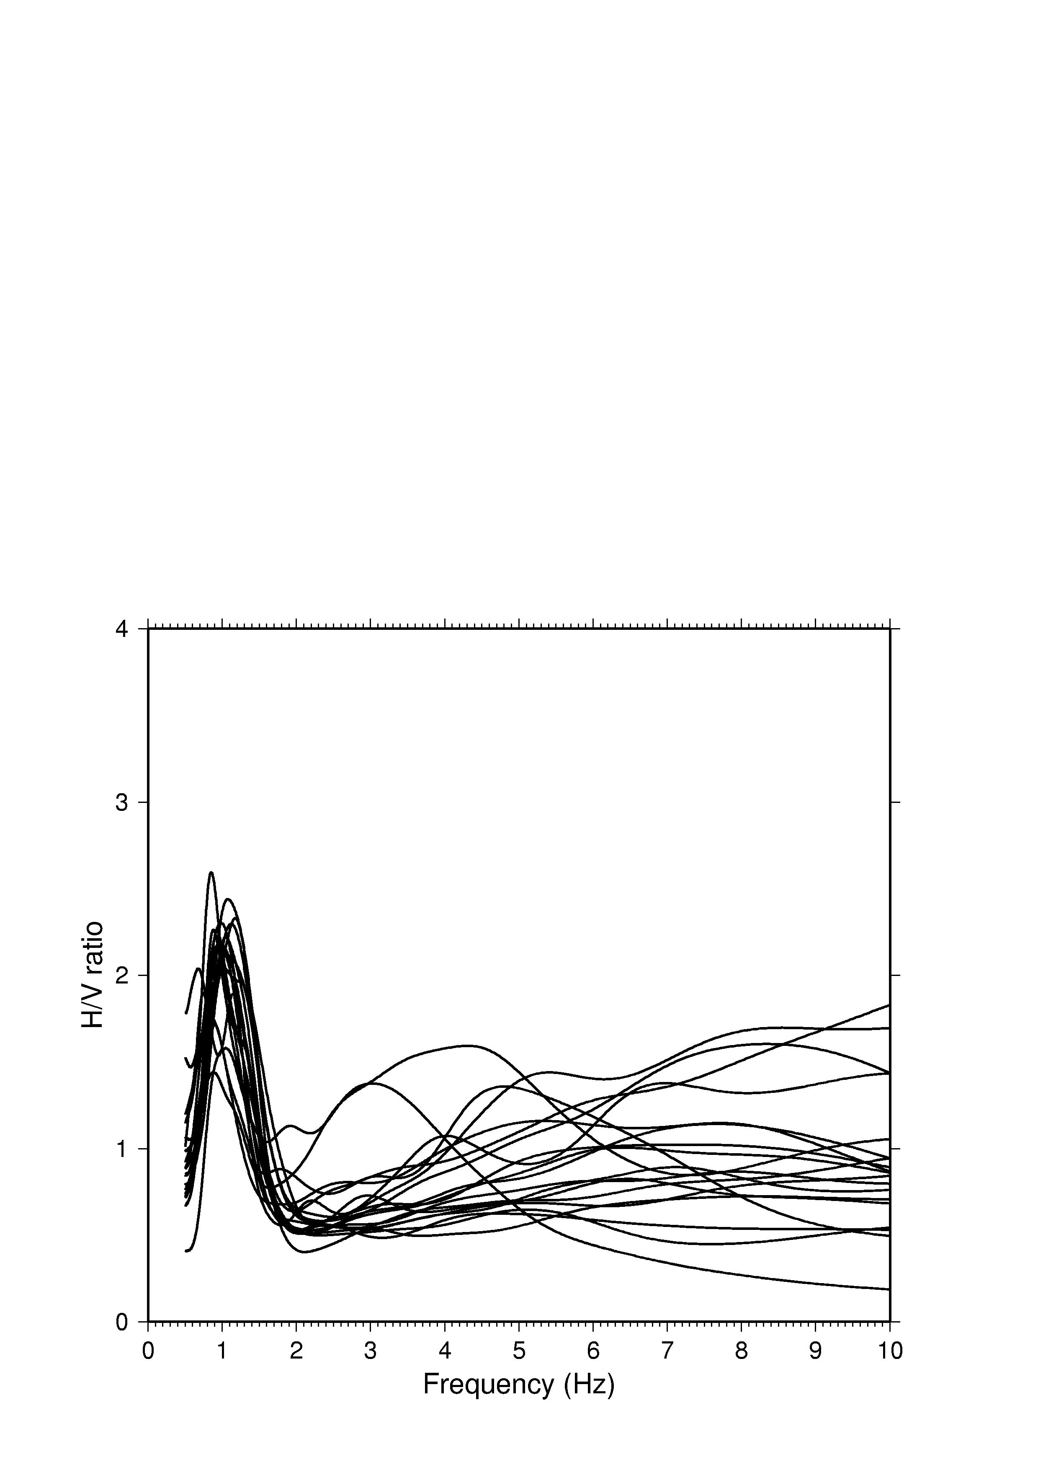

 | Figure 3.3.5. Average H/V spectral ratios for sites located at Bakirköy formation. | Project No: EVG1-CT-2002-00069
 | Annual report 2004 (Partner # 6: UiB)
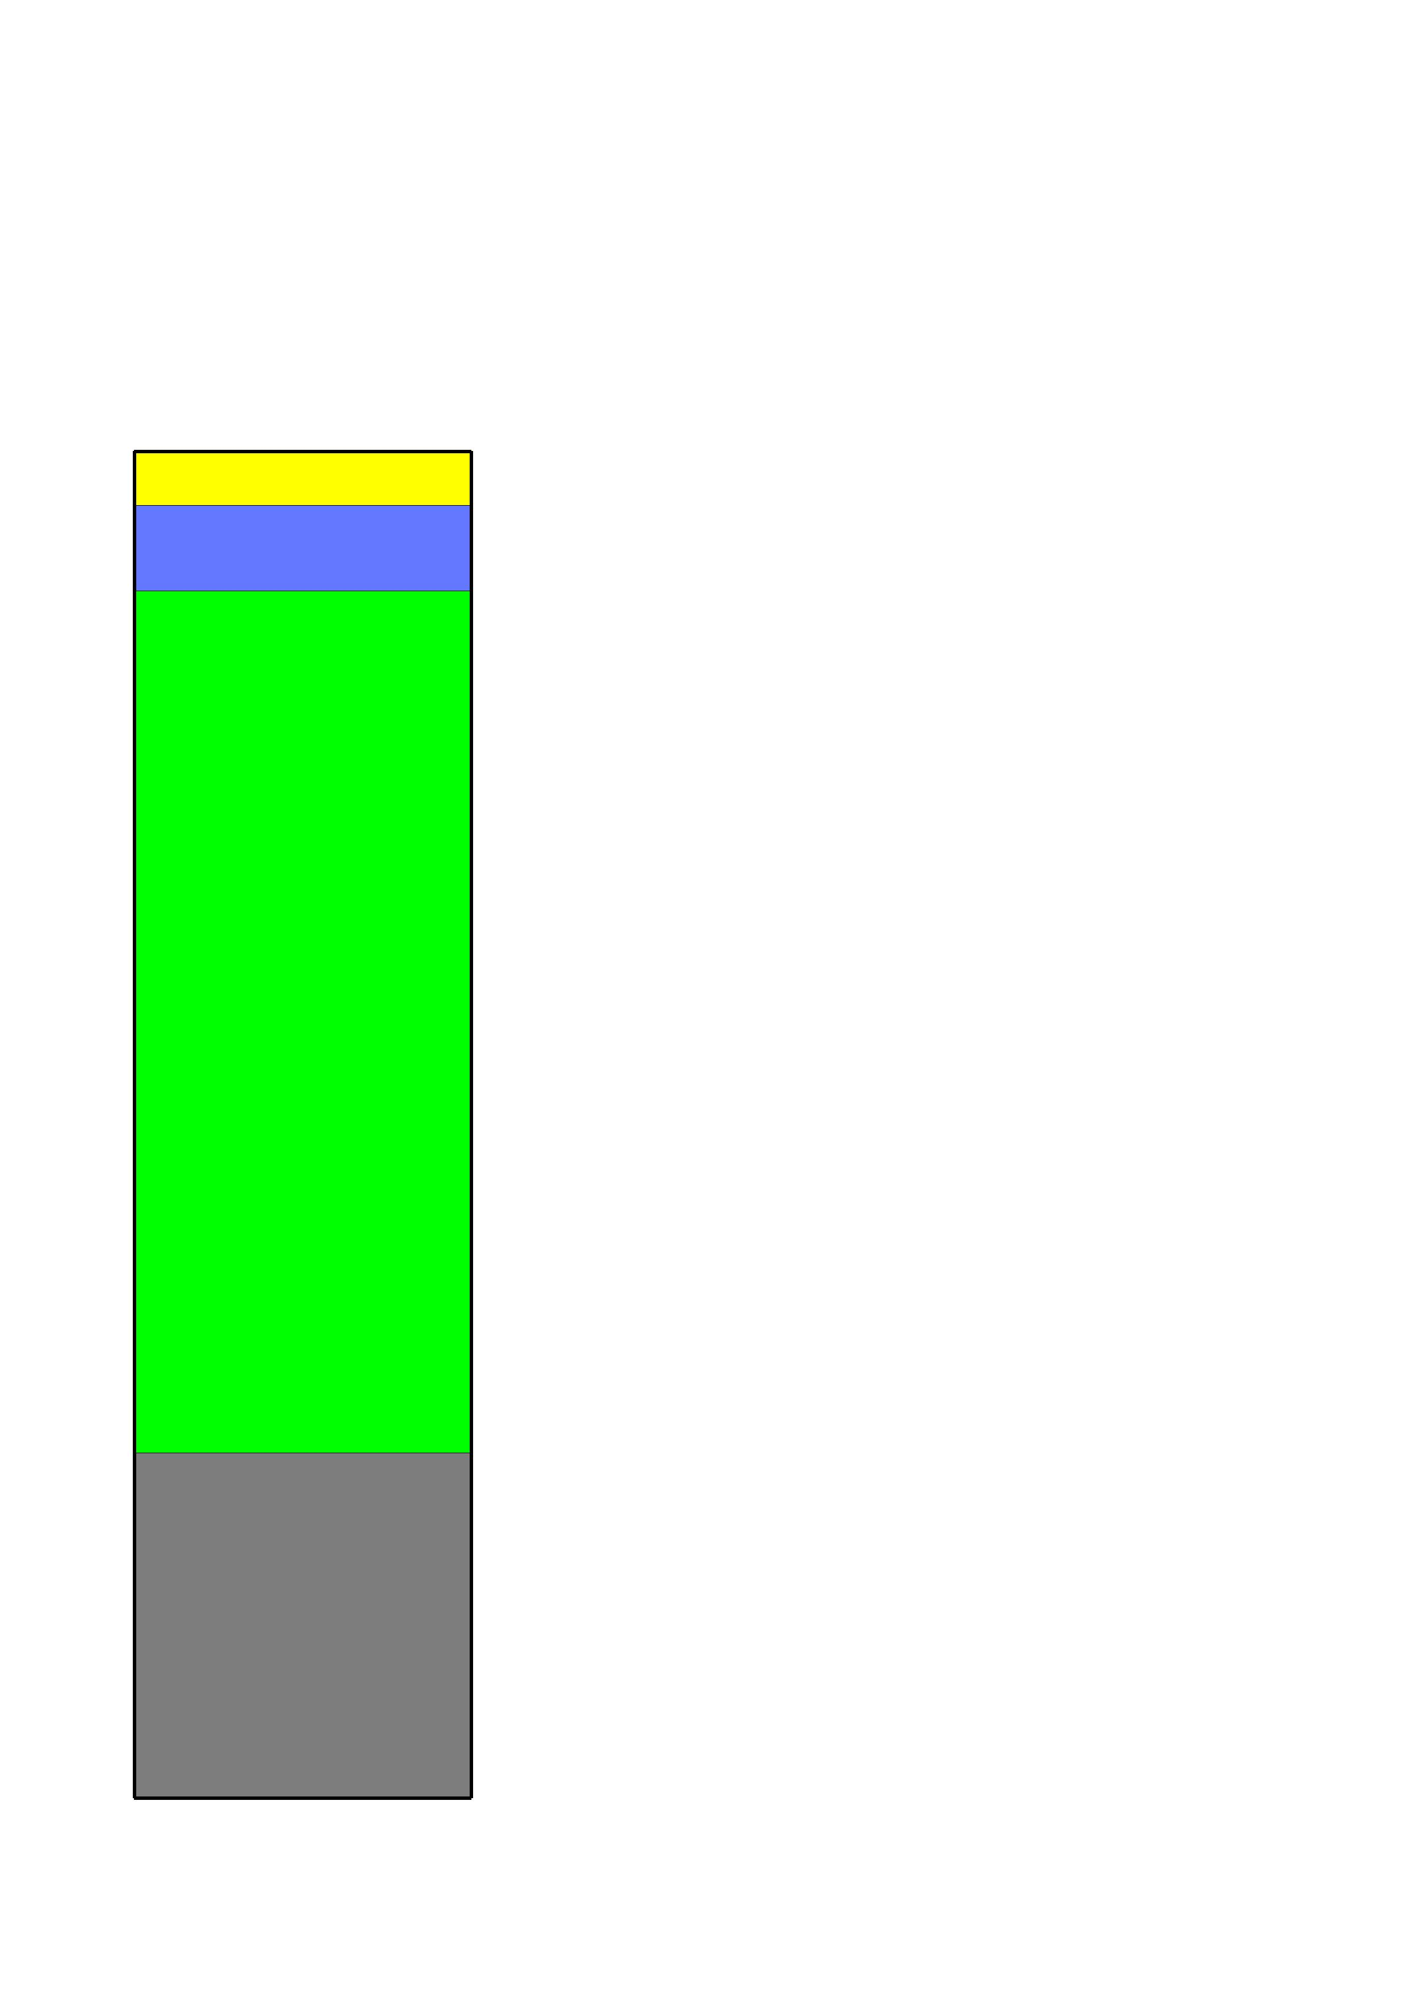

 | Figure 3.3.6. 1D model used for simulating microtremors at an alluvial site. Yellow: 5 m alluvial layer, blue: 8 m Bakirköy formation, green: 80 m Güngören formation, gray: bedrock (half space). Velocities of the different layers are given in Table 3.3.1. | Project No: EVG1-CT-2002-00069
 | Annual report 2004 (Partner # 6: UiB)
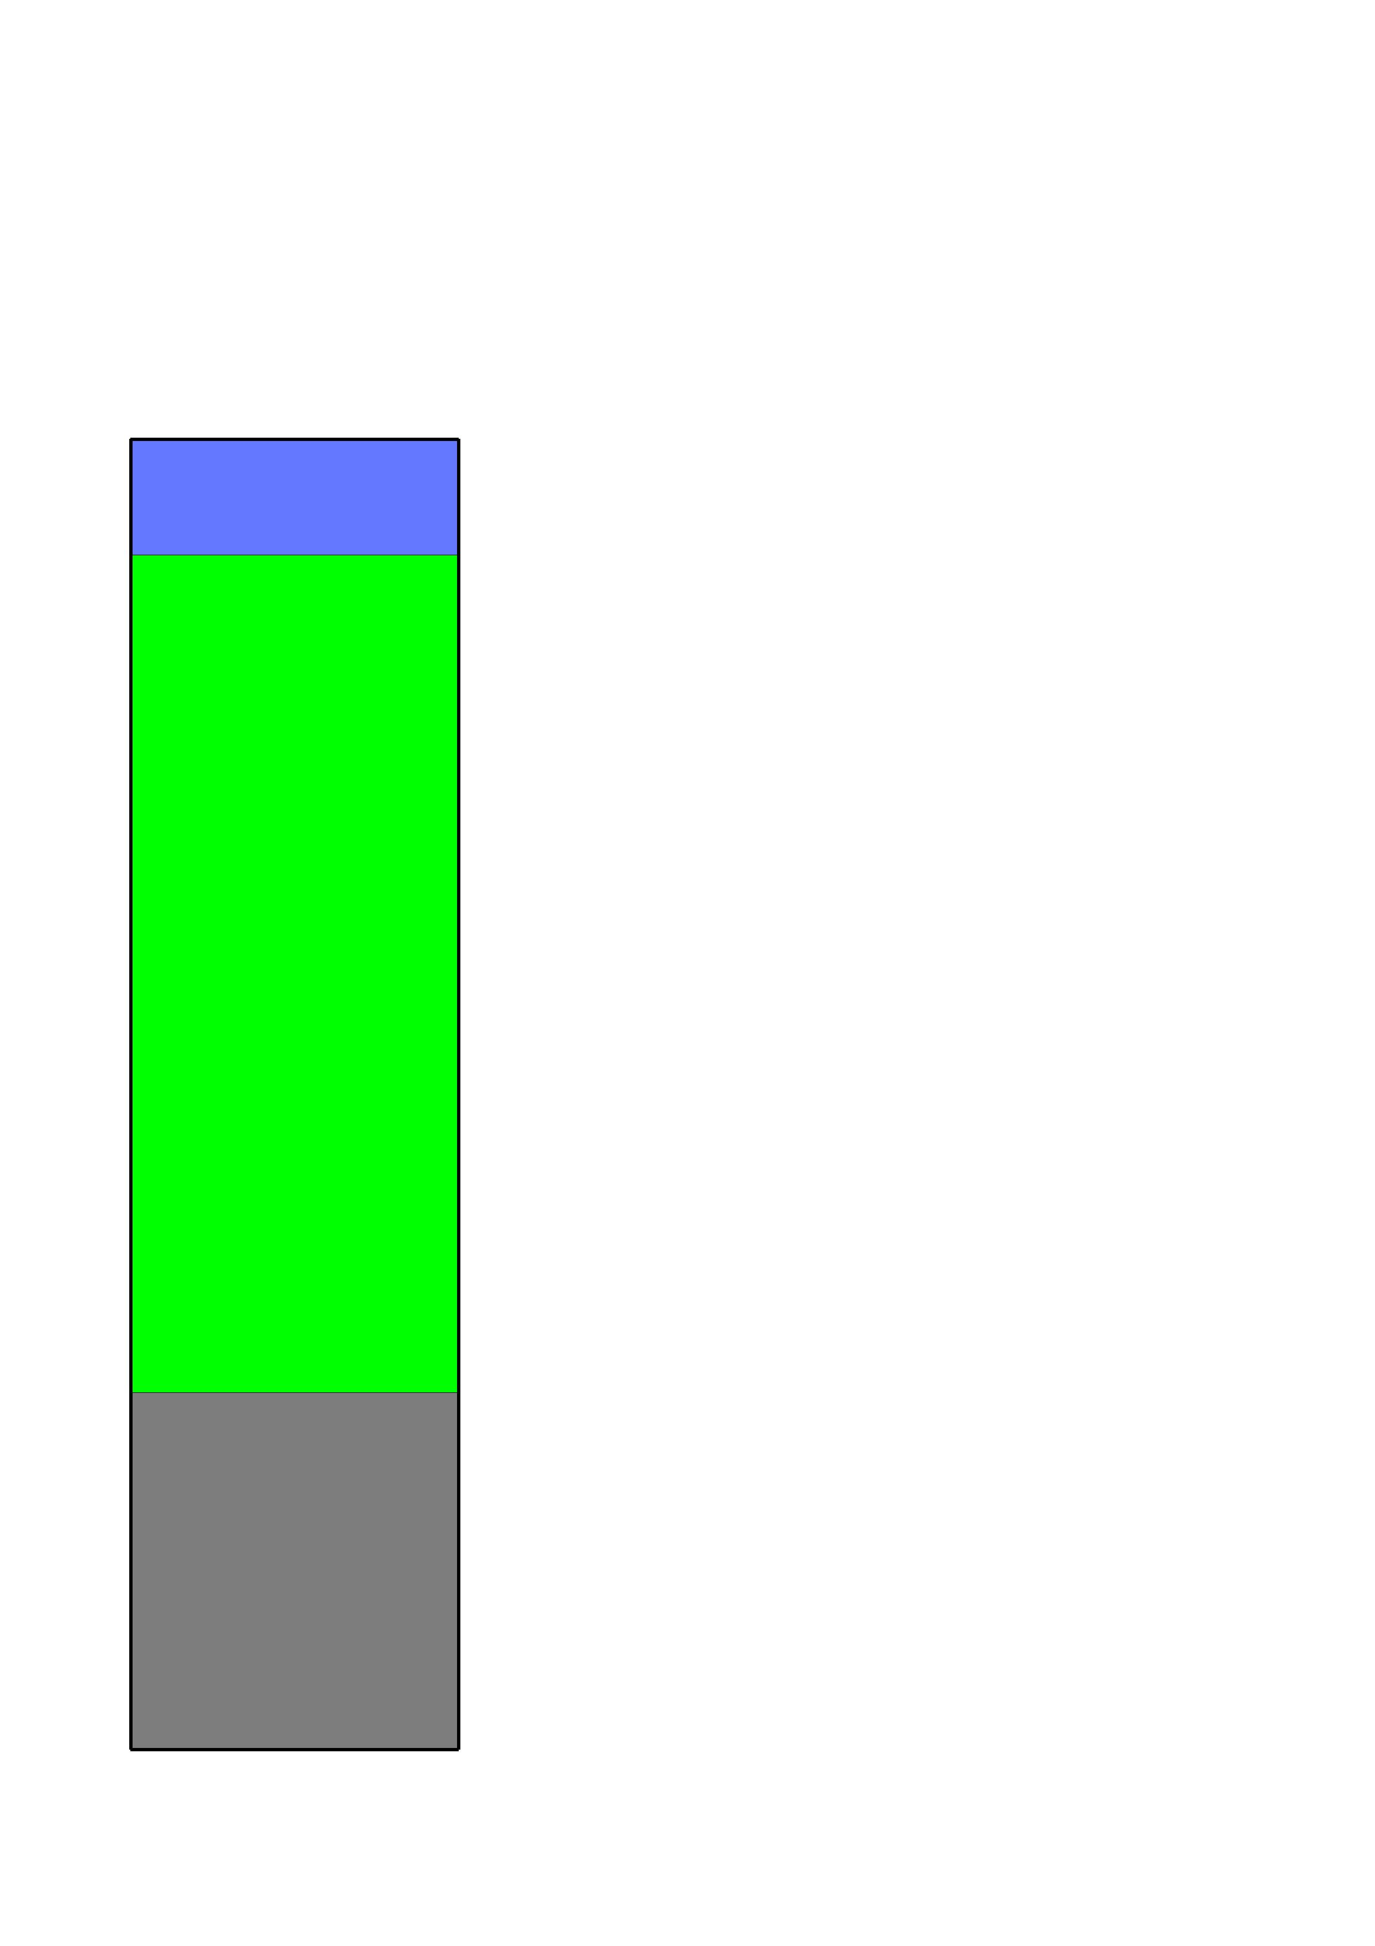

 | Figure 3.3.7. 1D model used for simulating microtremors at a Bakirköy formation site. Blue: 11 m Bakirköy formation, green: 80 m Güngören formation, gray: bedrock (half space). Velocities of the different layers are given in Table 3.3.1. | Project No: EVG1-CT-2002-00069
 | Annual report 2004 (Partner # 6: UiB)
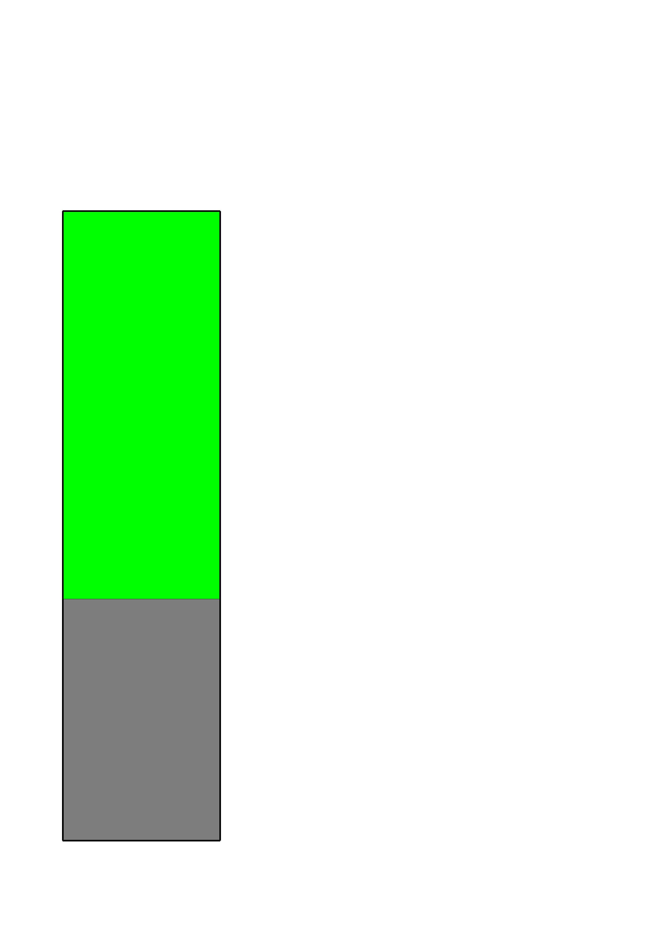

 | Figure 3.3.8. 1D model used for simulating microtremors at a Güngören formation site. Green: 77 m Güngören formation, gray: bedrock (half space). Velocities of the different layers are given in Table 3.3.1. | Project No: EVG1-CT-2002-00069
 | Annual report 2004 (Partner # 6: UiB)
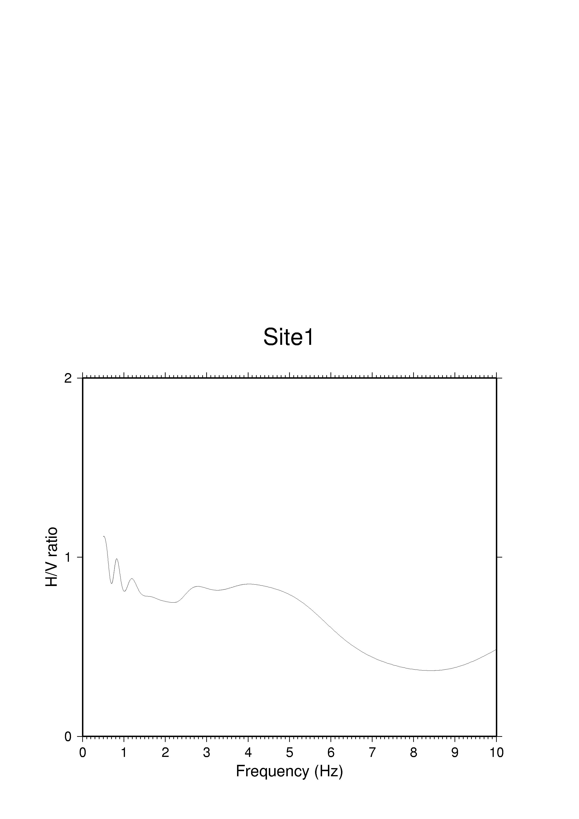

 | Figure 3.3.9. H/V spectral ratio calculated for simulated ambient noise at 1D site 1 (Alluvium). | Project No: EVG1-CT-2002-00069
 | Annual report 2004 (Partner # 6: UiB)
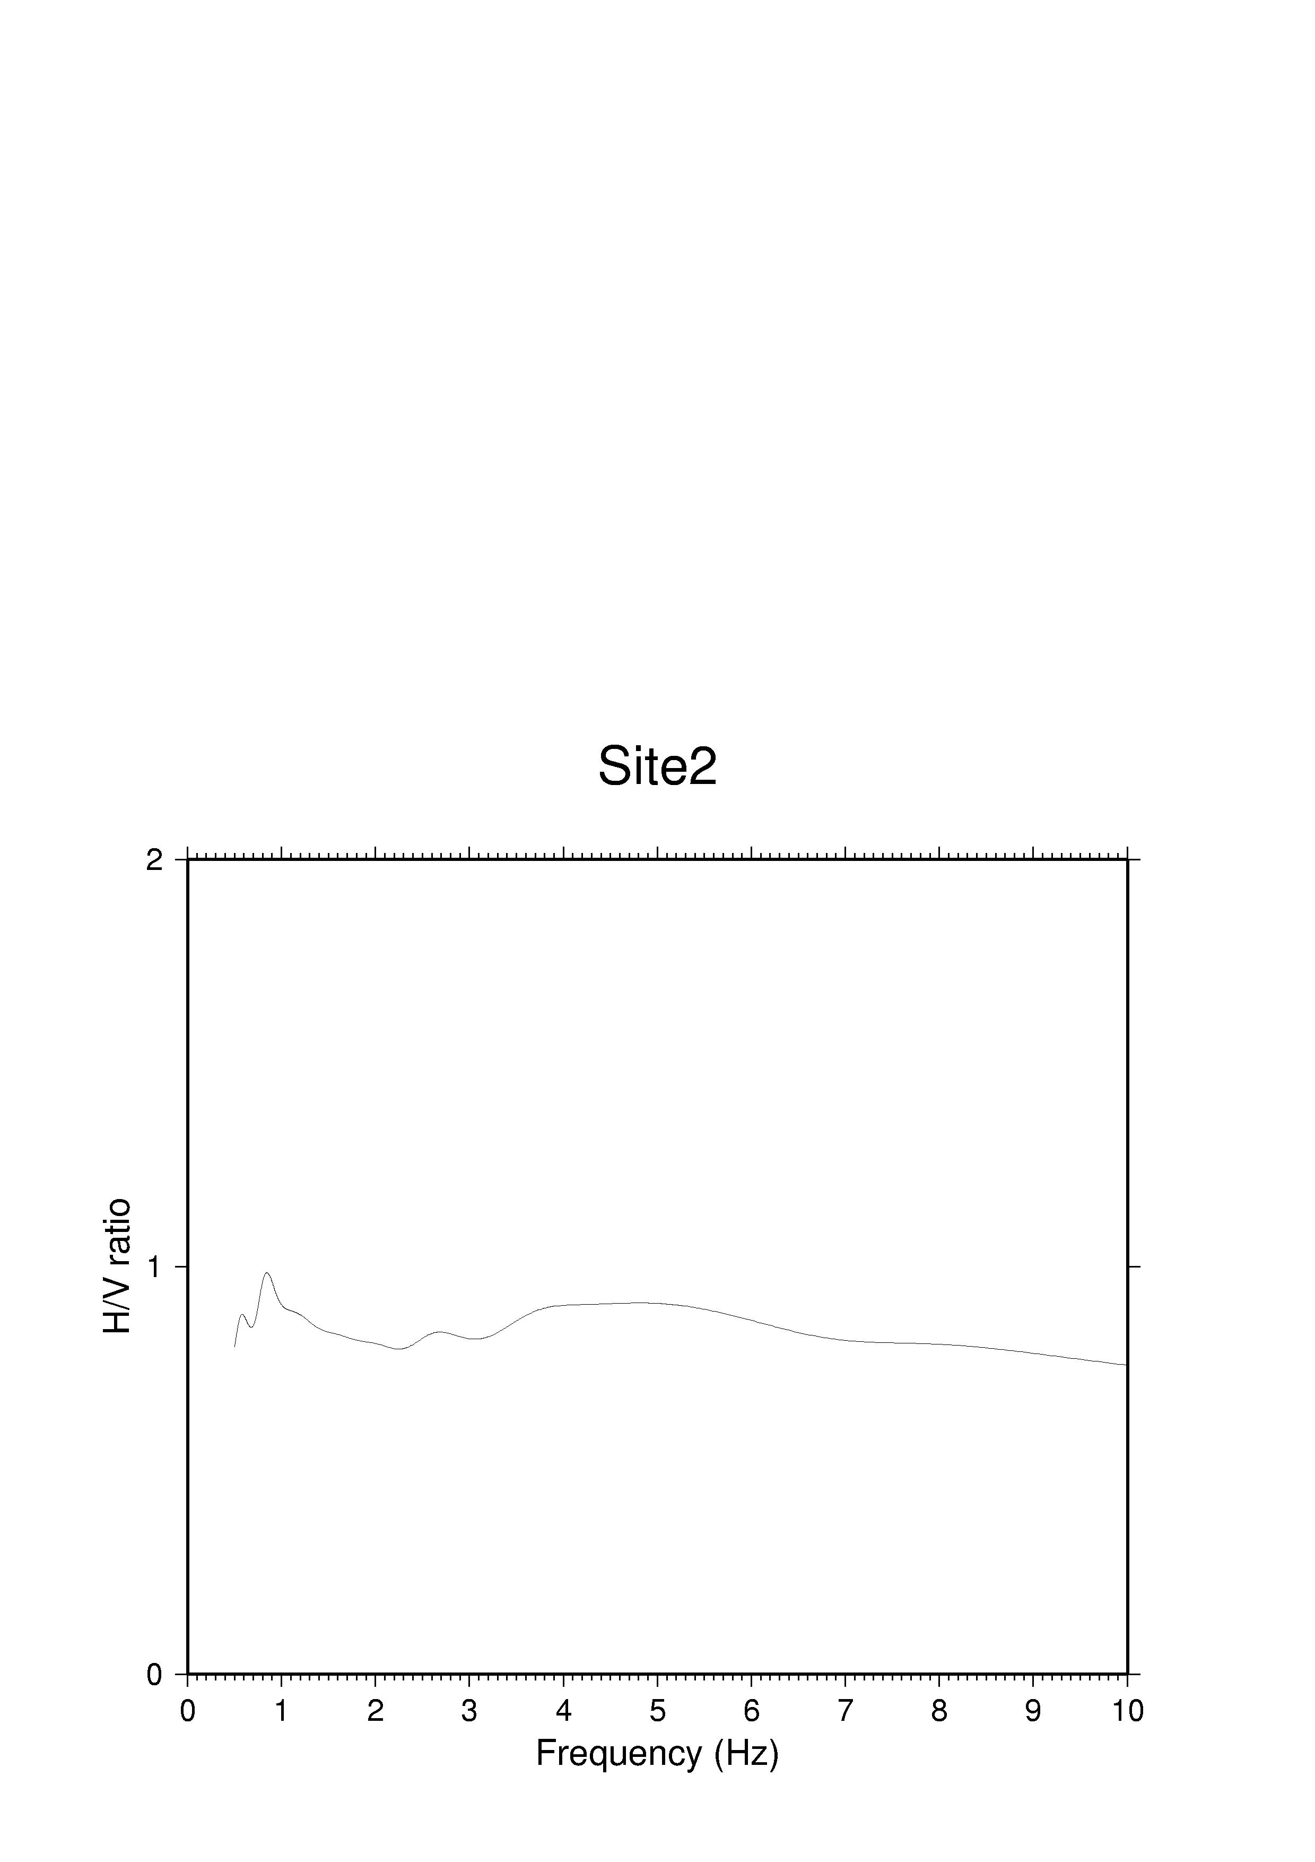

 | Figure 3.3.10. H/V spectral ratio calculated for simulated ambient noise at 1D site 2 (Bakirköy formation). | Project No: EVG1-CT-2002-00069
 | Annual report 2004 (Partner # 6: UiB)
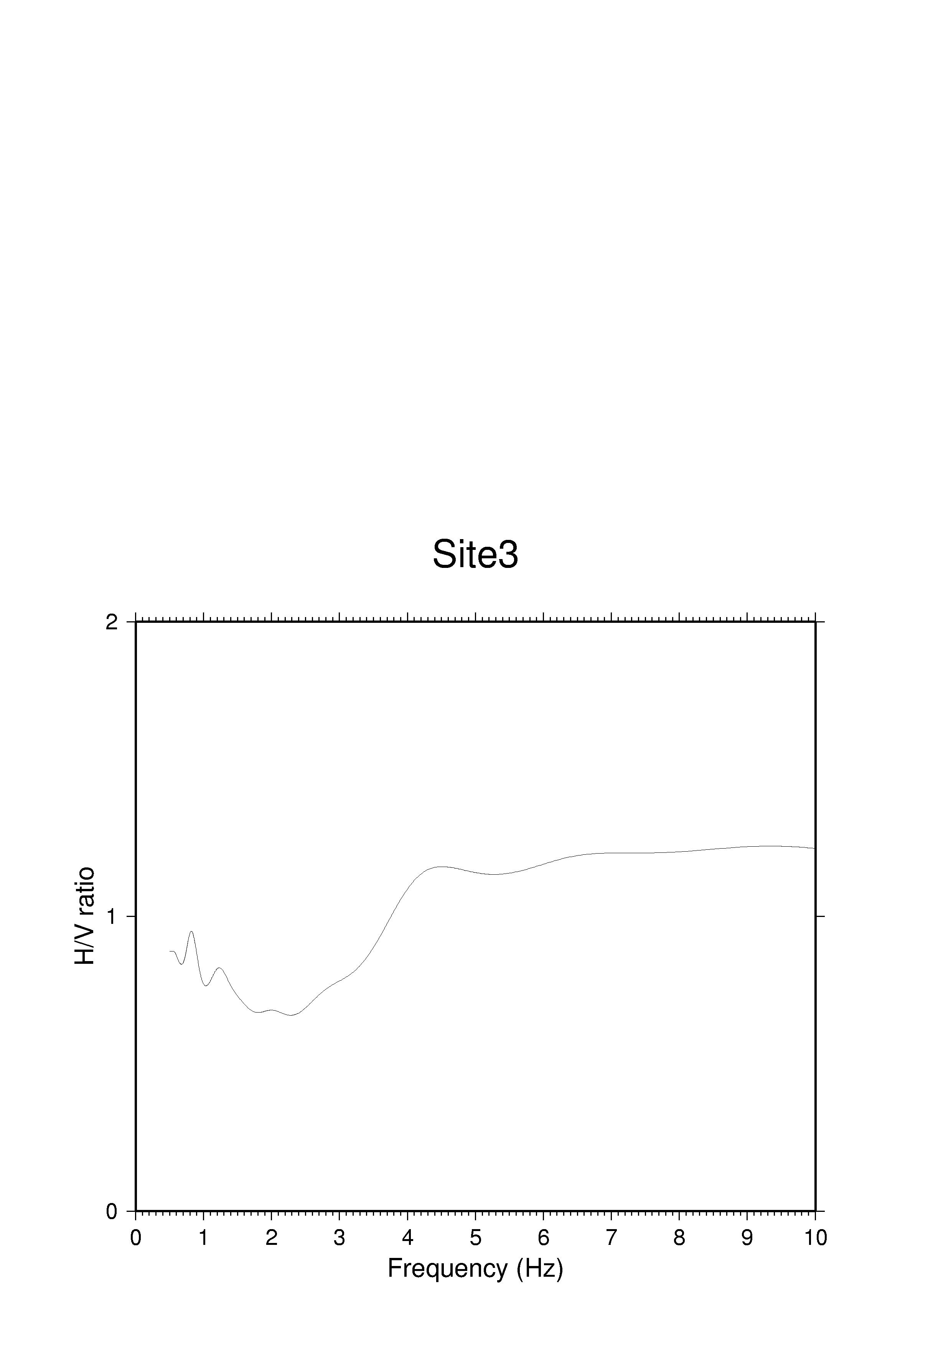

 | Figure 3.3.11. H/V spectral ratio calculated for simulated ambient noise at 1D site 3 (Güngören formation). | Project No: EVG1-CT-2002-00069
 | Annual report 2004 (Partner # 6: UiB)
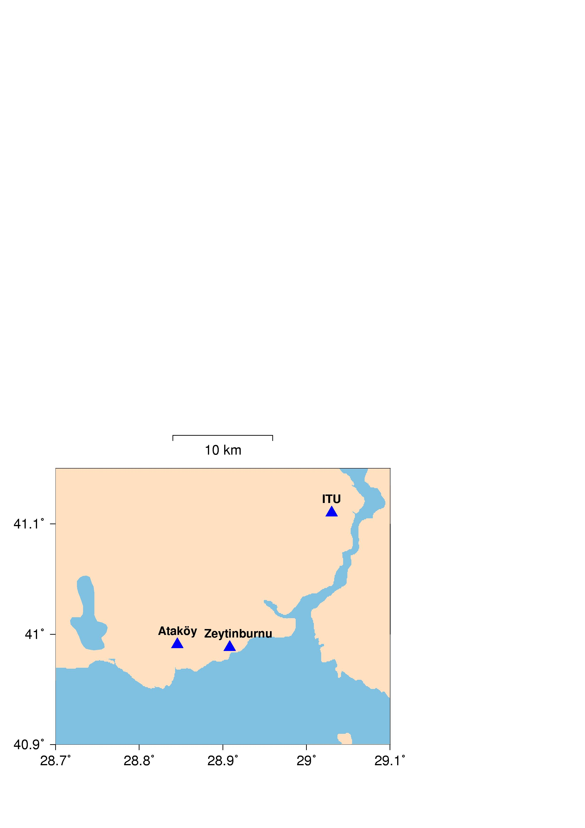

 | Figure 3.3.12. Location of three temporary Broadband stations in Istanbul. | Project No: EVG1-CT-2002-00069
 | Annual report 2004 (Partner # 6: UiB)
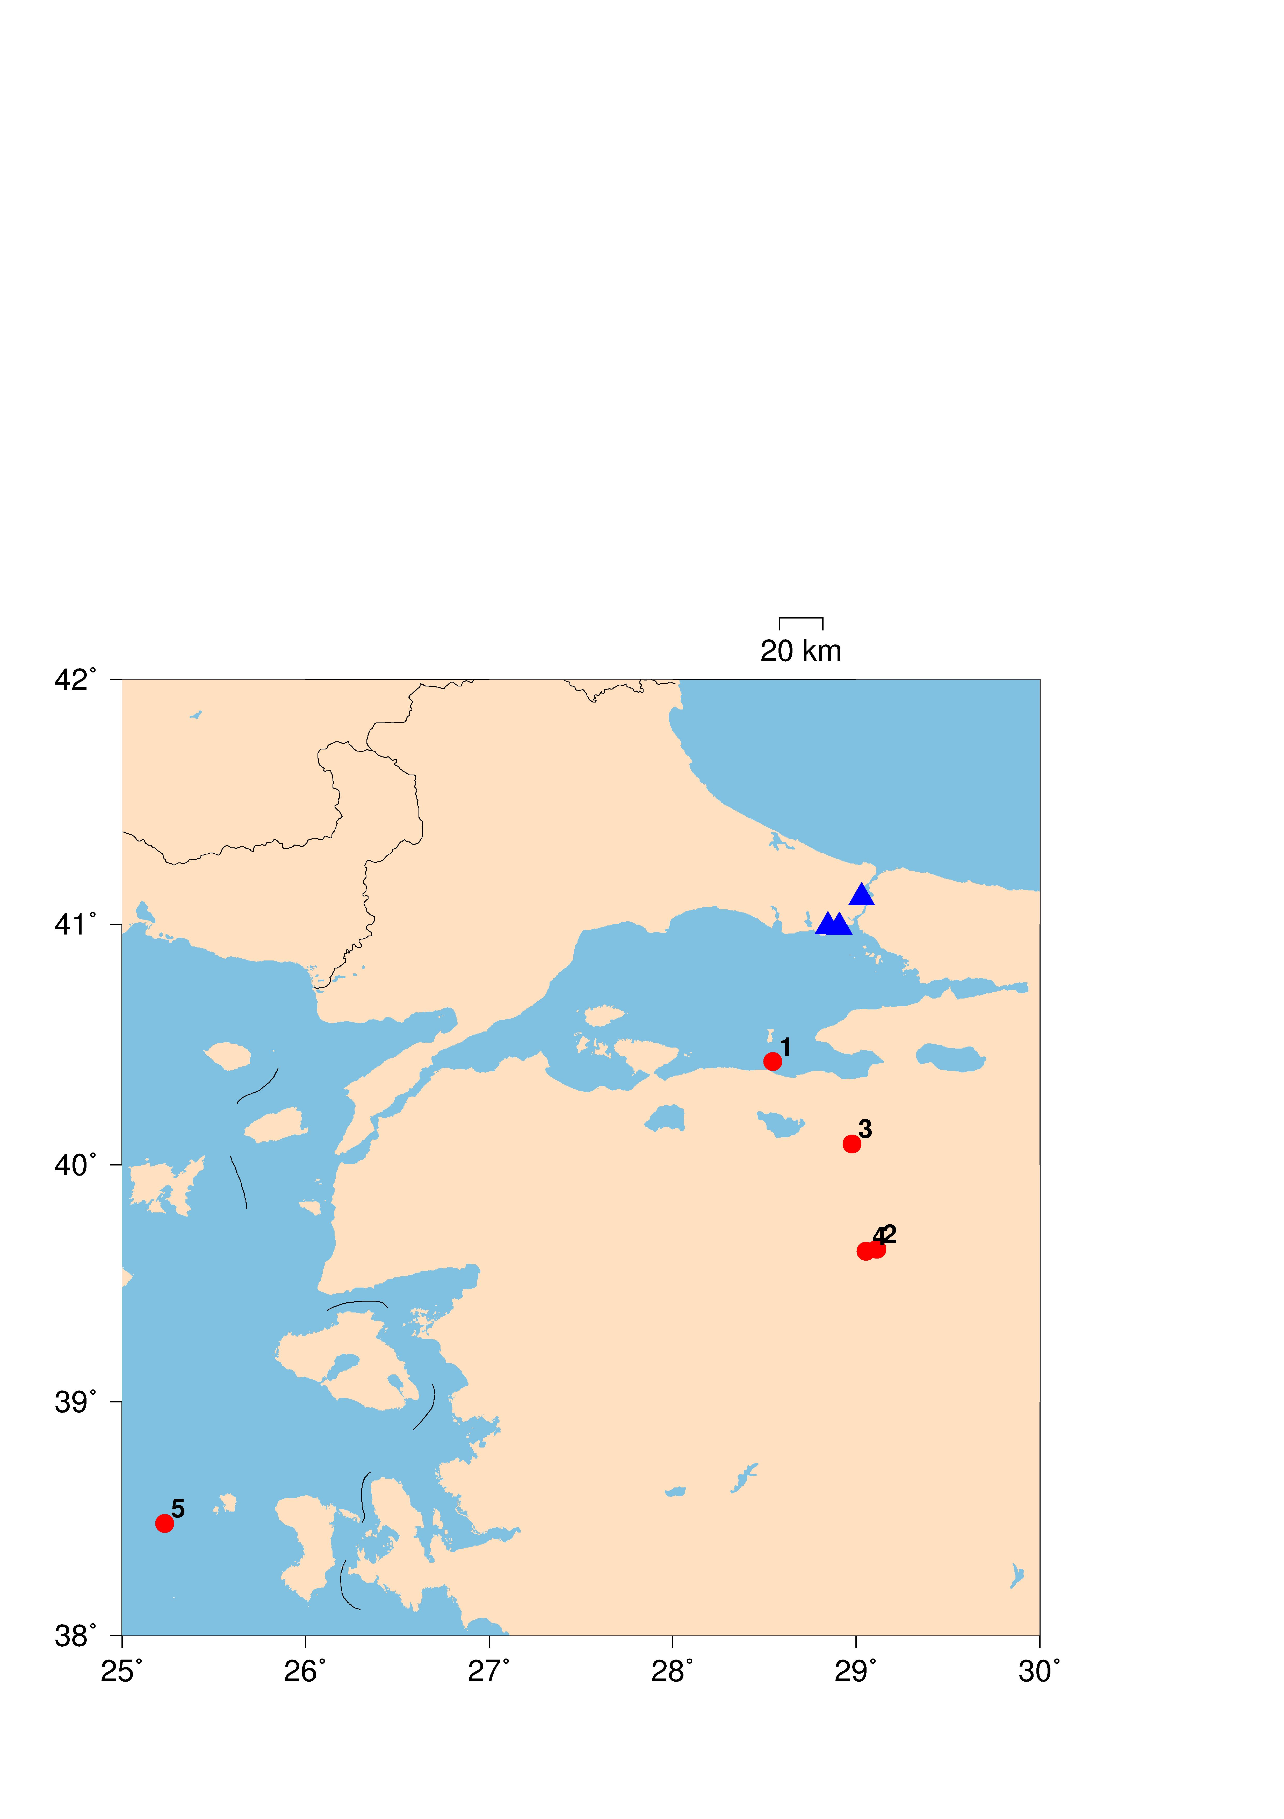

 | Figure 3.3.13. Events used for SSR analysis. | Project No: EVG1-CT-2002-00069
 | Annual report 2004 (Partner # 6: UiB)
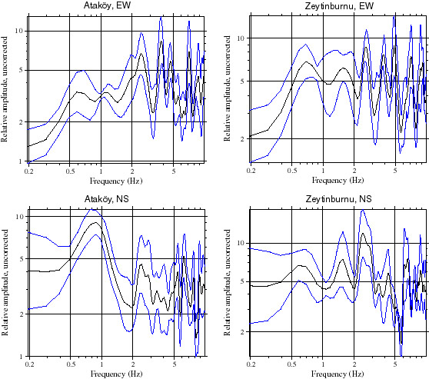

 | Figure 3.3.14. Average S-wave spectral ratios calculated for the Ataköy and Zeytinburnu stations, EW and NS components for all the events shown in Figure 3.3.13. Black line is average spectral ratio, blue lines are +/- one standard deviation. | Project No: EVG1-CT-2002-00069
 | Annual report 2004 (Partner # 6: UiB)
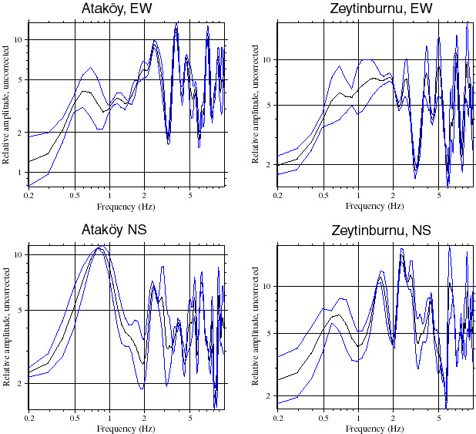

 | Figure 3.3.15. Average S-wave spectral ratios calculated for the Ataköy and Zeytinburnu stations, EW and NS components for events 2 and 4 shown in Figure 3.3.13. Black line is average spectral ratio, blue lines are +/- one standard deviation. | Project No: EVG1-CT-2002-00069
 | Annual report 2004 (Partner # 6: UiB)
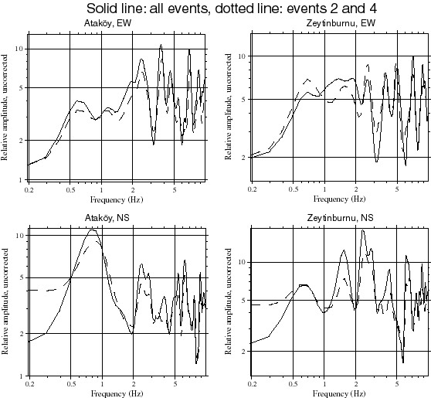

 | Figure 3.3.16. Overlay of average spectral ratios calculated using all events (solid line) and events 2 and 4 only (dotted line). | Project No: EVG1-CT-2002-00069
 | Annual report 2004 (Partner # 6: UiB)
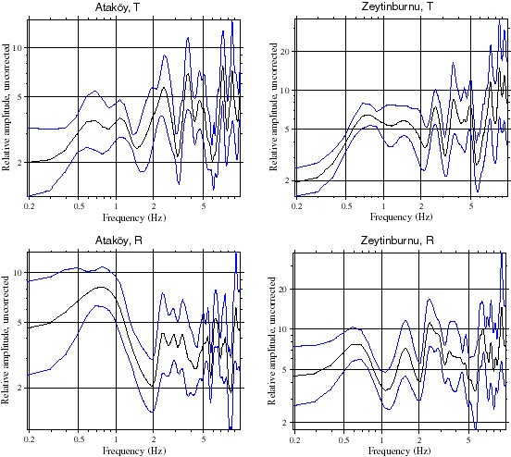

 | Figure 3.3.17. Average S-wave spectral ratios for the rotated seismograms, calculated for the Ataköy and Zeytinburnu stations, R and T components for all events shown in Figure 3.3.13. Black line is average spectral ratio, blue lines are +/- one standard deviation. | Project No: EVG1-CT-2002-00069
 | Annual report 2004 (Partner # 6: UiB)
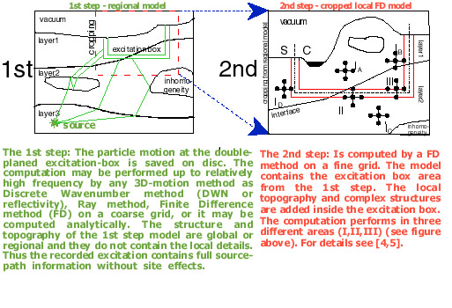

 | Figure 3.3.18. Schematic illustration of hybrid procedure. In the first step, ground motions are calculated on the excitation box using a regional model. In the second step, surface ground motions are calculated using a finite difference scheme and a local model. | Project No: EVG1-CT-2002-00069
 | Annual report 2004 (Partner # 6: UiB)
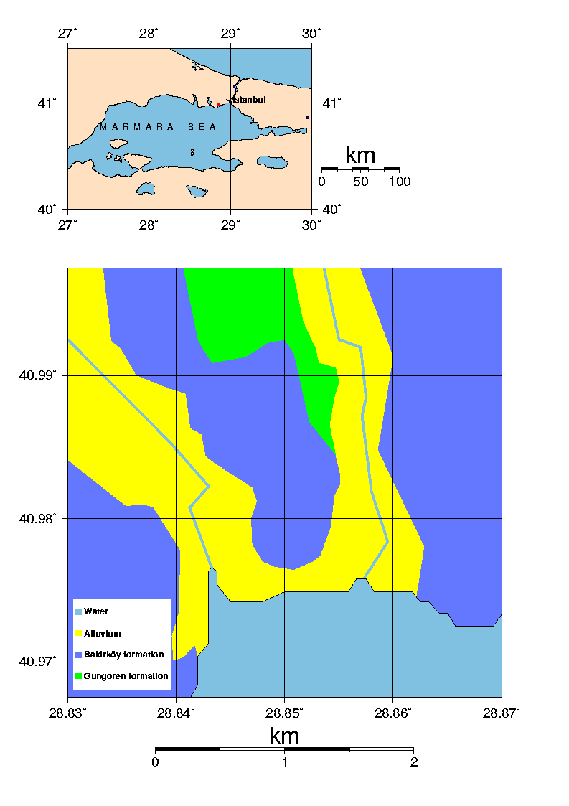
 | Figure 3.3.19. Surface geometry of geological model of Ataköy, used in 3D finite difference model. The red square in the uppermost plot shows the extent and location of the lowermost map. | Project No: EVG1-CT-2002-00069
 | Annual report 2004 (Partner # 6: UiB)
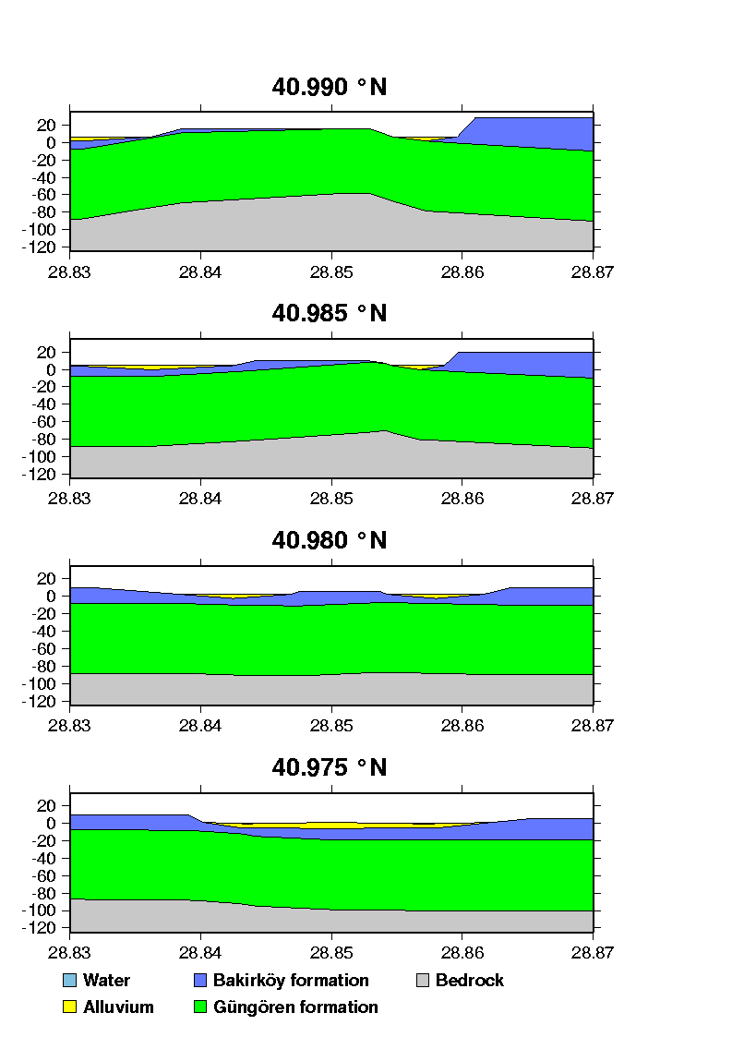
 | Figure 3.3.20. EW cross-sections of geological model of the Ataköy area, used in 3D finite difference model. The lowermost plot is in the southernmost part of the model, going northwards. Note the thinning of the Bakirköy formation towards north in most of the model due to erosion. | Project No: EVG1-CT-2002-00069
 | Annual report 2004 (Partner # 6: UiB)
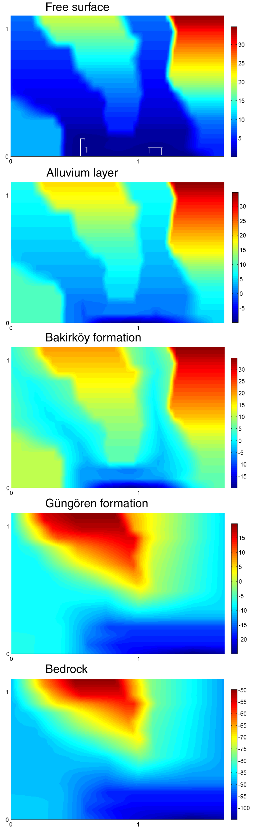
 | Figure 3.3.21. Elevation plots of the layers of the geological model of Ataköy, used in 3D finite difference model. | Project No: EVG1-CT-2002-00069
 | Annual report 2004 (Partner # 6: UiB)
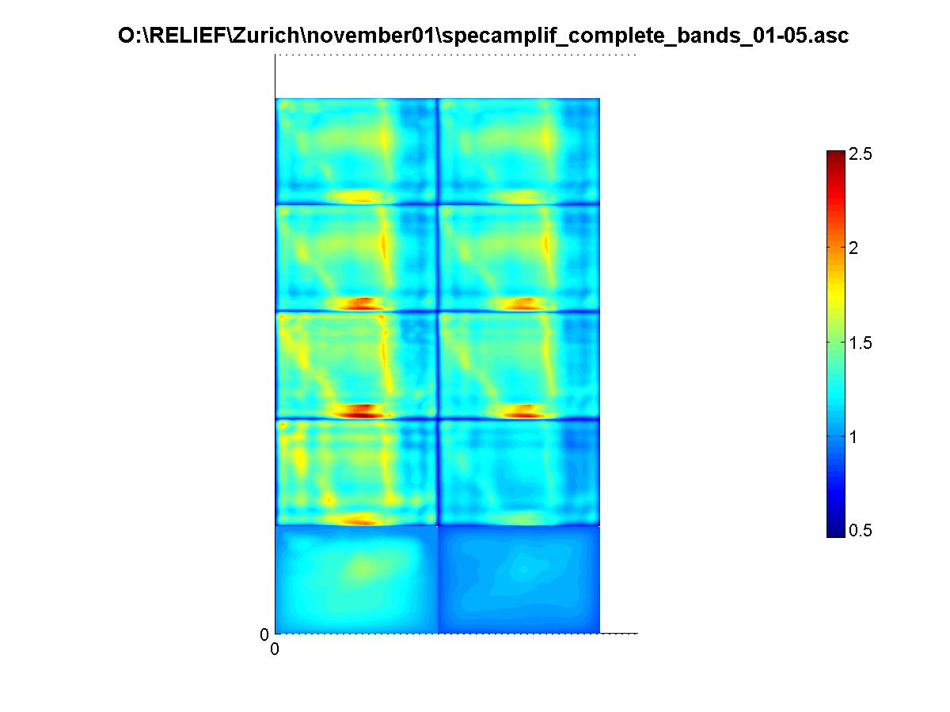

 | Figure 3.2.22. Ground motion amplification for 3D velocity model. The five frequency bands are, from below, 0-2Hz, 2-4Hz, 4-6Hz, 6-8Hz and 8-10Hz. Left column shows maximum amplification, right column is average amplification. | Project No: EVG1-CT-2002-00069
 | Annual report 2004 (Partner # 6: UiB)
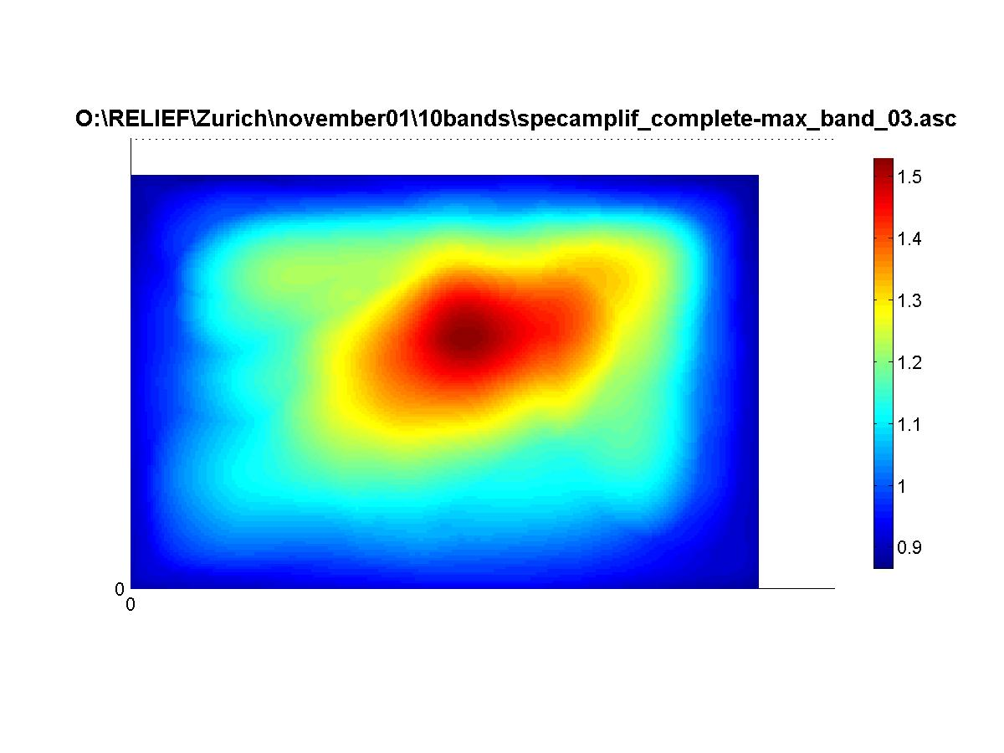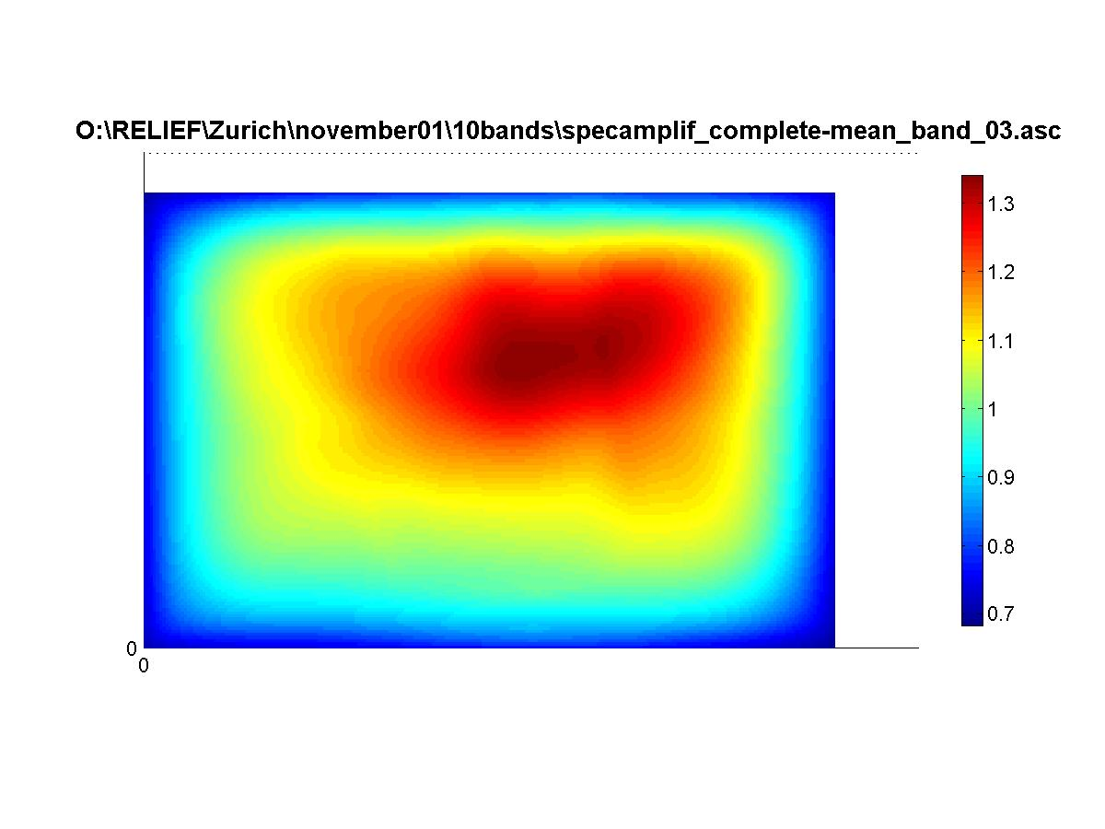

 | Figure 3.3.23. Ground motion amplification for 3D velocity model. The frequency band is 0.8-1.2 Hz. Left figure shows maximum amplification, right figure is average amplification. | Project No: EVG1-CT-2002-00069
 | Annual report 2004 (Partner # 6: UiB)
Thickness (m) | Vs (m/s) | Vp (m/s) | Density (kg/m^3) | Formation
Alluvial site
5 | 163 | 260 | 1.169 | Alluvium
8 | 784 | 1406 | 2.691 | Bakirköy
80 | 1028 | 1850 | 2.500 | Güngören
Half space | 1473 | 2799 | 2.700 | Bedrock
Bakirköy formation site
11 | 533 | 960 | 2.078 | Bakirköy
80 | 1006 | 1811 | 2.500 | Güngören
Half space | 1451 | 2757 | 2.700 | Bedrock
Güngören formation site
77 | 748 | 1346 | 1.878 | Güngören
Half space | 1297 | 2464 | 2.700 | Bedrock

 | Table 3.3.1. Velocity model used for 1D modeling for alluvium, Bakirköy formation and Güngören formation sites. The sites are taken out from the model used for 3D site effect modeling (section 6), and average velocities have been taken for each layer. | Project No: EVG1-CT-2002-00069
 | Annual report 2004 (Partner # 6: UiB)
4. WP9: Multidisciplinary Seismic Hazard Assessment

In terms of the seismic hazard assessment of the region, we have followed three separate lines of study. These are: (i) Probabilistic seismic hazard assessment (PSHA) based on poissonian earthquake occurrence, (ii) Time-dependant seismic hazard assessment (TDSHA) based on renewal models and (iii) Ground motion simulations based on earthquake scenarios. These approaches were all described in some detail in the RELIEF 1st annual report from UiB in 2003 with main focus on points (i) and (ii). Only a short update will be given for these two points. Substantial work has been done with regard to the ground motion simulations during 2004, and this is described in detail below.

4.1 Probabilistic seismic hazard assessment in the Marmara Sea region

As described in the RELIEF 1st annual report from UiB, 2003 and in RELIEF deliverable no. 18, substantial work has been done on probabilistic seismic hazard assessment in the Marmara Sea region. Both time-independent studies based on poissonian earthquake occurrence and time-dependent studies based on a renewal model are performed. The studies are based on existing attenuation relationships valid for either similar tectonic environments or the European area, and different source models are tested. The catalogues used are from ISC and a new catalogue valid for the instrumental period (1900 – present) for the Marmara Sea region, collected as part of the RELIEF project (RELIEF deliverable no. 16).

Results from the two poissonian PSHA using different catalogues show significant differences in the absolute values of ground motion, however the distribution is relatively similar in both cases. This underlines the importance of establishing a new and reliable seismic catalogue for the region. Therefore the next planned step in the seismic hazard calculations is to repeat the above calculations using the improved catalogue described in RELIEF deliverable no. 16, also including historical earthquakes (pre-1900). This will be done when the final attenuation model described in section 3.2 and the final seismic catalogue are ready. These calculations will give an even better estimate of the seismic hazard in the Marmara Sea area due to the use of a local attenuation model. In addition, the new results obtained in workpackage 3 for the individual fault segments will be integrated in the time dependent PSHA. These results will be presented in RELIEF deliverables 25 and 26, which are due in November 2005.

4.2. Ground Motion Simulations based on earthquake scenarios

Another approach followed in seismic hazard assessment for the Marmara Sea region is ground motion simulations for a M = 7.5 scenario earthquake in the Marmara Sea. This work is done in collaboration with Nelson Pulido from Earthquake Disaster Mitigation Research Center EDM, NIED, Kobe, Japan, Martin Mai from ETH, Zurich, Switzerland, Anibal Ojeda from INGEOMINAS, Colombia, and a number of people from the Kandilli Observatory and Earthquake Research Institute (KOERI), Istanbul, Turkey.

We follow the approach of Pulido et al. (2004), using a hybrid method for modeling the ground motion. This method combines deterministic calculations for low frequencies (0.1-1Hz) with a semi-stochastic procedure for high frequencies (1-10 Hz). The basic idea of the method is to determine the ground motion radiated from a finite-fault source model composed of asperities, embedded in a flat-layered velocity structure. Each asperity is divided into a number of subfaults, which are considered point sources, and the ground motion at a given receiver is then calculated by summing the contributions from each subfault. For the low frequencies, the subfault contributions are calculated using discrete wave number theory (Bouchon, 1981), and summation is performed assuming a given rupture velocity. At high frequencies the gound motions are calculated using the stochastic method of Boore (1983) and the emperical Green’s function method of Irikura (1986). A frequency dependent radiation pattern is introduced in the calculations (Pulido et al., 2004), transferring from a theoretical double couple radiation pattern at f =1 Hz to an isotropic radiation pattern at f=3Hz.

The first work was done by Pulido et al. (2004) who performed calculations on a regular grid, testing the effects of different rupture initiation points. They used a M = 7.5 scenario earthquake rupturing a 150 km long segment of the North Anatolian Fault (NAF) in the Marmara Sea. They showed that the worst-case earthquake scenario for the city of Istanbul is a scenario where the rupture initiates in the western end of the rupturing fault. This causes substantial forward directivity towards the city. With this scenario they predict ground accelerations up to 0.5g in the southern part of Istanbul.

The next step in this study has been to perform calculations for this worst-case scenario earthquake at the recording sites of the Istanbul Earthquake Early Warning and Rapid Response System (IEEWRR) of KOERI (Erdik et al., 2003). This is a recently installed system of 110 accelerometer stations (Figure 4.2.1) making early warnings and rapid response to earthquake damage possible. The early warning system consists of 10 stations located close to the NAF (green triangles in Figure 4.2.1), recording online. When several stations trigger, an alarm level is set depending on the number of triggering stations and the recorded peak ground motions. This alarm level is sent directly to critical facilities (such as power stations, computer centers and telephone systems), which then have a chance to close down before the earthquake strikes. The rapid response system consists of 100 stations located in densely populated areas of Istanbul with an average station spacing of 2-3 km (black dots in Figure 4.2.1). These stations are run in dial-up mode with a trigger system. When a station triggers, it calculates spectral acceleration at a number of frequencies together with 12 Hz filtered PGA and PGV values and sends these data to a main data center as an sms message every 20 s. The main data center combines data from all stations to produce shake, damage and casualty maps which are passed on to the end users where they are available within 5 min after the earthquake. This makes it possible to respond rapidly to a large earthquake and provides a great help in distributing the emergency aid.

Since the IEEWRR system is recently installed, there has not yet been any significant earthquakes recorded by the system, except for a moderate sized earthquake (M=4.2) on May 16, 2004 (Birgören et al., 2004). By performing our ground motion calculations at these stations, we can provide a realistic earthquake scenario input to the system. This can be used for calibrating the system and for calculating realistic shake, damage and casualty maps for a large earthquake scenario. In addition it gives us the opportunity of comparing our calculated ground motions to actual recordings.

Figures 4.2.1 and 4.2.2 show the calculated PGV and PGA values interpolated over the whole Istanbul area. The most striking feature of the results is the strong forward directivity towards the city of Istanbul. The largest ground motions are predicted in the southern part of the city in agreement with the results of Pulido et al. (2004). Due to the irregular grid, artifacts are introduced in the interpolation, and the results from calculating with a regular grid (Pulido et al., 2004) should be used if a general overview of the peak ground motions in the city is wanted. However, the most important output from these calculations is the single station waveforms at the individual recording sites. An example of such a waveform is shown in Figure 4.2.3. This waveform is for a station in Avcilar in the western part of Istanbul, which suffered great damage during the 1999 Izmit earthquake due to strong local site effects and is therefore a place of interest for the present study. It is important here to note that the above described calculations are performed for a bedrock site, meaning that no local site effects are taken into account. The waveforms show that even without taking local site effects into account, relatively strong accelerations can be expected, up to 449 cm/s². In the velocity waveforms, a clear forward directivity pulse is seen with a period of 5-7 s.

There are several activities planned with the ground motion simulations for the future. Recently, the simulation results have been sent to KOERI who are going to apply the simulated ground motions to the system. This will give a realistic picture of the expected effects of a large earthquake. There is a plan of assigning an amplification factor to each simulation site depending on the local geology, in order to take local site effects into account. Furthermore, there are plans of testing the effect of changing the source parameters for the scenario earthquake, such as stress drop.

Working with the IEEWRR simulations allowed us to improve the hybrid method applied in the ground motion calculations. The deficiency in the method in producing correct estimates of ground motion within the frequency range where the low and the high frequency computations are combined is now corrected by removing the previously implemented filter effects.

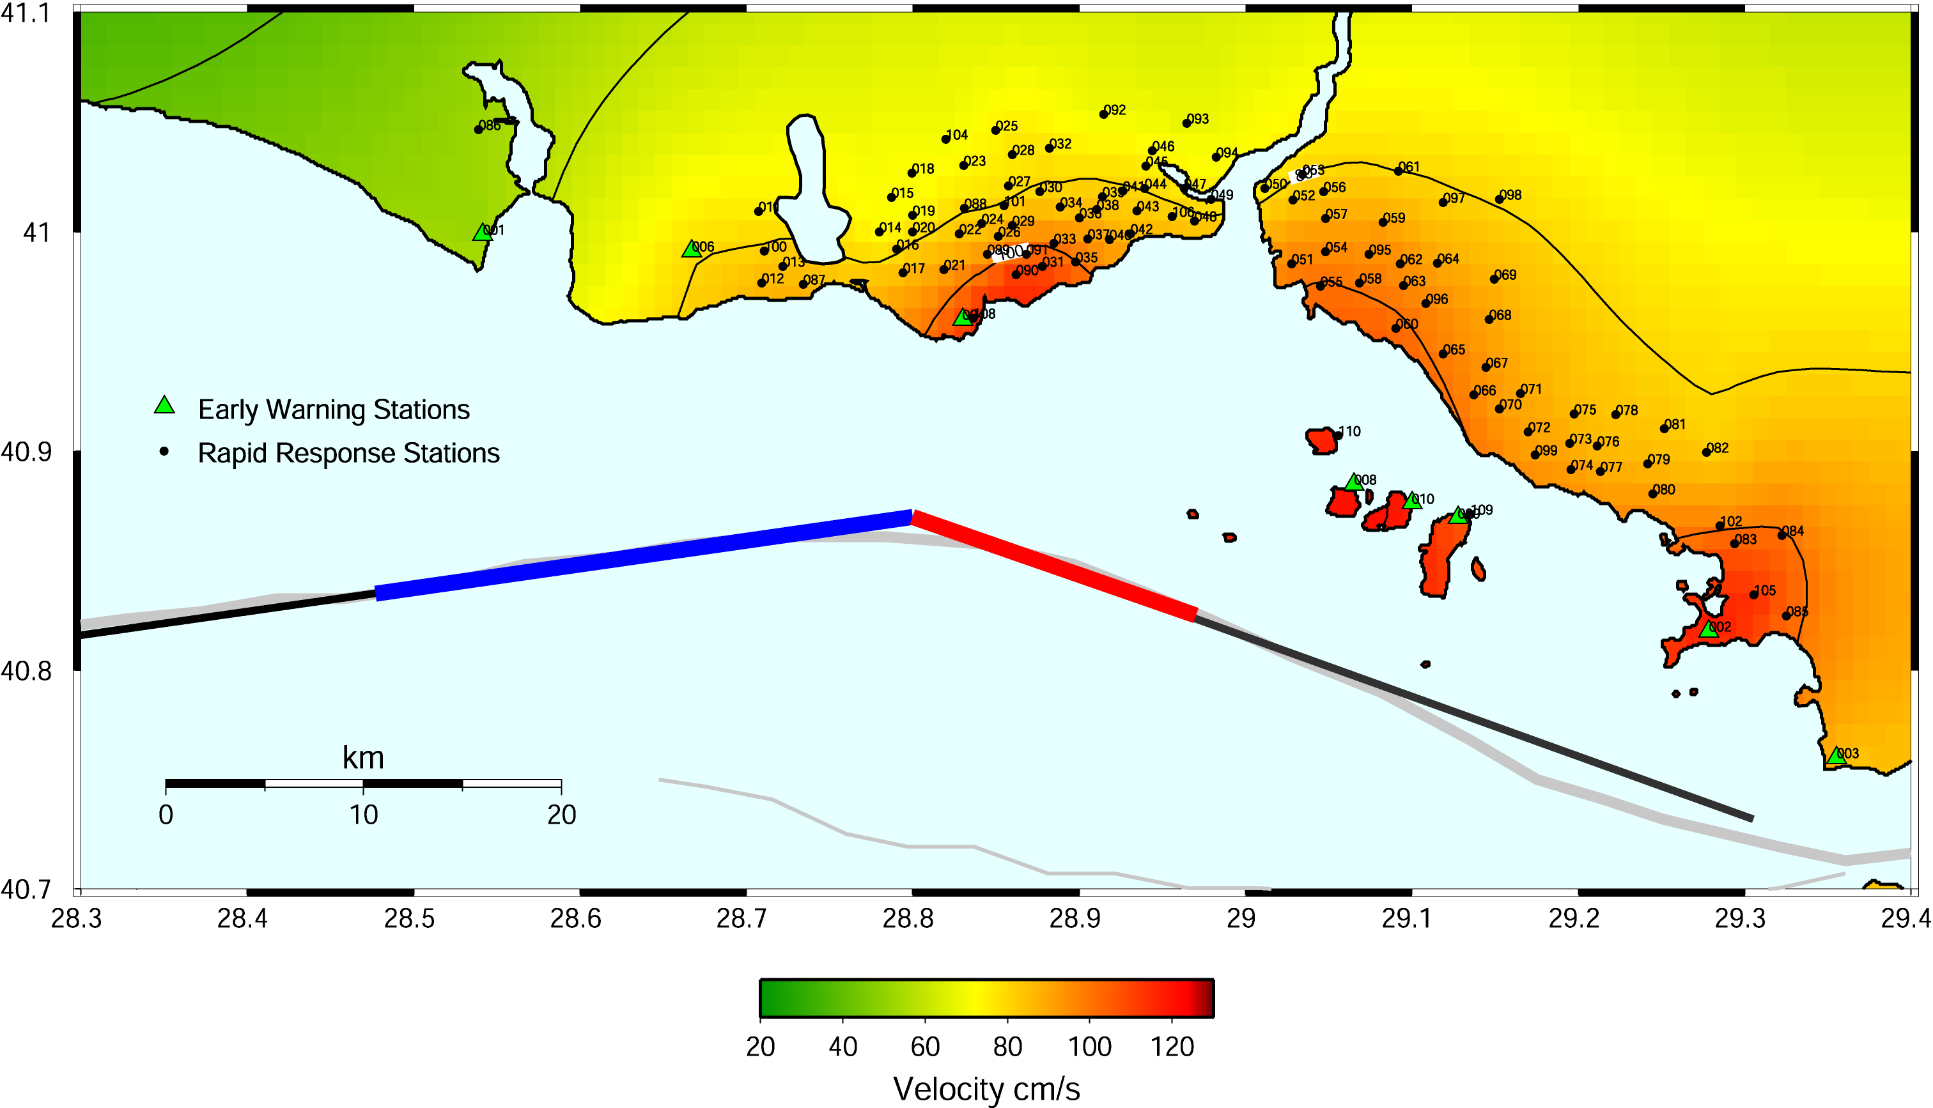

 | Figure 4.2.1. PGV results of ground motion simulations for a scenario earthquake (marked as black line) in the Marmara Sea, calculated on the irregular grid of the IEEWRR system. Red and blue lines are fault asperities used in the model. Numbers indicate the IEEWRR stations. | Project No: EVG1-CT-2002-00069
 | Annual report 2004 (Partner # 6: UiB)
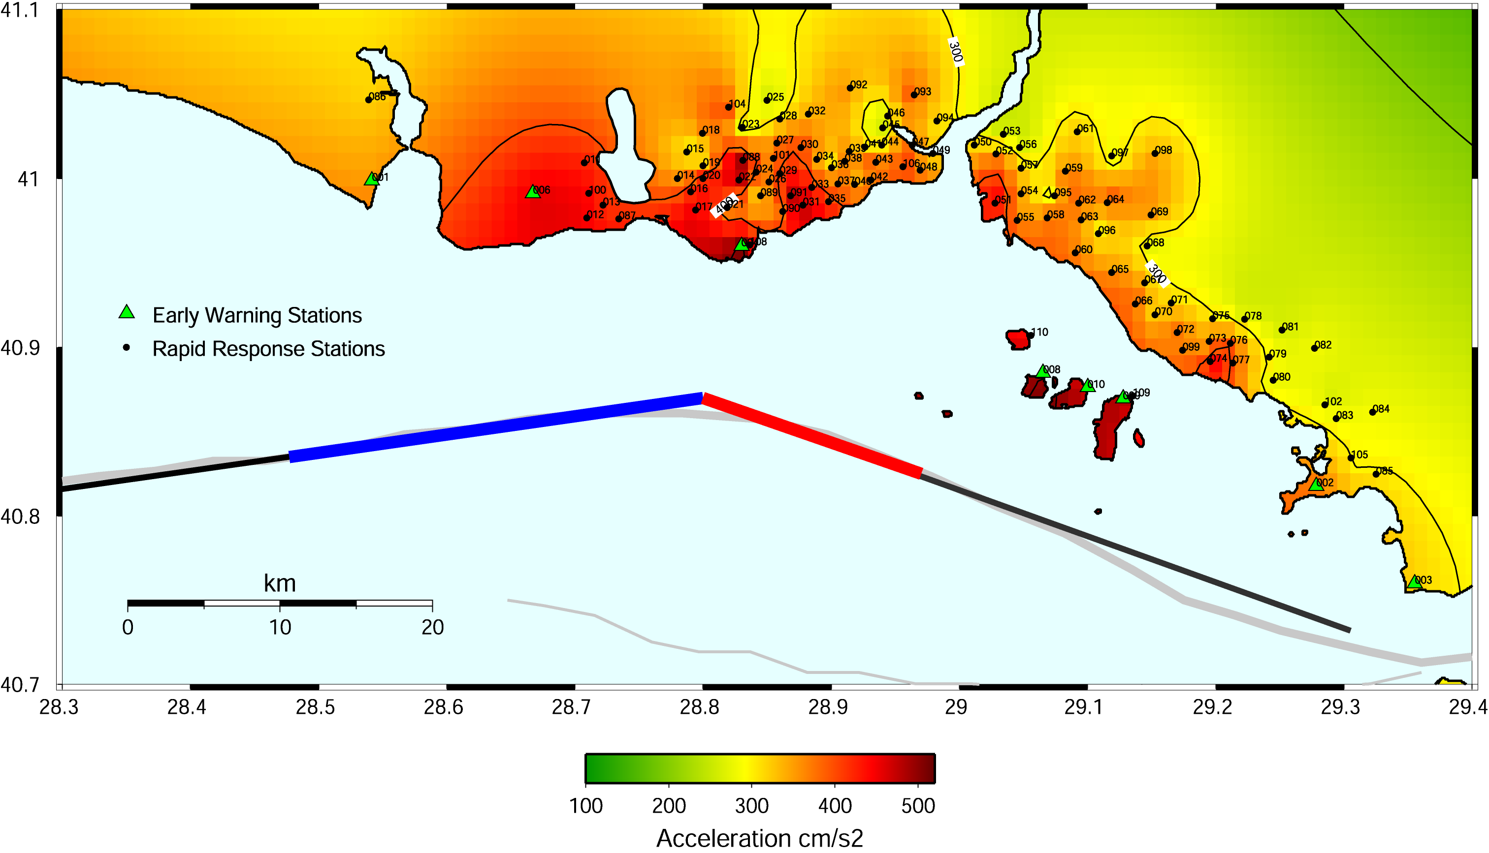

 | Figure 4.2.2. PGA results of ground motion simulations for a scenario earthquake (marked as black line) in the Marmara Sea, calculated on the irregular grid of the IEEWRR system. Red and blue lines are fault asperities used in the model. Numbers indicate the IEEWRR stations. | Project No: EVG1-CT-2002-00069
 | Annual report 2004 (Partner # 6: UiB)

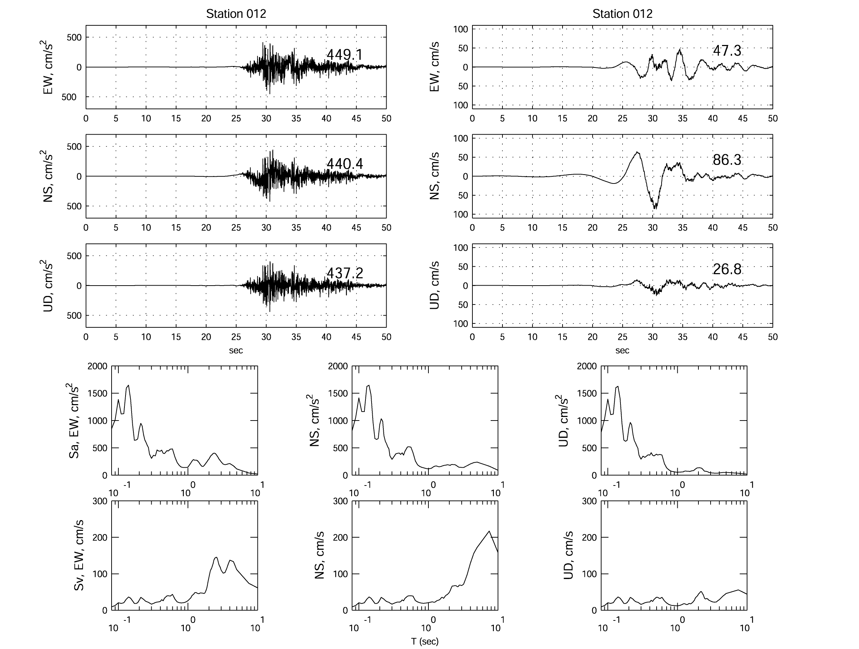

 | Figure 4.2.3. Waveforms simulated for a site in Avcilar, western Istanbul. To the left is 3-component ground acceleration, to the right are velocity traces. Peak values are shown above each seismogram to the right. | Project No: EVG1-CT-2002-00069
 | Annual report 2004 (Partner # 6: UiB)
5. WP10: Dissemination of the results

5.1. Development of the 3-D ground motion visualization software: GM3D

In the RELIEF 1st annual report from UiB, 2003, the GM3D software was described in detail. GM3D is a software for visualizing the propagation of the waveforms from a strong motion simulation over time from the rupture initiation point of the earthquake over the entire area. This software is now in use by the UiB and is being distributed to collaborators for visualizing for example the results of 3D modeling of local site effects (section 3.3.4).

5.2. Dissemination of the results (publications, conference presentations etc.)

Following is a summary of the dissemination of the results during 2004:

Publications:

Pulido, N., Ojeda, A., Atakan, K. and Kubo, T. (2004): Strong ground motion estimation in the Sea of Marmara region (Turkey) based on a scenario earthquake, Tectonophysics, 391, 357-374.

Sørensen, M. B., Oprsal, I., Pulido, N., Mai, M. and Atakan, K. (in prep.): 3D hybrid modeling of local site effects in Ataköy area, Istanbul, Turkey, due to finite-extent earthquake source.

Sørensen, M. B., Bonnefoy-Claudet, S., Atakan, K. and Yalciner, C. (in prep.): Local site effects in Ataköy, Istanbul, Turkey

Conference presentations:

Meghraoui, M., Pantosti, D., Akyuz, S., Leroy, S., Mai, M., Atakan, K. 2004. The RELIEF Project: Large earthquake faulting and implications for the seismic hazard assessment in Europe, the 1999 Izmit-Duzce earthquake sequence (MW 7.3 – 7.1, Turkey). 32nd International Geological Congress, 20-28 August 2004, Florence, Italy. (Poster presentation).

Sørensen, M. B., Pulido, N., Ojeda, A., Atakan, K. and Erdik, M. (2004): Ground motion simulations at Rapid Response sites in Istanbul, Turkey, Oral presentation at the 29th general assembly of the European Seismological Commission, Potsdam, Germany, 12-17 September, 2004.

Sørensen, M. B., Bonnefoy-Claudet, S., Atakan, K. and Yalciner, C. (2004): Local site effects and noise characteristics in Ataköy area, Istanbul, Turkey, Oral presentation at the 29th general assembly of the European Seismological Commission, Potsdam, Germany, 12-17 September, 2004.

Sørensen, M. B., Oprsal, I., Pulido, N., Mai, M. and Atakan, K. (2004): 3D hybrid modeling of local site effects in Ataköy area, Istanbul, Turkey, due to finite-extent earthquake source, poster presentation at the 29th general assembly of the European Seismological Commission, Potsdam, Germany, 12-17 September, 2004.

Sørensen, M. B., Pulido, N., Bonnefoy-Claudet, S. and Atakan, K. (2004): Ground motion simulations and site effect estimation for Istanbul, Turkey, oral presentation on the 35th Nordic seminar on detection seismology, Åkersberga, Sweden, 29 September – 1 October, 2004.

Acknowledgements

In addition to the persons that are listed in the list of contributors, the work presented in this report has benefited largely from the other project participants. We thank all of them for their enthusiasm and help throughout this time.

References

Atakan, K., Duval, A.-M., Theodulidis, N., Guillier, B., Chatelain, J.-L., Bard, P.-Y. and the SESAME-team (2004): The H/V spectral ratio technique: Experimental conditions, data processing and empirical reliability assessment, Paper no. 2268 at 13th World Conference on Earthquake Engineering, Vancouver, Canada, 1-6 August, 2004.

Birgören, G., Özel, O., Fahjan, Y. and Erdik, M.: Determination of site effects in Istanbul area using a small earthquake record of the dense strong ground motion network, Poster at 29th general assembly of the European Seismological Commission, Potsdam, Germany 12-17 September 2004.

Bonnefoy-Claudet, S., Cornou, C., Kristek, J., Ohrnberger, M, Wathelet, M., Bard, P.-Y., Moczo, P., Faeh, D. and Cotton, F. (2004): Simulation of seismic ambient noise: I. Results of H/V and array techniques on canonical models, Proceedings of the 13th World Conference on Earthquake Engineering, Vancouver, Canada, paper no. 1120.

Boore, D. M. (1983): Stochastic simulation of high frequency ground motions based on seismological models of the radiated spectra, Bull. Seism. Soc. Am., 73, 1865-1894

Bouchon, M. (1981): A simple method to calculate Green’s functions for elastic layered media, Bull. Seism. Soc. Am., 71, 959-971

Erdik, M., Fahjan, Y., Ozel, O., Alcik, H., Mert, A. and Gul, M. (2003): Istanbul Earthquake Rapid Response and the Early Warning System, Bulletin of Earthquake Engineering, 1, 157-163.

Havskov, J. and Ottemöller, L. (2003): SEISAN: The earthquake analysis software, manual for SEISAN ver. 8.0, available at http://www.geo.uib.no/Seismologi/software/seisan/seisan.html

Hisada, Y. (1994): An efficient method for computing Green’s functions for a layered half-space with sources and receivers at close depths, Bulletin of the Seismological Society of America, 84(5), 1456-72.

Irikura, K. (1986): Prediction of strong acceleration motion using empirical Green’s function, Proceedings of the 7th Japan. Earthq. Eng. Symp., 151-156

Nakamura, Y. (1989): A method for dynamic characteristics estimation of subsurface using microtremors on the ground surface. Q. Rep. Railway Tech. Res. Inst., 30, 1, Feb. 1989.

Ojeda, J. Å., Natvik, Ø., Berland, O. and Fjeldstad, F. (2004): SEISLOG CE (SEISLOG for Pocket PC), Poster at 29th general assembly of the European Seismological Commission, Potsdam, Germany 12-17 September 2004.

Oprsal, I and Zahradnik, J. (2002): Three-dimensional finite difference method for modeling of earthquake ground motion, Journal of Geophysical Research, Vol. 107

Oprsal, I., Brokesova, J., Fäh, D. and Domenico, G. (2002): 3D hybrid ray-FD and DWN-FD seismic modeling for simple models containing complex local structures, Stud. Geophys. Geod., 46, 711-730

Pulido, N. and Kubo, T. (2004): Near-fault strong motion complexity of the 2000 Tottori earthquake (Japan) from a broadband source asperity model , Tectonophysics, 390, 177-192.

Pulido, N., Ojeda, A., Atakan, K. and Kubo, T. (2004): Strong ground motion estimation in the Sea of Marmara region (Turkey) based on a scenario earthquake, Tectonophysics, 391, 357-374.

Schön, J. H. (1996): Physical properties of rocks – Fundementals and principles of petrophysics, Pergamon, 1996.

