

J-SESAME

USER MANUAL

Version 1.08

July 2004

Table of contents

1. Introduction

2. Requirements

3. Installation
3.1 CD Structure
3.2 Installing on Windows
3.3 Installing on Unix, Linux, Solaris or MacIntosh

4. Getting Started

5. Using JSESAME
5.1.Configuration of the program
5.2.Creating a new project
5.3.Plotting data files
5.4.Selecting windows
5.5.Plotting filtered traces
5.6.Computing H/V spectral ratio
5.7. Showing output results
5.8. Setting graph properties and creating images of the output results
6. Other items
6.1 Decimation factor
6.2 Errors and warnings
Acknowledgments
Disclaimer

1. Introduction

JSESAME is a JAVA application for providing a user-friendly graphical interface for H/V spectral ratio technique used in local site effect studies. The program uses the functions of automatic window selection and H/V spectral ratio by executing external commands. The automatic window selection and H/V process are standalone applications developed in Fortran. JSESAME is mainly a tool for organizing the input data, execute window selection and processing, and display the processing results. The software operates in Unix, Linux, Solaris, Macintosh and Windows environments.

2. Requirements

The following tool has to be installed in the Operating System:
- Java Runtime Environment (JRE) version 1.4 (minimum). You can download the files relevant for your operating system from the following web site: http://www.sun.com

For Linux/Unix/Solaris you will need to recompile the Fortran code, so you need g77 (or compatible) Fortran compiler installed.

Windows minimum requirements: Windows 98, 128MB RAM (suggested configuration: Windows 2000 or XP, 256MB RAM)

Macintosh minimum requirements: OSX System 10.2.8 or higher

It is advisable that you have your monitor configured to 1024x768.

3. Installation

Two installation options are provided, according to the platform you are using.

- For Windows the CD contains a setup program.
- For MacIntosh, Unix, Linux and Solaris the JAR file and the Fortran source codes are provided. It is necessary for the user to compile the Fortran code (see the instructions bellow).

3.1. CD Structure

The CD contains 5 directories, a setup for Windows and a readme file.
The contents of each directory are:
- Doc directory: contains the J-Sesame manual and a small explanation about the programs options
- Hvproc directory
  - Hvproc0_1.exe: main processing module for H/V ratio (windows executable)
  - Dep*: three directories with fortran files necessary to compile in the different platforms
  - Inc: files needed for compilation
  - Test: an input file (20010314165000.pal), the output file (output), the hvproc parameters (hv.par) and the selected windows (window.lst)
  - Src: all fortran programs
- JSesame directory
  - JSesame.jar: main executable program in Java
  - Src: directory containing the Java source code
  - Images: directory with tools-bar images
- Samples directory: contains some example input files (.gse and .saf)
- WindowSelection directory
  - winselection.exe: automatic window selection program (executable)
  - Dep*: three directories with fortran files necessary to compile in the different platforms
  - Test: an input file (POV_20011010_1309.saf), the output file (winselect.out), the winselection parameters (winparameters.inp) and the list of files to be processed (list)
  - Src: all fortran programs

3.2. Installing on Windows

A setup program is provided. This program creates two directories on the C:\ root directory, for hvproc and for windowselection. It also installs the JAR file and it’s dependencies in the programs directory, under JSesame. It creates a shortcut on your desktop.

3.3. Installing on Unix, Linux, Solaris or Macintosh

To compile the Fortran sources go to:
…/Hvproc/Src
and check in the Makefile_L the name of the Fortran compiler you have installed in your computer (i.e. f77, g77, …). There are some routines which are compiler dependent; however those contained in the directory …/Hvproc/Dep_L, which are designed for g77, should work on most Unix platforms.
Macintosh users should also copy the file “itw.f_mac” into “itw.f”.

Then:
$ makefile –f Makefile_L
will prepare the executable.
If you do not use this makefile, note the executable must be named “hvproc0_1” and its location is under ../Hvproc

Then go to :
…/Windowselection/Src
Perform the same check described above and run the makefile:
$ makefile –f Makefile_L
If you do not use the provided makefile, note that the executable must be named “winselection” and its location is under ../WindowSelection

4. Getting started

On Windows double click in the JSesame icon on the desktop.

Under Unix, Linux and Solaris go to the Jsesame directory and start the program from the prompt line using the command:

java –jar ./JSesame.jar

On the Macintosh double click on Jsesame.jar.

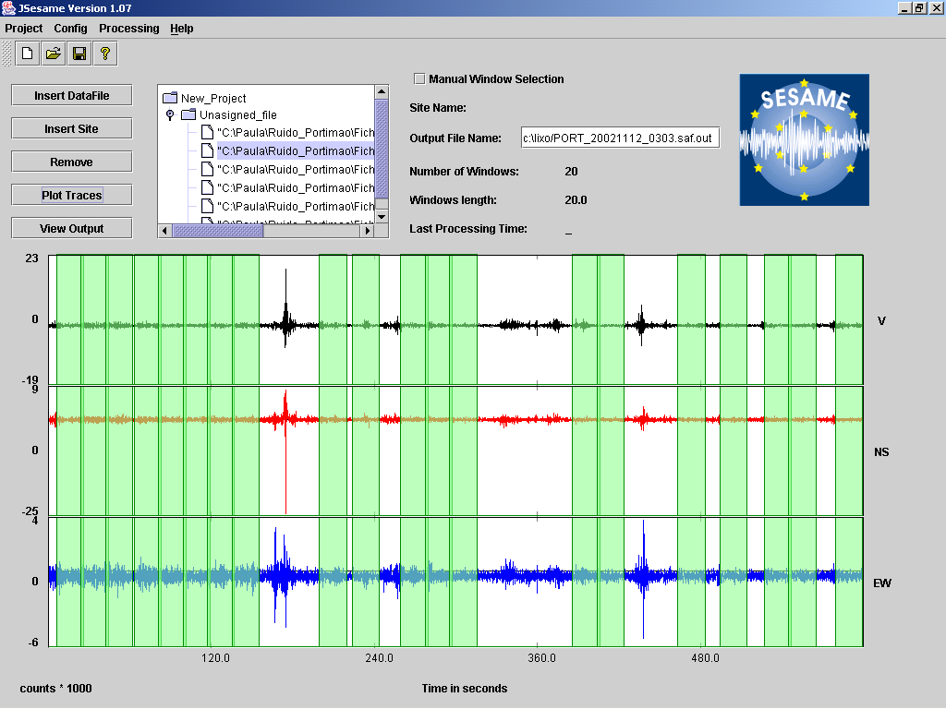

Figure 1. Main window

5. Using JSESAME

The user interaction with JSESAME (Figure 1) can be classified as: (1) Organizing the information, (2) processing the information and (3) displaying the results. The interface has a main window where the user can create a new project or loaded an existing project, plot the traces on the screen, perform automatic or manual window selection, apply the H/V spectral ratio computations and see all the results in a user-friendly interface. Only two waveforms data format are accepted: GSE and SAF (SESAME ASCII Format). The extension of the data files is required to be one of these words (GSE or SAF).

5.1. Configuring the program

JSESAME has several configuration variables to be set up by the user. In order to configure the variables, you have to click the item menu <Config> (Figure 2). The configuration parameters are shown in five dialog boxes. The first one is for configuring the automatic window selection (Figure 3), the second for the manual window selection, the third for the H/V processing module (Figure 4), the fourth for the filters parameters (Figure 5) and the last one for general configuration parameters (Figure 6). Note it is very important set the correct path for the window selection and processing module programs since they are external command call by JSESAME.

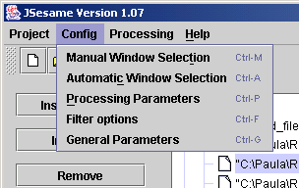

Figure 2. Configuration menu

5.2. Creating a new project

The structure of the project has a tree shape (Figure 1) where the data files are grouped by sites when several noise measurements are performed for a single location. Data files grouped in the “Unassigned_files” node are treated independently. That is the user has only one data file for each site. Each node in the tree has several parameters shown on the right side of the tree. The “Site name” and the “Output File name” parameters can be modified by the user. The changes are applied after pressing the RETURN key. Data file nodes can be dragged and dropped through the tree structure. For inserting new data files or sites and removing nodes from the project, users can press the corresponding button shown on the left site of the tree (Figure 1). The tree structure allow for multi-selection of nodes, which means that batch processing can be performed for several sites or individual data files. The project can be saved by using the item menu <project> (Figure 7) or by using the tools bar shown below the menu (Figure 1).

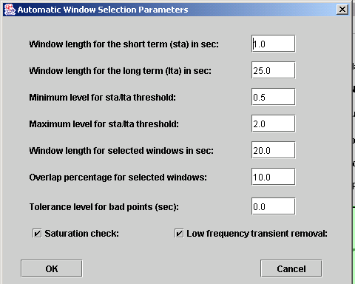

Figure 3. Automatic window selection parameters

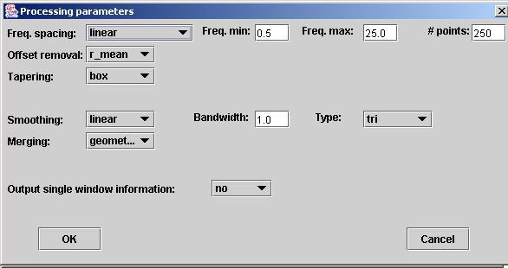

Figure 4. Processing module parameters for H/V spectral ratio

5.3. Plotting data files

The highlighted or selected data-file can be plotted by pressing the button <Plot traces>. All the selected windows will be shown (Figure 8). Zooming can be done by clicking the left button of the mouse, then drag the mouse and release the button at the end of the selected time of the window. Clicking the left mouse button on anywhere on the plot will take you back to the original trace before zooming.

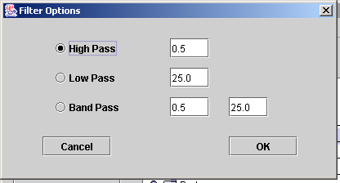

Figure 5. Filter options
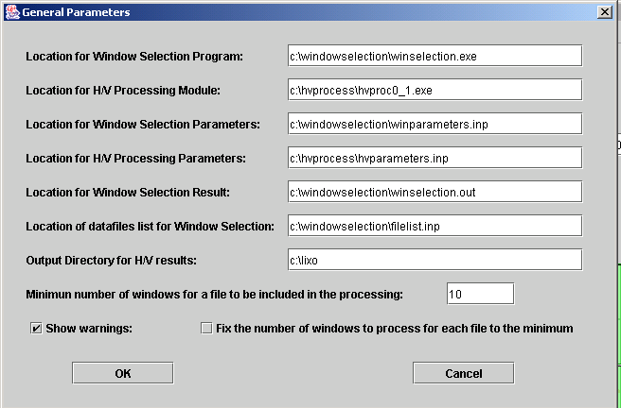

Figure 6. General parameters

5.4. Selecting windows

Windows can be selected automatically or manually. The manual window selection can be done if the check-box labeled as “Manual window selection” (Figure 8) is active. The window is selected using the same procedure as zooming action. Individual windows can be removed by clicking the right button of the mouse twice: one click for selecting the window and another click for the deleting action. Automatic window selection can be performed in four different ways (Figure 9). The first one is applied to the original traces. The second is applied to the filtered trace with the filter selected in the <Config> option. The third is the common windows between the original and the filtered traces. The last option keeps the same selected windows of the first file for the rest of the selected files. This option makes sense when the user highlights (select) a group of files from the project.
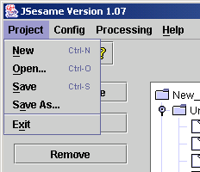

Figure 7. Project options

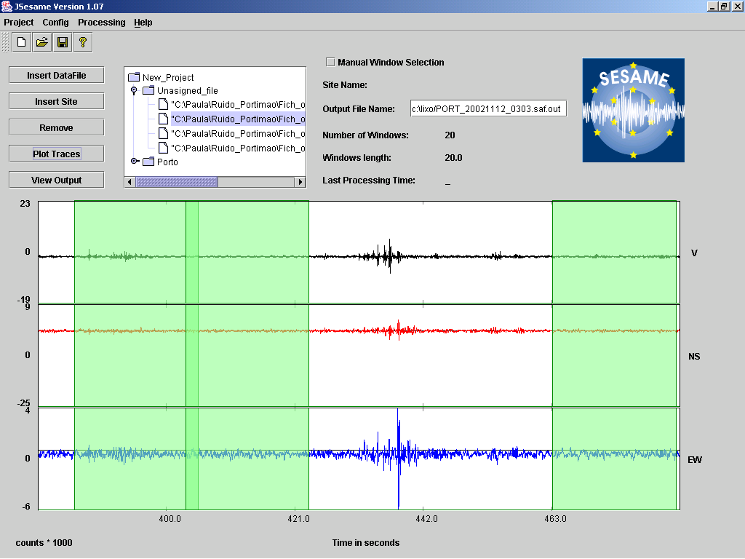

Figure 8. Zoomed traces with the selected windows

5.5. Plotting filtered traces

The selected data-files can be filtered with the previous selected filter in the <Config> option (Figure 5) and then plotted on the screen. This option is available within the <Processing> menu item (Figure 9). The selected windows for the plotted data-file are also shown. Zooming on the filtered traces can be performed as explained in section 5.3.

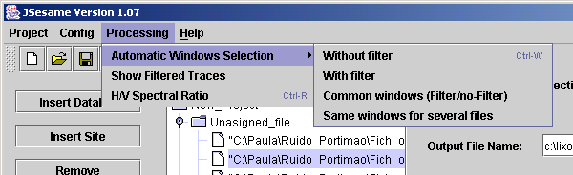

Figure 9. Processing options

5.6. Computing H/V spectral ratio

The processing module (option shown in Figure 9) is applied according to the selected nodes in the tree. If the selected node is a site, then all the selected windows of the data-files collected for this site will be used for computing the average H/V spectral ratio. Output for each window can be also obtained by setting up the configuration parameters of the processing module (Figure 4). Batch processing will be performed when several sites or data-files are selected.

5.7. Showing output results

By pressing the <View Output> button (Figure 8) the user can navigate through three dialog boxes. The first dialog box (Figure 10) shows the H/V spectral ratio of the merged horizontal components. The second dialog box (Figure 11) shows the H/V spectral ratio for each one of the NS and EW components. The third one (Figure 12) shows the spectral ratio of the merged (H), NS and EW horizontal components and the spectra of Z, NS and EW for each individual window, if “output single window information” is selected in the configuration parameter of the processing module (Figure 4). To select an individual window the user has to click the right button of the mouse on it.
Zooming action can be done over the spectrum using the same procedure explained in section 5.3. The individual values of the spectrum can be shown by clicking the middle button of the mouse over the spectral curve. However, these two functionalities only work when the spectra are represented on a linear scale (see next section).

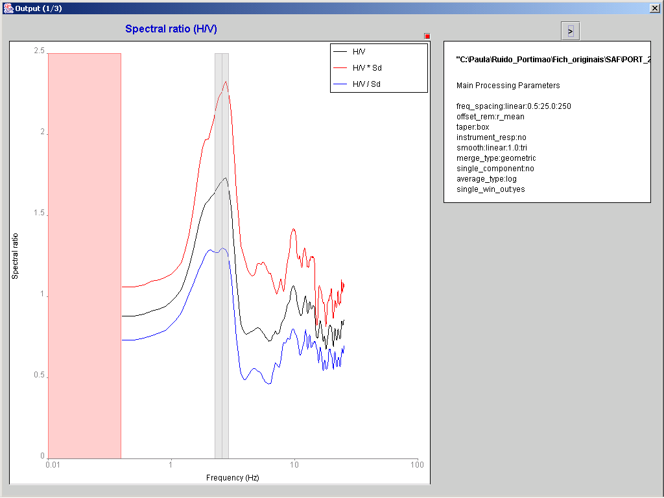

Figure 10. Spectral ratio for merged horizontal components

5.8. Setting graph properties and creating images of the output results

For each graph shown in Figures 10,11 and 12 there is a small red box in the upper right corner without any label. By clicking there the properties and scale of the graph can be modified and images of the graph can be created (Figure 13a). The button <Properties and series> pop up a dialog box (Figure 13b) where line type, width and colour (Figure 13c) can be changed for each spectral curve. The button <Scales> pop up a dialog box (Figure 13d) where the minimum, maximum and scale for each one of the vertical and horizontal axes can be modified. The button <Save> allows to create an image of the graph (Figure 13e).

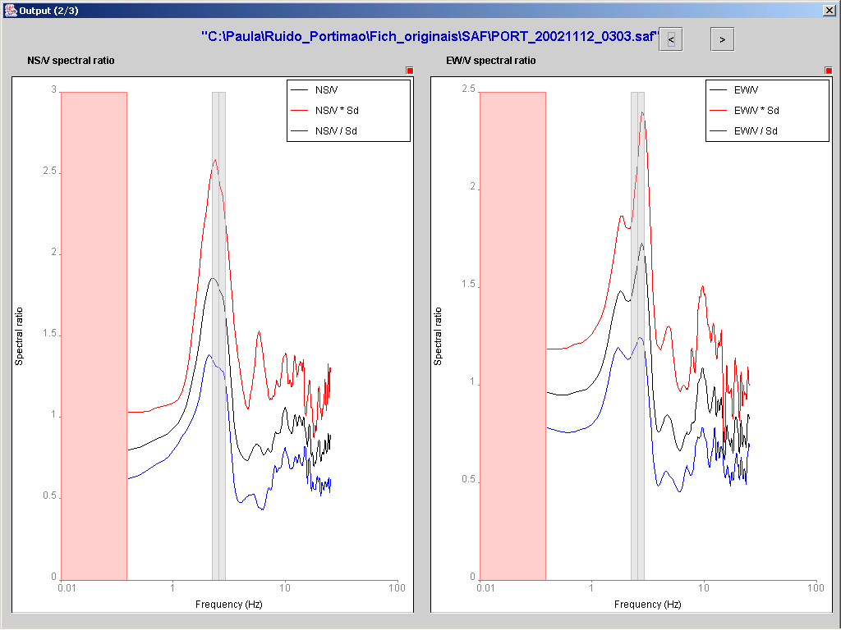

Figure 11. Spectral ratio for each NS and EW horizontal component
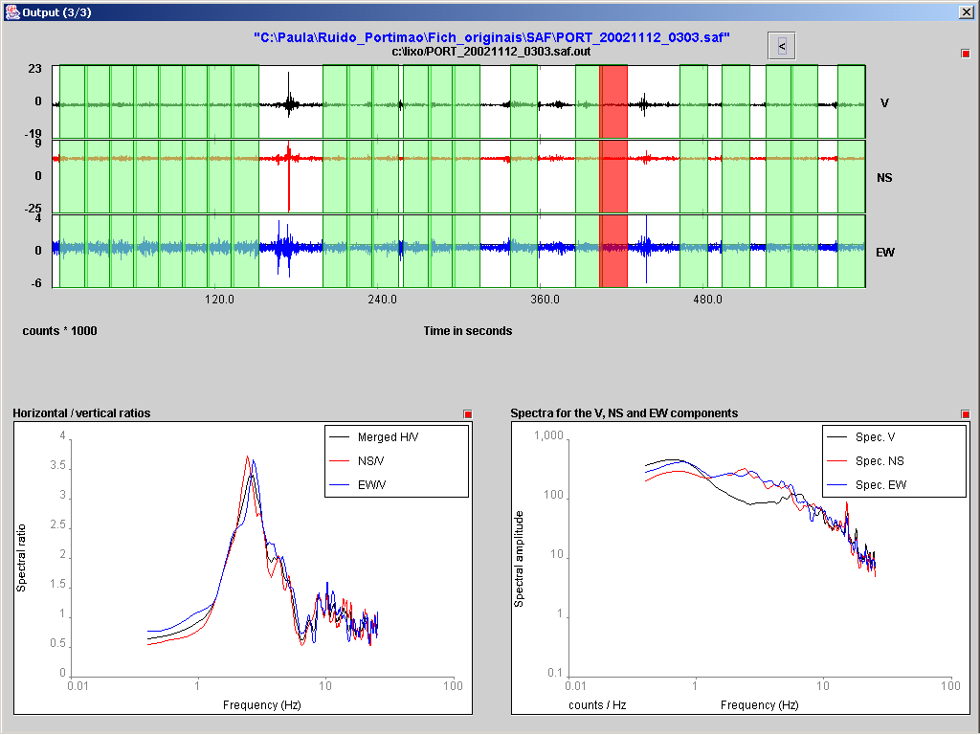

Figure 12. Result for individual windows

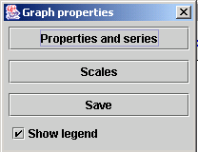

Figure 13a. Graph properties

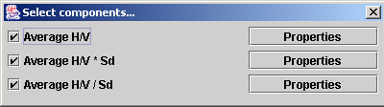

Figure 13b. Selection of the components

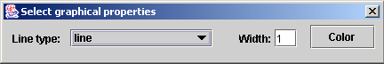

Figure 13c. Properties of the Spectral curve

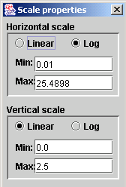

Figure 13d. Scale properties for the spectral curve

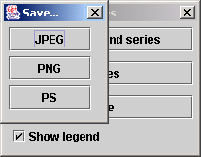

Fig 13e. Selecting the type of image to be created

6. Other Items

6.1 Decimation factor

Depending on the sampling rate and the file length (duration of the record) the graphical representation may not represent all the points. A different decimation factor can be specified on the command line. The default value is 10000. Increasing this value will force the representation of more sample points.
For instance, running in Windows we could specify:

C:\Program Files\JSesame>jsesame.jar 12000

6.2 Errors and warnings

A number of error messages may be issued during the execution of J-Sesame preventing the correct completion of the planned processing.
They concern:
- Required amount of computer memory exceeds current dimensions
- Problems encountered during the reading of the time history file
- Processing parameters inappropriately set

Some warning messages may also be issued, they concern:
- According to the setting of processing parameters, the smoothing procedure can compute significant spectral values only in a range which is different from that set by the user.
- Computation of Fo:
  - Fo does not appear in H/V ratio or it is not possible to compute it. The value of Fo is set to -9.
  - The scheme used for the assessment of Fo would require a larger frequency window than that available.

Acknowledgements

Acknowledgments are due for the use of some subroutines:

- FFTPACK: package of Fortran subprograms for the fast Fourier transform
P.N. Swartztrauber. Vectorizing the FFT’s, in Parallel Computations (G. Rodrigue, ed.), Academic Press, 1982, pp. 51-83.
- CODECO3: format conversion software
Urs Kradolfer, Karl Koch, Klaus Stammler. Swiss Seismological Service, Zurich.
- FILTERING: some routines developed by
Dave Harris. Laurence Livermore National Laboratory. Livermore, CA, USA. Copyright 1990 Regents of the University of California.

Disclaimer

The J-SESAME software, the utility programs supplied with it and all related texts were developed within the framework of the EU project SESAME (EVG1-CT-2000-00026) “Site Effects Assessment Using Ambient Excitations.”

J-SESAME software is provided "as-is" free of charge for scientific purposes. No warranty or any kind of support, expressed or implied, is provided, in particular in what concerns the use, accuracy and reliability of the software. Users are cautioned before using it for decisions that concern personal or public safety or in relation with business involving financial or operational consequences. Conclusions drawn from, or actions undertaken on the basis of this software are the sole responsibility of the user.

No commercial use of the original software and of all related texts is allowed!

