

Collaboration in mathematics and natural sciences - Sudanese universities and the University of Bergen

Report on visiting University of Bergen,
Norwegian National Seismological Network
Department of Earth Science, University of Bergen

7.08 – 22.08, 2007

Cooperation in Seismology

By

Hatim Siddig Hag Elbashir
Abdel Hadi Ibrahim Elhassan
Geological Research Authority of the Sudan
Sudan Seismic Network

August, 2007
Introduction:

As part of cooperation between GRAS and the University of Bergen, we were invited to visit the Norwegian National Seismological Network (NNSN) from the period from 7/8/2007 to 22/8/2007.

This visit was arranged to gain benefit from and learning about how the NNSN works in real time and what hardware, software and protocols was used to operate the network and how we can transfer and apply this to Sudan Seismic Network.

It was also the purpose to use the SARA instrument, the instrument that GRAS bought three of them recently, to be familiar to how setup in trigger mode and continuous mode and how retrieve the data, extract and put it into the SEISAN database.
Finally, to make future plan for Sudan Seismic Network
Sudan seismic network (SSN)

Introduction
After the 1993 Khartoum earthquake, it was decided to build a seismic network around Khartoum. The original plan was to acquire, in order of priority:
- A central acquisition unit to be based in Khartoum: This gathers the signals coming via radio from the seismic stations; four telemetric stations, to be installed around the capital, at a distance allowed by the radio transmission; an off-line system (PC) to process and analyze data.
- Two stand-alone stations to be installed in the south Juba region and in the North East, to monitor the seismisity of the most active regions in the Sudan, the Juba region and the Red Sea.
- Spare parts for the instrumentation.
- Two Drums for analog recording for the seismic traces.

Equipment was finally bought in 2000, and due to the time delay and changing equipment standards the equipment bought was 3 digital telemetric stations from Lennartz including a central station. Since then one more telemetric station has been bought (2002), which has not yet been installed. Also 3 portable Lennartz stations have been acquired.

The Sudan Seismic Network (SSN) now consists of 3 + 2 remote stations and one Central Station. The 3 remote stations are installed in 2001 around The Capital Khartoum as follows:
- Silate Remote Station (SLAT) about 32 Km of GRAS NE.
- Merkhyat Remote Station (MRKH) about 23 Km of GRAS NW.
- Jebel Aulia Remote Station (JAWL) about 42 Km of GRAS to the S.
- The fourth remote station will be installed soon at Alameen region about 35 Km East Khartoum.
- The 5th remote station is arrived last year and it uses telephone line for sending data instead of radio communication.

The network started operation in 2001, however due to a disk crash, data is only available from November 2003.

Each remote station consists of:

- A Compact Long-period three component seismometer with frequency response flat from 0.05 to 20 Hz.
- MARS-88 basic data acquisition unit comprising 3 A/D converters ( > 96 dB dynamic range) and a microprocessor with flexible triggering options.
- Modem Control comprising a dedicated modem.
- GPS receiver for timing.
- Bidirectional RF telemetry with transmitting and receiving unit for digital transmission for MARS-88. It uses error-correcting transmission protocol.
- Directional Antenna.
- 3 (12V) Batteries charged with a solar unit.
The Central station Consists of:

- Directional Antennas.
- Bidirectional RF telemetry consisting of transmission and receiving unit for digital transmission for MARS-88.
- RF Multiplexer (4 way) so that the unit can work with 4 stations in sequence..
- Ethernet Gateway in the form of a Unix PC.
- SPARC Workstation including SUN’s Solaris operating system used for automatically collect data from the field stations and do preprocessing.

Mechanisim of data Aquisition

- The 3 channel seismometer senses the earth motion and converts it to an electric signal.
- The data logger receives these signals, converts them from analog to digital signals, link them with precise time (coming from the GPS). The data stream is checked for seismic events and if an event occurs, it is stored in a data buffer. When the data buffer is full., it is overwritten. Currently the data buffer can store 4 hours of data. The data remains at the field station until the central station request it.
- The Central Station can request for a specific range of data. The data logger then, selects this range and forwards it to the radio modem to prepare it for transmission using the transceiver.
- There are two types of data coming from the data logger:
  - Monitor data, which is low resolution continuous data just for monitoring.
  - Triggered data, which is fulfill the trigger criteria and is a high resolution data for analysis.

In the SPARC Workstation, there is the software (RCM), responsible for requesting data from the remote stations, and arranging these blocks of data in a database.
RCM first request trigger times from all field station. Once the trigger times from the three stations have been received, the RCM program inspect these times for coincidence within a time window. If 2 out of 3 field stations trigger within this time window (usually around 60 secs.), then a network event is declared and the central station will collect corresponding waveform data.
Data events coming from field stations by radio link into the central station through the gateway after checking for the trigger parameters, events can be displayed and then export it into SEISAN database for processing.
One of the stand alone stations was put in SLAT in continuous mode operation to compensate the stopping of the SLAT telemetric station due to some problem in transmission.

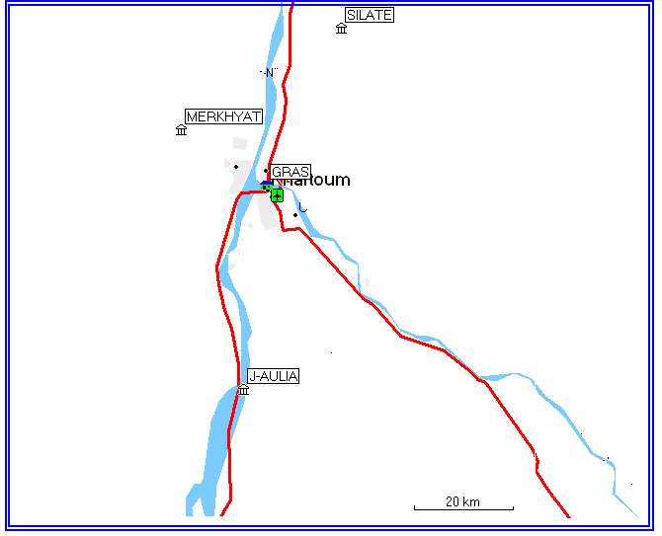
Central station
^{Seismic station}

Figure 1: Map showing the SSN Seismological Stations

Plan for new stations and:
So far SSN had 2 telemetric stations not installed yet. The plan is to install one near the capital Khartoum to join the three previously installed; the preparation for installation was almost started.
The second station is using telephone line rather than radio communication, so we are free to put this station far from the capital at any location in the country which we find a telephone line, probably at the east region of Sudan (Port Sudan Area).
On the other hand SSN had 3 portable standalone stations. The plan is to install one of them permanently at the southern region of Sudan (Juba city).
SSN ordered for 3 SARA stations and one M24 station which did not arrived yet. The plan is to distribute them to cover the North and the West of Sudan.

Future Plans:

- Increasing the number of stations and distributed them to cover all the Sudan especially areas that known as high seismic activity, such as the Red Sea region in the Eastern Sudan and Juba town in the southern Sudan.

- Change or enhance the communication that is used as a link between the field stations and the central station, by using telephone line, satellite or different type of the internet option such as:
- Fixed internet
- Internt with ADSL
- Interent with ISDN
- Internet with mobile phone (3G, Edge or GPRS)
- Collaborate and cooperate with the other agencies regionally and globally
- Joining to a seismological specialization organization

The Norwegian National Seismic Network (NNSN)

The NNSN began 100 years ago with a single seismograph station then development took place to reach 30 stations at this time. All these stations are joined in the national network.

The Norwegian Seismic Network consists of following:

- Nine stations equipped by three- component short-period seismometers.digitizers (24-bit Earth Data or Nanometrics), and a SEISLOG data acquisition system. Precision timing is acquired by GPS clocks. Data transfer to the central station is done by ftp and telnet.
- Three of the stations with three-component force-balanced accelerometers are installed in addition to the short-period seismometers (SUE, MOL and LOF).
- Five of the stations, (KONO, NSS, TRO, BJO, KBS), contain broad-band sensors designed to detect tele-seismic events. The stations KONO and KBS are part of the global IRIS network, which allows for online communication with international agencies.
- The three-station network around Bergen (ASK,BER and ESG), is designed for continuous recordings through a 24- hours open data line, where the station in Bergen.
- The other three-station network in the arctic island Jan Mayen, operates separately to monitor the volcanic activity.
Further processing using SEISAN is performed regularly for different research tasks. The

Norwegian Seismic Network has the following main functions:

- General monitoring of seismicity in Norway and adjacent areas, with a capacity of providing rapid information to the society.
- Collection of earthquake data to be used in national seismic design codes and earthquake maps for mainland and offshore areas.
- Compilation of earthquake catalogues to be used in seismic hazard analyses for offshore constructions, hydropower stations, dams, tunnels and other critical industrial installations.

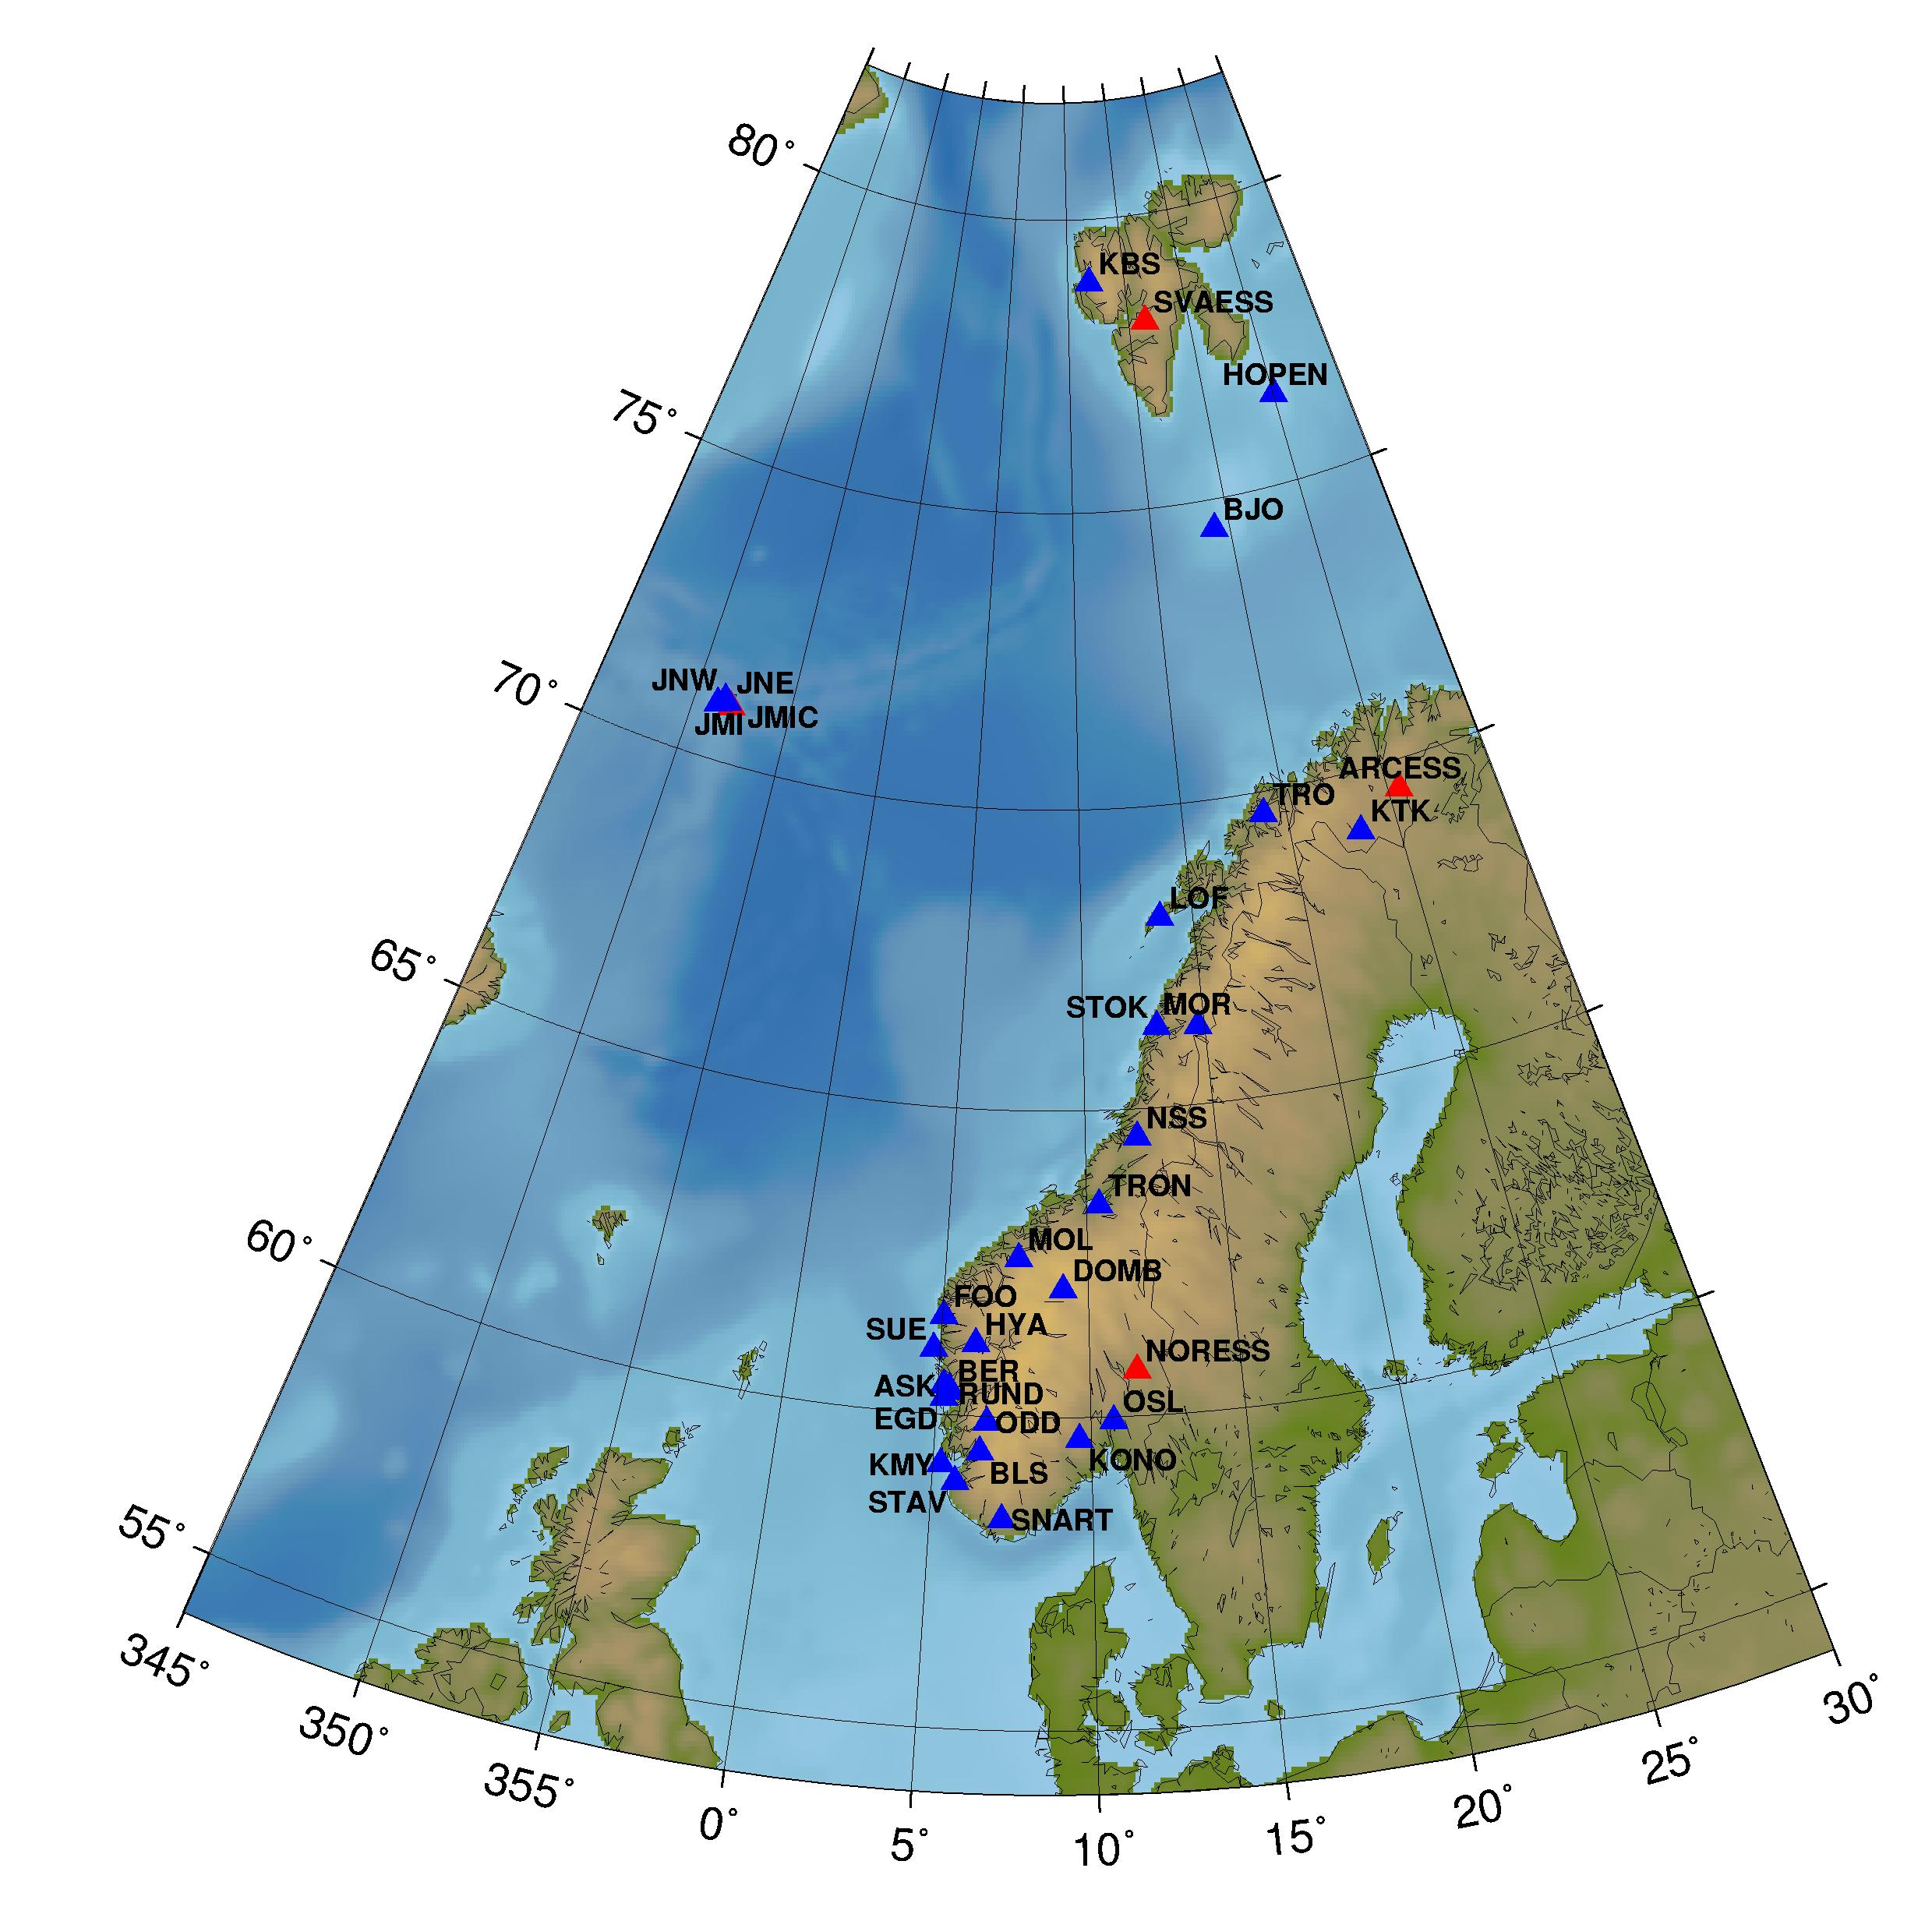

Figure 2: show the Norwegian National Seismic Network and other seismic stations in Norway. Blue symbols are NNSN stations and red are NORSAR arrays. The station JMIC is operated by NORSAR.

The NNSN composed two main types of real time continuous data through the internet these are:
- WINDOWS SEISLOG
- LINUX SEISLOG
- Global Seismographic Network (GSN)

Windows and Linux Seislog transmit data in liss format to NNSN central station at University of Bergen. The central station is a Seedlink server that receives all data from the stations. The data is then sent to an Eatrhworm system for detection and for recording of the events in the Seisan database.
Also real time continuous data comes from the Global Seismic Network (GSN) through LISS protocol to central station at University of Bergen.

There are different internet types that are used in real time communication in NNSN, these are:
- Fixed internet
- Internet with ADSL
- Internet with ISDN
- Internet with mobile phone (3G, Edge or GPRS)

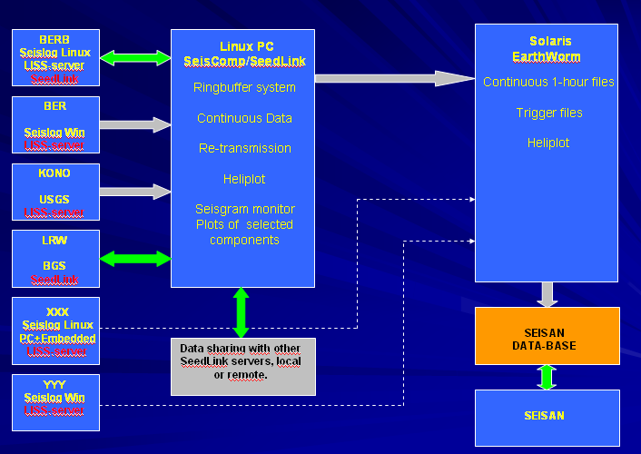

Figure 3: Flow chart showing NNSN real-time data acquisition

Options for field station communication

To access the data of the field station, one can use the following methods depending on the facilitate of the station:

- Manual data download (Flash-disk, Hard disk, or via PC using serial connection).
- Remotely connect to the station by modem or ISDN.
- Remotely connect to the station over the internet.
- Remotely connect to the station by mobile phone network system (GPRS or 3G).
- Remotely connect to the station by Iridium (Satellite).
- Remotely connect to the station LAN.
Digital Network

SeisComP

The Seismological Communication Processor (SeisComP) is a networked seismographic system that deals with the following operations:
1. Data acquisition
2. Data recording
3. Monitoring and controlling
4. Real-time communication
5. User access
6. Automatic (near-) real-time data processing (quality control, event detection and location).

Usage for permanent and mobile stations as well as for network processors and data centers:
- stand-alone usage of the different sub-packages,
- data communication by dedicated and dial-up lines and Internet
- real-time data distribution station - data center,
- configuration of "virtual" seismograph networks,
- usage of standard PC hardware with Linux operating system as station, network and DC processors.
- usage of embedded PC104 boards as low power SeisComP station processor
- Supported communication links: standard phone, GSM, Inmarsat-M, ISDN, DSL, radio, Internet.

The advantages of the SeisComp:
- Flexible configurable- and easy upgradeable system,
- Support of cheap, worldwide available hardware,
- Usage of standard UNIX protocols and software,
- Usage of most modern and/or adequate communication and storage techniques,
- Usage for permanent and mobile stations as well as for network processors and data centres,
- Data communication by dedicated and dial-up lines and Internet
- Real-time data distribution station - data centre,
SeedLink

The SeedLink protocol is a data transmission intended for use on the Internet or private circuits that support TCP/IP. The protocol is robust in that clients may disconnect and reconnect without losing data, the transmission is started where it ended. Requested data streams may be limited to specific stations, locations and/or channels. All data packets are 512-byte Mini-SEED records. The most common implementation, and the one used at the DMC, is the seedlink server within the SeiscomP packages.
Real-time Data from the IRIS DMC
The DMC runs a publicly accessible SeedLink server on the following host and port:
Host: bud.iris.washington.edu
port: 18000 (default SeedLink port)
All open data that the DMC receives in real-time is available via this SeedLink server.

Protocol Details
The SeedLink protocol can be summarized as a simple, ASCII-based, data selection phase followed by the streaming of data packets from the server. SeedLink packets are composed of a small header followed by a 512-byte Mini-SEED record (data only SEED). The negotiation phase allows the client to request only specified data from the server for each selected data stream. A data stream is defined by a network and station code pair.

By utilizing sequence numbers for each packet in a data stream the SeedLink protocol allows for connections to be resumed, eliminating most data gaps. The ability to resume data streams is primarily dependent on how much data, time-wise, the remote SeedLink has in its buffer.

Special, out-of-band packets created by a seedlink server and recognized by libslink are used to communicate server details to clients and to implement keep-alive packet swapping. These special INFO packets are XML formatted data embedded in Mini-SEED comment records.

The protocol allows for two different modes of data transmission, uni-station and multi-station modes. Uni-station mode operates by transmitting a single data stream (data from a single station) through one network connection. In this mode the data stream does not need to be specified by the client as it is implied by the internet address and port. Multi-station mode operates by transmitting multiplexed data streams (data from multiple stations) through a single network connection. Almost all connections are negotiated as multi-station, even if only a single station is requested; uni-station mode, for most publicly accessible servers is deprecated.
dumpseed
DUMPSEED is a program allow LISS client to connect to any LISS station for a given station and receive near real-time data in mini-SEED format. Then user can displayed the output on the screen.

A number of command-line arguments are available to allow the user to control the output. In addition, dumpseed can convert mini-SEED data files from binary format into text. This allows users to get data in a format suitable for plotting and graphing.

LISS protocol

LISS is a distributing digital seismic data, in near-real-time, via the Internet. These seismic data are collected by USGS stations of the Global Seismographic Network (GSN) at sites around the world.

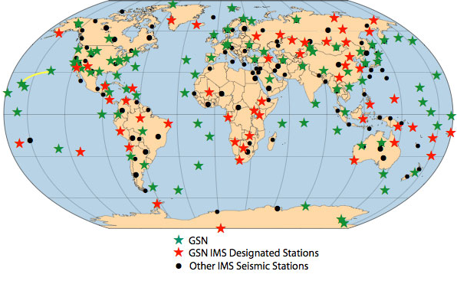

Figure 4: Map showing the Global Seismographic Network (GSN) at sites around the world.
Data from these seismographic stations are used for a variety of purposes, such as earthquake reporting, tsunami warning, and nuclear monitoring.

(LISS) can support any number of simultaneous client connections. Each client connects to the LISS via the Internet and receives copies of the digital seismic waveform data which the server receives from the seismographic stations.

Live Internet Seismic Server (LISS Server)

- (LISS) is an internet-based distribution mechanism.
- Allowing near-real-time data flow from seismic stations around the world to clients.
- Data are available to all.
- Data requests are not necessary.
- A client simply connects to a specific internet address to begin receiving data.
- The LISS automatically requests data from the station.
LISS server running at the USGS under Seismological Laboratory. When a data record is received from a station, the LISS duplicates the record and sends copies to each client that is connected to the LISS.
Latency of data obtained from the LISS is typically less than 30 seconds.

Data from 24 stations around the world are presently available via the LISS. In addition to distributing these data, the most recent 24 hours of data from each station are plotted in a manner resembling the popular drum style recording (helicorder) mechanism which is widely familiar to the public. These plots are updated every thirty minutes and are accessible via the internet.

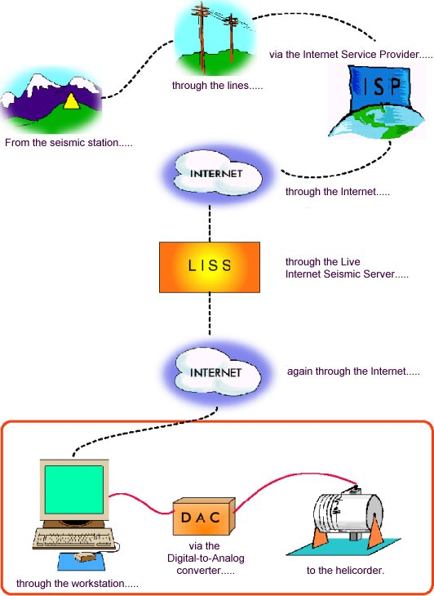
Figure 5: showing how data comes to LISS and distribution to other clients

Earthworm and Antelope

Both the Earthworm (EW) and Antelope are system for seismic network data acquisition and processing system. They do the same functions with the priority to Antelope.

The Earthworm is non commercial software, and it is available for free, so it is used by many networks in the world.

While the Antelope is commercial software, you must have license to use this program.
The input to the EW system is comprised of many real-time electronic seismic waveforms fed to a multichannel digitizer on a PC platform in Mini-SEED and Seisan formats.

SEISNET

SEISNET serves as link between seismic stations of different type and the SEISAN analysis software. The main operations carried out automatically by the SEISNET software are given in the following list:

• Retrieve the parameters information from remote seismic stations.
• Network event detection
• Retrieve the waveform data from remote seismic stations.
• Automatic phase picking, hypocenter location and magnitude determination
• Transfer of waveform data for a given hypocenter location and origin time

SEISNET is supported for the Sun Solaris operating system; it has also been partly tested on
Linux. SEISNET can only be used in connection with the SEISAN.

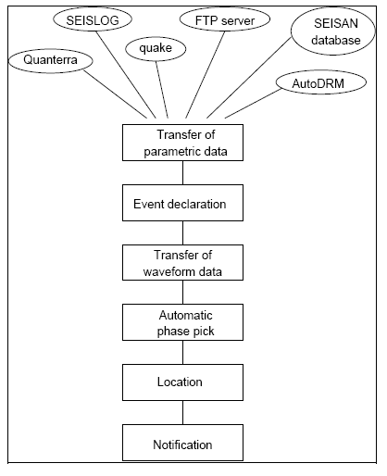
Figure 5: Flow chart showing how SEISNET works

SeisLog

Seislog is a data acquisition system for recording earthquakes.
SeisLog has been in use for fifteen years and is installed at about 100 sites in twenty countries.
The Seislog data acquisition system consists of one or several digitizers connected to a PC using the serial lines or input from files. . The digitizers will normally provide time stamped data blocks.
The data from the physical channels will enter memory ring buffers (one for each logical channel), where STA/LTA calculations are performed, and single channel detections declared. Each channel can optionally be written to a disk ring buffer, and there can thus be a disk ring buffer for each logical channel.
There are two types of the Seislog depending on the operating system that was used, Linux seislog and Windows seislog.
FTP/Telnet can be used to retrieve data from SEISLOG whether its from a desktop PC or an embedded system.
A server module that communicates over sockets takes care of communication with utility clients like monitoring and plotting of signals.
A server function that emulates the LISS server will send out miniseed data buffers on request.
The data buffers received can be plotted with the utility LISSPLOT in “near-real-time”. LISSPLOT and RTNET can also be used to plot data from any station in the GSN network.
The data buffers from the server can also be used as input to Earthworm or SeisComp

A practical installation of Linux (SuSe 9.3) operating system, and also a practical installation of Seislog application was performed.

Table 1: Comparison between Linux Seislog and Windows Seislog
Linux Seislog | Windows Seislog
well tested | less tested
easy set up and use | easy to set up and use
very good communication capability | Good communication capability
lacks flexibility in using a mix of digitizers and sample rates | More Flexible
recording directly into the Seisan database | recording directly into the seisan database
well suited for local and regional operation | well suited for local operation

Embedded Linux
Small single board computer, low power, normally no hard disk and no console.
Systems have Linux embedded in memory. Seislog Linux runs on this system. Recording of data on a USB disk or transmission of data on LISS protocol.
An embedded Linux system is used in SARA recording system and others data loggers to allow communication within the internet.

Report on SARA Instrument

The SL07 consists of the following:
- 3 channels seismometer
- GPS Receiver
- A/D Converter
- CPU with Recording capability
- Data logger with flash memory.

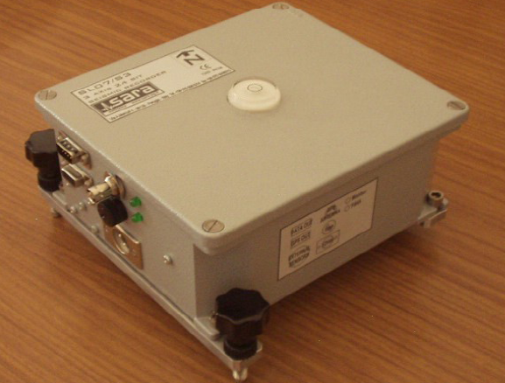

Figure 6: General view for SARA Instrument type SL07

Applications
- Earthquake network survey
- Personal Seismograph
- Professional remote seismic installation
- Education
File system structure
The SL07 unit works with SD card using the FAT 16 standard.
The disk is divided in subfolders as follows:
FLASH-DISK
FLASH-DISK\ root (this folder must remain empty)
FLASH-DISK\ root\SL07

DATALOG EVENTS LOG.TXT EVENTS.TXT
Folder contain Folder contain
Continuous files events files

How the SL07 works
The sensor receives mechanical movement then converts it to electrical waves. The A/D converter converts these waves from analog to digit type. Then with aid of GPS the data will be linked with real time and location. The data will be stored on a flash disk.
The parameters of the SL07 should be setup before recording.

Setting the SL07 Parameters:
First the SL07 should be connected to the PC with RS-232 on COM port, then power on the unit.
- On the PC open a terminal emulator to communicate with SL07
- The default communication parameters are 115200 baud rate, no parity, 8 bits, 1 stop bit.
The handshake protocol must be set to x-on/x-off.
- Type LOGIN to get in the unit and have access to change the parameters.
- setting the parameters such as Station Name, Station Code, Lat/Lon/Elev. Pre and post
Event Time, Trigger Mode, STA Time and LTA Time.

Training on SARA
- The SARA instrument was put in continuous mode by putting trigger off and recoding continuously every 30 minutes
- The instrument placed in the Basement Room (seismo lab) for many days.
- The data has been transferred to the PC by taking the SD card memory including in SARA instrument, also can be download the triggers by DL and DE commands after checking if there triggers or not by LIST command,
- After that data has been converted into SEISAN format by using wavetool program.
- Then merge the three component files into one file by using seisei program.
- By using mulplt program to display the waveform and check if any event was recorded
Acknowledgements

We would thanks GRAS for providing support for the travel to Norway, Bergen, and the University of Bergen represented in Professor Jens Havskov for inviting us to visit the Norwegian National Seismic Network (NNSN). Also we would like to thanks Terje, Berit and Jose for their efforts and knowledge that we gain, my thanks also extended to all the staff of Norwegian National Seismic Network (NNSN).
References

Havskov, J. and T. Utheim (1992). SeisLog and SeisAn: A complete system for seismic data acquisition and analysis
Havskov, J. and L Ottemöller (1999). SeisAn earthquake analysis software
Johnson, C.E., Lindh A.G., and Hirshorn, B. 1994. Robust regional phase association. USGS Open File Report 94-621.
Natvik, Y. and J. Havskov (1999). SeisLog: A Seismic Data Acquisition System for Windows 95/NT, Version 1.0, Manual, Institute of Solid Earth Physics, University of Bergen, Norway.
Ottemöller, L. and J. Havskov (1999). SeisNet: A general purpose virtual seismic network,
Utheim, T. and J. Havskov (1999). The SeisLog Data Acquisition System, Version 8.1, manual, Institute of Solid Earth Physics, University of Bergen, Norway.
WWW.folkworm.ceri.memphis.edu/ew-doc/
WWW.gfz-potsdam.de/geofon/seiscomp/

